

Admission Module
Global Master

Define Profession
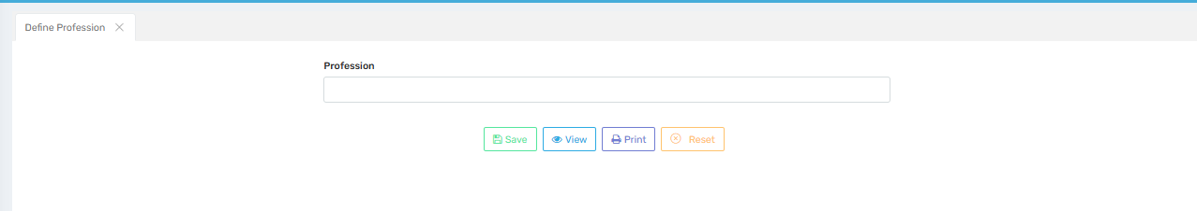

Purpose
This screen is used to define and manage professions that can be selected during student admission, typically for the parent’s or guardian’s profession field in the student registration form.

Where to Find
You can access this screen by navigating to:
Admission Module → Global Master → Define Profession

Field Description
Field / Button | Description
Profession | A text box where the user can enter the name of the profession (e.g., Doctor, Engineer, Farmer, Businessman).
Save | Saves the entered profession into the database so that it is available in dropdown lists during student admission.
View | Displays a list of all professions that have been defined so far. Useful for reviewing or verifying available options.
Print | Allows the user to print the list of defined professions for record-keeping or verification.
Reset | Clears the text box so the user can enter a new profession without manually deleting existing text.

✅ Use Case
- Student Admission Form:
When registering a student, this profession list appears as a dropdown or selection option for Father’s Profession, Mother’s Profession, or Guardian’s Profession fields.
- Reports & Certificates:
The defined profession linked to a parent/guardian is often displayed in reports, ID cards, certificates, and other official documents generated by the system.
- Filters in Reports:
You can filter or group students based on parent/guardian profession in various reports (e.g., profession-wise student list).

Important Notes
- Ensure professions are entered without spelling errors, as these will directly reflect in reports and certificates.
- Duplicate profession names should be avoided to maintain clean and consistent data.
- Changes or deletions of profession names may affect existing student records where these professions are already assigned.
- Regularly review the list of defined professions to keep it updated and relevant for the institution’s reporting needs.

Define Session

Define Academic Year
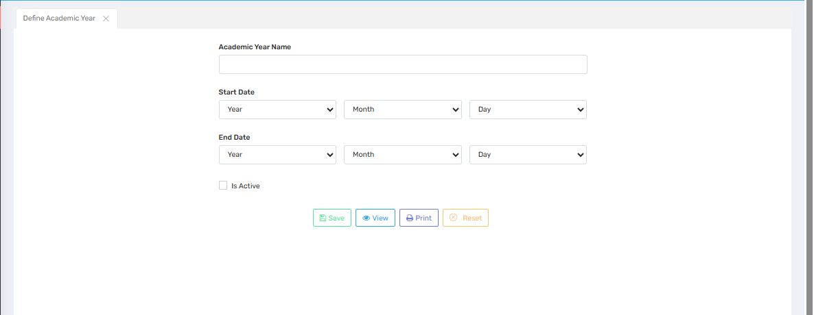

Purpose
This screen is used to define and manage academic years (sessions) for the school or institution. Academic years define the timeline for admissions, classes, exams, fee schedules, and reports.

Where to Find
You can access this screen by navigating to:
Admission Module → Global Master → Define Session / Define Academic Year

Field Description
Field / Button | Description
AcademicYear Name | Enter the name of the academic year (e.g., 2025-2026). This will appear in dropdowns wherever academic year selection is required.
Start Date | Select the starting date (year, month, day) of the academic year. This defines when the academic session begins.
End Date | Select the ending date (year, month, day) of the academic year. This defines when the academic session closes.
Is Active | A checkbox to mark this academic year as active. Only one academic year should typically be active at a time for data consistency in admissions, attendance, exams, etc.
Save | Saves the academic year details into the system.
View | Displays the list of all defined academic years for review.
Print | Prints the list of defined academic years for documentation or record-keeping.
Reset | Clears all entered data from the form so you can re-enter values.

✅ Use Case
- Student Admission:
Determines the academic session under which a student is enrolled.
- Fee Management:
Fee structures and schedules are tied to the academic year.
- Attendance & Exams:
Attendance records and exam schedules refer to the active academic year.
- Reports:
Academic year filters are used to generate session-wise reports like admission reports, performance reports, and fee defaulter lists.

Important Notes
- Always enter accurate academic year names and dates, as these impact fee plans, exams, reports, and other records.
- Only one academic year should be marked as active at a time to avoid conflicts in admissions, attendance, and reporting.
- Avoid editing or deleting academic years that have already been used in transactions, as this may cause data inconsistencies.
- Regularly review and deactivate old academic years that are no longer in use to keep the data clean.

Define Financial Year
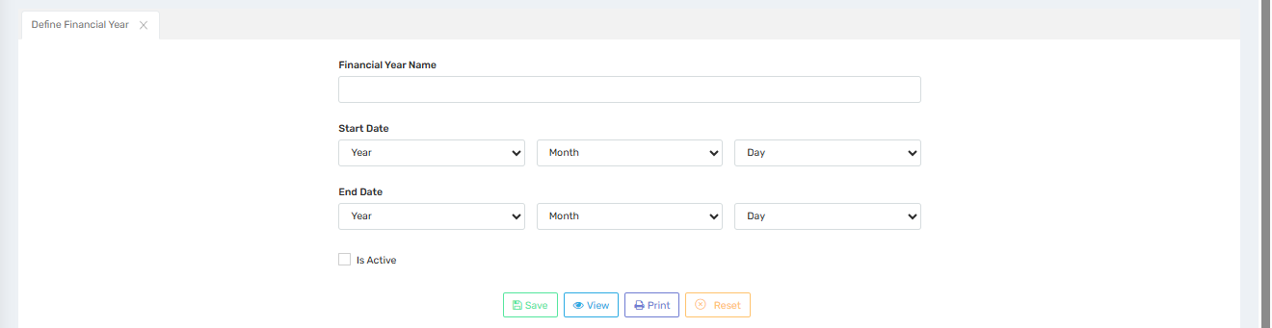

Purpose
This screen allows administrators to define and manage financial years. The financial year determines the period for which financial transactions (e.g., fee collection, salary processing, and accounting) are recorded and reported.

Where to Find
You can access this screen by navigating to:
Admission Module → Global Master → Define Session → Define Financial Year

Field Description
Field / Button | Description
Financial Year Name | Enter the name of the financial year (e.g., 2025-2026). This name will be used to identify the year in financial records and reports.
Start Date | Select the starting date (year, month, day) for the financial year. This marks the beginning of financial accounting for that period.
End Date | Select the ending date (year, month, day) for the financial year. This marks the closure of financial transactions for that period.
Is Active | Check this box to make the financial year active. Only the active financial year will allow transactions. Previous years will be locked or read-only.
Save | Saves the financial year details into the system.
View | Displays the list of all defined financial years for review or editing.
Print | Prints the list of financial years for documentation or audit purposes.
Reset | Clears all entered data so the form can be filled afresh.

✅ Use Case
- Fee Collection:
Determines the financial year in which fees are recorded.
- Accounting Reports:
Used to generate year-wise reports such as income, expenditure, balance sheets, and fee defaulters.
- Salary & Expenses:
Links salaries, vendor payments, and other financial transactions to the relevant financial year.
- Audit:
Helps during financial audits by clearly segmenting transactions year-wise.

Important Notes
- Ensure correct start and end dates are set, as these directly affect financial reporting, audits, and transaction validity.
- Only one financial year should be active at a time to maintain accounting accuracy.
- Avoid changing dates or names of financial years once transactions have been recorded, as this may cause audit and reporting issues.
- Keep old financial years deactivated to prevent accidental posting of transactions in closed periods.

Define School

School Global Details
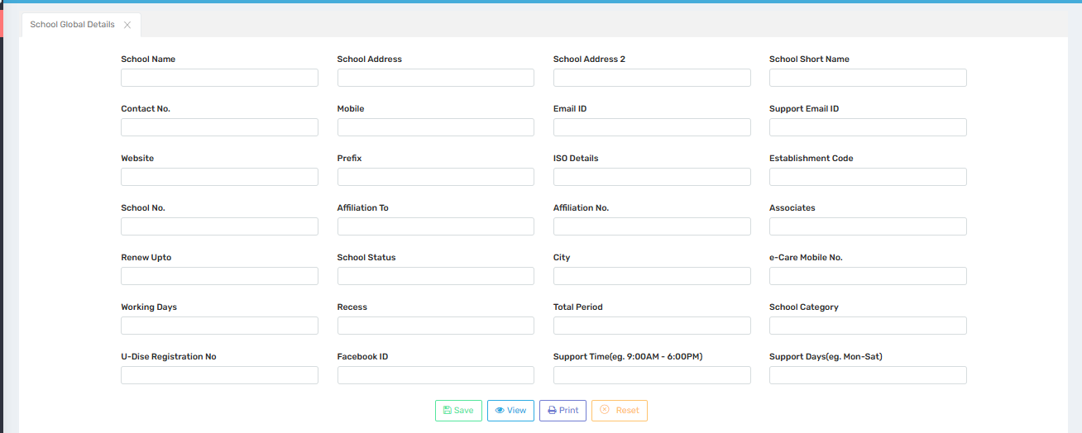

Purpose
This screen is used to define and update the basic profile and official details of the school. These details appear on official documents like fee receipts, report cards, certificates, and various system-generated reports.

Where to Find
You can access this screen by navigating to:
Global Masters→ Define School → School Global Details

Field Descriptions
Field | Description
School Name | Full legal name of the school.
School Address / School Address 2 | Primary and additional address information of the school.
School Short Name | Abbreviated or short form name of the school for internal use or reports.
Contact No. / Mobile / e-Care Mobile No. | Landline and mobile numbers for official contact and e-Care support services. This reflects on the user's web login.
Email ID / Support Email ID | Official email ID and a dedicated support email ID for queries.
Website | School’s official website URL.
Facebook ID | Official Facebook page or ID of the school.
Support Time / Support Days | Time slots and days when support is available (e.g., 9:00 AM – 6:00 PM, Mon–Sat).This reflects on the user's web login.
Prefix | A prefix used in student IDs or admission numbers (e.g., SCH, ABC).
ISO Details | ISO certification details, if applicable.
Establishment Code | Official code assigned at the time of school establishment/registration.
School No. | School’s unique identification number as per regulatory bodies.
Affiliation To / Affiliation No. | The board or authority the school is affiliated with (e.g., CBSE, ICSE) and its affiliation number.
Associates | Names of associate or partner institutions, if any.
Renew Upto | Date up to which the school’s affiliation/approval is valid.
School Status | Operational status of the school (e.g., Active, Inactive).
City | City where the school is located.
School Category | Type/category of the school (e.g., Primary, Secondary, Senior Secondary).
Working Days | Number of working days in an academic session.
Recess | Duration of daily recess/break time.
Total Period | Total number of periods per day.
U-Dise Registration No | U-DISE (Unified District Information System for Education) code provided by the government.

Button Descriptions
Button | Description
Save | Saves or updates the school global details in the system.
View | Displays the current saved school details.
Print | Prints the school profile details for official records.
Reset | Clears all entered data from the form to re-enter information.

✅ Use Cases
- Displayed on fee receipts, report cards, certificates, transfer certificates, and other official documents generated by the system.
- Referenced in admission forms, SMS/email communication, and portals where school identity is shown.
- Used in statutory and regulatory reporting (e.g., U-DISE reports).

⚠️ Important Notes
- Ensure all information is accurate and up to date, as this data reflects on all official communication and documents.
- Any change in affiliation or school status must be promptly updated to avoid discrepancies in compliance reports.
- Changes made here may take immediate effect on system-generated documents; review carefully before saving.
- Only users with administrative privileges should be allowed to modify these settings.

School Global Details With Fee Type

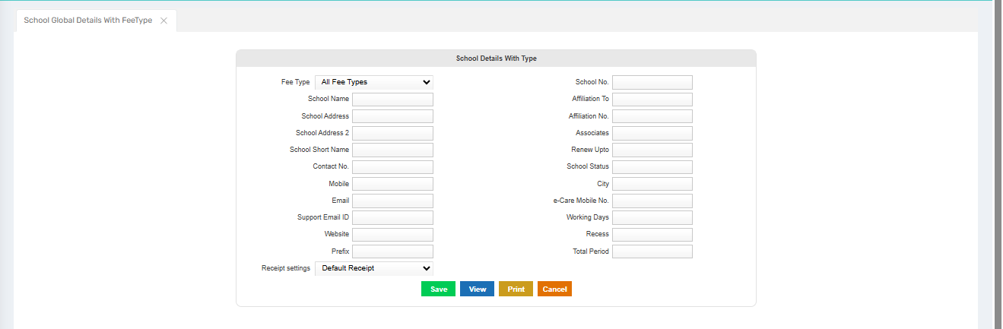

Purpose
This screen allows the admin to define school profile details specific to different fee types (e.g., Regular Fee, Transport Fee, Hostel Fee). This ensures that the correct school identity information appears on receipts and reports based on the selected fee type.

Where to Find
You can access this screen by navigating to:
Global Masters→ Define School → School Global Details with fee type

Field Descriptions
Field | Description
Fee Type | Select the applicable fee type (e.g., All Fee Types, Regular Fee, etc.). Data entered here will be linked to the selected fee type.
School Name | Official name of the school for the chosen fee type.
School Address / School Address 2 | Primary and additional address lines.
School Short Name | Short form of the school’s name for display on receipts/reports.
Contact No. / Mobile / e-Care Mobile No. | Contact numbers relevant for that fee type.
Email / Support Email ID | Official and support email IDs.
Website | School’s official website address.
Prefix | Prefix for admission or fee numbers on receipts (e.g., SCH, ABC).
School No. | Official school number assigned by authorities.
Affiliation To / Affiliation No. | Board or body the school is affiliated to, with the affiliation number.
Associates | Linked schools/institutions, if any.
Renew Upto | Validity date for affiliation.
School Status | Status (Active/Inactive) for that fee type.
City | City of the school campus.
Working Days / Recess / Total Period | Operational details for schedule-related reporting on receipts.
Receipt Settings | Choose default receipt template (e.g., Default Receipt).

Button Descriptions
Button | Description
Save | Saves the entered school details for the selected fee type.
View | Displays saved records for review.
Print | Prints school global details for record-keeping or audit.
Cancel | Closes the screen without saving changes.

✅ Use Case
✅ The details here reflect on fee receipts, invoices, and statements generated for the selected fee type.
✅ Ensures accurate school identity on documents across different fee structures (like Hostel, Transport).
✅ Supports multi-campus or multi-branch schools managing different receipts per fee type.

⚠️ Important Notes
- It is essential to define each fee type separately to ensure proper display of school information across reports.
- Incorrect or missing entries may result in misrepresentation of school details on financial documents.
- Always select the appropriate receipt template under “Receipt Settings” to align with school branding.
- Only authorized users should modify these records, as they impact printed and digital financial communications.

Define Class Details

Define Wing
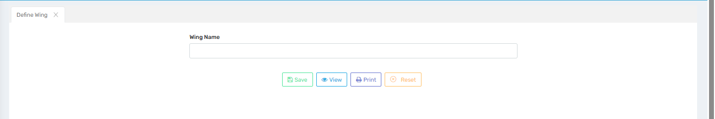

Purpose
This screen allows the admin to define different wings or academic divisions of the school.
Examples of wings include:
- Pre-Primary Wing
- Primary Wing
- Secondary Wing
- Senior Secondary Wing
Defining wings helps organize students, staff, and records by academic sections or divisions for more efficient administration.

📍 Where to Find
You can access this screen by navigating to:
Global Masters → Deine Class Details → Define Wing

📝 Field Descriptions
Field | Description
Wing Name | Enter the name of the academic wing (e.g., Primary, Senior Secondary, Nursery).

🔘 Button Descriptions
Button | Description
Save | Saves the entered wing name to the system.
View | Displays a list of all previously defined wings for review or editing.
Print | Prints the list of all wings for documentation or administrative records.
Reset | Clears the entered data to allow re-entry or correct a mistake.

✅ Use Case
✅ Helps categorize school structure into different wings for academic and administrative clarity. ✅ Useful in student management, class assignments, and report generation based on school divisions.
✅ Supports schools with multiple levels or departments by providing clear segmentation.

⚠️ Important Notes
- Always ensure unique and meaningful names are used for each wing to avoid confusion.
- Defining wings properly is essential for reports, class distribution, and permission control based on roles.
- Only authorized users should manage wing definitions as it affects organizational hierarchy and reporting structure.

Define Wing
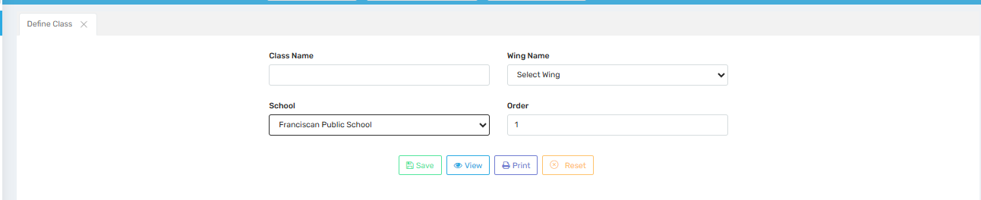

Purpose
This screen allows the admin to define academic classes within the school structure.
Each class is linked to a specific wing and school, and arranged in a desired order.
This ensures that all classes are properly organized for use in:
- Student enrollment
- Timetables
- Academic reports
- Section allocations

📍 Where to Find
You can access this screen by navigating to:
Global Masters → Deine Class Details → Define Class

📝 Field Descriptions
Field | Description
Class Name | Enter the name of the class (e.g., Nursery, KG-1, Class 1, Class 12).
Wing Name | Select the wing (e.g., Primary Wing, Senior Wing) under which this class falls.
School | Select the school (if managing multiple schools/campuses) to which the class belongs.
Order | Specify the display order for the class. This affects how classes appear in dropdowns and lists.

🔘 Button Descriptions
Button | Description
Save | Saves the entered class details into the system.
View | Displays the list of already defined classes.
Print | Prints the list of classes for administrative documentation or records.
Reset | Clears the entered data to allow fresh input.

✅ Use Case
✅ Helps maintain a structured academic hierarchy within each school and wing.
✅ Essential for linking students, timetables, subjects, and teachers to specific classes.
✅ Useful in multi-campus schools to manage class-level distinctions across branches.

⚠️ Important Notes
- Ensure class names follow a standardized format (e.g., Class 1, Class 2, not One, Two).
- The order field determines how classes are sorted—important for user-friendly dropdowns.
- Always link each class to the correct wing and school to avoid confusion in academic mapping.
- Only authorized personnel should configure classes to prevent data structure inconsistencies.

Define Section
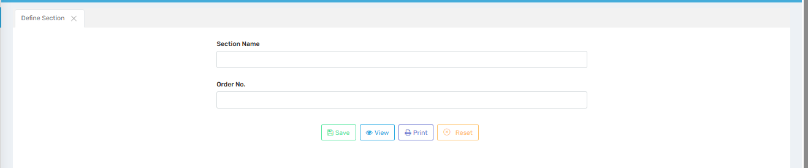

Purpose
This screen allows the admin to create and organize sections within a class (e.g., Section A, B, C).
Sections help in managing students more efficiently within the same class level by grouping them into smaller units.
It supports:
- Class-wise student distribution
- Timetable management
- Attendance, examination, and report generation by section

📍 Where to Find
You can access this screen by navigating to:
Global Masters → Deine Class Details → Define Section

📝 Field Descriptions
Field | Description
Section  Name | Enter the section name (e.g., A, B, Red, Blue). This name will appear in reports and dropdowns.
Order No. | Determines the display sequence of sections in lists and dropdowns. For example, A = 1, B = 2.

🔘 Button Descriptions
Button | Description
Save | Saves the new section information into the system.
View | Shows a list of all defined sections for review or editing.
Print | Prints the section list for internal documentation or administrative use.
Reset | Clears the form inputs to allow fresh data entry.

✅ Use Case
✅ Enables schools to divide students in each class for better teacher-student ratio.
✅ Helps in assigning teachers, creating section-wise reports, and organizing section-wise activities.
✅ Especially useful in schools with large student strength per class.

⚠️ Important Notes
- Use consistent and logical naming for sections (e.g., A, B, C or Alpha, Beta) to avoid confusion.
- Order No. should be set carefully to ensure correct display and sorting in lists.
- Changes to section structure may impact timetables, student allocation, and report formats, so modify cautiously.
- Only authorized staff should handle section creation and updates.

Relate Class Section
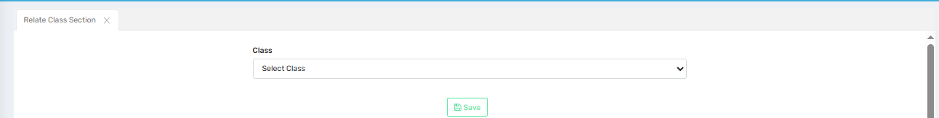

Purpose
This screen allows the admin to assign or link sections to specific classes.
It defines the relationship between classes and their corresponding sections, enabling the school to structure students under appropriate combinations like:
- Class 1 → Sections A, B
- Class 2 → Sections A, B, C
This is essential for managing academic records, timetables, and staff allocation at the section level.

📍 Where to Find
You can access this screen by navigating to:
Global Masters → Deine Class Details → Relate Class Section

📝 Field Descriptions
Field | Description
Class | Select the class (e.g., Class 1, Class 2) from the dropdown to which you want to assign sections.
Once a class is selected, the system displays the available sections (not shown in this cropped image), allowing the user to checkmark and assign them.

🔘 Button Descriptions
Button | Description
Save | Saves the class-section relationships defined on the screen.

✅ Use Case
✅ Helps in organizing students into class-section combinations for all academic operations.
✅ Ensures accurate linkage for student admission, timetable generation, examination setup, and teacher allocation.
✅ Reduces manual errors and ensures system-wide consistency for class-structure-based modules.

⚠️ Important Notes
- Only predefined classes and sections can be linked here. Ensure both are already created.
- Each class can have multiple sections based on the school structure.
- Assignments made here affect admissions, attendance, and academic reporting, so changes should be handled carefully.
- Only authorized personnel should perform mappings to maintain data accuracy.

Define Religion
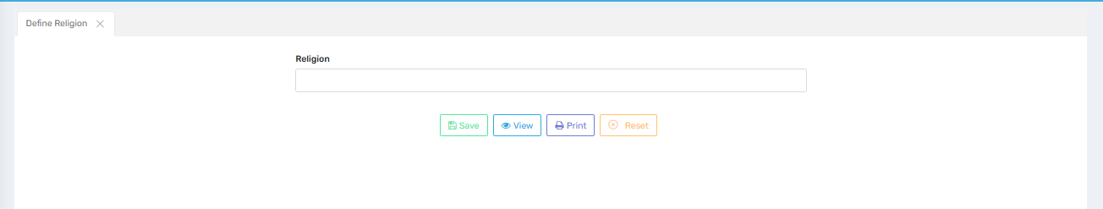

Purpose
This screen allows the admin to define and manage religion categories in the system.
The defined religion names are used across multiple modules including:
- Student admission
- Staff registration
- Reports and demographic analysis
It helps the school maintain accurate personal records for each individual, respecting diversity and regulatory compliance.

📍 Where to Find
You can access this screen by navigating to:
Global Masters → Define Religion

📝 Field Descriptions
Field | Description
Religion | Enter the name of the religion (e.g., Hindu, Muslim, Christian, Sikh, etc.).

🔘 Button Descriptions
Button | Description
Save | Saves the entered religion to the master list.
View | Displays a list of all religions already saved in the system.
Print | Prints the religion master list for administrative reference or audit purposes.
Reset | Clears the input field to allow fresh entry.

✅ Use Case
✅ Enables schools to record religious affiliation for students and staff during admission or profile creation.
✅ Helps in generating customized reports or fulfilling government education board requirements.
✅ Useful for statistical analysis, scholarship eligibility, and inclusive event planning.

⚠️ Important Notes
- Enter religion names accurately and without duplication to avoid confusion in dropdowns.
- This master list is used in various modules—editing or deleting an entry may affect historical data.
- Ensure religion options are created with cultural sensitivity and aligned with school policy.
- Only authorized users should update this list to maintain data integrity and compliance.

Define Caste
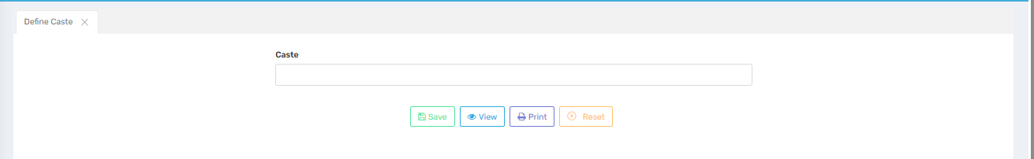

Purpose
This screen allows the admin to define and manage caste categories in the school system.
Caste information is used during:
- Student admission
- Government reporting
- Scholarship eligibility tracking
- Demographic analysis
Proper configuration ensures that the institution complies with educational regulations and supports inclusion policies.

📍 Where to Find
You can access this screen by navigating to:
Global Masters → Define Caste

📝 Field Descriptions
Field | Description
Caste | Enter the caste name (e.g., General, OBC, SC, ST, Others). This will be used in student/staff profiles and reports.

🔘 Button Descriptions
Button | Description
Save | Saves the entered caste to the system's master list.
View | Displays all previously saved caste entries for review or update.
Print | Prints the caste master list for administrative records or audits.
Reset | Clears the caste field input for fresh entry.

✅ Use Case
✅ Helps the school in recording caste-related data for students and staff.
✅ Facilitates government compliance, reporting, and scholarship processing.
✅ Supports schools in creating inclusive admission reports and ensuring transparency.

⚠️ Important Notes
- Ensure caste names are entered correctly and without duplication to maintain data quality.
- Caste entries once created may appear in student admission forms, so avoid casual edits.
- Handle caste data with confidentiality and respect, in accordance with institutional and legal guidelines.
- Only authorized personnel should update this list to maintain system-wide consistency.

Define Sub caste
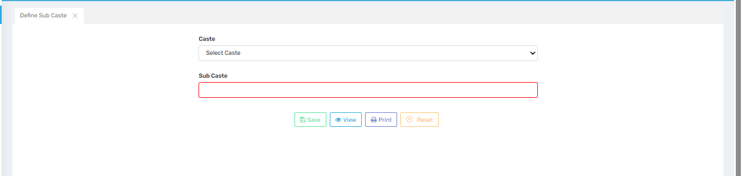

Purpose
This screen allows the admin to define and manage sub-caste details under each caste category.
It enhances the granularity of demographic data collected during:
- Student admissions
- Staff profiling
- Government reporting or welfare program eligibility
Sub-castes are useful for schools that require more detailed classification under caste for compliance or statistical purposes.

📍 Where to Find
You can access this screen by navigating to:
Global Masters → Define Sub Caste

📝 Field Descriptions
Field | Description
Caste | Select the parent caste from the dropdown (must be defined earlier in “Define Caste”).
Sub Caste | Enter the sub-caste name (e.g., Yadav, Jat, Meena, Khatik). This will be linked to the selected caste.

🔘 Button Descriptions
Button | Description
Save | Saves the sub-caste entry linked with the selected caste.
View | Displays the list of all sub-castes added in the system.
Print | Prints the sub-caste master list for record-keeping or official use.
Reset | Clears the input fields for fresh data entry.

✅ Use Case
✅ Helps institutions record accurate and detailed caste information as required by various government education bodies.
✅ Supports eligibility verification for scholarships, reservations, or educational schemes.
✅ Enhances the quality of demographic reporting and school analytics.

⚠️ Important Notes
- Sub-castes should only be created after their parent caste is defined in the system.
- Avoid creating duplicate or inconsistent sub-caste names to ensure clean data.
- Be sensitive and respectful while managing caste-related information—it should only be accessed or updated by authorized personnel.
- Once sub-castes are linked with student records, editing them should be done with caution.

Define Category
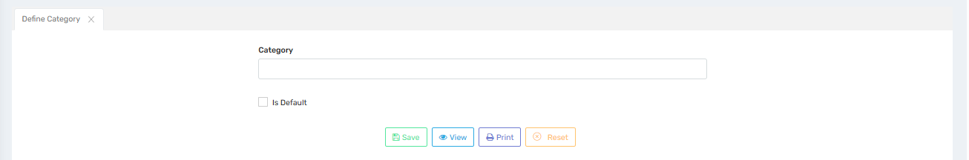

Purpose
This screen allows the admin to define student or admission categories that can be used to classify students based on various criteria such as:
- General
- SC
- ST
- OBC
- EWS (Economically Weaker Section)
- Management Quota
These categories are important for managing admissions, fees, reports, and eligibility for schemes or concessions.

📍 Where to Find
You can access this screen by navigating to:
Global Masters → Define Category

📝 Field Descriptions
Field | Description
Category | Enter the name of the student category (e.g., General, SC, ST, OBC, EWS).
Is Default | Check this box to mark this category as the default when no other is selected.

🔘 Button Descriptions
Button | Description
Save | Saves the category to the master list.
View | Displays a list of already defined categories.
Print | Prints the list of categories for documentation or administrative reference.
Reset | Clears the form fields for fresh entry.

✅ Use Case
✅ Allows schools to classify students for fee structure, seat allotment, and reporting.
✅ Supports government-mandated reporting and reservation management.
✅ Enables custom reporting by category for scholarships, analysis, and performance comparison.

⚠️ Important Notes
- Category names should be clearly defined and aligned with government norms or school policy.
- Use the “Is Default” option carefully—it sets the default category for all new entries.
- Avoid duplication of category names for clean dropdowns and report accuracy.
- Only authorized personnel should modify category settings to ensure system-wide consistency.

Define Parish
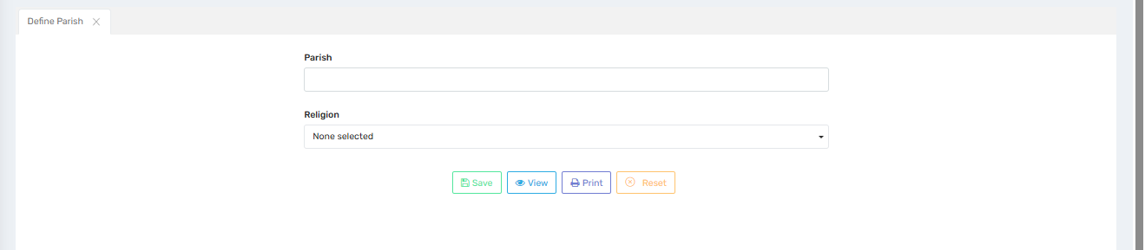

Purpose
This screen allows the admin to define student or admission categories that can be used to classify students based on various criteria such as:
- General
- SC
- ST
- OBC
- EWS (Economically Weaker Section)
- Management Quota
These categories are important for managing admissions, fees, reports, and eligibility for schemes or concessions.

📍 Where to Find
You can access this screen by navigating to:
Global Masters → Define Category

📝 Field Descriptions
Field | Description
Category | Enter the name of the student category (e.g., General, SC, ST, OBC, EWS).
Is Default | Check this box to mark this category as the default when no other is selected.

🔘 Button Descriptions
Button | Description
Save | Saves the category to the master list.
View | Displays a list of already defined categories.
Print | Prints the list of categories for documentation or administrative reference.
Reset | Clears the form fields for fresh entry.

✅ Use Case
✅ Allows schools to classify students for fee structure, seat allotment, and reporting.
✅ Supports government-mandated reporting and reservation management.
✅ Enables custom reporting by category for scholarships, analysis, and performance comparison.

⚠️ Important Notes
- Category names should be clearly defined and aligned with government norms or school policy.
- Use the “Is Default” option carefully—it sets the default category for all new entries.
- Avoid duplication of category names for clean dropdowns and report accuracy.
- Only authorized personnel should modify category settings to ensure system-wide consistency.

Define Committee
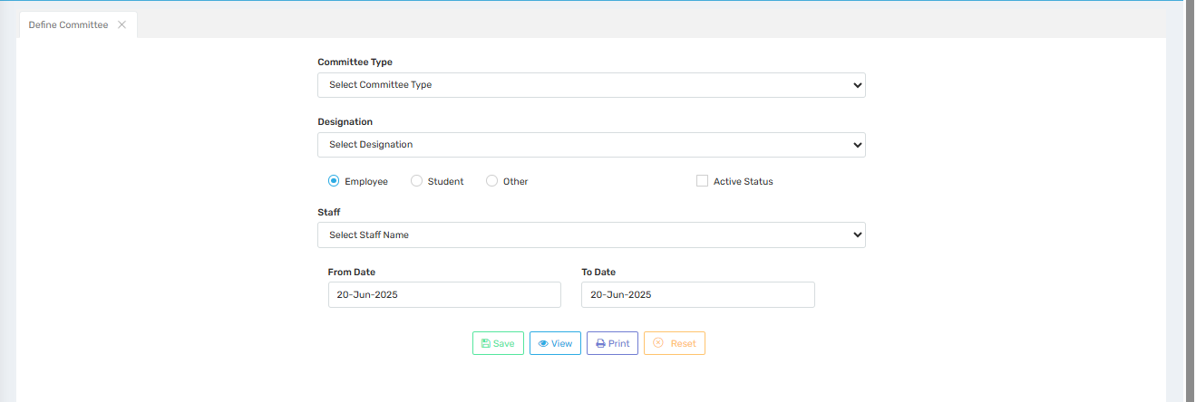

Purpose
This screen allows the admin to define a committee by assigning members (employees, students, or others) to a specific committee type, along with their designation and duration of association. It helps in organizing institutional committees like:
- Disciplinary Committee
- Cultural Committee
- Academic Committee
- Examination Committee
- Anti-Ragging Committee
This feature streamlines committee management for roles, responsibilities, and reporting.

📍 Where to Find
You can access this screen by navigating to:
Global Masters → Define Committee

📝 Field Descriptions
Field | Description
Committee Type | Select the type of committee (e.g., Academic, Discipline, Sports).
Designation | Choose the role/designation of the member in the committee (e.g., Chairman, Member).
Employee/Student/Other | Select whether the person being assigned is an employee, student, or other.
Active Status | Check this box if the committee member is currently active.
Staff | Select the staff name to be assigned to the committee.
From Date | Specify the start date of the committee assignment.
To Date | Specify the end date of the committee assignment.

🔘 Button Descriptions
Button | Description
Save | Saves the current committee assignment.
View | Displays a list of existing committee definitions.
Print | Prints the current list or committee configuration for documentation purposes.
Reset | Clears all fields on the form for fresh data entry.

✅ Use Case
- ✅ Assign and manage committee roles for faculty, students, or external members.
- ✅ Maintain a record of active and past committee members with duration.
- ✅ Enable role-based communication and responsibility mapping within the institution.
- ✅ Print committee details for audits, approvals, or official records.

⚠️ Important Notes
- Ensure date fields (From Date & To Date) are accurate to avoid overlapping assignments.
- "Active Status" must be used judiciously to track current members effectively.
- Only valid staff/students should be selected to avoid inconsistencies in reports.
- Committees should be predefined before assigning members (manage via Master screens).

Define Club
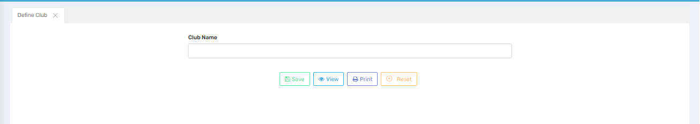

Purpose
This screen allows the admin to define and manage different clubs within the institution. Clubs can be academic, cultural, or interest-based groups that help in holistic development of students and staff, such as:
- Science Club
- Literary Club
- Music Club
- Drama Club
- Robotics Club
Defining clubs helps streamline event planning, student participation, and report generation related to extracurricular activities.

📍 Where to Find
You can access this screen by navigating to:
Global Masters → Define Club

📝 Field Descriptions
Field | Description
Club Name | Enter the name of the club (e.g., Science Club, Art Club).

🔘 Button Descriptions
Button | Description
Save | Saves the entered club name to the system master list.
View | Displays a list of all previously defined clubs.
Print | Prints the list of defined clubs for documentation or review.
Reset | Clears the current field to allow fresh data entry.

✅ Use Case
- ✅ Enables management of co-curricular and extra-curricular student activities.
- ✅ Facilitates assigning members and coordinators to specific clubs.
- ✅ Supports reports and dashboards related to club-wise student participation.
- ✅ Useful for organizing inter-house and inter-school competitions effectively.

⚠️ Important Notes
- Avoid duplicate club names to ensure clean dropdowns and reporting.
- Clearly name the clubs to reflect their purpose and engagement area.
- Only authorized staff should define or edit club names for consistency.

Define House
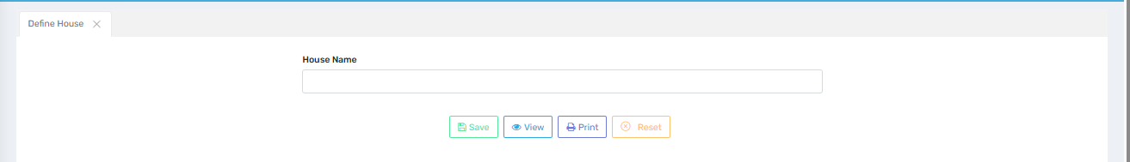

Purpose
This screen allows the admin to define houses within the school system for inter-house competitions, discipline, attendance, and team activities. These houses foster a sense of identity, teamwork, and healthy competition among students.
Common examples include:
- Red House
- Blue House
- Green House
- Yellow House
Defining houses is essential for organizing sports, debates, quizzes, and other inter-house events.

📍 Where to Find
You can access this screen by navigating to:
Global Masters → Define House

📝 Field Descriptions
Field | Description
House Name | Enter the name of the house (e.g., Emerald, Ruby, Blue House).

🔘 Button Descriptions
Button | Description
Save | Saves the entered house name to the system.
View | Displays a list of previously defined houses.
Print | Prints the list of houses for reports or administrative documentation.
Reset | Clears the form for new entry.

✅ Use Case
- ✅ Enables the creation of house groups for students and staff.
- ✅ Helps in managing inter-house competitions and assigning points.
- ✅ Facilitates attendance, discipline, and performance tracking by house.
- ✅ Supports automatic sorting of students into houses during admission.

⚠️ Important Notes
- Ensure each house name is unique to avoid confusion in reports and assignments.
- Use consistent naming conventions for clear recognition across the system.
- Avoid frequent edits to house names after student assignments to maintain data integrity.

Meeting Details
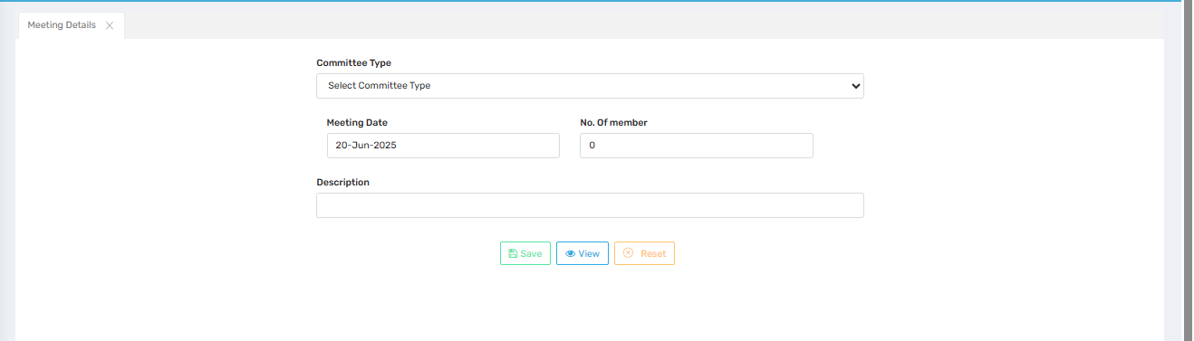

Purpose
This screen allows the admin to record meeting details for various institutional committees. It helps track meeting schedules, attendance, agenda descriptions, and the number of participating members.
It is useful for documenting:
- Academic Committee Meetings
- Disciplinary Meetings
- Cultural or Event Planning Discussions
- Safety or Compliance Committee Reviews

📍 Where to Find
You can access this screen by navigating to:
Global Masters → Meeting Details

📝 Field Descriptions
Field | Description
Committee Type | Select the type of committee (e.g., Academic, Examination, Anti-Ragging).
Meeting Date | Choose the date on which the meeting is scheduled or has occurred.
No. of Members | Enter the number of members who participated in the meeting.
Description | Provide a brief summary or agenda of the meeting (e.g., “Finalized exam schedule”).

🔘 Button Descriptions
Button | Description
Save | Saves the meeting record into the system for future reference.
View | Displays a list of all saved meeting records.
Reset | Clears the form to allow new data entry.

✅ Use Case
- ✅ Maintains a centralized log of all committee meetings.
- ✅ Helps with audits, compliance checks, and activity tracking.
- ✅ Enables transparency in institutional decision-making processes.
- ✅ Assists in documenting minutes and outcomes of the meetings.

⚠️ Important Notes
- Ensure the correct committee type is selected to avoid data misclassification.
- Include clear and concise descriptions for better documentation.
- Meeting records can support reviews, inspections, or administrative reports.
- Avoid entering incorrect dates or participant counts to maintain accuracy.

Import Student
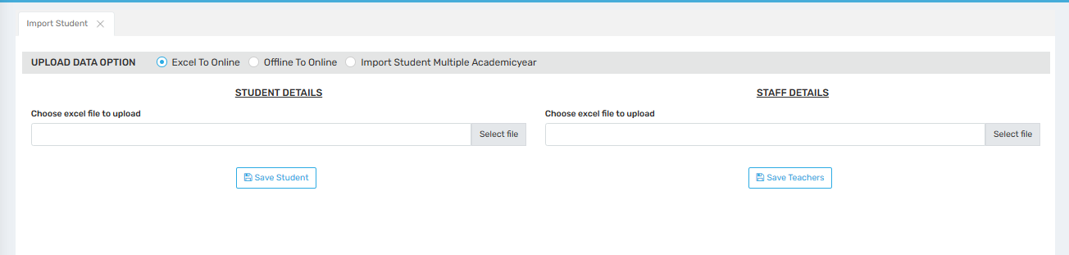

Purpose
This screen allows the admin to bulk import student and staff data into the system using Excel files. It significantly reduces manual data entry by enabling the upload of records in batches.
The tool supports multiple upload methods:
- Excel to Online
- Offline to Online
- Import Student for Multiple Academic Years

📍 Where to Find
You can access this screen by navigating to:
Global Masters → Import Student

📝 Field Descriptions
Section | Field | Description
Upload Data Option | Excel to Online / Offline to Online / Import Student Multiple Academicyear | Select the preferred method for uploading data.
Student Details | Choose Excel File to Upload | Browse and upload an Excel (.xls/.xlsx) file containing student data.
Staff Details | Choose Excel File to Upload | Browse and upload an Excel (.xls/.xlsx) file containing staff/teacher data.

🔘 Button Descriptions
Button | Description
Save Student | Uploads and saves student data from the selected Excel file.
Save Teachers | Uploads and saves staff data from the selected Excel file.

✅ Use Case
- ✅ Import large batches of student or teacher records efficiently.
- ✅ Update data across multiple academic years when required.
- ✅ Minimize manual errors and speed up admissions or onboarding processes.
- ✅ Useful for newly onboarded schools or institutions transitioning from offline systems.

⚠️ Important Notes
- Ensure the Excel file format strictly matches the required template (column names and order).
- Always validate the data in Excel (no missing or incorrect values) before uploading.
- For multi-academic year imports, ensure consistency in year-wise data entries.
- Use the correct section (Student or Staff) to avoid uploading errors.

Define Strem
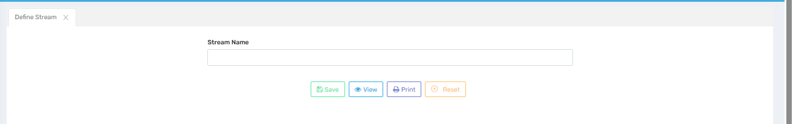

Purpose
This screen allows the admin to define different academic streams offered by the institution, such as:
- Science
- Commerce
- Humanities (Arts)
- Vocational
- Technical
Streams help in grouping students based on curriculum focus in higher classes (usually Grade 11 & 12), enabling better management of subjects, timetables, and exam patterns.

📍 Where to Find
You can access this screen by navigating to:
Global Masters → Define Stream

📝 Field Descriptions
Field | Description
Stream Name | Enter the name of the academic stream (e.g., Science, Commerce).

🔘 Button Descriptions
Button | Description
Save | Saves the entered stream to the master list.
View | Displays a list of all previously defined academic streams.
Print | Prints the list of defined streams for reports or internal reference.
Reset | Clears the form field to allow fresh data entry.

✅ Use Case
- ✅ Helps in stream-wise student admissions and subject allocation.
- ✅ Useful in configuring class sections, timetables, and stream-specific activities.
- ✅ Enables reporting and analytics based on academic streams.
- ✅ Mandatory for institutions offering senior secondary education (Classes 11–12).

⚠️ Important Notes
- Avoid duplicate or confusing stream names to maintain reporting accuracy.
- Once streams are assigned to students, changing the stream name may affect data consistency.
- Follow institutional or board-prescribed naming conventions for standardization.
- Stream names should reflect the academic focus clearly (e.g., "Science – PCM").

Parent Status
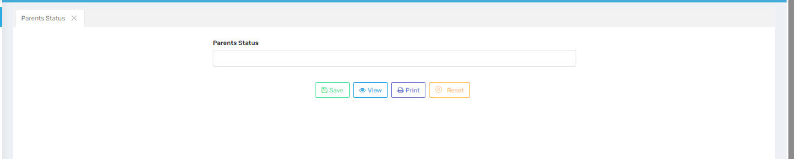

Purpose
This screen allows the admin to define various parental status categories to be associated with student records. This helps institutions track and record the current status of a student’s parents for documentation, eligibility, or support programs.
Common examples include:
- Alive
- Deceased
- Single Parent
- Divorced
- Guardian Only
This data is essential for ensuring appropriate support, fee waivers, or counseling services.

📍 Where to Find
You can access this screen by navigating to:
Global Masters → Parents Status

📝 Field Descriptions
Field | Description
Parents Status | Enter the name of the parental status category (e.g., Single Parent).

🔘 Button Descriptions
Button | Description
Save | Saves the entered parental status to the master list.
View | Displays a list of all defined parent status options.
Print | Prints the list for records or administrative use.
Reset | Clears the field for new entry.

✅ Use Case
- ✅ Helps identify students needing emotional, financial, or social support.
- ✅ Enables customized reporting and eligibility for scholarships or concessions.
- ✅ Aids in parental communication management (e.g., only mother/father contact).
- ✅ Supports legal documentation processes involving guardianship or care.

⚠️ Important Notes
Use standardized status names to avoid confusion in reporting.
Make sure entries reflect actual legal/guardian status for accuracy.
This data should be updated only by authorized users due to its sensitivity.
May be linked with student profile updates during admission or review.

Define Optional Subject
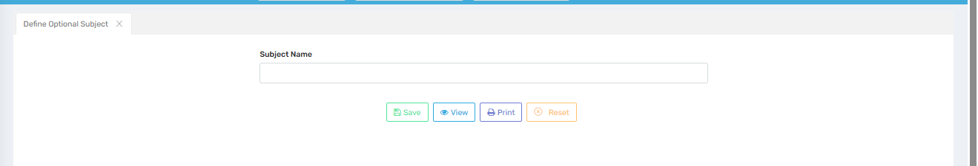

Purpose
This screen allows the admin to define various optional subjects that students can choose in addition to core subjects, based on their interests or academic requirements.
Examples of optional subjects include:
- Physical Education
- Informatics Practices
- Fine Arts
- Computer Science
- Music
- Economics (for non-Commerce students)
These subjects play a key role in curriculum flexibility and student development.

📍 Where to Find
You can access this screen by navigating to:
Global Masters → Define Optional Subject

📝 Field Descriptions
Field | Description
Subject Name | Enter the name of the optional subject to be offered (e.g., Fine Arts).

🔘 Button Descriptions
Button | Description
Save | Saves the optional subject to the master list.
View | Displays all previously defined optional subjects.
Print | Prints the list of optional subjects for records or academic planning.
Reset | Clears the entry field for fresh input.

✅ Use Case
- ✅ Enables students to select subjects that align with their interests or career paths.
- ✅ Assists in optional subject mapping during admission or section allocation.
- ✅ Useful for flexible curriculum management, especially in Grades 9–12.
- ✅ Supports report generation and exam configuration based on subject choices.

⚠️ Important Notes
- Ensure subject names follow the board-prescribed naming (e.g., CBSE, ICSE).
- Avoid duplicate entries to keep the subject list clean and accurate.
- Optional subjects should be linked to applicable classes/streams in subsequent configurations.
- Periodically review and update the list to match institutional offerings and trends.

Define Classification
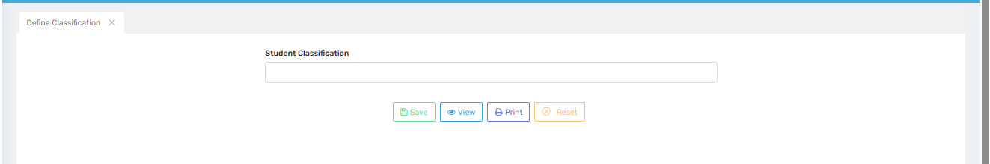

Purpose
This screen allows the admin to define student classification types, which can be used to group or categorize students based on specific criteria. These classifications help in personalized management, reporting, and filtering of student data.
Examples of student classifications include:
- Regular
- Special Needs
- Scholarship Holder
- Transport Availing
- Day Scholar / Hostel
Such classifications support differentiated treatment in attendance, fee structure, examination, and services.

📍 Where to Find
You can access this screen by navigating to:
Global Masters → Define Classification

📝 Field Descriptions
Field | Description
Student Classification | Enter the classification type (e.g., Regular, Special Needs, Day Scholar).

🔘 Button Descriptions
Button | Description
Save | Saves the entered classification type to the master list.
View | Displays all previously defined classifications.
Print | Prints the list of classifications for administrative or planning use.
Reset | Clears the form to allow new data entry.

✅ Use Case
- ✅ Helps filter students for reporting, examination setup, or transportation.
- ✅ Supports specialized fee setup or policy application (e.g., concession for scholarship holders).
- ✅ Enables structured data grouping for better administration.
- ✅ Useful for customizing student support programs or academic interventions.

⚠️ Important Notes
- Use clear and non-overlapping names for each classification to avoid confusion.
- Avoid making unnecessary changes after student records are assigned to a classification.
- Classifications should reflect meaningful and actionable groupings aligned with school policies.
- Can be used in conjunction with filters across modules like Attendance, Reports, and Fee.

Define Reason
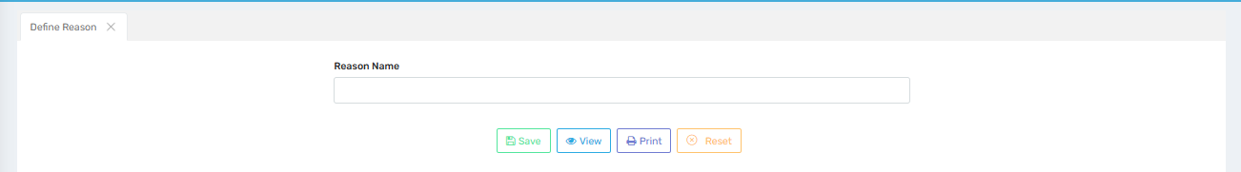

Purpose
This screen allows the admin to define different reasons that can be used across multiple school modules—such as for attendance, leave applications, disciplinary actions, transfer certificates, or activity cancellations.
Common examples include:
- Sick Leave
- Personal Reason
- Transfer to Another School
- Medical Emergency
- Fee Non-payment
Having predefined reasons ensures consistency in data entry and reporting across the system.

📍 Where to Find
You can access this screen by navigating to:
Global Masters → Define Reason

📝 Field Descriptions
Field | Description
Reason Name | Enter the reason (e.g., Sick Leave, Disciplinary Action, TC Issued).

🔘 Button Descriptions
Button | Description
Save | Saves the entered reason to the master list.
View | Displays a list of all defined reasons.
Print | Prints the list for administrative documentation or review.
Reset | Clears the entry field to allow for a new reason to be entered.

✅ Use Case
- ✅ Ensures uniformity in recording student/staff leave or disciplinary actions.
- ✅ Enables clean and categorized reporting (e.g., number of students on medical leave).
- ✅ Useful for Transfer Certificates (TC), dropout tracking, or cancellation logs.
- ✅ Helps maintain consistent dropdown options across modules requiring a “reason” field.

⚠️ Important Notes
- Keep reason names concise and unambiguous.
- Avoid duplicate or redundant entries (e.g., “Sick” vs “Medical Leave”).
- Review periodically to update or deactivate obsolete reasons.
- Used system-wide—changes will reflect in multiple reporting areas.

Country Setting

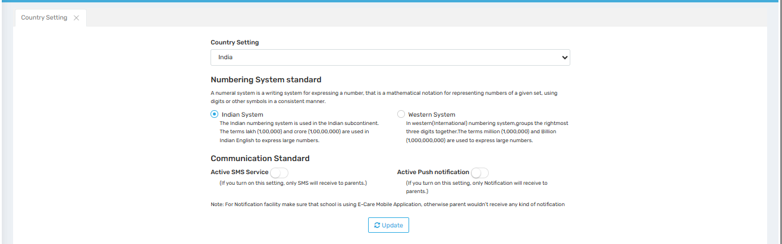

Purpose
This screen allows the admin to configure country-specific settings that impact number formatting and communication preferences within the school management system. These settings ensure regional accuracy in representing numerical data and define how communication with parents is handled.
Common use cases include:
- Displaying student fees or grades using the Indian or Western number format.
- Sending notifications to parents via SMS or push notifications, depending on preferences and app usage.

📍 Where to Find
You can access this screen by navigating to:
Global Masters → Country Setting

📝 Field Descriptions
Field | Description
Country Setting | Dropdown to select the country (e.g., India). Determines the available options for numbering and communication formats.
Numbering System Standard | Choose between:  🔘 Indian System – Uses lakh (1,00,000) and crore (1,00,00,000).  🔘 Western System – Uses million (1,000,000) and billion (1,000,000,000).
Communication Standard | Toggle-based options for enabling parent communication:  📩 Active SMS Service – Sends SMS only to parents.  🔔 Active Push Notification – Sends app-based notifications. Requires the E-Care Mobile Application.

🔘 Button Descriptions
Button | Description
Update | Saves the selected country and communication settings.

✅ Use Case
✅ Automatically displays numbers in a format familiar to the region (e.g., fee: ₹1,00,000 instead of ₹100,000).
✅ Controls how important school updates are sent to parents (SMS or push).
✅ Ensures parents receive timely updates using their preferred or most accessible communication method.
✅ Supports multi-country school setups with region-specific settings.

⚠️ Important Notes
- For Push Notification to work, ensure that parents have access to the E-Care Mobile App.
- Only one numbering system can be active at a time.
- Settings apply system-wide and affect how data is viewed and communicated.
- Schools should verify phone number and app usage accuracy before relying solely on one communication method.

Define Remark
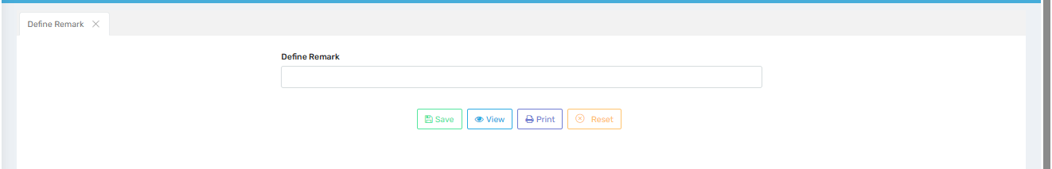

Purpose
This screen allows the admin to predefine standard remarks that can be used across various school modules—such as for student reports, assessments, behavioral tracking, or progress cards.
Common examples include:
- Excellent Performance
- Needs Improvement
- Absent During Assessment
- Well Disciplined
- Incomplete Work
Having predefined remarks ensures uniform and consistent communication across reports, teacher comments, and other student records.

📍 Where to Find
You can access this screen by navigating to:
Global Masters → Define Remark

📝 Field Descriptions
Field | Description
Define Remark | Enter the remark text to be saved (e.g., “Excellent participation in class”).

🔘 Button Descriptions
Button | Description
Save | Saves the entered remark into the master list.
View | Displays a list of all previously defined remarks.
Print | Prints the list of remarks for administrative use or reference.
Reset | Clears the input field to allow a new remark to be entered.

✅ Use Case
✅ Enables consistent language in student feedback across all classes and terms.
✅ Saves time for teachers by offering ready-to-use remark options.
✅ Standardizes the tone and terminology used in school documentation.
✅ Helps in generating automated report cards or disciplinary records.

⚠️ Important Notes
- Keep remarks concise, clear, and positive where possible.
- Avoid spelling errors or vague phrases (e.g., replace “Good” with “Shows consistent improvement”).
- Periodically review and update remarks to align with school tone or new academic strategies.
- Remarks are used school-wide—ensure they are appropriate for all grade levels and contexts.

Session Transfer
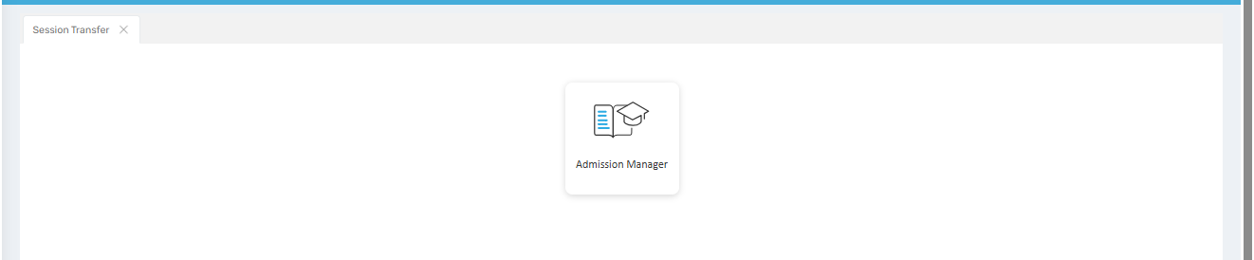
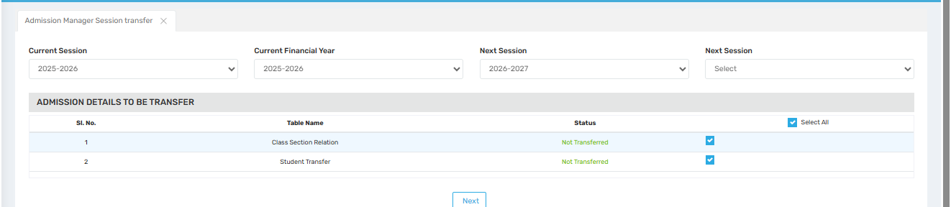

Purpose
This screen enables the admin to transfer academic session data (such as class-section assignments and student admissions) from the current session to the next academic session. It ensures that students and their respective classes are properly migrated to the new academic year, maintaining continuity in academic records.
Typical use cases include:
- Promoting students to the next grade with correct section mapping.
- Preparing the system for a new academic year without losing historical data.
- Ensuring student data is accurately retained for the new session setup.

📍 Where to Find
You can access this screen by navigating to:
Global Masters → Session Transfer

📝 Field Descriptions
Field | Description
Current Session | Displays the ongoing academic year (e.g., 2025–2026).
Current Financial Year | Shows the current financial year (usually aligns with the academic year).
Next Session | Dropdown to select the upcoming academic year (e.g., 2026–2027).
Table Name | Lists system tables involved in session transfer:  1. Class Section Relation  2. Student Transfer
Status | Indicates if the data has already been transferred (e.g., "Not Transferred").
Select All | Checkbox to select/deselect all transfer options. Individual options can be toggled.

🔘 Button Descriptions
Button | Description
Next | Proceeds to the next step in the session transfer process.

✅ Use Case
✅ Promotes all students to their next grade and associates them with the correct class-section automatically.
✅ Transfers historical class-section configurations to avoid reassigning manually.
✅ Ensures no data loss during transition from one academic session to another.
✅ Reduces administrative effort at the end/start of an academic year.

⚠️ Important Notes
- Make sure that the Next Session is already created/configured in the system before proceeding.
- Only authorized staff should perform this transfer to avoid errors in student promotion.
- The status will change to “Transferred” once the action is completed.
- Transferring is usually irreversible—double-check all selections before confirming.
- Backup data is recommended before initiating the session transfer.

Master Settings
Global Search Option Settings
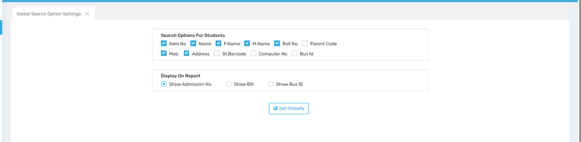

Purpose
This screen allows the admin to configure the default search filters and display settings used across the student information system. It defines how students can be searched (e.g., by name, admission number, mobile number) and what key identifier should appear in reports.
These settings ensure that staff can locate student records efficiently and that reports show consistent, relevant details.

📍 Where to Find
You can access this screen by navigating to:
Master Settings → Global Search Option Settings

📝 Field Descriptions

Search Options for Students
Allows enabling/disabling the following identifiers for student search filters:
Feild | Description
Adm. No | Admission Number – unique student identifier.
Name | Full name (typically student's given name).
F. Name | Father's Name – used to distinguish between similar names.
M. Name | Mother's Name – additional family identifier.
Roll No | Student's roll number (if allocated).
Parent Code | Unique code assigned to a parent (if used by system).
Mob. | Mobile number – generally the parent’s contact.
Address | Residential address – helps in location-based search.
St. Barcode | Student Barcode (used if barcode ID cards are implemented).
Computer No | Internal computer number (used in some legacy systems).
Bus ID | Bus route/vehicle ID (if transport module is active).

Display On Report
Specifies which key field should appear on student-related reports:
Option | Description
Show Admission No | Displays admission number in reports. (Default/Recommended)
Show Bill | Displays billing/account reference instead.
Show Bus ID | Displays the transport/bus route ID.

🔘 Button Description
Button | Description
Set Globally | Applies the selected search and display settings system-wide.

✅ Use Case
✅ Helps front-office staff and administrators quickly locate student data.
✅ Ensures a consistent search experience across modules like attendance, fee management, and academics.
✅ Reduces time spent filtering large student databases.
✅ Customizes report headers to match school priorities (e.g., admission vs. transport tracking).

⚠️ Important Notes
- Selected options will reflect system-wide for all staff users.
- Too many active search fields can slow down search performance—enable only the most used ones.
- Default recommendation is to keep Admission No, Name, and Mobile Number checked.
- Review periodically to adjust for changes in school operations or staff workflows.

Change Academic Year
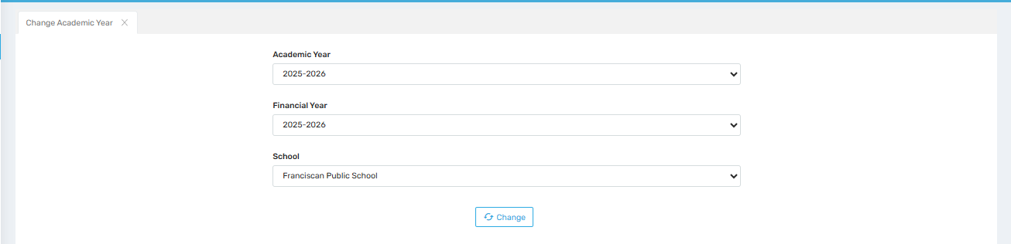

Purpose
This screen allows users to switch the active academic and financial year for their session within the school management system. It is particularly useful when moving between sessions to view, edit, or manage data from different academic years.
This ensures that users work in the correct data context related to admissions, attendance, fees, exams, and more.

📍 Where to Find
You can access this screen by navigating to:
Master Settings → Change Academic Year

📝 Field Descriptions
Field | Description
Academic Year | Dropdown to select the academic year (e.g., 2025–2026). Controls the education session you work in.
Financial Year | Dropdown to select the financial year (e.g., 2025–2026). Affects fees, transactions, and reports.
School | Dropdown showing the selected school (useful for multi-branch or group schools).

🔘 Button Description
Button | Description
Change | Applies the selected academic and financial year, switching your session context accordingly.

✅ Use Case
✅ Essential for administrative staff to manage or review records from past or upcoming sessions.
✅ Used at the beginning of the new academic session to transition into new data entry.
✅ Helpful for audit, reporting, or student data verification from previous years.
✅ Supports working in a multi-school environment (if applicable).

⚠️ Important Notes
- This change typically applies to your user session only, not globally unless you have admin rights.
- Make sure relevant session data (like classes, fees, timetables) has been configured before switching.
- Always confirm the selected academic year before performing tasks like fee entry, exam uploads, or admissions.
- You may need to refresh or re-navigate after clicking Change to load the selected session fully.

Quick Link
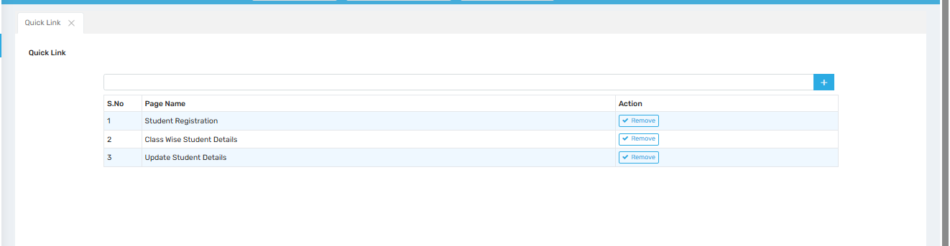

Purpose
This screen allows users to manage their personalized Quick Links—shortcuts to frequently used pages or modules within the school management system. It enhances workflow efficiency by minimizing navigation time to commonly accessed features.
Common quick links may include:
- Student Registration
- Class-wise Student Details
- Fee Collection
- Exam Marks Entry

📍 Where to Find
You can access this screen by navigating to:
Master Settings → Quick Link

📝 Field Descriptions
Field | Description
Search/Add Box | Input field to search or select a page/module name to add as a quick link.
Page Name | Displays the name of the linked page (e.g., “Student Registration”).
Action | Contains the “Remove” button to delete the quick link from the list.
+ (Add Button) | Adds the selected or typed page to the quick link list.

🔘 Button Description
Button/Icon | Description
➕ (Plus Icon) | Adds the entered page/module to your personal quick links.
✔ Remove | Removes the corresponding page from your quick link list.

✅ Use Case
✅ Helps teachers, staff, and admins quickly access frequently used modules.
✅ Reduces repetitive navigation through multi-level menus.
✅ Customizable per user—each staff member can maintain their own set of quick links.
✅ Ideal for fast-paced tasks like admissions, attendance, or result entry.

⚠️ Important Notes
- Only valid and authorized modules/pages will appear when typed in the input field.
- This feature is user-specific—quick links added here are only visible to the logged-in user.
- Avoid clutter—add only genuinely useful shortcuts.
- Use the search bar to check if a module already exists before adding again.

Admission Setting
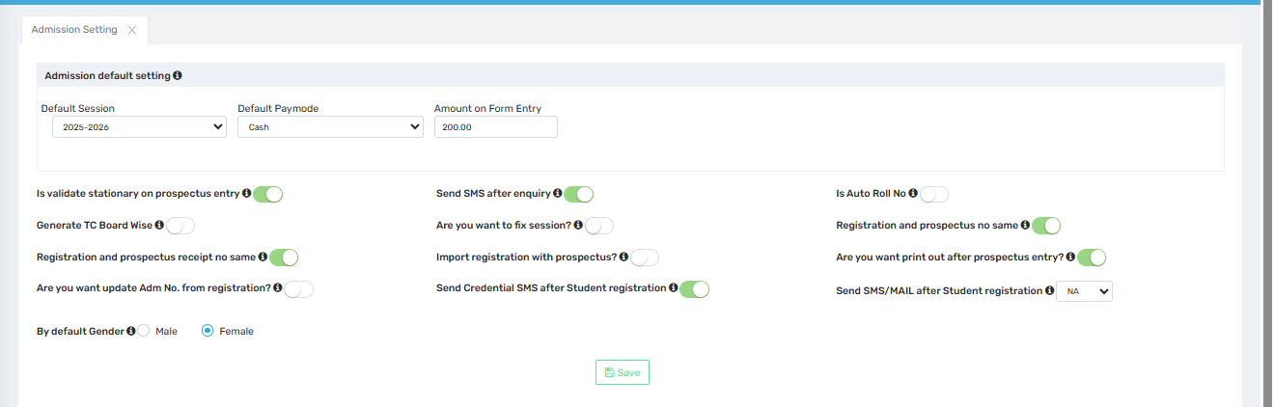

Purpose
This screen enables the admin to configure default settings for the student admission process, including form charges, session settings, SMS notifications, and prospectus handling. It standardizes and streamlines the workflow for student registrations, enquiries, and follow-up communications.

📍 Where to Find
You can access this screen by navigating to:
Master Settings → Admission Setting

📝 Field Descriptions

Top Section: Defaults
Field | Description
Default Session | Sets the academic session that admission forms and registrations will default to.
Default Paymode | Sets the default payment method for admission form fees (e.g., Cash, Online).
Amount on Form Entry | The fee amount (e.g., ₹200) to be charged for filling out the admission form.

Admission Process Toggles
Option | Description
Is validate stationary on prospectus entry | Ensures the physical stock of prospectus is tracked and validated.
Send SMS after enquiry | Sends an SMS to the applicant after an enquiry is submitted.
Is Auto Roll No | Automatically assigns a roll number upon admission.
Generate TC Board Wise | Enables TC (Transfer Certificate) generation based on the board (e.g., CBSE).
Are you want to fix session? | Prevents changes to the session during registration.
Registration and prospectus receipt no same | Uses the same receipt number for both registration and prospectus.
Import registration with prospectus? | Automatically links a prospectus purchase with registration.
Are you want update Adm No. from registration? | Uses registration number as the admission number.
Are you want print out after prospectus entry? | Automatically triggers a print action after prospectus entry.
Send Credential SMS after Student registration | Sends login credentials via SMS after student registration.
Send SMS/MAIL after Student registration | Dropdown to choose how notifications are sent post-registration (SMS/Mail/NA).

Gender Setting
Option | Description
By default Gender | Sets the default gender for new student registrations (Male / Female).

🔘 Button Description
Button | Description
Save | Saves all configured settings and applies them system-wide.

✅ Use Case
✅ Automates communication and reduces manual follow-up with SMS alerts.
✅ Simplifies prospectus and registration tracking with synchronized receipt numbers.
✅ Allows for configuration based on school policy (e.g., auto roll no., admission fee).
✅ Ensures consistency in form processing for every admission cycle.

⚠️ Important Notes
- Make sure stationary validation is enabled only if inventory tracking is actively used.
- Enquiry SMS improves engagement with prospective parents and students.
- Credential SMS should be sent only if the parent portal or app is in use.
- Periodically review settings before the start of a new session to ensure alignment with school policy.

Enquiry No Setting
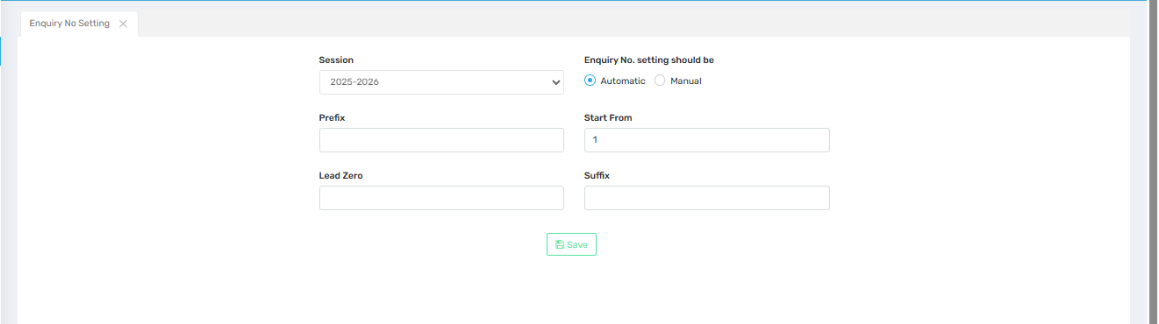

Purpose
This screen allows the administrator to configure the format and generation method for enquiry numbers during the student admission enquiry process. It helps standardize how enquiry IDs are assigned, making tracking and record-keeping more organized and automated.

📍 Where to Find
You can access this screen by navigating to:
Master Settings → Enquiry No Setting

📝 Field Descriptions
Field | Description
Session | Select the academic session for which the enquiry number format is being set.
Enquiry No. setting should be | Choose between:
– Automatic: System generates enquiry numbers sequentially.
– Manual: Staff manually enters enquiry numbers.
Prefix | Optional text added before the number (e.g., “ENQ” → ENQ001).
Start From | Defines the starting number in the sequence (e.g., 1 = ENQ001).
Lead Zero | Sets the number of leading zeros to maintain format length (e.g., 3 = 001).
Suffix | Optional text added after the number (e.g., 001-25 for year suffix).

🔘 Button Description
Button | Description
Save | Saves the configured enquiry number settings for the selected session.

✅ Use Case
✅ Ensures unique and systematic enquiry numbers for tracking admissions.
✅ Useful in institutions with high enquiry volumes needing auto-numbering.
✅ Enhances professionalism when communicating enquiry IDs with parents.
✅ Prefixes/suffixes can denote branch code, year, or campaign for better categorization.

⚠️ Important Notes
- If manual mode is selected, staff must enter enquiry numbers carefully to avoid duplicates.
- Changing prefix/suffix after enquiries have been entered may affect sorting/reporting.
- “Start From” works only for new sessions—does not reset existing data.
- Consistency in format is key for data exports and integrations.

Prospectus & Registration No Setting
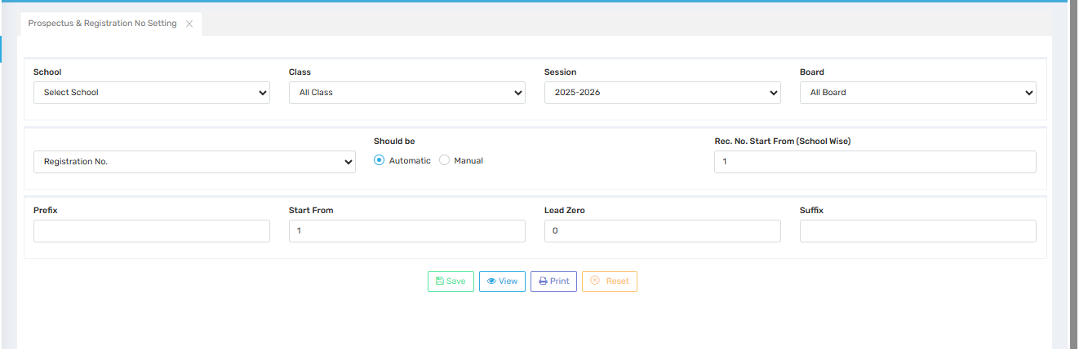

Purpose
This screen enables administrators to configure the format, type, and sequence of numbers issued for Prospectus and Registration. It ensures a consistent, structured approach across sessions, schools, and boards for tracking student admissions and document distribution.

📍 Where to Find
Navigate to:
Master Settings → Prospectus & Registration No Setting

📝 Field Descriptions

Field | Description
School | Select the school for which the settings will apply (for multi-branch setups).
Class | Optionally restrict settings to a specific class or keep it as "All Class."
Session | Choose the academic session (e.g., 2025–2026) the numbering applies to.
Board | Filter settings by education board (e.g., CBSE, ICSE, etc.), if applicable.

Numbering Settings
Field | Description
Dropdown (Registration No.) | Choose whether to configure Registration or Prospectus number format.
Should be | Select Automatic (system-generated) or Manual (user input).
Rec. No. Start From (School Wise) | Enter the starting number of the record, unique per school if desired.
Prefix | Text to appear before the number (e.g., "REG-", "PROS-").
Start From | Number from which the sequence begins (e.g., 1).
Lead Zero | Number of zeros to pad before the actual number (e.g., "3" = 001, 002, etc.).
Suffix | Text to appear after the number (e.g., “-25” for year).

🔘 Button Descriptions
Button | Description
Save | Stores the current format configuration.
View | Displays existing format settings.
Print | Prints the current configuration details (useful for audit).
Reset | Clears all fields to their default state for new input.

✅ Use Case
✅ Useful for assigning structured and trackable Prospectus and Registration numbers.
✅ Supports unique numbering per school, session, or board.
✅ Enhances transparency in the admission process.
✅ Prevents duplication and ensures standardized document issuance.

⚠️ Important Notes
- If using Automatic, make sure to choose unique start numbers across sessions or classes.
- Lead Zero improves readability and sorting but should be consistent year over year.
- Updating settings mid-session may affect historical document continuity—use cautiously.
- Apply consistent prefix/suffix schemes across schools to avoid confusion.

User Permission
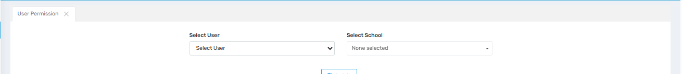

Purpose
This screen allows administrators to assign and manage user-specific permissions within the system. It ensures that staff members have access only to the features and modules that are relevant to their roles and responsibilities.

📍 Where to Find
Navigate to:
Global Masrers → User Permission

📝 Field Descriptions
Field | Description
Select User | Dropdown to choose a user (e.g., teacher, staff, clerk) whose permissions need to be managed.
Select School | If the system manages multiple schools, choose the relevant school for user-specific settings.
Once a user and school are selected, the interface typically expands to show checkboxes or toggles for different modules (like Admissions, Reports, Fees, Attendance, etc.) that can be enabled or disabled.

✅ Use Case
✅ Ensures role-based access control across departments.
✅ Prevents unauthorized access to sensitive data or administrative modules.
✅ Streamlines the user interface by hiding irrelevant features from users.
✅ Supports multi-school management with school-specific permissions.

⚠️ Important Notes
- Only admins/super-admins can modify user permissions.
- Always review permissions after assigning new roles or during audits.
- Permissions may need to be reconfigured if system modules are added or updated.
- Ensure school selection matches the user’s actual working branch in a multi-school environment.

Receipt Certificate Setting
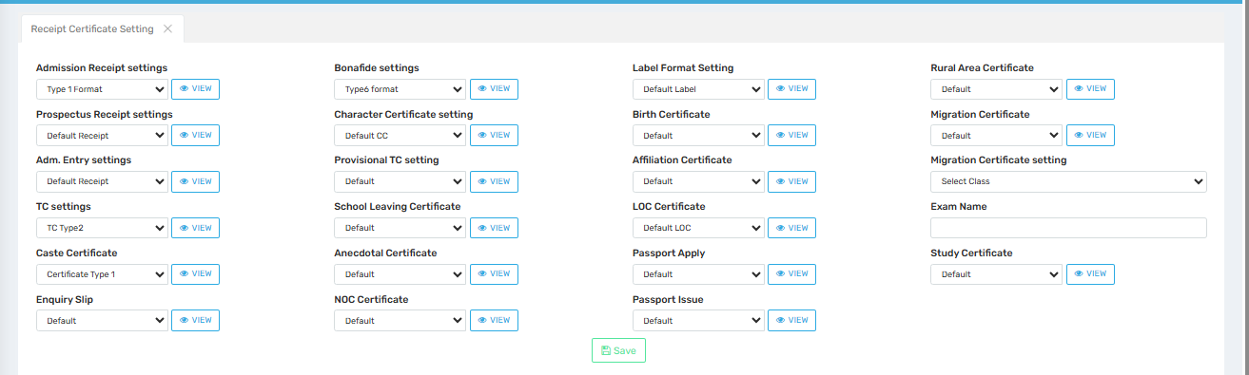

Purpose
This screen allows administrators to select and manage the default format templates for various types of certificates and receipts issued by the school. By configuring these settings, the institution ensures consistency in official documentation and streamlines the printing process.

📍 Where to Find
Navigate to:
Master Settings → Receipt Certificate Setting

📝 Section & Field Descriptions

🧾 Receipt Settings
Setting | Description
Admission Receipt | Choose a format for fee receipts issued at the time of admission.
Prospectus Receipt | Select template for receipts issued when selling prospectuses.
Adm. Entry | Format used for admission entry confirmation receipts.
TC Settings | Set the default Transfer Certificate (TC) format.
Caste Certificate | Choose the format used for issuing caste-related certificates.
Enquiry Slip | Format for printing enquiry acknowledgment slips.

📜 Certificate Settings
Setting | Description
Bonafide | Format for issuing Bonafide certificates.
Character Certificate | Choose template for student's character certificate.
Provisional TC | Format for temporary transfer certificate.
School Leaving Certificate | Layout for official school-leaving documentation.
Anecdotal Certificate | Format used for personalized or narrative-style student evaluations.
NOC Certificate | Template for No Objection Certificates.
Label Format | Used for default label printing (often for books, ID cards, etc.).

🎓 Academic Certificates
Setting | Description
Birth Certificate | Layout for birth certificate issued by the school.
Affiliation Certificate | Format for affiliation-related official documentation.
LOC Certificate | Format for List of Candidates (often used in exam boards).
Passport Apply / Issue | Templates for passport-related student documents.
Rural Area Certificate | Format used to certify students from rural backgrounds.
Migration Certificate | Layout for migration certificates for students transferring to other boards.
Migration Certificate Setting | Allows selection of class and exam name to customize the document content.
Study Certificate | Format confirming enrollment and period of study.

🔘 Button Descriptions
Button | Description
View 👁️ | Previews the currently selected format before saving or printing.
Save | Stores the selected default templates across all categories.

✅ Use Case
✅ Maintains a standard format for each type of certificate/receipt across the institution.
✅ Helps print ready-to-use documents without reconfiguring format each time.
✅ Simplifies compliance with board/university guidelines requiring uniform certificate styles.
✅ Enables easy format switching for specific years, schools, or use-cases (e.g., exam-wise TC formats).

⚠️ Important Notes
- Make sure all selected templates are compatible with your print layout and content fields.
- Double-check certificate contents (name, class, date, etc.) in the preview using the View button.
- If managing multiple schools/branches, different templates may be configured per school.
- Some formats may require admin-level access to create or edit (via Format Master module).

Define Tc details
Define Language
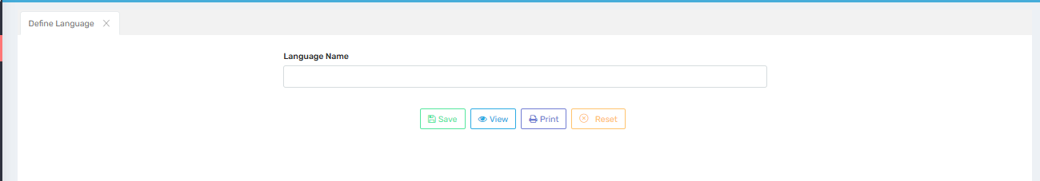

Purpose
This screen is used to define and manage languages that may be used or referenced across the system—such as for communication preferences, academic languages, or personal profile settings. It ensures standardized language data entry and usage across modules.

Where to Find
You can access this screen by navigating to:
Master Settings → Define Tc Details → Define Language

Field Description
Field / Button | Description
Language Name | A text box where the user enters the name of a language (e.g., English, Hindi, Bengali, Tamil).
Save | Saves the entered language into the database. The saved language will then be available in dropdowns or selection lists.
View | Opens a list of all previously defined languages, allowing users to verify, edit, or manage them.
Print | Prints the list of defined languages for record-keeping or administrative purposes.
Reset | Clears the input field, allowing users to enter a new language without manually deleting the existing text.

✅ Use Cases
- Student Admission Form:
Allows selecting the student’s or parent’s preferred language or medium of instruction during registration.
- Academic Records:
Defined languages may appear in report cards, transfer certificates, or internal reports where language preferences are required.
- Communication Preferences:
Helps institutions record and manage language preferences for communicating with parents and students.

Important Notes
- Ensure accurate spelling while entering language names, as these appear in reports and official records.
- Avoid duplicate entries (e.g., "English" vs "english") to maintain clean and standardized data.
- If a language is deleted or renamed, check for impacts on records where it has already been used.
- Periodically review the list of defined languages to ensure it's up-to-date and relevant to the institution’s needs.

Define Caste
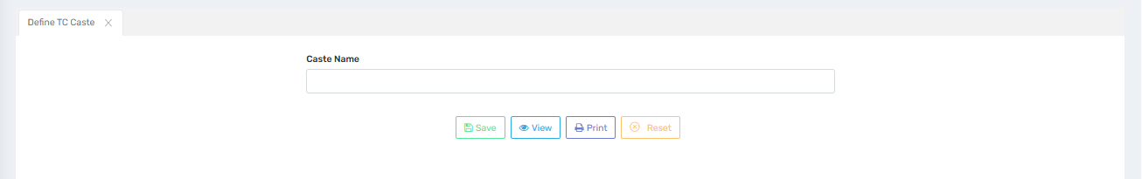

Purpose
This screen is used to define and manage caste categories that are required for Transfer Certificate (TC) generation or other official student records. It helps standardize caste-related data entry across the institution’s academic and administrative modules.

Where to Find
You can access this screen by navigating to:
Master Settings → Define Tc Details → Define TC Caste

Field Description
Field / Button | Description
Caste Name | A text box where the user can enter the name of the caste (e.g., General, OBC, SC, ST).
Save | Stores the entered caste name into the system for future use in dropdowns or official documents.
View | Displays a list of all caste names already defined in the system. Useful for verification or updates.
Print | Allows the user to print the complete list of defined caste names for records or administrative reference.
Reset | Clears the input field so the user can add a new caste without manually deleting the current entry.

✅ Use Cases
- Transfer Certificate (TC) Generation:
The defined caste is displayed on the student’s TC as part of personal and demographic information.
- Admission Form:
During admission, caste information is selected from the predefined list for consistency.
- Scholarship Eligibility and Reporting:
Caste information is used for filtering eligibility for scholarships or government benefit schemes.
- Reports and Filters:
Administrators can generate caste-wise student reports or statistics for internal analysis or official submission.

Important Notes
- Ensure caste names are spelled correctly and entered uniformly (e.g., avoid “O.B.C” and “OBC” as separate entries).
- Do not create duplicate caste names; this can lead to inconsistent reporting and data duplication.
- Be cautious while editing or deleting caste names that are already associated with existing student records.
- Review the list periodically to ensure alignment with updated government classifications or institutional needs.

Define Extra Activity
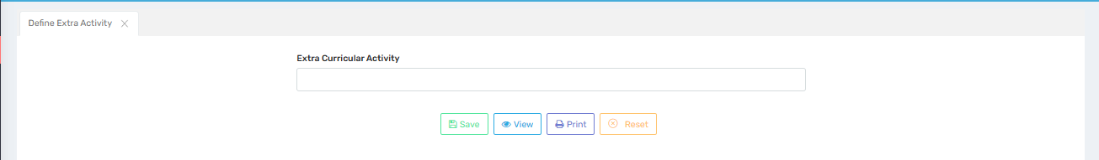

Purpose
This screen is used to define and manage extra-curricular activities that students can participate in. These activities are often recorded in student profiles, report cards, and certificates, helping track holistic development beyond academics.

Where to Find
You can access this screen by navigating to:
Master Settings → Define Tc Details → Define Extra Activity

Field Description
Field / Button | Description
Extra Curricular Activity | A text box where the user can enter the name of an activity (e.g., Dance, Debate, Music, Sports).
Save | Saves the entered activity into the system so it can be selected during student activity tracking or performance reporting.
View | Displays the list of all previously defined activities. Useful for reviewing or updating entries.
Print | Prints the list of defined extra-curricular activities for administrative use or record-keeping.
Reset | Clears the input field so a new activity can be entered easily.

✅ Use Cases
- Student Profile:
Selected activities can be displayed in the student’s personal profile or academic dashboard.
- Report Cards & Certificates:
These activities may appear in report cards, especially if assessed, or on participation/achievement certificates.
- Activity-Based Awards:
Helps in tracking and awarding students based on their participation in specific extra-curricular areas.
- Club/House Allotment:
Used to organize students into clubs or houses based on their interests or talents.

Important Notes
- Use standard, clear names for activities to ensure consistency across records (e.g., use "Drama" instead of both "Drama" and "Theater").
- Avoid creating duplicate entries with slightly different spellings or names.
- Changes to activity names after they are used in student records may affect reporting and display accuracy.
- Review the activity list annually to keep it relevant to your school’s offerings and student interests.

Define Chracter
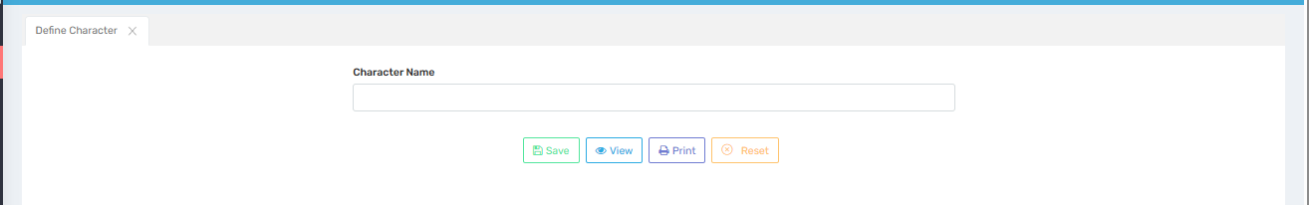

Purpose
This screen is used to define and manage character traits or remarks that can be assigned to students, particularly for use in Transfer Certificates (TC), report cards, or character certificates. It ensures consistency in how character-related attributes are recorded and reported.

Where to Find
You can access this screen by navigating to:
Master Settings → Define Tc Details→ Define Character

Field Description
Field / Button | Description
Character Name | A text box where the user enters a character trait or remark (e.g., Excellent, Good, Sincere, Disciplined).
Save | Saves the entered character name into the system so it can be used in TC or character certificates.
View | Shows the list of all previously defined character entries for verification, editing, or review.
Print | Prints the defined character traits for administrative or audit purposes.
Reset | Clears the input field to allow entering a new character value without manually deleting the current one.

✅ Use Cases
- Transfer Certificate (TC):
The student’s character can be selected from this list and displayed in the character field on the TC.
- Character Certificate:
When generating a character certificate, predefined values ensure consistency and professionalism.
- Report Cards or Remarks:
Some schools may choose to show general character observations on academic reports or feedback forms.

Important Notes
- Use positive and professional terms that reflect common educational standards (e.g., avoid vague or negative entries).
- Avoid duplicate or similar traits (e.g., "Very Good" and "Excellent" might be confusing if overused interchangeably).
- Do not delete or rename character traits that are already in use for existing student records.
- Regularly review and update the list to align with institutional standards and reporting practices.

Define Promotion Master
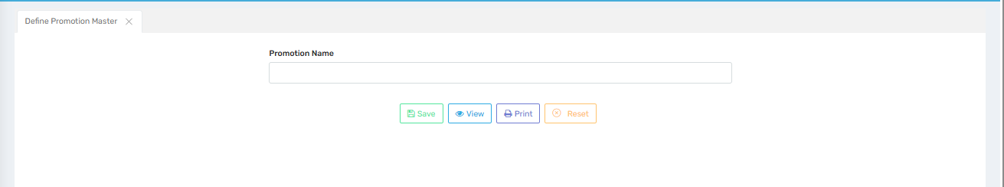

Purpose
This screen is used to define and manage promotion-related remarks or status labels that are used during the student promotion process (e.g., Promoted, Not Promoted, Promoted with Condition). It ensures standardization across promotion workflows and reports.

Where to Find
You can access this screen by navigating to:
Master Settings → Define Tc Details → Define Promotion Master

Field Description
Field / Button | Description
Promotion Name | A text box where the user can enter the name of a promotion status or remark (e.g., Promoted, Detained, Conditional Promotion).
Save | Saves the promotion label so it can be used during student promotion processing.
View | Displays a list of all defined promotion statuses for review, edits, or audit purposes.
Print | Prints the list of all defined promotion statuses for documentation.
Reset | Clears the current entry field to allow the user to enter a new promotion name.

✅ Use Cases
- Annual Promotion Processing:
When promoting students to the next class, these predefined labels are applied to specify each student’s promotion status.
- Report Cards or Promotion Reports:
The defined promotion status appears in academic reports or promotion summaries shared with parents and staff.
- TC/Exit Certificate:
The promotion status is sometimes displayed in Transfer Certificates or final documents when a student exits the school.

Important Notes
- Keep promotion names short, clear, and formal (e.g., use "Promoted" instead of "Passed to Next Class").
- Avoid duplicate or unclear entries to maintain consistency in reports and avoid confusion.
- Make sure promotion statuses match your school’s academic policy and promotion criteria.
- Once a promotion name is in use, editing or deleting it may affect existing records or past promotion history.

Define Last Result
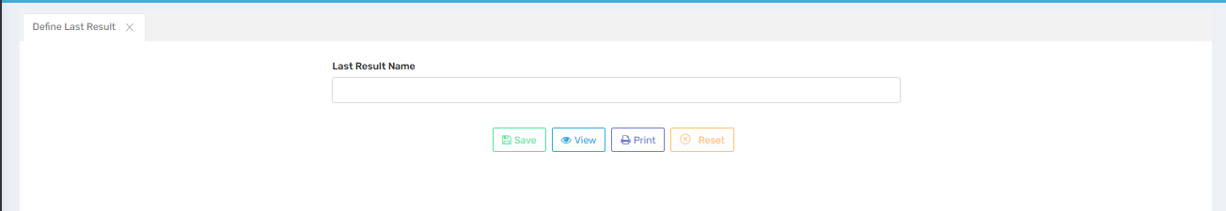

Purpose
This screen is used to define and manage the final academic result status labels for students, particularly for use in Transfer Certificates (TC), report cards, or student history records. It helps standardize result-related remarks like "Pass", "Fail", "Promoted", or "Detained".

Where to Find
You can access this screen by navigating to:
Master Settings → Define Tc Details → Define Last Result

Field Description
Field / Button | Description
Last Result Name | A text box where the user can enter a final result status (e.g., Passed, Failed, Promoted, Detained).
Save | Saves the entered result status to be used in academic and administrative records.
View | Shows the list of all defined result statuses for review or modification.
Print | Prints the complete list of defined final results for documentation purposes.
Reset | Clears the input field so a new result name can be entered easily.

✅ Use Cases
- Transfer Certificate (TC):
The last result is displayed on a student's TC to indicate their academic outcome for the year.
- Report Cards:
Shows the final academic status based on performance across terms or the academic session.
- Historical Records:
Maintains a standardized log of each student’s final result over the years for analytics or official audits.

Important Notes
- Use consistent and standardized terminology to maintain professional and uniform reporting (e.g., use "Passed" instead of "pass" or "Pass out").
- Avoid duplicate entries that only vary in capitalization or phrasing.
- Be cautious when editing or deleting result statuses that have already been assigned to student records.
- Align result names with institutional grading/promotion policies and ensure clarity for parents and external bodies.

Term Master
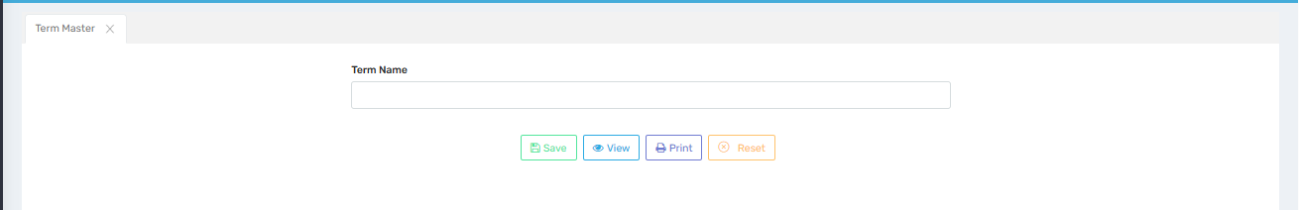

Purpose
This screen is used to define academic terms (e.g., Term 1, Term 2, Semester 1) for use in exam scheduling, result processing, and academic planning. Defining terms helps institutions manage curriculum delivery, assessments, and reporting in structured phases.

Where to Find
You can access this screen by navigating to:
Master Settings → Define Tc Details → Term Master

Field Description
Field / Button | Description
Term Name | A text box where the user enters the name of the academic term (e.g., Term 1, Mid Term, Semester 2).
Save | Saves the entered term name into the system, making it available during exam and timetable setup.
View | Displays the list of all previously defined academic terms for review or modification.
Print | Prints the term list for academic planning, coordination, or record purposes.
Reset | Clears the input field to allow entry of a new term name.

✅ Use Cases
- Examination Planning:
Helps in grouping exams and assessments under specific terms for easier management and reporting.
- Report Cards:
Results are organized and presented term-wise for clarity and phased performance tracking.
- Curriculum Distribution:
Enables educators to plan syllabus coverage across defined terms.
- Attendance & Evaluation:
Supports term-based attendance and evaluation summaries.

Important Notes
- Use clear and consistent naming conventions (e.g., avoid using "T1" in one place and "Term 1" elsewhere).
- Don’t duplicate term names; it can cause confusion in reports and student records.
- Ensure all terms are created before setting up exam schedules or report card templates.
- Once used in records, changes to term names may affect historical data or linked assessments.

Define Moral
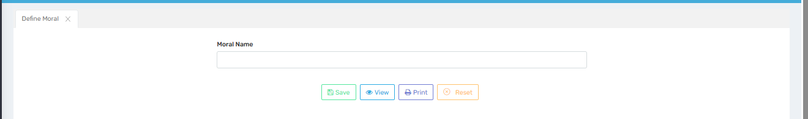

Purpose
This screen is used to define and manage moral or value-based attributes (e.g., Honest, Responsible, Respectful) that can be assigned to students. These may appear in report cards, character evaluations, or value education assessments to promote ethical and behavioral development.

Where to Find
You can access this screen by navigating to:
Master Settings → Define Tc Details→ Define Moral

Field Description
Field / Button | Description
Moral Name | A text box where the user enters a value or moral trait (e.g., Honest, Kind, Obedient, Helpful).
Save | Saves the entered moral trait to the system for use in character grading or student evaluations.
View | Displays the list of all moral traits that have been defined so far. Useful for review and selection.
Print | Prints the defined list of morals for academic planning or reporting needs.
Reset | Clears the field so the user can enter a new moral value without manually deleting the current one.

✅ Use Cases
- Character Evaluation:
Helps teachers assign specific moral traits to students based on behavior and classroom conduct.
- Report Cards / Progress Reports:
Moral traits can be included in report cards to show development in values-based education.
- Certificates:
Moral values may appear in character or conduct certificates for students during school leaving.
- Value Education Programs:
Supports moral education initiatives by allowing the institution to track and reward good moral behavior.

Important Notes
- Use clear, positive, and widely accepted values to ensure consistency and clarity (e.g., “Respectful” instead of “Nice”).
- Avoid redundancy or near-duplicate values that can confuse evaluators.
- Don’t delete values in use to prevent issues with linked records or historical student data.
- Periodically review the list to align with evolving value education frameworks or institutional goals.

Define Mother Tounge
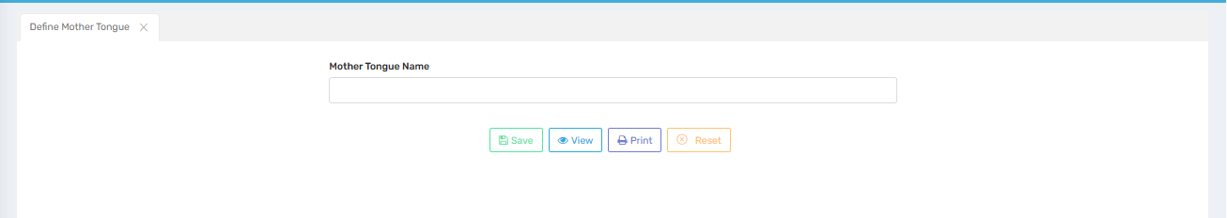

Purpose
This screen is used to define and manage mother tongue languages for students, which are recorded during the admission process or in student profiles. This helps institutions maintain demographic data and personalize communication and educational support.

Where to Find
You can access this screen by navigating to:
Master Settings → Define Tc Details → Define Mother Tongue

Field Description
Field / Button | Description
Mother Tongue Name | A text box where the user enters the name of the mother tongue (e.g., Hindi, Tamil, Bengali, Urdu).
Save | Stores the entered mother tongue so it can be selected in student forms and reports.
View | Displays the list of all defined mother tongues for review or editing.
Print | Prints the list for record-keeping, audits, or administrative reference.
Reset | Clears the text field to allow new entries without manually deleting existing text.

✅ Use Cases
- Student Admission:
During the registration process, mother tongue is selected from this list for each student.
- Demographic Reports:
Helps generate reports based on language background to support regional planning or government reporting.
- Communication Planning:
Assists schools in tailoring communications or notifications in students’/parents’ native languages.
- Census & Compliance:
Useful for compliance with educational board or governmental surveys that require linguistic data.

Important Notes
- Ensure correct spelling and avoid duplicates (e.g., "Bengali" vs. "Bangla").
- Use official or widely accepted names of languages for consistency in reports and certificates.
- Once linked to student records, editing or deleting a mother tongue may impact data integrity.
- Periodically review the list for relevance based on changing demographics and regional language preferences.

Update Address And Blood
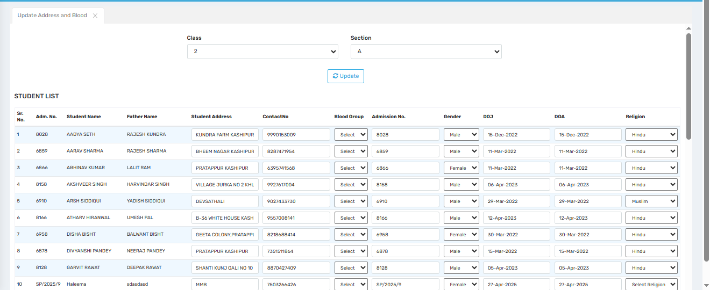

Purpose
This screen is used to update student address and blood group information for all students of a specific class and section. It ensures that key demographic and health-related data are accurately recorded and can be updated easily by administrative staff.

Where to Find
You can access this screen by navigating to:
Master Settings → Update Address and Blood

Field Description
Field / Button | Description
Class | Dropdown to select the class for which student data needs to be updated.
Section | Dropdown to select the section within the selected class.
Update | Applies the selected class and section filter to load the student list.
Student List Table | Displays a list of all students from the selected class and section with editable fields.
Admission No. | Unique admission number of each student.
Student Name | Full name of the student.
Father Name | Name of the student’s father (guardian).
Student Address | Editable field for updating the student’s residential address.
Contact No. | Editable field to update the student’s or guardian’s contact number.
Blood Group | Dropdown to select the student's blood group.
Gender | Dropdown to view or update the student's gender (Male/Female).
DOJ (Date of Joining) | Date the student joined the school.
DOA (Date of Admission) | Official date when the student was admitted.
Religion | Dropdown to select the student’s religion.

✅ Use Cases
- Student Record Correction:
Enables school admins to quickly update outdated or missing address and contact information.
- Health Emergency Readiness:
Blood group data helps in case of student medical emergencies.
- Data Consistency Across Modules:
Ensures that address and contact details are reflected correctly in reports, ID cards, communication modules, etc.
- Bulk Updates:
Allows updating multiple student records in a single view, saving time and improving accuracy.

⚠️ Important Notes
- Ensure that all fields (especially contact numbers and addresses) are correctly spelled and formatted.
- Blood group and religion must be selected from predefined dropdowns to maintain consistency.
- Changes made on this screen may immediately reflect across other modules (e.g., transport, communication, health logs).
- Double-check values before clicking Update, as overwriting existing data can affect reports and documents.

Certificate Ref No. Setting
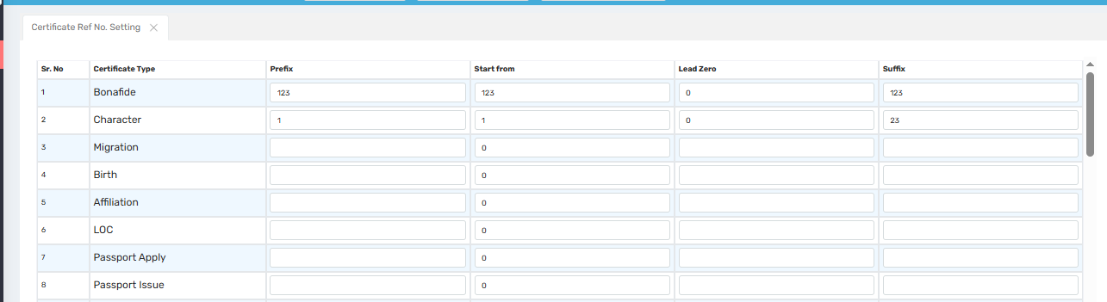

Purpose
This screen is used to configure reference number formats for various types of certificates issued by the school (e.g., Bonafide, Character, Migration, etc.). It allows administrators to define how certificate numbers are generated, including prefixes, starting numbers, lead zeros, and suffixes, ensuring consistent and traceable documentation.

Where to Find
You can access this screen by navigating to:
Master Settings → Certificate Ref No. Setting

Field Description
Field / Column | Description
Sr. No. | Serial number (auto-generated for listing).
Certificate Type | Type of certificate for which reference number settings are being configured (e.g., Bonafide, Character, Migration).
Prefix | Optional text that appears before the reference number (e.g., BON, CH, 2025-). Helps in categorizing or identifying the type of certificate.
Start From | Starting number for the reference sequence (e.g., 001, 100). Used to begin the numbering from a custom value.
Lead Zero | Number of digits to pad with zeros (e.g., 3 → 001, 002). Ensures uniform length of reference numbers.
Suffix | Optional text that appears after the reference number (e.g., -2025, /CBSE). Useful for denoting year, board, etc.

✅ Use Cases
- Document Control:
Helps generate unique and easily identifiable reference numbers for official school certificates.
- Batch Configuration:
Allows batch setup of numbering for multiple certificate types from a single interface.
- Customization per Type:
Enables different formats for each certificate type based on administrative or compliance requirements.
- Audit & Verification:
Ensures each certificate issued has a traceable number that can be verified later for authenticity.

⚠️ Important Notes
- Avoid using duplicate prefixes and starting numbers across certificate types to maintain uniqueness.
- Ensure the correct number of lead zeros is applied to maintain standard formatting across sessions.
- Suffixes like the year or board name can help during audit and sorting, especially in multi-year records.
- Any change to existing numbering mid-session may cause inconsistencies—always confirm before modifying.
- Apply changes only through authorized personnel to avoid misuse or numbering conflicts.

Admission Form Settings
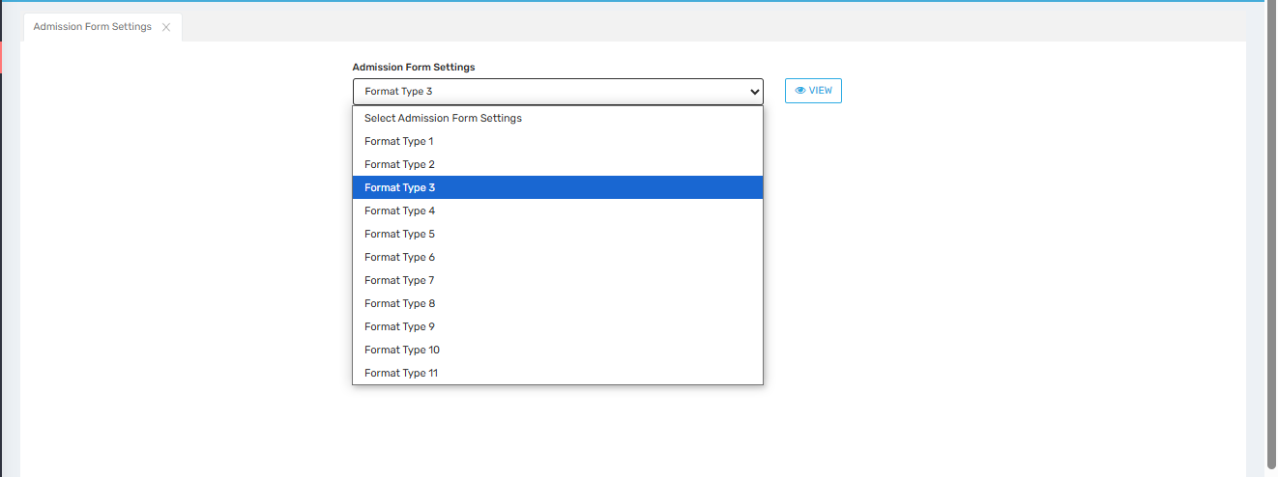

Purpose
This screen allows administrators to select and apply a specific layout or format for the student admission form. Each format type corresponds to a predefined structure, which may differ in layout, included fields, design elements, or print configuration based on institutional preferences or compliance needs.

Where to Find
You can access this screen by navigating to:
Master Settings → Admission Form Settings

Field Description
Field / Button | Description
Admission Form Settings (Dropdown) | Allows the user to select from multiple predefined admission form formats (Format Type 1 to Format Type 11).
Format Type 1–11 | Different predefined layouts for the admission form, each with its own field arrangement, style, and structure.
View Button | Opens a preview of the selected format so the admin can visually verify the layout before saving or printing.

✅ Use Cases
- Customization Per School:
Schools with multiple campuses or boards can choose different admission form layouts per branch.
- Regulatory Compliance:
Some formats may align with CBSE, ICSE, or State Board requirements.
- Design Preference:
Enables choosing a clean, structured form for better presentation during offline or printed admissions.
- Data Collection Needs:
Depending on the school’s requirement, some formats may include or exclude optional fields (e.g., medical history, previous school info).

⚠️ Important Notes
- Review each format carefully using the “View” button before finalizing, as layout affects data entry and printouts.
- Changes to the admission form format may reflect immediately across student registration screens and print forms.
- If the institution uses both online and offline admission modes, make sure the selected format supports both.
- Format changes should be made only by authorized personnel to maintain consistency and compliance.

Saral ID Settings
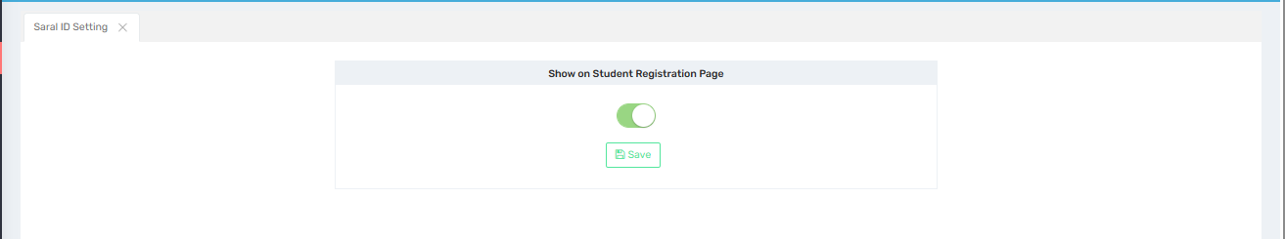

Purpose
This screen is used to enable or disable the display of the Saral ID field on the student registration page. The Saral ID is a unique student identification number often used by government educational systems for tracking student records across institutions and sessions.

Where to Find
You can access this screen by navigating to:
Master Settings → Saral ID Setting

Field Description
Field / Button | Description
Show on Student Registration Page (Toggle) | When turned on, the Saral ID field will appear on the student registration form. If off, the field remains hidden.
Save Button | Saves the current toggle setting and applies it system-wide.

✅ Use Cases
- Government Mandates:
Required in states where the Saral ID is part of student data reporting and government compliance.
- Transfer Student Identification:
Ensures continuity of records for students transferring from other institutions.
- Institutional Record Keeping:
Schools using government or state-linked portals often need Saral ID for uploading student information.

⚠️ Important Notes
- Enabling this field is essential if Saral ID is mandatory in your region or school board.
- Disabling it will hide the field from the registration interface, which may result in missing data during audits or uploads.
- This setting affects all users accessing the student registration form, so configure carefully.
- Changes should only be made by users with administrative privileges.

Stationary Details
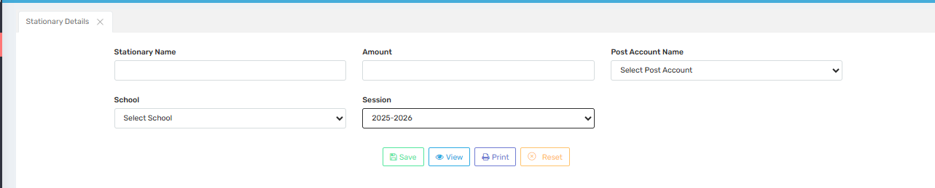

Purpose
This screen is used to define and manage stationery items, their associated charges, and accounting details. Schools can use this to track stationery fees per academic session and ensure proper financial posting to the designated accounts.

Where to Find
You can access this screen by navigating to:
Master Settings → Stationary Details

Field Description
Field / Button | Description
Stationary Name | Input field to enter the name of the stationery item (e.g., Diary, ID Card, Prospectus).
Amount | Enter the amount/fee charged for the stationery item.
Post Account Name | Dropdown to select the financial account where the stationery revenue should be posted.
School | Dropdown to select the school (for institutions managing multiple campuses).
Session | Dropdown to select the academic session the stationery details are applicable for.
Save | Saves the entered stationery details into the system.
View | Displays the list of already entered stationery items for review or editing.
Print | Prints the stationery list for audit or administrative use.
Reset | Clears all fields to allow new entries.

✅ Use Cases
- Fee Integration:
Helps associate stationery items with student fees and ensure proper billing.
- Session-wise Tracking:
Maintains historical records of stationery charges per academic session.
- Accounting Accuracy:
Ensures correct mapping of revenue from stationery to specific post accounts.
- Multi-school Management:
Supports tracking stationery records distinctly for each school branch.

⚠️ Important Notes
- Ensure all stationery names are unique and clearly descriptive to avoid confusion.
- Double-check the post account selection, as incorrect mapping could affect financial reports.
- Amounts should include applicable taxes or charges, if any.
- Any updates to stationery pricing or session must be reviewed by finance/admin users to maintain consistency.

Tc Settings
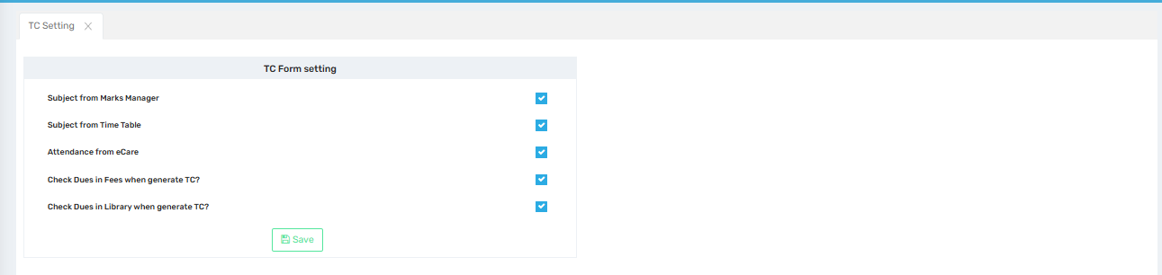

Purpose
This screen is used to configure Transfer Certificate (TC) generation rules and data dependencies. It allows administrators to define what information should be automatically pulled and what checks should be performed before generating a TC for a student.

Where to Find
You can access this screen by navigating to:
Master Settings → TC Setting

Field Description (TC Form Setting)
Field / Option | Description
Subject from Marks Manager | If enabled, the subjects listed in the TC will be fetched from the Marks Manager module.
Subject from Time Table | If enabled, subjects are pulled from the Time Table configuration instead.
Attendance from eCare | Pulls attendance records from the eCare module to include in the TC.
Check Dues in Fees when generate TC? | When checked, the system will verify if any fee dues are pending before allowing TC generation.
Check Dues in Library when generate TC? | Ensures that library dues are cleared before generating the Transfer Certificate.
Save Button | Saves the selected TC rules/settings for the system.

✅ Use Cases
- Automated TC Generation:
Pulls academic and attendance data directly into the TC to reduce manual entry.
- Compliance & Clearance Checks:
Ensures students have cleared fee and library dues before being issued a TC.
- Data Consistency:
Prevents discrepancies by sourcing subjects and attendance from official modules.
- Custom Rule Application:
Lets schools choose whether to pull data from Marks Manager or Time Table based on internal practices.

⚠️ Important Notes
- Enable only one source for subject data—either Marks Manager or Time Table—to avoid conflicts.
- Ensure modules like eCare, Fee Management, and Library are fully updated to reflect accurate clearance status.
- Disabling dues checks may result in students receiving TCs without clearing financial obligations.
- Only admin users should be allowed to change these settings, as they directly impact certificate issuance policy.

Report Layout Setting
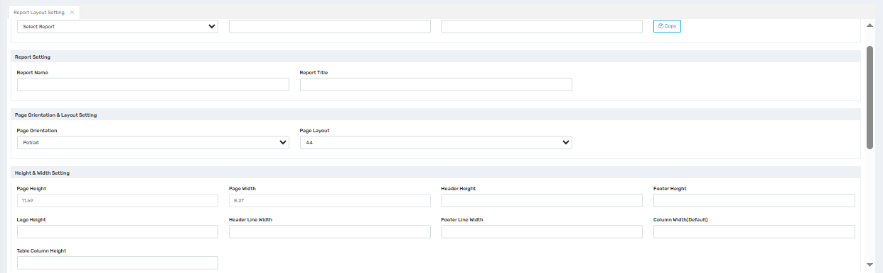
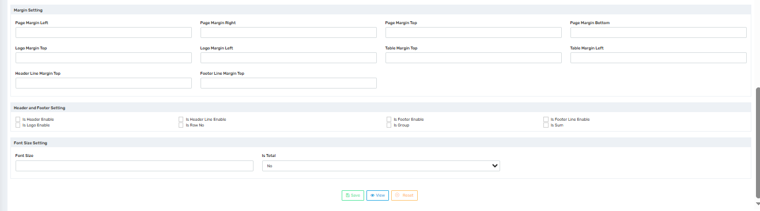

Purpose
This screen is used to design and customize the layout of printable reports generated from the school management system. It provides granular control over report structure, page size, orientation, margins, headers/footers, fonts, and more—ensuring that all printed outputs follow a professional and institution-specific format.

Where to Find
You can access this screen by navigating to:
Master Settings → Report Layout Setting

Section-Wise Field Descriptions

🔹 Report Selection
Field / Button | Description
Select Report | Dropdown to choose the specific report you want to format (e.g., Fee Receipt, Report Card).
Copy Button | Allows duplicating the layout of one report to another for faster configuration.

🔹 Report Setting
Field | Description
Report Name | Internal name used to identify the report layout.
Report Title | Title that will appear at the top of the printed report.

🔹 Page Orientation & Layout Setting
Field | Description
Page Orientation | Choose between Portrait or Landscape mode.
Page Layout | Select page size (e.g., A4, Letter).

🔹 Height & Width Setting
Field | Description
Page Height/Width | Define dimensions of the page (typically in inches).
Header/Footer Height | Customize vertical space allocated for header and footer areas.
Logo Height | Set height for the logo displayed in the header.
Header/Footer Line Width | Thickness of lines separating sections.
Table Column Height | Controls the row height for tabular data.
Column Width (Default) | Default column width across the report.

🔹 Margin Setting
Field | Description
Page Margins (Left, Right, Top, Bottom) | Define the whitespace boundaries around the report content.
Logo Margin (Top, Left) | Spacing around the logo placement.
Table Margin (Top, Left) | Control spacing before tables start.
Header/Footer Line Margin Top | Controls line position relative to header/footer.

🔹 Header and Footer Settings
Checkbox Options | Description
Is Header Enable | Enables a report header section.
Is Footer Enable | Enables a report footer section.
Is Header Line Enable | Draws a separating line below the header.
Is Footer Line Enable | Draws a line above the footer.
Is Logo Enable | Displays the school logo in the header.
Is Row No / Is Group / Is Sum | Configures display of row numbers, groupings, or total sums in the report.

🔹 Font Size Setting
Field | Description
Font Size | Sets the font size for report text.
Is Total | Allows marking total values or rows.

✅ Use Cases
- Custom Report Formatting: Tailor every report’s structure to your school’s branding and documentation standards.
- Board/Exam Compatibility: Align reports with CBSE, ICSE, or state board certificate and report formats.
- Print Optimization: Control print layout for minimal paper use or enhanced readability.
- Institution Identity: Ensure logos, titles, and margins match your school’s visual identity.

⚠️ Important Notes
- Incorrect margins or dimensions may result in text cutoff or misalignment during printing.
- Always use the View button to preview layout before saving and printing.
- Layout settings are report-specific—each format must be individually configured.
- Only authorized personnel should modify layout settings to avoid disruption of standardized report formats.

Define Document Type
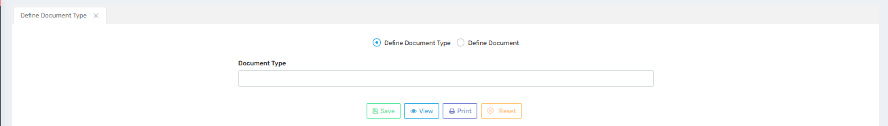
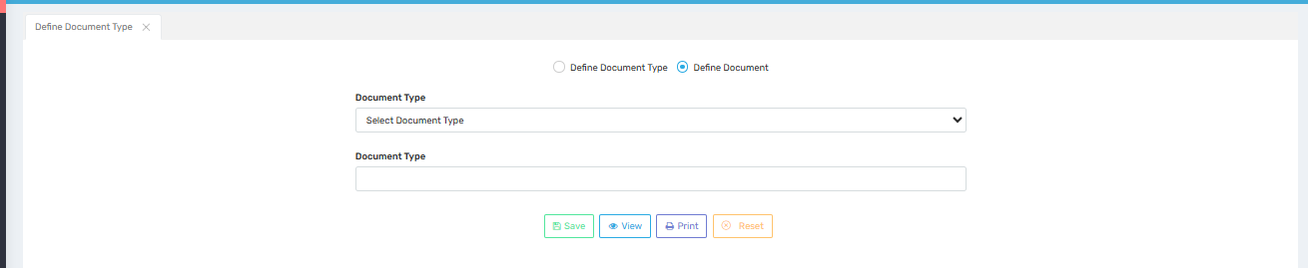

Purpose
This screen is used to create and manage document types that are referenced across the student management system—for example, ID proof, address proof, transfer certificates, etc. It ensures consistency in the kinds of documents collected or generated and provides a structure for attaching or categorizing them.

Where to Find
You can access this screen by navigating to:
Master Settings → Document Settings → Define Document Type

Field Description
Field / Button | Description
Define Document Type / Define Document (Radio Buttons) | Toggle between two modes:  Define Document Type – to create new types.  Define Document – to assign existing types to actual documents.
Document Type (Dropdown) | Appears when "Define Document" is selected; choose from previously defined types.
Document Type (Textbox) | Enter a new document type name (e.g., Aadhar Card, Birth Certificate).
Save | Saves the document type into the system for reuse.
View | Displays the list of all defined document types.
Print | Prints the list for reference or auditing purposes.
Reset | Clears current selections and fields to allow fresh entry.

✅ Use Cases
- Document Uploads & Verification:
Allows consistent tagging of uploaded documents during admission or compliance checks.
- Certificate Mapping:
Define internal types such as Bonafide, Character, or TC for auto-document generation.
- Simplified Filtering:
Helps in filtering or retrieving documents by type in reporting and admin panels.
- Audit and Administration:
Maintains a registry of acceptable document types for legal or organizational purposes.

⚠️ Important Notes
- Avoid duplicate entries with similar names (e.g., “Birth Cert” vs. “Birth Certificate”) to prevent confusion.
- Use meaningful and specific names that clearly define the purpose of the document type.
- Deleting or modifying a document type already in use may affect linked records—proceed with caution.
- The defined types are shared across modules, so ensure naming is consistent with institutional standards.

Admission
Enquiry
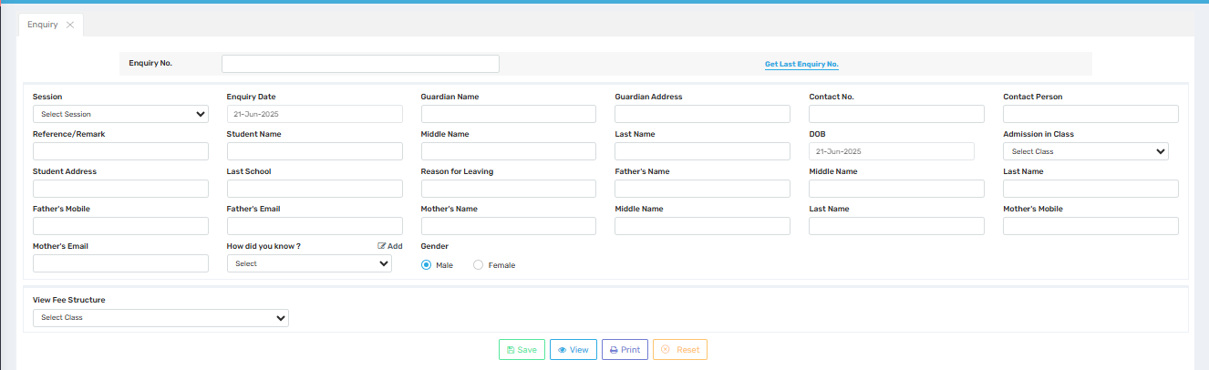

Purpose
This screen is used to record and manage admission enquiries received from prospective students or their guardians. It helps the school keep track of interest, follow up with potential admissions, and maintain a database of all leads for future communication and reporting.

Where to Find
You can access this screen by navigating to:
Admission → Enquiry

Field Description
Field / Section | Description
Enquiry No. | A unique identifier automatically or manually assigned to each enquiry.
Get Last Enquiry No. | Button to fetch the most recent enquiry number for reference or auto-increment.
Session | Dropdown to select the academic session the enquiry is for.
Enquiry Date | The date the enquiry was recorded (default is the current date).
Student Name / Middle Name / Last Name | Full name of the prospective student.
DOB | Date of Birth of the student.
Admission in Class | Dropdown to select the class the enquiry pertains to.
Contact No. | Primary mobile/contact number for communication.
Contact Person | Name of the person to be contacted (parent, guardian, etc.).
Guardian Name / Address | Details of the guardian, if different from parents.
Student Address | Residential address of the student.
Last School | Name of the student’s previous school (if applicable).
Reason for Leaving | Reason for leaving the last school (optional).
Father’s Name / Middle / Last Name | Full name of the father.
Father’s Mobile / Email | Contact and email for the father.
Mother’s Name / Middle / Last Name | Full name of the mother.
Mother’s Mobile / Email | Contact and email for the mother.
How did you know? | Dropdown to select source of enquiry (e.g., Online, Advertisement, Reference).
Add Checkbox | Allows entering additional options if the source is not listed.
Gender | Select the gender of the student (Male/Female).
Reference/Remark | Notes or remarks about the enquiry.
View Fee Structure (Class Dropdown) | Select class to view the applicable fee structure.

✅ Use Cases
- Lead Management:
Maintain records of all potential admissions with detailed personal and academic history.
- Follow-Up Planning:
Helps admission teams follow up with interested parties using accurate contact details.
- Source Analysis:
Analyze which marketing channels (online, referrals, print, etc.) bring in the most enquiries.
- Data Reference:
Link enquiry records to final admission records once converted.

⚠️ Important Notes
- Ensure unique enquiry numbers to avoid record duplication.
- All contact details must be verified for accuracy to support follow-up processes.
- Do not leave mandatory fields blank—especially those marked for session, contact, and class details.
- Enquiries can be converted to admissions, so avoid entering dummy data.

Enquiry FollowUp
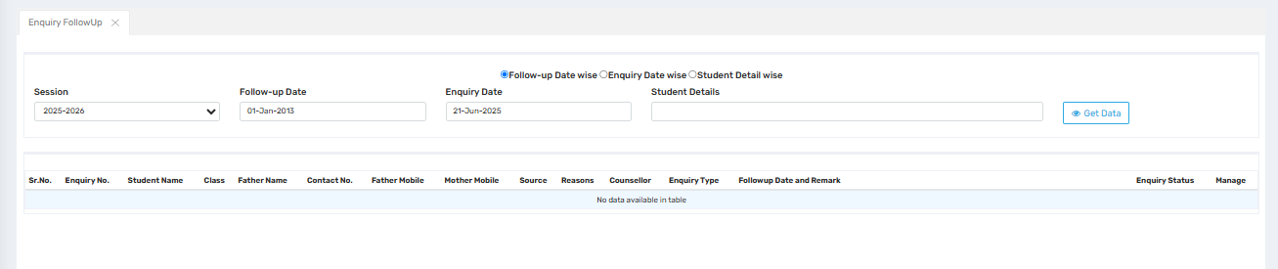

Purpose
This screen is designed to help schools track and manage follow-ups on admission enquiries. It enables staff to filter and review pending or completed follow-ups, record remarks, and ensure no enquiry goes unattended—thereby improving conversion rates from enquiry to admission.

Where to Find
You can access this screen by navigating to:
Admission → Enquiry Follow-Up

Field Description
Field / Section | Description
Session | Dropdown to select the academic session for which enquiries are being tracked.
Follow-up Date | The date when the follow-up is scheduled or occurred. Used to filter results.
Enquiry Date | Original date when the enquiry was first made.
Student Details | Search bar to filter by student name or enquiry-related keyword.
Follow-up Filters
• Follow-up Date wise – Filters follow-ups scheduled for the selected date.
• Enquiry Date wise – Filters by original enquiry submission date.
• Student Detail wise – Allows searching using name, class, or other info.
Get Data (Button) | Fetches records based on selected filters and displays them in the table.

Table Columns Displayed
Column | Description
Sr. No. | Serial number of entries in the table.
Enquiry No. | Unique ID assigned to each enquiry.
Student Name | Name of the student related to the enquiry.
Class | Intended admission class.
Father Name / Contact / Mobile | Guardian details for communication.
Mother Mobile | Alternate contact for follow-up.
Source | How the enquiry was received (e.g., online, referral).
Reasons | Notes on why admission was or wasn’t pursued.
Counsellor | Staff member assigned to handle the enquiry.
Enquiry Type | Categorization of enquiry (e.g., Walk-in, Call, Online Form).
Follow-up Date and Remark | Displays scheduled follow-up date and any notes or updates.
Enquiry Status | Shows whether the enquiry is open, closed, or converted.
Manage | Button/action to update follow-up status or details.

✅ Use Cases
- Timely Follow-Up:
Ensures no enquiry is missed and enables effective communication with prospective students.
- Enquiry Conversion Tracking:
Identify which follow-ups lead to actual admissions and optimize response strategies.
- Workload Management:
Allows counselors to view and manage their assigned follow-ups.
- Data-Driven Outreach:
Enables filtering by specific dates or student details for targeted contact.

⚠️ Important Notes
- Use consistent date formats when entering follow-up and enquiry dates to avoid filtering issues.
- Always update follow-up remarks after each interaction for future reference.
- The “Manage” column should only be accessible to users with appropriate permissions.
- Data might not display unless filters are applied correctly—ensure session and date selections are made before clicking Get Data.

Prospectus Entry
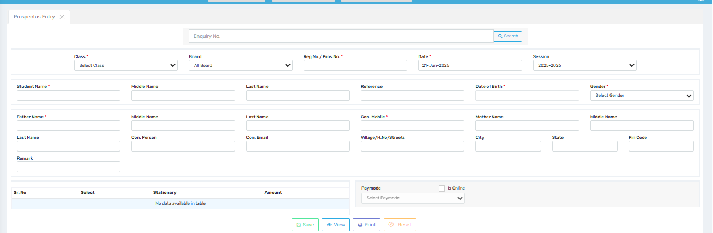

Purpose
This screen is used to record the sale or issue of prospectuses to prospective students. It allows the institution to capture key applicant and parent details, track registration/prospectus numbers, and record payment modes, ensuring an organized admission inquiry workflow.

Where to Find
You can access this screen by navigating to:
Admission → Prospectus Entry

Field Description
Field / Section | Description
Enquiry No. | Optional field to link this entry to a prior enquiry.
Class (Required) | Select the class the prospectus is being issued for.
Board | Choose applicable educational board (e.g., CBSE, ICSE, etc.).
Reg No. / Pros No. (Required) | Unique registration/prospectus number issued to the student.
Date | Date the prospectus was issued (defaults to current date).
Session | Academic session the admission is intended for.

🔹 Student & Guardian Information
Field | Description
Student Name / Middle / Last Name | Full name of the applicant.
Reference | Source of enquiry or how the applicant heard about the school.
Date of Birth | Applicant’s birth date.
Gender | Select student’s gender.
Father Name / Middle / Last Name | Father's full name.
Con. Person / Con. Mobile / Con. Email | Primary contact person's name, phone, and email.
Mother Name / Middle Name | Mother's name details.
Village / H.No / Streets | Address line 1 or local area info.
City / State / Pin Code | Remaining address fields.
Remark | Any administrative notes or comments.

🔹 Prospectus & Fee Information
Field | Description
Stationary Table (Sr. No. / Select / Amount) | Table to display and select available stationery/prospectus fee items.
Paymode | Dropdown to select payment mode (Cash, Online, UPI, etc.).
Is Online (Checkbox) | Marks whether the payment was made online.

✅ Use Cases
- Admission Pipeline Tracking:
Maintain a log of every prospectus issued along with student details.
- Integrated Enquiry Linking:
Connect the form to prior enquiries to carry forward data and simplify processing.
- Fee Audit & Reporting:
Record and monitor payment details for prospectus sales for accounting purposes.
- Data Readiness for Admission:
Collect early-stage data needed during the formal registration process.

⚠️ Important Notes
- Ensure Reg No. / Pros No. is unique to avoid duplication.
- Mandatory fields must be filled to allow saving.
- Use consistent formatting for contact numbers and names to maintain data cleanliness.
- Linking enquiry numbers improves traceability between interest and actual admission steps.
- Always confirm that Paymode and Is Online status are accurately recorded for financial audits.

Admission Form Registration
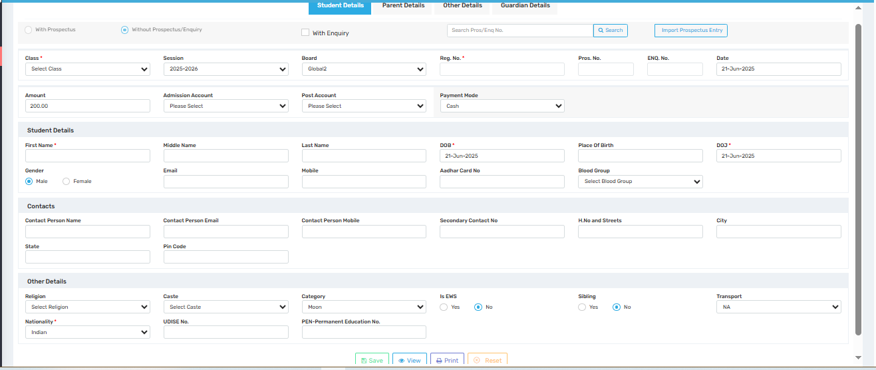

Purpose
This screen is used to register new students into the system either with or without prior enquiry or prospectus. It captures the essential academic, personal, and demographic information needed to enroll a student in a specific academic session and class.

Where to Find
You can access this screen by navigating to:
Admission → Student Registration Form

Field Description (Tab: Student Details)

🔹 Top Bar Options
Option | Description
With Prospectus / With Enquiry | Allows importing data from an existing prospectus or enquiry entry.
Without Prospectus/Enquiry | Choose this to manually enter student details from scratch.
Search Button | Use to fetch existing details linked to prospectus or enquiry.
Import Prospectus Entry | Pulls data directly from a prospectus record.

🔹 Registration Information
Field | Description
Class (Required) | Select the class for which the student is being registered.
Session | Academic year/session.
Board | Select educational board (CBSE, ICSE, etc.).
Reg. No. (Required) | Unique registration number for the student.
Pros. No. / Enq. No. | Link to existing prospectus or enquiry if applicable.
Date | Date of registration.
Amount | Fee amount associated with admission.
Admission Account | Account into which admission payment is received.
Post Account | Account for financial posting of the admission.
Payment Mode | Dropdown to select how payment was made (Cash, Online, etc.).

🔹 Student Details
Field | Description
First / Middle / Last Name | Full student name.
Gender | Male or Female.
Email / Mobile | Student contact details.
DOB / DOJ | Date of birth and date of joining the institution.
Place of Birth | City or location where student was born.
Aadhar Card No. | Unique ID number (if applicable).
Blood Group | Select the student’s blood group.

🔹 Contact Information
Field | Description
Contact Person Name | Primary guardian or parent's name.
Contact Person Email | Guardian’s email address.
Contact Person Mobile | Guardian’s mobile number.
Secondary Contact No. | Alternate number for emergencies.
H.No. and Streets / City / State / Pin Code | Full residential address of the student.

🔹 Other Details
Field | Description
Religion / Caste | Select the student’s religion and caste for demographic tracking.
Category | General, SC, ST, OBC, etc.
Is EWS | Mark if the student is from the Economically Weaker Section.
Sibling | Indicate if the student has a sibling enrolled.
Transport | Assign transport route or mark NA if not applicable.
Nationality / UDISE No. / PEN | Nationality of the student and optional educational IDs.

✅ Use Cases
- New Admission Entry:
Complete form for fresh admissions not linked to previous enquiries or prospectuses.
- Data Linking:
Quickly pull and reuse data from previously created enquiry or prospectus entries.
- Financial Mapping:
Records amount, payment mode, and account heads for auditing and finance integration.
- Student Demographic Record:
Captures full profile for use in communication, reports, ID cards, and regulatory submissions.

⚠️ Important Notes
- Fields marked with * are mandatory.
- Ensure that registration numbers are unique.
- Linked enquiry or prospectus data must match the current session and class to be imported.
- Payment and account details affect fee records—review carefully before saving.

Possible Siblings
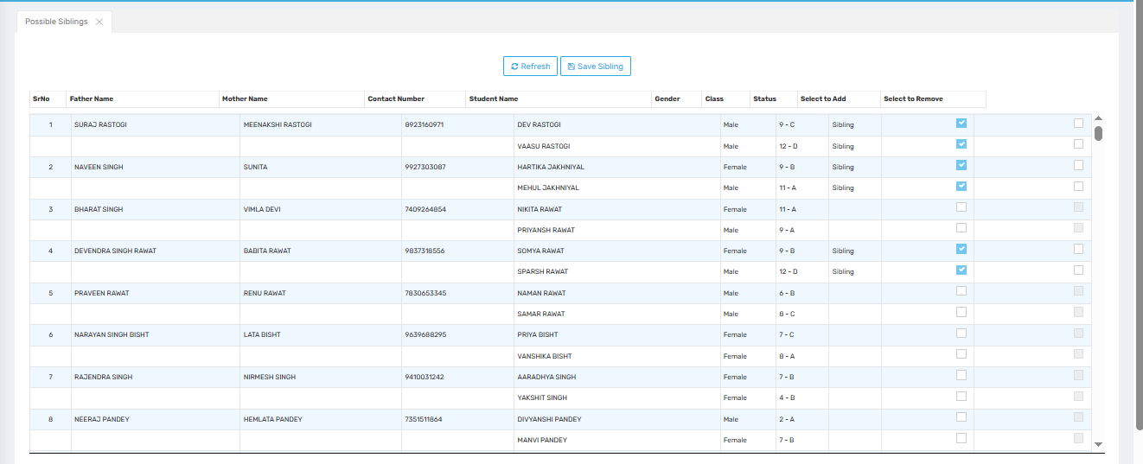

Purpose
This screen is used to identify and manage sibling relationships between students in the school system. It allows administrative staff to match students who share parental and contact details, and mark them as siblings for fee concessions, communication grouping, or academic tracking.

Where to Find
You can access this screen by navigating to:
Admission → Possible Siblings

Field Description
Column / Field | Description
Sr. No. | Auto-generated serial number for listing.
Father Name | Name of the student's father. Used for matching possible siblings.
Mother Name | Name of the student's mother.
Contact Number | Shared contact number for both students (used for matching).
Student Name | Name of the student under evaluation.
Gender | Student's gender (Male/Female).
Class | Class in which the student is currently enrolled.
Status | Displays "Sibling" if already linked as a sibling.
Select to Add | Checkbox to add a sibling relationship between the currently selected and matched student.
Select to Remove | Checkbox to remove an existing sibling relationship.

Top Buttons
Button | Function
Refresh | Refreshes the list of possible sibling matches using the latest data.
Save Sibling | Saves the checked additions or removals of sibling records.

✅ Use Cases
- Sibling Fee Concessions:
Identifies siblings eligible for discounts or special fee categories.
- Parent Communication:
Links students so communication (SMS, notices, etc.) can be consolidated per family.
- Academic Tracking:
Allows viewing progress or movement of siblings in a grouped manner.
- Duplicate Record Prevention:
Ensures no redundant student records are created for the same family.

⚠️ Important Notes
- Ensure that the parent names and contact numbers match exactly for correct sibling detection.
- The "Select to Remove" option should be used cautiously as it unlinks sibling records and may impact fee settings or group messaging.
- You must click “Save Sibling” after making selections for changes to take effect.
- This screen only shows possible siblings—you can verify the relationship manually before confirming.

Manual List Generation
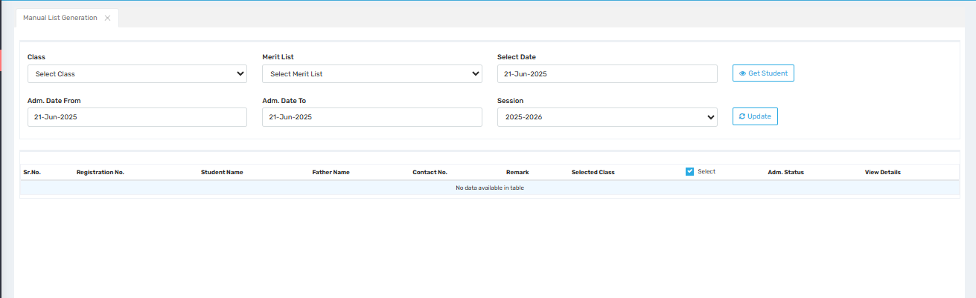

Purpose
This screen is used to manually generate and manage student merit or admission lists based on selected criteria such as class, session, date, and admission status. It is especially useful for schools that use merit-based admission processes or need to manually track and organize student records during the enrollment cycle.

Where to Find
You can access this screen by navigating to:
Admission → Manual List Generation

Field Description
Field / Section | Description
Class | Dropdown to select the class for which the list is to be generated.
Merit List | Select a predefined merit list or create a new one.
Select Date | Date of processing or list generation.
Adm. Date From / To | Admission date range used to filter students who were admitted during a specific period.
Session | Academic session being considered for the list.
Get Student (Button) | Fetches student data based on selected filters.
Update (Button) | Applies changes to the list or saves a newly generated list.

Table Columns
Column | Description
Sr. No. | Auto-incremented serial number.
Registration No. | Unique registration number of the student.
Student Name | Name of the student fetched based on criteria.
Father Name | Father's name for identification.
Contact No. | Primary contact number associated with the student.
Remark | Any comments or administrative notes.
Selected Class | Displays the class linked to the student.
Select | Checkbox to include the student in the merit/admission list.
Adm. Status | Shows if the admission is confirmed, pending, or canceled.
View Details | Allows you to open the student's full profile or admission form.

✅ Use Cases
- Merit-Based Admissions:
Useful for compiling a class-wise list of selected students based on admission timelines.
- Reporting & Filtering:
Helps quickly generate custom lists for review, approvals, or communications.
- Batch Processing:
Allows mass actions on a filtered list of students (e.g., status update or list printing).
- Audit & Verification:
Supports management reviews and audits of how students were admitted into specific classes or sessions.

⚠️ Important Notes
- Ensure you select both date range and session to avoid an empty result.
- Only students matching the selected class and date filters will be displayed.
- Use the “Select” checkbox carefully before updating the list—once saved, changes may reflect in downstream processes (e.g., reports or merit notices).
- The View Details button should be used for final verification before confirming entries.

Student Registration
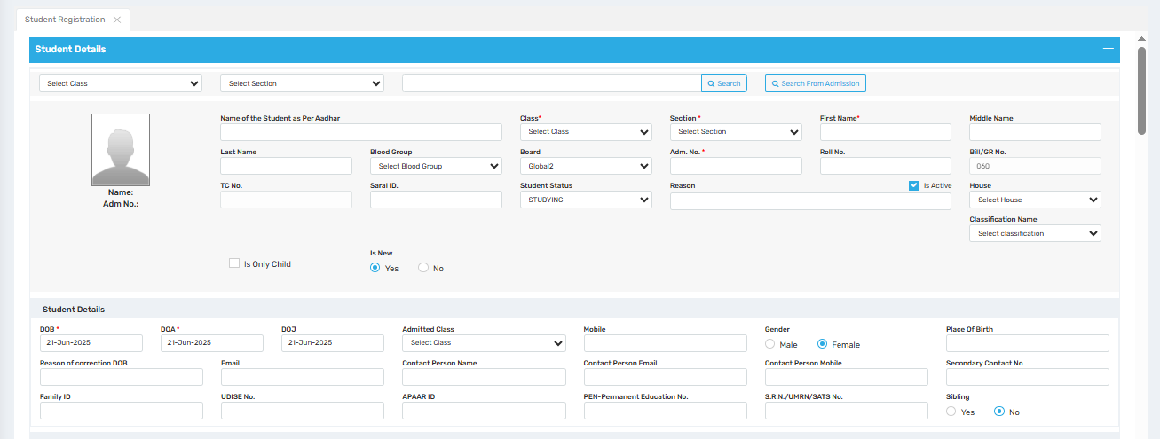
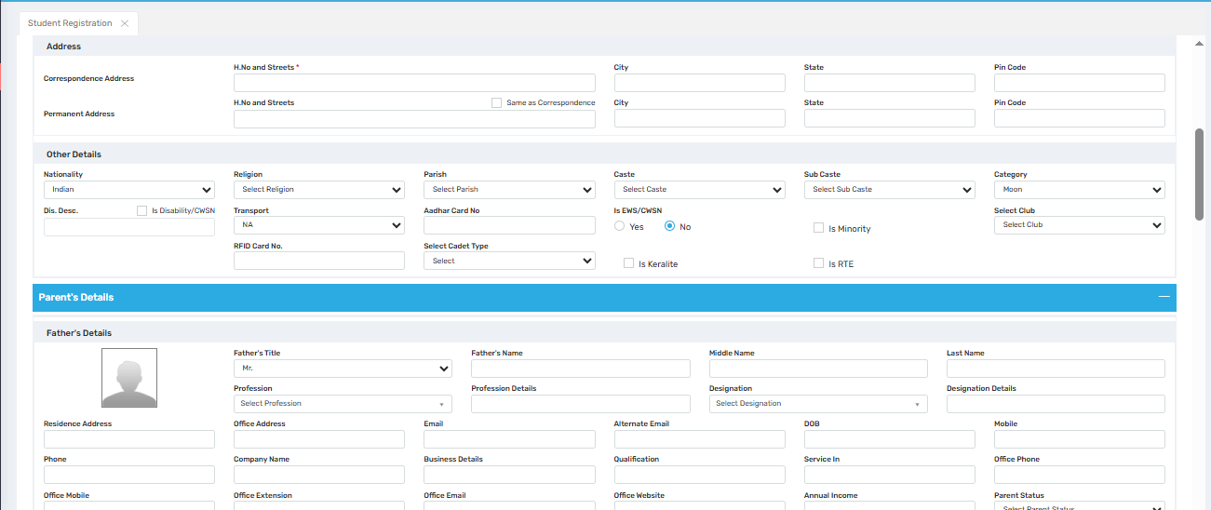
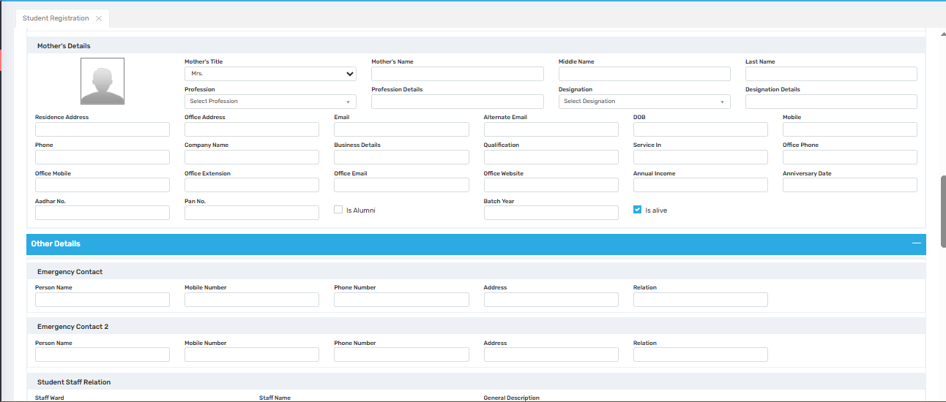
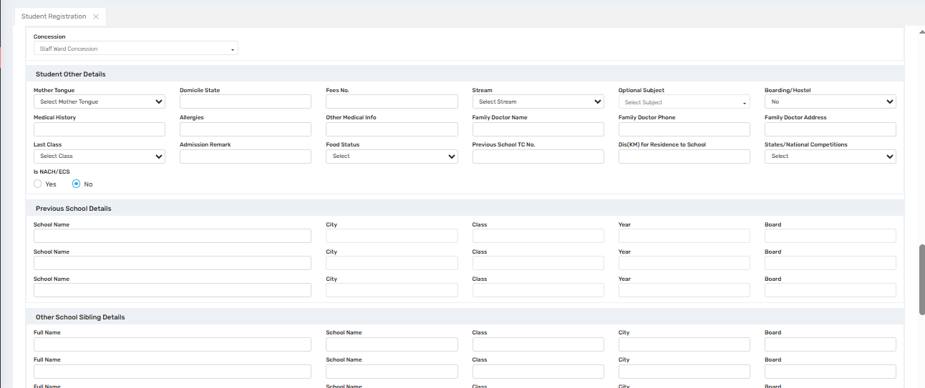
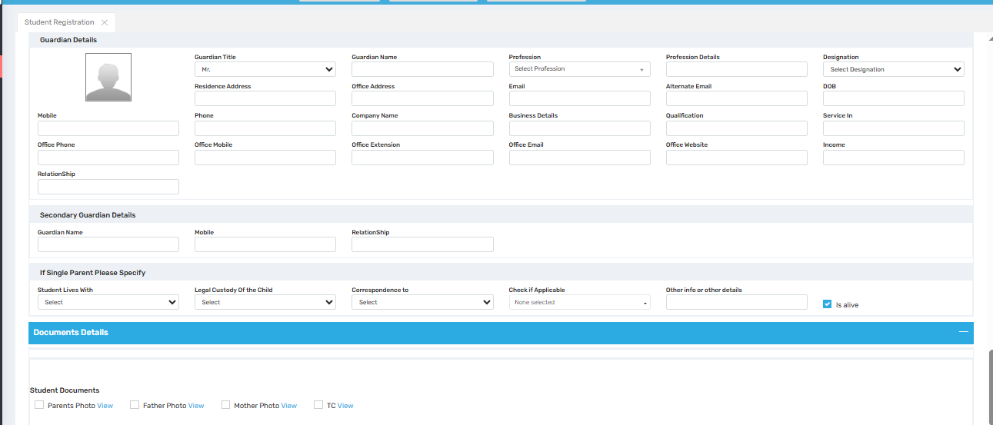

Purpose
This screen is used to register a student fully into the system, capturing all necessary personal, academic, demographic, and contact details. It is the most comprehensive admission form used when onboarding new or transferring students.

📍 Where to Find
Navigate to:
Admission → Student Registration

🗂️ Form Sections & Field Descriptions

1. Header Options
Field | Description
With Prospectus / Without Prospectus / With Enquiry | Choose source of student registration.
Search Bar | Search using Prospectus or Enquiry number.
Import Prospectus Entry | Autofills the form using earlier prospectus data.

2. Basic Admission Info
Field | Description
Class, Section, Session, Date | Academic details of admission.
Reg. No., Pros. No., ENQ No. | Unique identifiers for the student.
Amount, Payment Mode, Admission Account, Post Account | Admission fee and accounting info.

3. Student Details
Field | Description
First, Middle, Last Name | Full name of the student.
DOB, DOJ, Place of Birth | Personal identification details.
Roll No., Bill/GR No. | Internal identifiers.
Blood Group, Aadhar Card No., Saral ID | Health & government ID.
Is Only Child, Is New | Checkbox-based additional flags.
House, Classification | Optional grouping.

4. Contacts
Field | Description
Contact Person Name, Email, Mobile | Primary contact.
Address (H.No, City, State, Pin) | Residential info.

5. Other Student Details
Field | Description
Religion, Caste, Sub-caste, Category | Demographic grouping.
UDISE No., PEN, S.R.N./UMRN/SATS No. | Govt-linked student tracking codes.
Transport, Club, Parish | Misc. assignments.
RFID Card No., Disability (CWSN), RTE, Minority, Keralite | Additional tags.

6. Parent’s Details

Father's Information
Field | Description
Name, Title, DOB | Personal info.
Profession, Designation, Company | Work info.
Email, Phone, Address | Contact details.
Income, Alumni, Is Alive | Status flags.

Mother's Information
| (Same structure as father) | Plus Anniversary Date field. |

7. Guardian Details
Field | Description
Name, Title, Relation, Profession, Contact | Guardian profile.
Secondary Guardian | Optional second guardian.
Single Parent Section | Child custody and living info.

8. Emergency Contact Details
Field | Description
Name, Mobile, Phone, Address, Relation (1 & 2 slots) | For emergency communication.

9. Student-Staff Relation
Field | Description
Staff Ward, Staff Name | Link student with employee (e.g., staff child).
General Description | Notes or classification.

10. Student Concession & Other Info
Field | Description
Concession Type | E.g., Staff Ward, EWS.
Medical History, Allergies, Last Class | Health & academic data.
Optional/Stream Subjects | For board-specific streams.
Doctor Info, Residence Distance | Logistics and support data.
States/National Competitions | Competitive records.

11. Previous School Details
Field | Description
School Name, City, Class, Year, Board (3 entries) | Historical academic records.

12. Other School Sibling Details
Field | Description
Name, School, Class, City, Board (multiple entries) | Track siblings in other institutions.

13. Document Uploads Section
| Student Documents | Parents, Father, Mother Photos, TC |
| Government Documents | Aadhar Card, Address Proof |
All include checkbox + View option.

14. Actions
Button | Function
Save | Stores all entered information.
View | Previews complete record.
Print | Prints the admission form.
Reset | Clears the form for re-entry.

✅ Use Cases
- Complete Student Registration: Ideal for entering all student-related details in one go.
- Data Migration: Can be used to onboard students coming from external systems with full details.
- Government Compliance: Fields such as UDISE, PEN, Aadhar, etc., support CBSE/State mandates.
- Audit-Ready Profiles: Structured sections ensure completeness for records, fees, health, and documents.

⚠️ Important Notes
- Fields marked with red asterisk (*) are mandatory.
- Government ID fields should be accurate to avoid errors in official reporting.
- Check all dropdowns for standardization (Caste, Category, Club, Profession, etc.).
- If you use imported data (via Enquiry or Prospectus), verify autofilled values before saving.

Manage Student Details
Download Photo
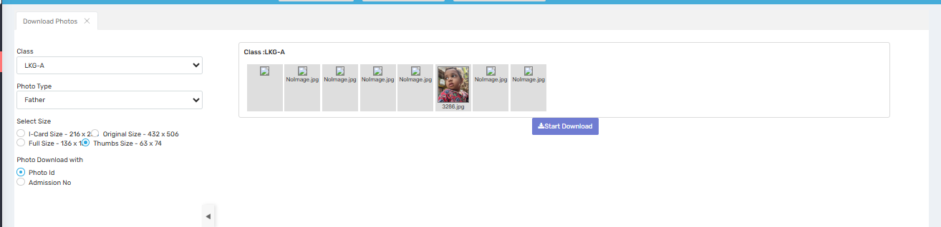

Purpose
This screen allows school administrators to download student or parent-related photographs (e.g., father, mother, student, guardian) class-wise in bulk. This is especially useful for printing ID cards, maintaining photo-based attendance records, and generating student files.

Where to Find
Navigate to:
Admission → Manage Student Details → Download Photos

Field Descriptions
Field / Option | Description
Class | Dropdown to select the class (e.g., LKG-A) from which you want to download photos.
Photo Type | Select the type of photo to download: Student, Father, Mother, Guardian, etc.
Photo Thumbnails Display | Shows a horizontal scroll of the available images for that selection. “NoImage.jpg” indicates a missing upload.
Select Size | Choose the desired image size for download:
• I-Card Size: 216×216
• Original Size: 432×506
• Full Size: 136×160
• Thumb Size: 63×74
Photo Download With | Select the file naming convention:
• Photo ID — uses student photo ID as filename
• Admission No — uses the admission number instead
Start Download (Button) | Begins the bulk download of all selected images based on filters and options.

✅ Use Cases
- ID Card Printing:
Download images in I-Card size for integration into printable student/staff ID cards.
- File Attachment:
Quickly gather father/mother photos for administrative documentation.
- Photo Verification:
Visually verify uploaded photos or spot missing entries (marked as NoImage.jpg).
- Data Backup:
Maintain a local archive of uploaded images, sorted by class and type.

⚠️ Important Notes
- Ensure photos are properly uploaded before downloading; “NoImage.jpg” indicates a missing or failed upload.
- Selecting the correct image size and naming method is critical for downstream processing (e.g., printing or uploading elsewhere).
- Always verify class and photo type before hitting Start Download to avoid unnecessary bandwidth use or incorrect files.

Update Student Details
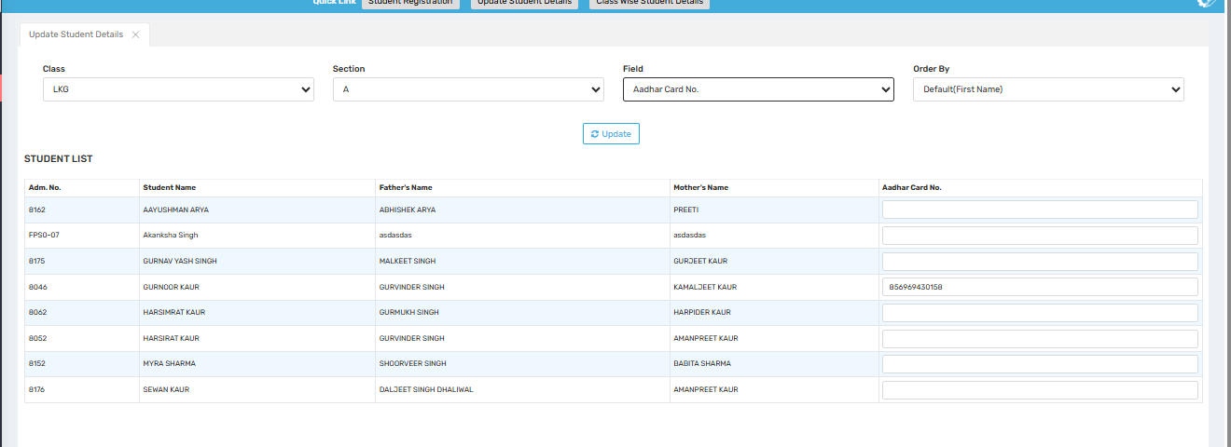

Purpose
This screen is used for class-wise and section-wise bulk updating of specific student fields without opening individual profiles. It supports a wide range of personal, academic, and administrative data points—streamlining the data correction and entry process.

Where to Find
Go to:
Admission →Manage Student Details→ Update Student Details

Main Options
Field | Description
Class | Select the class for which student details need to be updated.
Section | Further narrows down the list to a specific section.
Field | Dropdown to select the specific student data field to update (e.g., Aadhar, Blood Group).
Order By | Choose sorting criteria for the student list (Default by First Name, Admission No., etc.).
Update Button | After modifying values, click this to save changes in bulk.

Available Fields for Bulk Update (from dropdown)
Here’s a selection of commonly used fields available for bulk update:
- Aadhar Card No.
- Admission No.
- Admitted Class
- Anniversary Date
- Apar ID
- Bill No.
- Birth Certificate Type
- Blood Group
- Board Registration No.
- Boarding/Hostel
- Booklet SLNO
- Cast
- Category
- Contact Email
- Contact Person Name, Mobile
- Emergency Contact Details (1 & 2)
- Disability/CWSN flag
- Is RTE, Is Minority, Is EWS
…and many more.
🔄 Scroll-enabled dropdown lets the user select from dozens of customizable fields. Only one field can be updated at a time.

✅ Use Cases
- Term Start Audit:
Ensure fields like Blood Group, Aadhar, Contact Info are completed for all students.
- CBSE/State Board Compliance:
Bulk update UDISE codes, Board Reg No, or Caste/Category as required for government submissions.
- Fee-Related Updates:
Fields like Boarding/Hostel, Category, or Bill No. affect how students are billed.
- Parent Communication Clean-up:
Quickly ensure that contact emails or mobile numbers are updated across sections.

⚠️ Important Notes
- You must select the class, section, and field to fetch the student list.
- Always click “Update” after making changes—unsaved edits will be lost on refresh.
- Some fields may have validations (e.g., Aadhar must be numeric and 12 digits).
- Only one field at a time can be updated across the student list.

Set Student Status
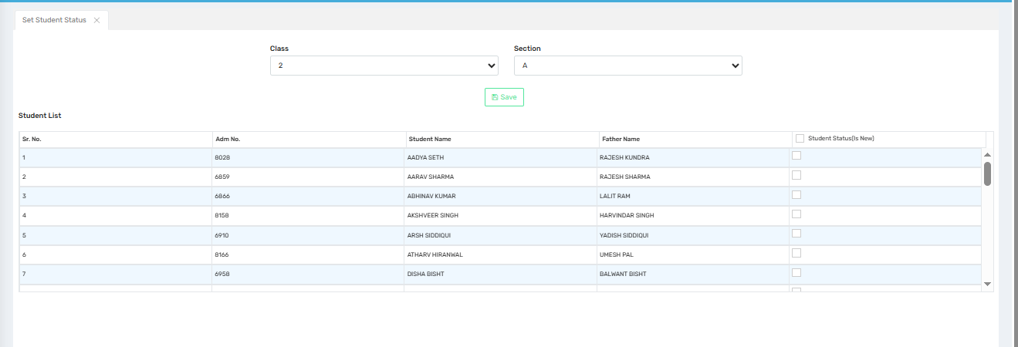

Purpose
This screen is used to mark students as “New” for the current academic session or a specific class/section. It's particularly useful for identifying newly admitted students versus continuing ones, and can influence reports, fee concessions, or communication tags.

Where to Find
Navigate to:
Admission →Manage Student Details→ Set Student Status

Field Descriptions
Field | Description
Class | Select the class (e.g., 2) from the dropdown to view students.
Section | Choose the section (e.g., A) of the class.
Save Button | After setting the status, click this to apply changes.

Student List Table
Column | Description
Sr. No. | Serial number in list.
Adm. No. | Student's Admission Number.
Student Name | Full name of the student.
Father Name | Name of the student’s father.
Student Status (Is New) | A checkbox that, when checked, flags the student as newly admitted.

✅ Use Cases
- Admission Reporting:
Identify and filter newly admitted students for reports or ID generation.
- Fee Setup:
Apply specific fee structures or concessions to new students only.
- Communication Filters:
Send welcome messages or orientation info only to new students.
- System Flags:
Use this checkbox to automate processes for "new joiners" like document collection, ID card printing, etc.

⚠️ Important Notes
- Changes are not saved until the Save button is clicked.
- Ensure you are viewing the correct class and section to avoid erroneous tagging.
- This field may integrate with other modules like Fee, Reports, or Student Documents.
- This does not affect previous sessions or transfer students unless manually unchecked.

Change Active / Inactive Status
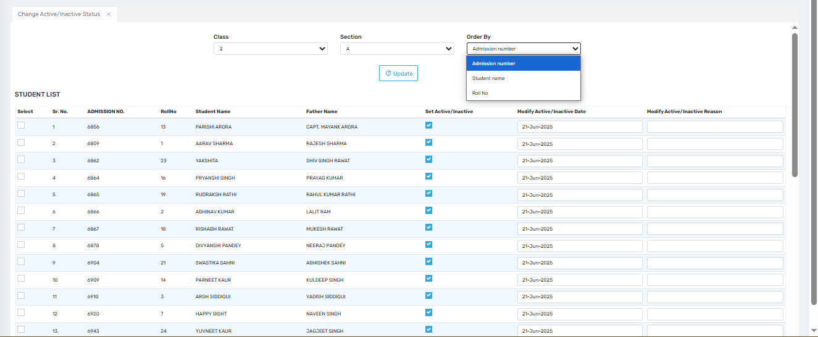

Purpose
This screen is used to mark students as active or inactive in bulk, class-wise. It allows administrators to manage enrollment status for current students—especially helpful for handling withdrawals, TC processing, reactivations, or temporary suspensions.

Where to Find
Navigate to:
Admission →Manage Student Details→ Change Active/Inactive Status

Field Descriptions
Field | Description
Class | Select the class (e.g., 2) to load student records.
Section | Choose the specific section (e.g., A) of the class.
Order By | Sort students by:
• Admission Number
• Student Name
• Roll No
Update Button | Apply all active/inactive changes once selections are made.

Student List Columns
Column | Description
Select | Checkbox to choose which student records to update.
Sr. No. | Serial number in list.
Admission No. | Student’s admission ID.
Roll No | Assigned roll number.
Student Name | Full name of the student.
Father Name | For reference or identification.
Set Active/Inactive | Checkbox toggle for the student’s current status. Checked = Active, Unchecked = Inactive.
Modify Active/Inactive Date | The date the status was updated.
Modify Active/Inactive Reason | Optional text field to note the reason (e.g., “TC issued”, “Rejoined”, “Fee Pending”).

✅ Use Cases
- TC (Transfer Certificate) Issuance:
Mark students inactive when transferring to another school.
- Mid-year Departures:
Reflect students who left during the session (with reason/date).
- Reactivation of Dropped Students:
Remove inactive status and update the reactivation date.
- Temporary Suspension:
Temporarily mark students inactive for cases like leave or suspension.

⚠️ Important Notes
- You must check or uncheck the "Set Active/Inactive" box for each student you want to update.
- The reason and date fields are helpful for audit purposes but may not be mandatory.
- Be sure to click “Update” to apply your changes.
- Once set to inactive, students may be excluded from active reports, fee schedules, or attendance.

Assign Computer No. To Student
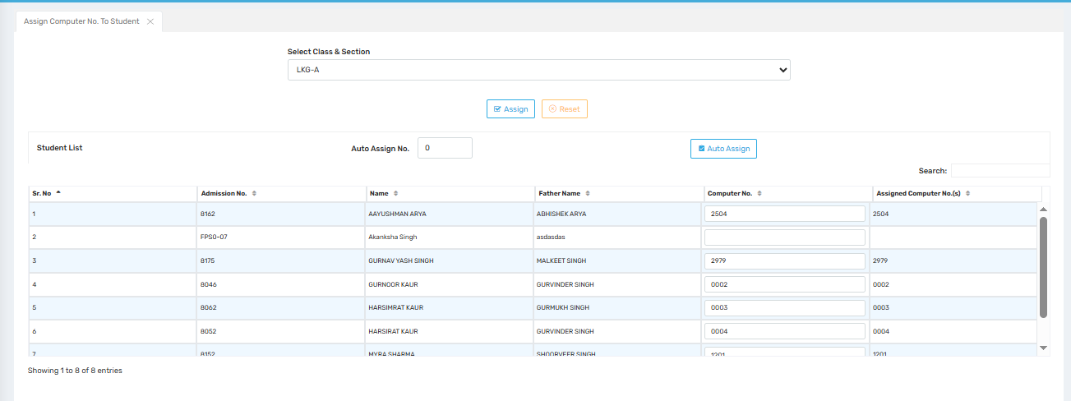

Purpose
This screen is used to assign or auto-assign unique computer numbers to each student within a class/section. These numbers are typically used for internal lab management, exam systems, or unique roll call systems where a separate “Computer No.” is required distinct from admission or roll numbers.

Where to Find
Navigate to:
Admission →Manage Student Details→ Assign Computer No. To Student

Field Descriptions
Field | Description
Select Class & Section | Choose the specific class and section (e.g., LKG-A) to work with.
Auto Assign No. | Starting number for auto-assign. System will incrementally assign numbers from this value.
Assign Button | Saves the manually entered computer numbers.
Reset Button | Clears the current entries before saving.
Auto Assign Button | Automatically assigns computer numbers sequentially from the value entered in “Auto Assign No.”

Student List Table
Column | Description
Sr. No. | Serial number of student in the list.
Admission No. | Unique admission number of the student.
Name | Student's full name.
Father Name | For additional identity reference.
Computer No. | Field where admin manually enters the computer number.
Assigned Computer No. | Shows saved/assigned computer number from the system.

✅ Use Cases
- Computer Lab Management:
Assign a machine number to each student for organized seating or exam sessions.
- Online Exam Integration:
Map each student to a system ID for MCQ/CBT software.
- Unique Student Mapping:
Helps in scenarios where roll numbers repeat or aren’t system-assigned.
- Batch/Cluster Allocation:
Segment students into hardware units or class sections efficiently.

⚠️ Important Notes
- Do not leave blank fields if you plan to assign manually. Use Auto Assign if you want system-generated values.
- Avoid duplicate numbers — each student should have a unique Computer No.
- Always click “Assign” after updating to save the new values.
- Use “Reset” before redoing assignment if you make an error.

Assign Roll No. to Student
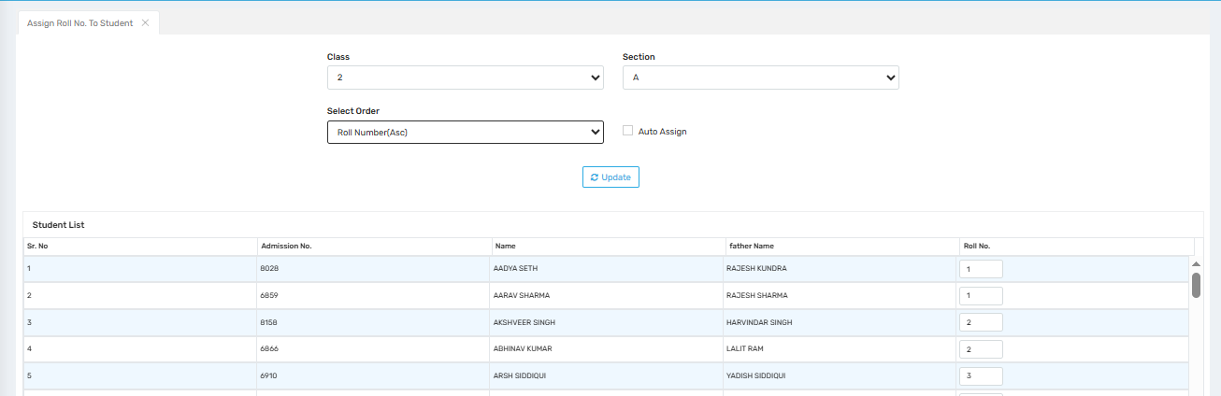

Purpose
This screen is used to assign or auto-assign unique computer numbers to each student within a class/section. These numbers are typically used for internal lab management, exam systems, or unique roll call systems where a separate “Computer No.” is required distinct from admission or roll numbers.

Where to Find
Navigate to:
Admission →Manage Student Details→ Assign Computer No. To Student

Field Descriptions
Field | Description
Select Class & Section | Choose the specific class and section (e.g., LKG-A) to work with.
Auto Assign No. | Starting number for auto-assign. System will incrementally assign numbers from this value.
Assign Button | Saves the manually entered computer numbers.
Reset Button | Clears the current entries before saving.
Auto Assign Button | Automatically assigns computer numbers sequentially from the value entered in “Auto Assign No.”

Student List Table
Column | Description
Sr. No. | Serial number of student in the list.
Admission No. | Unique admission number of the student.
Name | Student's full name.
Father Name | For additional identity reference.
Computer No. | Field where admin manually enters the computer number.
Assigned Computer No. | Shows saved/assigned computer number from the system.

✅ Use Cases
- Computer Lab Management:
Assign a machine number to each student for organized seating or exam sessions.
- Online Exam Integration:
Map each student to a system ID for MCQ/CBT software.
- Unique Student Mapping:
Helps in scenarios where roll numbers repeat or aren’t system-assigned.
- Batch/Cluster Allocation:
Segment students into hardware units or class sections efficiently.

⚠️ Important Notes
- Do not leave blank fields if you plan to assign manually. Use Auto Assign if you want system-generated values.
- Avoid duplicate numbers — each student should have a unique Computer No.
- Always click “Assign” after updating to save the new values.
Use “Reset” before redoing assignment if you make an error.

Upload Student Document
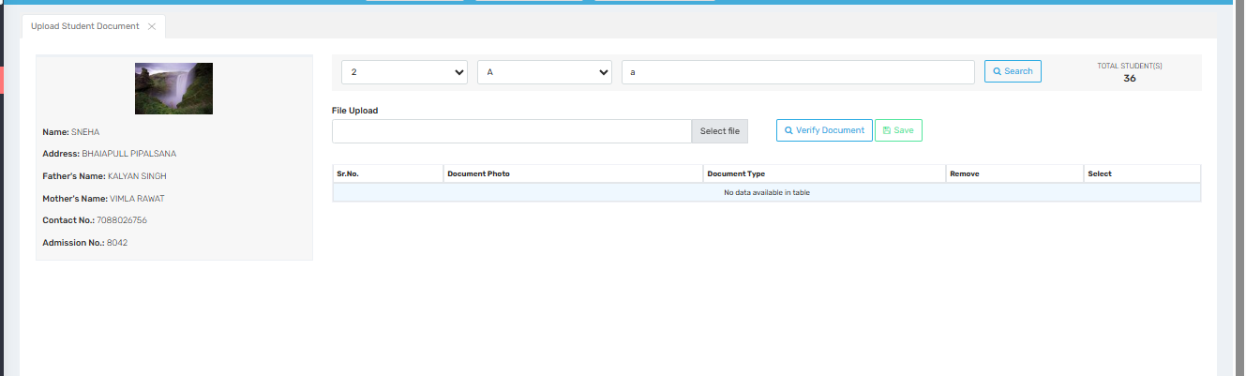

Purpose
This screen is used to upload and manage student documents (e.g., ID proof, birth certificate, report cards) for a selected student. It allows the admin to attach document files to individual student profiles for verification and record-keeping.

Where to Find
Navigate to:
Admission → Manage Student Details → Upload Student Document

Field Descriptions
Field | Description
Class & Section | Dropdowns to select the student’s class (e.g., 2) and section (e.g., A).
Student Dropdown/Search | Allows you to search/select the specific student from the chosen class-section.
File Upload | Input field with “Select file” button to upload a document file.
Verify Document Button | Opens or previews the uploaded file for review.
Save Button | Saves the uploaded file with document details to the student record.
Total Students | Shows the total number of students in the selected class-section.

Student Profile Section (Left Panel)
Displays selected student’s details:
- Photo (if available)
- Name (e.g., SNEHA)
- Address
- Father’s Name
- Mother’s Name
- Contact No.
- Admission No. (e.g., 8042)

Student Document Table (Bottom Right)
Column | Description
Sr. No. | Serial number of uploaded documents.
Document Photo | Thumbnail or file name of uploaded document.
Document Type | Type/category of the document (e.g., Aadhar Card, Report Card).
Remove | Option to delete an uploaded document.
Select | Option to choose or view details of a specific document.
Currently, the message “No data available in table” means no document has been uploaded for the selected student.

✅ Use Cases
- Admission Verification: Upload ID, birth certificate, caste certificate, etc.
- Academic Records: Store past mark sheets, TC, or report cards.
- Compliance Tracking: Maintain digital records for audits and inspections.
- Online Access: Enable quick retrieval of student documents when required.

⚠️ Important Notes
- Always verify the uploaded document before saving.
- Ensure correct Document Type is selected for easy categorization.
- Use the Remove option to delete incorrect or outdated uploads.
- Uploaded documents should be in standard formats (PDF, JPEG, PNG).

Student Bank Details
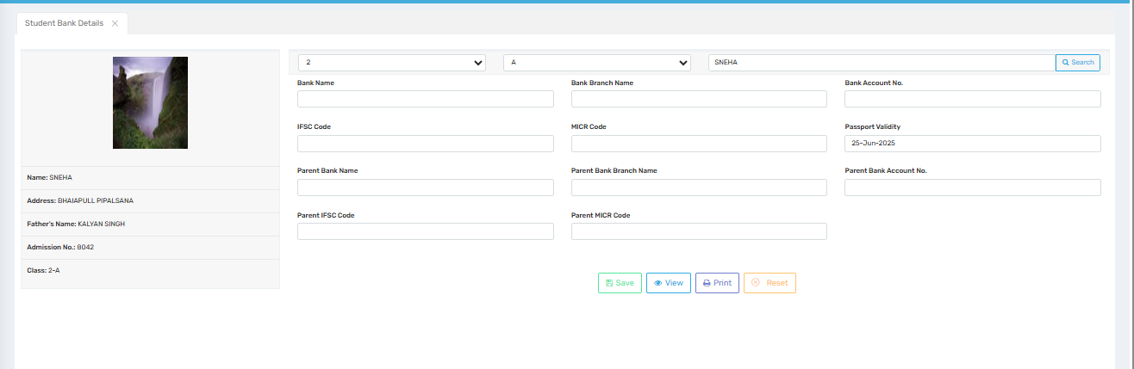

Purpose
This screen is used to enter, view, and manage student and parent bank details. It is typically required for fee refunds, scholarship disbursal, bank-linked welfare schemes, or other financial transactions involving students.

Where to Find
Navigate to:
Admission → Manage Student Details → Student Bank Details

Field Descriptions
Field | Description
Class / Section / Student | Dropdowns to select class (e.g., 2), section (e.g., A), and student (e.g., SNEHA).
Bank Name | Name of the student’s bank (e.g., SBI, HDFC).
Bank Branch Name | Specific branch of the student’s bank.
Bank Account No. | Student’s bank account number for transactions.
IFSC Code | Unique identification code of the student’s bank branch.
MICR Code | Optional; 9-digit MICR code of the bank branch.
Passport Validity | (Optional) Validity date of the passport, if required for international transactions or ID proof.
Parent Bank Name | Bank name where the parent holds an account.
Parent Bank Branch Name | Parent’s bank branch name.
Parent Bank Account No. | Parent’s bank account number.
Parent IFSC Code | IFSC code of the parent’s bank branch.
Parent MICR Code | MICR code of the parent’s bank branch.

Student Profile (Left Panel)
Displays key identity details for reference:
- Student Photo
- Name (e.g., SNEHA)
- Address
- Father's Name
- Admission No. (e.g., 8042)
- Class (e.g., 2-A)

Button Functions (Bottom Right)
Button | Function
Save | Saves or updates the entered bank details.
View | Allows viewing previously saved bank details.
Print | Prints the bank details for records or submission.
Reset | Clears the current input fields for re-entry.

✅ Use Cases
- Scholarship Disbursement: Capture student bank details for government or private scholarship transfers.
- Refund Management: Use account data for fee or caution deposit refunds.
- Parent-Linked Schemes: Store parent bank details for schemes like PM Cares, or fee reimbursement.
- Bank Linking: Support Aadhaar/financial identity mapping when needed.

⚠️ Important Notes
- Always verify account and IFSC code accuracy before saving.
- Ensure no blank mandatory fields are left while submitting data.
- If both student and parent accounts are used, fill both sets of fields carefully.
- Use the Reset button if you need to clear and correct any mistaken entries.
- Ensure passport validity is updated only if applicable for the student.

Student Last Exam Details
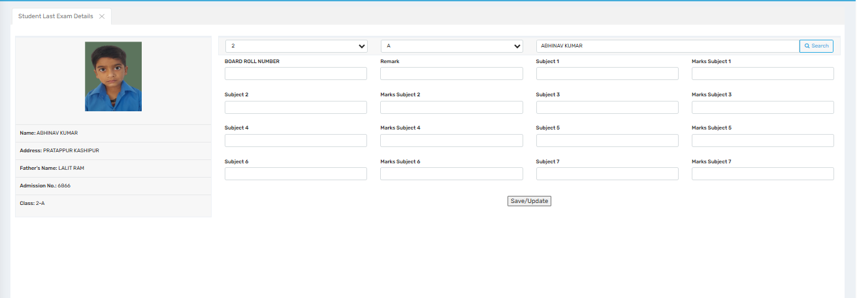

Purpose
This screen is used to record and update a student’s marks from their last examination, including subject-wise scores, board roll number, and remarks. It is useful for academic tracking, report generation, and student performance monitoring.

Where to Find
Navigate to:
Admission → Manage Student Details → Student Last Exam Details

Field Descriptions
Field | Description
Class / Section / Student | Dropdown selectors to choose the relevant class (e.g., 2), section (e.g., A), and student (e.g., ABHINAV KUMAR).
Board Roll Number | Unique roll number assigned by the education board, especially for standardized exams.
Remark | Optional field to enter general feedback (e.g., “Excellent”, “Needs Improvement”).
Subject 1 to Subject 7 | Fields to enter subject names for up to 7 subjects.
Marks Subject 1 to Subject 7 | Corresponding fields to enter the marks obtained in each subject.
Save/Update Button | Click this to save or update the student’s exam details.

Student Profile Section (Left Panel)
Displays the selected student's identity details:
- Photo
- Name (e.g., ABHINAV KUMAR)
- Address (e.g., PRATAPPUR KASHIPUR)
- Father’s Name (e.g., LALIT RAM)
- Admission No. (e.g., 6866)
- Class (e.g., 2-A)

✅ Use Cases
- Academic Recordkeeping: Maintain historical exam data for report generation or transfer certificates.
- Performance Monitoring: Teachers can analyze subject-wise trends.
- Migration/Promotion Decisions: Use exam results for promotion to next grade.
- Parent Communication: Provides input for PTM and report card discussions.

⚠️ Important Notes
- Ensure subject names and corresponding marks are entered correctly.
- Leave no required marks field blank to avoid incomplete records.
- Use the “Save/Update” button after each entry or edit.
- Marks must be numeric; validate against the total marks criteria if applicable.
- Board Roll Number is important for official records (for students from Board exam classes).

Student Class Promotion
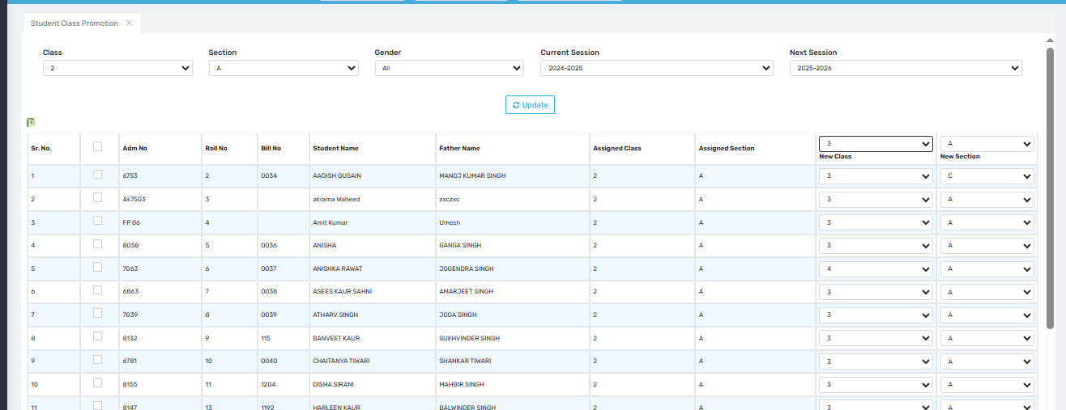

Purpose
This screen is used to promote students from one academic session/class to the next. It allows school administrators to shift student records to a new class and section for the upcoming academic year while retaining historical academic data.

Where to Find
Navigate to:
Admission → Manage Student Details → Student Class Promotion

Field Descriptions
Field | Description
Class / Section | Select the current class and section (e.g., Class 2 / Section A) of the students to be promoted.
Gender | Optional filter to view only Male/Female/Other students or all.
Current Session | The present academic session (e.g., 2024–2025).
Next Session | The session to which students will be promoted (e.g., 2025–2026).
Update Button | Loads student list based on selected filters.

Student Promotion Table
Column | Description
Sr. No. | Serial number in list.
Admn No. | Student’s Admission Number.
Roll No. | Current class roll number.
Bill No. | Internal billing ID/reference number.
Student Name | Name of the student.
Father Name | Name of the father for identity confirmation.
Assigned Class/Section | Currently assigned class and section.
New Class | Dropdown to select the next class (e.g., 3).
New Section | Dropdown to assign the new section (e.g., A, B, C).
Checkbox (✓) | Select box to choose students to be promoted.

✅ Use Cases
- End-of-Year Promotions: Move students to the next class for a new session.
- Section Reassignments: Shift students to different sections as needed.
- Batch Migration: Promote an entire class in bulk using filters and dropdowns.
- Custom Promotions: Handle edge cases (e.g., repeating a class or skipping a class).

⚠️ Important Notes
- Ensure the “New Class” and “New Section” are correctly selected before saving.
- Only selected (checked) students will be processed for promotion.
- Always verify the academic session to avoid record mismatch.
- Promotions should ideally be done after final exam results are recorded.

Student Class Section Transfer
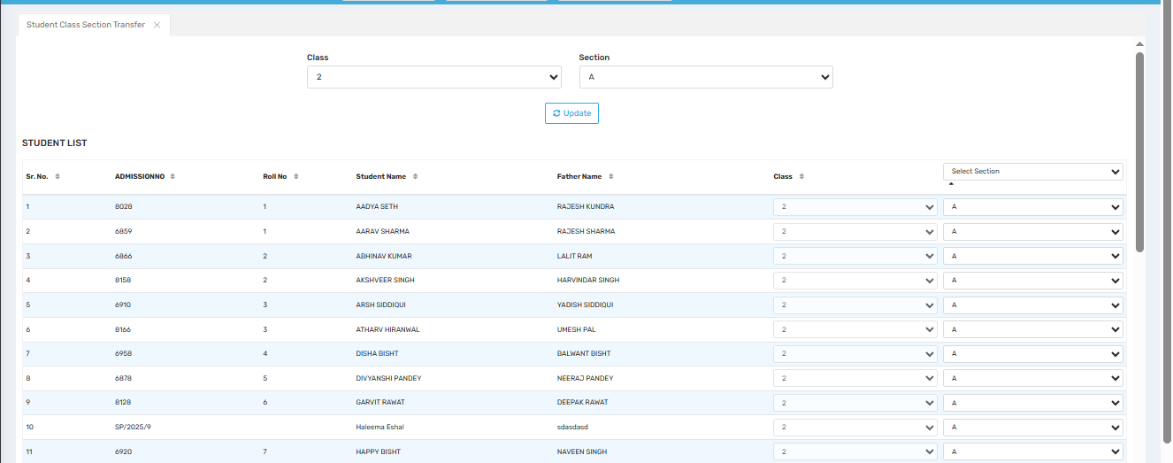

Purpose
This screen is used to transfer students from one section to another within the same class. It is helpful for managing section reassignments due to capacity balancing, behavioral grouping, or academic adjustments.

Where to Find
Navigate to:
Admission → Manage Student Details → Student Class Section Transfer

Field Descriptions
Field | Description
Class | Dropdown to select the class (e.g., Class 2) from which students are to be transferred.
Section | Dropdown to select the current section (e.g., A) of the students.
Update Button | Loads the student list for the selected class and section.
Select Section | Dropdown (above the table) that may act as a bulk selection filter to apply a section to multiple students.

Student List Table
Column | Description
Sr. No. | Serial number of the list.
Admission No. | Unique admission number of each student.
Roll No. | Student’s current roll number.
Student Name | Name of the student.
Father Name | Father’s name (for reference).
Class | Confirms the student is in the selected class.
New Section Dropdown | Allows admin to select a new section (e.g., B, C, etc.) for each student individually.

✅ Use Cases
- Balancing Class Strength: Transfer students to equalize the number of students in each section.
- Behavioral Grouping: Assign students to different sections based on discipline or group behavior needs.
- Subject or Language Preference: Adjust sections based on optional subject/language choices.
- Staff Allocation: Change sections based on availability or specialization of class teachers.

⚠️ Important Notes
- Ensure section changes are properly communicated to teachers and parents.
- Double-check that no student is duplicated or unintentionally moved to an incorrect section.
- Click the Update button after selecting class/section to refresh the list before making changes.
- After assigning new sections, there may be a Save or Confirm button (not visible in the image) — make sure to finalize the process.

Student Image Management
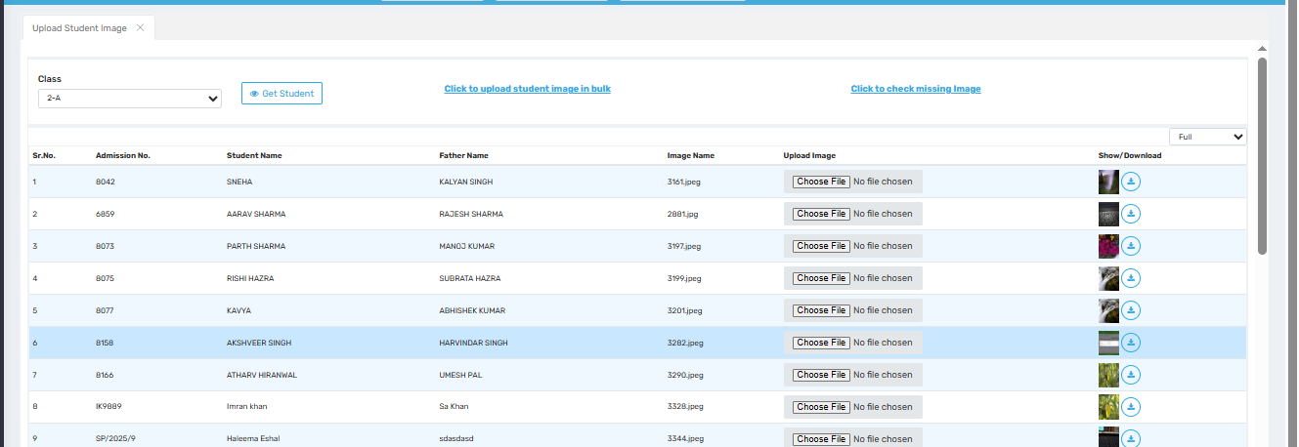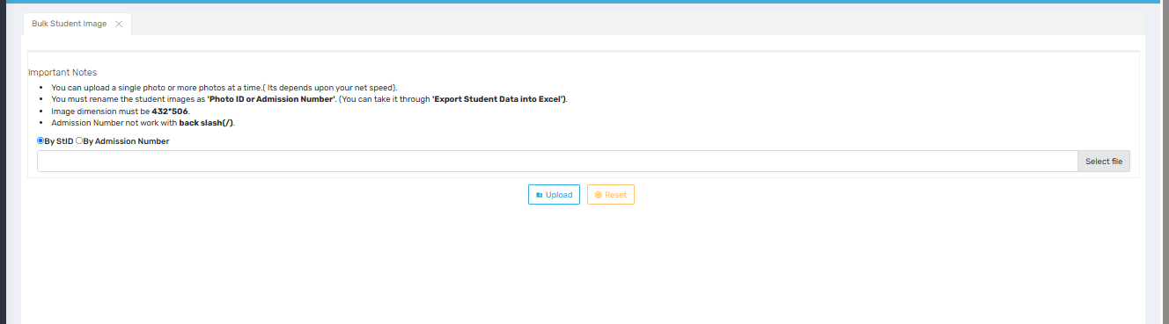

Purpose
This module helps school administrators upload, verify, and manage student profile images individually or in bulk. The system ensures each student has a properly linked image for records, ID cards, report cards, and other digital/printed uses.

🔹 1. Missing Images Screen
Purpose:
To identify students whose profile images are missing or improperly linked.
Where to Find:
Navigate to:
Student Management → Image Management → Missing Images
Field Descriptions:
Field | Description
User | Select user type (e.g., Student, Staff).
Image Size | Filter images by size (Full, Thumb, etc.).
Class | Select class-section (e.g., 2-A).
Only Missing | Tick to show only records with missing images.
Show Button | Displays student image data.
Set NoImage | Assigns a default “No Image” file to students without images.
Table Columns:
Column | Description
Image Name | Name of the saved image file.
Image Status | Shows which versions (Full, Thumb, IDCard, Original) exist or are missing.
“No Image Set” | Indicates no profile image uploaded yet.

🔹 2. Upload Student Image Screen
Purpose:
To upload or replace individual student images, view existing photos, and check/download image files.
Where to Find:
Navigate to:
Student Management → Image Management → Upload Student Image
Features:
- Class Dropdown to load student list.
- Get Student Button to refresh student data.
- Choose File to upload or update a photo for that student.
- Show/Download Icon to preview and download existing images.
- Bulk Upload Option and Missing Image Checker links at the top.
Notes:
- Images can be replaced anytime.
- Students already having images will display file names (e.g., 3161.jpeg).
- Photos show as thumbnails beside each record for quick review.

🔹 3. Bulk Student Image Upload Screen
Purpose:
To upload multiple student photos at once using a naming convention (via Excel export and matching filenames).
Where to Find:
From the “Upload Student Image” screen → click “Click to upload student image in bulk”
Important Notes:
Rule | Explanation
Filename Format | Must be saved as Photo ID or Admission Number (e.g., 8042.jpg)
Image Size Requirement | 432×506 px for compatibility.
Backslash not allowed | Filenames with / or \ will cause errors.
Upload by StID or Admission No. | Choose method to link images to student records.
Select File & Upload | Choose multiple images and upload in one go.

✅ Use Cases
- Generate ID cards with student images.
- Attach student photos in report cards, exam slips, or attendance.
- Maintain complete student records for inspections or UDISE+ requirements.
- Use student images in biometric/smartcard integration.

⚠️ Important Reminders
- Always rename image files before uploading in bulk.
- Do not upload blurry, stretched, or low-resolution images.
- Ensure each student has only one valid image set (Full, Thumb, ID).
- Use “Set NoImage” only when real photos are not available (temporary fallback).

Upload Parent Image
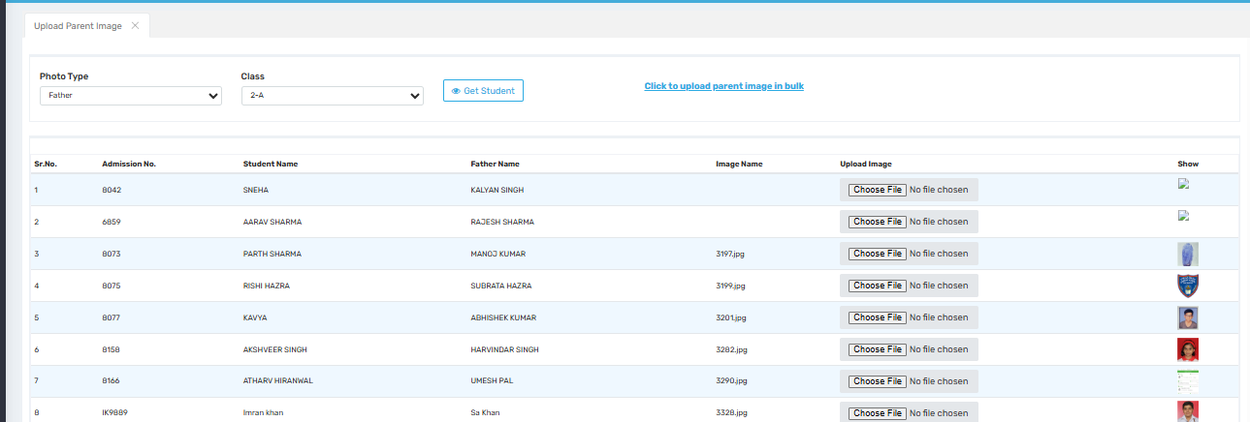
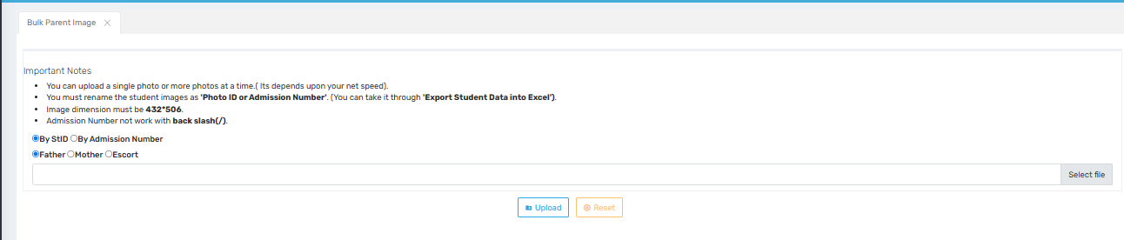

Purpose
This screen allows administrators or data entry personnel to upload and manage parent images (Father, Mother, or Escort) for students. These images are typically used in ID cards, reports, or internal verification.

🔍 Where to Find
You can access this screen by navigating to:
Admission → Manage Student Details → Upload Parent Image

🧾 Screen Description (Image 1: Upload Parent Image Individually)
Field/Button | Description
Photo Type | Dropdown to select the type of image to upload (Father, Mother, or Escort).
Class | Dropdown to select the class (e.g., 2-A) for which student data is to be fetched.
Get Student | Button to display a list of students for the selected class.
Click to upload parent image in bulk | Link to switch to the bulk upload screen.
Student List Table | Displays student info with fields such as:  - Sr. No., Admission No., Student Name, Father Name  - Image Name (already uploaded)  - Upload Image (file selector for individual image upload)  - Show (preview of uploaded image if available)

🧾 Screen Description (Image 2: Bulk Upload Parent Image)

Important Notes
- Only one or multiple images can be uploaded based on internet speed.
- Image files must be renamed as Photo ID or Admission Number.
- Recommended image dimension: 432×506 pixels.
- Do not use backslashes (/) in file names (e.g., Admission Numbers).
- Options to match by:
  - Student ID
  - Admission Number
Field/Button | Description
Father/Mother/Escort Radio Buttons | Select which parent image type you are uploading in bulk.
Select File | Choose one or multiple image files from your system.
Upload | Uploads the selected images to the corresponding student records.
Reset | Clears the selected files and resets the form.

✅ Use Case
- During admission: Upload parent images individually or in bulk to maintain complete student profiles.
- For ID Cards/Certificates: The uploaded images can be used in auto-generated documents like ID cards, certificates, etc.
- Security: Escort photos help in gate-pass or student pick-up verification processes.

⚠️ Important Notes
- Ensure images are renamed correctly (based on Admission No. or Student ID).
- Use the correct resolution to maintain quality and uniformity.
- Upload the correct image type to avoid mismatches.
- Always verify image previews post-upload.

DOB Request
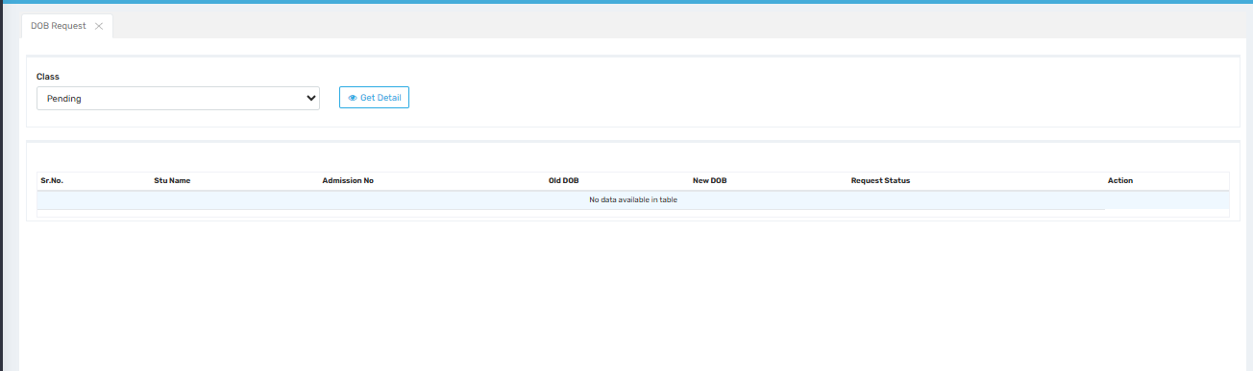

Purpose
This screen is used to review, track, and manage Date of Birth (DOB) change requests submitted for students. It is typically used by school administrators or registrars to ensure proper documentation and approval of DOB modifications.

🔍 Where to Find
You can access this screen by navigating to:
Admission → DOB Request

🧾 Screen Description
Field/Button | Description
Class Dropdown | Allows the user to filter DOB requests by class or status (e.g., “Pending”).
Get Detail | Fetches and displays the list of students with DOB change requests for the selected class/status.
Table Columns:
Sr. No. | Serial number of the request in the list.
Stu Name | Student's full name.
Admission No | Unique admission number of the student.
Old DOB | The currently registered Date of Birth.
New DOB | The new Date of Birth being requested.
Request Status | Status of the request (e.g., Pending, Approved, Rejected).
Action | Button(s) or link(s) to approve, reject, or view more details about the request.

✅ Use Case
- Schools may allow parents or staff to request corrections to a student’s DOB.
- These requests appear here for administrative review and decision-making.
- Useful in case of clerical errors during student registration or legal DOB updates.

⚠️ Important Notes
- Only authorized users should be allowed to approve or reject DOB changes.
- DOB changes can affect certificates, ID cards, reports, and government documents — verify properly before approval.
- Maintain audit trails or logs of all changes for compliance.

Slot Creation
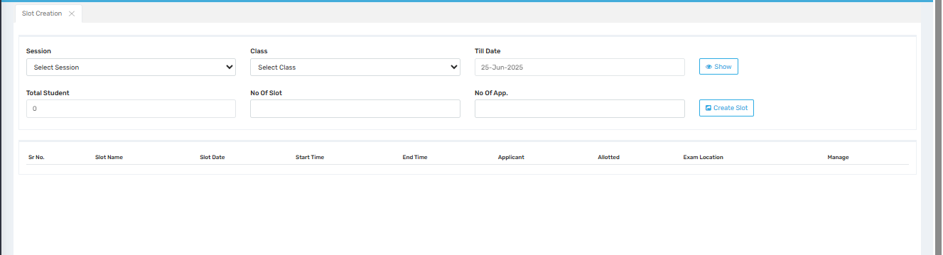

Purpose
This screen is used to create and manage time slots for examinations, interviews, document verifications, or other scheduled student-related activities. It helps in dividing total applicants across multiple slots to avoid overcrowding and ensure smooth operations.

🔍 Where to Find
Navigate to:
Admission → Slot Creation

🧾 Field Descriptions
Field | Description
Session | Select the academic session (e.g., 2024–2025) for which slots are to be created.
Class | Select the target class for which the slots are being generated.
Till Date | Final date up to which slots are to be created. Example: 25-Jun-2025.
Total Student | Displays the number of students for the selected session and class (auto-populated).
No Of Slot | Enter how many slots you want to divide the applicants into.
No Of App. (Applicants) | Specify how many applicants should be assigned per slot.
Show | Button to view existing slot details based on filters selected above.
Create Slot | Button to generate slots based on your input (Total Students, Slots, and Applicants).

📊 Slot Table (Below Form)
Column | Description
Sr. No. | Serial number of the slot entry.
Slot Name | Name of the slot (e.g., Morning Slot, Slot A).
Slot Date | Date assigned to the slot.
Start Time / End Time | Duration for which the slot is scheduled.
Applicant | Total number of applicants eligible for that slot.
Allotted | Number of applicants already assigned to this slot.
Exam Location | Venue where the slot is scheduled.
Manage | Option to edit, delete, or assign students to that slot.

✅ Use Cases
- Schedule entrance exams with student batches across different times.
- Assign document verification slots.
- Split interview sessions efficiently over multiple time blocks.
- Create class-wise time-based assessments or practice sessions.

⚠️ Important Notes
- Slot creation must be based on accurate student count and capacity per slot.
- Ensure slots do not overlap in timing or exceed seating capacity at a location.
- After slot creation, use the “Manage” option to assign or modify student slot allocations.
- Maintain equal distribution across slots to ensure fairness.

Define Merit Criteria
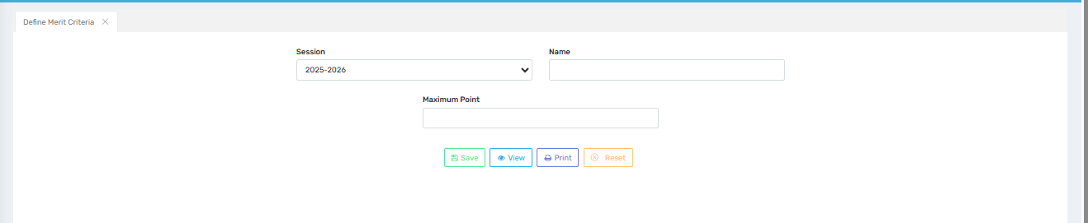

Purpose
This screen is used to define and manage merit point criteria for student admissions or selections. The merit criteria typically help the institution rank or shortlist students based on predefined parameters like academic performance, distance from school, sibling points, etc.

🔍 Where to Find
Navigate to:
Admission → Define Merit Criteria

🧾 Field Descriptions
Field | Description
Session | Dropdown to select the academic session for which the merit criteria is being defined (e.g., 2025–2026).
Name | Text field to name the merit criteria (e.g., Academic Excellence, Distance from School, Alumni Quota).
Maximum Point | Numeric field to define the maximum score a student can receive under this criterion (e.g., 10, 20).

🔘 Action Buttons
Button | Description
Save | Saves the entered merit criterion to the system.
View | Displays a list of already defined merit criteria for the selected session.
Print | Prints the list of merit criteria, useful for documentation and review.
Reset | Clears all fields to allow a fresh entry.

✅ Use Case
- During admission merit list generation, students can be scored against multiple criteria (e.g., marks, distance, sibling studying in school, alumni).
- The maximum point helps standardize evaluation (e.g., total score out of 100 from various merit criteria).
- Used in automated ranking systems to determine admission priority.

⚠️ Important Notes
- Ensure that no two criteria have the same name in the same session unless intentional.
- The sum of maximum points across all defined criteria should align with the institution’s total merit policy (e.g., total out of 100).
- Regularly review and update merit criteria as per policy changes or government guidelines.

Slot Wise Point Entry
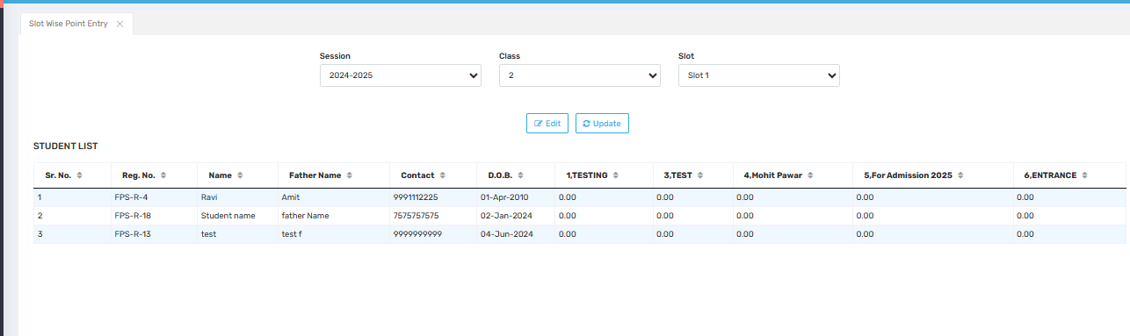

Purpose
This screen allows users to enter and update merit points for individual students based on predefined merit criteria, slot by slot. It helps in scoring students during evaluations such as entrance tests, interviews, document verifications, or admission rounds.

🔍 Where to Find
Navigate to:
Admission → Slot Wise Point Entry

🧾 Field Descriptions (Top Filters)
Field | Description
Session | Dropdown to select the academic session (e.g., 2024–2025).
Class | Select the target class for which the point entry is being performed.
Slot | Choose the specific slot (e.g., Slot 1) assigned during slot creation.
Edit / Update Buttons
- Edit: Enables editing of point values.
- Update: Saves the entered or modified points into the system.

📋 Student List Table
Column Name | Description
Sr. No. | Serial number of the student in the list.
Reg. No. | Unique registration number assigned to the student.
Name | Student’s full name.
Father Name | Name of the student’s father.
Contact | Contact number for student/parent communication.
D.O.B. | Date of Birth of the student.
1.TESTING, 3.TEST, etc. | These columns represent individual merit criteria defined earlier (with serial numbers and names). Points for each criterion are entered in these fields.
5.For Admission 2025, 6.ENTRANCE | Additional merit criteria created during the "Define Merit Criteria" process, appearing here for evaluation.

✅ Use Cases
- Admissions Evaluation: Schools may assess students based on multiple parameters and assign scores for each one using this screen.
- Interviews or Skill Tests: Points can be entered for each evaluation area.
- Final Merit List: The scores entered here are used to compute the total merit for admission ranking.

⚠️ Important Notes
- Points should be entered carefully as they impact student ranking.
- Ensure the correct slot and session are selected before updating.
- Merit criteria must be defined in the "Define Merit Criteria" screen to appear here.
- Only users with proper access should be allowed to modify scores.

Merit List Generation
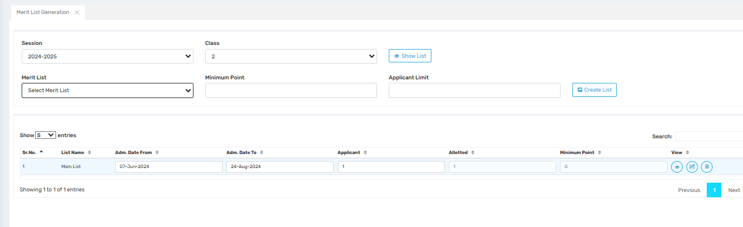

Purpose
This screen allows administrators to generate merit lists for admissions based on points awarded in the evaluation process. These merit lists help in selecting students for admission in an orderly and fair manner, based on their scores and predefined eligibility criteria.

🔍 Where to Find
Navigate to:
Admission Module → Merit Management → Merit List Generation

🧾 Field Descriptions (Top Section)
Field | Description
Session | Select the academic session (e.g., 2024–2025) for which the merit list is being generated.
Class | Select the class for which the merit list is to be created.
Merit List (Dropdown) | Choose an existing merit list (if available) or leave blank to create a new one.
Minimum Point | Enter the minimum merit point threshold required for inclusion in the list.
Applicant Limit | Maximum number of applicants allowed in the generated list.
Show List (Button) | Displays existing merit lists for the selected session and class.
Create List (Button) | Creates a new merit list based on input parameters (minimum points and applicant limit).

📋 Merit List Table (Below Form)
Column Name | Description
Sr. No. | Serial number of the merit list entry.
List Name | Custom or system-generated name for the merit list (e.g., "Main List").
Adm. Date From / To | The admission window (start and end dates) for students in this list.
Applicant | Number of students selected in this merit list.
Allotted | Number of students already admitted or confirmed from the list.
Minimum Point | The lowest point score of any applicant included in this list.
View (Icons)
- 👁️ Preview list details
- 🔄 Edit or update list information
- 💾 Download or save list report

✅ Use Case
- Generate main and waiting lists based on score ranking.
- Set admission cut-off points and cap the number of students to be admitted.
- Maintain a historical record of all generated merit lists for audit or reporting.
- Automate and simplify shortlisting for interviews or document verification.

⚠️ Important Notes
- Ensure merit points have been entered correctly before generating the list.
- Admission dates must be defined properly, as they impact scheduling.
- Use applicant limits cautiously to avoid excluding eligible students.
- You may generate multiple lists (e.g., Main, Waiting List 1, etc.) using different filters.

Re Slotting
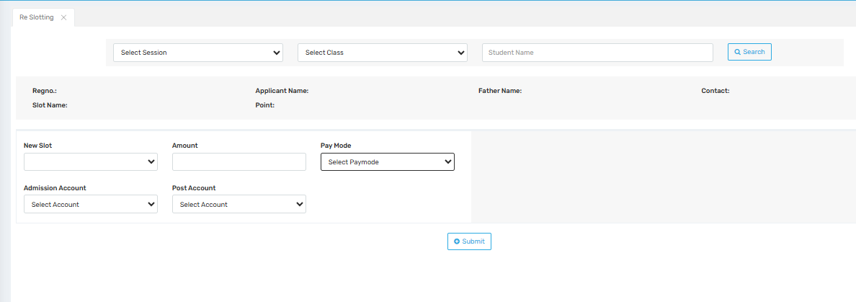

Purpose
The Re Slotting screen is used to reassign a student from one slot to another—typically when a reschedule or slot correction is needed due to student request, admin adjustment, or error during original allocation. It also manages the associated payment adjustment if any fee is involved in the slot change.

🔍 Where to Find
Navigate to:
Admission → Re Slotting

🧾 Field Descriptions

🔍 Search Filters (Top Section)
Field | Description
Session | Select the academic session (e.g., 2024–2025) for which reslotting is to be done.
Class | Select the student's class.
Student Name | Enter the student’s name to search for their current slot details.
Search Button | Fetches the student's current slot information based on filters.

👤 Student Info Display (Mid Section)
After selecting and searching a student, these details will auto-fill:
Field | Description
Regno. | Student's registration number.
Slot Name | Currently allotted slot.
Applicant Name | Full name of the student.
Father Name | Father's name.
Contact | Contact number.
Point | Points scored (likely from merit evaluation).

🔁 Re-slotting Form (Bottom Section)
Field | Description
New Slot | Dropdown to select the new slot the student should be moved to.
Amount | Amount payable (if any) for re-slotting or adjustment.
Pay Mode | Mode of payment (e.g., Cash, UPI, Online, DD).
Admission Account | Account where the admission-related payment is to be deposited.
Post Account | Financial ledger/account where the slotting-related fee is posted.
Submit | Confirms the slot change and saves the transaction and updated slot in the system.

✅ Use Case
- If a student missed their original slot and needs to be rebooked.
- In case of parental or administrative request for a different date/time.
- To redistribute students more evenly across slots based on capacity or staff changes.
- For fee-based slot corrections, with payment details recorded.

⚠️ Important Notes
- Ensure the new slot has available capacity before confirming.
- Confirm payment is properly recorded when fees apply.
- Audit trail should be maintained for any slot reassignment.
- Only authorized users should access re-slotting due to sensitive scheduling and financial impact.

Upload School Details Document
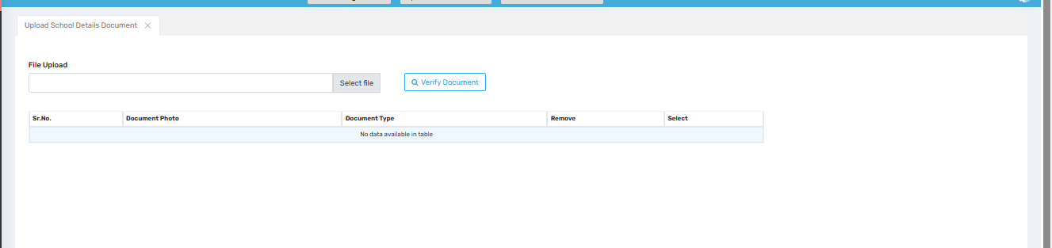

Purpose
This screen is used to upload official school-related documents, such as affiliation certificates, recognition letters, infrastructure proofs, or any other required administrative files for school verification, audits, or internal recordkeeping.

🔍 Where to Find
Navigate to:
Admission → Upload School Details Document

🧾 Field Descriptions
Field | Description
File Upload | Text box and "Select File" button to browse and choose a document from your computer.
Select File Button | Opens a file picker dialog to select the document for upload.
Verify Document Button | Used to check the file format, size, and possibly preview before final submission.

📋 Uploaded Document Table
Column | Description
Sr. No. | Serial number of the uploaded document.
Document Photo | Preview or thumbnail of the uploaded document/image.
Document Type | Type/category of the document (e.g., Affiliation Certificate, Fire Safety, School Building Photo).
Remove | Option to delete the document from the list.
Select | Checkbox or control to mark specific documents for further action (e.g., bulk delete or processing).

✅ Use Cases
- Uploading mandatory compliance documents (CBSE/State Board recognition, infrastructure verification).
- Maintaining a digital archive of all important school documents.
- Supporting school accreditation or inspection processes.
- Enabling admins or auditors to remotely verify uploaded files.

⚠️ Important Notes
- Ensure document format is as per system specification (PDF, JPG, PNG, etc.).
- Document size must be within the allowed upload limit.
- Uploaded documents may be used in verification workflows or during inspections.
- Avoid uploading duplicate or irrelevant files to maintain clarity.

Requests for Changes from Parent
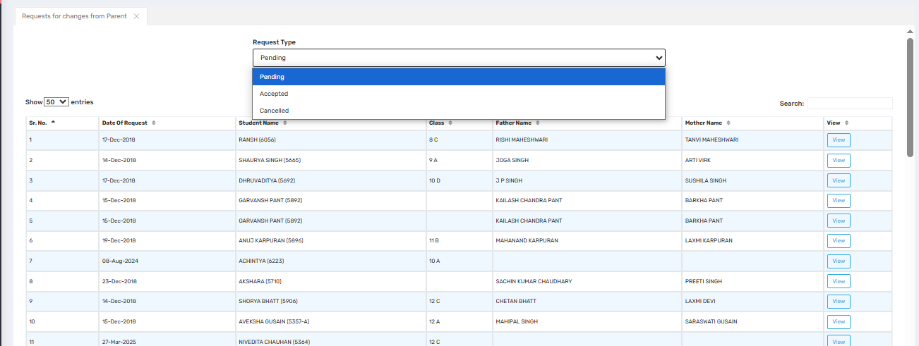

Purpose
This screen allows school administrators to view, manage, and respond to requests submitted by parents for changes in student information. These changes could be related to name corrections, class details, contact updates, or other editable data fields in the student profile.

🔍 Where to Find
Navigate to:
Admission → Requests for Changes from Parent

🧾 Field Descriptions

🔘 Filter & Dropdown Controls (Top Section)
Field | Description
Request Type | A dropdown menu to filter the list based on status:
- Pending: Newly submitted and unprocessed requests
- Accepted: Approved and updated in the system
- Cancelled: Denied or withdrawn requests |
| Search Box | Allows free-text search (e.g., by student name, class, or date). |

📋 Request List Table
Column | Description
Sr. No. | Serial number of each request.
Date of Request | When the parent submitted the request.
Student Name | Name of the student (with admission or registration number in brackets).
Class | Current class of the student.
Father Name | Name of the student's father (pre-filled from database).
Mother Name | Name of the student's mother (pre-filled from database).
View (Button) | Opens the detailed view of the specific change request, showing requested modifications for approval or rejection.

✅ Use Cases
- Handling name corrections or date of birth updates.
- Updating parental or guardian information.
- Adjusting contact details, address, or uploaded documents.
- Ensuring change requests are audited and tracked for transparency.

⚠️ Important Notes
- Only users with appropriate rights should approve or reject requests.
- Changes should be cross-verified with physical documents or parent declarations.
- A digital audit trail should be maintained for regulatory compliance.
- Avoid approving duplicate or conflicting requests for the same student.

Admission Entry
Admission Fee Collection
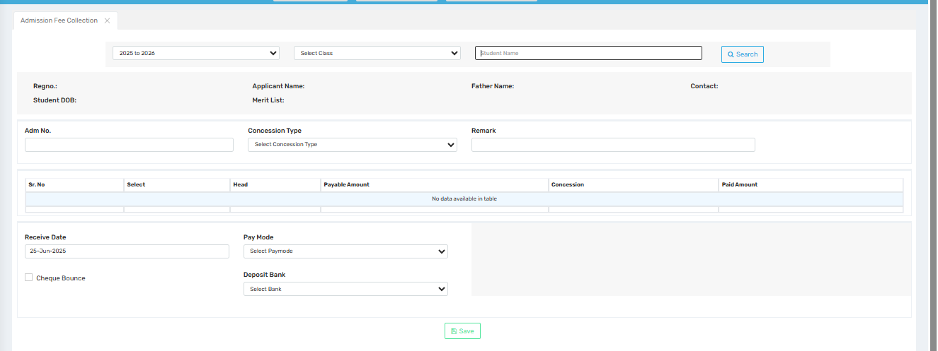

Purpose
This screen is used to collect and manage admission fees from students during the enrollment process. It also allows entry of concessions (if any), payment details, and proper allocation to heads and bank accounts.

🔍 Where to Find
Navigate to:
Admission → Admission Entry → Admission Fee Collection

🧾 Field Descriptions

🔎 Search Section (Top)
Field | Description
Session | Dropdown to select the academic year (e.g., 2025–2026).
Class | Choose the student's class to filter the list.
Student Name | Search box to find a student by name.
Search Button | Displays student details and fee structure based on search filters.

👤 Student Info Section (Auto-Filled After Search)
Field | Description
Regno. | Student’s registration number.
Applicant Name | Full name of the student.
Father Name | Student’s father’s name.
Contact | Mobile number or phone for follow-up.
Student DOB | Date of Birth of the student.
Merit List | Indicates which merit list the student belongs to, if applicable.

💸 Fee & Concession Details
Field | Description
Adm No. | Admission number assigned after student selection.
Concession Type | Dropdown to select type of concession (e.g., Sibling, Staff Ward, Scholarship).
Remark | Optional remarks related to the concession or fee handling.

Table Column | Description
Sr. No. | Serial number of fee head.
Select | Checkbox to select which heads to include.
Head | Fee category name (e.g., Tuition, Admission Fee, Transport).
Payable Amount | Total fee before concession.
Concession | Amount or percentage of fee waived off.
Paid Amount | Final fee amount to be paid by the student.

🏦 Payment Details (Bottom Section)
Field | Description
Receive Date | Date when the payment is received.
Pay Mode | Payment method (Cash, Cheque, UPI, DD, Online, etc.).
Cheque Bounce (Checkbox) | Option to mark cheque as bounced if applicable.
Deposit Bank | Select the bank where the fee will be deposited.

✅ Action Button
Field | Description
Save | Submits and records the fee transaction, updating the student’s financial ledger.

💡 Use Cases
- Collecting admission fee from newly admitted students.
- Applying concessions for eligible students.
- Tracking payments by mode, date, and deposit account.
- Ensuring data accuracy before finalizing admission.

⚠️ Important Notes
- Verify student details carefully before saving.
- Concession logic should be predefined and role-restricted.
- Ensure selected bank account matches institutional accounting protocols.
- Use remarks for audit clarity.

Adm Entry AmtStructure
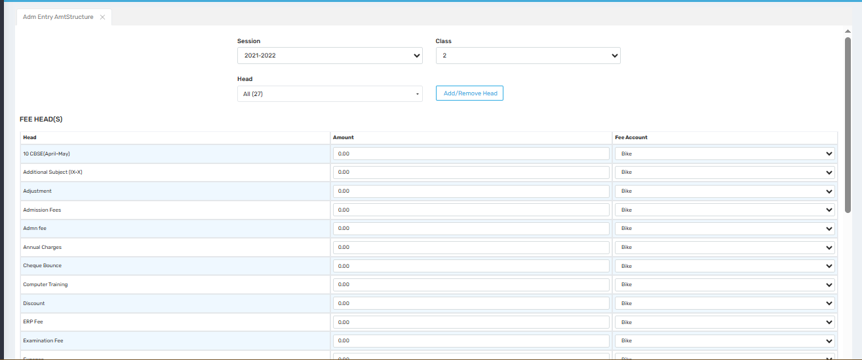

Purpose
This screen is used to define, assign, or modify the fee structure (amounts and categories) for a particular class and session. It helps in organizing how fees are broken down under different heads (e.g., tuition, admission, ERP fee) and links them to the correct financial accounts.

🧭 Where to Find
Navigate to:
Admission → Admission Entry → Adm Entry AmtStructure

🔍 Field Descriptions

🔽 Top Filters
Field | Description
Session | Select the academic year (e.g., 2021–2022).
Class | Choose the class for which fee structure is being configured.
Head | Dropdown filter to show either “All” heads or specific categories.
Add/Remove Head | Opens a dialog to manage the available fee heads used in the system.

💡 Fee Head(s) Table
This section lists all the applicable fee components (heads) with fields to define the amount and associate them with accounts.
Column | Description
Head | Name of the fee component (e.g., Admission Fee, Exam Fee, ERP Fee, Discount, Cheque Bounce).
Amount | The numeric value to be charged under this head. Default is 0.00 but can be edited.
Fee Account | Dropdown to select the corresponding account where the fee amount will be posted (e.g., Bank accounts, ERP collection account).
⚠️ Heads like Discount or Adjustment are typically negative entries or special cases and should be carefully managed.

✅ Use Case
- Defining class-wise and session-wise fee structure.
- Linking each head to the appropriate accounting bucket.
- Setting standardized charges for each student enrolled in a particular class/session.

💬 Important Notes
- Ensure fee heads are clearly named and relevant to avoid confusion during collection and reporting.
- Linking the correct Fee Account is crucial for accounting, especially in financial reports and audits.
- Zero amounts may indicate optional heads or pending configuration.
- This screen typically affects:
  - Admission Fee Collection screen
  - Student Ledger/Reports
  - Balance Sheet/Accounts Integration

Challan Amount
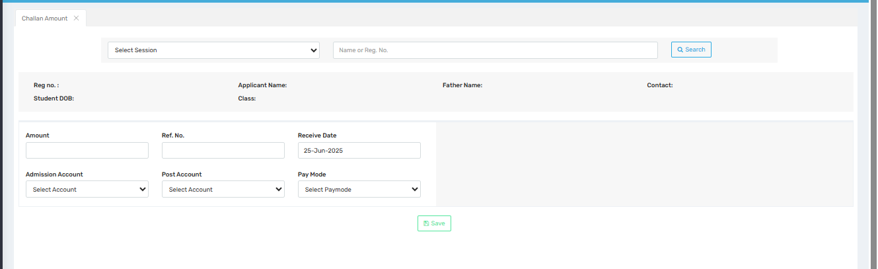

Purpose
This screen is used for manual entry of payment details against a student’s challan or fee demand. It allows the school administrator or accountant to record received payment amounts, reference numbers, and update accounting records accordingly.

🧭 Where to Find
Navigate to:
Admission → Admission Entry → Challan Amount

🔍 Field Descriptions

🔼 Search Section
Field | Description
Session | Select the academic session (e.g., 2024–2025).
Name or Reg. No. | Search student by name or registration number.
Search Button | Fetches student details below based on the input fields.

📄 Student Details Display (Auto-filled After Search)
Field | Description
Reg. No. | Registration number of the student.
Student DOB | Date of birth of the student.
Applicant Name / Father Name / Contact | Personal and contact details of the applicant.
Class | Class in which the student is enrolled.

🧾 Challan Payment Entry Section
Field | Description
Amount | Total payment amount received.
Ref. No. | Reference number from the bank/cheque/online transaction.
Receive Date | Date on which the payment was received.
Admission Account | The specific account under which the amount is recorded for admission.
Post Account | The actual bank or ledger account where the funds will be deposited.
Pay Mode | Payment mode (e.g., Cash, Cheque, Online, UPI).

✅ Action Button
Button | Function
Save | Submits the challan entry and updates the database and fee records.

💡 Use Case
- Useful when a student pays outside the portal and manual acknowledgment is needed.
- For adjusting offline or pending payments against the student's account.
- Integrates into financial reports and receipts post-save.

⚠️ Important Notes
- Make sure the session and student are selected accurately before proceeding.
- Ref. No. and Pay Mode are important for audit and transaction tracing.
- Accounts selected must match those defined in the fee structure for proper allocation.

student ID cards
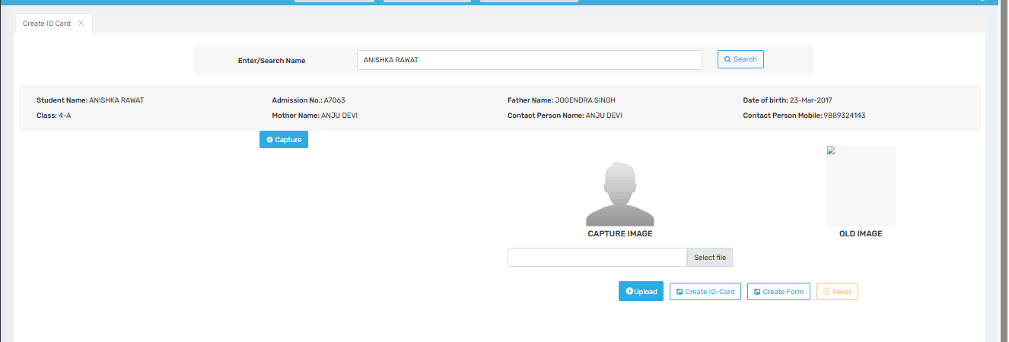

Purpose
This screen is used to create and manage student ID cards by capturing or uploading the student's photograph, and fetching personal and academic details from the school database. This ensures every ID card is personalized and accurate.

Where to Find
You can access this screen by navigating to:
Admission → Create ID Card

Field Description
Field / Button | Description
Enter/Search Name | A search box to type and find a student's name from the database.
Search | Button to initiate the search based on the entered name.
Student Details | Displays retrieved details like: Student Name, Class, Admission No., Parents’ Names, DOB, Contact Number, etc.
Capture | Opens the camera or webcam to take a live photo of the student.
Capture Image | Placeholder area where the live image will be shown once captured.
Old Image | Displays the student’s previously saved image (if available).
Select File | File picker to upload an existing photo from the device instead of capturing a new one.
Upload | Saves the newly selected or captured image to the student’s profile.
Create ID-Card | Generates a printable or downloadable ID card for the student with all details and photograph.
Create Form | Creates a physical form layout, possibly for manual ID card data verification or printing blank cards.
Reset | Clears all entries and resets the interface to its initial state.

✅ Use Cases

1. Issuing ID Cards
The primary use is to generate professional student ID cards that include name, photo, class, admission number, DOB, and contact info.

2. Updating Student Photo
You can replace or update a student’s photo by capturing a new one or uploading a recent image.

3. Reprinting Lost or Damaged Cards
Easily search and reprint ID cards for students who lost or damaged theirs.

Important Notes
- Ensure the image is clear and front-facing for ID purposes.
- Double-check personal details for accuracy before printing the card.
- Use consistent file naming and size for uploaded images.
- The old image is useful to compare and verify before updating with a new photo.
- Make sure image uploads do not exceed file size limits and follow format restrictions (usually JPG or PNG).

Generate Student Performa forms in bulk
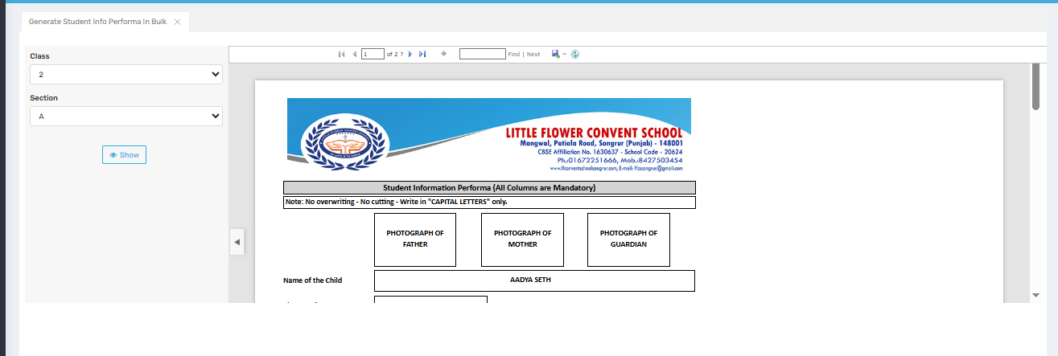

Purpose
This screen is used to generate and print Student Information Performa forms in bulk for a selected class and section. These forms are used to collect or verify detailed information about each student, including parent/guardian details and photographs.

Where to Find
You can access this screen by navigating to:
Admission → Generate Student Info Performa In Bulk

Field Description
Field / Button | Description
Class | Dropdown to select the class for which you want to generate student performa forms.
Section | Dropdown to choose the specific section of the selected class.
Show | Button to generate and display student performa forms for all students in the selected class-section.
Performa Display | The right side shows the PDF preview of each student’s info performa, ready for print or verification.
Navigation Buttons | Allows page-by-page navigation through the list of students (e.g., Page 1 of 2).
Print/Export Options | May include features like export to PDF, print, or download (depending on system configuration).

✅ Use Cases

1. New Admissions or Yearly Verification
Schools use this form to gather or reconfirm details such as:
- Student Name
- Parent/Guardian Names
- Contact Info
- Photographs of Father, Mother, and Guardian

2. Manual Record Keeping
Printed performa forms are used to maintain physical files for administrative or audit purposes.

3. Photo Collection
Helps collect passport-size photos of each family member for school records or ID cards.

Important Notes
- The form clearly mentions: “No overwriting – No cutting – Write in CAPITAL LETTERS only”, ensuring uniformity and clarity.
- All columns are mandatory, so incomplete forms may be rejected or flagged.
- Make sure class and section are correctly selected before printing, to avoid mismatch.
- Use this feature to print in bulk instead of generating individual forms, saving time.

Print student labels
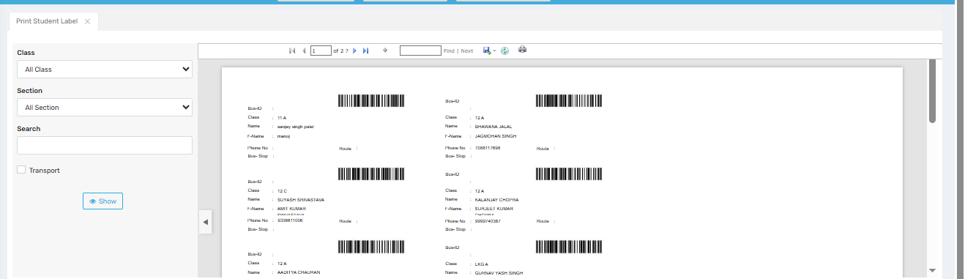

Purpose
This screen is used to print student labels in bulk, which typically include student details along with a barcode. These labels can be used for books, files, bus passes, ID tracking, examination attendance, or asset tagging.

Where to Find
You can access this screen by navigating to:
Admission → Print Student Label

Field Description
Field / Button | Description
Class | Dropdown to select a specific class. You can choose “All Class” to include every student across the school.
Section | Dropdown to select a particular section of the chosen class, or “All Section” to include every section.
Search | Allows you to search for a specific student by name or ID for targeted label printing.
Transport (Checkbox) | Optional checkbox to include only students using transport. Useful for printing bus labels or transport-related info.
Show | Button to generate and display the list of student labels based on the selected filters.
Barcode Labels Display | Right panel displays the generated barcode labels with each student’s name, class, parent name, contact info, route, and stop info.
Print/Export Toolbar | Tools at the top (printer, download, navigation) to print or save the label pages as PDF.

✅ Use Cases

1. Bus Pass / Transport Tagging
- Useful for generating bus route labels for students using school transport.

2. Library or File Management
- Stick labels on library cards, answer sheets, or student files for quick identification using barcodes.

3. Exam Attendance / Barcode Scanning
- Labels can be used for roll number-based identification using barcode scanners during exams.

4. Inventory & Bag Tags
- Can be printed and attached to school bags or belongings for identification.

Important Notes
- Ensure barcode scanners used are compatible with the label format.
- Keep data clean and updated — wrong names or phone numbers will reflect on labels.
- If “Transport” is selected, ensure route and stop data is properly filled for each student.
- Page navigation (top toolbar) helps review multiple pages before final printing.
- Use high-quality paper/sticker sheets for long-lasting use of labels.

Child Portrait
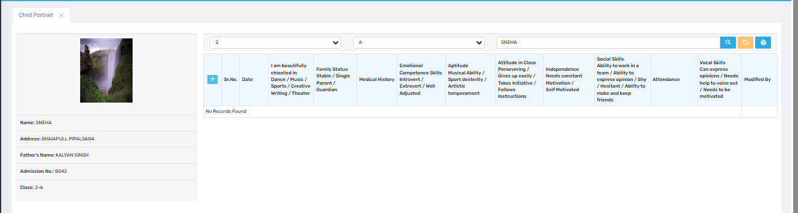

Purpose
This screen is used to maintain a holistic profile of a student’s personality and development in non-academic areas. It covers aspects like aptitude, emotional and social skills, medical history, and other attributes that help teachers, counselors, and administrators better understand the child's overall growth.

Where to Find
You can access this screen by navigating to:
Admission → Child Portrait

Field Description
Field / Section | Description
Student Photo | Displays the uploaded photograph of the student.
Basic Details | Shows basic student info: Name, Address, Father’s Name, Admission No., and Class.
Class & Section Filters | Dropdowns to filter records by Class, Section, and Student Name.
Add Record (+) | Opens a form to input a new observation or assessment for the selected student.
Columns in Table | Each column represents a specific developmental or personality aspect.
I am beautifully chiselled in... | Describes the student’s talents in areas like dance, music, writing, theater, etc.
Family Status | Indicates whether the child is from a stable, single parent, or guardian-led family.
Medical History | Any known medical conditions or history relevant to school life.
Emotional Competence | Observations on whether the student is introvert/extrovert and emotionally adjusted.
Aptitude | Describes skills in music, sports, artistic areas, or other talents.
Attitude in Class | Notes about student’s perseverance, initiative, and response to instructions.
Independence | Indicates how self-motivated or dependent the student is.
Social Skills | Evaluates team participation, ability to express, shyness, or ability to build friendships.
Attendance | Records attendance-related notes or summaries.
Vocal Skills | Notes the student’s ability to speak, share opinions, or whether they need help to express themselves.
Modified By | Shows who entered or updated the record.

✅ Use Cases

1. Counseling and Development
- Enables counselors or teachers to track personality growth and recommend activities accordingly.

2. Parent-Teacher Meetings
- Provides deep insights beyond academics that can be shared with parents.

3. Co-curricular Activity Planning
- Helps identify students who should be encouraged to join clubs, teams, or arts based on aptitude.

4. Behavioral Tracking
- Useful in tracking improvement or concerns over time regarding a student’s emotional or social growth.

Important Notes
- This screen is focused on qualitative, observational data—ensure honest and consistent inputs.
- Should be updated regularly by class teachers or counselors to reflect current student development.
- Can be valuable in preparing student profiles, report cards, or psychological assessments.
- “No Records Found” means no child portrait entries have been made yet for this student.

Prospectus Settlement Entry
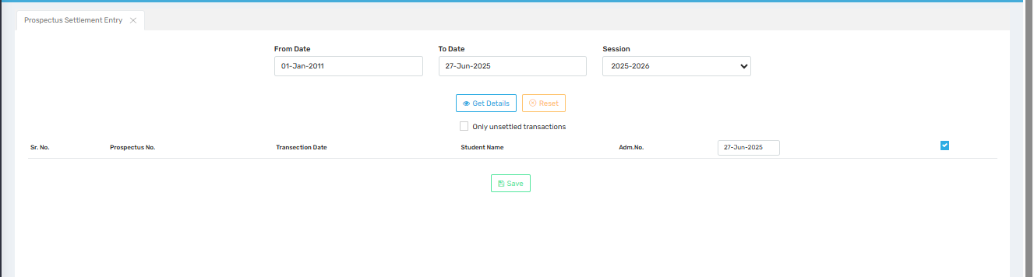

Purpose
This screen is used to record, track, and settle the distribution of prospectuses issued during admissions. It helps the school reconcile prospectus issuance with student admission records, ensuring accurate accounting and transparency.

Where to Find
You can access this screen by navigating to:
Admission → Prospectus Settlement Entry

Field Description
Field / Button | Description
From Date | Starting date for filtering prospectus issue transactions.
To Date | Ending date for filtering. It limits the range of records shown in the table.
Session | Academic session dropdown (e.g., 2025–2026) to filter transactions belonging to a specific academic year.
Get Details | Displays all prospectus records within the date range and session selected.
Reset | Clears the filters and resets the screen.
Only unsettled transactions | Checkbox to display only those entries that have not yet been linked or settled with a student admission.
Save | Button to finalize the settlement of selected records. Links the issued prospectus to the admitted student officially.

✅ Use Cases

1. Admission Reconciliation
- Ensures every sold or issued prospectus is matched with an actual student admission.

2. Prevent Prospectus Misuse
- Helps schools track unused or unreturned prospectuses to avoid financial loss or manipulation.

3. Report Generation
- Can be used in internal audits to show how many prospectuses were distributed vs. how many led to admissions.

4. Accounting Validation
- Acts as a cross-verification tool between prospectus sales (often paid) and final admission entries.

Important Notes
- Ensure student details and admission numbers are accurate before saving settlement entries.
- Regularly check the “Only unsettled transactions” box to keep records up-to-date and avoid duplication.
- If no entries appear after clicking “Get Details,” ensure correct date range and session are selected.
- This screen is often managed by admission officers or finance/admin staff.

Gate Pass
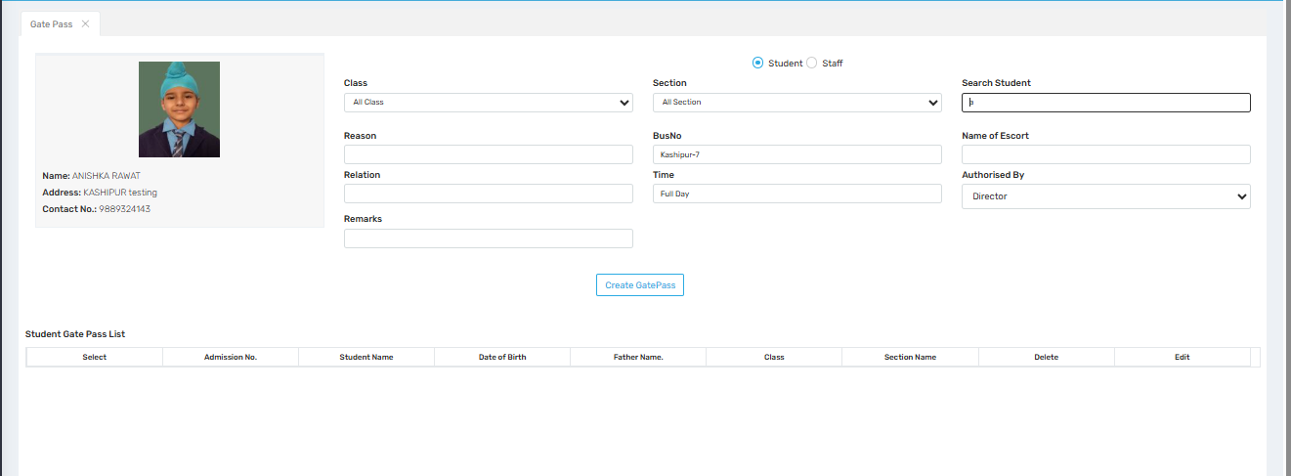

Purpose
This screen is used to generate and manage student or staff gate passes, allowing authorized entry/exit from the school premises during school hours. It ensures security and proper record-keeping of all exits.

Where to Find
You can access this screen by navigating to:
Admission → Gate Pass

Field Description
Field / Section | Description
Photo & Basic Info | Displays the selected student’s photo, name, address, and contact number.
Student / Staff Toggle | Allows switching between generating a gate pass for a Student or Staff member.
Class & Section | Dropdowns to filter students by class and section.
Search Student | Field to search and select a student for whom the gate pass is being generated.
Reason | Enter the reason why the student is being allowed to exit (e.g., medical, family emergency, etc.).
Bus No | Optional field to mention the bus number if the student is leaving via school transport.
Time | Indicates duration of exit — can be "Full Day", "Half Day", etc.
Relation | Describes the relationship of the escort (e.g., Parent, Uncle).
Name of Escort | Full name of the person accompanying or picking up the student.
Remarks | Any additional notes or instructions.
Authorised By | Dropdown to select the authority (e.g., Director, Principal) who is approving the gate pass.
Create GatePass | Button to generate and save the gate pass entry.

Student Gate Pass List (Below)
Column | Description
Select | Checkbox to select one or multiple entries.
Admission No. | Student’s admission number.
Student Name | Name of the student the gate pass was issued to.
Date of Birth | Student’s date of birth.
Father Name | Father's name of the student.
Class / Section | Displays academic details.
Delete / Edit | Options to manage or update previously created gate passes.

✅ Use Cases
- Student Early Leave
For students leaving early due to illness, personal matters, etc., with official approval.
- Gate Security Record
Enables security personnel to check who is permitted to leave the premises.
- Transport Coordination
Helps transport staff manage bus routes or stop changes for students leaving early.
- Audit & Safety
Keeps logs of all entries and exits for internal audits and student safety tracking.

Important Notes
- Mandatory Fields should be filled clearly, especially escort name, reason, and authorizing authority.
- Always verify escort identity physically at the gate, even if listed in the system.
- Gate passes can be reviewed or deleted later if created by mistake.
- If managing staff exits, toggle to “Staff” mode before generating the pass.

Send SMS
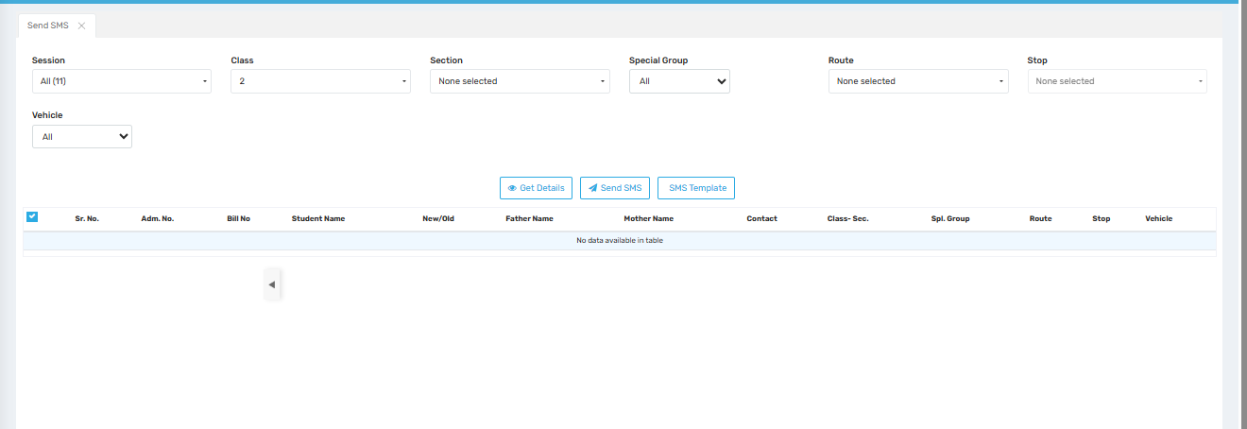

Purpose
This screen is used to send SMS notifications in bulk to students or their parents based on filtered criteria like class, route, session, or special group. It helps the school communicate important announcements, fee reminders, or event notices quickly.

Where to Find
You can access this screen by navigating to:
Admission → Send SMS

Field Description
Field / Dropdown | Description
Session | Select the academic session (e.g., 2024–2025) for which SMS is to be sent.
Class | Filter students by class.
Section | Filter further by section (optional).
Special Group | Used to target custom student groups (e.g., Scholarship, RTE, etc.).
Route | Filter students by transport route.
Stop | Narrow down by specific bus stop.
Vehicle | Filter based on assigned transport vehicle.

Buttons & Actions
Button | Function
Get Details | Fetches and displays student records matching the selected filters.
Send SMS | Opens a confirmation dialog to send the selected SMS template to filtered students.
SMS Template | Opens a popup/modal to select or edit predefined SMS templates.

Student List Table (Below Filters)
Column | Description
Checkbox (Select) | Select individual or all students to send SMS.
Sr. No. / Adm. No. | Displays student order and their admission number.
Bill No. | Shows billing number (useful for fee reminders).
Student, Father, Mother Name | Displays student and parent names for reference.
Contact | The phone number where the SMS will be sent.
Class–Sec., Route, Stop, Vehicle, Spl. Group | Shows complete classification for verification.

✅ Use Cases
- Fee Reminders
  - Remind parents about pending fees using student billing details.
- Transport Updates
  - Notify changes in bus routes, delays, or stop changes.
- Emergency Announcements
  - Quickly send urgent messages like school closures or event cancellations.
- Event Notifications
  - Inform about parent-teacher meetings, annual day, exams, etc.

Important Notes
- Ensure DLT-approved SMS templates are configured for transactional messages.
- Double-check selected students before clicking Send SMS.
- Use filters smartly to avoid sending messages to the wrong group.
- “No data available in table” means no student matches the filters – review your selections.

Certificate
Certificates
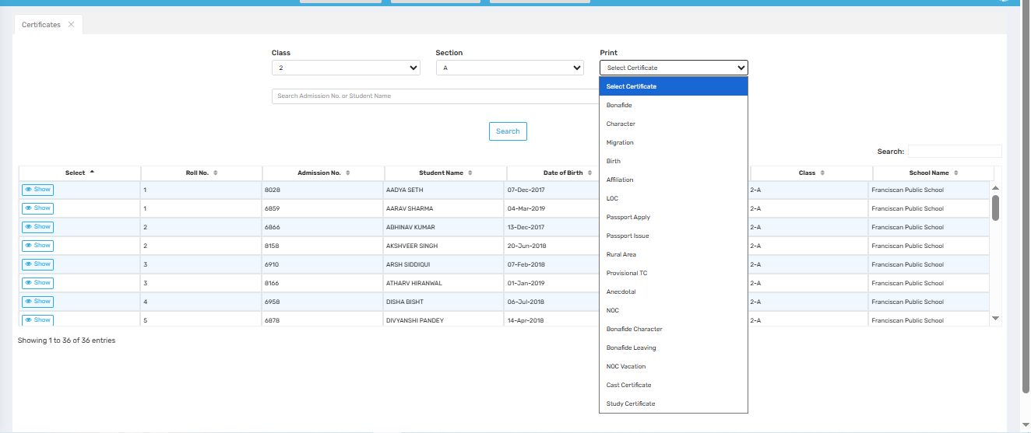

Purpose
This screen is used to generate and print various certificates (such as Bonafide, Character, Migration, etc.) for students. It allows school staff to quickly search students by class/section and produce official documents as needed.

📍 Where to Find
You can access this screen by navigating to:
Certificate → Certificates

🧾 Field Description
Field / Button | Description
Class | Dropdown to select the class of students (e.g., 1, 2, 3...).
Section | Dropdown to filter students within a selected class (e.g., A, B, C...).
Search Admission No. or Student Name | Text box to search students directly using admission number or name.
Search | Button to execute the search based on class/section or entered keyword.
Student Table | Displays student details including: Roll No., Admission No., Student Name, Date of Birth, etc.
Show Button | Lets you view individual student details or certificate preview (depending on system logic).
Print Dropdown | Provides a list of all available certificates that can be printed for the selected student (e.g., Bonafide, Character, Passport Apply, NOC, etc.).
Right Panel (Class/School Name) | Shows the selected class and associated school name for each student listed.

✅ Use Case

1. Certificate Generation
For any student listed, staff can select a certificate type (like Bonafide or Migration) and generate a printable document immediately.

2. Student Record Verification
Before generating certificates, the “Show” button can be used to verify student details.

3. Bulk Certificate Issuance
The filtered list allows multiple certificates to be generated quickly for a whole class or section (if supported).

📊 Reports & Documentation
- The certificates generated from this screen are often used for:
  - Transfer requests
  - Passport applications
  - School migrations
  - Parent occupation records
  - Exam board submissions (like LOC for board exams)

⚠️ Important Notes
- Accurate Data: Ensure all student data (name, DOB, admission no.) is correct as it reflects directly in certificates.
- Preview Before Print: Always verify the certificate preview (if available) to avoid reprints or incorrect entries.
- Defined Templates: Certificate formats are typically predefined. Customizations should be made in the backend/template configuration.
- Access Rights: Only authorized staff should have access to this module, especially for official certificate printing.

TC
UP Board TC Form
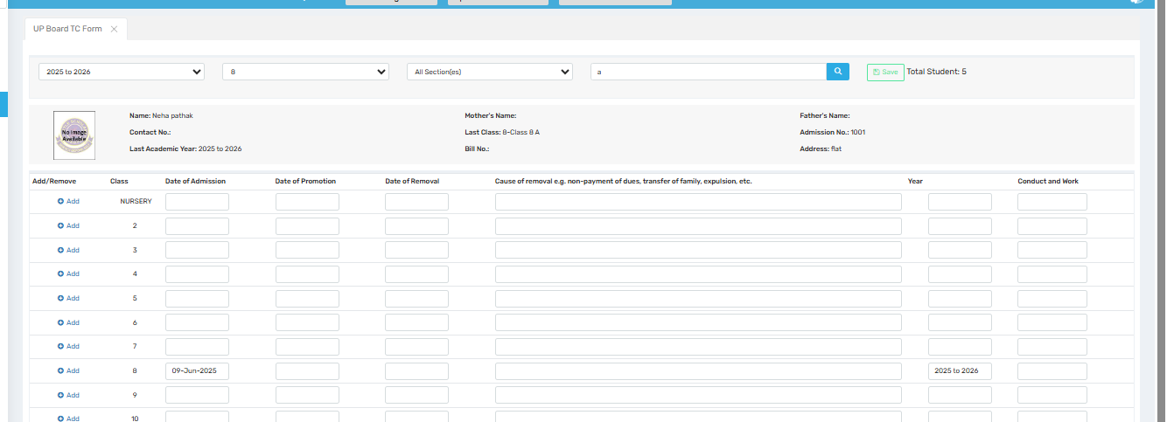

Purpose
This screen is used to fill and manage Transfer Certificate (TC) details for students who are leaving the school, as per UP Board requirements. It records admission, promotion, and removal data year-wise and is essential for generating the Transfer Certificate in the prescribed format.

📍 Where to Find
You can access this screen by navigating to:
Certificate → TC → UP Board TC Form

🧾 Field Description
Field / Button | Description
Academic Year | Dropdown to select the academic year range for which TC is being generated (e.g., 2025 to 2026).
Class | Dropdown to filter students by class (e.g., 8).
Section | Dropdown to filter by section or select "All Sections."
Search Box | Allows searching a student by name, admission number, etc.
Save Button | Saves the entered TC data for the selected student.
Total Students | Displays the number of students available as per filters applied.
Student Details Panel | Shows selected student information like Name, Admission No., Last Academic Year, Class, Parent Names, Contact, Address, etc.
Add/Remove Radio Button | Lets the user add or remove rows in the student’s academic record section.
Class | Displays or allows entry of class-wise data (Nursery, 1, 2, etc.).
Date of Admission | The date the student was admitted to the respective class.
Date of Promotion | The date when the student was promoted to the next class.
Date of Removal | The date the student officially left the school.
Cause of Removal | Text field to enter reason for leaving (e.g., transfer, non-payment of dues, etc.).
Year | Automatically shows or allows entry of academic year (e.g., 2025 to 2026).
Conduct and Work | Field to mention behavior and academic performance during that class/year.

✅ Use Case

1. Student Transfer/Withdrawal
Used when a student is leaving the school to:
- Join another school
- Move to a different city
- Exit due to personal reasons

2. UP Board Documentation Compliance
This form helps generate a Transfer Certificate in a format required by UP Board regulations for proper documentation and audits.

3. Year-wise History Tracking
It helps maintain a year-wise record of a student’s admission, promotion, and conduct throughout their schooling in the institution.

📊 Reports & Documentation
- The data filled here is used to:
  - Generate official Transfer Certificates
  - Submit student records to the UP Board
  - Verify student history for admission into other schools

⚠️ Important Notes
- Ensure Accuracy: Dates and reasons for removal must be accurate and complete, as these are official school records.
- Conduct Field: This is often reviewed by future schools; ensure fair and consistent entries.
- Complete Past Years: Make sure all relevant past academic years are properly filled before issuing the TC.
- Save Frequently: After filling each student’s data, always use the “Save” button to avoid data loss.

Tc Form
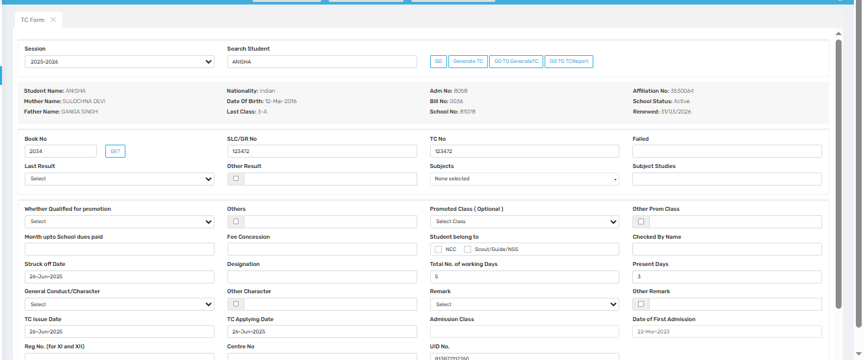

Purpose
This screen is used to fill, manage, and generate Transfer Certificates (TC) for students leaving the school. It includes all required details such as academic history, promotion status, school dues, character, attendance, and personal details necessary for an official TC document.

📍 Where to Find
You can access this screen by navigating to:
Certificate → TC→ TC Form

🧾 Field Description
Field / Section | Description
Session | Dropdown to select academic session (e.g., 2025–2026).
Search Student | Search bar to locate a student by name or admission number.
Student Details Panel | Displays auto-filled student info: Name, Parents’ Names, DOB, Last Class, Admission No., Bill No., School No., Affiliation No., and Status.
Book No / GET Button | Manual entry for Book No. used in TC records; "GET" button may auto-generate based on logic.
SLC/GR No. | Student’s School Leaving Certificate or General Register number.
TC No. | Transfer Certificate number assigned to the student.
Subjects / Subject Studies | Fields to enter the subjects studied by the student.
Last Result / Other Result | Dropdown and checkbox for capturing student’s exam result.
Failed | Field to indicate any failed subjects or years, if applicable.
Qualified for Promotion | Dropdown to state whether the student is promoted to the next class.
Promoted Class (Optional) | If promoted, select the new class here.
Other Prom Class | Checkbox for alternate promotion scenarios.
Month Upto School Dues Paid | Text field to mention the latest month for which fees were paid.
Fee Concession | Field to mention any fee concessions availed.
Designation | Used to note any student title (e.g., Prefect).
Struck off Date | Date the student was officially removed from the school roll.
General Conduct/Character | Dropdown to select conduct remarks (e.g., Good, Excellent, Satisfactory).
Other Character | Optional remarks related to student’s character.
Student Belong to | Checkboxes to note NCC, Scouts/Guides/NSS participation.
Total No. of Working Days | Total working days in the session.
Present Days | Total days the student was present in school.
Remark / Other Remark | Fields for any additional notes about the student or exit reason.
TC Issue Date / TC Applying Date | Dates for when TC is applied for and officially issued.
Admission Class | Class in which the student was admitted.
Date of First Admission | Date the student was first admitted to the school.
Reg No. (for XI and XII) | Registration number (especially for board classes).
UID No. | Student's unique identification number.
Checked By Name | Field to enter the name of the staff member verifying the form.
Generate TC / Go to Generate TC / TC Report | Buttons to preview, generate, or go to TC report for printing or records.

✅ Use Case

1. Transfer Processing
- Complete details to issue official Transfer Certificate.
- Covers academic, financial, and behavioral records.

2. Audit & Compliance
- Ensures compliance with board requirements like CBSE/UP Board documentation.

3. Certificate Tracking
- Every TC generated can be traced using Book No., TC No., and SLC/GR No.

📊 Reports & Documentation
- This data contributes to:
  - Transfer Certificates (TC)
  - Leaving Records
  - Board Transfer Register
  - Student Exit Reports

⚠️ Important Notes
- Mandatory Fields: TC will not generate unless all required fields are filled.
- Consistent Records: Ensure values like attendance, dues, and conduct match school MIS records.
- Audit Compliance: Book No. and TC No. must be unique and sequential.
- Security: Only authorized users should have permission to generate TCs.

Tc Form Class Wise
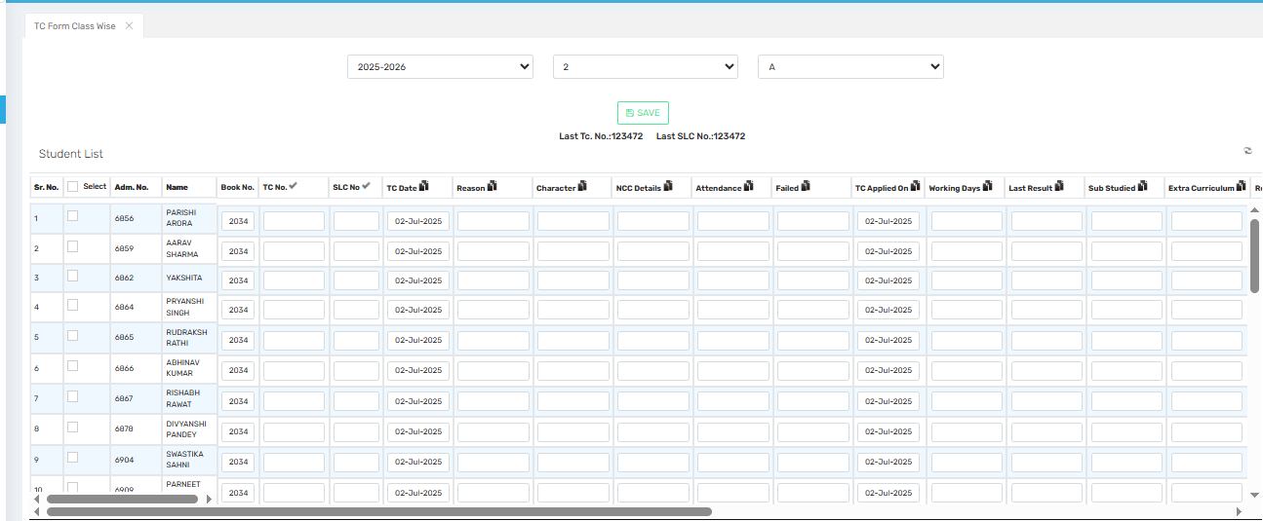

Purpose
This screen is used to bulk fill and manage Transfer Certificate (TC) data for an entire class. It allows school administrators to input TC-related details for multiple students simultaneously, saving time and ensuring consistency in record-keeping.

📍 Where to Find
You can access this screen by navigating to:
Certificate→ TC→ TC Form Class Wise

🧾 Field Description
Field / Section | Description
Session | Dropdown to select the academic session (e.g., 2025–2026).
Class | Dropdown to filter students by class (e.g., 2).
Section | Dropdown to filter students by section (e.g., A).
Save Button | Saves the data entered for all listed students.
Last TC/SLC No. | Displays the most recently used Transfer Certificate and SLC numbers to avoid duplication.
Student List Table | A grid layout for entering TC details for each student. Columns include:

🧾 Student List Table Fields
Column | Description
Sr. No. | Serial number of the student in the list.
Select | Checkbox to select student for processing.
Adm. No. | Student's admission number.
Name | Student's full name.
Book No. | TC book number assigned to the batch.
TC No. | Unique Transfer Certificate number for the student.
SLC No. | School Leaving Certificate number.
TC Date | Date on which the TC is issued.
Reason | Reason for leaving school (e.g., transfer, family relocation, fee issue).
Character | Student’s conduct or behavior remark (e.g., Good, Excellent).
NCC Details | Whether the student participated in NCC, Scouts, Guides, or NSS.
Attendance | Number of days the student was present.
Failed | If the student failed during the session, this can be marked.
TC Applied On | Date on which the student applied for the Transfer Certificate.
Working Days | Total working days in the session.
Last Result | Final result for the student (e.g., Passed, Promoted).
Sub Studied | Subjects studied during the session.
Extra Curriculum | Information about extracurricular activities participated in.
(Scrolls to more fields not visible in the image) | Additional details like remarks, admission class, etc. may be present beyond the scroll.

✅ Use Case

1. Mass TC Data Entry
- Ideal for filling TC details of an entire section in one go.

2. Batch Generation
- After data entry, Transfer Certificates can be generated in bulk for the selected students.

3. Audit-Ready Documentation
- Ensures every student’s transfer details are accurately stored and retrievable when needed.

📊 Reports & Documentation
- Used for:
  - Batch Transfer Certificate generation
  - Year-end school leaving reports
  - UP Board documentation
  - Historical record for audits

⚠️ Important Notes
- Ensure Uniqueness: Book No., TC No., and SLC No. must be unique for each student.
- Auto-fill Defaults: Dates may auto-fill for ease but must be checked for correctness.
- Validation Required: Some fields (like Reason, Character, Attendance) may be mandatory depending on the board rules.
- Bulk Save Frequently: Use the Save button after every few entries to avoid data loss.

Generate Tc
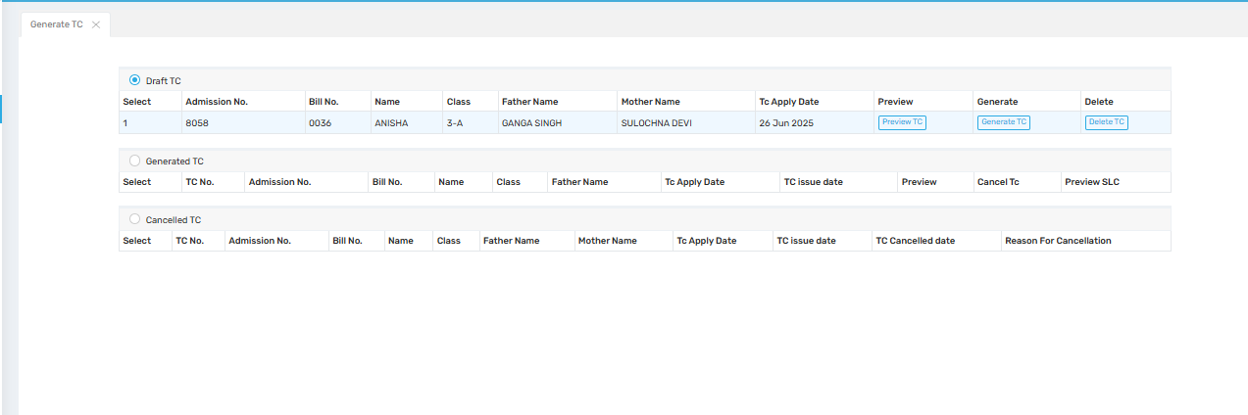

Purpose
This screen is used to preview, generate, and manage Transfer Certificates (TCs) for students. It categorizes TCs into Draft, Generated, and Cancelled, and allows for actions like previewing, final generation, or deletion/cancellation of a TC record.

📍 Where to Find
You can access this screen by navigating to:
Certificate → TC→ Generate TC

🧾 Section-wise Description

🔹 Draft TC
Displays TCs that are filled but not yet finalized. These records can still be edited or deleted.
Field | Description
Select | Checkbox to select the draft TC entry.
Admission No. | Unique student admission number.
Bill No. | Associated fee bill number.
Name | Student's full name.
Class | Class and section of the student (e.g., 3-A).
Father / Mother Name | Parent information.
TC Apply Date | Date on which TC was requested/applied.
Preview | Opens a preview of the TC form for verification before final generation.
Generate | Finalizes the draft and moves it to "Generated TC."
Delete | Deletes the draft TC record permanently.

🔹 Generated TC
Shows the list of TCs that have been officially generated.
Field | Description
TC No. | Unique Transfer Certificate number.
Admission No., Bill No., Name, Class, Father/Mother Name | Basic student details.
TC Apply Date / TC Issue Date | Dates for TC application and official issue.
Preview | View the final version of the generated TC.
Cancel TC | Revoke a generated TC and move it to the "Cancelled TC" list.
Preview SLC | View the corresponding School Leaving Certificate, if applicable.

🔹 Cancelled TC
Displays a history of cancelled TCs.
Field | Description
TC No., Admission No., Name, Class, Father/Mother Name | Basic student data.
TC Issue Date / Cancelled Date | Shows when TC was issued and when it was cancelled.
Reason for Cancellation | User-defined reason explaining why the TC was revoked (e.g., student re-admitted).

✅ Use Case

1. TC Finalization Workflow
- From Draft → Preview → Generate → Final Output

2. Record Tracking
- View status of all TC entries (pending, generated, or cancelled).

3. Audit-Ready Trail
- Helps maintain a complete log of issued and revoked certificates.

📊 Reports & Documentation
- Finalized TCs can be used for:
  - Printing physical certificates
  - Submitting to education boards
  - Maintaining historical exit records

⚠️ Important Notes
- Review Carefully: Always use "Preview TC" to verify data before generating.
- Generate Button is Final: Once a TC is generated, edits are typically restricted unless cancelled.
- Cancellation Log: Use proper reasons when cancelling to maintain transparency and traceability.
- Bookkeeping: Ensure TC numbers are issued in order and not duplicated.

Generate TC In Bulk
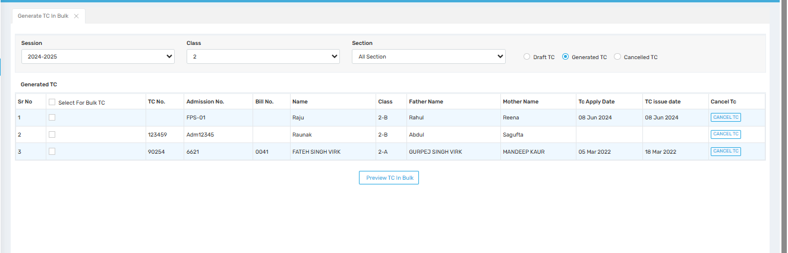

Purpose
This screen is used to view, preview, and manage multiple Transfer Certificates (TCs) that have already been generated for an entire class or section. It also allows bulk previewing of certificates and supports TC cancellation actions.

📍 Where to Find
You can access this screen by navigating to:
Certificate → TC→ Generate TC In Bulk

🧾 Field Description
Field / Section | Description
Session | Dropdown to select the academic session (e.g., 2024–2025).
Class | Dropdown to filter by class (e.g., 2).
Section | Dropdown to filter by a specific section (e.g., 2-A, 2-B) or select All Sections.
TC Status Options | Radio buttons to choose whether to view Draft TC, Generated TC, or Cancelled TC records.

🧾 Generated TC Table Columns
Column | Description
Sr No | Serial number of the student in the list.
Select For Bulk TC | Checkbox to select multiple records for bulk preview.
TC No. | Unique Transfer Certificate number assigned to the student.
Admission No. | Unique admission number for each student.
Bill No. | The student's fee bill number associated with TC generation.
Name | Full name of the student.
Class | Student’s class and section (e.g., 2-B, 2-A).
Father Name / Mother Name | Names of the student’s parents.
TC Apply Date | Date on which the student requested a TC.
TC Issue Date | Official date when the TC was issued.
Cancel TC | A button to revoke a generated TC (moves it to Cancelled TC list).

✅ Use Case

1. Bulk Review and Printing
- View and preview multiple generated TCs for printing or verification purposes.

2. Certificate Management
- Check TC status across the class and manage cancellations as needed.

3. Quick Oversight
- Filter and monitor all students with issued TCs in a selected class or section for the academic year.

📊 Reports & Documentation
- Data from this screen is used for:
  - Bulk printing of Transfer Certificates
  - Record auditing of issued and cancelled TCs
  - Maintaining historical student exit data

⚠️ Important Notes
- Use "Preview TC In Bulk" before final printing to avoid errors in the certificates.
- Cancellation should only be done if there's a valid reason (e.g., re-admission, data mistake).
- Keep TC Numbers Sequential and consistent with the TC register for audit purposes.
- Bulk Operations are useful but should be reviewed carefully to ensure no accidental cancellations or omissions.

Tc Report
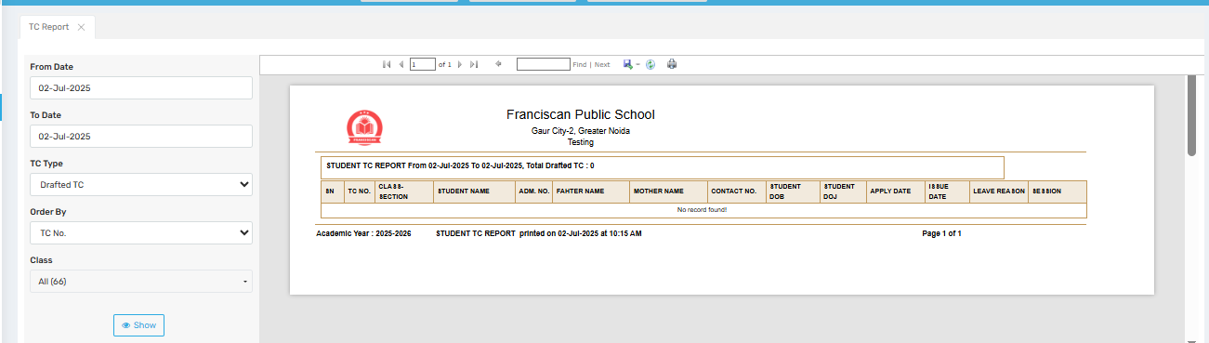
This screen is used to generate and view Transfer Certificate (TC) reports for a specified date range. It provides a printable summary of all TCs (Drafted, Generated, or Cancelled) issued during that period—helpful for audits, record maintenance, or board inspections.

📍 Where to Find
Navigate to:
Certificates → TC→ TC Report

🧾 Field Description
Field / Filter | Description
From Date | Start date for the TC report range. Only records created/updated from this date onward are included.
To Date | End date for the TC report range.
TC Type | Dropdown to choose the type of TC to report:
- Drafted TC
- Generated TC
- Cancelled TC |
| Order By | Determines how the report is sorted:
- TC No.
- Admission No.
- Student Name |
| Class | Filter by specific class or view for All Classes. |
| Show Button | Displays the report in the preview panel based on selected filters. |

📋 Report Preview Section
Displayed Fields in the Report | Explanation
SN (Serial No.) | Auto-generated row number.
TC No. | Transfer Certificate number.
Class-Section | Indicates the student’s class and section (e.g., 3-A).
Student Name / Adm. No. | Name and admission number of the student.
Father / Mother Name | Parent names of the student.
Contact No. | Registered contact number, if available.
Student DOB / DOJ | Date of Birth and Date of Joining.
Apply Date / Issue Date | Dates when the TC was applied for and officially issued.
Leave Reason | Reason provided for leaving school (e.g., Transfer, Fee Due, Relocation).
Session | Academic session (e.g., 2025–2026).

✅ Use Case

1. Audit Preparation
- Generate reports for inspectors or management to verify TCs issued over a date range.

2. Internal Record-Keeping
- Track TCs for a particular class, session, or reason (especially helpful during year-end).

3. Compliance & Board Requirements
- Print and attach the report to official registers or submit to educational boards like CBSE/UP Board.

📊 Report Actions
- Print / Export: Use top toolbar to print or export as PDF.
- Search Within Report: Use the "Find" box to quickly search for a specific admission number or name.

⚠️ Important Notes
- If "No record found" appears (as in the image), it means:
  - No TCs were drafted/generated/cancelled within the selected date range.
  - You may need to adjust filters (date range or class).
- Ensure TCs are finalized before generating reports for accurate and complete data.
- Report Layout: Follows a formal, printable format with school header, making it suitable for documentation.

Assign Characteristics to Student
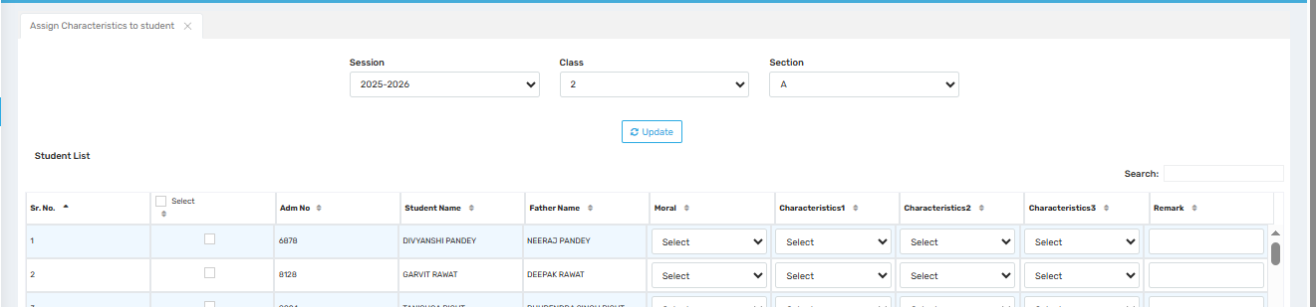

Purpose
This screen allows school administrators or class teachers to assign behavioral and moral characteristics to each student for a given academic session. These entries are often used in Transfer Certificates, report cards, and student conduct reports.

📍 Where to Find
Navigate to:
Certificate → TC → Assign Characteristics to Student

🧾 Field Description
Field / Column | Description
Session | Dropdown to select the academic year (e.g., 2025–2026).
Class / Section | Filters the student list by specific class and section.
Update Button | Saves the assigned characteristics for the selected students.
Select (Checkbox) | Used to choose students for updating characteristics in bulk.
Adm No | Unique admission number of the student.
Student Name | Full name of the student.
Father Name | Father's name (for reference and reporting).
Moral | Dropdown to assign moral behavior (e.g., Excellent, Good, Satisfactory, Poor).
Characteristics1/2/3 | Fields to select specific traits such as:
- Punctual,
- Obedient,
- Helpful,
- Creative,
- Responsible, etc. |
| Remark | Free-text field to enter any custom notes or observations about the student's character. |

✅ Use Case

1. For TC and Certificates
- These characteristics appear in the General Conduct / Character section of Transfer Certificates (TCs).

2. Annual Reports / Parent-Teacher Meetings
- Traits can be used in progress reports or during performance reviews.

3. Behavioral Tracking
- Helps maintain a log of each student’s moral and personality development over the years.

⚠️ Important Notes
- Always review entries before hitting Update as they reflect in formal documents.
- If no characteristics are selected, TCs may display the field as blank or “Not Assigned.”
- Encourage consistency among teachers while assigning character traits to avoid bias.

Bonafide Form
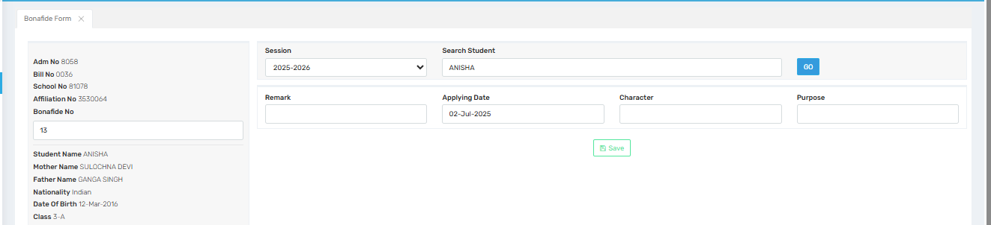

Purpose
This screen is used to generate a Bonafide Certificate for a student. A Bonafide Certificate confirms that a student is currently studying in the institution and is often required for official documentation, such as applying for scholarships, visas, or residence certificates.

📍 Where to Find
Navigate to:
Certificate → Bonafide Form

🧾 Field Description
Field | Description
Session | Select the academic session (e.g., 2025–2026).
Search Student | Enter the student’s name or admission number to auto-fill details.
Adm No | Auto-populated unique admission number of the student.
Bill No / School No / Affiliation No | Auto-fetched identifiers of the student and school.
Bonafide No | Auto-generated or user-input certificate number (for internal record tracking).
Student Name / Parent Details | Auto-filled from the database once the student is selected.
Date of Birth / Class | Auto-filled for use in the certificate body.
Remark | Optional notes (e.g., "Issued on request" or "For visa application").
Applying Date | The date when the certificate is being applied for.
Character | Description of the student's general conduct (e.g., Good, Excellent).
Purpose | Mention the reason for which the bonafide certificate is being issued (e.g., Bank Account Opening, Passport Application, etc.).
Save Button | Saves the certificate data for further preview or print.

✅ Use Case

1. For Student Documents
- Used by parents/students for official needs (e.g., railway pass, bank KYC, visa, etc.).

2. As Proof of Enrollment
- Confirms the student’s active enrollment in a particular session and class.

3. Attached in Applications
- Can be attached with transfer, address proof, or other applications requiring institutional validation.

⚠️ Important Notes
- Ensure all details are accurate and match school records—especially name, DOB, and class.
- Enter Bonafide Number in sequential order to maintain consistency in school records.
- The Purpose field is mandatory for issuing a relevant and valid certificate.
- The Character field will also appear in many official formats; use values like Excellent, Good, or Satisfactory only.

Assign Visa Details to Student
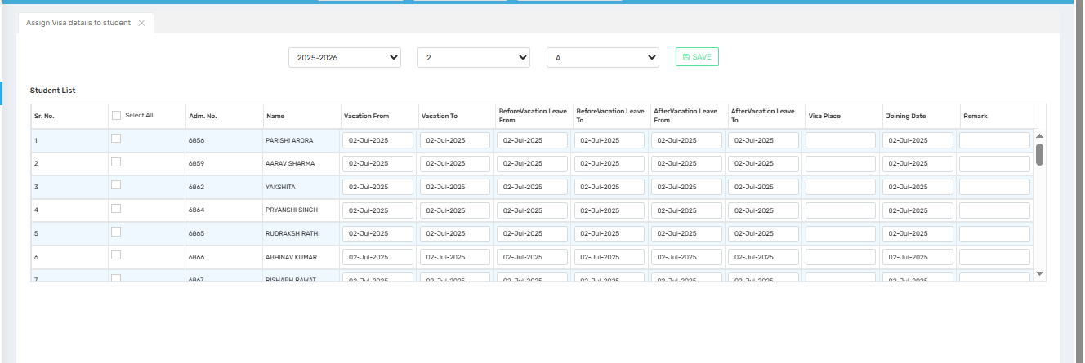

Purpose
This screen is used to record student travel and vacation details, particularly for students who go abroad and may require a visa-related certificate or report. It helps maintain logs for immigration, academic attendance, and regulatory compliance.

📍 Where to Find
Navigate to:
Certificate → Assign Visa Details to Student

🧾 Field Description
Field | Description
Session / Class / Section | Dropdowns to filter and manage students by academic year, class, and section.
Select / Select All | Allows selecting one or more students for editing or bulk save.
Adm. No | Admission number of the student.
Name | Full name of the student.
Vacation From / To | Dates during which the student is officially on vacation.
Before Vacation Leave From / To | Date range when the student is on leave before the vacation period starts.
After Vacation Leave From / To | Date range when the student is on leave after the vacation period ends.
Visa Place | Enter the destination or country where the visa is being issued for (e.g., USA, Dubai).
Joining Date | Date when the student is expected to resume classes.
Remark | Any notes related to the visa leave—such as medical leave extension, family travel, etc.
Save Button | Click to store the entered details into the student record system.

✅ Use Case

1. For International Travel / NOC Certificate
- This data is often required for issuing visa-related certificates, NOC for travel, or Bonafide for embassy purposes.

2. For Attendance and Promotion Decisions
- Helps the administration keep track of absenteeism during term time or extended travel-related absences.

3. For Legal / Immigration Audit
- Some schools submit this data to immigration consultants or educational authorities for compliance or student verification.

⚠️ Important Notes
- Make sure the Vacation and Leave dates do not overlap or contradict each other.
- Visa Place must be accurate and ideally match the place on visa/NOC applications.
- All leave records must be approved in advance and filed with proof if needed.
- Keep the Remark field meaningful for future tracking (e.g., "Travel to Canada with parents for 3 months").

