Attendance Module Manual

Search Menu
The Search Bar is a user-friendly navigation tool designed to enhance speed and efficiency when working within the Payroll module of the ERP system.

Where to find it:
- On the left sidebar (where menu options like Global Masters, Master Setting, Attendance, etc. are listed),
- Just above the menu items, there's a "Search Menu" bar with a placeholder text saying:

🎯 Purpose : This helps you navigate faster without scrolling through the full menu.

✅ Use Case: Quickly find specific options or sub-modules within Attendance.
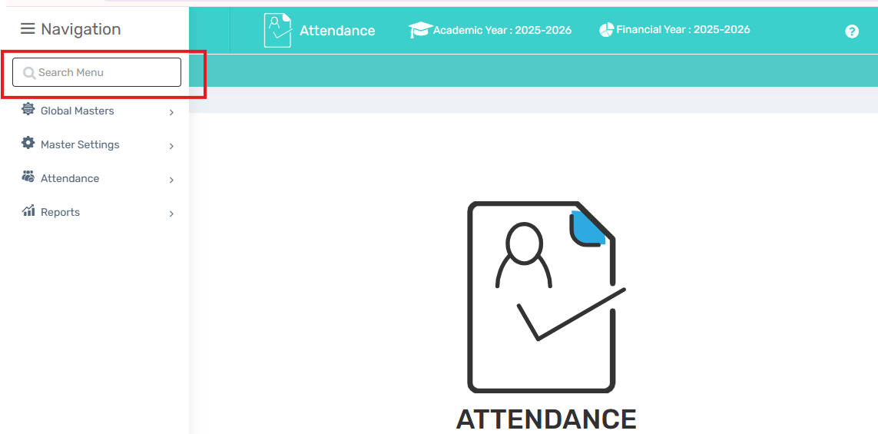

Global Masters

1. Define Holiday

🎯 Purpose : In this tab user can define Holidays name like Holi, Diwali , Mahavir Jayanti etc

Navigate to: Attendance Module → Global Masters → Define Holiday
Field Description: 1. Holiday Name 2. Department 3.From Date- To Date

Use Case : This will show on the attendance report ( Daily & monthly) and will impact attendance report of staffs.

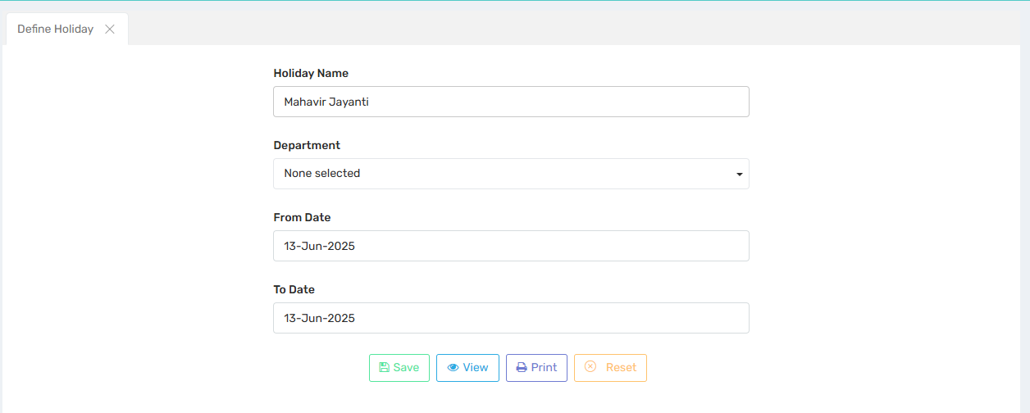

2. Define Leave

🎯 Purpose : This section is used to define the various types of leave that employees can avail of or that apply within the organization.

📍 Navigate to: Attendance Module → Global Masters → Define Leave

Field Description:
i) Select Leave Type : Select the leave type in which you want to assign your leave. We have already calculate the settings in backend for these leaves.
ii) Enter Leave Name : Enter the name of the leave which you want to assign.
iii) Enter Leave Abbreviation: We will enter the short name for the leave.
iv) Max Limit for the Leave : We will define the max limit of the leaves in this section.
v) Limit of Max Leave at the end of Service : Here we will define the max days of leave in the end of the service.
vi) Pay Deduction Per Leave : Deduction of payment per leave can be defined here, If any.
vii) Max Leave Acceptance in a Month : We can define that how many leaves can be accepted in continuation.
viii) Max acceptance in Continuation : We can define that how many leaves can be accepted in continuation.
ix) Not Acceptable if less than:
x) No of Late Days counted for 1 LWP : Here we can define that how many days will be counted as 1 LWP.
xi) Leave Carry Forward : We can define here that is this leave carry forward or not?

✅ Use Case: It allows for the configuration of rules such as leave deductions, maximum limits, accrual settings, and other related policies. Includes rules on how leave is accrued, carried forward, .
Examples of leave types include:
- Casual Leave
- Earned Leave
- Leave Without Pay (LWP)
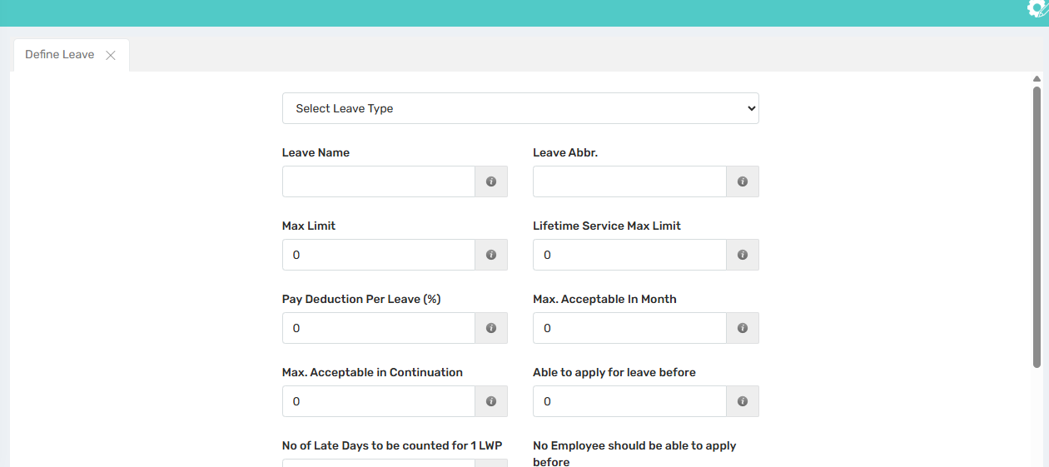

3. Define Shift Master

🎯 Purpose : This section is used to define the diffrernt types of shifts that will be assigned to the different staff.

Shift means - In and Out time for staff, late in allowed (if any) and Additional settings.

📍 Navigate to: Attendance Module → Global Masters → Define Shift Master
Field Description : i) Enter Shift Name ii) Select Shift Start Time iii)Shift End Time
iv) Late in Allowed Minute

✅ Use Case :
- This will show on the attendance report and will impact attendance report of staffs.
- We can relate this shift to staff/ Department. ( Attendance>> Staff Shift Relation)

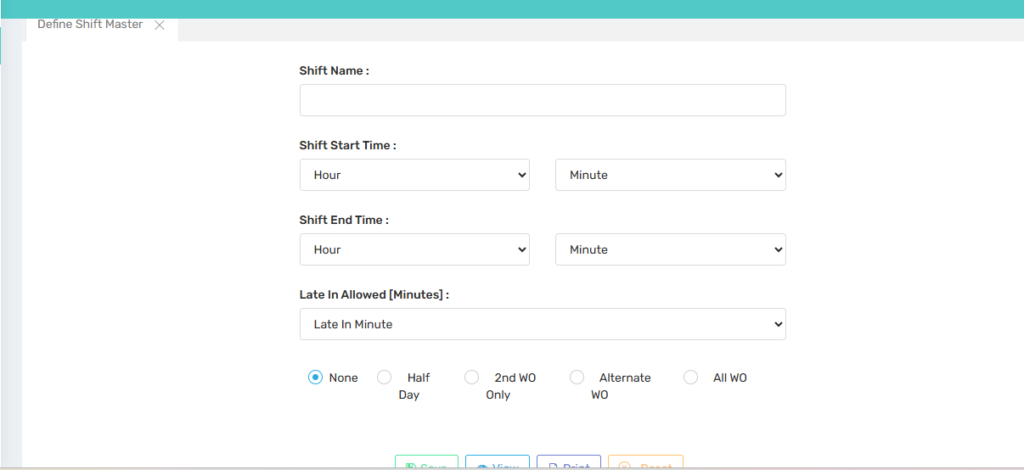

4. Attendance Setting

🎯 Purpose: In this section users can set the permission for send SMS, Send SMS timings, In/Out Missing Attendance SMS timings.

📍 Navigate to: Attendance Module → Global Masters → Attendance Setting
Field Description:

✅ Use Case :

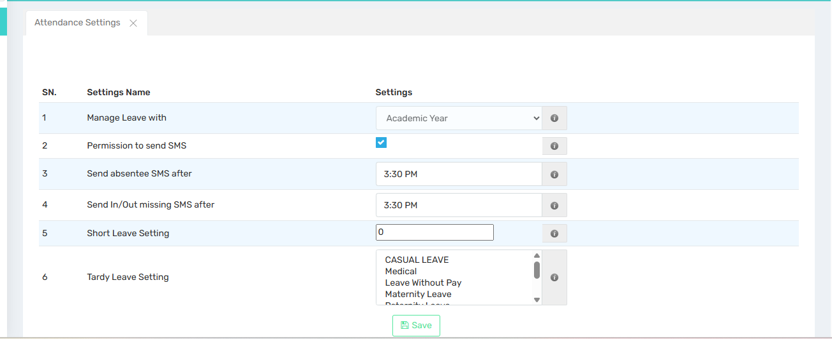

5. Report Setting

🎯 Purpose : In this section we can set the format for the reports.

📍 Navigate to: Attendance Module → Global Masters → Report Setting
Field Description : In this section we can set the format for the reports.
Note: Please select the format 1 for all the Report.

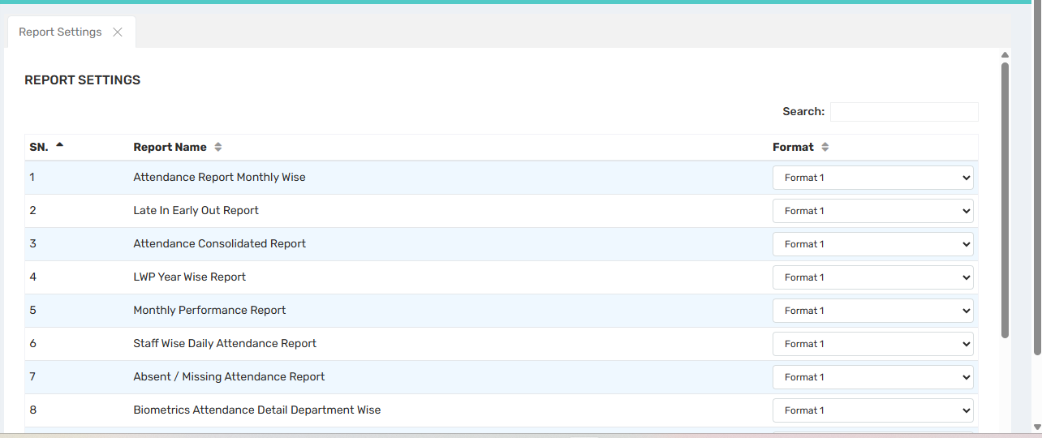

6. LWP Setting

🎯 Purpose : In this section we will assign the Leave without Pay to individual or multiples employees for salary generation purpose.

📍 Navigate to: Attendance Module → Global Masters → LWP Setting

✅ Use Case : If we want to do any setting with Late comers, We can do the defining here.

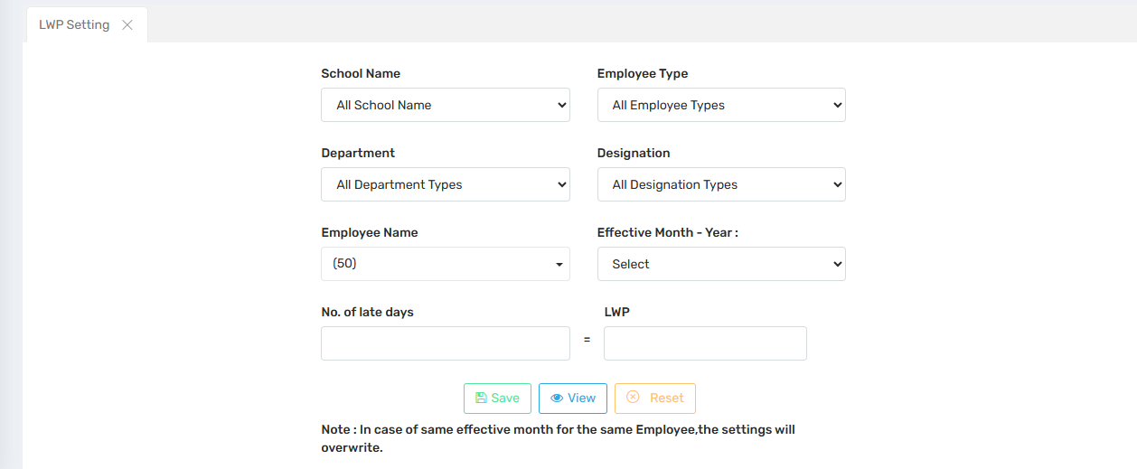

7. Session Transfer

Master Settings

1. Change Academic Year

🎯 Purpose : This section allows users to switch between different academic years and financial years within the ERP system to access 📍 Navigate to: Attendance Module → Master Settings→ Change Academic Year

✅ Use Case : After Academic Year change you can review data from previous or upcoming sessions.

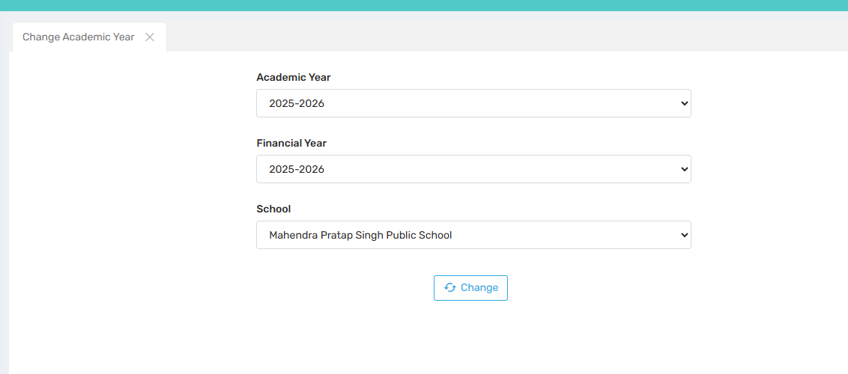

Attendance:

1. Assign Leave To Staff

🎯 Purpose : In assign leave to staff user can assign multiple leave to employee, includes Casual leave, earned leave, Medical leave and so on.

📍 Navigate to: Attendance Module → Attendance → Assign Leave to Staff
Field Description :
1.Select School Name and Employee type
We will select the school name and employee type for which we want to assign leaves.

2.Select Leave Type
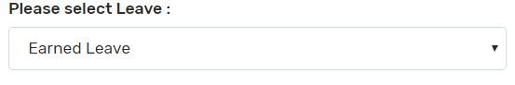

Select the leave type which we want to assign to employees.

3.Select Employee Name and fill the leaves
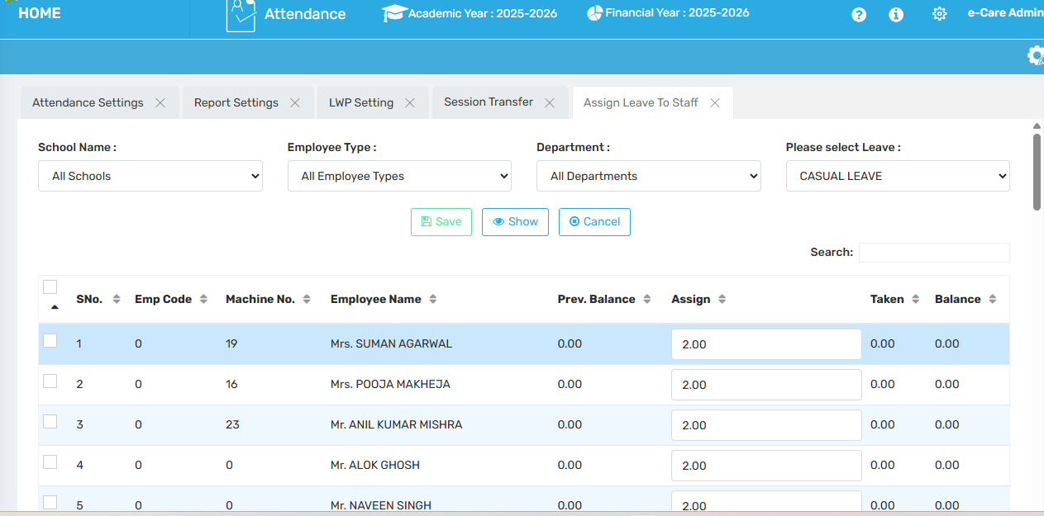

✅ Use Case: 1. After Assign the Leave to Staff , it will be shown on Attendance module as well as on e-care ( Staff Login > Menu > My info > My Leave )
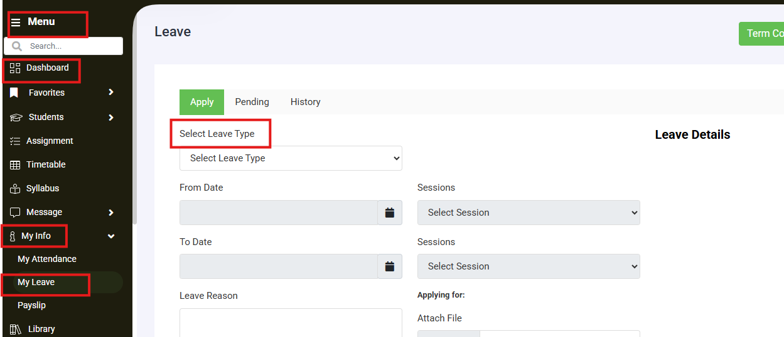

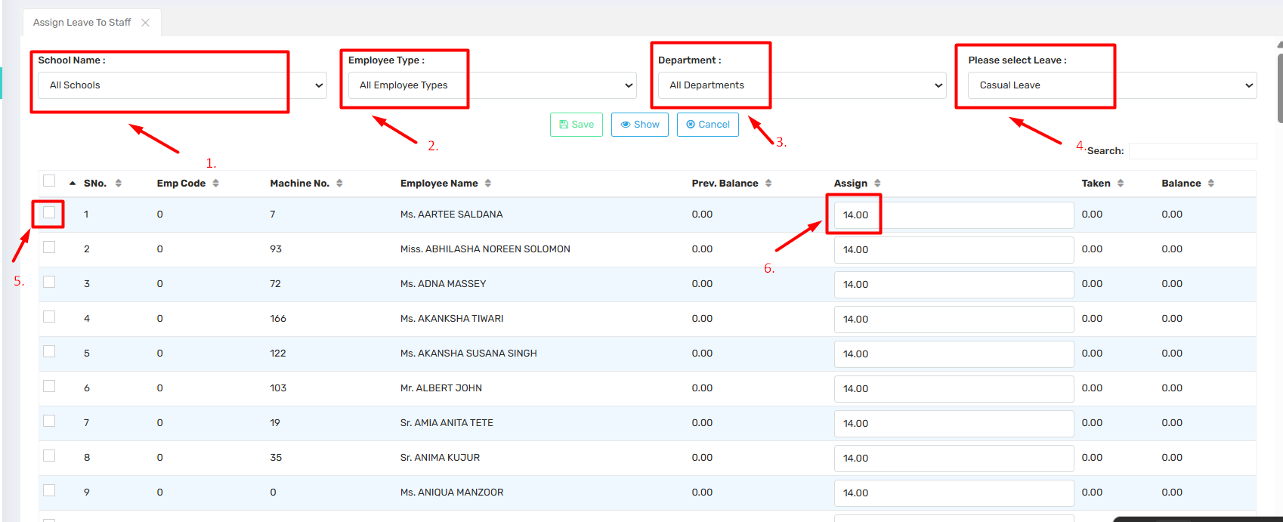

- Select school name
- Select employee type
- Select department
- Select leave
- Select the particular staff member
- Assign Leave and save.

2. Mark Attendance

In this tab, users can view the connection status of the biometric device.

📍 Navigate to: Attendance Module → Attendance → Mark Attendance

Note: Not in use in live schools.
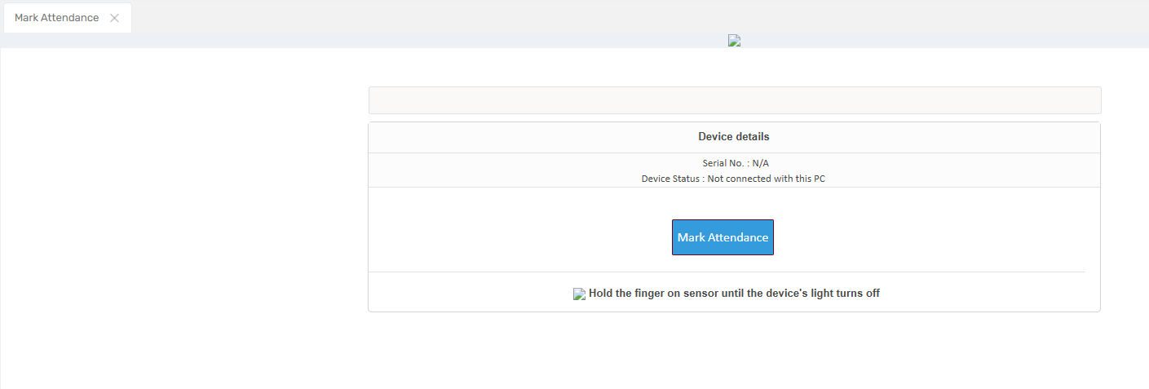

3. Assign Leave To Staff MonthWise

🎯 Purpose : In assign leave to staff monthwise user can assign multiple leave to employee month wise, includes Casual leave, earned leave, Medical leave and so on.

📍 Navigate to: Attendance Module → Attendance → Assign Leave to Staff MonthWise

Field Description:
1.Select school name
2.Select employee type
3.Select department
4.Select leave
5.Select moth
6.Select the particular staff member
7.Assign Leave and save.

Except Select Month Tab, all tabs are similar to Assign Leave To Staff.
In Select Month, you can assign the leave according to Month wise.

✅ Use Case: After Assign the Leave to Staff , it will be shown on Attendance module.
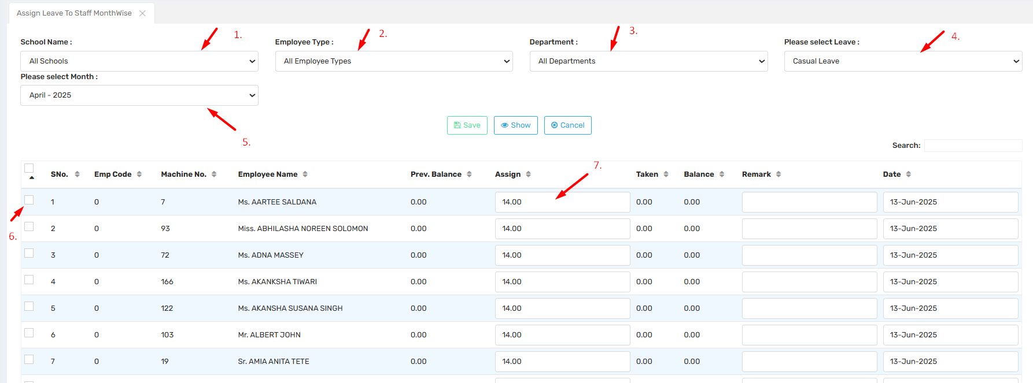

4. Staff Shift Relation

🎯 Purpose : In staff shift relation we relate the shifts to staff.
Only one shift will be assign to indivisual staff.

📍 Navigate to: Attendance Module → Attendance → Staff Shift Relation

Field Description :
1.Select staff :
- Select Shift name
- Select effective from
- Assign

✅ Use Case : At the time of biometric attendance integration, when staff attendance data is not coming on attendance module then we should check whether staff shift relation is assigned or not.
It should also be checked whether the machine number is given to the employees or not.

Note: Only one shift will be Assign to individual staff.

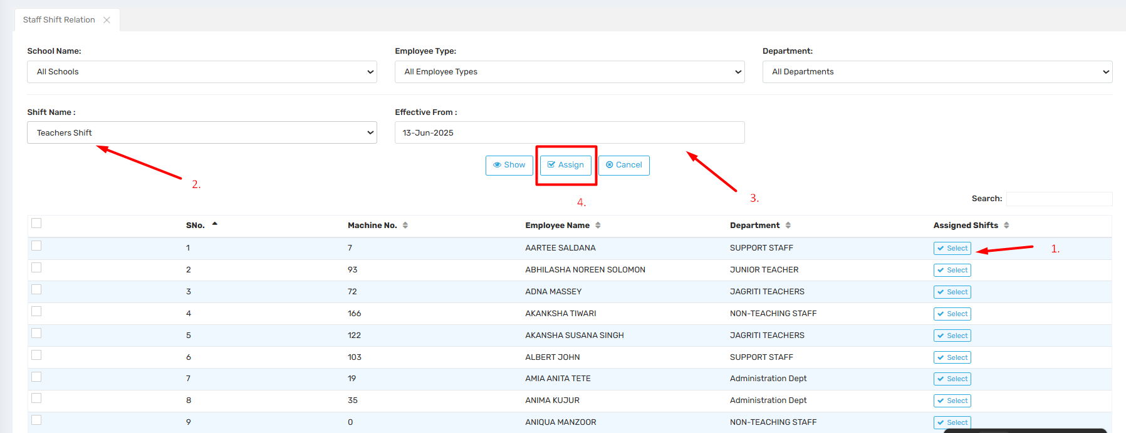

5. Process Attendance for Payroll

🎯 Purpose : This module will process attendance for the whole month.
It will process the present, absent and leaves of the employees according to the settings made in accordance with integration with Bio-Metric connected.

📍 Navigate to: Attendance Module → Attendance → Process Attendance for Payroll

Field Description :

✅ Use Case: This is help for salary generation , when you select month > View > select staff & save it .
These all data will move to payroll Module for salary generation.

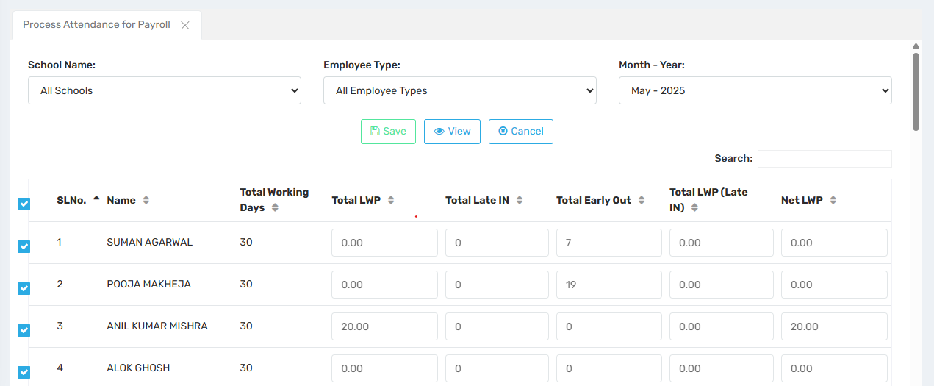

6. Mark Manual Attendance

🎯 Purpose : This section allows for the manual recording of an employee's attendance.

📍 Navigate to: Attendance Module → Attendance → Mark Manual Attendance
Field Description:
- Select Employee Type
- Select Employee Name
- Select Date
- Select time
- Click on Mark Button

✅ Use Case: If a staff member is off-campus for official duties and unable to mark their attendance, the HR department can record it manually using this option, provided they follow the established protocol of the respective school or organization.

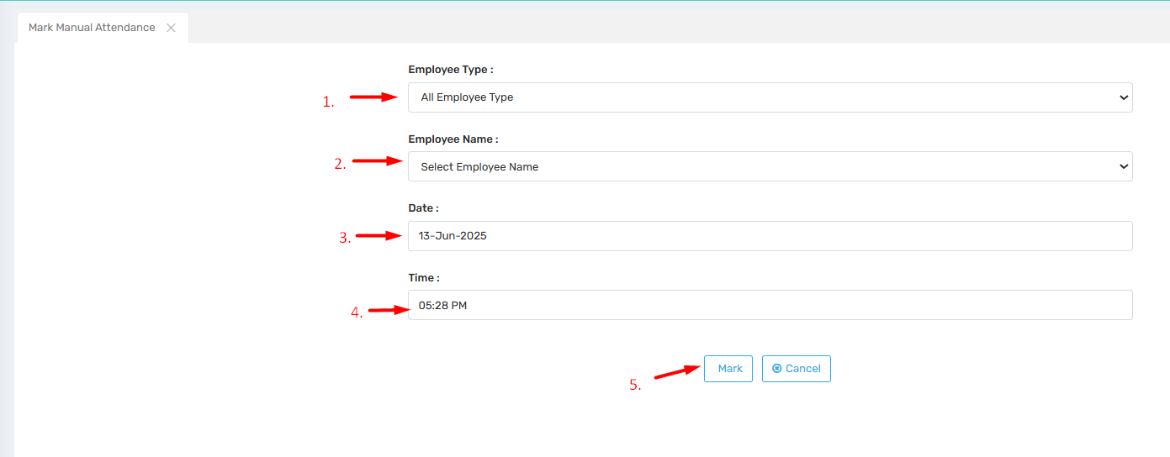

7. Upload Attendance

🎯 Purpose : This section is used to upload the attendance file retrieved from biometric machines.

Field Description :

- Select format : Format 2
- Click on Select file : Select .dat file( log file)
- Click on update button
- After that choose A2 , A0 , A1

📍 Navigate to: Attendance Module → Attendance → Upload Attendance

✅ Use Case : In cases where the machine is not integrated with the Attendance Manager due to compatibility issues.

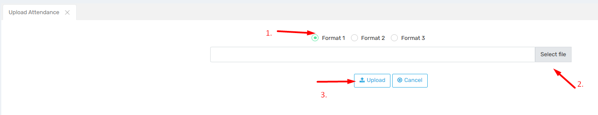

8. Process Leave Application

🎯 Purpose : This section is used to process leave applications submitted by employees, including full-day, short-duration, or half-day leave requests.

Field Description :
- Select School name
- Select Emp Type
- Select Department
- Select Month & Year
- Select Leave type
- Click on view button.

📍 Navigate to: Attendance Module → Attendance → Process Leave Application
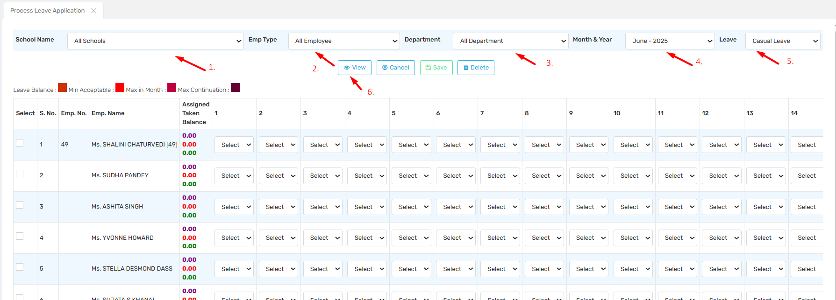

Select leave type to full, half & short.

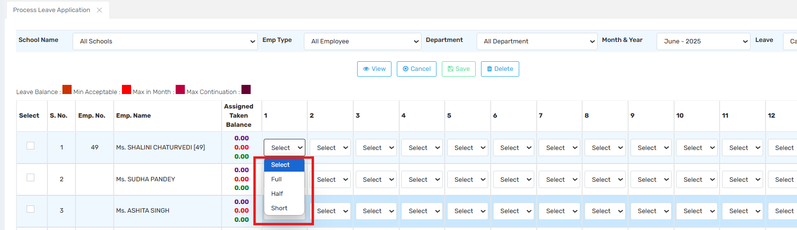

9. Mark Manual Attendance In Bulk

🎯 Purpose : This section allows for the manual recording of an employee's attendance.

📍 Navigate to: Attendance Module → Attendance → Mark Manual Attendance in Bulk

Field Description : Staff Type , Date , Time

✅ Use Case : This tab is used to mark manual attendance in bulk for all employees.

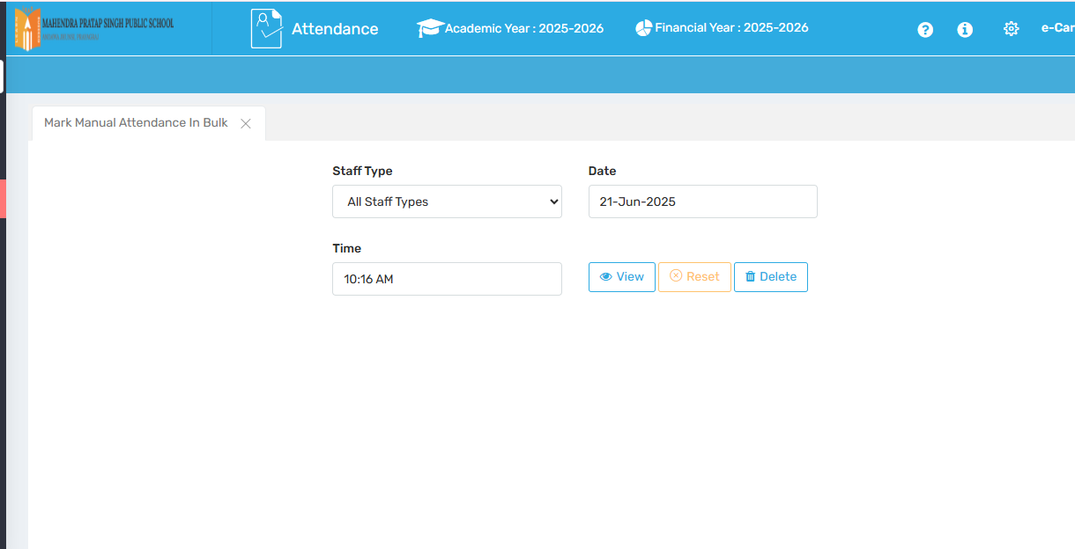

10. Process Leave

🎯 Purpose: In this tab users can mark leave manually according to Leave Type.

📍 Navigate to: Attendance Module → Attendance →Process Leave

Field Description : Select School & Select Date , click on view.

✅ Use Case : users can mark leave manually according to Leave Type.
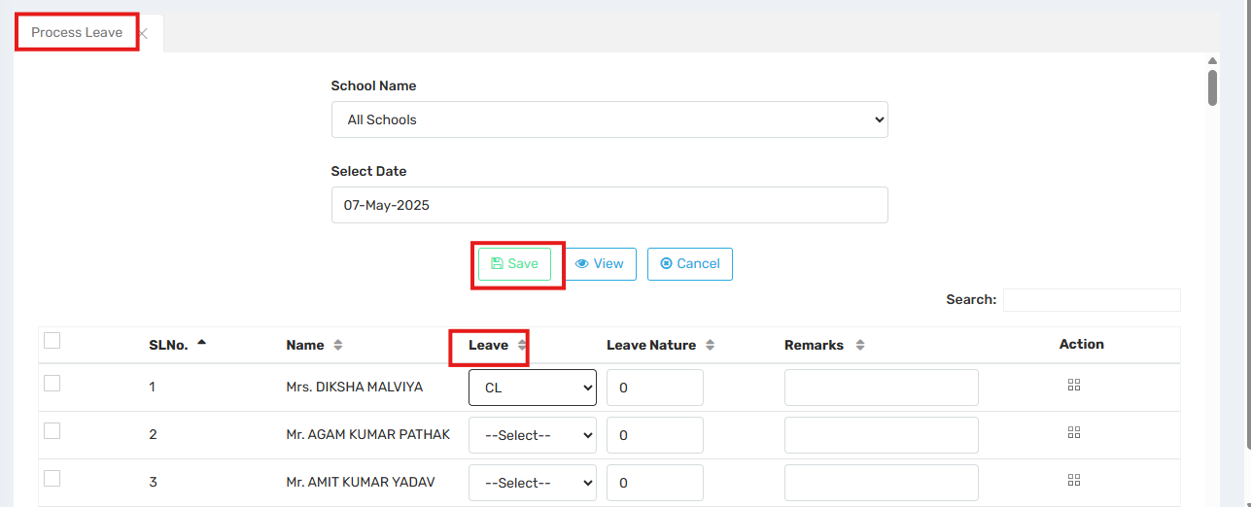

11. Reprocess Attendance

🎯 Purpose : This section is used to process attendance from bio-metric machine for particular date range.

📍 Navigate to: Attendance Module → Attendance → Reprocess Attendance

Field Description :
- Select from date
- Select To date
- Click on the process button.

✅ Use Case: After Biometric integration, if machine is online and you run the commands(Op Stamp and Transtamp) then when you check attendance on ERP, if attendance is not coming then you Reprocess the attendance on particular date.
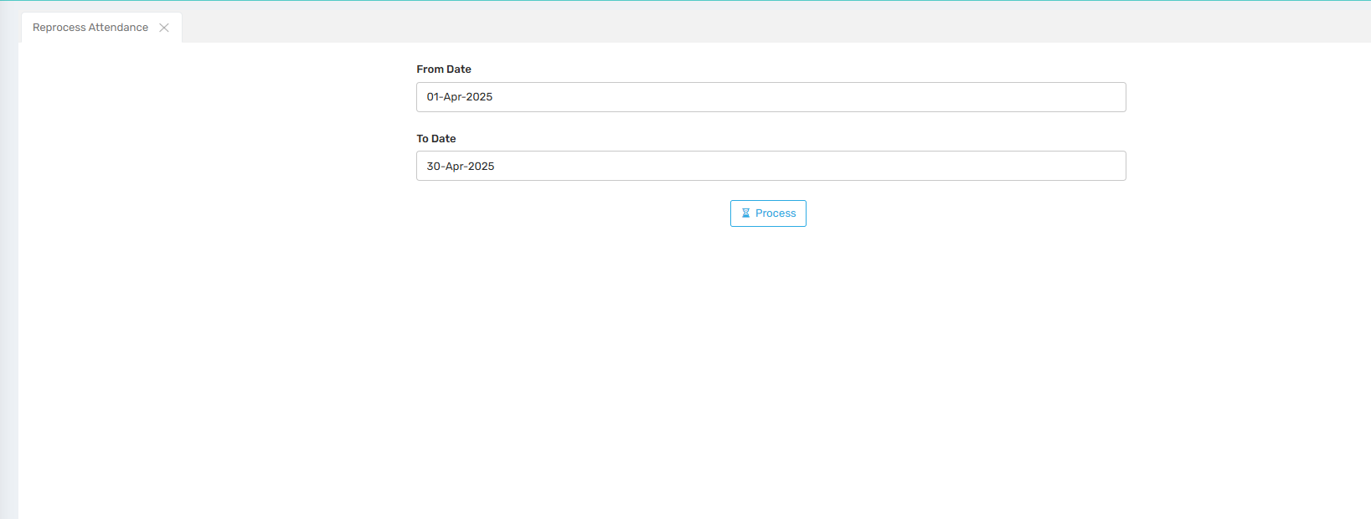

12. Leave Acceptance Employee Wise

🎯 Purpose : In this tab , accept the leave ( CL , EL etc.) employee name wise.

📍 Navigate to: Attendance Module → Attendance → Leave Acceptance Employee Wise

Field Description :
1)Select school Name
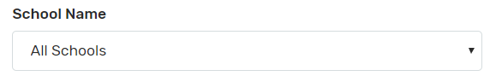
We will Select school name from here.
2)Select Employee type
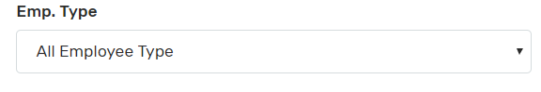
We will select employee type from here.

3) Select Employee Name
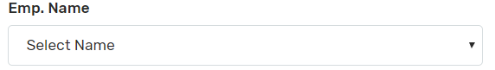
Select the employee name for which we want to process the leave.

4) Select Leave
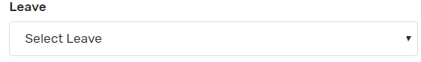
Select Leave for which we want to process.

5) Select Leave Value
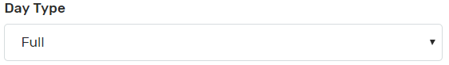
We will selct the leave value from here whether the leave is full day or half day.

6) Leave Balance
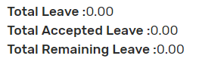
We can check the leave balance from here.

7) Select From Date
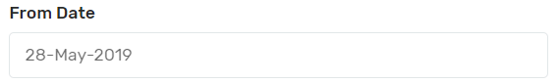
We will select from date of leave in this section.

8.Select to Date
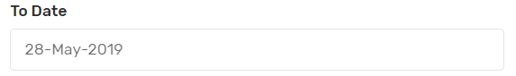
We will select to date of the leave in thi section.

8) Type Remak
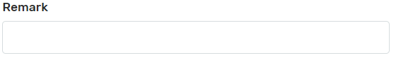We will type the remark for the leave.

✅ Use Case : This option is used for accepting/managing the leave of individual employee, if request is generated manually .

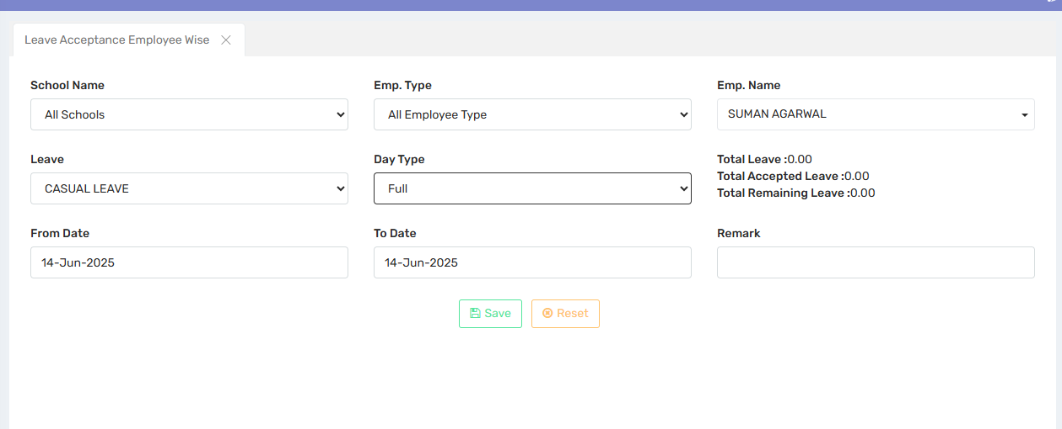

13. Mark Leave Staff Type wise

🎯 Purpose: In this tab users can mark Leave manually staff type wise.

📍 Navigate to: Attendance Module → Attendance → Mark Leave Staff Type Wise

Field Description:

✅ Use Case

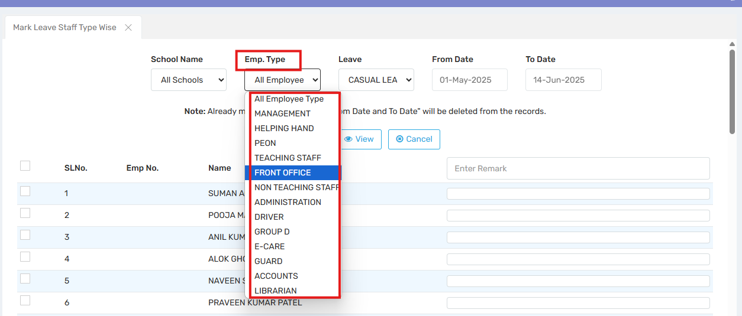

14. Assign Opening Leave

🎯 Purpose: In this tab users can assign Opening Leave (Leave Balance) if any.

📍 Navigate to: Attendance Module → Attendance → Assign Opening Leave

Field Description : School Name , Employee Type , Department , Please select Leave

✅ Use Case

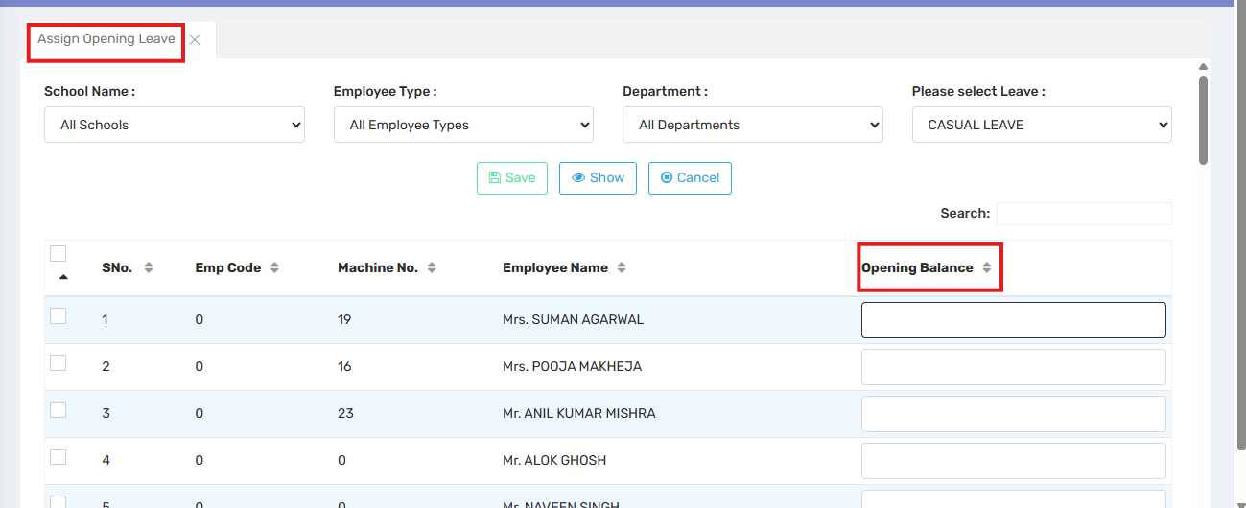

15. Send SMS to Staff

🎯 Purpose : In this tab users can send SMS regarding Late arrival, Missing attendance etc.

📍 Navigate to: Attendance Module → Attendance → Send SMS to Staff
Field Description : School Name , Employee Type , Department , Month , SMS Type( Late SMS , Leave SMS)

✅ Use Case : Sending late sms to staff

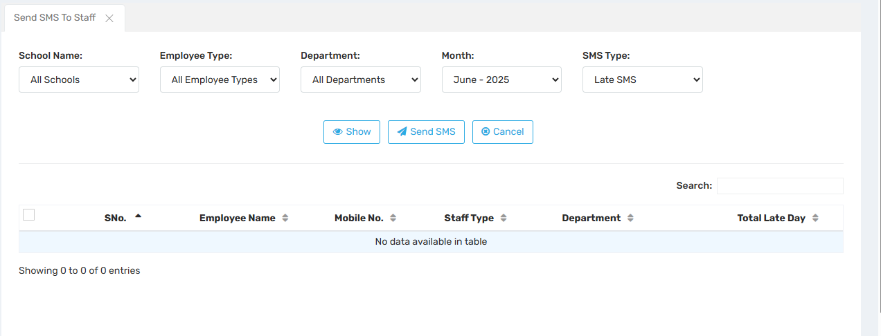

16. Download Attendance

🎯 Purpose : In this tab users can download the attendance by date range.

📍 Navigate to: Attendance Module → Attendance → Download Attendance

Field Description

✅ Use Case

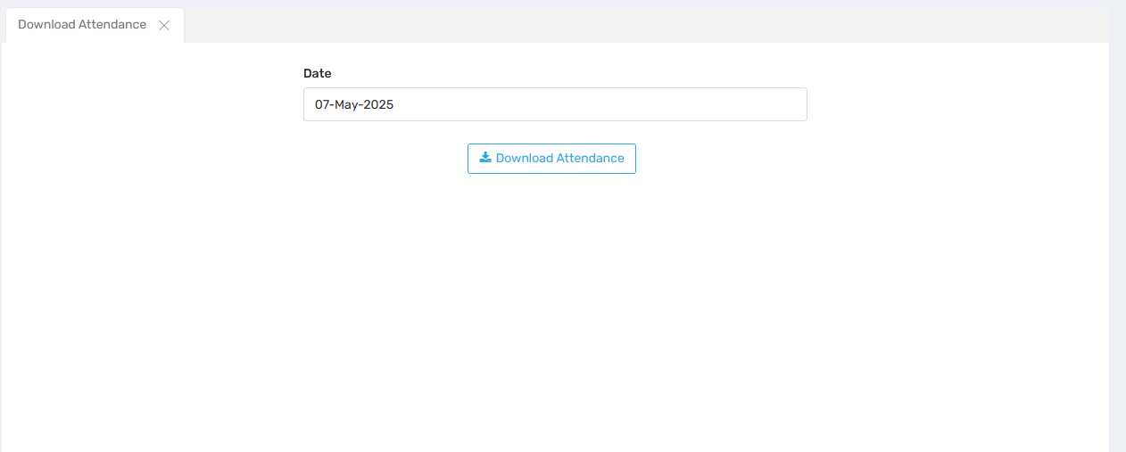

Reports :

Daily Reports :

Late in Early out Report

🎯 Purpose : This report highlights employees who have marked their attendance late or Early.
This report will display the in time, out time, check-in time, check-out time, late entries, and early exits.

📍 Navigate to: Attendance Module → Reports → Daily Reports → Late in Early out Report
Field Description :
- Select Type
- Select Designation
- Select Name
- Select From Date
- Select To date

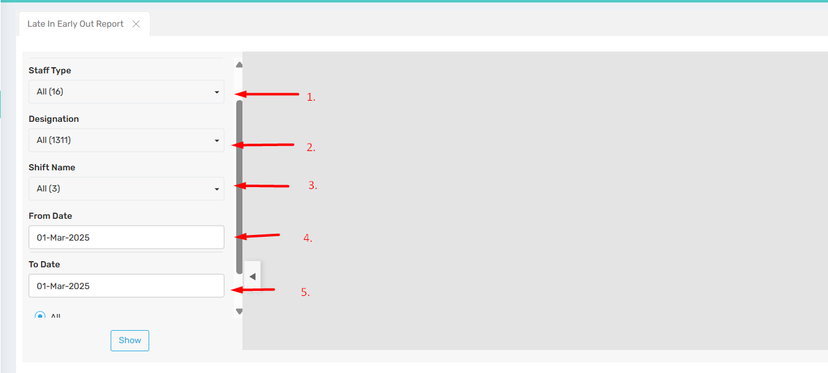

Select the Status
User can select the required button as per the report.
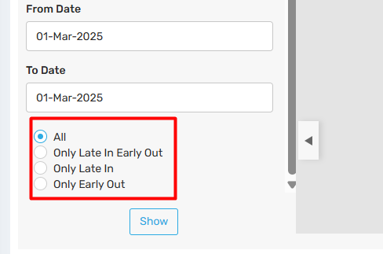

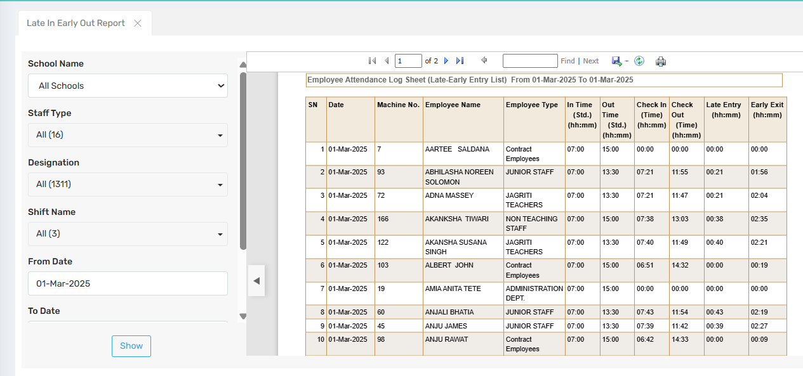

2. Attendance Consolidated Report

🎯 Purpose : This report will display consolidated log sheet for the given date range.

📍 Navigate to : Attendance Module → Reports → Daily Reports → Attendance Consolidated Report

Field Description :
- Select Name
- Select Shift Name
- Select From Date
- Select To date
- User can select the required button as per the report.

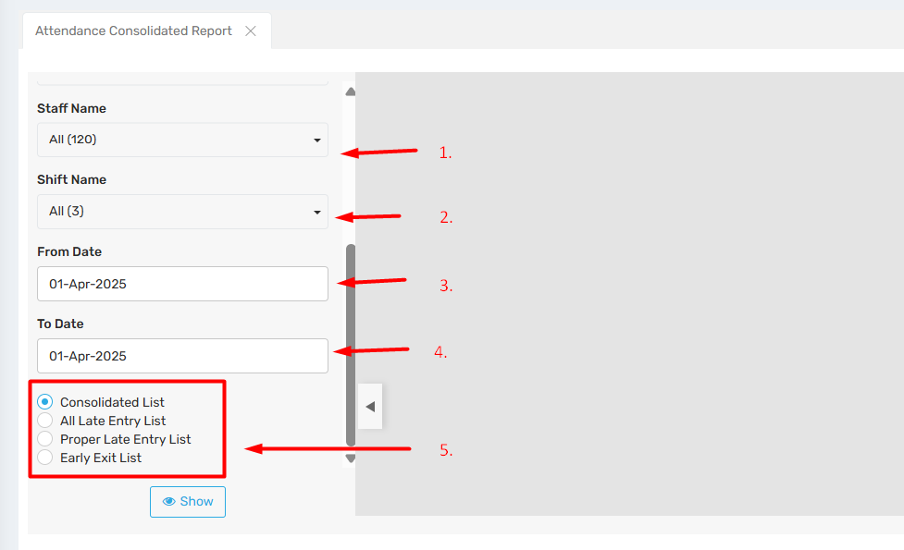

For Example :
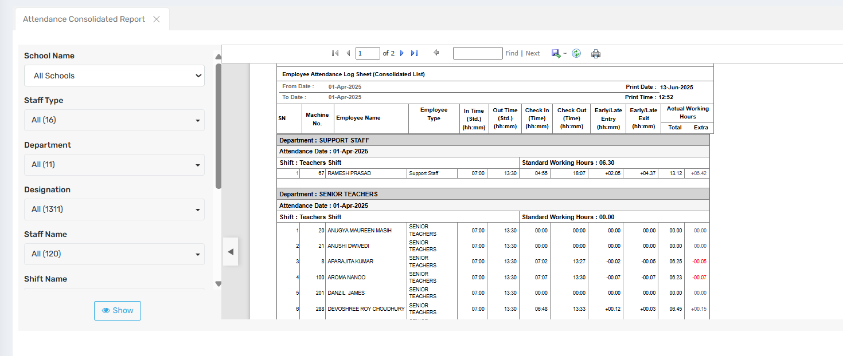

3. Staff Wise Daily Attendance Report

🎯 Purpose : This report displays attendance details for each employee individually.

📍 Navigate to: Attendance Module → Reports → Daily Reports → Staff Wise Daily Attendance Report
Field Description:
- Select Designation
- Select Name
- Select Shift Name
- Select From Date
- Select To date

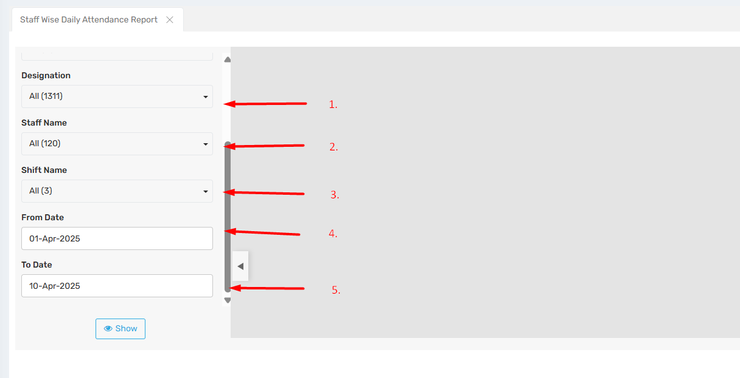

For Example:
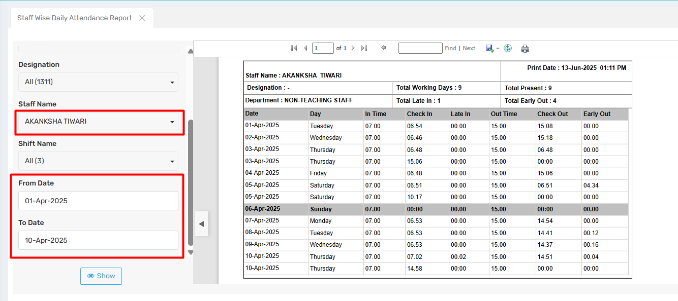

4. Biometrics Attendance Detail Department Wise

🎯 Purpose : This report provides In-Time and Out-Time attendance details of employees, categorized by department.

📍 Navigate to: Attendance Module → Reports → Daily Reports → Biometrics Attendance Detail Department Wise
Field Description :
- Select Department
- Select Designation
- Select Name
- Select Shift Name
- Select From date
- Select To date

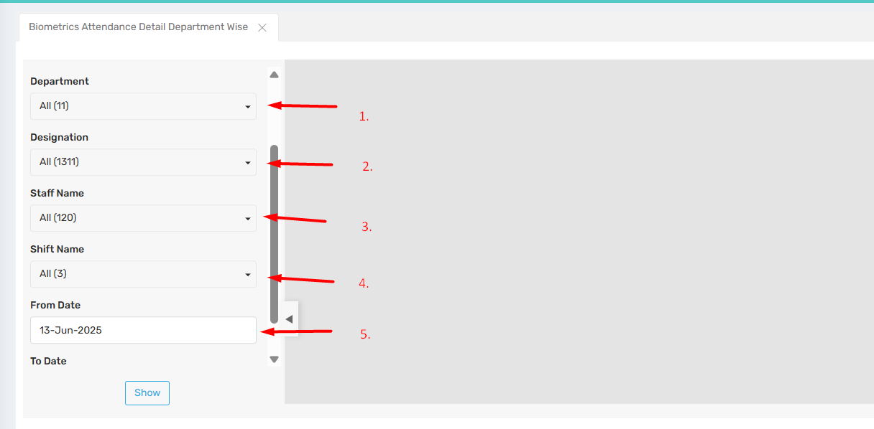

For Example :
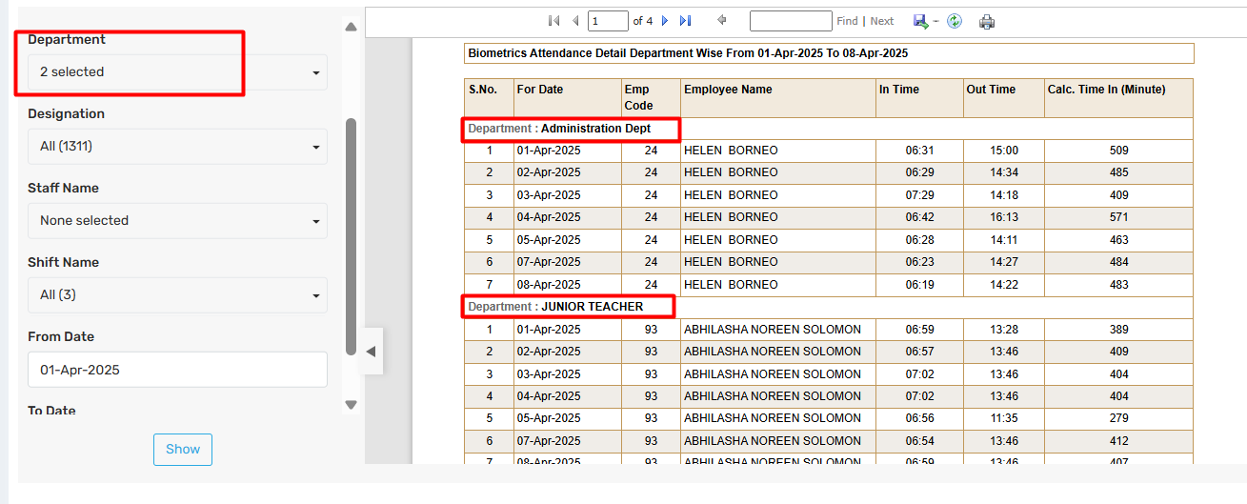

5. Weekly Attendance Report

🎯 Purpose : This report shows the weekly attendance for each individual employee, including actual working days, days absent, days present, early our, and late in.

📍 Navigate to: Attendance Module → Reports → Daily Reports → Weekly Attendance Report
Field Description :
- Select Department
- Select Designation
- Select Name
- Select Shift Name
- Select From date
- Select To date

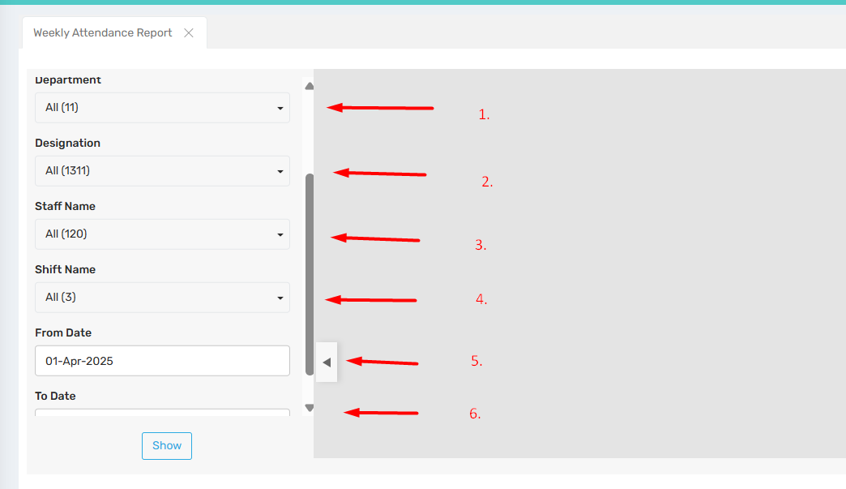
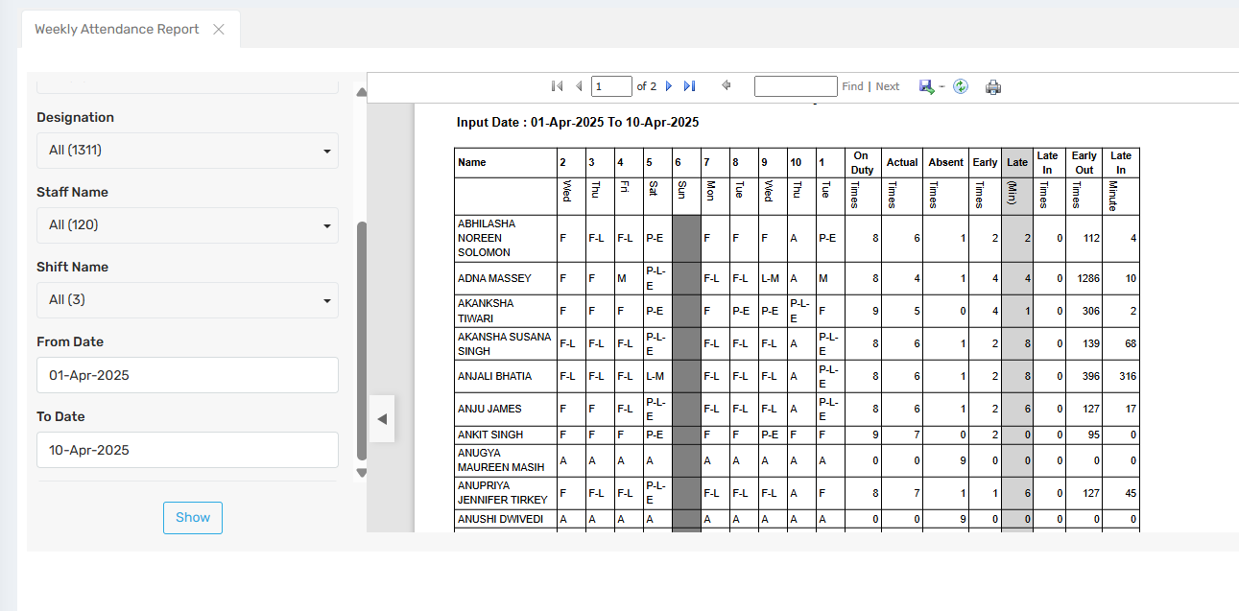

6. Daily Performance Report

🎯 Purpose : This report shows the daily attendance details for the selected employee, including Shift In, In Time, Early In, Late In, Shift Out, Out Time, Early Out, and Late Out.

📍 Navigate to: Attendance Module → Reports → Daily Reports → Daily Performance Report
Field Description :
- Select Department
- Select Designation
- Select Name
- Select Shift Name
- Select On Date

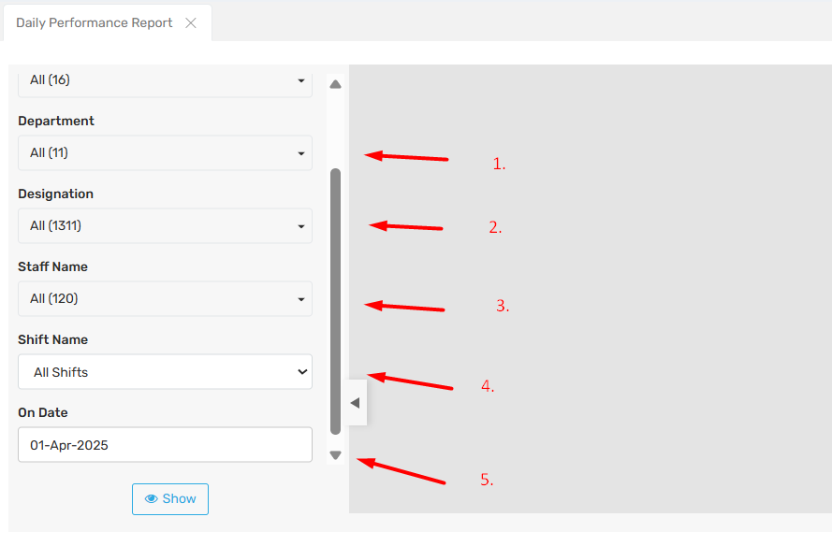

For Example :

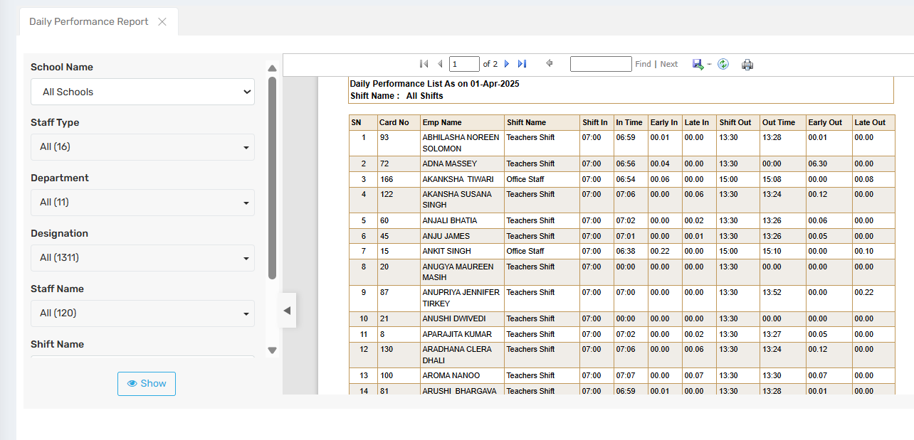

7. Attendance Report

🎯 Purpose: This report shows the attendance details of an individual employee, including their present or absent status along with check-in and check-out times.

📍 Navigate to: Attendance Module → Reports → Daily Reports → Attendance Report
Field Description

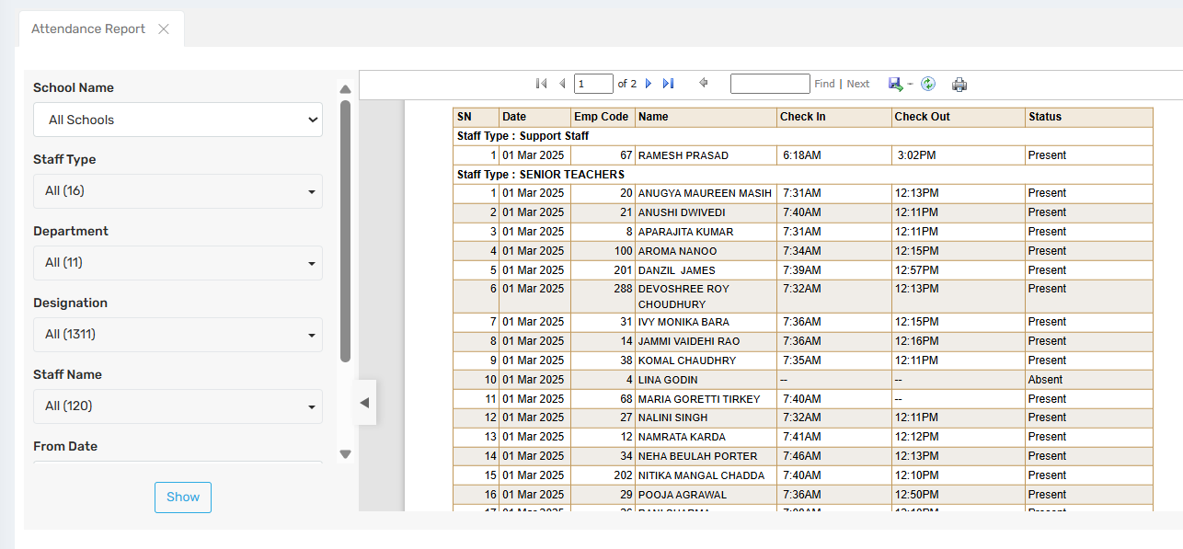

2. Monthly Reports:

1. Attendance Report Monthly Wise

🎯 Purpose : This report provides the monthly attendance details of an individual employee, organized by month-year, and includes information on late hours, late days, and absent days.

📍 Navigate to: Attendance Module → Reports → Monthly Reports → Attendance Report Monthly Wise
Field Description :
- Select Type
- Select Department
- Select Designation
- Select Shift Name
- Select Month - Year

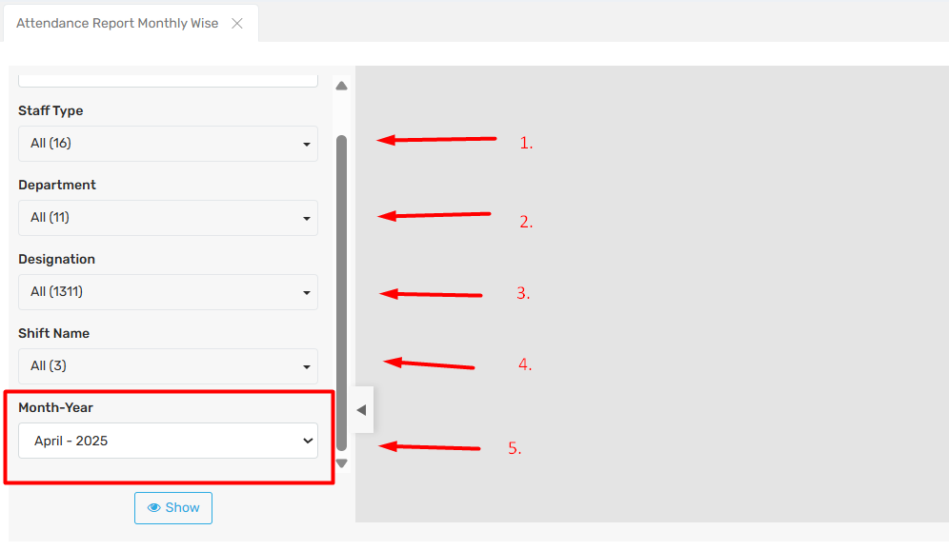
For Example:
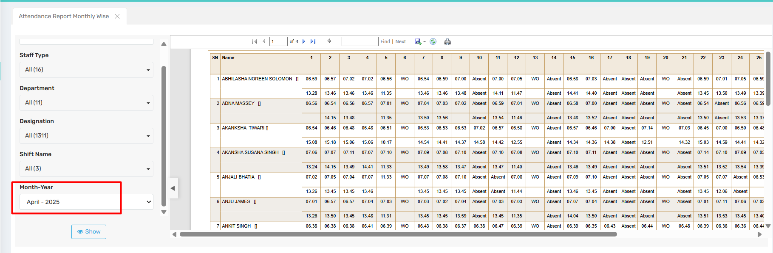

2. Monthly Attendance Report

🎯 Purpose: This report provide monthly attendance report of individual employee organized by month-year.

📍 Navigate to : Attendance Module → Reports → Monthly Reports → Monthly Attendance Report
Field Description

✅ Use Case

For Example:
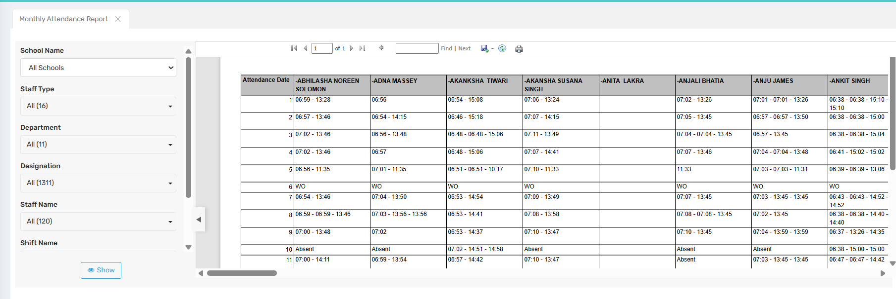

3. Monthly Performance Report

🎯 Purpose : This report provides a monthly, date-wise attendance summary that includes employee number, machine number, presence status, holidays, week-offs, absences, leave taken, hours worked, and overtime.

📍 Navigate to: Attendance Module → Reports → Monthly Reports → Monthly Performance Report
Field Description

✅ Use Case

For Example:
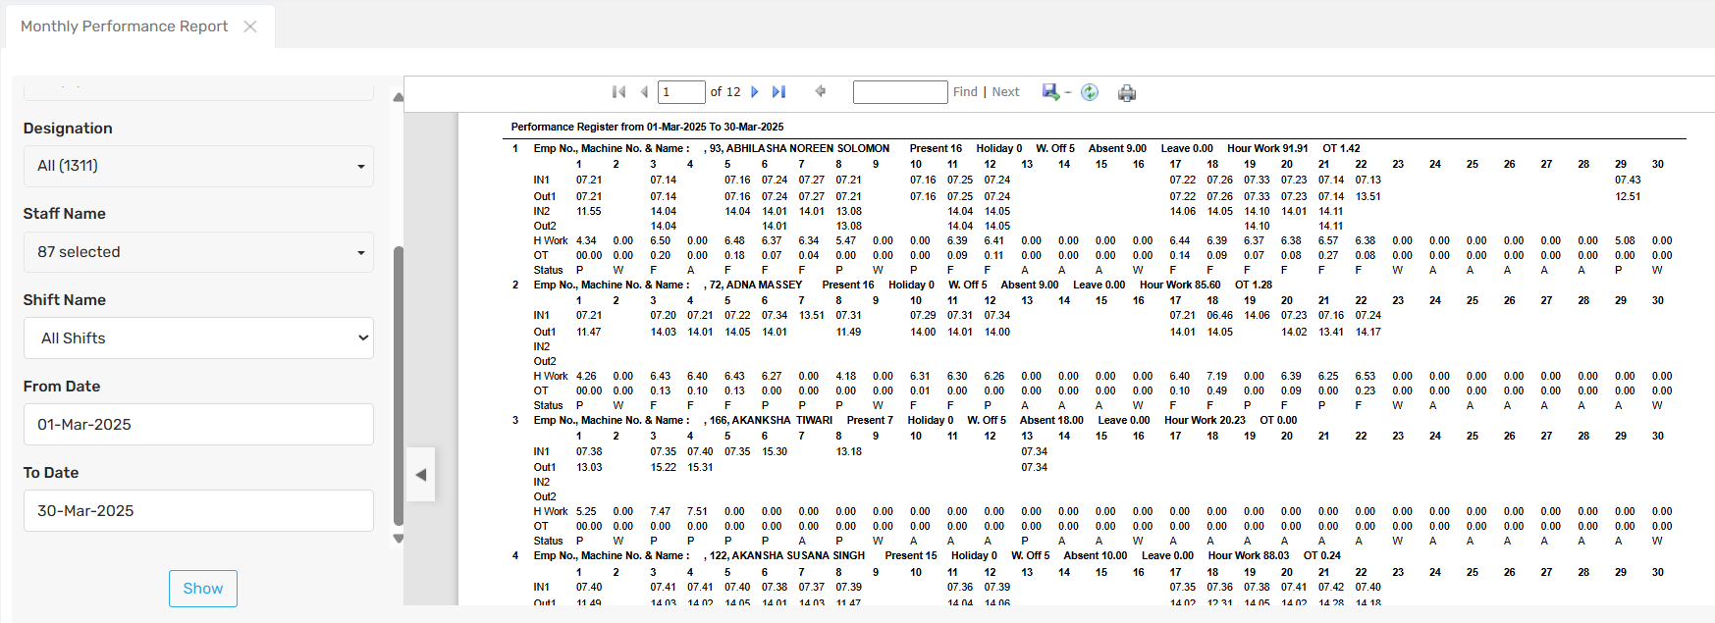

4. School Staff Attendance Register

🎯 Purpose : This report provides the school staff attendance register, organized by staff type and month-year.

📍 Navigate to: Attendance Module → Reports → Monthly Reports → School Staff Attendance Register
Field Description :
- Select school name
- Select staff type
- Select Month-year

✅ Use Case

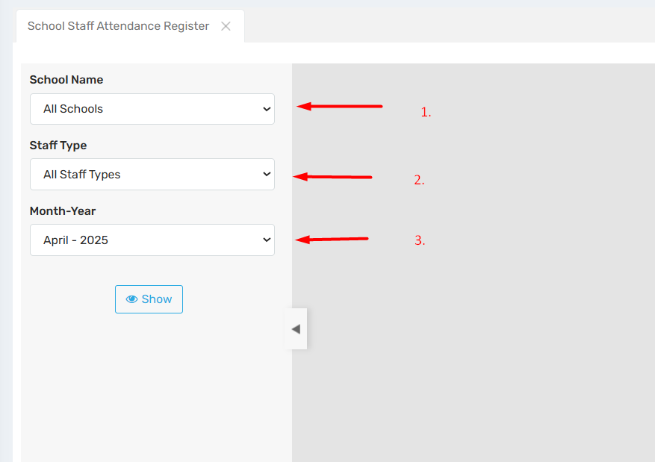

For Example :
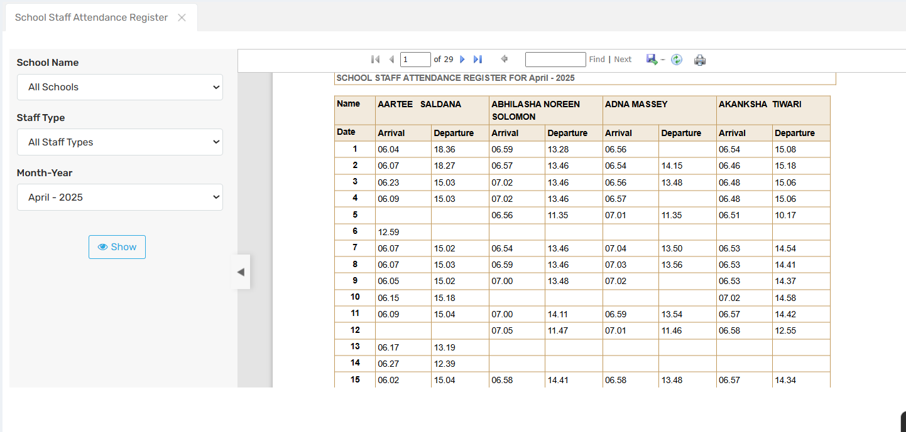

5. Monthly Late In Count Report

🎯 Purpose : This report provides a monthly summary of late arrivals, including late hours, half-day counts, and total absences.

📍 Navigate to : Attendance Module → Reports → Monthly Reports → Monthly Late In Count Report
Field Description

✅ Use Case

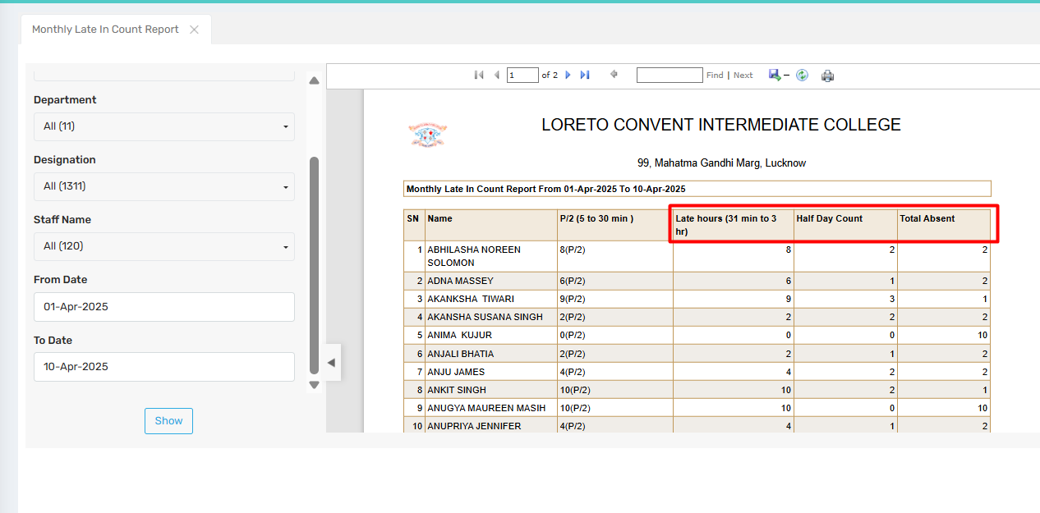

6. Monthly Consolidated Biometric Report

🎯 Purpose : This report provides a monthly consolidated biometric summary with a date range, including total number of days, days present, working days, leave without pay (LWP), late day count, and short leaves.

📍 Navigate to: Attendance Module → Reports → Monthly Reports → Monthly Consolidated Biometric Report
Field Description

✅ Use Case

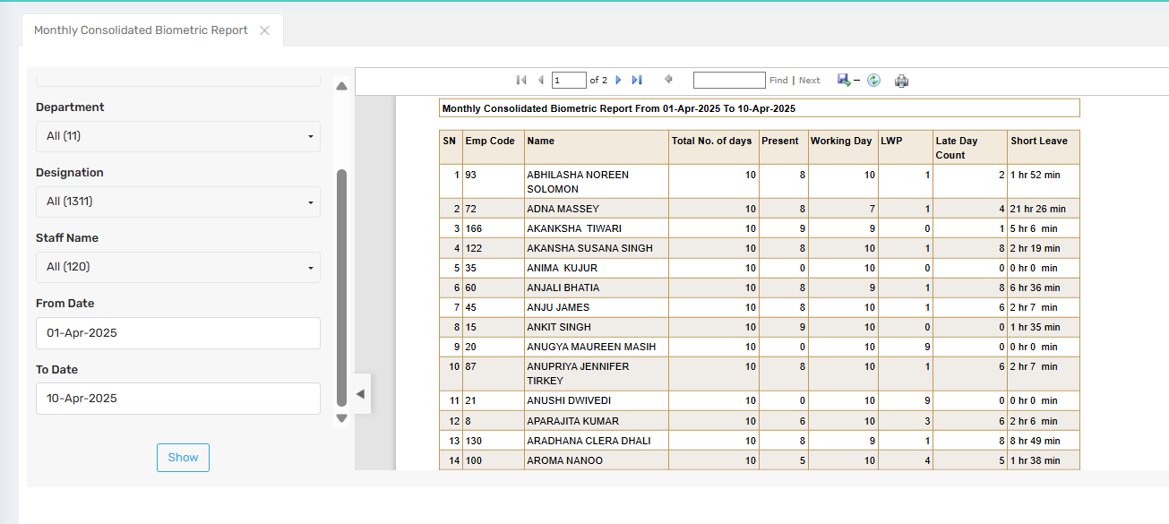

Leave Reports

Leave Format Report

Leave Balance Report

Sancationed Leave Report

Leave Card Report

Leave Ledger Report

Leave Absent Report

Leave Register Report

Leave Bucket Report

Leave Report Staff wise

Leave Status Report

Leave Report

Other Reports

Staff Shift Relation Report

Attendance Analysis Report

LWP Year Wise Report

SMS Report

