FRONT OFFICE MANAGEMENT (FOM)

Steps to Book an Appointment

Step 1: In this tab user will be asked to enter the mobile no.

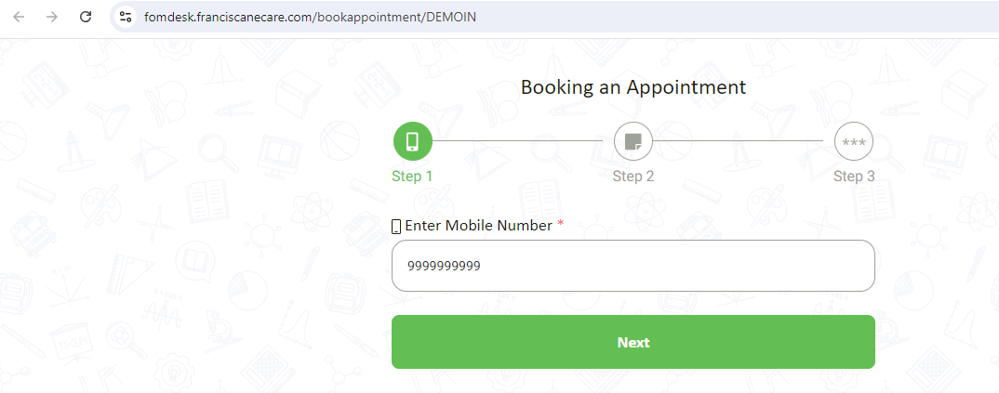

Step 2: In this tab User will asked to select the type of Person i.e. Visitor, Parent, Vendor.
User need to fill the Personal details, Meeting purpose, Visiting date, Appointment time, Id Proof, No. of visitor, Co-Visitor name, Appointment Duration
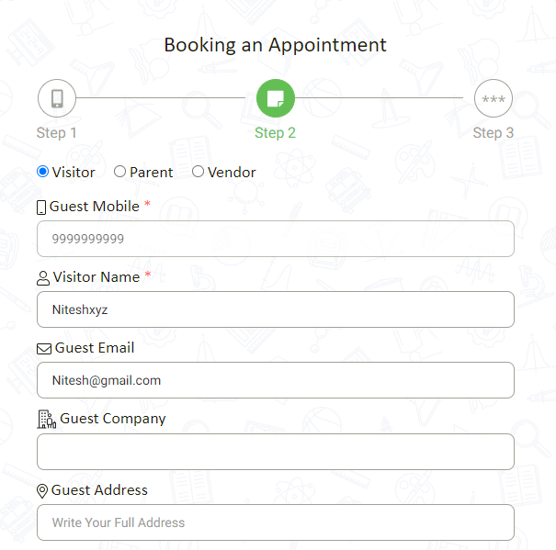

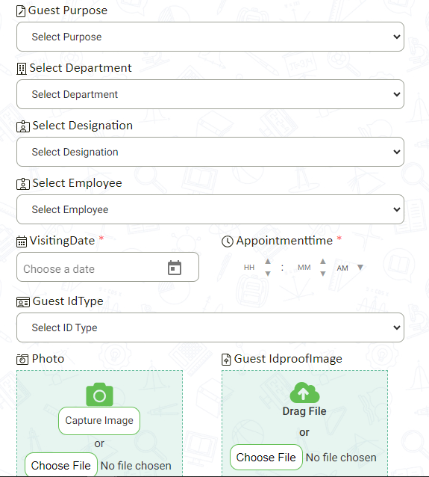

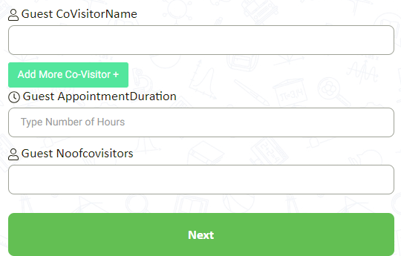

Step 3: Verification Code:

In this tab user will ask to enter the verification i.e. received on their mobile no. and on email id.
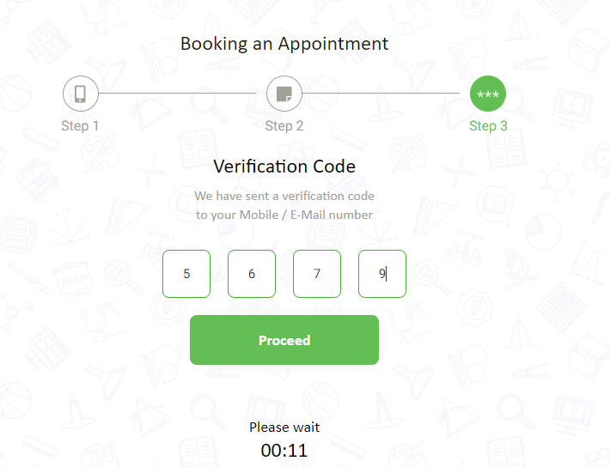

How to Accept/Reject Appointment from e-Care
Step 1: Login to e-Care Portal by using Credentials provided.
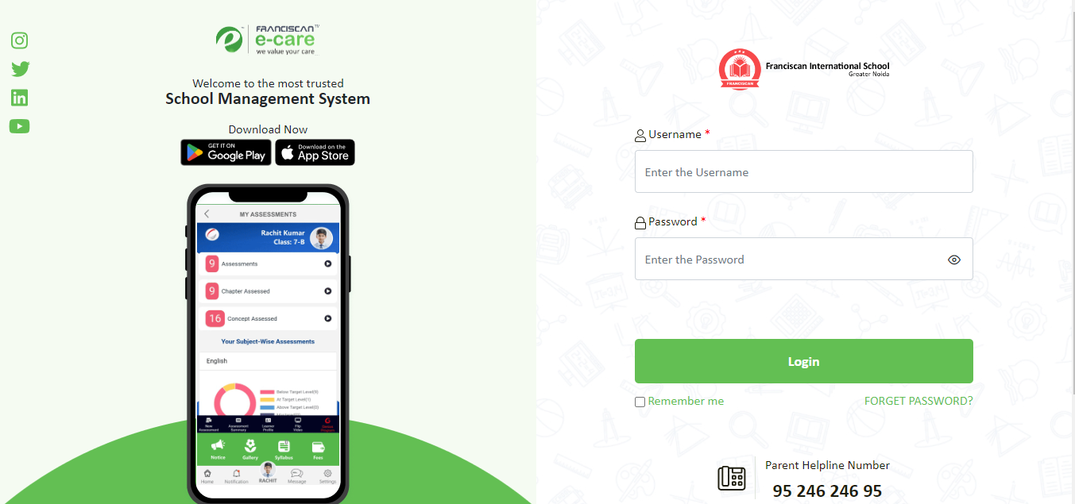

Step 2: Navigate to Appointment tab
It allow the user to choose among the applied appointments.
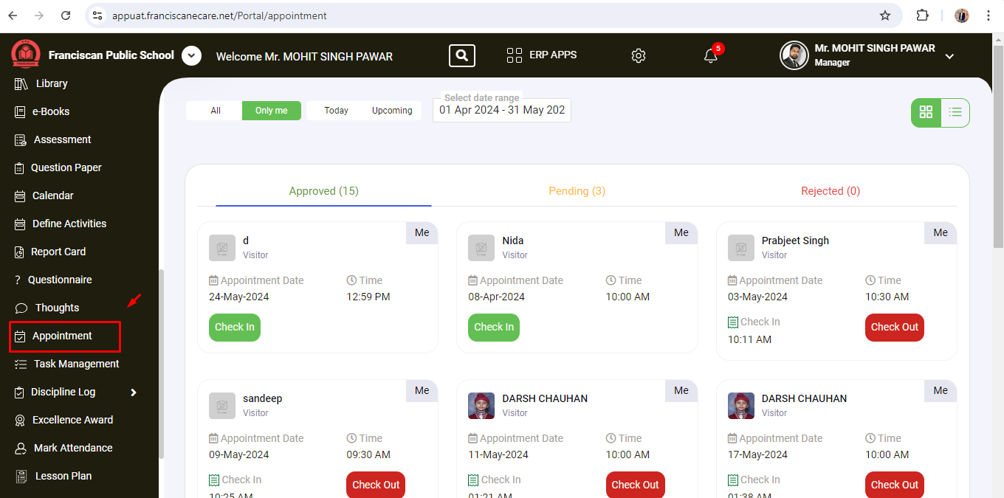

How to Book Appointment from Guard App

- User will asked to enter the school code & their Credentials.
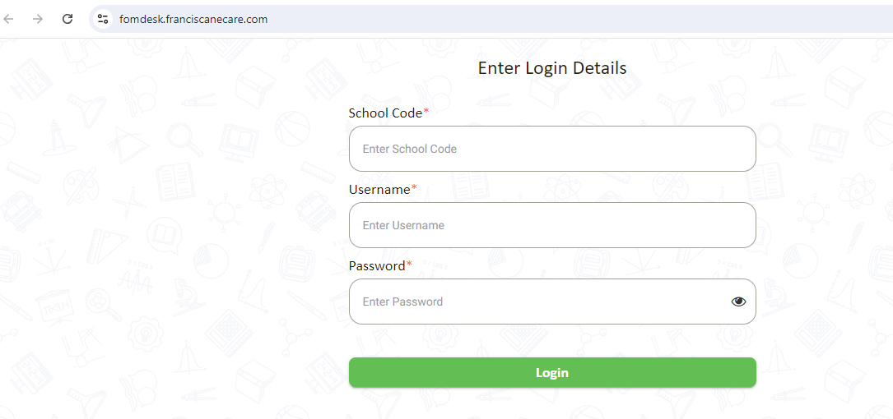

- Guard will check the appointment book applied by the Visitor.
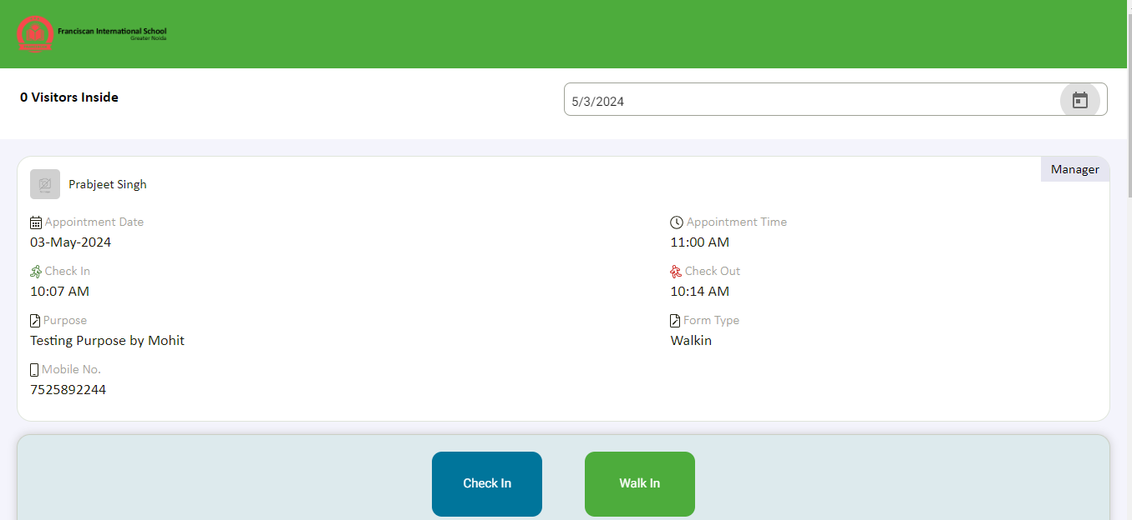

- Guard will confirm the application no. received by the user to check in.
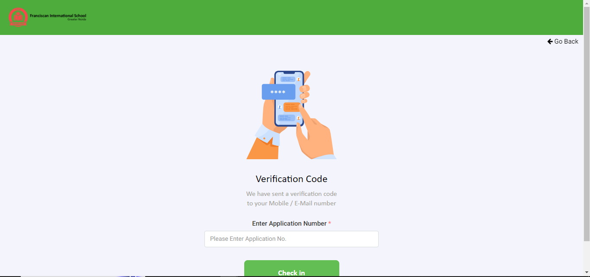

How to Book Appointment by Walkin

- Guard will ask the mobile no. of the user.
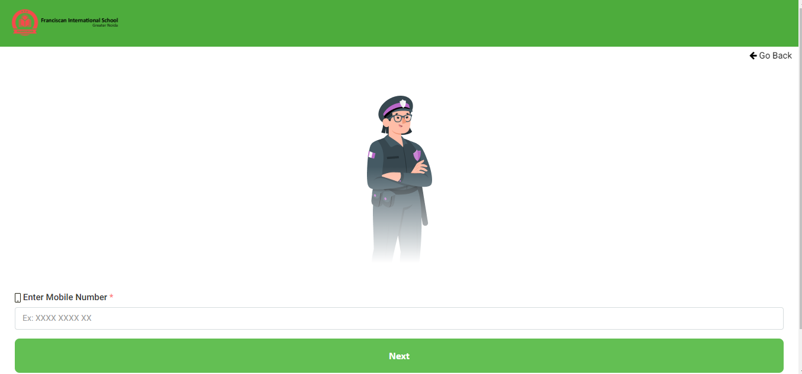

- Guard will ask the user to enter the details for the appointment.
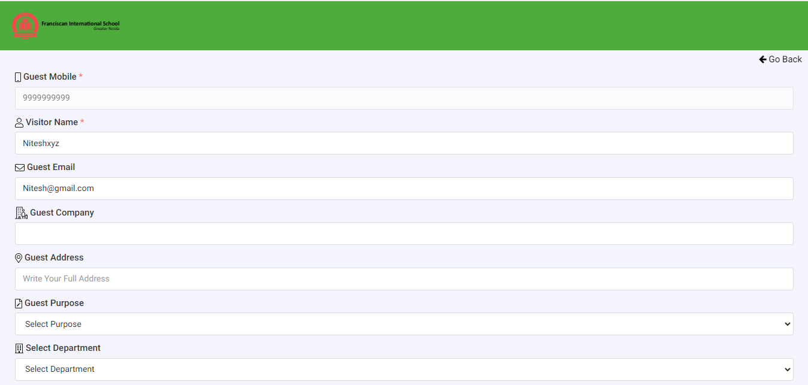

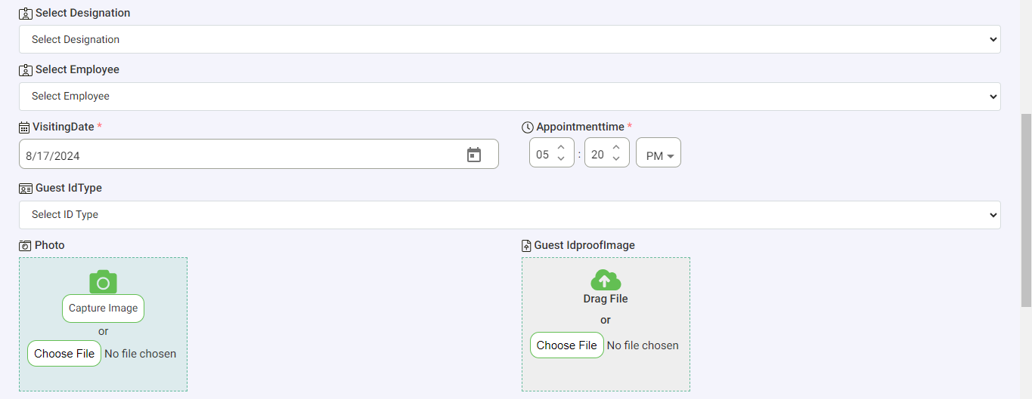

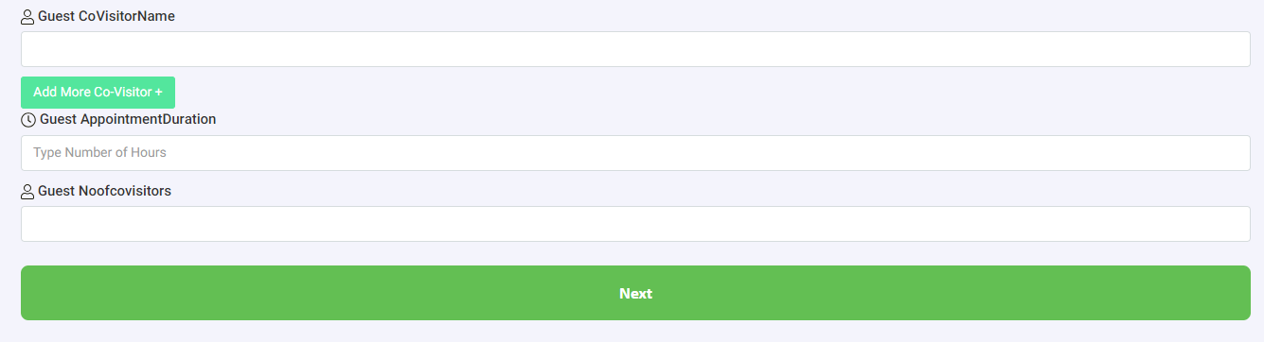
- A Gate Pass will be issued to the user with the appointment details.
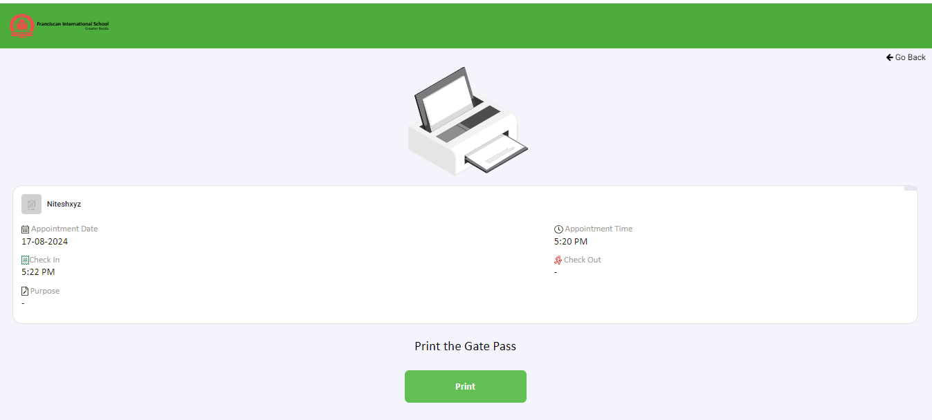

APPLICATION SETTINGS

GENERAL SETTING

In this tab user will give the access of appointment to Departments, Designations., User can also do the settings of Auto check out time, OTP Settings, Notification Settings, Enable Rejection Reason.
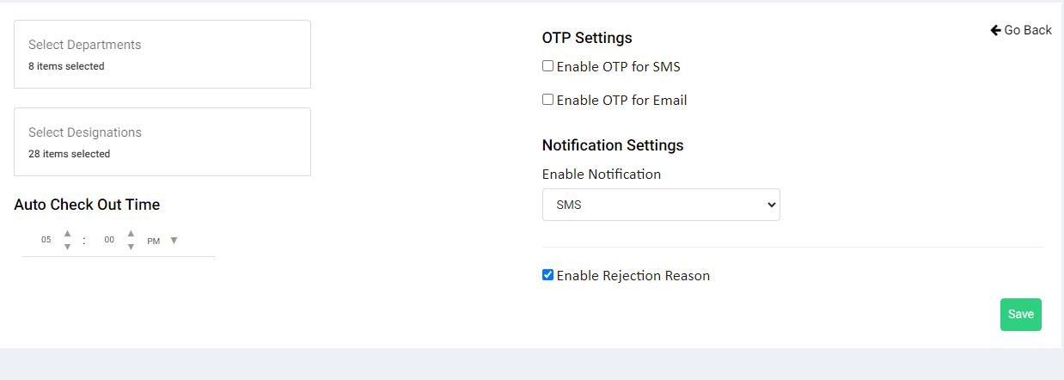

HOURS SETTING

In this tab user can set the days & time of appointment for assigned staff and department.
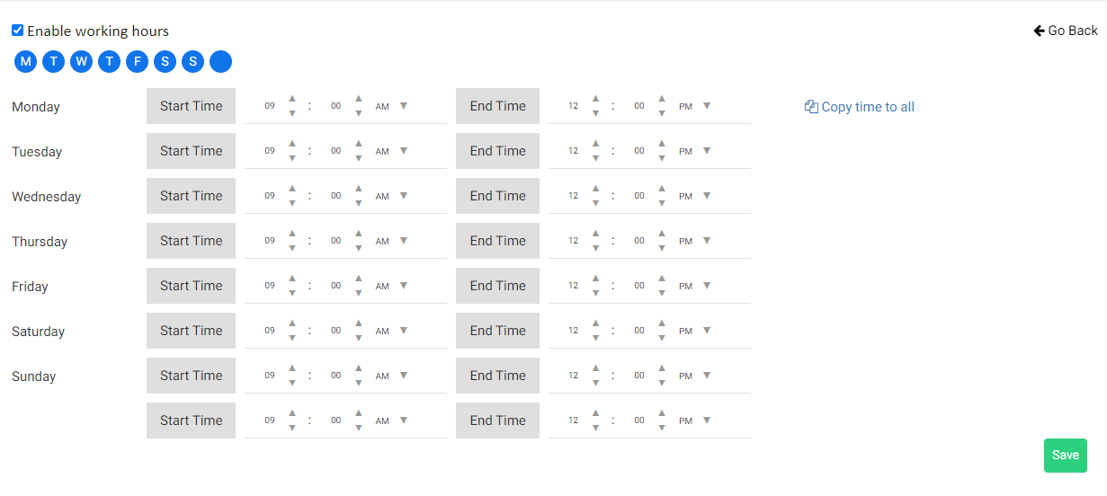
FORM SETTING

In this tab user can set the fields required for Website/QR, Walkin, e-Care, Invitation Form.
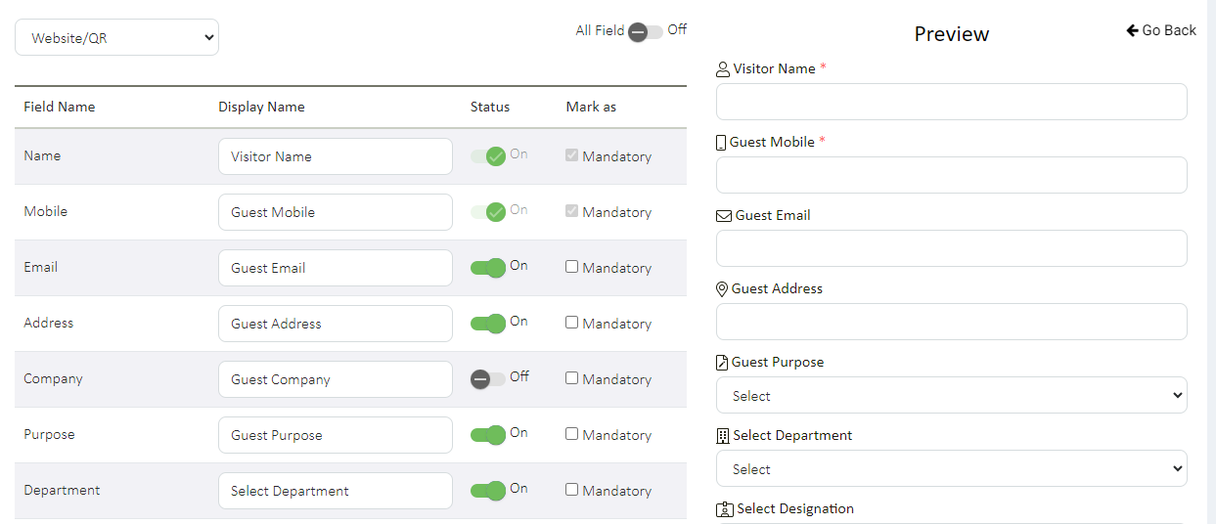

PURPOSE
In this tab user can define the purpose for the appointment.
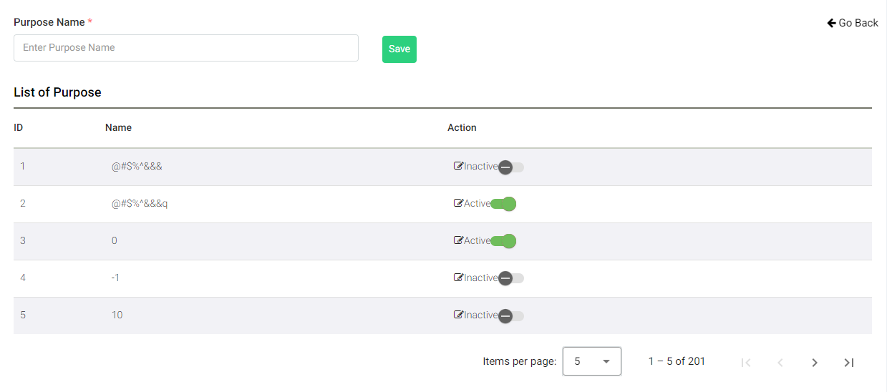
ALLOW APPOINTMENT FOR

In this tab user can allow appointment for different departments. User can also activate appointment option for Parents, Visitors, to the selected staff.
User can also give the access or share selected staff’s appointment scheduled with another staff member (Assistant).
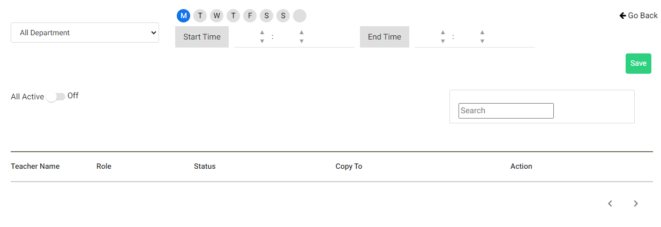
NOTIFICATION SETTINGS

Email Templates
In this tab user can set the OTP and Notification message for email.

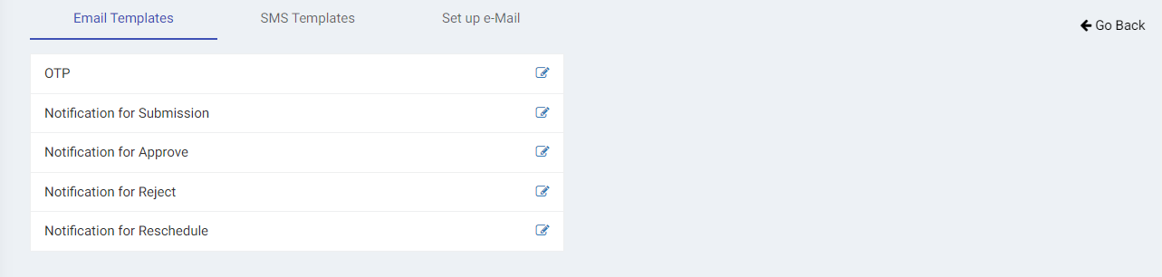

SMS Templates

In this tab user can set the OTP and Notification messages for Text Messages.

