HEALTH CARE

- MASTER SETTING

1.1 CHANGE ACADEMIC YEAR

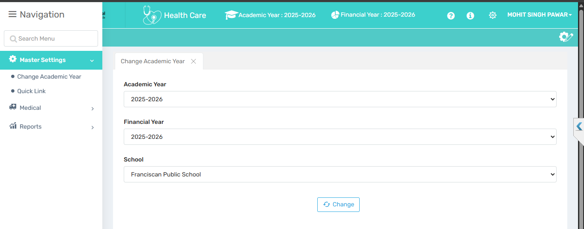

🎯 Purpose
From here a user can change the academic session.

📍 Navigate to
Health Care → Master Settings → Change Academic Year

Field Description
- Academic Year determines which session’s data (students, medicine records, etc.) the system should display or manage.

- Financial Year aligns financial transactions of the selected timeline. Indicates the financial year for accounting and budgeting purposes.

- School allows selection of the school (if the user has access to multiple institutions). It applies settings and changes to the selected school only.

- Change Button saves and applies the selected academic year, financial year, and school.

✅ Use Case
The tab is used to switch the academic year, financial year and institution. This ensures that the data being accessed, managed, or reported is relevant to the correct academic session, financial period, and institution.

⚠ Important Notes
Changes are session-specific and may reset upon logout. It does not affect global software settings unless stored per profile.

1.2 QUICK LINK

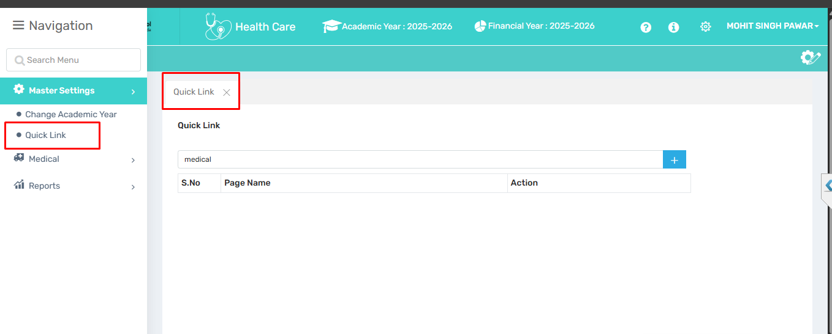
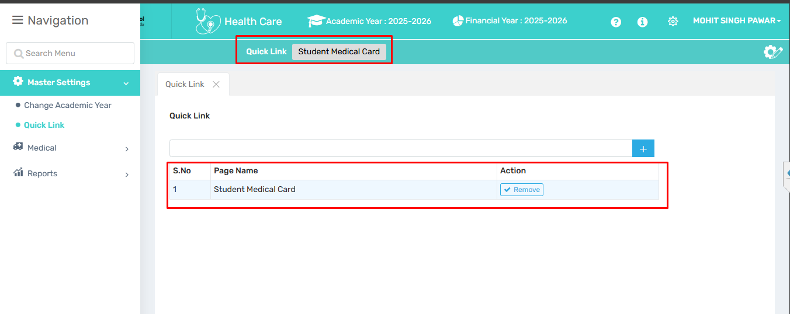
🎯 Purpose
This tab allows users to customize their Quick Access menu by adding or removing pages they frequently use.
📍 Navigate to
Health Care → Master Settings → Quick Link
Field Description
- Input Box (Top Bar):
Enter the name of the page you want to add as a quick link.
- ➕ Button (Blue Plus Icon):
Click to add the entered page name to the quick link list.
- S.No:
Serial number of the quick link entry.
- Page Name:
The name of the page (e.g., "Student Medical Card") added as a quick access link.
- Action – Remove:
Click the Remove button to delete the page from your quick links.
✅ Use Case
The Quick Link feature allows users to save shortcuts to frequently used pages for faster access. Instead of navigating through menus, users can quickly open important pages from their saved list. It helps save time and improves workflow efficiency, especially for tasks that are used often.
⚠ Important Notes
Quick links are user-specific and will not be visible to others.

- MEDICAL

2.1. MEDICINE ENTRY

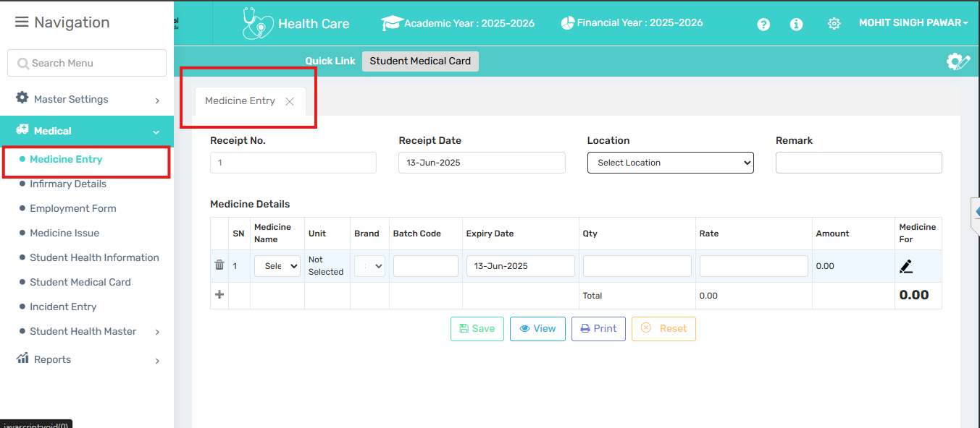

🎯 Purpose
This page is designed to log and track medicine inventory, including details like batch number, quantity, expiry date, and cost. It is essential for managing school health resources efficiently.
📍 Navigate to
Health Care → Medical → Medicine Entry
Field Description
- Receipt No.: Unique number assigned to the medicine entry record.
- Receipt Date: Date when the medicine was received or recorded.
- Location: Medical outlet from where medicine was purchased.
- Remark: Optional field for additional comments or notes.
- SN (Serial Number): Auto-generated row number for each medicine entry.
- Medicine Name: Dropdown to select the name of the medicine being added.
- Unit: Measurement unit (e.g., tablet, ml).
- Brand: Brand name of the medicine.
- Batch Code: Identifier for the medicine batch (for tracking and expiry purposes).
- Expiry Date: Date when the medicine expires.
- Qty (Quantity): Number of units being received or recorded.
- Rate: Price per unit of the medicine.
- Amount: Auto-calculated field: Qty × Rate.
- Medicine For: Field to mention the disease or condition the medicine is intended to treat.
- ➕ (Add Row): Add another medicine entry row.
- 🗑 (Delete Row): Remove an existing row.
- Save: Save the entered details.
- View: View saved records.
- Print: Print the receipt.
- Reset: Clear all fields to start fresh.
✅ Use Case
The Medicine Entry tab is used to record and manage medicine stock received in the medical department. It helps staff log details like medicine name, quantity, expiry date, and cost. This ensures proper inventory tracking, timely usage before expiry, and accurate reporting for audits or medical needs.
⚠ Important Notes
- Enter accurate details for each medicine, especially expiry date and batch code.
- Ensure the quantity and rate are correct to avoid wrong stock valuation.
- Use remarks for any special instructions or observations.
- Always click Save to store the entry, unsaved data will be lost.
- Expired or incorrect entries should be reviewed and updated immediately.
- Printing the entry helps in maintaining physical records if needed.

2.2. INFIRMARY DETAILS

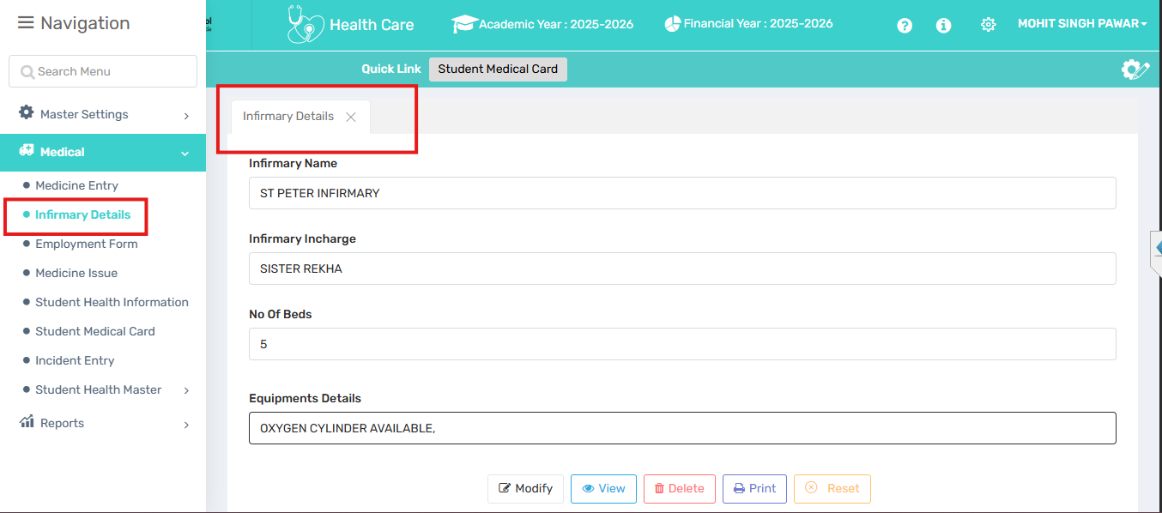
🎯 Purpose
From here a user can define the Infirmary details.
📍 Navigate to
Health Care → Medical → Infirmary Details
Field Description
- Infirmary Name: Enter the name of the infirmary.
- Infirmary Incharge: Name of the person responsible for managing the infirmary.
- No Of Beds: Total number of beds available in the infirmary.
- Equipments Details: List or description of medical equipment available in the infirmary.
✅ Use Case
This form is used to record and manage basic details of an infirmary, such as its name, person in charge, available beds, and medical equipment. It helps maintain updated infirmary records for administrative, audit, or healthcare planning purposes.
⚠ Important Notes
- Ensure all fields are filled accurately for proper recordkeeping.
- "No of Beds" should be a valid number.
- Equipment details should be specific (e.g., stretcher, oxygen cylinder).
- Use the Save button to store the data, View to check entries, Print for hard copies, and Reset to clear the form.

2.3. EMPLOYMENT FORM
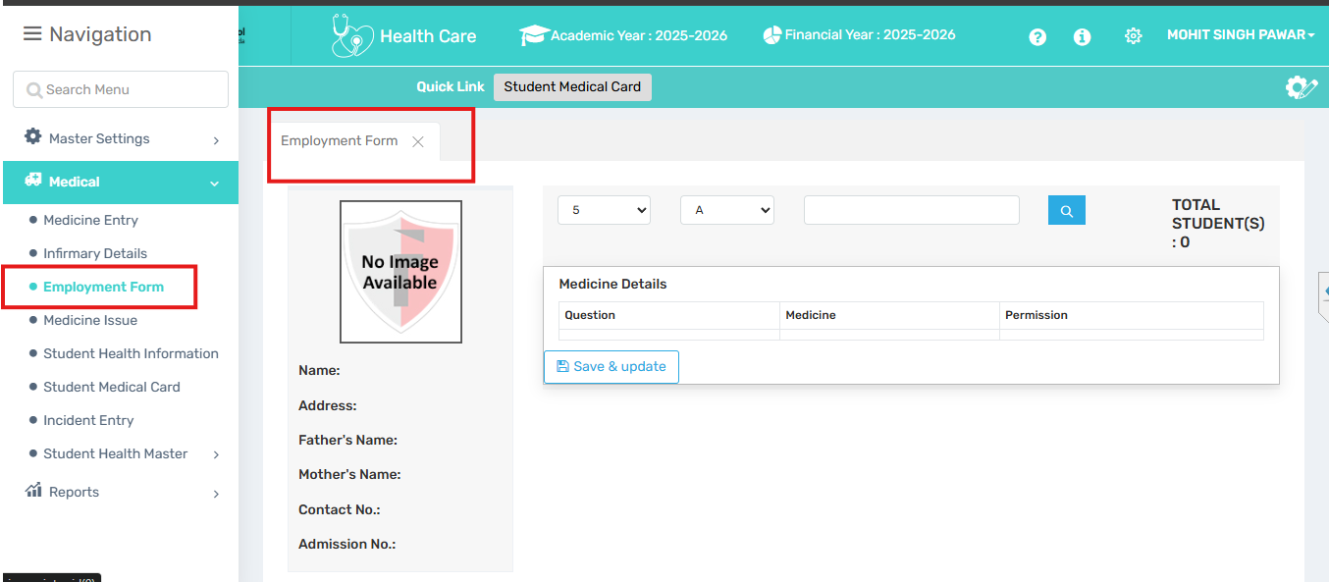

🎯 Purpose

📍 Navigate to
Health Care → Medical → Employment Form
Field Description
✅ Use Case
⚠ Important Notes

2.4. MEDICINE ISSUE

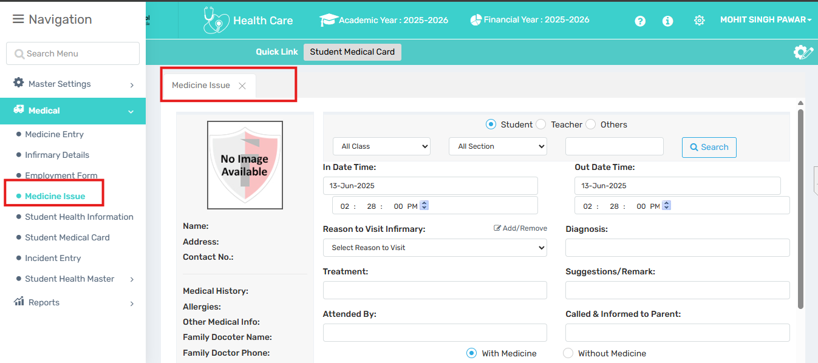

🎯 Purpose
This page is used for logging and managing medical visits and issuing medicine to students, teachers, or others. It ensures medical visit records are detailed and traceable.
📍 Navigate to
Health Care → Medical → Medicine Issue

Field Description
- Student/Teacher/Others: Select the person type (student, teacher, or other) receiving medical attention.
- Class / Section: Dropdowns to filter students by class and section.
- Search: To search the student/teacher name.
- In Date Time / Out Date Time: Time and date when the person entered and exited the infirmary.
- Reason to Visit Infirmary: Select or enter the reason for the medical visit.
- Diagnosis: Description of the diagnosed condition.
- Treatment: Details of the treatment given.
- Suggestions/Remark: Any additional advice or notes.
- Attended By: Name of the staff or doctor who attended the case.
- Called & Informed to Parent: Whether the parent was informed.
- With Medicine / Without Medicine: Indicates if medicine was given.
✅ Use Case
The "Medicine Issue" tab is used to document and track medical visits to the infirmary, including the reason for the visit, diagnosis, treatment provided, and whether medicine was issued. It helps maintain a medical history for students, teachers, or others and ensures proper communication with parents when needed.
⚠ Important Notes
- Always record accurate in-time and out-time for proper tracking.
- Specify the reason for visit and diagnosis clearly for medical history.
- Mention whether medicine was issued or not.
- Use the remarks section for any follow-up suggestions or observations.
- Ensure parent communication details are updated if required.

2.5. STUDENT HEALTH INFORMATION
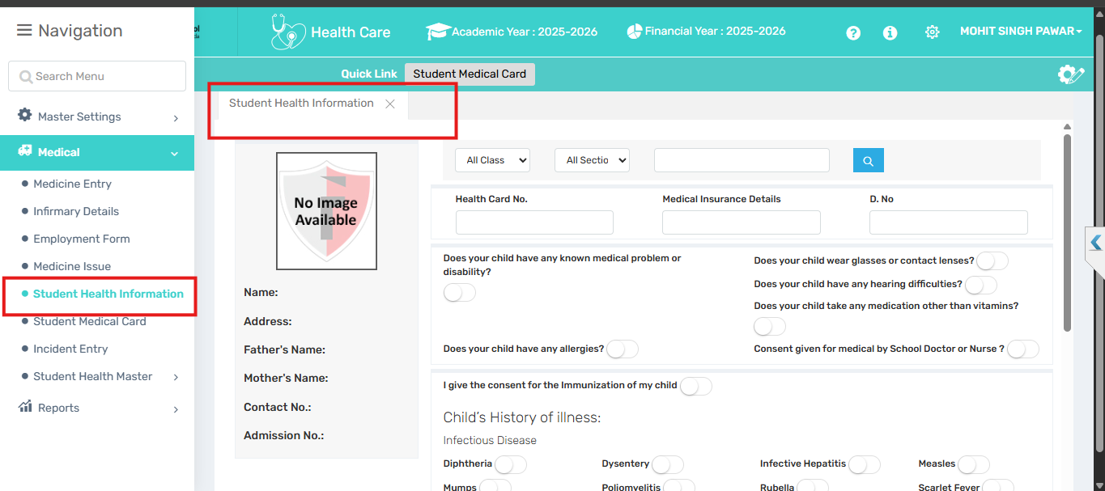

🎯 Purpose
The Student Health Information form is used to collect and maintain important health-related data of students, such as medical conditions, allergies, immunization consent, and illness history. This helps the school manage health emergencies, ensure proper care, and coordinate with parents and healthcare providers when needed.
📍 Navigate to
Health Care → Medical → Student Health Information
Field Description
- Health Card No.: Unique ID or number associated with the student's health record.
- Medical Insurance Details: Information about the student's medical insurance, if any.
- D. No: A document number.
- Known medical problem or disability: Indicates if the child has any existing health issues.
- Wears glasses/contact lenses: Identifies vision support needs.
- Hearing difficulty: Notes if the student has trouble hearing.
- Takes medication (other than vitamins): Indicates ongoing treatments or conditions.
- Allergies: States if the child has any known allergies.
- Immunization Consent: Parent’s permission for vaccinations at school.
- Consent for medical aid by school/doctor: Permission for school staff or doctors to treat in case of need.
- Child’s History of Illness: Tick boxes for past illnesses.
- Family History: Field to mention any hereditary or family medical conditions (e.g., diabetes, asthma).
- Other Information: Additional health-related notes or observations not covered in other fields.
✅ Use Case
This form helps schools maintain key health records of students, such as medical conditions, allergies, past illnesses, and consent for treatment or immunization. It ensures better care, quick response in emergencies, and smooth coordination with parents and healthcare providers.
⚠ Important Notes
- Fill in accurate and updated medical details for each student.
- Ensure consent fields are properly selected for treatments or immunizations.
- Mention any allergies, chronic conditions, or past illnesses clearly.
- Update the form regularly to reflect changes in health status or contact information.
- This data is crucial for managing emergencies and providing appropriate care.

2.6. STUDENT MEDICAL CARD
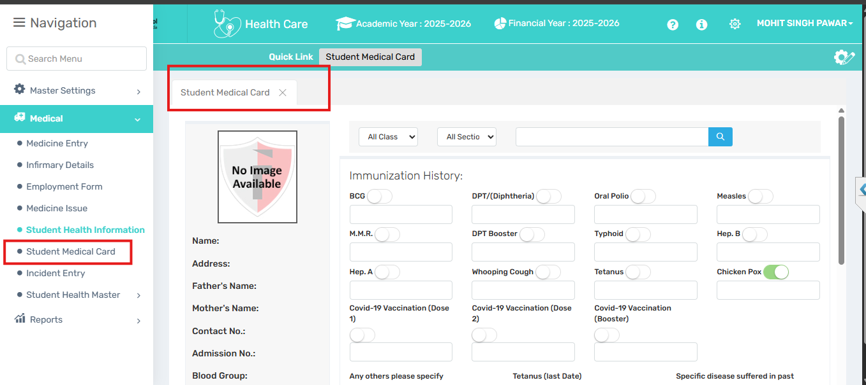
🎯 Purpose
The Student Medical Card is designed to record and manage a student’s complete immunization history, chronic ailments, past diseases, surgeries, allergies, and family medical background. It helps schools monitor student health, ensure timely vaccinations, and provide appropriate care in medical situations.
📍 Navigate to
Health Care → Medical → Student Medical Card
Field Description

Immunization History:
Toggle and text fields for vaccination records, including:
- BCG, DPT (Diphtheria), Oral Polio, Measles, M.M.R., Typhoid, Hep. A, Hep. B, DPT Booster, Whooping Cough, Tetanus, Chicken Pox, and Covid-19 Doses (1, 2 & Booster).

Additional Health Info:
- Any others please specify: For listing vaccines not already mentioned.
- Tetanus (last date): Date of the most recent tetanus vaccination.
- Specific disease suffered in past: Any notable past illnesses.
- Family History: Dropdown to specify inherited health issues.
- Chronic Ailments: Dropdown to select any long-term health conditions.
- Allergies if any: Known allergies of the student.
- Surgery undergone in the past: Details of any surgeries.
- Other diseases for which the child is on regular medication: Ongoing treatments.
✅ Use Case
The Student Medical Card helps schools maintain a comprehensive health profile for each student. It tracks immunization status, chronic conditions, past surgeries, allergies, and family medical history. This ensures timely medical care, supports health-based decision-making, and aids in emergency preparedness.
⚠ Important Notes
- Ensure all vaccination dates and details are accurate and up to date.
- Mention any allergies or chronic illnesses clearly.
- Use the "Other diseases" field to list ongoing treatments.
- Keep surgery and family history fields updated to support better care.
- Regularly review and update the card as the student’s health status changes.

2.7. INCIDENT ENTRY
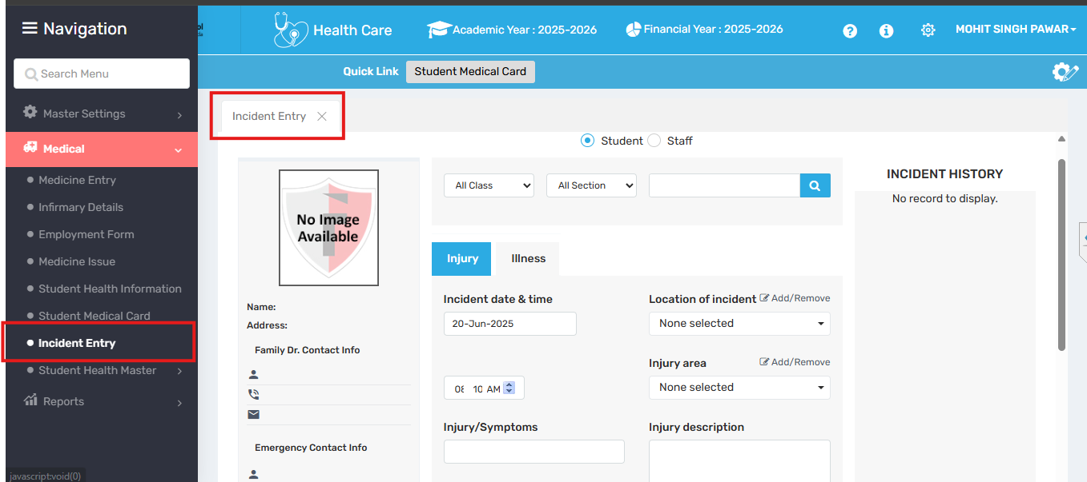
🎯Purpose:
The Incident Entry page is designed to log and manage medical incidents involving students or staff, such as injuries or illnesses that occur on campus. It provides a centralized record for future reference, safety analysis, and health interventions.

📍 Navigate to:
Health Care Module→Medical→Incident Entry
Field Description
- Incident date & time: When the injury/illness occurred.
- Location of incident: Where the incident happened (e.g., playground, classroom).
- Injury area: Body part affected (dropdown selection).
- Injury/Symptoms: Describe visible symptoms or signs.
- Injury description: Details about the nature of the injury.
- How it happened?: Explanation of how the incident occurred.
- Reported by: Staff member who reported the incident.
- Reported to: Staff member to whom the incident was reported.
- What happened next?: Action taken after the incident (e.g., sent home, treated).
- Treatment/Remark: Medical response or additional comments.
- Document (if any): Upload related files like medical reports or photos.

✅ Use Case

This form is used to record details of any health-related incident (injury or illness) involving a student. It ensures timely documentation, communication, and follow-up actions, providing a clear trail for internal records, health staff, and parents.

⚠ Important Notes
- Fill out the form immediately after the incident for accuracy.
- Include specific details of the incident and symptoms.
- Ensure the contact info is updated in case emergency communication is needed.
- Attach relevant documents or medical notes if available.
- Proper reporting helps in preventing future incidents and supports accountability.

2.8. STUDENT HEALTH MASTER

2.8.1. HEALTH UNIT MASTER
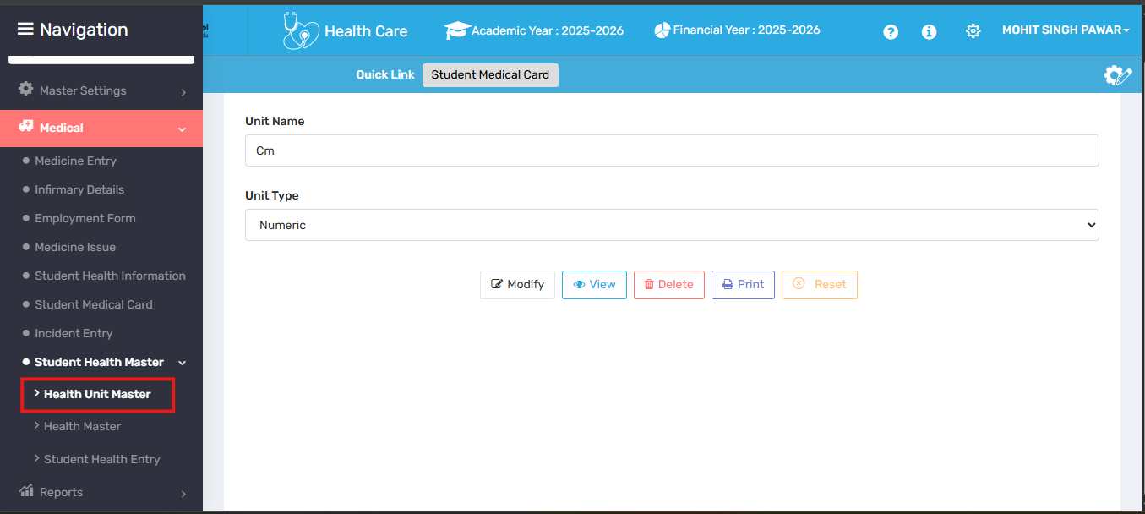
🎯Purpose:
The Health Unit Master page is used to define and manage measurement units (e.g., cm, kg, bpm) for medical data entries like height, weight, temperature, etc. It ensures standardization and consistency across all student and staff health records.

📍 Navigate to:

Medical → Student Health Master → Health Unit Master

Field Description
Unit Name: Name of the health-related unit (e.g., Temperature, Blood Pressure, Dosage).Unit Type: Category or type of the unit (selected from a predefined dropdown list).

✅ Use Case
The Health Unit Master is used to define and manage standardized health measurement units in the system. These units are later used across medical records for consistency in tracking vitals, prescriptions, and treatment details.

⚠ Important Notes
- Ensure unit names are clear and medically relevant.
- Select the correct unit type to avoid mismatches during data entry.
- Maintaining consistent unit definitions supports accurate reporting and patient care.
- Use the View, Print, and Reset options for review and adjustments.

2.8.2. HEALTH MASTER
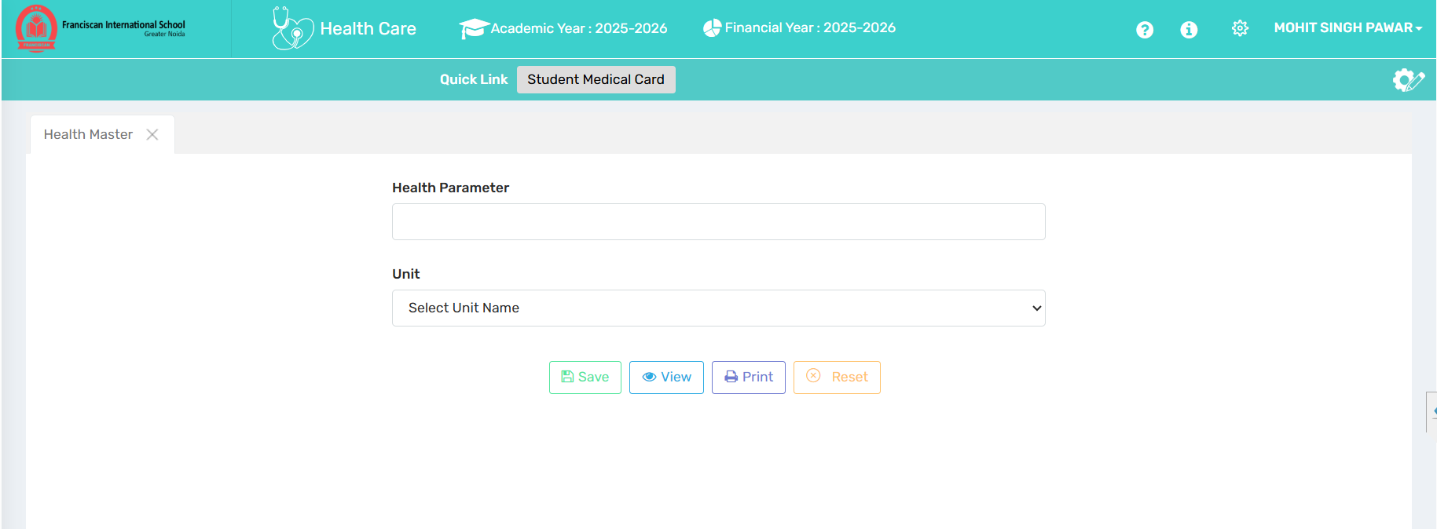

🎯Purpose:
The Health Master page is used to define and manage health parameters such as Weight, Height, Vision, BMI, etc. It allows the system to track standardized medical fields linked with the appropriate measurement units (e.g., Kg, cm, bpm) for health data collection.

📍 Navigate to:

Medical → Student Health Master → Health Master
Field Description
- Health Parameter: The specific health attribute to be monitored (e.g., Height, Weight, Blood Pressure).
- Unit: The unit of measurement related to the selected health parameter (e.g., cm, kg, mmHg), chosen from a dropdown.

✅ Use Case
The Health Master is used to define various health parameters and their respective measurement units. These parameters are later used in student health profiles and reports for accurate health monitoring and data consistency.

⚠ Important Notes
- Only valid and measurable health parameters should be entered.
- Units must align appropriately with the type of parameter (e.g., don’t use “kg” for blood pressure).
- Ensure consistency, as these entries affect health records and reports across the system.
- Use Save to store data, View to review entries, Print for documentation, and Reset to clear inputs.

2.8.3 STUDENT HEALTH ENTRY

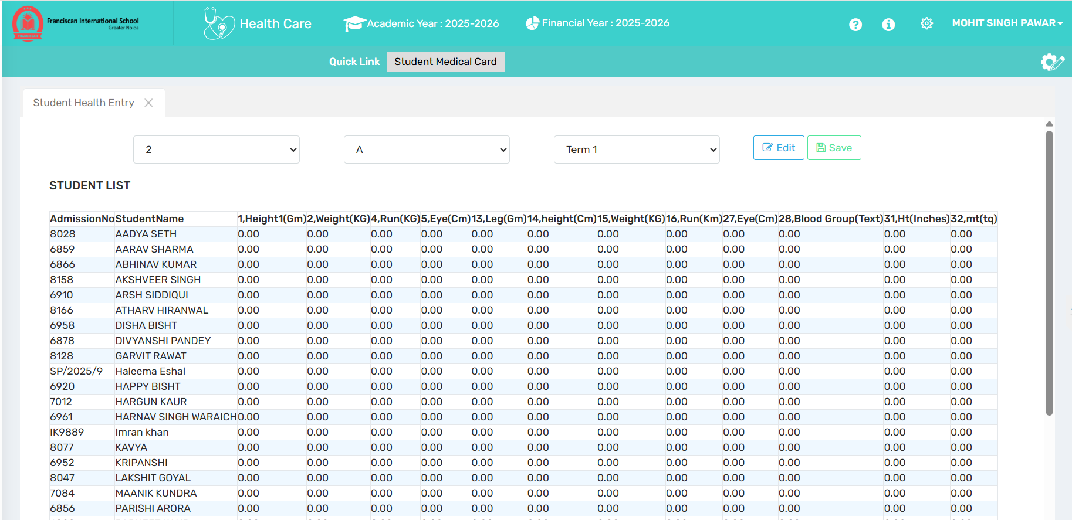

🎯 Purpose
This tab is designed to record and manage various health parameters of students such as height, weight, eyesight, running ability, and blood group, across different terms in bulk.
📍 Navigate to

Medical → Student Health Master → Student Health Entry
✅ Use Case
The Student Health Entry module is used to record and track students’ physical health parameters like height, weight, vision, blood group, and fitness metrics. It helps the school monitor student health over time, identify health issues early, and generate medical reports for parents, teachers, or healthcare professionals.
⚠ Important Notes
- Ensure data is entered accurately and consistently for all terms.
- Blood group and medical data must be updated from verified sources only.

3. REPORTS

3.1. MEDICAL ENTRY REPORT

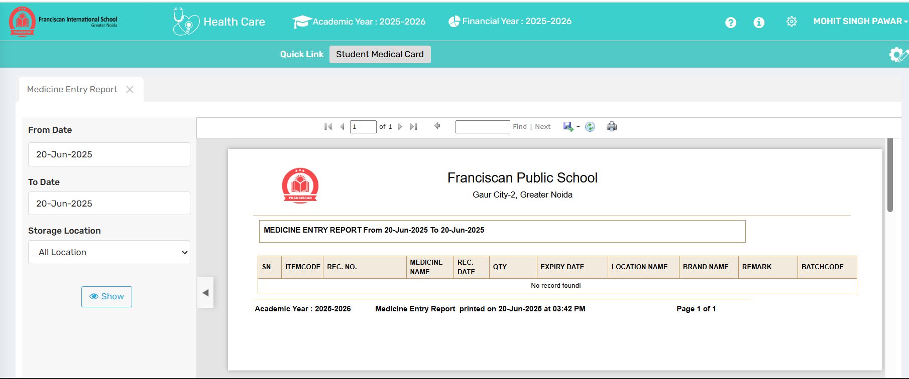
🎯 Purpose
To generate and view records of medicines added to school inventory within a specific date range.
📍 Navigate to

Heath Care→ Reports → Medical Entry Report
Field Description
- From Date / To Date: Select the period for which you want to view medicine entries.
- Storage Location: Filter the report by a specific location.
- Show: Button to generate the report.
- Report Table: Displays details like medicine name, quantity, expiry, brand, location, etc.
✅ Use Case
Used by school health staff or admin to track incoming medicine stock, monitor expiry, and keep a log of medicines received across locations.
⚠ Important Notes
- Make sure the correct date range is selected; otherwise, the report may show “No record found.”
- Ensure medicine entries are logged beforehand through the medicine entry module.
- Useful for inventory audit, restocking, and compliance purposes.

3.2. MEDICINE STOCK REPORT NEW
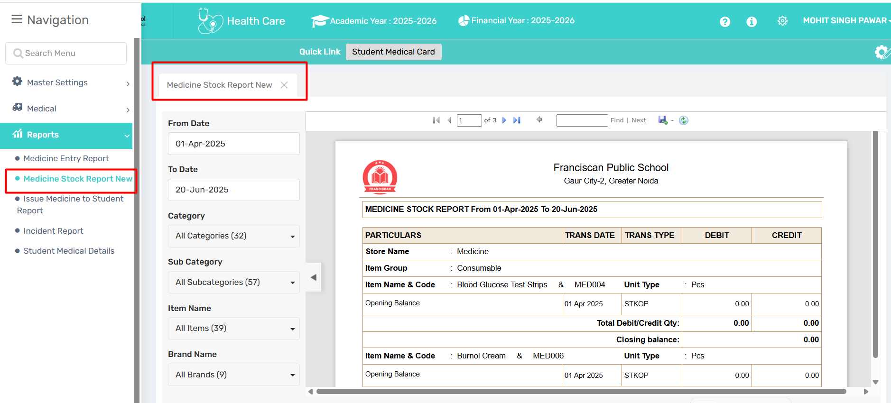
🎯 Purpose
To track and review medicine stock movements (debit/credit) and current inventory status over a selected time period.
📍 Navigate to:
Health Care →Reports →Medicine Stock Report New
Field Description
- From Date / To Date: Specify the duration for the report.
- Category / Subcategory: Filter items by their classification.
- Item Name / Brand Name: Further refine the report by specific medicine or brand.
- Report Table: Displays opening balance, transaction details (date/type), quantity debited/credited, and closing balance.
✅ Use Case
Used by school medical/admin staff to monitor stock levels, identify usage trends, and ensure timely reordering of medicines and consumables.
⚠ Important Notes
- Make sure item master and transaction entries are properly updated for accurate reporting.
- Can be used during internal audits and compliance checks.
- Helps detect discrepancies or unusual consumption patterns.
3.3. ISSUE MEDICINE TO STUDENT REPORT
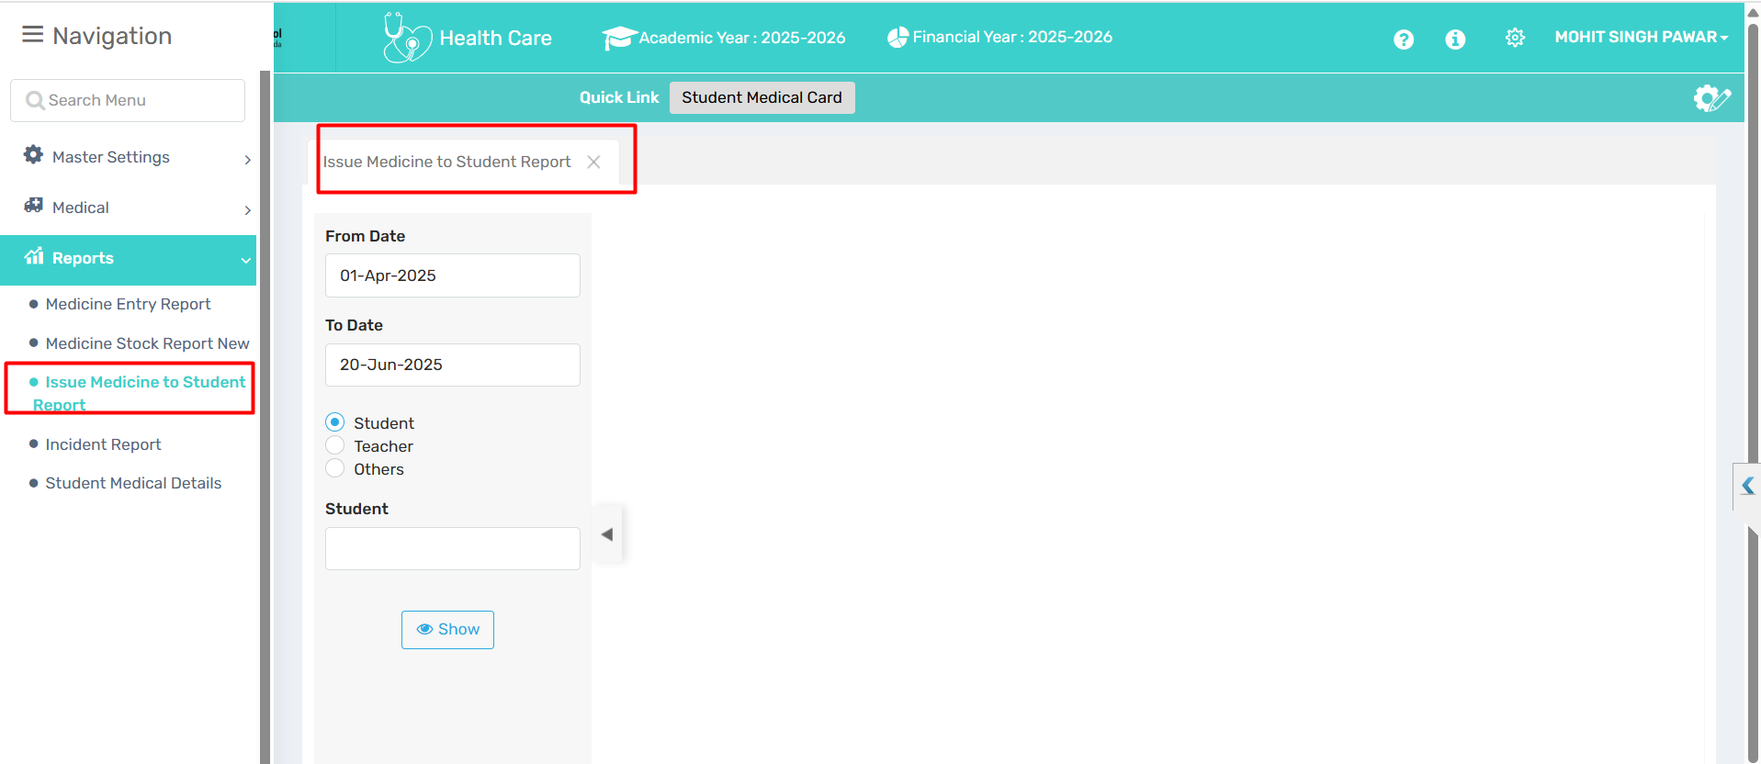
🎯 Purpose
To track and report medicine issued to students, teachers, or others within a specified time range.
📍 Navigate to
Health Care →Reports →Issue Medicine to Student Report

Field Description
- From Date / To Date: Set the time period for the report.
- Student / Teacher / Others: Select the recipient category.
- Student: (Optional) Choose a specific student name if "Student" is selected.
- Show Button: Generates the report based on selected filters.
✅ Use Case
Used by medical or admin staff to review medical issuance history, ensure proper medicine distribution, and generate reports for internal tracking or audits.
⚠ Important Notes
- Make sure issuance entries are recorded correctly for accurate reporting.
- Useful for monitoring frequent medicine usage and detecting patterns.
- Helps support student health records and inventory management.
3.4. INCIDENT REPORT

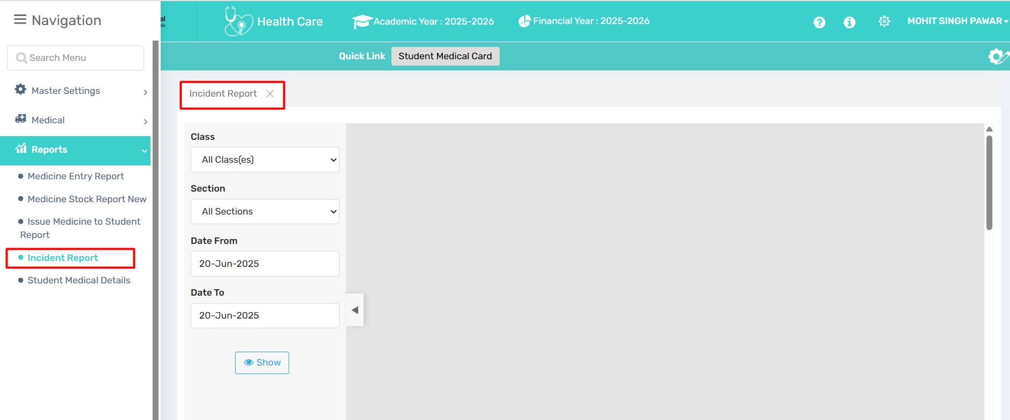
🎯 Purpose
To view and track incidents related to students’ health, accidents, or emergencies within a specified date range and class/section.
📍 Navigate to
Health Care →Reports →Incident Report
Field Description
- Class: Select class or "All Classes" to include all.
- Section: Choose specific section or "All Sections."
- Date From / Date To: Define the date range for incident reports.
- Show Button: Click to display the incident data.
✅ Use Case
Used by school medical/admin staff to review past health or injury incidents, for documentation, follow-up, and reporting to parents or authorities if needed.
⚠ Important Notes
- Ensures timely review of critical health-related events.
- Helps in maintaining a safe school environment.
- Data may be used for preventive measures and audits.
3.5. STUDENT MEDICAL DETAILS
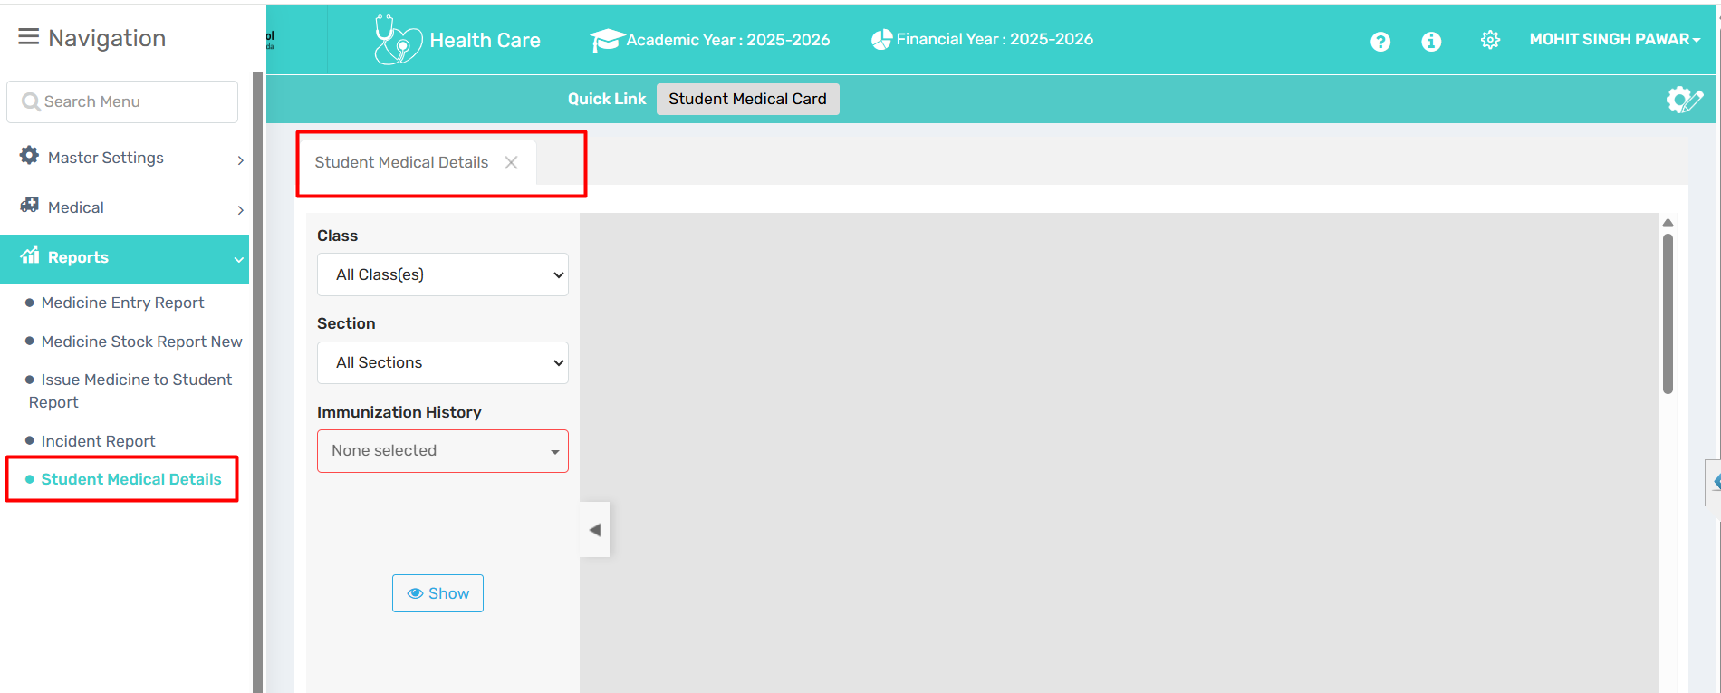
🎯 Purpose
To view students' immunization and medical records based on class, section, and vaccination history.
📍 Navigate to
Health Care →Reports →Student Medical Details
Field Description
- Class: Select a specific class or view all.
- Section: Filter by particular section or all sections.
- Immunization History: Choose specific immunization records (e.g., Polio, Hepatitis) to check students who have received or missed them.
- Show Button: Displays the medical details based on selected filters.
✅ Use Case
Used by school health staff to monitor vaccination status and medical history of students for health compliance and safety tracking.
⚠ Important Notes
- Ensure immunization data is regularly updated.
- Useful for preparing health compliance reports.
- Can help in identifying students who may need follow-up or reminder for vaccinations.

