 Franciscan Solutions Pvt Ltd

Library Manager Manual
1- Master Setting
1.1 Change Academic Year

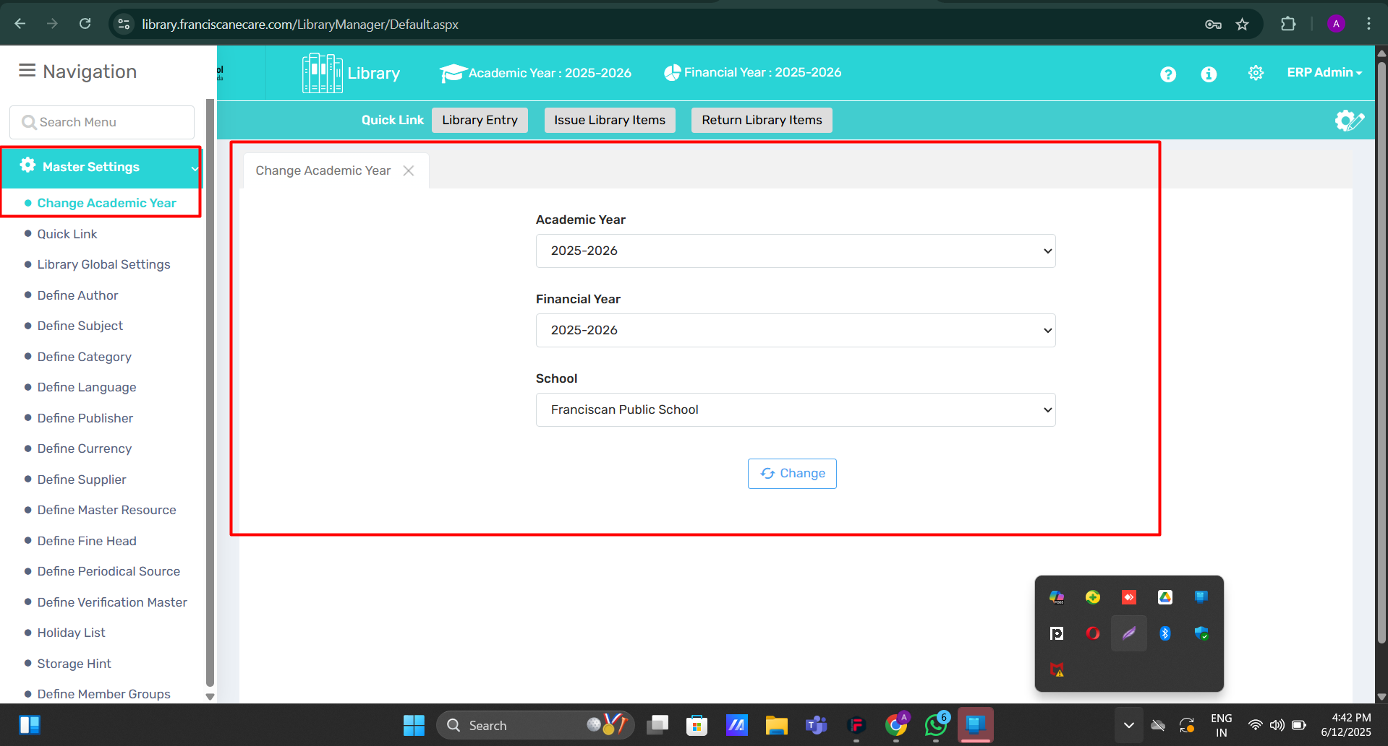🔍 Purpose
This page is designed to provide user-specific control over academic year selection. Changing the academic year here:
- Only impacts the logged-in user's view.
- Does NOT alter the system-wide academic year for the school or for other users.

🧭 Where to Find It
Navigate to:
Library Module < Master Setting < Change Academic Year

🖥️ Field Discription
- Dropdown Menu (Academic Year):
Select the desired academic session from the list (e.g., 2025–2026, 2024–2025, etc.).
- Change Button:
Applies the selected academic year for the current user session.
- Reset Button:
Reverts the selection back to the default academic year (usually the currently active year in the system).
✅ Use Case (Library Module)
If a librarian, teacher, or admin wants to:
- View book issue and return history for a previous academic year
- Track fines or overdue records from earlier sessions
- Check book availability or circulation data based on a specific year
- Generate session-wise library usage reports
...they can simply change the academic year using this page without affecting data views for other users or modules.

⚠️ Important Notes
- This action is session-specific and user-specific.
- No global or permanent change is made to the overall software settings.
- After logging out, the system may reset to the default academic year unless the selection is stored per user profile.
1.2 Quick Links-
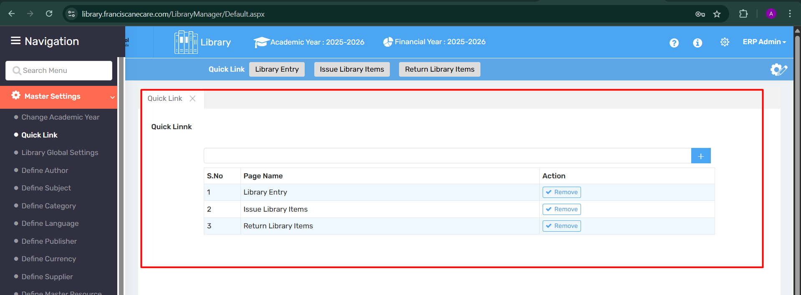

🔍Purpose
The Quick Link feature allows users to create shortcuts for frequently used pages or actions in the Library module. This enhances workflow efficiency by reducing navigation time and making commonly used features instantly accessible.

📍 Where to Find It
- Menu Path: Master Settings > Quick Link

🖥️ Field Discription
Element | Description
Quick Link Tab | Shows all the shortcuts currently defined.
+ Button | Allows users to add new quick links to desired pages.
Page List Table | Displays added quick links with Serial No, Page Name, and Action.
Remove Button | Lets the user delete an existing quick link shortcut.
Shortcut Buttons (Top) | Buttons like Library Entry, Issue Library Items, and Return Library Items for one-click access.

🧑‍💼 Use Case
The Quick Link feature is ideal for:
- Librarians who repeatedly access certain pages.
- Streamlining daily library tasks like book entries, issuing, and returns.
- Minimizing the need to navigate through multiple menu levels.

⚠️ Important Notes
- Only frequently used pages should be added as Quick Links to avoid clutter.
- Removing a link from the list only deletes the shortcut—not the functionality.
- Quick Links are user-specific and can be customized as per role/access level.

1.3 Library Global Settings -

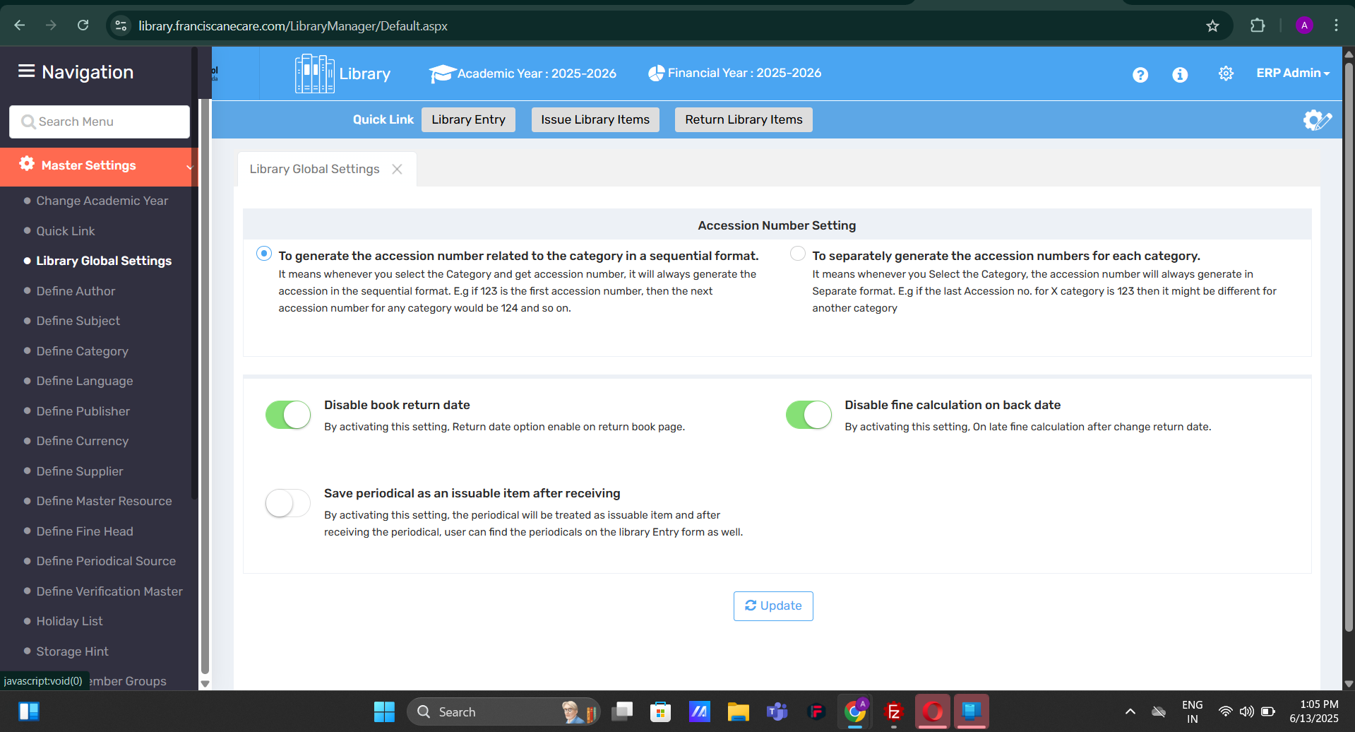

🔍 Purpose
The Library Global Settings page provides configurable options that define how certain key behaviors function within the library system. These settings help streamline operations related to book entry, issuing, returning, fines, and periodical management, ensuring the system works as per your institution’s policies.

🧭 Where to Find It
Go to:
Library Module → Master Settings → Library Global Settings

🖥️ Field Discription
- 📚 Accession Number Setting
  - Option 1: Generate the accession number related to the category in a sequential format
    - When selected, the system generates a continuous series of accession numbers across all categories (e.g., 123, 124, 125...).
  - Option 2: Separately generate accession numbers for each category
    - Generates independent accession number sequences for each category. (e.g., Category A: 123, Category B: starts from 001, etc.)
- 📅 Disable Book Return Date
  - Enables/disables the return date option on the return book page.
  - When ON: Return date can be selected/modified while returning the book.
  - Purpose: Useful when adjusting return records or handling special return cases.
- 💰 Disable Fine Calculation on Back Date
  - When enabled, no late fine is calculated if the return date is changed to a past date.
  - Purpose: Avoids incorrect fine imposition during data corrections or retroactive entries.
- 🗞️ Save Periodical as an Issuable Item After Receiving
  - When this setting is enabled, received periodicals will be treated like books and can be issued to users.
  - The periodicals appear in the Library Entry list as issuable items.
  - Purpose: Enables circulation of periodicals like magazines or journals if your institution allows them to be borrowed.
- 🔄 Update Button
  - Applies and saves any changes made to the global settings.

✅ Use Cases
- A librarian wants to maintain separate accession number ranges for different book categories.
- Admin wants to allow users to modify return dates during book return for correction purposes.
- An institute decides not to penalize students for back-dated returns in special circumstances.
- Schools or colleges that allow magazines or journals to be issued like regular books.

⚠️ Important Notes
- Changes made here apply system-wide and affect all users of the Library Module.
- These settings should be reviewed and updated by authorized personnel only.
- Always click the Update button to save any configuration changes.
- Misconfiguration may lead to inconsistent records or fines, so verify settings carefully.

1.4 Define Author
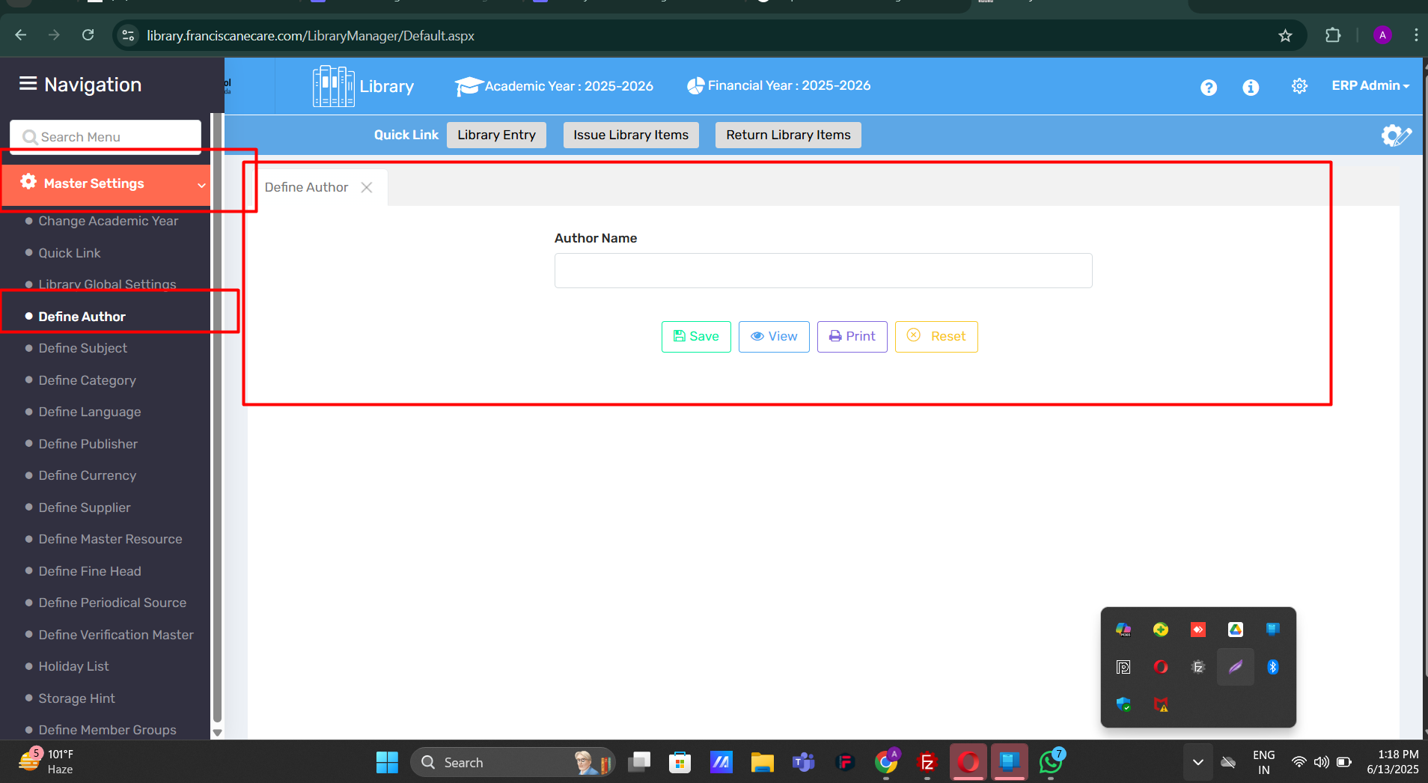

🔍 Purpose:
The Define Author section allows library administrators to create and manage a list of authors. This setup is essential for cataloging books accurately by linking them with their respective authors, improving searchability and organization within the system.

🧭 Where to Find It:
- Navigate to: Library Module → Master Settings → Define Author

🖥️ Field Discription
Element | Description
Author Name Field | A text input box to enter the author's name.
✅ Save Button | Saves the entered author name into the system.
👁️ View Button | Displays a list of all defined authors.
🖨️ Print Button | Prints the list of defined authors.
🔄 Reset Button | Clears the current input field.

✅ Use Cases :
Suppose the librarian is entering a new book into the library system. To maintain consistency and accuracy, the author must already exist in the system. This page enables the librarian to add a new author if it's not already defined.

⚠️ Important Notes:
- Avoid duplicate entries; check using the View option before adding a new author.
- Author names should be entered in a standard format (e.g., "J.K. Rowling", not "Rowling, J.K.") to ensure uniformity.
- This is a mandatory master field required for book entry, issuing, and searching.

1.5 Define Subject
The system allows users to create and manage subject names based on their library or school needs. Users can manually enter subjects like Science, History, or Literature, which help in organizing and classifying books properly. This ensures that the library is in line with the school’s curriculum or categorization system.
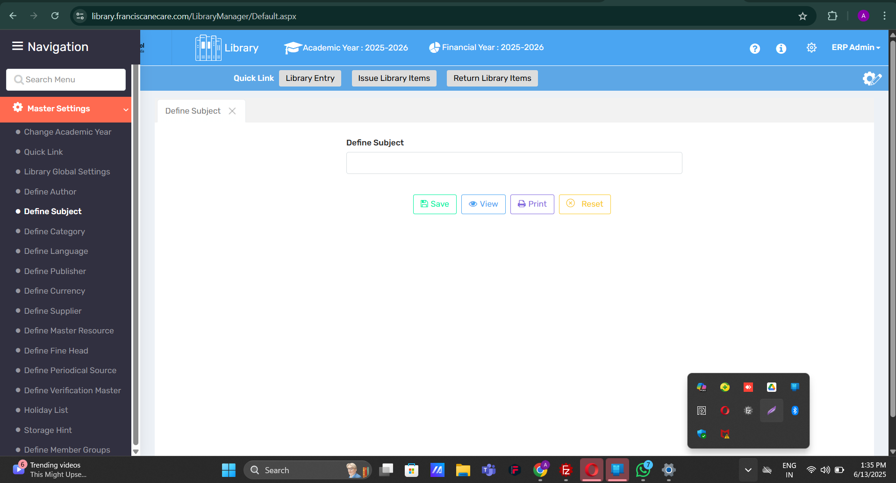

🔍 Purpose:
The "Define Subject" feature allows the user to manually create and manage subjects used in the library database. This helps in categorizing books and other resources by academic subjects (e.g., Mathematics, Physics, History) for better organization and searchability.

📍 Where to Find It:
Library Module → Master Settings → Define Subject

🖥️ Field Discription
- Text Field (Define Subject):
  - A single input field where the subject name is entered.
- Action Buttons:
  - 🟩 Save – Stores the newly entered subject in the system.
  - 🟦 View – Displays a list of previously defined subjects.
  - 🟪 Print – Prints the list of defined subjects for record-keeping or review.
  - 🟨 Reset – Clears the text input field.

📌 Use Case:
Used by Library Admins or ERP Admins to:
- Add new subject categories for book entries.
- Maintain standardized subject naming across the library system.
- Facilitate accurate filtering, searching, and reporting.

⚠️ Important Notes:
- Avoid duplication: Check existing subjects using the View option before adding.
- Enter clear and commonly used subject names.
- This setup impacts how books are categorized in the library inventory, so changes

1.5 Define Category
This feature allows the user to define and manage different categories for library items

✅ Purpose:
The “Define Category” option allows users to create custom categories for library items. Categories help in grouping books and resources based on type, genre, or content (e.g., Fiction, Reference, Biography, Textbook), making them easier to manage, locate, and report on.

📍 Where to Find It:
- Library Module → Master Settings → Define Category

🖥️ Field Discription
- Text Field (Define Category):
  - A single input field where the user types the name of the category to be created.
- Action Buttons:
  - 🟩 Save – Adds the entered category to the system.
  - 🟦 View – Displays a list of all existing categories.
  - 🟪 Print – Prints the list of defined categories for reference.
  - 🟨 Reset – Clears the input field for fresh entry.

📌 Use Case:
Used by Library Admins to:
- Classify books based on content type (e.g., Novels, Study Material, Encyclopedias).
- Streamline search, shelving, and reporting.
- Maintain consistency in how resources are grouped in the system.

⚠️ Important Notes:
- Make sure the category name is clear and widely understood.
- Avoid duplicates by checking the View list before adding a new category.
- These categories will reflect in other library sections during book entry or reporting.
- should be done carefully.
1.6 Define Language -
This user is allowed to define Language.
🎯 Purpose:
The Define Language feature allows users to manually add languages into the system. These entries help in classifying and organizing library items based on the language in which they are written.

📍 Where to Find It:
Go to the Library Module → under Master Settings, click on Define Language.

🧩Field Discription :
- 📝 Text Box: Enter the name of the language (e.g., English, Hindi, French).
- 💾 Save: Stores the new language.
- 👁️ View: Displays all previously defined languages.
- 🖨️ Print: Prints the list of defined languages.
- 🔄 Reset: Clears the input field.

📘 Use Case:
This feature is useful in schools or institutions that maintain a multilingual collection of books. By tagging books with specific languages, users can filter and locate them easily.

⚠️ Important Notes:
- Avoid duplicates (e.g., “Hindi” vs “hindi”).
- At least one language must be defined to classify books effectively.
- Enhances accuracy in search and cataloging.

1.7 Define Publisher-
In this user can define the publisher.

🔍 Purpose
The Define Publisher option allows users to manually enter and manage the names of book publishers. This helps maintain a consistent and searchable record of publishers for all library items, improving catalog accuracy and reporting.

📍 Where to Find It
Library Module → Master Setting→ Define Publisher

🧩 Field Discription
- 📝 Input Field: Type the name of the publisher (e.g., Penguin Books, Oxford University Press).
- 💾 Save: Adds the publisher to the library database.
- 👁️ View: Displays a list of all defined publishers.
- 🖨️ Print: Allows printing the publisher list.
- 🔄 Reset: Clears the field for a new entry.

📘 Use Case
Useful when cataloging books, ensuring that each entry has the correct publisher linked. This is especially beneficial for schools with a wide variety of books from multiple sources, as it helps in filtering and organizing inventory efficiently.

⚠️ Important Notes
- Enter publisher names accurately to avoid duplicates.
- Consistency in naming (e.g., "Macmillan" vs. "MacMillan") is essential.
- Helps generate reports sorted by publisher.

1.7 Define Currency
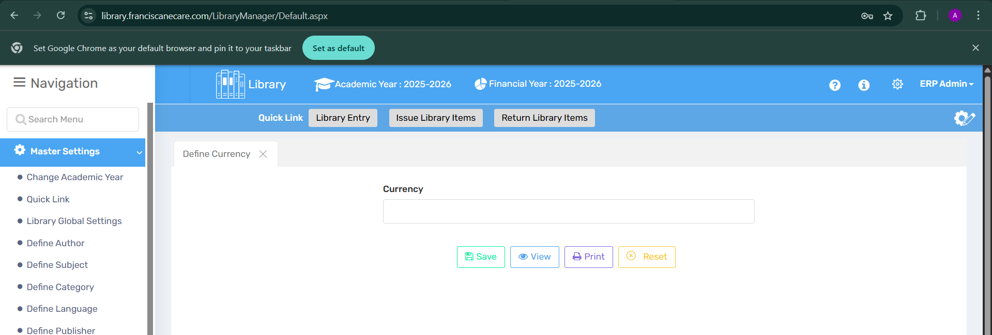

🔍 Purpose
The "Define Currency" function allows users to configure the currency used for library-related financial records such as fines, book costs, supplier transactions, and more. This ensures consistency across all monetary entries.

📍 Where to Find It
- Path: Library Module > Master Settings > Define Currency
- Located in the left-hand sidebar under the Master Settings section.

🧩Field Discription
🔹 Element | 📝 Description
Currency Field | A textbox where the user types the desired currency name or code (e.g., INR, USD).
Save Button 🟩 | Stores the entered currency to the system.
View Button 👁️ | Displays a list of already defined currencies.
Print Button 🖨️ | Allows the user to print the currency list.
Reset Button 🔁 | Clears the input field to allow fresh entry.

💼 Use Case
A school librarian wants to ensure all fine-related entries reflect the local currency. By defining the currency here (e.g., "INR"), all related reports and transactions in the library system automatically adopt this format.

⚠️ Important Notes
- Ensure only standard or relevant currency codes are used (e.g., INR, USD, EUR).
- Defining the currency once is typically sufficient unless the system allows multiple or regional settings.
- This configuration may impact reports and financial summaries, so changes should be made cautiously.

1.10 Define Supplier-

🎯 Purpose
The Define Supplier feature allows users to store and manage detailed information about vendors who supply books and other library materials. This ensures smooth procurement, tracking, and communication with library vendors.

🔍 Where to Find It
📂 Navigation Path:
Library Module <Master Setting < Define Supplier

🧩 Field Discription
🔢 Field/Element | 📄 Description
🏷️ Supplier Name | Enter the official name of the book/material supplier.
📬 Contact Address | Add the physical address of the supplier for correspondence.
📧 Contact Email | Enter the supplier’s email address for communication and orders.
📞 Contact Phone | Provide the phone number to enable direct contact.
💾 Save | Saves the supplier information to the database.
👁️ View | Displays a list of already defined suppliers.
🖨️ Print | Prints the list or specific supplier details.
♻️ Reset | Clears the entered data for fresh input.

💡 Use Case
- Schools can register multiple book suppliers.
- Track supplier history for purchases.
- Communicate easily with vendors for reordering or queries.
- Ensure accountability by linking suppliers to invoices and receipts.

📝 Important Notes
- All fields should be filled with accurate and up-to-date information.
- Avoid duplication by checking existing suppliers using the View option.
- Changes in contact details must be promptly updated to avoid communication gaps.
- Printing supplier details can be useful during audits or for physical documentation.

1.10 Define Master Resource
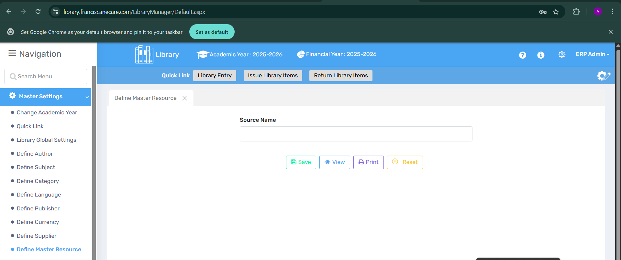

🔍 Purpose
The Define Master Resource feature is used to categorize and manage the various sources from which library resources are acquired, such as donations, purchases, gifts, or institutional contributions. This helps in tracking the origin of books and materials in the library inventory.

🔍 Where to Find It
📂 Navigation Path:
Library Module → Master Settings → Define Master Resource

🧩 Field Discription
🔢 Field/Element | 📄 Description
📝 Source Name | Enter the name of the resource source (e.g., Donation, Purchased, Government Supply).
💾 Save | Saves the entered source name.
👁️ View | Displays a list of existing resource sources.
🖨️ Print | Prints the list of defined master resources.
♻️ Reset | Clears the form for new entry.

💡 Use Case
- Schools can record and classify how each book/item entered the library.
- Useful for audits and reporting — especially to distinguish purchased items from donated ones.
- Supports transparency and accountability in library inventory management.

📝 Important Notes
- Ensure consistency in naming (e.g., always use “Donation” instead of sometimes “Donated”).
- Avoid duplicate source names by reviewing existing entries using the View option.
- Recommended before entering new books so that acquisition sources can be selected accurately.

1.11 Define Fine Head- In define fee head we can define the Library book fine.
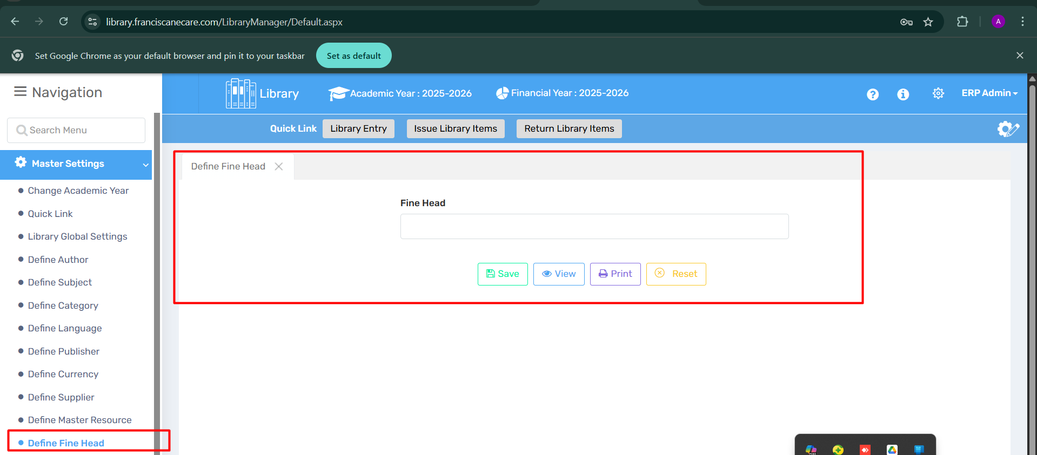

🔍 Purpose
The Define Fine Head section is used to set up categories for fines in the library system. These heads represent different types of penalties, such as late return, lost book, or damaged book, and help in organizing and applying fines appropriately.

🔍 Where to Find It
📂 Navigation Path:
Library Module → Master Settings → Define Fine Head

🧩 Field Discription
🔢 Field/Element | 📄 Description
🏷️ Fine Head | Enter a title for the fine type (e.g., "Late Return", "Lost Book").
💾 Save | Saves the entered fine head.
👁️ View | Displays all existing fine heads.
🖨️ Print | Prints the list of defined fine heads.
♻️ Reset | Clears the form for a new entry.

💡 Use Case
- Create distinct categories for applying fines in different scenarios.
- Allows for easy identification and reporting of fine types.
- Ensures standardization across all library fine entries.
- Helpful during fee collection or dispute resolution.

📝 Important Notes
- Always use clear and descriptive names for fine heads.
- Avoid duplicating similar fine heads with slightly different names.
- Fine heads must be defined before configuring fine policies or rules elsewhere in the system.

1.12 Define Periodical Source
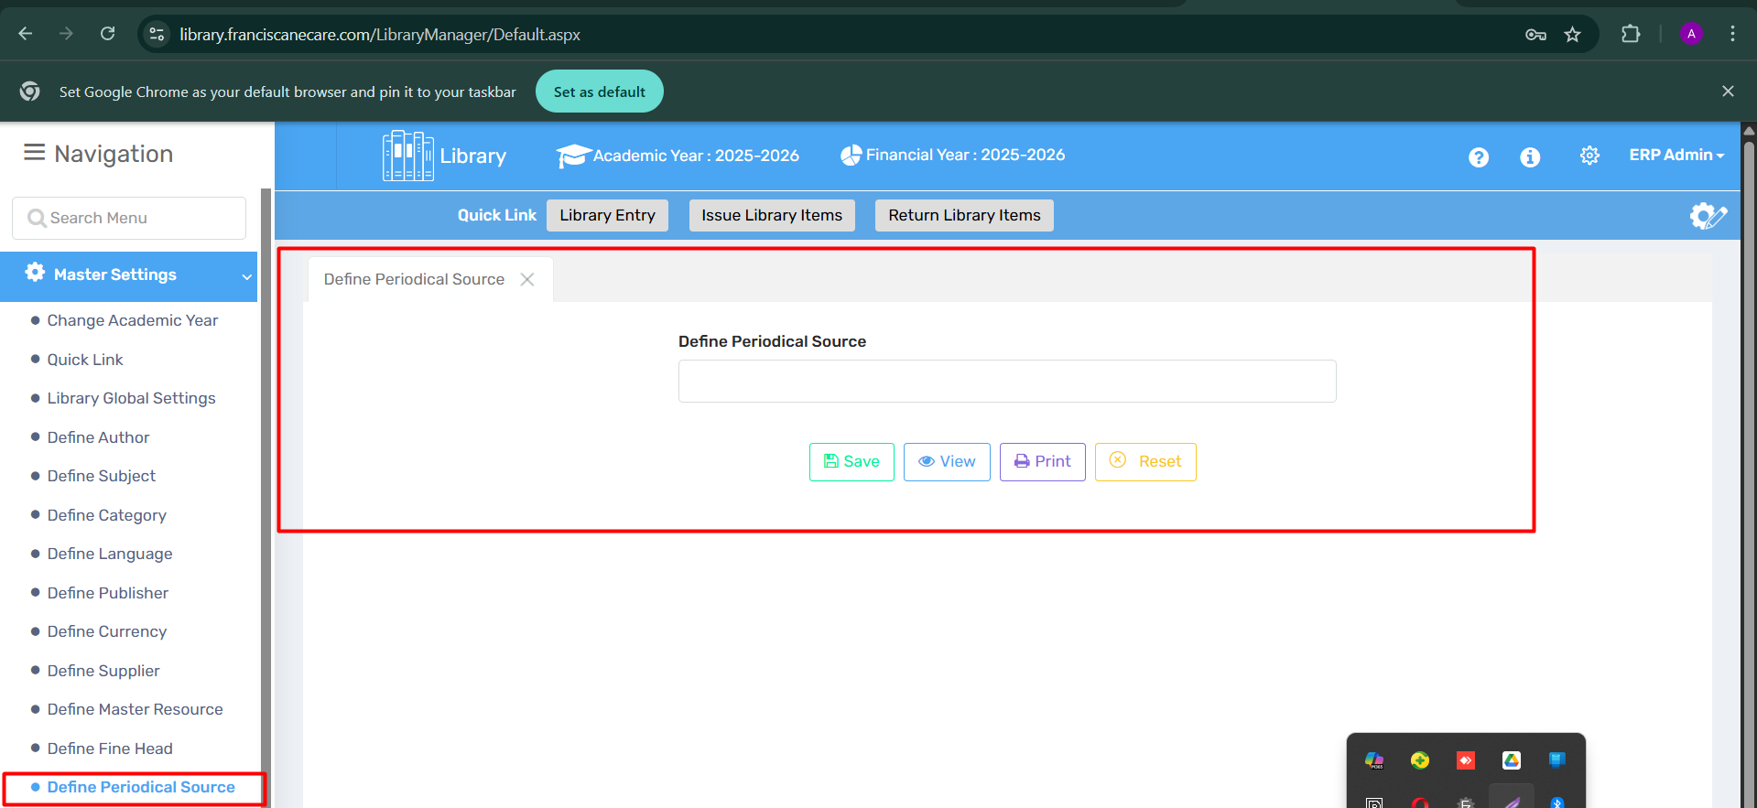

🔍 Purpose
The Define Periodical Source section allows users to register sources of periodical materials—such as magazines, journals, and newspapers. This helps in tracking their origin, publisher, or vendor, and facilitates organized cataloging and management of recurring library materials.

🔍 Where to Find It
📂 Navigation Path:
Library Module → Master Settings → Define Periodical Source

🧩 Field Description
🔢 Field/Element | 📄 Description
📰 Define Periodical Source | Enter the name of the journal/magazine source (e.g., "The Hindu", "IEEE", "Nature Publications").
💾 Save | Saves the entered source name.
👁️ View | Displays the list of previously defined periodical sources.
🖨️ Print | Prints the list for record-keeping.
♻️ Reset | Clears the input field for fresh entry.

💡 Use Case
- Define periodical sources once and reuse across subscriptions.
- Enables efficient tracking of recurring materials from specific providers.
- Supports reports generation for periodical transactions.
- Helps maintain consistency and accuracy in periodical records.

📝 Important Notes
- Avoid creating multiple entries for the same source under slightly different names.
- Ensure spelling and naming conventions are standardized across records.
- Define periodical sources before recording subscriptions or library receipts.

1.12 Define Verification Master-
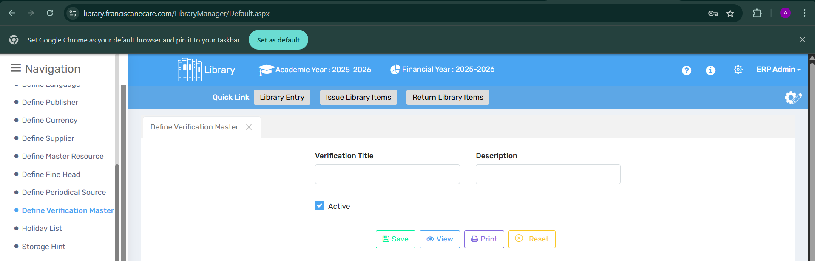

🔍 Purpose
The Define Verification Master feature allows the library admin to create custom verification stages or checkpoints (e.g., “Principal Approved”, “Librarian Verified”) to ensure tracking and validation of library items or processes. This helps maintain accountability, audit readiness, and process integrity.

📍 Where to Find It
📂 Navigation Path:
Library Module → Master Settings → Define Verification Master

🧩 Field Discription
🔢 Element | 📄 Description
🏷️ Verification Title | Title or name of the verification (e.g., “Librarian Check”, “Audit Verified”).
📝 Description | Additional details or notes about the verification stage.
☑️ Active Checkbox | Enable or disable the verification title. Useful for temporary or seasonal verifications.
💾 Save | Save the verification title and description.
👁️ View | View existing verification titles.
🖨️ Print | Print the list for audits or records.
♻️ Reset | Clear current entry fields.

💡 Use Case
- To define custom approval levels in the library transaction process.
- Helps manage a multi-level checking system before issuing/returning high-value or rare items.
- Supports workflow documentation and internal control mechanisms.
- Can be referred to during stock verification or audits.

📝 Important Notes
- Ensure that titles are clear and specific to avoid confusion during verification.
- Only active titles are shown in workflows—keep unused ones inactive.
- Can be reused across different academic years once defined.
1.13- Define Holiday List -
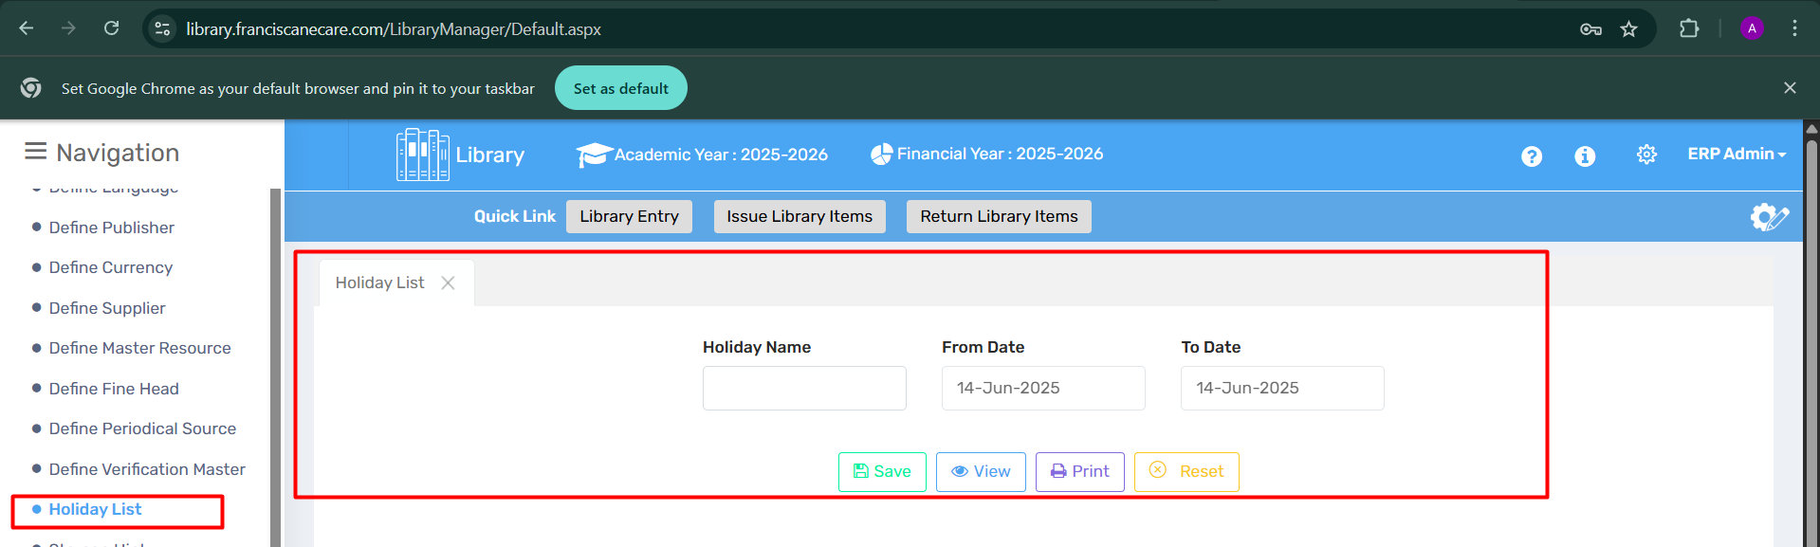

🔍 Purpose
The Define Holiday List feature allows the library admin to define holidays when the library will remain closed or unavailable for transactions. This ensures proper planning for library activities and helps the team avoid scheduling errors during these periods.

📍 Where to Find It
📂 Navigation Path:
Library Module → Master Settings → Holiday List

🧩 Field Discription
🔢 Element | 📄 Description
🏷️ Holiday Name | Name of the holiday (e.g., "Eid al-Adha", "New Year's Day").
📅 From Date | The starting date of the holiday period.
📅 To Date | The ending date of the holiday period.
💾 Save | Save the holiday details.
👁️ View | View the list of holidays already defined.
🖨️ Print | Print the holiday list for records or distribution.
♻️ Reset | Clear all entered fields.

💡 Use Case
- To create and maintain an accurate list of holidays for the library, ensuring that it is properly reflected in the library system.
- Helps library staff and students keep track of when the library is closed and plan activities accordingly.
- Can be integrated with library scheduling tools for advanced planning.

📝 Important Notes
- Multiple holidays can be defined for each year, ensuring full coverage.
- Only active holidays are reflected in the system during library transactions.
- Ensure that holiday dates do not overlap with other critical library events to avoid confusion.

1.14 Define Storage Hint- 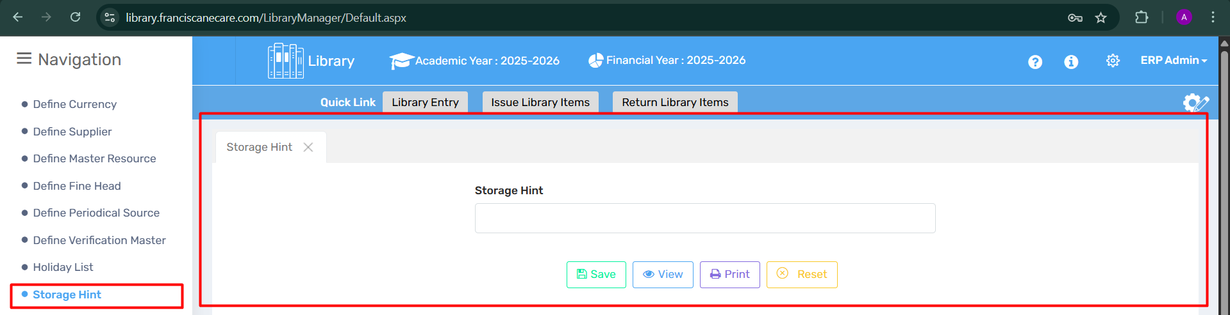

🔍 Purpose
The Storage Hint feature helps users provide brief location-based or categorization hints for storing books and other library materials. It ensures that physical resources are placed systematically and retrieved efficiently.

📍 Where to Find It
📂 Navigation Path:
Library Module → Master Settings → Storage Hint

🧩 Field Discription
🔢 Element | 📄 Description
🗂️ Storage Hint | Text field to enter a storage identifier or location cue (e.g., "Rack A3", "Science Section", "Top Shelf").
💾 Save | Save the entered storage hint.
👁️ View | View existing storage hints.
🖨️ Print | Print the list of defined hints.
♻️ Reset | Clear the input field.

💡 Use Case
- Helps library staff and students locate books faster using consistent naming.
- Can be used to categorize storage areas like sections, shelves, or racks.
- Enhances inventory tracking by linking storage hints with books.

📝 Important Notes
- Use clear and short names for easy understanding and quick recall.
- These hints can be reused across resources to maintain consistency.
- Avoid special characters or ambiguous naming.

1.15 Define Member Group- 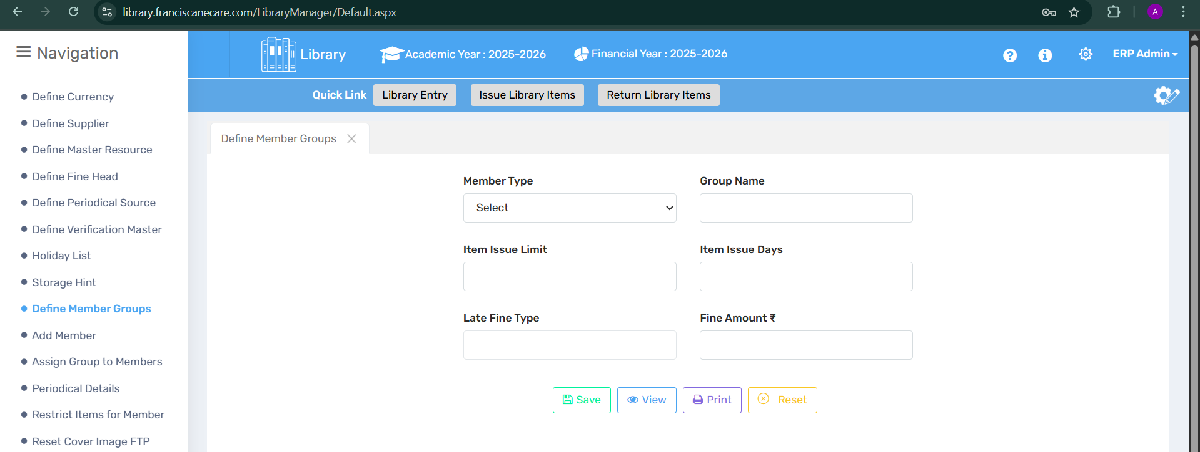

🔍 Purpose
The Define Member Groups feature allows the creation and management of different member categories—such as students, staff, or guests—with specific borrowing rules like item limits, issue duration, and fines. This helps in applying customized library policies for each group.

📍 Where to Find It
📂 Navigation Path:
Library Module → Master Settings → Define Member Groups

🧩 Field Discription
🔢 Element | 📄 Description
🧑‍🎓 Member Type | Dropdown to select the type (e.g., Student, Teacher, Admin Staff).
🏷️ Group Name | Custom name for the group (e.g., “Class 6 Students”, “Science Faculty”).
📚 Item Issue Limit | Maximum number of items allowed per member in this group.
📅 Item Issue Days | Number of days an item can be issued before it's due for return.
💰 Late Fine Type | Type of fine applicable (per day, fixed, etc.).
💸 Fine Amount ₹ | Fine amount charged if item is returned late.
💾 Save | Save the group details.
👁️ View | View existing member groups.
🖨️ Print | Print the list of groups.
♻️ Reset | Clear all input fields.

💡 Use Case
- Assign different borrowing rules to different member types.
- Manage late fines based on group-specific rules.
- Enable efficient reporting and tracking by member group.

📝 Important Notes
- Defining clear group names helps in easy allocation and management.
- Ensure item limits and fine policies match your institution's library rules.
- Use this in conjunction with the “Assign Group to Members” option for full functionality.

1.16 Add Member-
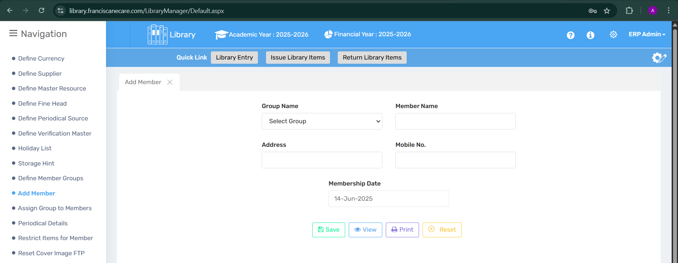

🔍 Purpose
The Add Member module is used to activate any user (student or staff) for library transactions. Only members added through this screen can issue or return books. It ensures that the selected users are recognized as library users within the system.

📍 Where to Find It
📂 Navigation Path:
Library Module → Master Settings → Add Member

🧩 Field Discription
🔢 Element | 📄 Description
🏫 Select Class | Dropdown to filter and select a specific class for student users.
🧑‍🏫 Staff Type | Dropdown to select type of staff (e.g., Teaching, Non-teaching).
🔍 Search | Filters the list of users based on selected class/staff type.
✅ Activate Checkbox | Tick box to make selected users active for book transactions.
💾 Save | Save the active member list.
🖨️ Print | Print the list of added/active members.

💡 Use Case
- Make a new batch of students or incoming staff eligible for library usage.
- Selectively activate only a few sections or types of users as needed.
- Keep inactive users hidden from issue/return screens.

📝 Important Notes
- Members must be activated here before issuing/returning books.
- Deactivated users will not appear in transaction-related lists.
- Best practice: update the list at the start of every academic session.
1.17. Assign Members to group.- 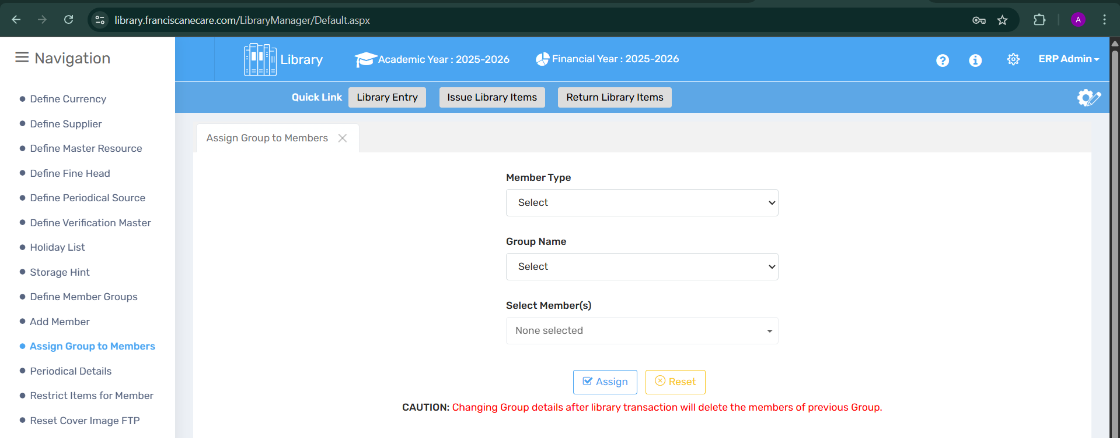

🔍 Purpose
The Assign Group to Members module allows the user to assign predefined library member groups (e.g., Student Group, Staff Group) to active library users. This grouping is essential for applying issue rules, late fines, and borrowing limits.

📍 Where to Find It
📂 Navigation Path:
Library Module → Master Settings → Assign Group to Members

🧩 Field Discription
🔢 Element | 📄 Description
🧑‍🏫 Select Member Type | Choose between Student or Staff.
👥 Select Group Name | Dropdown to choose the member group (previously defined).
📋 Member List | Displays active members from the selected group.
✔️ Assign Button | Assigns the selected group to the displayed members.

💡 Use Case
- Assigning all Class 8 students to a "Student Group" with specific book issue policies.
- Assigning non-teaching staff to a separate group with a limited issue quota.
- Differentiating library policies per group by linking them with member profiles.

📝 Important Notes
- Users must be added as members first using the "Add Member" module.
- Group assignment controls borrowing rules, fines, and access restrictions.
- Groups can be reassigned later if needed.
1.18 Periodical Details- In this user allows to define periodical details like. Newspapers etc.
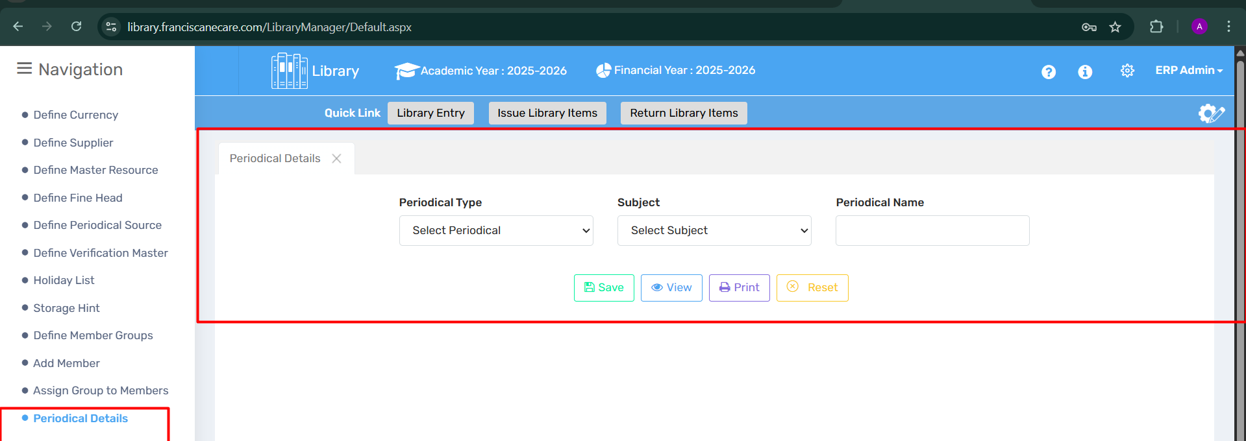

🔍 Purpose
The Periodical Details module allows users to record and manage information about periodicals such as newspapers, magazines, journals, etc., that are subscribed to by the library. This helps in organizing regular publications and tracking their frequency and issues.

📍 Where to Find It
📂 Navigation Path:
Library Module → Periodical Details

🧩 Field Discription
🔢 Element | 📄 Description
📘 Periodical Type | Enter the title of the newspaper, journal, or magazine.
📝 Subject Name | Select the name of the subject.
🔢 Periodical Name | Select name of the periodical
💾 Save | Saves the entered periodical details.
👁️ View | Shows the list of saved periodicals.
🖨️ Print | Prints the periodical records.
❌ Reset | Clears the form to re-enter details.

💡 Use Case
- Adding the “The Hindu” daily newspaper to track delivery and issues.
- Recording monthly science magazines for student references.
- Tracking the number of copies received of weekly journals for internal circulation.

📝 Important Notes
- Periodicals added here are informational only, they are not issued like books.
- Helps in subscription renewal tracking and inventory planning.
- Ensure accurate frequency selection for proper documentation.
- Can be cross-linked with reports to analyze periodical usage trends.

1.19- Restrict items to members - In this user can restrict some of library items to a member.

🔍 Purpose
This module is used to limit access to specific library items for certain groups or individual members. It ensures that sensitive, high-value, or specialized materials are issued only to authorized users.

📍 Where to Find It
Navigation Path:
Navigation Menu → Restrict Items for Member

🧩 Field Discription
Element | Description | Icon
Group Name | Dropdown to select member group (e.g., Students, Staff, Teachers) | 👥
Rule | Dropdown to apply restriction rule (e.g., Block, View Only) | 🛡️
Subject | Filter by book subject (optional) | 📘
Search Item | Search for a specific item using title or accession number | 🔍
Item Table | Displays book/item info: Sl. No., Accession No., Author, Title, ISBN, Subject | 📚
Select All Checkbox | Selects all visible items in the table | ☑️
Save | Applies selected restrictions to the selected group and items | 💾
View | Displays existing restrictions | 👁️
Print | Prints current restriction list | 🖨️
Reset | Clears all selected inputs and filters | 🔄

📌 Use Case Example
Let’s say you want to restrict final-year thesis books to only faculty members:
- Go to “Restrict Items for Members”.
- Select Group Name as "Faculty".
- Choose Rule as “Block”.
- Set Subject to “Research” or search directly by title.
- Select the required books from the list.
- Click Save. ✅
Now, non-faculty members will be unable to issue those items.

⚠️ Important Notes
- Restrictions apply only at the circulation level (issue/return), not to catalog viewing.
- Admin rights may be needed to change existing rules.
- Use View to regularly audit active restrictions.
- Ensure Group-Member mapping is correctly done under Assign Group to Members.

1.20 Reset Cover Image FTP - In this user can set the exact cover image from ftp.
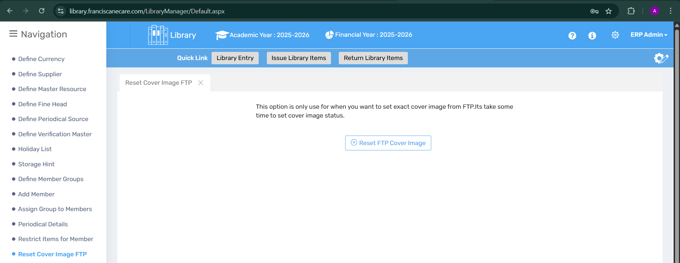

🔍 Purpose
This feature is designed to reset or refresh the cover image of a library item by fetching the image directly from the FTP (File Transfer Protocol) server. It’s particularly useful when:
- The cover image is missing or outdated.
- Manual cover image updates are needed in bulk from the FTP directory.

📍 Where to Find It
Navigation Path:
Library → Reset Cover Image FTP

🧩 Page Element Overview
Element | Description | Icon
Information Text | Instructions explaining the purpose of this feature | ℹ️
Reset FTP Cover Image Button | Initiates the image reset process from the FTP server | 🔁
Status Message (optional) | May appear post-action, indicating success or failure | ✅❌

⚙️ Use Case Example
Scenario: You have recently uploaded updated book cover images to your FTP server, but they aren’t reflecting in the library system.
- Navigate to Reset Cover Image FTP.
- Click on the 🔁 Reset FTP Cover Image button.
- Wait a few moments as the system fetches and updates the cover image(s).
- The library catalog now reflects the correct covers from FTP.

⚠️ Important Notes
- Ensure that the FTP configuration is correctly set and accessible.
- Only use this option if:
  - Automatic image syncing failed.
  - You uploaded updated images via FTP.
- The reset process might take time depending on the number of items.
- Recommended to avoid repeated resets in short intervals to reduce server load.

2- Manage Library-
2.1 Library Entry- Library Items Entry Page: This page allows for the entry of all the Below-mentioned items. It generates an Accession Number and captures essential details like ISBN for books or ISSN for magazines and periodicals.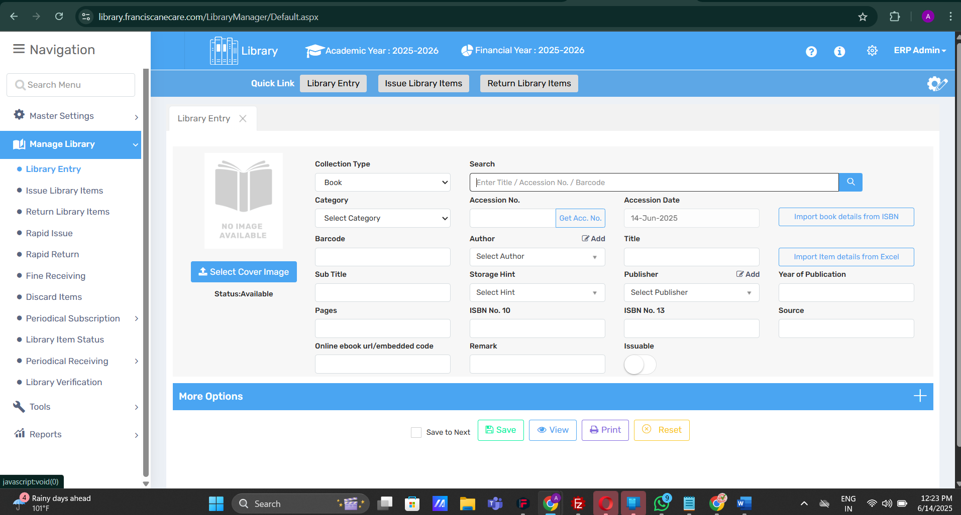

🔍 Purpose
The Library Entry page is used to enter, register, and catalog all library items (Books, Magazines, Periodicals, etc.) into the system.
It helps generate a unique Accession Number, captures key bibliographic and classification details, and provides integration tools for faster entry.

📍 Where to Find It
Navigation Path:
Manage Library → Library Entry

🧩 Field Discription
Section | Element | Description | Icon
📘 Item Cover | Select Cover Image | Upload or select an image to represent the book/periodical | 🖼️
📚 Collection Type | Dropdown to choose item type (Book, Journal, etc.) | 📂
🏷️ Category | Select classification category | 🏷️
📅 Accession Date | Auto or manual date of entry | 📆
🔢 Accession No. | System-generated unique number for each item | 🔖
✍️ Author | Dropdown with option to add a new author | ✏️
📖 Title / Subtitle | Title and any subtitles for the item | 📝
🧾 ISBN / ISSN | ISBN-10, ISBN-13 for books or ISSN for periodicals | 🔍
🏢 Publisher | Select or add publisher information | 🏛️
📅 Year of Publication | Year the item was published | 📆
📚 Storage Hint | Physical location in the library | 📦
🌐 Online URL | Link or embedded code for e-books or digital versions | 🌍
🗃️ Source | Source of procurement (purchase, donation, etc.) | 🏷️
📝 Remark | Additional notes or condition of the item | 🗒️
✔️ Issuable Toggle | Indicates whether the item can be issued to users | ✅
📥 Import Buttons
Import from ISBN: Fetch data via ISBN
Import from Excel: Bulk entry via spreadsheet | ⬇️

🧠 Use Case Example
Scenario: New Book Entry
- Select Collection Type → "Book"
- Enter or generate Accession Number
- Enter Title, Author, Publisher, and ISBN
- Upload a Cover Image
- Toggle Issuable ON if the book can be borrowed
- Click Save

⚠️ Important Notes
- 📌 Always ensure the Accession Number is unique for every entry.
- 🔗 ISBN fields help to auto-fill details using the "Import from ISBN" button.
- 📥 Use Excel import for bulk data entry to save time.
- 🖼️ If cover image doesn't display properly, try "Reset Cover Image FTP" from the tools menu.
- 🧾 Don’t forget to add online URLs for e-books or digital resources.
- ✅ Make sure the "Issuable" toggle is enabled for borrowable items.

2.2 Issue Library Items- In this tab, users can quickly issue library items to members, making it easy to manage and track checkouts efficiently.
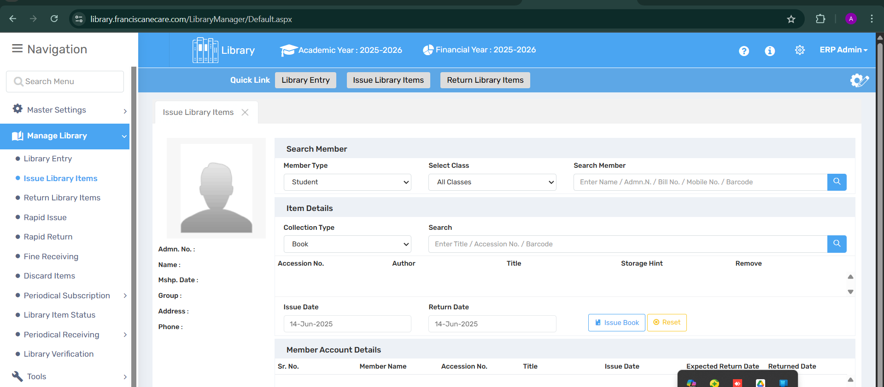

🔍 Purpose
The Issue Library Items tab allows librarians to issue books and other resources to library members (students/staff).
It ensures quick, accurate tracking of who has borrowed which item and when it is due for return, streamlining library operations.

📍 Where to Find It
Navigation Path:
Manage Library → Issue Library Items

🧩 Field Discription
Section | Element | Description | Icon
🔍 Search Member | Member Type | Choose between Student, Staff, etc. | 👤
 | Select Class | Filter students by class (if applicable) | 🏫
 | Search Field | Enter Name / Admission No. / Mobile No. etc. to identify the member | 🔎
🧾 Member Info Card | Auto-populated details like Name, Admn. No., Address, etc. after selection | 📇
📚 Item Details | Collection Type | Choose Book, Magazine, etc. | 📂
 | Search | Enter title / accession no. / barcode to locate item | 🔍
 | Accession No., Author, Title, Storage Hint | Auto-filled once book is selected | 🧾
📆 Dates | Issue Date | Default to current date, can be changed | 🗓️
 | Return Date | Set expected return date | 📅
🔘 Action Buttons | Issue Book | Confirms the issuance to selected member | 📤
 | Reset | Clears form fields | ♻️
📋 Member Account Details | Shows a table of already issued books with details like Return Date | 📑

🧠 Use Case Example
Scenario: Issue a Book to a Student
- Select Member Type → Student
- Choose Class, then enter Admission No. or Name
- Member info loads automatically
- Choose Collection Type → Book
- Enter Title / Accession No. / Barcode
- Verify the auto-filled details
- Set Return Date (if different from default)
- Click Issue Book
- The item will now appear in the Member Account Details table

⚠️ Important Notes
- 📌 Ensure the Return Date is set appropriately to avoid overdue fines.
- 🧾 Only issuable items (marked as such in Library Entry) will be eligible.
- ⛔ The system may prevent issuing if the member exceeds the allowed limit.
- 🔄 Use the Reset button before switching between members to avoid data mix-up.
- 📅 Dates should be checked carefully before confirming issuance.
- 📑 History section below helps track and validate already issued items.

2.3 Return Library Items- In this tab, users can return library items that have been checked out. This feature allows for the seamless processing of item returns, updating the inventory, and ensuring that all items are accurately tracked within the library
System.
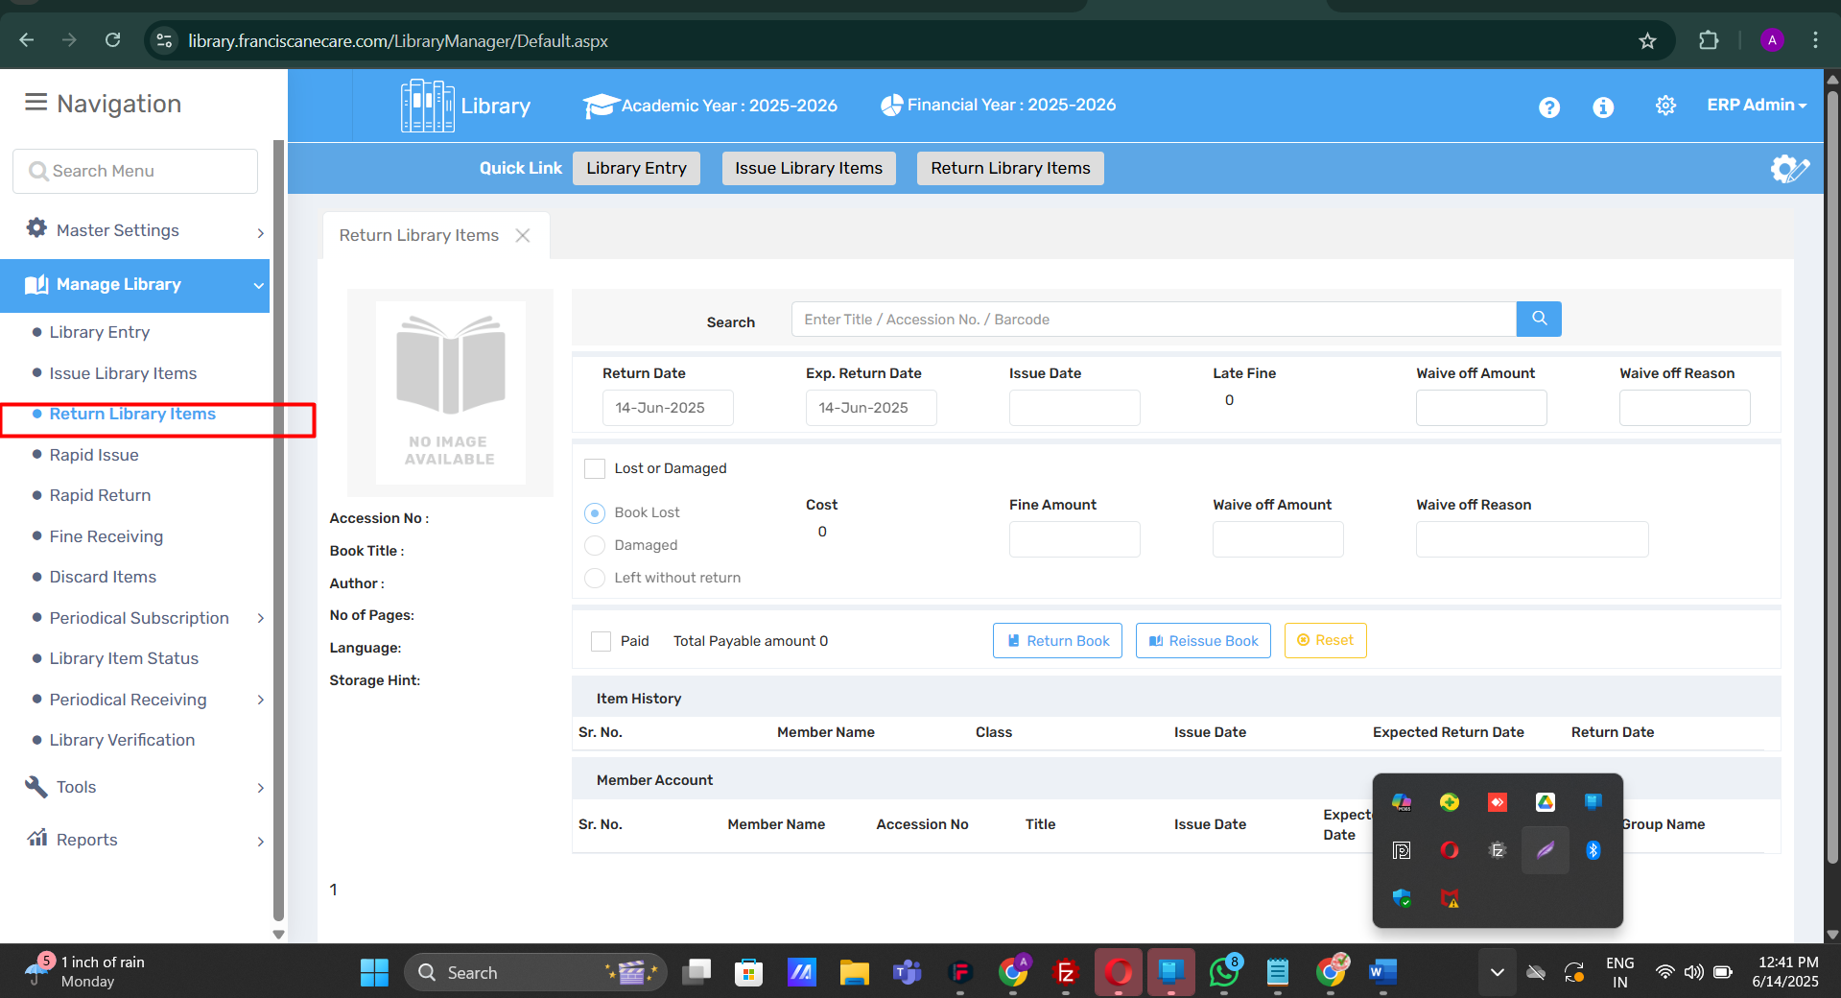

Purpose-
The Return Library Items tab enables the return process of previously issued library items. It ensures:
- Accurate inventory updates
- Calculation and collection of late fines
- Management of lost or damaged resources
- Seamless tracking of user borrowing history

📍 Where to Find It
Navigation Path:
Manage Library → Return Library Items

🧩 Field Discription
Section | Element | Description | Icon
🔍 Search | Title / Accession No. / Barcode | Locate item being returned | 🔎
🗓️ Date Fields | Return Date | Default to current date | 📅
 | Expected Return Date | From previous issue | 🗓️
 | Issue Date | Original issue date for reference | 📘
💰 Fine & Waiver | Late Fine | Auto-calculated based on return delay | ⏰
 | Waive Off Amount / Reason | Option to waive fine with reason | ✂️
❌ Lost or Damaged Items | Options | Mark item as “Book Lost”, “Damaged”, or “Left without return” | 🚫
 | Cost, Fine, Waive Off | Add related penalties or waivers | 💸
✅ Return Action | Return Book | Processes the return | 🔁
🔄 | Reissue Book | Option to reissue the same item to the member | 🔄
🔃 | Reset | Clears all fields | ♻️
📄 Book Info | Title, Author, Pages, Language, Storage Hint | Auto-filled from item database | 📘
📋 Item & Member History | Item History / Member Account | Displays transaction history and member’s borrow list | 📊

🧠 Use Case Example
Scenario: Returning a Book
- Enter the Accession No. / Title / Barcode in the search field
- The system auto-fills book details, issue date, and expected return date
- Set Return Date (usually today's date)
- If the return is late, a Late Fine appears automatically
- Optionally, enter Waive Off Amount and Reason
- If item is lost or damaged, check the appropriate option and update cost/fine
- Click Return Book to complete the process
- The system updates the inventory and logs the transaction in Item History

⚠️ Important Notes
- 🧾 Late fine calculations are automated; verify before waiving
- 📘 All returns should be confirmed under the correct member account
- 🔃 “Reissue Book” is helpful when a student continues needing the book
- 🚫 For lost/damaged items, ensure correct cost and reason fields are filled
- 🧾 Always check Member Account at the bottom to avoid duplications or errors

2.4 Rapid Issue - The Rapid Issue tab lets users quickly issue multiple items with fewer steps, making it ideal for fast checkouts during busy times or for large groups.
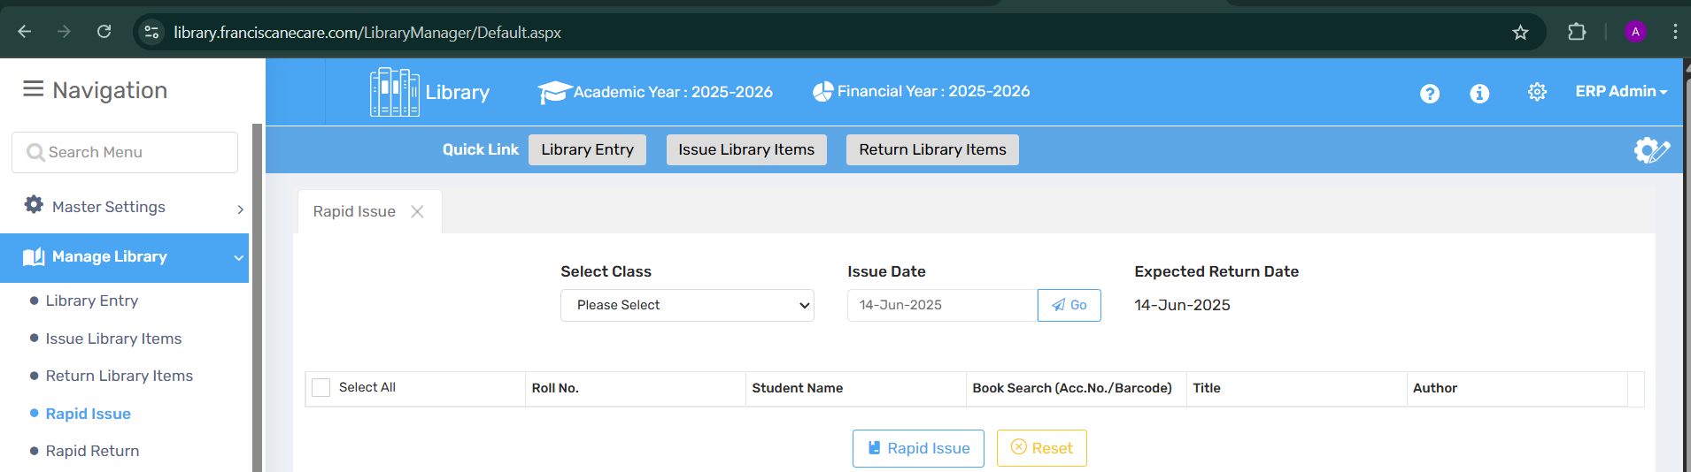

🔍 Purpose
The Rapid Issue tab is designed to speed up the book issuing process, allowing librarians to issue multiple books to students in bulk with minimal clicks. It's best used during:
- High-traffic periods (e.g., start of term)
- Classroom-based book distribution
- Bulk textbook distribution events

📍 Where to Find It
Navigation Path:
Manage Library → Rapid Issue

🧩 Field Discription
Section | Element | Description | Icon
🏫 Class Selection | Select Class | Dropdown list to filter students by class | 🏷️
📅 Date Controls | Issue Date | Set or auto-fill today's issue date | 📘
 | Expected Return Date | Auto-set or user-defined due date | 📆
🔎 Book Search Table | Roll No., Student Name | Auto-loaded once class is selected | 🧑‍🎓
 | Book Search (Acc. No. / Barcode), Title, Author | Fields to search and assign books to each student | 📚
✅ Action Buttons | Rapid Issue | Issues selected items in one go | ⚡
🔁 | Reset | Clears the current session | ♻️
⬜ Checkboxes | Select All / Individual Rows | Bulk-select students for issuing | ☑️

🧠 Use Case Example
Scenario: Distributing English textbooks to Class 7A
- Select Class 7A from the dropdown.
- Enter Issue Date (default: today) and Expected Return Date.
- The system loads the list of students (Roll No. & Name).
- In the Book Search column, scan or enter the Accession No./Barcode for each student.
- Optionally, use Select All if issuing the same book to all.
- Click Rapid Issue to confirm and complete issuing in bulk.

⚠️ Important Notes
- 📌 Ensure books are scanned/entered for the correct students to avoid inventory mismatches.
- 🔁 Use Reset to clear selections before processing a new class.
- 🚨 This module doesn’t support advanced checks (e.g., max issue limit) — ideal for controlled group distributions only.
- ⏳ Rapid Issue logs are stored in the regular issue history for each student.

2.5 Rapid Return- The Rapid Return feature allows quick return of multiple items in just a few steps, making it easy to handle large volumes and update the system efficiently.
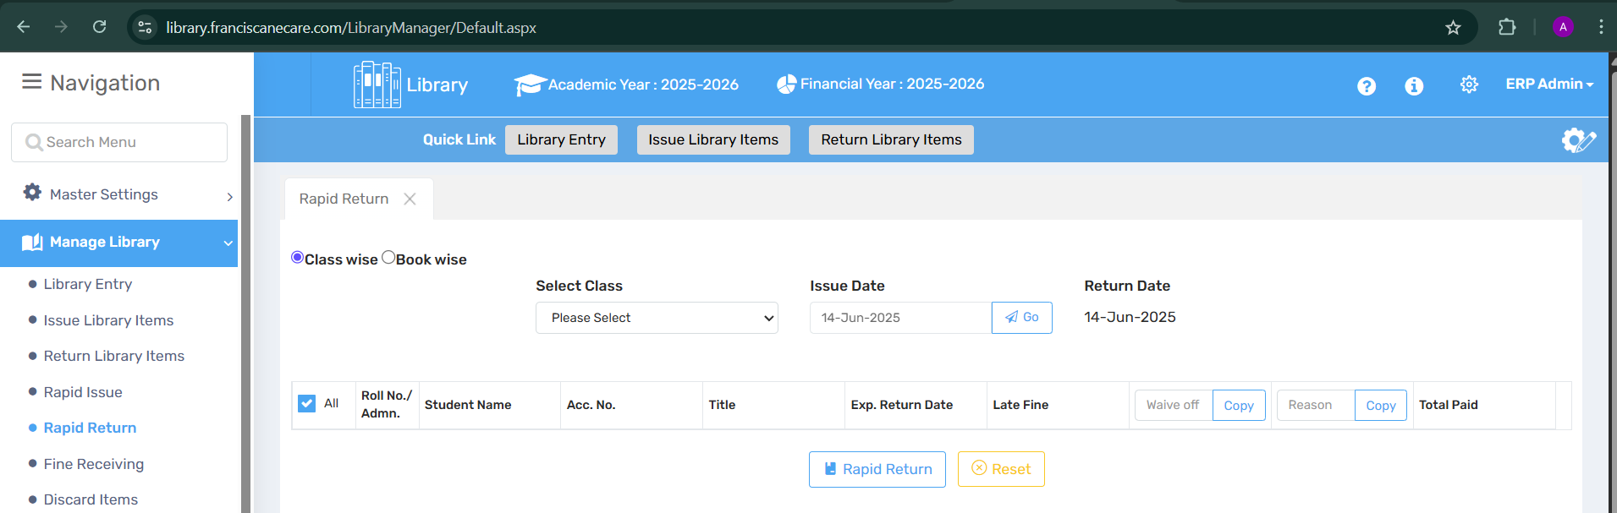

🎯 Purpose
The Rapid Return feature enables librarians to process the return of multiple library items in bulk with just a few clicks. Ideal for:
- End-of-term book collection
- Whole-class returns
- Mass check-ins after school events or exams

📍 Where to Find It
Navigation Path:
Manage Library → Rapid Return

🧩 Field Discription
Section | Element | Description | Icon
🗂️ View Mode | Class wise / Book wise | Toggle to filter by class or book | 📘
🏫 Class Selection | Select Class | Dropdown to filter students by class | 🧑‍🏫
📅 Date Controls | Issue Date | Date the book was issued (for reference) | 🗓️
 | Return Date | Defaults to today, can be edited | 📆
📋 Return Table | Roll No., Student Name, Acc. No., Title | Displays items issued per student | 👤
 | Exp. Return Date, Late Fine | Shows due date & auto-calculated fines (if any) | 💸
⚙️ Action Controls | Waive off | Waives off late fine | 🚫💰
 | Reason | Input field for fine waiver reason | ✏️
 | Copy | Copy fine or reason fields to other entries | 📋
✅ Action Buttons | Rapid Return | Processes all selected entries at once | 🔁
🔁 | Reset | Clears the current entries | ♻️

🧠 Use Case Example
Scenario: Collecting all books from Class 9B at session-end
- Choose Class wise option.
- Select Class 9B from the dropdown.
- All issued books for the selected class will appear in the list.
- Review each entry’s expected return date and late fine (if any).
- If needed, waive off fines and provide a reason.
- Click Rapid Return to return all books in one go.
- Books are now marked as returned in the system and ready for reissue.

⚠️ Important Notes
- ✅ Return Date is auto-filled with today’s date but can be modified.
- 🧾 Fine is auto-calculated based on late return policy; always double-check before processing.
- 🚫 Waive off should be done responsibly and always with a documented reason.
- 📚 Returned books immediately become available for the next issue.
- 🔁 Use Reset if you're switching to a different class or need to clear all selections.

2.6 Fine Receiving - The Fine Receiving feature allows users to efficiently process and record payments for overdue library items. This functionality ensures accurate tracking of fines, providing a streamlined process for settling dues and maintaining the financial integrity of the library system.
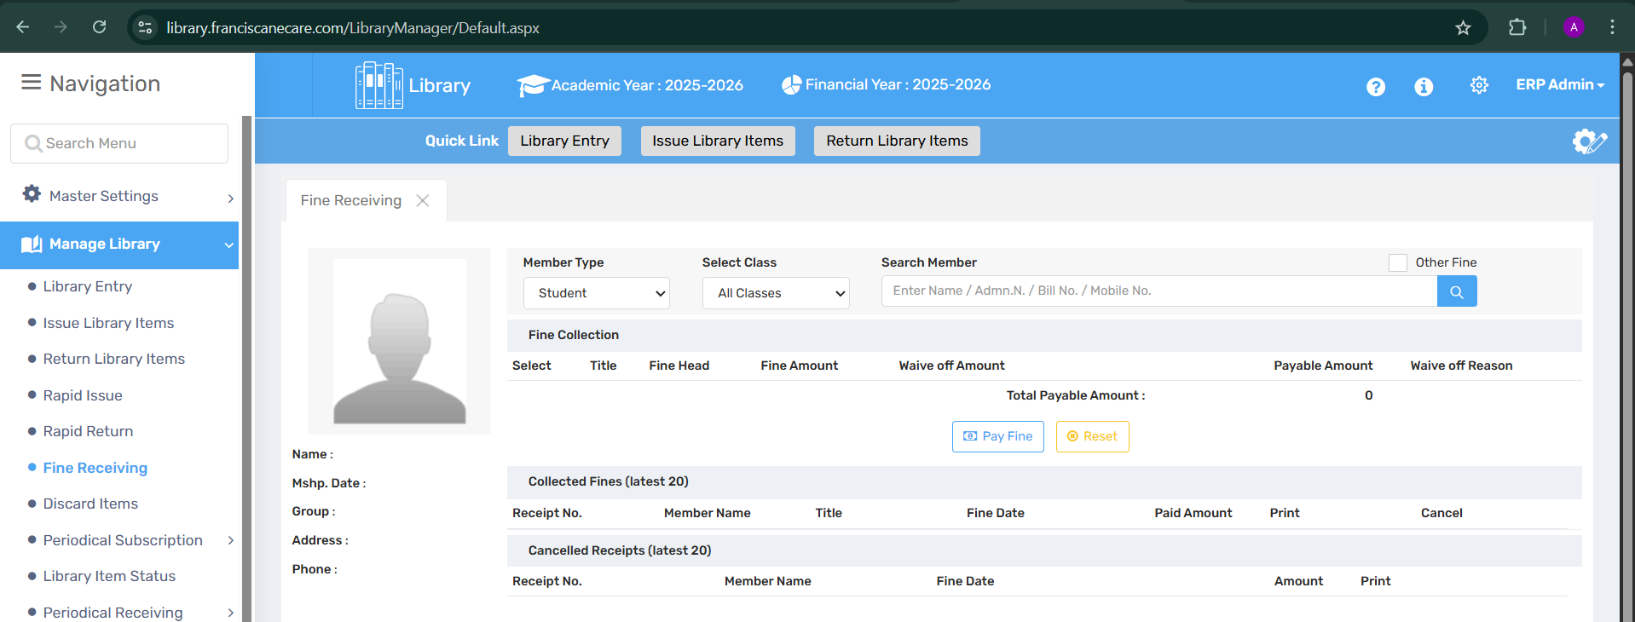

🔍 Purpose
The Fine Receiving feature allows the librarian to process and record overdue fine payments from students or staff. It helps in:
- Ensuring timely settlement of dues
- Tracking waived amounts and reasons
- Maintaining transparent financial records

📍 Where to Find It
Navigation Path:
Manage Library → Fine Receiving

🧩 Field Discription
Section | Element | Description | Icon
👥 Member Info | Member Type | Select “Student” or “Staff” from dropdown | 🧑‍🎓 / 🧑‍🏫
 | Select Class | Filter records by class (if Student is selected) | 🏫
 | Search Member | Enter name/admission no./mobile/bill no. to locate member | 🔍
 | Other Fine | Checkbox to include non-library fines (if applicable) | ☑️
📄 Fine Details | Title, Fine Head, Fine Amount | Shows item info and fine due | 📚
 | Waive off Amount, Waive off Reason | Option to waive partial or full fine with justification | 📝
💸 Action Buttons | Pay Fine | Finalize payment and update system | 💳
 | Reset | Clear all selections and filters | ♻️
🧾 Receipts | Collected Fines (Latest 20) | View recent payments | 📑
 | Cancelled Receipts | Shows details of voided transactions | 🚫🧾

🧠 Use Case Example
Scenario: A student from Class 10A has returned a book late and must pay a fine.
- Select Student from the "Member Type" dropdown.
- Choose Class 10A and enter the student’s admission number or name.
- The fine details will be auto-populated.
- If a part of the fine is waived, enter the waive-off amount and reason.
- Click Pay Fine to process the transaction.
- The entry is saved, and a receipt is generated in the Collected Fines list.

⚠️ Important Notes
- 🔍 Ensure accurate search using multiple ID fields (Name / Adm. No. / Bill No. / Mobile No.)
- 📝 Always input reason when waiving off any part of a fine for auditing.
- 💳 Receipts are generated automatically and can be reviewed under Collected Fines.
- ❌ Cancelled receipts are retained for transparency and can be viewed anytime.
- ♻️ Use Reset to refresh the form when moving to a new user.
2.7 Discard Item - The Discard Item feature enables users to remove outdated, damaged, or no longer needed library items from the system. This process ensures that the library's inventory remains current and relevant, helping maintain the quality and usability of the collection.

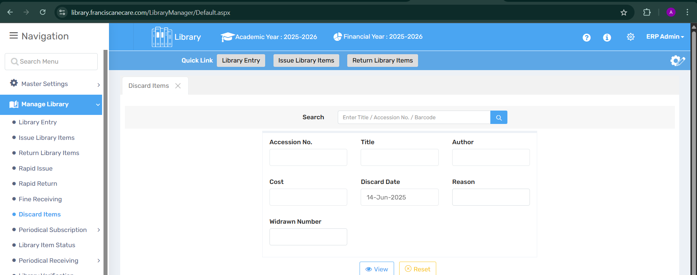

🎯 Purpose
The Discard Item feature is used to remove outdated, damaged, lost, or irrelevant library materials from the system. It ensures:
- Better space utilization
- Updated and relevant collections
- Accurate inventory and catalog management

📍 Where to Find It
Navigation Path:
Manage Library → Discard Items

🧩 Field Discription
Section | Element | Description | Icon
🔍 Search Bar | Title / Accession No. / Barcode | Lookup the item you wish to discard | 🔎
📦 Item Details | Accession No. | Unique ID for the library item | 🆔
 | Title | Name of the book/item | 📘
 | Author | Name of the author | ✍️
💵 Financial Info | Cost | Purchase value of the item | 💰
🗓️ Discard Info | Discard Date | Date on which the item is being removed | 🗓️
 | Reason | Justification (e.g., Torn, Lost, Outdated) | 📝
🧾 Tracking Info | Withdrawn Number | Record for withdrawal reference | 🔢
🛠️ Action Buttons | View | Preview discard list | 👁️
 | Reset | Clear form fields | ♻️

🧠 Use Case Example
Scenario: A textbook from the 2015 syllabus is torn and outdated.
- Navigate to Discard Items.
- Search using Accession No. or Title.
- Confirm details like Cost, Author, and Title.
- Enter the Discard Date and select Reason (e.g., Outdated or Damaged).
- Assign a Withdrawn Number for internal record-keeping.
- Click View to preview or Submit (if available) to finalize.

⚠️ Important Notes
- 📚 Only users with discard rights can process this operation (based on role settings).
- 🗑️ Discarded items are permanently removed from circulation and visible in discard logs.
- 🧾 Maintain a physical record or log of discard activity for audit or stock verification.
- 🕵️ Double-check the Accession No. before discarding to avoid mistakes.
- 📝 A reason is mandatory for transparency and future reference.

📚 2.8 Periodical Subscription
This module is designed to manage subscriptions of newspapers, magazines, and journals. It helps libraries streamline delivery tracking, renewal management, and recordkeeping for periodicals.

📰 A. Newspaper Subscription
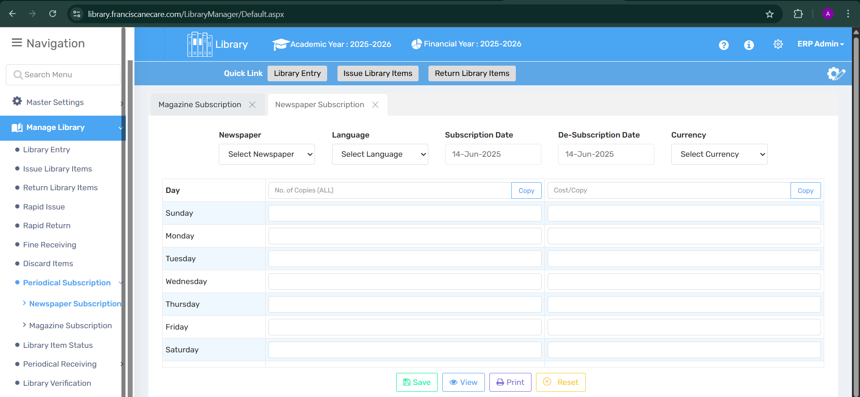

🔍 Purpose
To efficiently manage newspaper subscriptions, including tracking delivery days, subscription periods, language, and cost per copy.

📍 Where to Find It
Navigation Panel → Manage Library → Periodical Subscription → Newspaper Subscription

🧭 Page Element Overview
- Dropdowns:
  - Newspaper
  - Language
  - Currency
- Date Fields:
  - Subscription Date
  - De-Subscription Date
- Weekly Grid:
  - Days of the week (Sunday to Saturday)
  - Input fields for:
    - Number of Copies
    - Cost per Copy
  - "Copy" Button (to duplicate values across all days)
- Action Buttons:
  - Save, View, Print, Reset

💡 Use Case
A librarian wants to subscribe to 3 copies of The Hindu in English from 14 June 2025. They set the same copy count for all days and record the cost per copy.

⚠️ Important Notes
- Ensure the subscription and de-subscription dates are accurate.
- Use the Copy button to avoid redundant entries for all days.
- Subscription details are crucial for billing and delivery audits.

📖 B. Magazine Subscription
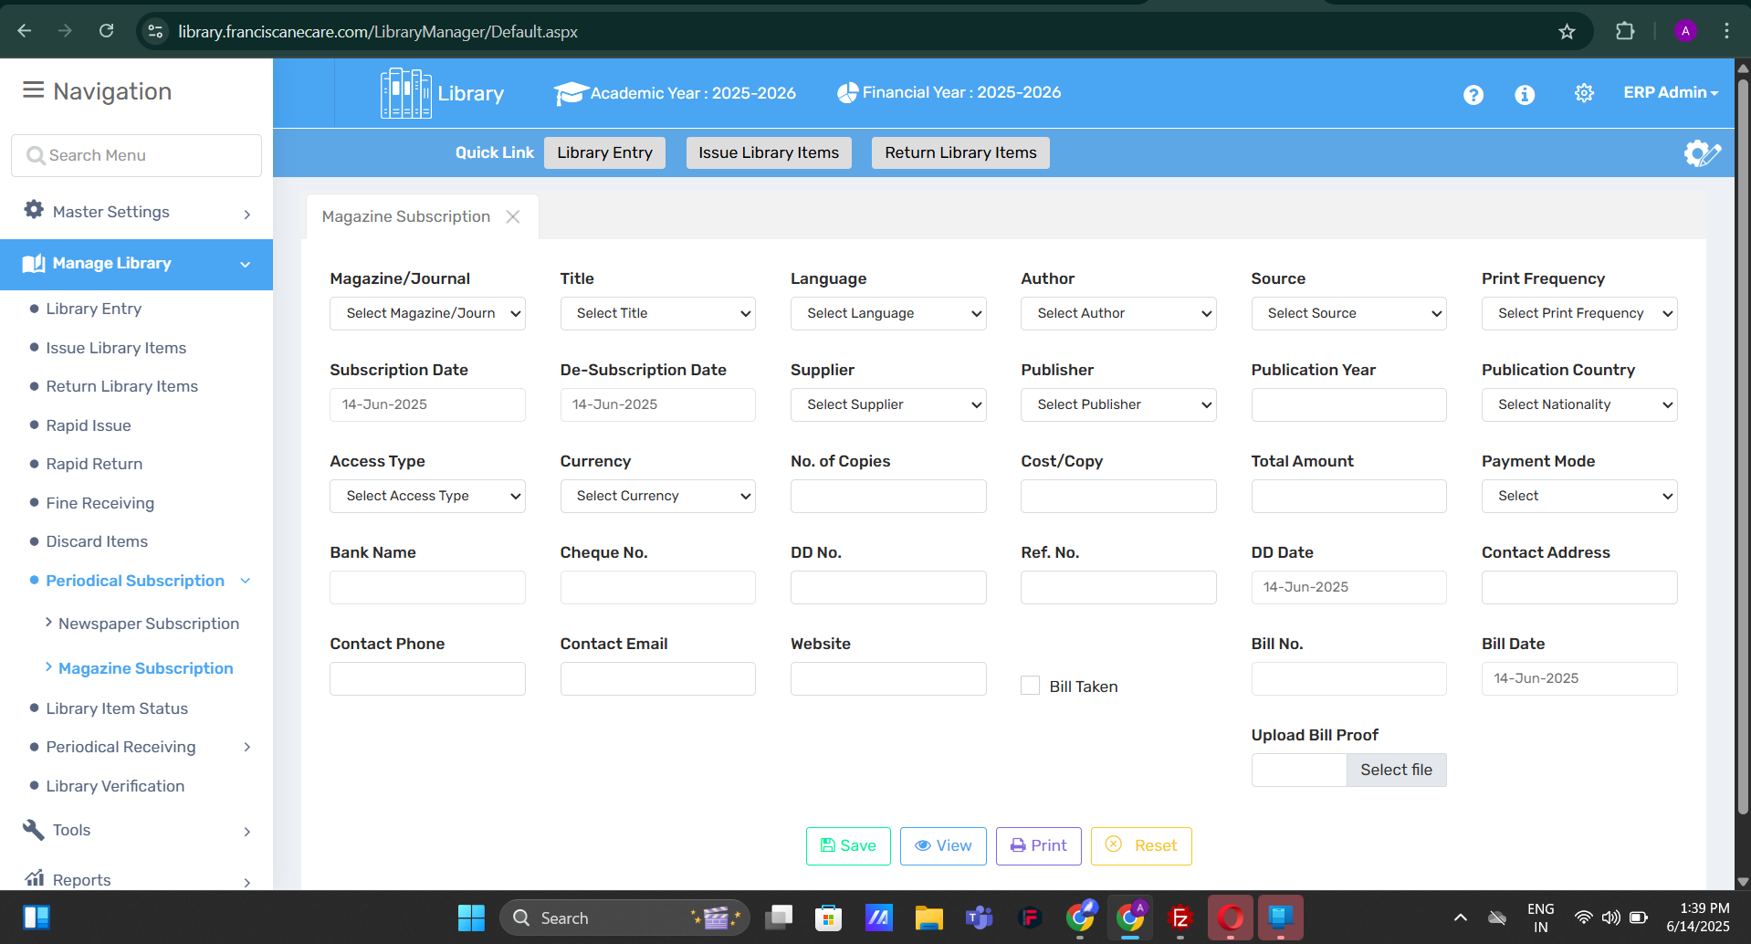

🔍 Purpose
To manage magazine and journal subscriptions by tracking supplier details, payment info, print frequency, and issue availability.

📍 Where to Find It
Navigation Panel → Manage Library → Periodical Subscription → Magazine Subscription

🧭Field Discription
- Dropdowns:
  - Magazine/Journal
  - Title, Language, Author, Source
  - Supplier, Publisher
  - Print Frequency, Access Type, Currency
  - Payment Mode, Publication Country
- Input Fields:
  - Subscription & De-subscription Dates
  - No. of Copies, Cost/Copy, Total Amount
  - Publication Year, Cheque No., DD No., Ref. No.
  - Contact Phone, Email, Address, Website
  - Bank Name, Bill No., Bill Date
- Upload Option:
  - Upload Bill Proof (file upload)
- Action Buttons:
  - Save, View, Print, Reset

💡 Use Case
A library subscribes to India Today, receives 2 copies every month, and uploads the bill proof for tracking payments. All supplier and publisher details are recorded.

⚠️ Important Notes
- Print Frequency and Access Type determine availability to patrons.
- Use bill upload to maintain transparent documentation.
- Ensure contact and billing details are filled for auditing.

2.9 Library Items Status - The Library Items Status feature provides users with real-time updates on the availability and condition of all library items. This tool allows for easy tracking of items currently checked out, reserved, or under maintenance, ensuring patrons have up-to-date information on the library's inventory.
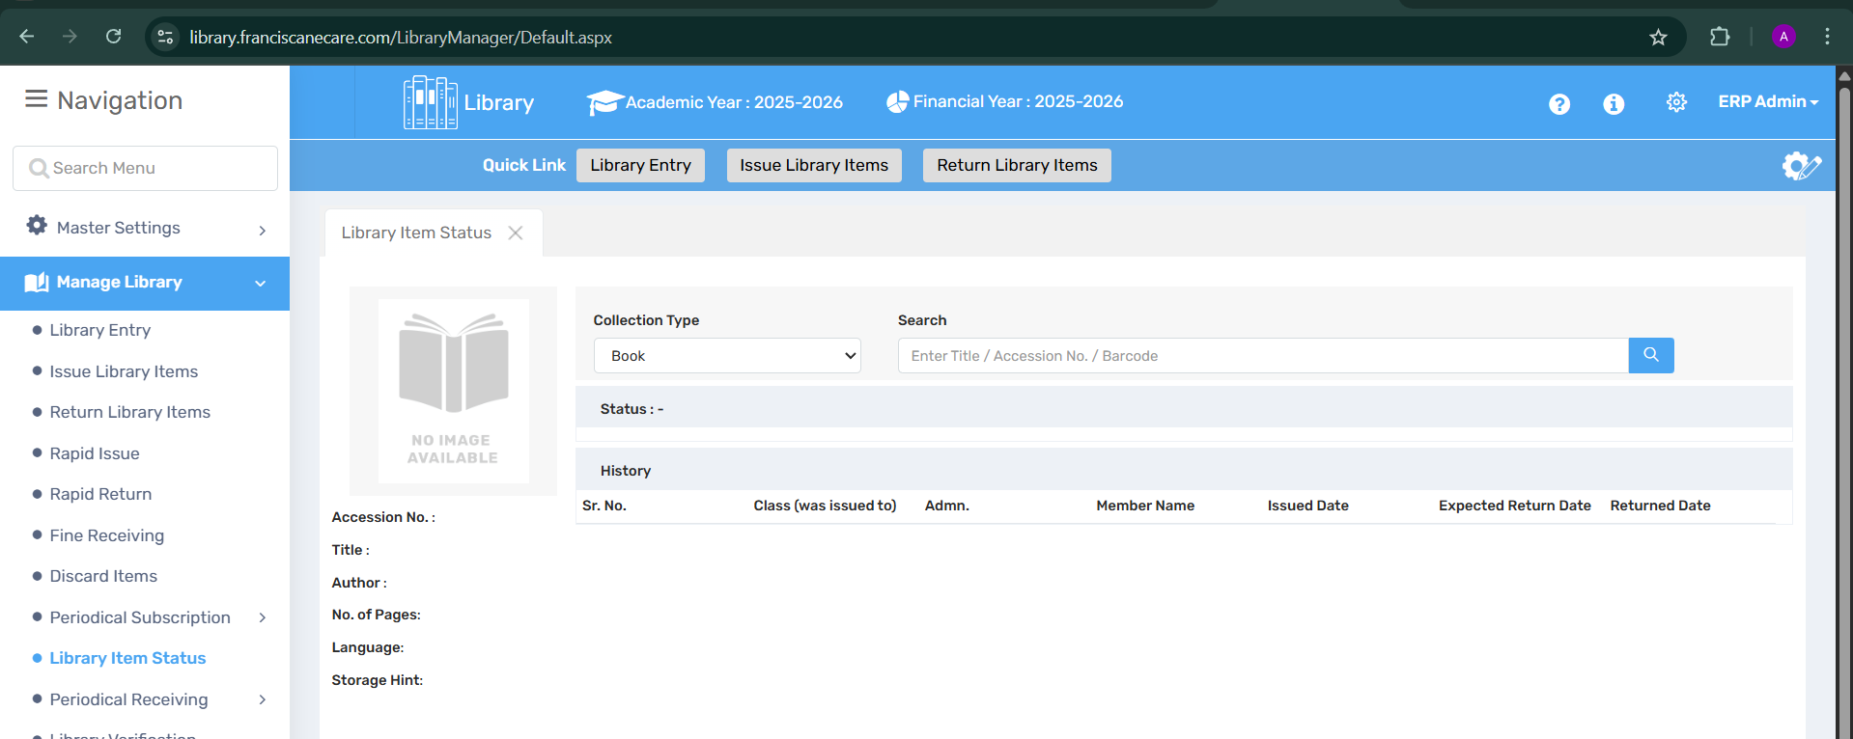

🔍 Purpose
The Library Item Status module offers real-time tracking of the availability, issue history, and current status of each library item. It helps librarians and users quickly check if a book is available, issued, reserved, or overdue.

📍 Where to Find It
Navigation Panel → Manage Library → Library Item Status

🧭 Field Discription
Element | Description
🔽 Collection Type | Dropdown to choose between types like Book, Magazine, Journal, etc.
🔍 Search Field | Input field to search by Title, Accession No., or Barcode
📊 Status Display | Shows the current status of the item (e.g., Available, Issued, Overdue)
🕘 History Table | Tracks previous issues with fields like Class, Admin No., Member Name, etc.
📚 Book Preview | Placeholder showing "No Image Available"—can be enhanced with actual cover.
History Table Columns:
- Sr. No.
- Class (was issued to)
- Admin.
- Member Name
- Issued Date
- Expected Return Date
- Returned Date

💡 Use Case
A student inquires if the book “Wings of Fire” is available. The librarian uses Library Item Status, selects Book, enters the Accession Number, and finds it is currently issued to Class X-B, due on 20 June 2025.

⚠️ Important Notes
- Enter Accession No. or Barcode for most accurate search results.
- If Status is blank, the item may be unregistered or discarded.
- Always check the Returned Date in the history to avoid duplicate entries.
- Useful during audits to track usage and item flow.

📰 2.10 Periodical Receiving

🔍 Purpose
The Periodical Receiving module ensures the systematic entry, tracking, and storage of incoming periodicals like newspapers and magazines, ensuring timely updates in the library system and availability to readers.

🅰️ Newspaper Receiving
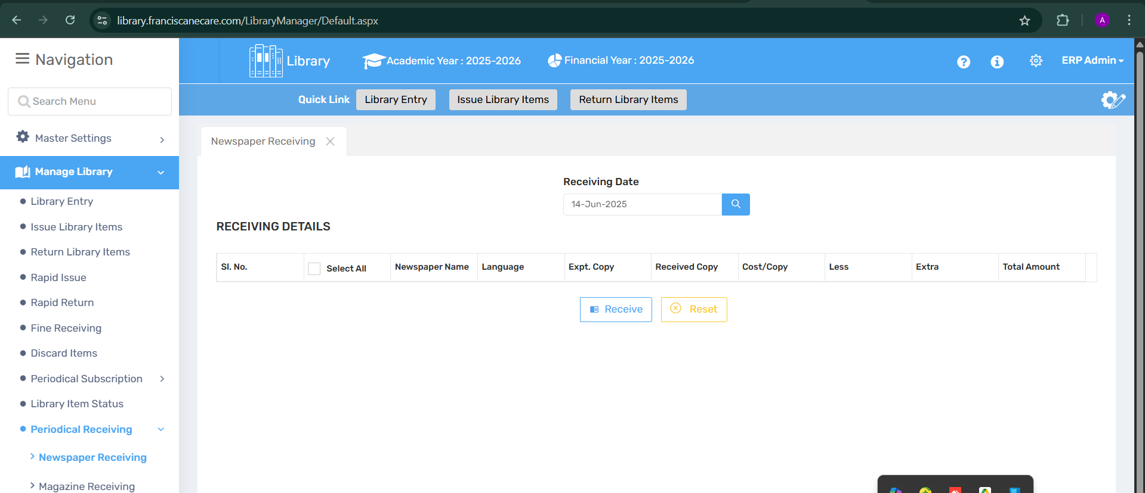

📍 Where to Find It
- Navigation Panel → Manage Library → Periodical Receiving → Newspaper Receiving

📄 Field Discription
- 🔽 Collection Type
- 🔍 Search Field
- 📊 Status Section (as in Library Item Status)
- 🧾 History Table (Issued and Returned details)

💡 Use Case
- When a new newspaper arrives, log it for tracking and archival.
- Keep an accurate record of daily/weekly newspapers.

⚠️ Important Notes
- Make sure to select the correct collection type.
- Useful for record keeping, especially in institutions requiring daily logbooks.

✅ Icon Suggestions
- 📰 for Newspaper
- 📅 for Daily Logs
- 📦 for Receiving
- ✅/❌ for Availability

🅱️ Magazine Receiving
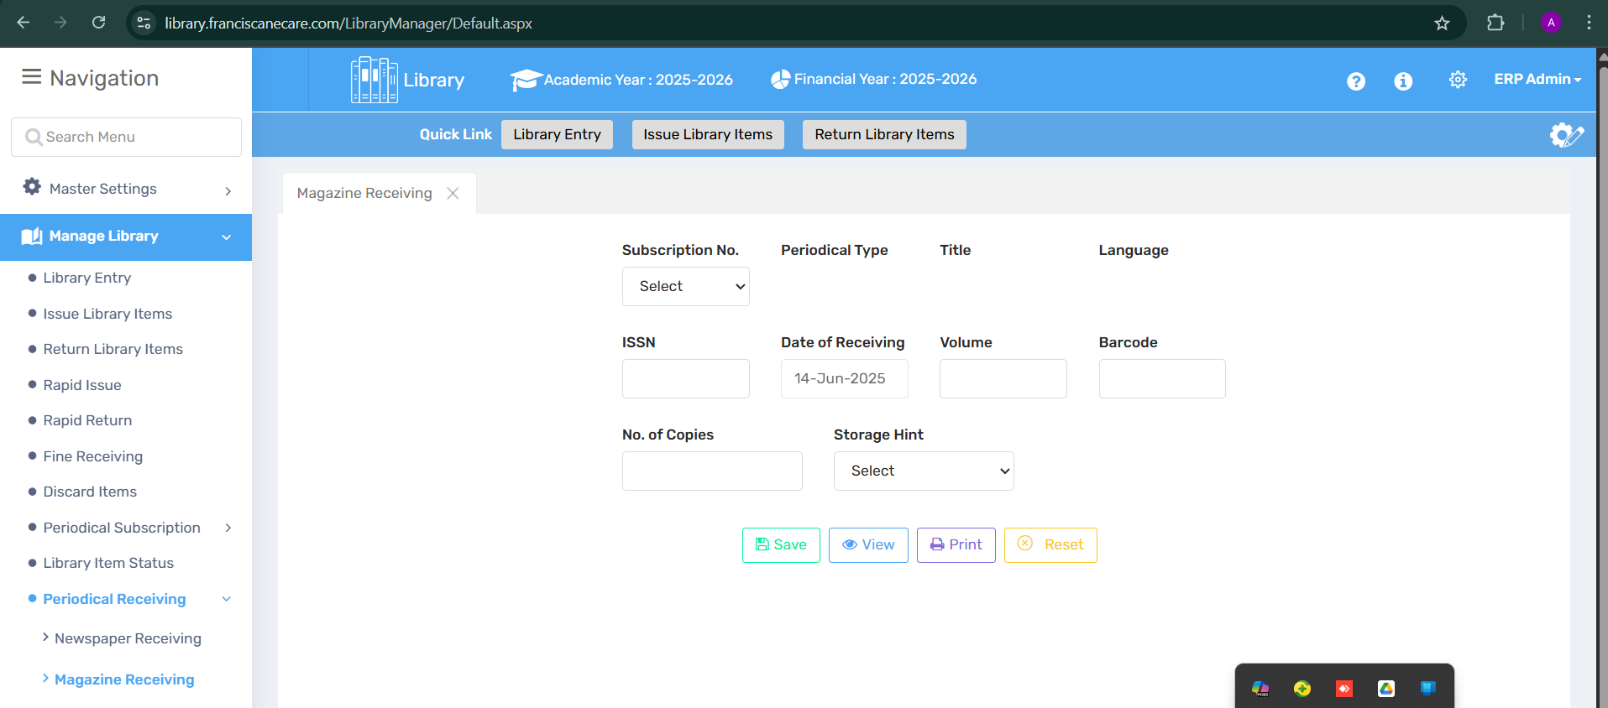

📍 Where to Find It
- Navigation Panel → Manage Library → Periodical Receiving → Magazine Receiving

📄 Field Discription
- 📌 Subscription No., Title, Language, Periodical Type
- 🧾 ISSN, Volume, Date of Receiving
- 🔢 No. of Copies, Barcode
- 📦 Storage Hint
- 💾 Save, 🔍 View, 🖨️ Print, ❌ Reset buttons

💡 Use Case
- Helps log newly received magazines by volume and ISSN.
- Keeps magazine inventory organized and traceable.

⚠️ Important Notes
- Must be linked to an existing subscription.
- Double-check ISSN and Volume to avoid duplicate entries.

Library Verification
The Library Verification feature enables users to validate and confirm the details of library items and transactions. This tool helps ensure the accuracy of item records, including checkouts, returns, and status updates, maintaining the integrity of the library’s inventory and operations.
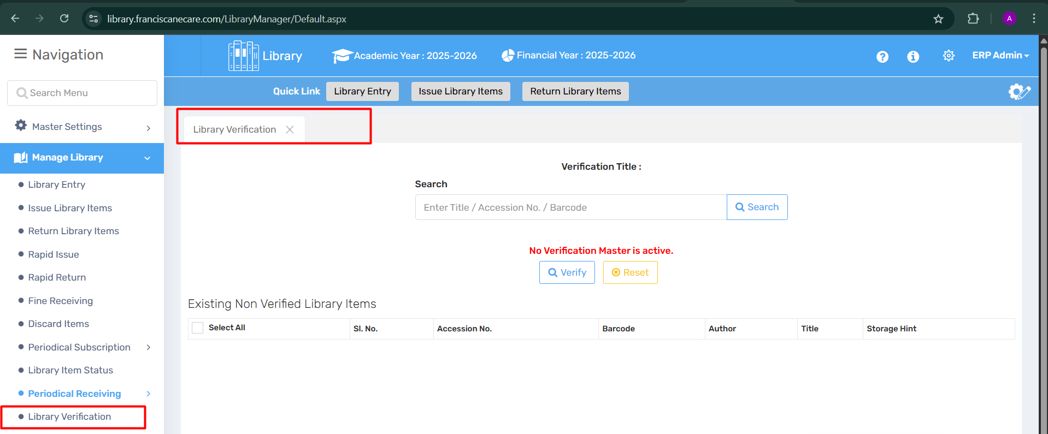

🔍 Purpose
The Library Verification feature enables users to validate and confirm the accuracy of library items and their records. It ensures that:
- All items are correctly logged in the system.
- Missing or misplaced books are detected.
- Inventory matches the digital records.
- Checkouts, returns, and status updates are consistent.
This helps maintain the integrity of the library’s inventory and supports periodic audits.

📍 Where to Find It
- Navigation Panel → Manage Library → Library Verification

📄 Field Discription
- 🔠 Verification Title: Displays the currently active verification session.
- 🔍 Search Field: Search by Title / Accession No. / Barcode.
- 🚫 "No Verification Master is active" message appears when no session is set up.
- 📋 Existing Non-Verified Library Items Table:
  - Columns: Select, Sr. No., Accession No., Barcode, Author, Title, Storage Hint.
- 🔘 Buttons:
  - ✅ Verify: Confirms and verifies selected items.
  - 🔄 Reset: Clears selections and resets the search.

💡 Use Case
- During a library audit or stock check, staff can verify physical items against system records.
- Quickly identify lost, misplaced, or unlogged books.
- Ensure periodic inventory validation is streamlined.

⚠️ Important Notes
- A Verification Master must be created and activated before use. If not, the system will display: "No Verification Master is active."
- Unverified items will be listed until manually verified.
- It helps with accurate reporting and accountability.
3- TOOLS
3.1 Bulk Image Upload Guide:
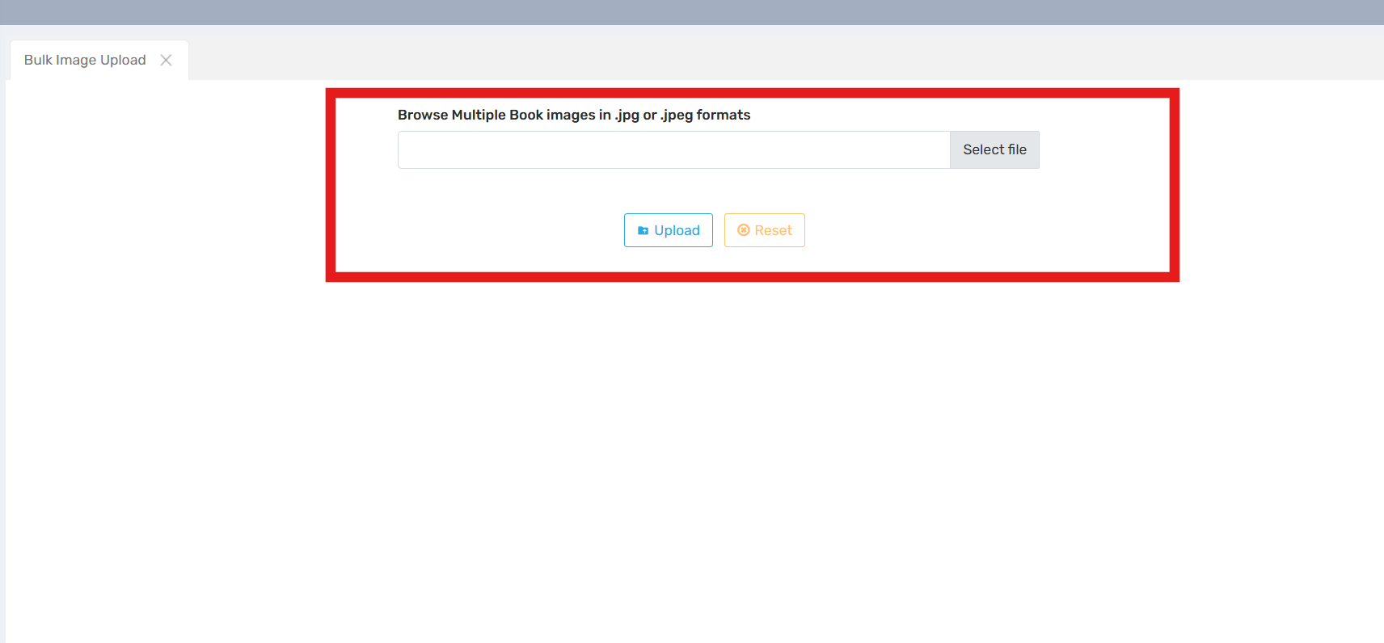

🎯 Purpose
The Bulk Image Upload feature is designed to:
* Allow multiple images to be uploaded simultaneously.
* Improve efficiency and organization within the library system.
* Streamline the cataloging process for assets like book covers, author photos, event posters, etc.
* Ensure media consistency across the platform.
📍 Where to Find It
You can access the Bulk Image Upload feature through:
Media Library Menu → “Bulk Upload”
* Or via the Dashboard shortcut tile labeled “📁 Bulk Upload Images”
* Also accessible through the Upload’ button in image gallery views.
📑 Field Description
Element Description
🖼️ Drag-and-Drop Zone Main area to drag multiple files at once.
📂 File Selector Button Alternative to browse and select files from your system.
📋 Upload Queue List of images queued for upload with file size & name.
🛠️ Metadata Editor (optional) Enter optional info such as title, tags, categories.
📤 Start Upload Button Initiates the batch upload process.
🔄 Progress Bar Shows real-time progress of uploads.
✅ Success/Error Logs Displays results of each upload (success/failure).
💼 Use Case
Librarians uploading multiple book cover images to new catalog entries.
Content managers updating author profile images in bulk.
Archivists digitizing and uploading event images from past library programs.
Marketing teams adding promotional graphics for upcoming events.

3.2 Upload Data in Global Library Guide
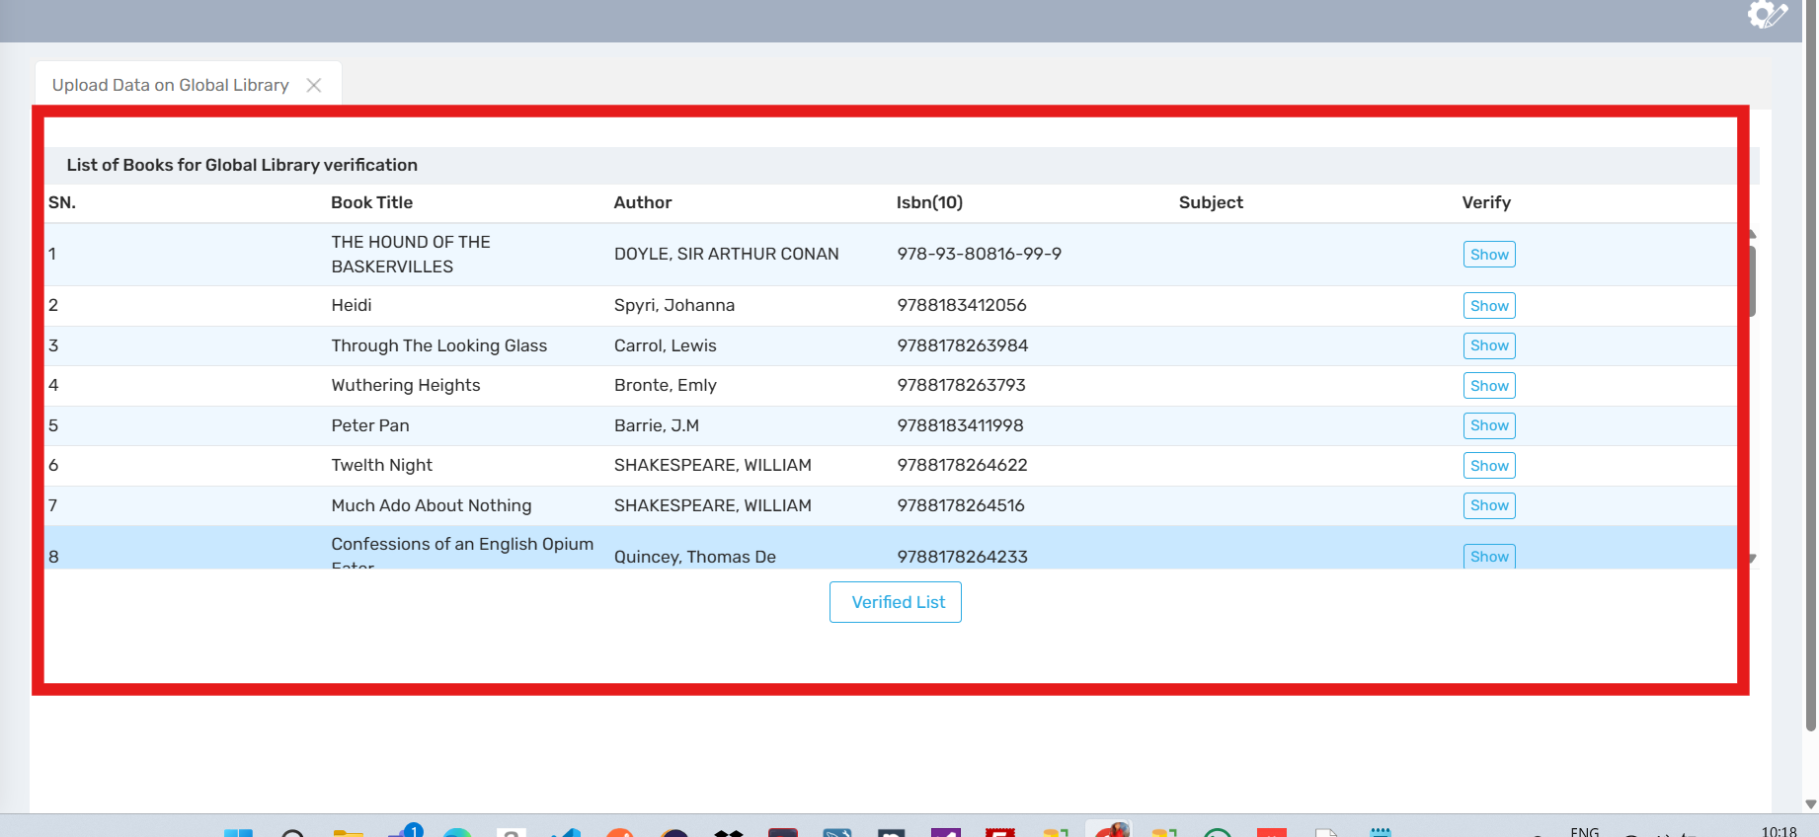

🎯 Purpose
The Upload Data in Global Library feature allows users to:
- Upload and integrate bulk data records into the centralized Global Library database.
- Add entries like books, journals, metadata, catalog information, or other structured data.
- Ensure uniformity and accessibility of content across multiple libraries or institutions using the system.

📍 Where to Find It
Users can access the Upload Data in Global Library tab via:
- Main Navigation Menu → “📥 Global Library” → “Upload Data”
- Or from the Global Library dashboard under the “📤 Upload Section”
- Also linked within admin or cataloging tools menus

📑 Field Description
Element | Description
📁 File Upload Section | Upload data files (CSV, Excel, or XML formats).
📋 Data Mapping Tool | Map uploaded data fields to Global Library fields.
🔍 Preview Panel | View sample of uploaded data before committing.
✅ Validation Report | Identifies errors or mismatches in data.
📤 Finalize Upload Button | Completes the data import into the Global Library.
📘 Upload History Log | Keeps track of past uploads with timestamps and results.

💼 Use Case
- Library administrators uploading a new catalog of titles for system-wide sharing.
- Institutions contributing metadata records to the shared Global Library database.
- Data migration teams transferring existing records into a modern digital system.

📝 Important Notes
- Accepted file types: .csv, .xlsx, .xml
- All fields must match Global Library schema for successful upload.
- Review validation errors carefully before finalizing uploads.
- Duplicates will be flagged—review warnings before proceeding.
- User must have Admin or Cataloging privileges to access this tab.

3.3 Search Book Guide
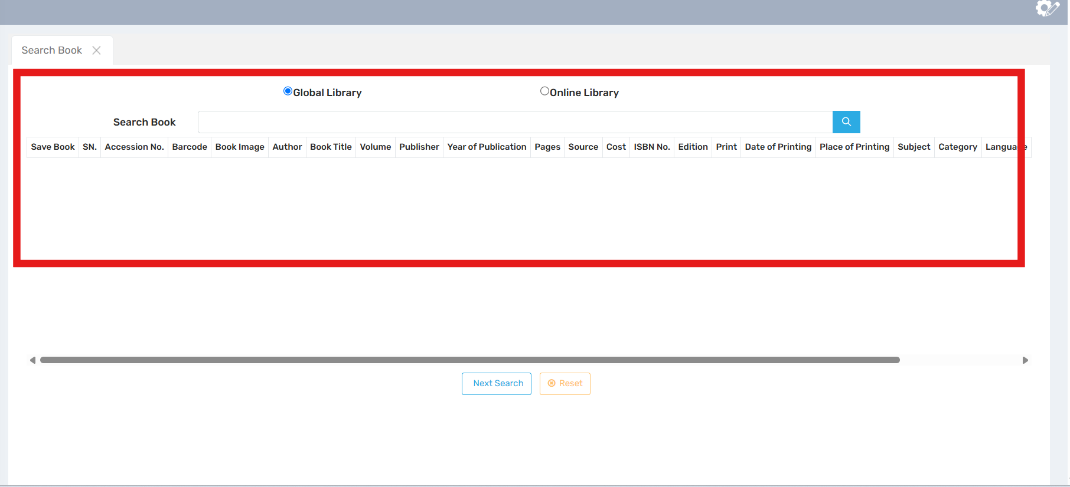

🎯 Purpose
The Search Book feature allows users to:
- Search book records across both the Global Library and Online Library.
- Access detailed book metadata such as title, author, ISBN, publisher, availability, and more.
- Find resources quickly for borrowing, referencing, or cataloging purposes.

📍 Where to Find It
The Search Book functionality is available through:
- Top Navigation Bar → “🔍 Search” or “Search Book”
- Dashboard Shortcut → “📚 Book Search”
- Within the Global Library and Online Library tabs

📑 Field Description
Element | Description
🔎 Search Bar | Enter keywords (title, author, ISBN, etc.)
📌 Filter Panel | Filter results by author, year, category, availability, etc.
🌐 Library Scope Toggle | Choose between Global Library or Online Library
📄 Search Results List | Displays matched books with title, author, cover, and summary
📘 Book Details View | View full metadata, availability, and location
📥 Action Buttons | Reserve, Download, or Request Book options (if enabled)

💼 Use Case
- Students or researchers searching for academic books in both online and global catalogs.
- Librarians verifying catalog entries or metadata consistency.
- Users checking book availability for borrowing or reserving.
- Cataloging staff comparing local entries with global records.

📝 Important Notes
- Use advanced filters for more accurate results.
- Scope toggle helps refine results between Global and Online records.
- System highlights duplicates or similar titles if found in both libraries.
- Internet connection is required for accessing Online Library results.
- Search history may be saved depending on user permissions.

🌟 Effective Icons for Each Topic
Topic | Icon | Reason
Purpose | 🎯 | Clear goal of the feature
Location | 📍 | Helps users know where to navigate
Page Elements | 📑 | UI structure overview
Use Cases | 💼 | Real-world application scenarios
Important Notes | 📝 | Cautions, tips, or technical notes
Search Bar | 🔎 | Universal symbol for search
Filter Options | 🧰 | Represents adjustable tools/settings
Scope Selector | 🌐 | Indicates global/online selection
Search Results | 📄 | List of results in document form
Book Info | 📘 | Represents book metadata/details
Actions (Download/Reserve) | 📥 | Symbol for next steps on search result.
3.4 Create List:
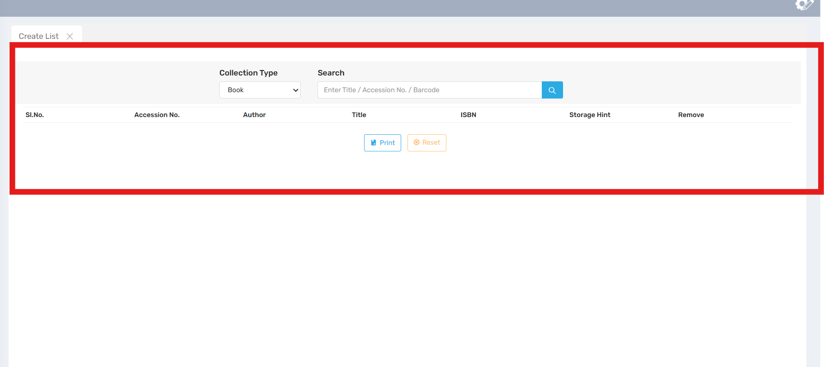

🎯 Purpose
The Create List feature allows users to:
- Compile a customized list of library items, such as books.
- Easily group and manage items for printing, reporting, or reference.
- Filter, view, and export selected book records for inventory, cataloging, or administrative purposes.

📍 Where to Find It
Navigate through:
- Main Menu → Tools or Utilities → Create List
- Or access from the Cataloging Section or Reports Module, depending on system setup.

📑 Field Description
Element | Description
📂 Collection Type Dropdown | Select the type of resource (e.g., Book, Journal, Thesis)
🔍 Search Bar | Enter Title / Accession No. / Barcode to find items
📋 Table View | Displays search results with columns: Sl.No., Accession No., Author, Title, ISBN, Storage Hint, Remove
💾 Print Button | Exports or prints the created list
🔁 Reset Button | Clears the current list to start over

💼 Use Case
- Librarians generating a list of books for stock-taking or reporting.
- Teachers preparing reading lists for classes.
- Administrators compiling book lists by accession or barcode for audits.
- Cataloging teams reviewing newly added resources.

📝 Important Notes
- You must select a Collection Type before searching.
- The search accepts multiple criteria (title, accession, barcode).
- You can remove individual entries from the list using the Remove option.
- The Print button prepares the list in a printable/exportable format.
- Use Reset to clear all entries and start fresh.

🌟 Effective Icons for Each Topic
Topic | Icon | Reason
Purpose | 🎯 | Feature’s main goal
Location | 📍 | Navigation help
Page Elements | 📑 | UI components
Use Cases | 💼 | Real-world usage
Notes | 📝 | Important reminders
Collection Type | 📂 | Category of items
Search | 🔍 | Finding books/items
Table/List | 📋 | Data display
Print | 💾 | Export/print list
Reset | 🔁 | Clear the form or list
3.5 Replace Duplicate Masters:
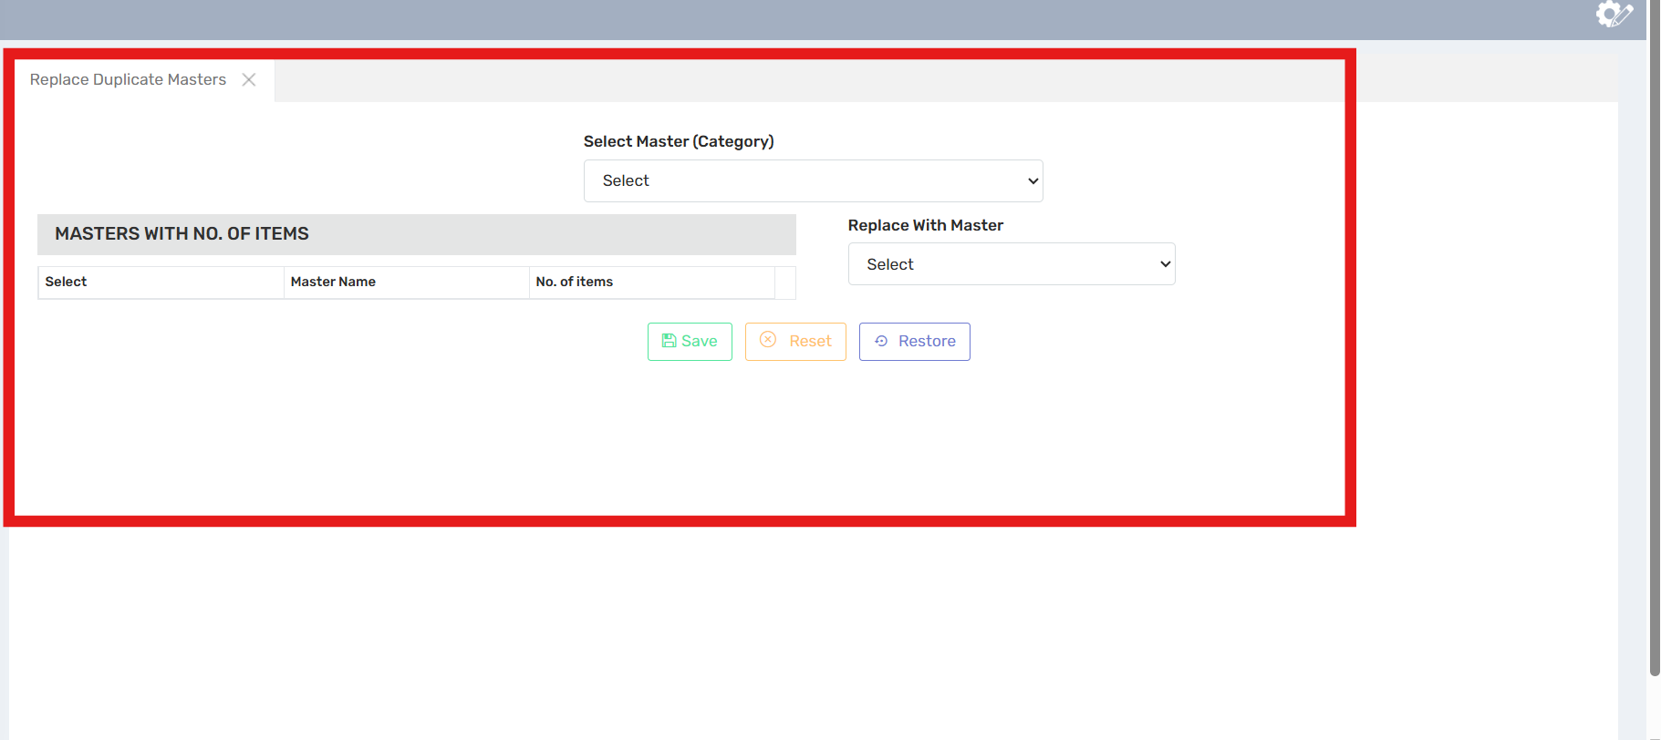

🎯 Purpose
The Replace Duplicate Data feature is designed to:
- Identify and replace duplicate records in the library system.
- Ensure the accuracy and integrity of cataloged data.
- Reduce redundancy and eliminate inconsistent entries in the Global or Online Library.
- Allow authorized users to merge or overwrite duplicates with the correct data.

📍 Where to Find It
You can access the Replace Duplicate Data feature via:
- Admin Tools → “🗃️ Data Management” → “Replace Duplicates”
- Cataloging Section → “Duplicate Checker”
- Or from the Search Book results, if a duplicate is detected

📑 Field Description
Element | Description
🔍 Duplicate Detection Table | Displays potential duplicate entries side-by-side
🧩 Match Criteria Filter | Allows filtering based on ISBN, title, author, etc.
📝 Comparison View | Highlights differences between duplicate records
✔️ Select Primary Record | Choose the correct (master) record to retain
♻️ Replace/Merge Button | Confirms replacement or merging of selected records
🕓 History Log | Tracks all replacement actions for audit and rollback

💼 Use Case
- Cataloging staff cleaning up newly uploaded or imported records.
- Librarians reviewing records flagged by the system as duplicates.
- Data migration teams resolving duplicate entries after large imports.
- System administrators merging book metadata from multiple sources.

📝 Important Notes
- Only users with admin or cataloging privileges can perform replacements.
- The system uses match logic based on key fields like title, ISBN, and author.
- Backups are automatically created before replacements.
- Changes are irreversible once confirmed unless undone from the history log.
- Avoid replacing if the duplicate holds unique borrowing or usage history—review carefully.

🌟 Effective Icons for Each Topic
Topic | Icon | Reason
Purpose | 🎯 | Defines the objective
Location | 📍 | Shows where the feature is accessed
Page Elements | 📑 | Interface overview
Use Cases | 💼 | Practical examples of how it's used
Important Notes | 📝 | Key considerations and tips
Duplicate Detection | 🔍 | Represents scanning/searching
Filter Criteria | 🧩 | Visual metaphor for matching pieces
Comparison View | 📝 | Indicates side-by-side data comparison
Select Primary | ✔️ | Check mark for correct record
Replace/Merge | ♻️ | Universal symbol for replace/refresh
History Log | 🕓 | Tracks actions and allows review
4- REPORTS

4.1-Member Account Overview
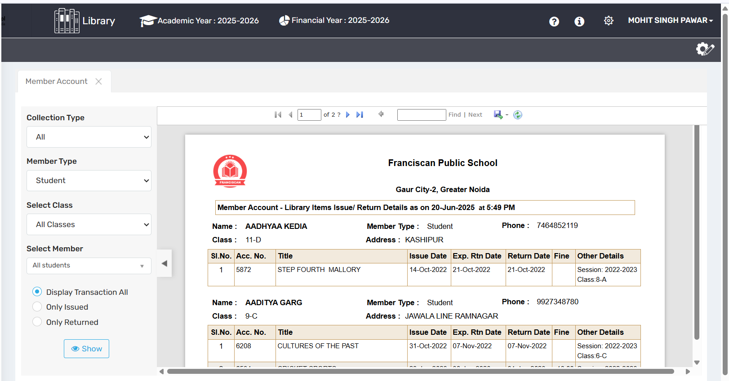

📌 Purpose
A Member Account serves as a personalized user profile that stores key information such as login credentials, preferences, and interaction history. It enables secure access to services, personalized experiences, and easy management of personal data within the platform.

🔍 Where to Find It
The Member Account can typically be accessed:
- By clicking the user avatar or name on the top-right corner of the website or app.
- Through a “Sign In” or “Account” button in the main navigation bar.
- On mobile apps, often found within a menu or tab labeled “Profile” or “Account.”

📄 Field Description
Key components of a Member Account page include:
- Profile Information: Name, email, phone number, and photo.
- Security Settings: Password management, two-factor authentication.
- Preferences: Notification settings, language, and display options.
- Activity Log: Login history or recent actions.
- Subscription & Billing: Plan details, payment methods, and invoices.

💼 Use Case
The Member Account is used to:
- Log in and out of the platform securely.
- Manage and update user profile data.
- Adjust preferences for personalized usage.
- Review and manage subscription or payment info.
- Track account-related activity and ensure security.

⚠️ Important Notes
- Always log out from public/shared devices to protect your account.
- Keep contact information updated for recovery and notifications.
- Enable multi-factor authentication for enhanced security.
- Regularly review account activity to identify unauthorized access.

✅ Effective Icons for Each Section:
Section | Suggested Icon | Emoji Alternative
Purpose | 🎯 Target | 🎯
Where to Find It | 🧭 Navigation Compass | 🔍
Page Element Overview | 🧩 Puzzle or Layout | 📄
Use Case | 🛠️ Tools | 💼
Important Notes | ⚠️ Warning Sign | ⚠️

4.2 Accession Register Overview
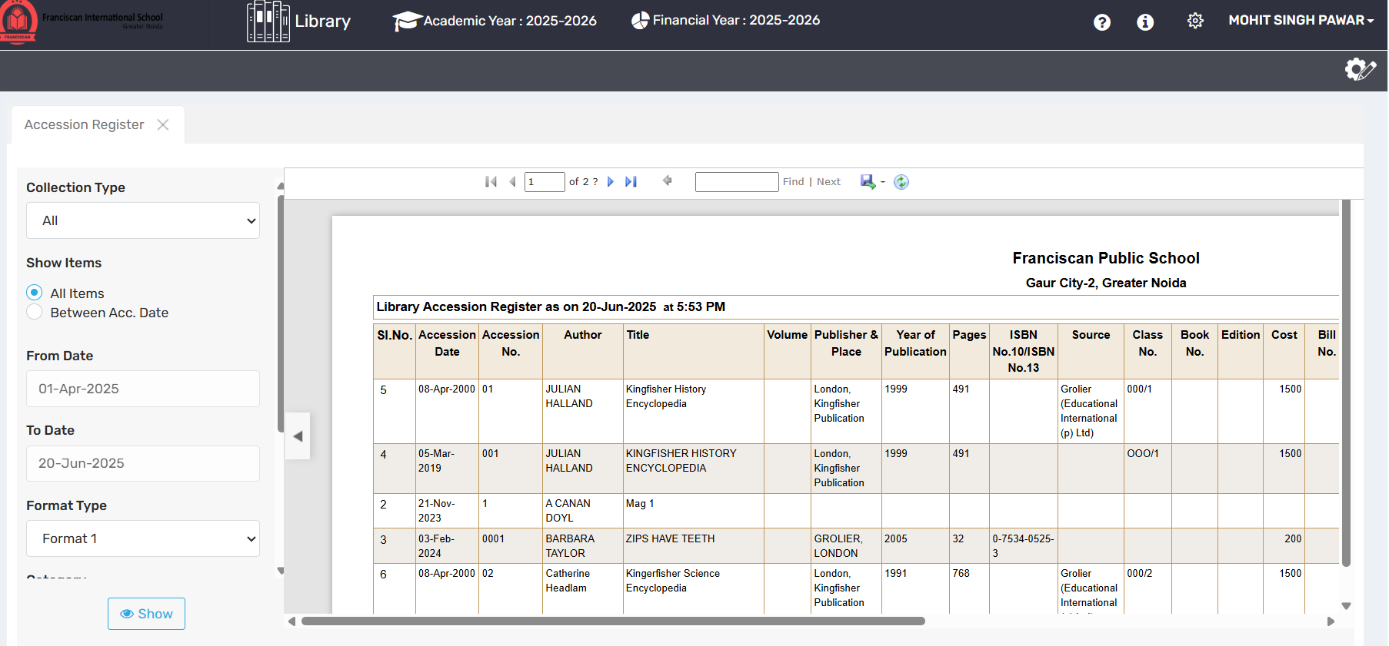

🎯 Purpose
The Accession Register is a formal log or record used primarily in libraries, museums, archives, and inventory systems to document the acquisition of items (books, artifacts, records, etc.). It provides a permanent, traceable history of each item’s entry into the collection.

🔍 Where to Find It
The Accession Register can typically be found:
- In the cataloging section of a library or institution.
- Within library management systems (LMS) or collection management software.
- As a physical ledger or digital record under the acquisitions module.

📄 Field Description
A standard Accession Register includes:
- Accession Number: A unique ID assigned sequentially.
- Date of Accession: When the item was added.
- Title/Description: Title of the book, artifact, or document.
- Source/Vendor: Where or from whom it was acquired.
- Cost/Value: Price or estimated worth.
- Remarks: Notes on condition, edition, or restrictions.

💼 Use Case
- Libraries: Track and manage new book acquisitions.
- Museums: Record incoming artifacts with historical provenance.
- Archives: Log new documents, records, or media.
- Auditing: Provide a verified trail for asset management or inventory checks.

⚠️ Important Notes
- Accession Numbers must be unique and never reused.
- Once entered, records should be permanent and unaltered (corrections should be logged separately).
- Digital and physical registers should be synchronized if both are maintained.
- Ensures legal accountability and asset traceability.

✅ Effective Icons for Each Section:
Section | Suggested Icon | Emoji Alternative
Purpose | 📘 Open Book | 🎯
Where to Find It | 📁 Folder or System Icon | 🔍
Page Element Overview | 📋 List or Table Icon | 📄
Use Case | 🗂️ Filing System | 💼
Important Notes | 🛑 Caution or Lock Icon | ⚠️

4.3📊 Session-wise Accession Report
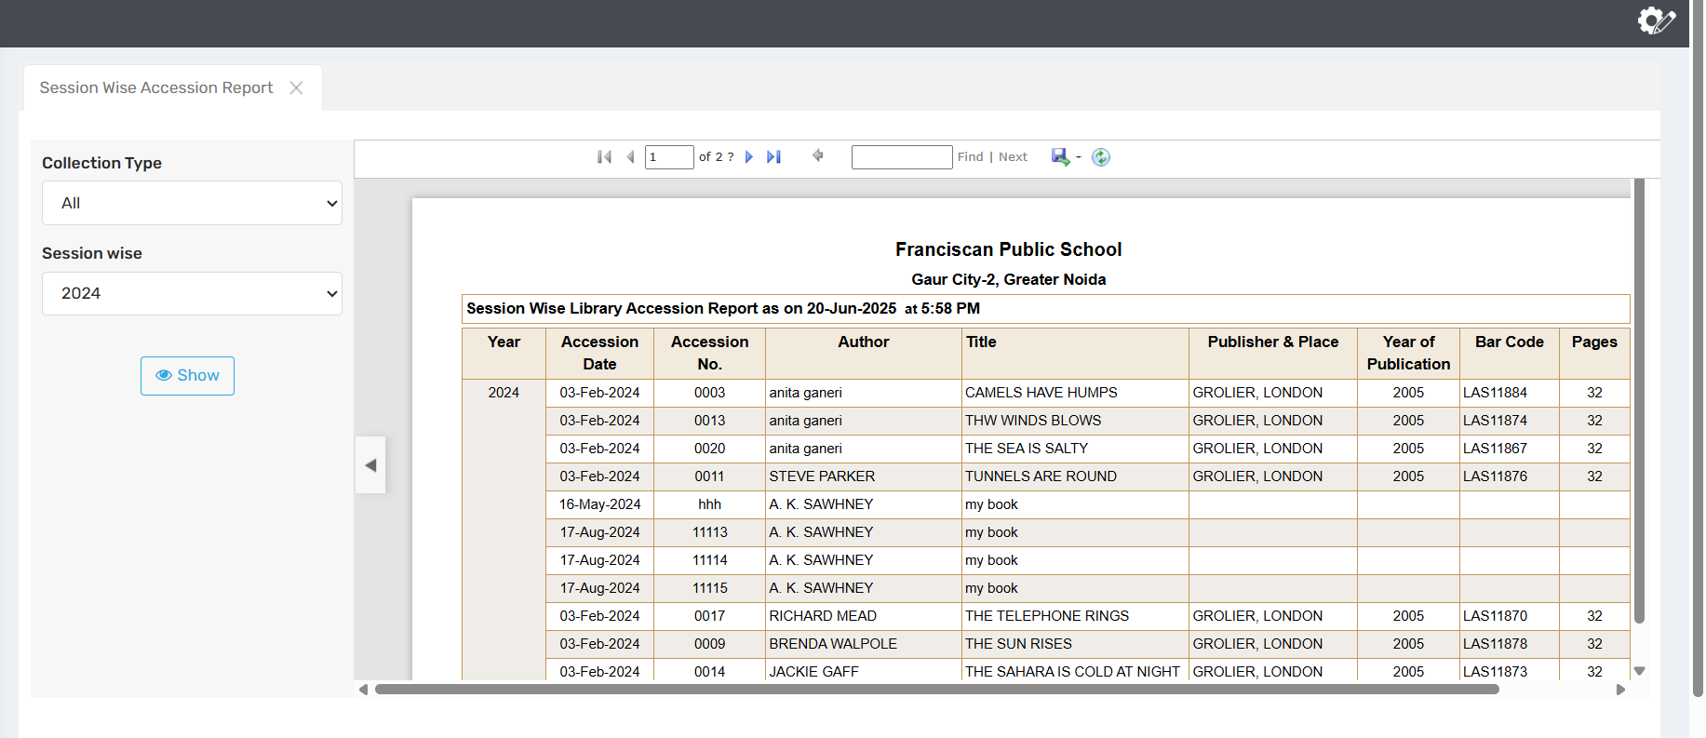

🎯 Purpose
A Session-wise Accession Report provides a detailed summary of items (like books, assets, or documents) added to a collection during a specific academic or financial session. It helps institutions track acquisitions over defined time periods for audit, inventory, budgeting, and reporting.

🔍 Where to Find It
You can typically find the Session-wise Accession Report:
- In the Reports module of a Library Management System (LMS) or inventory software.
- Under “Acquisition” or “Reports” tabs in admin dashboards.
- In the cataloguing section (for manual reports) or as an exportable file (PDF/Excel) in digital systems.

📄 Field Description
A typical Session-wise Accession Report includes:
- Session Period: e.g., 2024–2025
- Accession Numbers: Sequential numbers of acquired items.
- Titles/Descriptions: Names of books/items added.
- Authors/Publishers (for books)
- Date of Accession: When the item was logged.
- Source or Vendor: Who supplied the item.
- Cost or Value
- Total Count and Amount Summary

💼 Use Case
- Libraries: Review all books added in an academic year for audits or reporting to higher authorities.
- Educational Institutions: Verify procurement records and budget usage session-wise.
- Inventory Teams: Maintain traceability and historical records of acquisitions.
- Reporting: Generate session-end acquisition reports for stakeholders or governing bodies.

⚠️ Important Notes
- Ensure the session filter is correctly set before generating the report.
- The report is essential for audits, so data must be complete and error-free.
- Some systems may require admin permissions to access this report.
- Always archive reports for future reference or compliance checks.

✅ Effective Icons for Each Section:
Section | Suggested Icon | Emoji Alternative
Purpose | 📈 Purpose/Goal Icon | 🎯
Where to Find It | 🗂️ Reports Folder Icon | 🔍
Page Element Overview | 🧾 Document Layout Icon | 📄
Use Case | 🧰 Toolbox or Use Case Icon | 💼
Important Notes | ⚠️ Alert or Lock Icon | ⚠️

4.4📊 Transaction Report
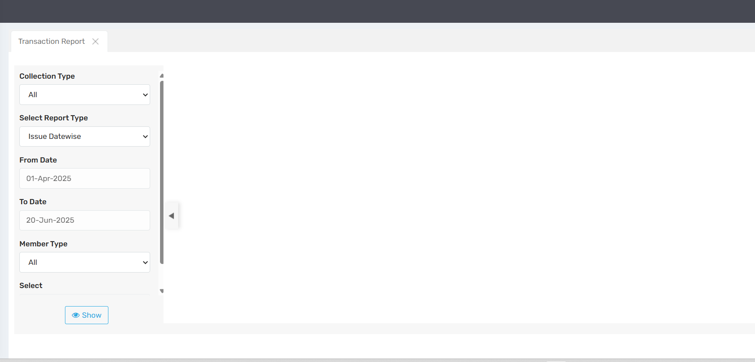

🎯 Purpose
The Transaction Report is a detailed record of all activities or exchanges involving items, users, or funds within a system—most commonly in library systems, financial software, or inventory tools. Its purpose is to provide a real-time or historical overview of all transactions (e.g., book issues/returns, purchases, payments, or transfers) for tracking, auditing, and decision-making.

🔍 Where to Find It
The Transaction Report can usually be found:
- Under the "Reports" or "Analytics" section of a Library Management System (LMS), accounting system, or ERP.
- In modules like "Circulation", "Finance", or "Inventory", depending on the system.
- Accessible through admin or reporting dashboards, often exportable in PDF, Excel, or CSV formats.

📄 Field Descriptions
A standard Transaction Report includes:
- Transaction ID or Serial Number
- Date & Time of each transaction
- Type of Transaction (e.g., Issue, Return, Purchase, Payment)
- Item/Asset Details (e.g., Book Title, SKU, Invoice No.)
- User/Staff Involved
- Amount or Quantity (if applicable)
- Remarks or Notes (for context or manual entries)
- Filters: By date, user, type, or department

💼 Use Case
- Libraries: Track daily book issue/return history for members.
- Finance Teams: Monitor payments, refunds, and collections.
- Inventory Managers: View item movement across locations or sessions.
- Administrators: Ensure accountability, monitor usage, and support audits.

⚠️ Important Notes
- Ensure accurate date filters are applied to avoid incomplete data.
- Use exported reports as official records for internal or external audits.
- Periodically review for discrepancies or suspicious activity.
- Access may be restricted based on user roles (e.g., only admins can view all transactions).

✅ Effective Icons for Each Section:
Section | Suggested Icon | Emoji Alternative
Purpose | 📊 Goal/Activity Icon | 🎯
Where to Find It | 🔎 Search Dashboard Icon | 🔍
Page Element Overview | 🧾 Table/Document Icon | 📄
Use Case | ⚙️ Gears or Function Icon | 💼
Important Notes | 🛑 Warning/Info Shield Icon | ⚠️

4.5📊 Master Report
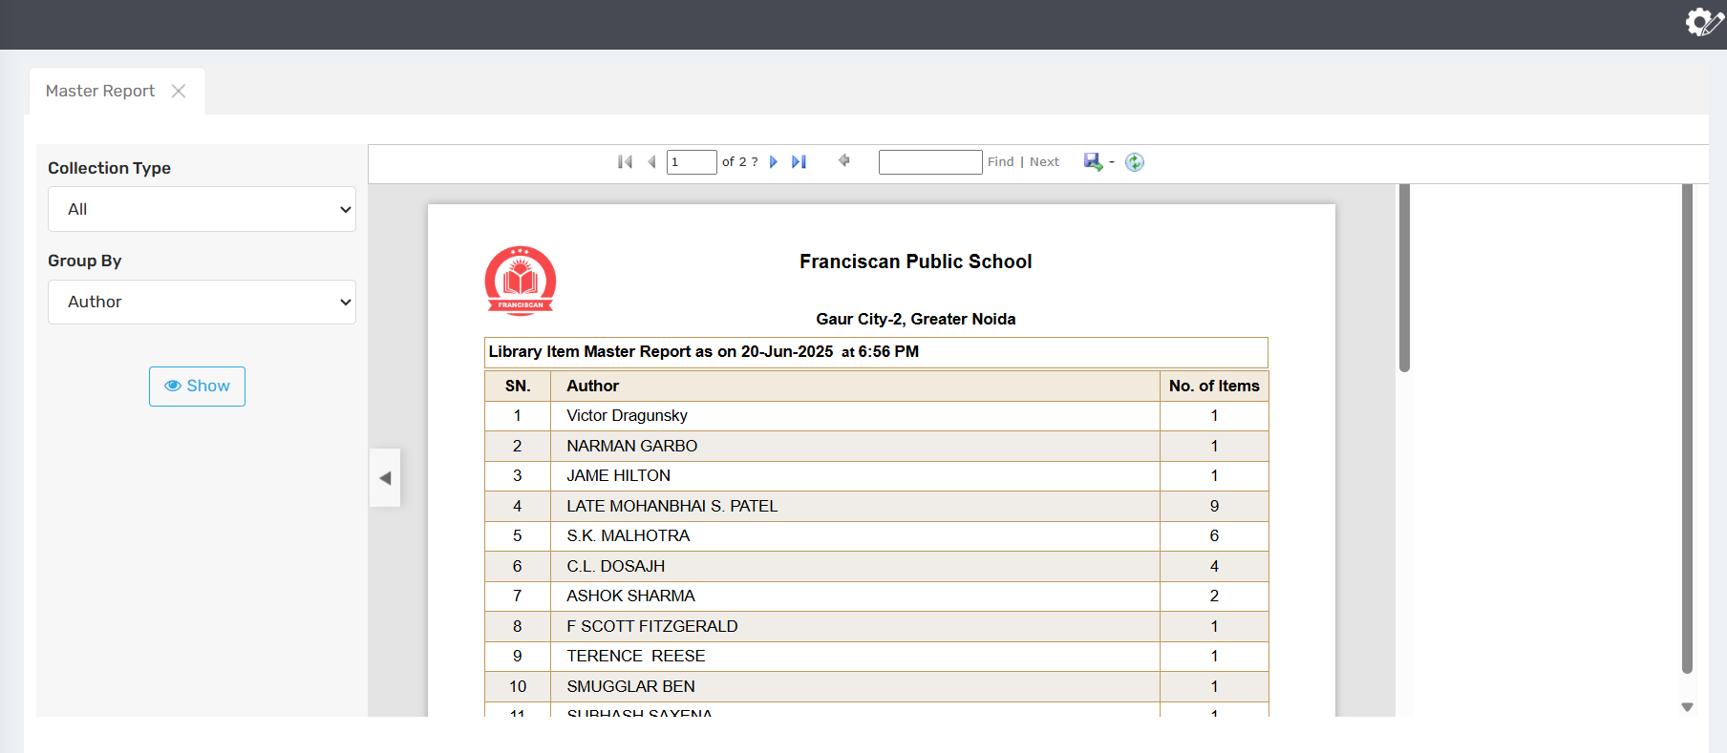

🎯 Purpose
The Master Report serves as a comprehensive and centralized report that compiles core records and foundational data across various modules (such as books, users, inventory, vendors, etc.). It provides a single source of truth to support administrative decisions, system setup reviews, and overall data integrity.

🔍 Where to Find It
You can typically find the Master Report:
- In the Admin or Reports section of a Library Management System (LMS), Enterprise Resource Planning (ERP), or asset management software.
- Under a label such as "Master Data Reports", "System Reports", or "Master List Export".
- Often accessible only to administrators or high-level staff due to its scope and sensitivity.

📄 Field Description
A Master Report typically includes:
- Entities Covered: Books, users, categories, departments, vendors, item types, subjects, etc.
- Fields per Entity: ID, Name, Description, Status, Linked Data
- Filters: By entity type, date added, status (active/inactive), or location.
- Export Options: Excel, PDF, or CSV formats for backup or offline review.
- Bulk Operations (optional): Like printing, exporting, or syncing data.

💼 Use Case
- System Audits: Review complete data records during internal or third-party audits.
- Setup Validation: Ensure all master data like departments, courses, or item types are correctly configured.
- Data Migration: Prepare for moving data to another system with a clean, consolidated view.
- Reporting & Planning: Use master data to inform decisions, detect duplicates, or plan expansions.

⚠️ Important Notes
- Master reports should not be editable directly—modifications must go through proper workflows.
- Only authorized personnel should access them, as they expose complete datasets.
- Regular backups are recommended to prevent data loss or corruption.
- Master reports can become outdated if not synced with live data—ensure real-time or recent refresh when generating.

✅ Effective Icons for Each Section:
Section | Suggested Icon | Emoji Alternative
Purpose | 📘 Database Book Icon | 🎯
Where to Find It | 🧭 Admin Navigation Icon | 🔍
Page Element Overview | 📊 Table/Grid Layout Icon | 📄
Use Case | 🛠️ Wrench or Strategy Icon | 💼
Important Notes | 🛑 Security or Info Icon | ⚠️

4.6📊 Discarded item Report
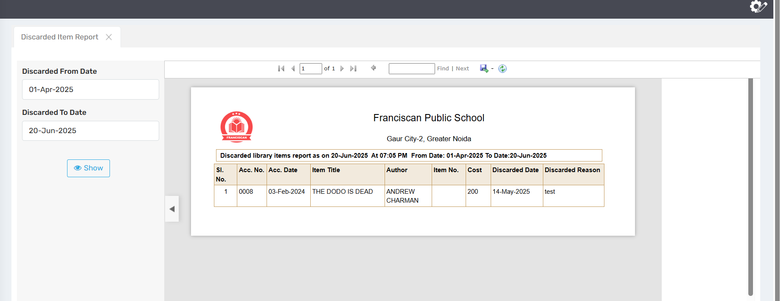

🎯 Purpose
The Discarded Item Report provides a record of all items removed or withdrawn from a library or inventory system. Items may be discarded due to damage, outdated content, loss, or redundancy. The report ensures transparency, accountability, and helps maintain an up-to-date and relevant collection.

🔍 Where to Find It
The Discarded Item Report can typically be accessed:
- In the Reports or Inventory/Weeding section of a Library Management System (LMS) or asset management software.
- Labeled as “Weeded Items,” “Removed Resources,” “Discard Register,” or “Write-Off Report.”
- Usually available to administrators, librarians, or audit staff.

📄 Field Description
A typical Discarded Item Report includes:
- Discard Date: When the item was removed.
- Accession Number / Item ID
- Title / Description of the item
- Author / Publisher (for books)
- Reason for Discard: Damaged, outdated, lost, duplicate, etc.
- Approval Status: Who authorized the discard
- Replacement Info (if applicable)
- Filters: By date, department, discard reason, or item type

💼 Use Case
- Librarians: Track and manage the removal of outdated or damaged books.
- Administrators: Maintain compliance with collection maintenance policies.
- Auditing Teams: Verify asset disposal records for accountability.
- Planning Committees: Identify gaps created by discards and plan replacements.

⚠️ Important Notes
- Discard actions should be authorized and logged with valid reasons.
- Once discarded, items should be removed from the active catalog but retained in history for audits.
- Keep evidence of discard decisions (photos, reports, approvals) for accountability.
- Useful for planning replacements or reallocating budgets for new acquisitions.

✅ Effective Icons for Each Section:
Section | Suggested Icon | Emoji Alternative
Purpose | 🧾 Trash Document Icon | 🎯
Where to Find It | 🗂️ Folder with Reports Icon | 🔍
Page Element Overview | 📋 List or Grid Layout Icon | 📄
Use Case | 🧰 Maintenance or Planning Icon | 💼
Important Notes | 🚫 Warning or Attention Icon | ⚠️

4.7📊 Fine Defaulter List
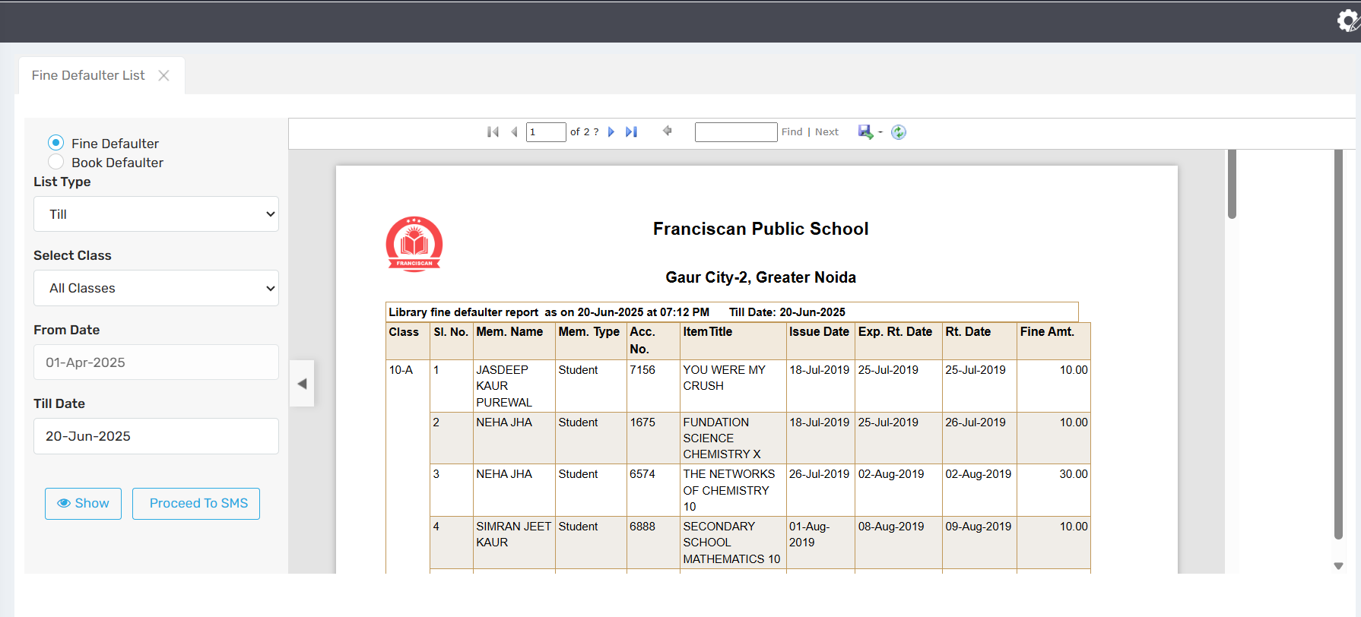

🎯 Purpose
The Fine Defaulter List is a report that identifies users who have overdue fines for not returning borrowed items (books, media, etc.) on time. Its purpose is to track pending payments, enforce borrowing rules, and encourage timely returns. It helps in maintaining circulation discipline and ensuring fair access to resources.

🔍 Where to Find It
The Fine Defaulter List is usually found:
- In the Circulation or Reports section of a Library Management System (LMS).
- Under categories like “Overdues,” “Fines & Penalties,” “Defaulters,” or “Pending Dues.”
- Accessible by librarians, circulation staff, and sometimes admins for follow-up actions.

📄 Field Description
A typical Fine Defaulter List includes:
- User Name / ID / Roll No.
- Item Details: Book title, accession number
- Due Date: When the item was expected back
- Days Overdue
- Fine Amount: Total calculated fine
- Status: Unpaid / Partially Paid / Cleared
- Contact Info (optional): Phone, email
- Filters: By user type, date range, department, or fine amount

💼 Use Case
- Librarians: Follow up with users who owe fines and restrict further checkouts if needed.
- Administration: Track unpaid dues for year-end reports or clearance certificates.
- Students / Staff: Review and settle pending fines to regain borrowing privileges.
- Accounts Dept.: Coordinate fine collections or reconciliations.

⚠️ Important Notes
- Regularly update the list to reflect cleared or waived fines.
- Consider sending automated reminders to defaulters.
- Fines may be customizable per policy (per day, item type, etc.).
- Ensure privacy and discretion when displaying or sharing the list.

✅ Effective Icons for Each Section:
Section | Suggested Icon | Emoji Alternative
Purpose | 💸 Coins or Penalty Icon | 🎯
Where to Find It | 📂 File or Search List Icon | 🔍
Page Element Overview | 📋 Report or Table Layout Icon | 📄
Use Case | 🔧 User Action or Process Icon | 💼
Important Notes | 🛑 Alert, Bell, or Info Shield Icon | ⚠️

4.8📊 Library Stock verification
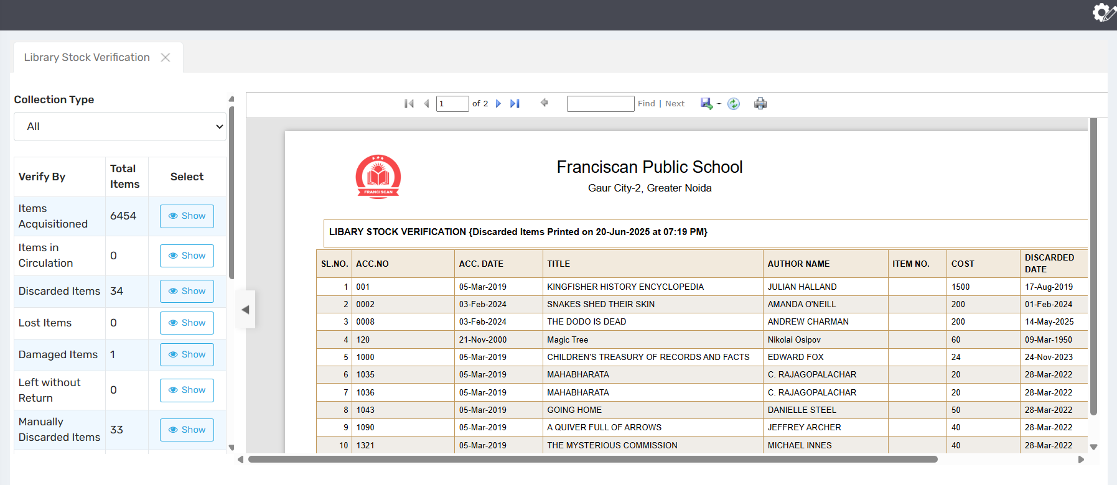

🎯 Purpose
Library Stock Verification is the process of physically checking and confirming the presence and condition of library materials (books, journals, multimedia, etc.) against the records in the Library Management System (LMS). Its purpose is to identify missing, misplaced, damaged, or unrecorded items, ensure accurate cataloging, and maintain accountability.

🔍 Where to Find It
Library stock verification tools or reports can typically be found:
- In the Admin, Inventory, or Reports module of a Library Management System (LMS).
- Under labels like “Stock Verification,” “Inventory Check,” “Physical Verification,” or “Asset Audit.”
- May also exist as a printable checklist or barcode scanning tool for manual verification.

📄 Field Description
A Library Stock Verification interface/report includes:
- Accession Number / Barcode
- Title & Author
- Shelf Location
- Status: Found / Missing / Damaged
- Remarks: For condition or notes
- Verification Date
- Verified By
- Filters: By category, location, or department

💼 Use Case
- Librarians: Conduct annual or periodic audits to ensure inventory accuracy.
- Administrators: Submit reports for audits, compliance, or grant renewals.
- Library Committees: Analyze loss rates, plan replacements, or discard damaged items.
- Audit Teams: Validate physical stock against the system's records.

⚠️ Important Notes
- Stock verification should be done at least once a year (or as per institutional policy).
- Discrepancies must be investigated and documented properly.
- Use barcode scanners or mobile apps for faster verification if supported.
- Always backup data before performing mass updates during verification.

✅ Effective Icons for Each Section:
Section | Suggested Icon | Emoji Alternative
Purpose | 🗃️ Ledger or Inventory Icon | 🎯
Where to Find It | 🔍 Checklist or Search Tool Icon | 🔍
Page Element Overview | 📋 Table or Scanner Layout Icon | 📄
Use Case | 🧰 Toolbox or Audit Icon | 💼
Important Notes | 🛑 Alert, Lock, or Note Icon | ⚠️

4.9📊 Barcode Report
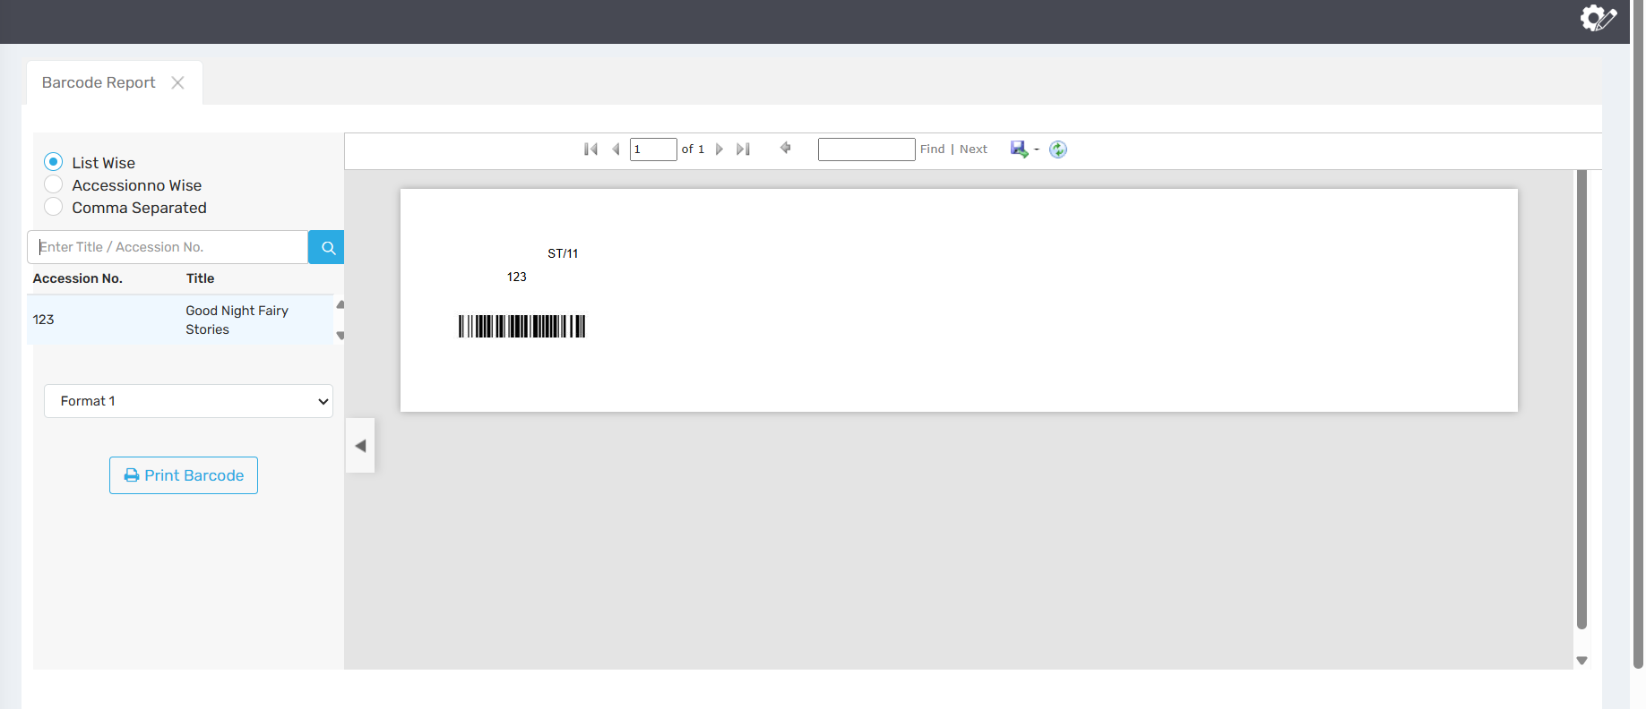

🎯 Purpose
The Barcode Report is a document or digital list that displays the barcodes assigned to library materials (books, journals, multimedia, etc.), usually alongside item details. It is used to organize, track, and manage items efficiently using barcode-based scanning systems. This report helps in cataloging, issuing, returning, and stock verification.

🔍 Where to Find It
The Barcode Report is typically found in:
- The Cataloging, Reports, or Barcode Management section of a Library Management System (LMS).
- Under names like “Barcode List,” “Barcode Generation Report,” “Item Barcode Report,” or “Barcode Printing Module.”
- Sometimes available as a PDF or printable layout for physical label printing.

📄 Field Description
A standard Barcode Report includes:
- Accession Number
- Item Title (Book, Journal, etc.)
- Barcode Number / Image
- Call Number / Location
- Author / Publisher
- Category / Item Type
- Print Status: Printed / Not Printed
- Filters: By item type, date added, location, department

💼 Use Case
- Cataloging Staff: Generate barcodes for newly added items.
- Librarians: Use barcode lists for issuing/returning books with scanners.
- Inventory Teams: Cross-check physical items during stock verification.
- Printing Vendors: Print barcode stickers using the formatted report.
- Auditors: Verify assets with barcode tagging.

⚠️ Important Notes
- Ensure barcode formats are consistent with your LMS and scanner systems.
- Avoid duplicate barcodes — each item must have a unique barcode.
- Keep a backup of generated barcodes, especially before printing.
- After barcode printing, mark items as printed to prevent duplicates.

✅ Effective Icons for Each Section:
Section | Suggested Icon | Emoji Alternative
Purpose | 🔖 Tag or Barcode Icon | 🎯
Where to Find It | 📂 Folder with Barcode Symbol | 🔍
Page Element Overview | 📋 Report or Barcode List Layout | 📄
Use Case | 🧰 Tools / Scanner Icon | 💼
Important Notes | 🚫 Alert / Scan Warning Icon | ⚠️

4.10📊 Library Statistics
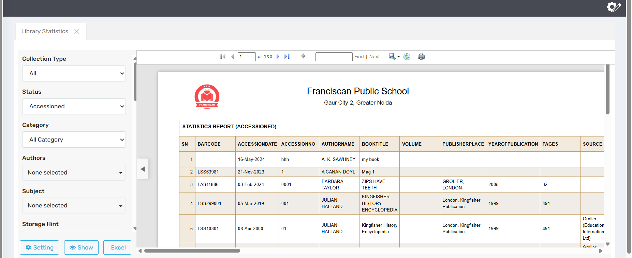

🎯 Purpose
The Library Statistics section provides quantitative data and performance metrics related to library usage, resources, services, and users. It is used to monitor operations, analyze trends, evaluate user engagement, and support data-driven decision-making for improving library services.

🔍 Where to Find It
You can typically find Library Statistics in:
- The Reports, Analytics, or Dashboard section of a Library Management System (LMS).
- Under labels like “Library Usage Stats,” “Library Metrics,” “Library Performance Reports,” or “Dashboard Overview.”
- Accessible by librarians, administrators, and institutional managers.

📄 Field Descriptions
A typical Library Statistics page includes:
- Total Books / Resources Available
- Books Issued & Returned (per day/month/year)
- User Statistics: Total active users, visits, new registrations
- Top Borrowed Titles / Authors
- Overdue and Fine Summary
- Digital Resource Usage (if applicable)
- Visuals: Charts, tables, and downloadable reports
- Filters: By date, department, resource type, or user category

💼 Use Case
- Librarians: Monitor circulation trends, manage demand, and report key metrics.
- Management / Principals: Evaluate library performance and make funding or staffing decisions.
- Planning & Development: Identify usage gaps and plan new acquisitions or upgrades.
- Accreditation & Reporting: Provide statistical data for institutional reports, audits, and external accreditation agencies.

⚠️ Important Notes
- Ensure data is updated regularly for accuracy.
- Use filters appropriately to avoid misinterpretation of data.
- Combine with qualitative feedback for well-rounded evaluation.
- Maintain data privacy when reporting user-specific statistics.

✅ Effective Icons for Each Section:
Section | Suggested Icon | Emoji Alternative
Purpose | 📊 Data Graph or Insight Icon | 🎯
Where to Find It | 🧭 Dashboard or Analytics Icon | 🔍
Page Element Overview | 📋 Table or Chart Layout Icon | 📄
Use Case | 🧰 Tools / Strategy Planning Icon | 💼
Important Notes | ⚠️ Info or Alert Shield Icon | ⚠️

