Payroll Module
1.Search Bar:
- 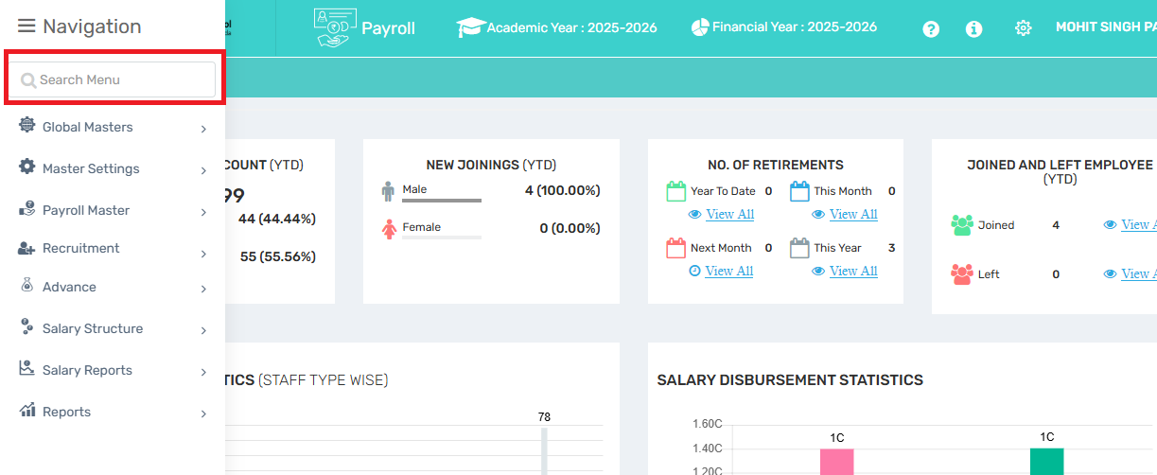
Menu Overview
1.The Search Bar in the Payroll module helps you quickly find any section within Payroll Manager, such as payslips, salary structure, or attendance. Just type a keyword to navigate instantly.

Where to find it:
- On the left sidebar (where menu options like Global Masters, Payroll Master, Recruitment, etc. are listed),
- Just above the menu items, there's a "Search Menu" bar with a placeholder text saying:
Use Case:
- Quickly find specific options or sub-modules within Payroll.
- For example, you can type: Import Staff,Session Transfer, Salary Reports, Payroll Manager
This helps you navigate faster without scrolling through the full menu.

2. Active Session:
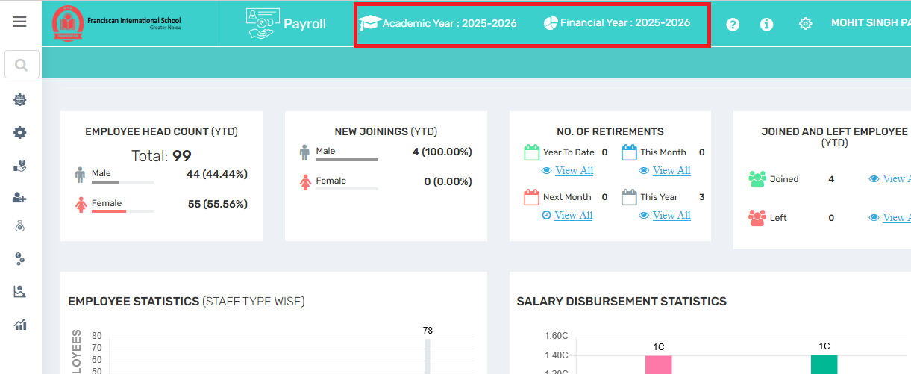
At the Top it shows which Academic Year And Financial Year Is Active.Ensures salary calculations, reports, and budget tracking are tied to the correct academic and financial periods.
Academic Year: Shows the currently selected academic session (e.g., 2025–2026). This determines how staff records, increments, and school-year-specific payroll elements are managed.
Financial Year: Displays the active financial session (e.g., 2025–2026). This is essential for accurate payroll processing, statutory reporting, and financial audits.
Use Case:
- Ensures salary calculations, reports, and budget tracking are tied to the correct academic and financial periods.
- Helps administrators verify they are working in the correct session before processing payroll.
- Prevents data mismatches when handling increments, leave balances, or deductions that are year-dependent.
- Critical for generating year-wise compliance reports (like PF, TDS, Form 16, etc.).

Important Notes:
- Always double-check the active session before generating payroll or reports.
- If sessions need to be changed (e.g., end of academic year), it should be done by users with admin rights through settings.
3. Help Center, Manuals & Settings:
- 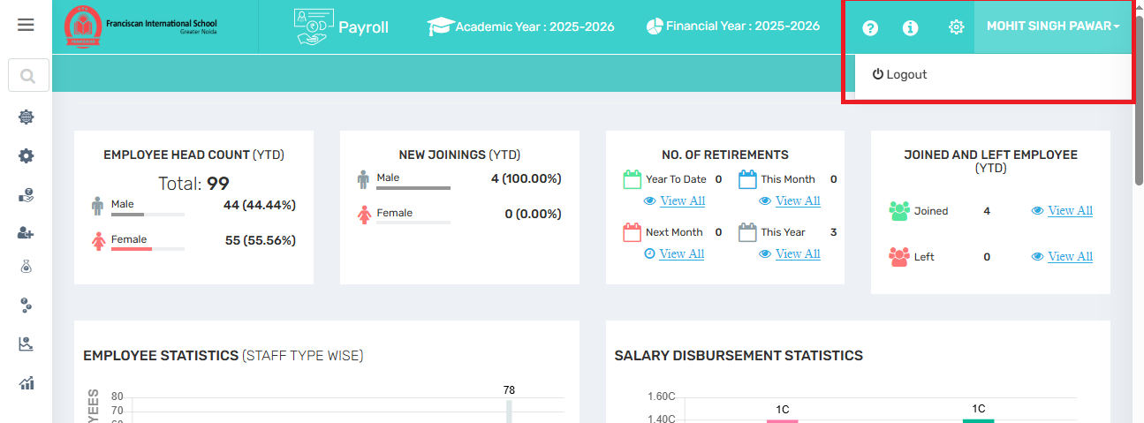
At the top Right one ? Help Desk (Zoho) Opens the support system (Zoho), where users can log in, raise queries, and get technical help. Useful for resolving ERP-related issues.
(i) Manuals / Information Opens user manuals, tutorials, or guidance documents to help navigate the module easily.
Settings Allows the user to customize the interface, such as changing the theme color, layout preferences, or language settings.
User Profile Dropdown Displays the logged-in user's name. Clicking on it opens a dropdown with the Logout option. Useful for session management and account switching.
Where to Find Them:
At the top-right corner of the Payroll screen (as seen in your screenshots), next to the logged-in user's name (e.g., MOHIT SINGH PAWAR), you'll find three icons:
❓ Help (Circle with a Question Mark)
📘 Manuals (Document or Info Icon)
⚙️ Settings (Gear Icon)
Use Case Example:
If you're uploading staff salary data and need the correct format:
- Click the 📘 Manuals icon to access the format guide.
If you're unsure about a button or process:
- Click the ❓ Help icon for immediate assistance or explanation.
4. Quick Links:
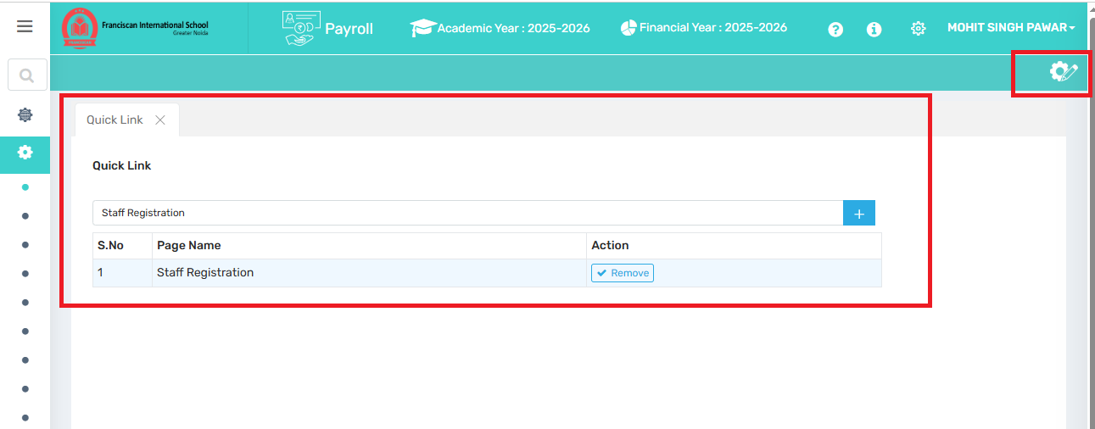
By using these features that users need to access frequently or quickly — without going through multiple menus.User can add or remove according to their need.
➕ Button Allows the user to add a new quick link by selecting a page/module they often use.
🗑️ Remove Button Lets the user remove any existing link that’s no longer needed.
List View Displays all the current quick links with serial number, page name, and action options.
Where to Find Them:
It is usually beside or near the “Staff Registration”
5. Dashboard:
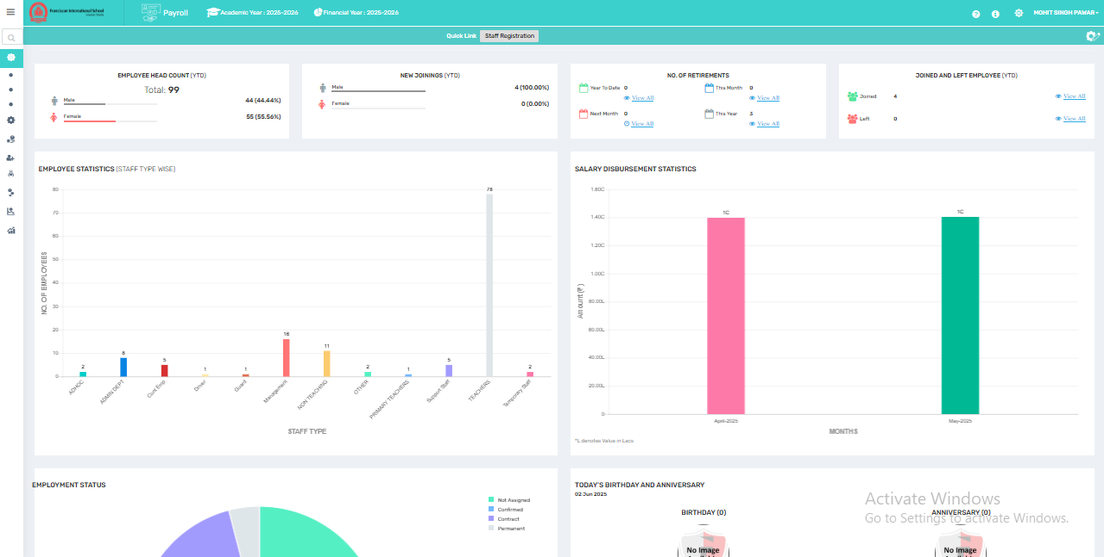
This option takes the user to the main dashboard, where they can get an overview of key metrics and quick access to essential features.
Employee Overview Metrics
- Employee Head Count (YTD): Total number of employees with gender-wise breakdown.
- New Joinings: Count of newly joined staff this year, also gender-wise.
- Retirements: Number of retirements this month and year.
- Joined & Left Employees : Shows the number of employees who joined and left the organization this financial year.
B. Employment Statistics
- Bar Chart by Staff Type: Shows distribution across Staff type like Teaching, Admin, Guards, Drivers, etc.
C. Salary Disbursement
- Graphical View: Shows total salary paid each month, gives quick financial insight.
D. Employment Status & Events
- Donut Chart: Display Distribution of staff as Permanent, Contract, Confirmed, or Not Assigned.
- Birthdays & Anniversaries: Displays current day celebrations (if any) for HR engagement.
E. Comparative & Demographic Analytics
- Month-wise Salary Comparison: Compares current year vs previous year salary.
- Nationality-wise Employee Strength: This section displays the total number of employees based on their nationality
- Department-wise Head Count: It provides a quick view of department-wise distribution across the organization. (e.g., Primary Teachers, Admin Dept., etc.).
F. Salary Range Distribution
- Bar chart representing:
  - Number of employees within defined salary brackets.
  - Helps analyze pay structure and equity.
Use Case Example:
This Payroll Dashboard acts as a centralized hub to:
- Monitor employee trends and HR metrics in real time.
- Track payroll disbursement and departmental distribution.
- Improve HR decision-making with data-driven visuals.
- Simplify access to frequently used payroll tools through “Quick Links.”
- Engage staff by acknowledging events like birthdays/anniversaries.

6. Global Master:
6.1. Define Mail Template:
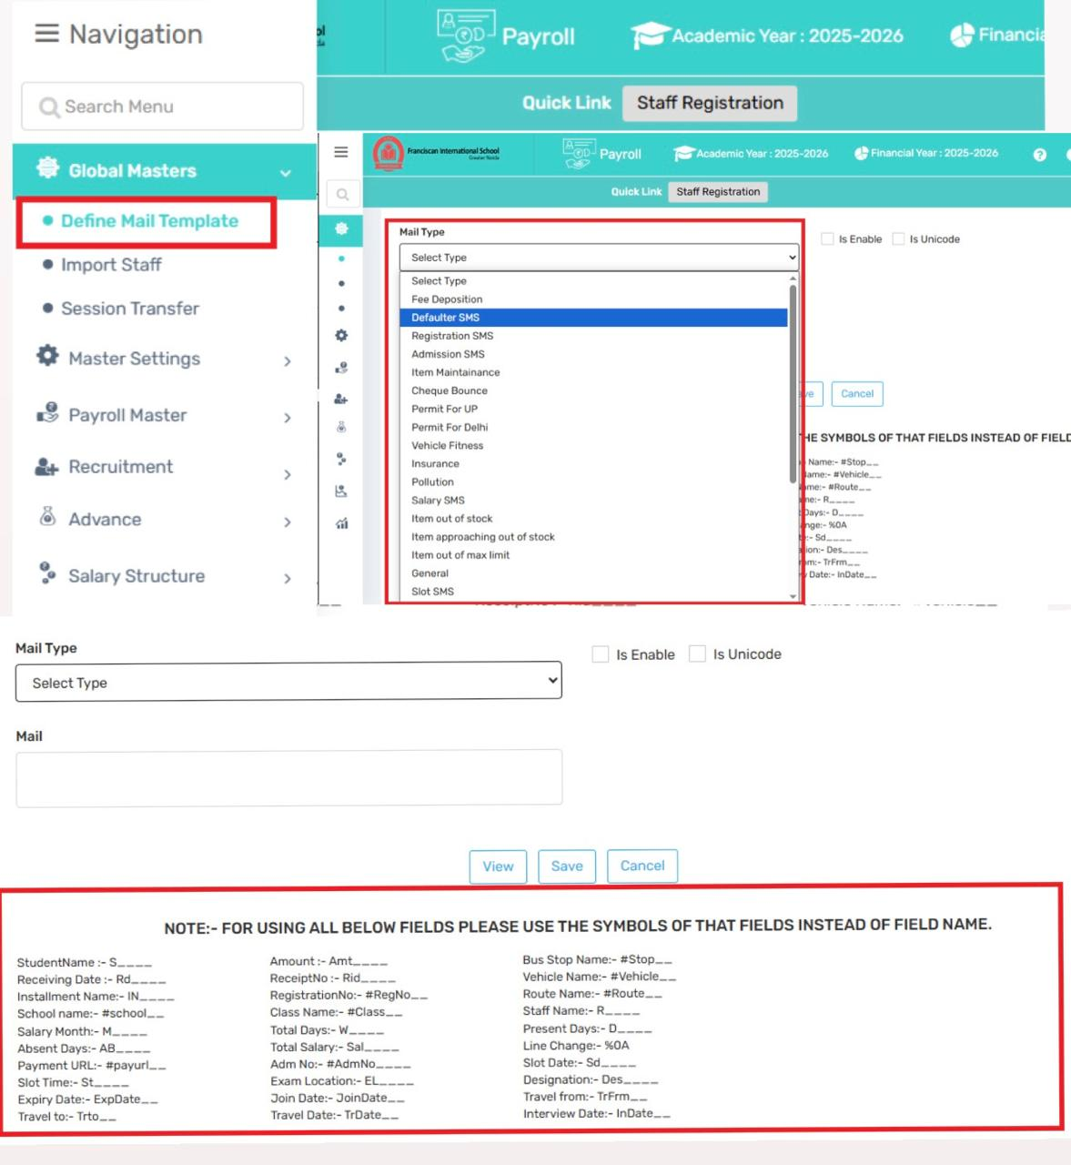

Email Template Configuration Module – User Manual
The Email Template module in your payroll software allows users to create and manage predefined email templates for various communication scenarios. This feature ensures that emails sent to parents, staff, or other users are consistent, professional, and automatically personalized based on user-specific data.
Purpose of this Module
This module enables the user to define and configure customized email templates that will be used across the system for sending automated or manual emails related to different operations such as:
- Attendance Reports
- Payroll Summaries
- Payslip Distribution
- Reminders and Announcements
- General Communication

Field Description:

Mail Type
- A dropdown menu to select the type of email (e.g., Salary Slip, TDS Summary, Payment Confirmation, etc.).
- Determines the purpose and trigger for the email.

☐ Is Enable
- Check this box to activate the template, so it starts sending mails as per the defined configuration.

☐ Is Unicode
- When selected, it allows the email content to support multilingual text, including Hindi, regional languages, symbols, etc.

📨 Mail (Body Text Field)
- This is where you write the email content.
- You can insert dynamic fields using shortcodes (shown below this section) like:
  - #school__ – School Name
  - #RegNo__ – Registration Number
  - #Sal__ – Total Salary
  - #St__ – Slot Time
  - #R__ – Staff Name
⚠️ These placeholders will be automatically replaced with actual employee-specific values when the mail is sent.

How It Works
- Create a New Template:
  - Navigate to the Email Template Configuration section.
  - Click on “Create Template”.
  - Choose the template type (e.g., Salary Mail, Attendance Report).
- Define Subject & Body:
  - Enter a suitable email subject.
  - In the email body, compose the message content using symbolic placeholders (also known as merge fields).
- Use of Placeholder Symbols:
  - Instead of using actual field names (like Staff Name,Salary Amout), you can insert symbols (e.g., {{staff_name}}, {{amount}}).
  - These symbols are dynamically replaced with actual data when the email is sent.
Example:
You want to send salary slips each month via email. You create a mail template like this:

Message:
Hello #R__,
Your salary for the month of #M__ has been processed.
Total Days: #W__
Present Days: #D__
Total Salary: ₹#Sal__
Regards,
Payroll Department
Now, when this mail is sent, the ERP will automatically fetch and insert employee-specific details in place of the tags like #R__, #M__, #Sal__, etc.
School Administration

- Save & Apply:
  - Once defined, click Save.
  - The template can now be automatically used when sending emails related to the selected category (e.g., when fee is due or a payslip is generated).
Key Features
- Allows use of dynamic placeholders for personalizing emails
- Helps in saving time by avoiding repetitive email drafting
- Reduces manual errors in names, amounts, dates, etc.
Best Practices
- Always test each template with a sample user to ensure placeholders are rendering correctly.
- Keep the content short, clear, and professional.

How to Edit a Saved Email Template
The system allows users to easily update any previously defined email templates. Whether you need to revise the subject line, change the body content, or update placeholder symbols, the editing process is straightforward and uses the same interface as the template creation screen.
Steps to Edit a Saved Email Template
- Navigate to the Email Template List:
  - Go to the Email Template Configuration module from the menu.
  - You will see a list of all previously defined templates.
- Click on the “View” Button:
  - Next to each template entry, there is a “View” button.
  - Click it to open the template in edit mode.
- Edit the Template:
  - The edit window is identical to the template creation window.
  - You can update:
    - Template Type (if allowed)
    - Email Subject
    - Email Body with dynamic placeholders like {{staff_name}}, {{amount__}}, etc.
- Save Changes:
  - After making your changes, click the “Save” button to update the template.
  - The changes will be immediately reflected wherever that template is used in the system.
Important Notes:
- If the template is in use for automated communications (e.g., fee alerts or payslips), changes will apply to all future emails sent using that template.
- Be cautious while modifying placeholder symbols—incorrect or missing symbols may result in blank or broken values in the final emails.
- Always review the content before saving to maintain professional tone and data accuracy.
Use Case
You want to update the subject line for the fee reminder template from:
Pay Slip - {{staff_name}}
To:
Your payslip for the month of {{month_year}} has been released and is now available in the ERP portal.
Kindly log in to your account to view or download the document for your records.
- Simply open the template using View, make the changes in the subject box, and hit Save.
Tip
Consider maintaining a naming convention or versioning system if multiple people have access to editing templates (e.g., "Pay Slip - v2").

6.2 Import staff:
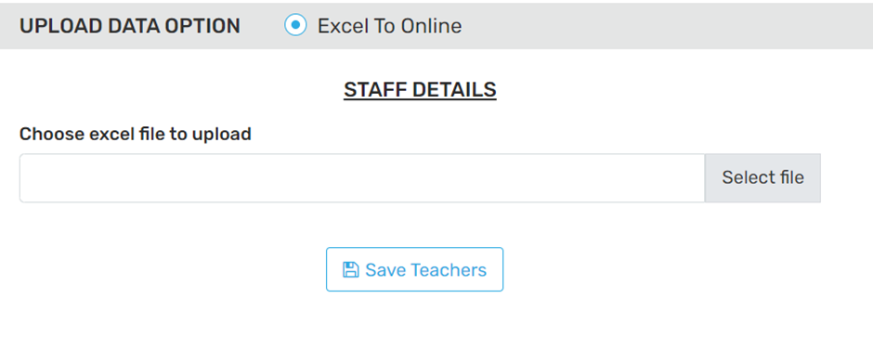
This Section allows bulk uploading of staff details into the Payroll ERP system via an Excel file. It is a time-saving utility designed to help administrators quickly register or update multiple teacher/staff records at once, instead of manually entering them one by one.
Import Type:
- Excel To Online: This option is selected by default, meaning the uploaded Excel file will be read and its data transferred into the system automatically.
Upload Excel Section
- Label: “STAFF DETAILS”
- Action: Upload an Excel file that contains the staff information (e.g., name, department, designation, contact details, etc.).
- Browse/Select file: Button to browse and choose the Excel file from your computer.
- Save Teachers: After selecting the file, clicking this button will:
  - Read the data from Excel.
  - Validate and import staff data into the Payroll system.
  - It will add new records.
Use Case:
- Onboarding New Academic Year Staff
- Migrating from Previous Payroll or HR Systems
- Mass Updates to Staff Information (e.g., designations, departments, pay scales)
Important Notes:
- Ensure the Excel file format matches the system's expected structure (usually provided as a template).
- Any missing mandatory fields may result in upload errors.
- Duplicate or inconsistent data (like mismatched employee codes) may be rejected.
6.3. Session Transfer:
The "Session Transfer" feature in the Payroll ERP allows users to move payroll-related data from the current academic or financial year to the next academic year without re-entering it manually.

7. Master Setting

7.1 Define Global Settings

7.1.i. Main Global Settings:
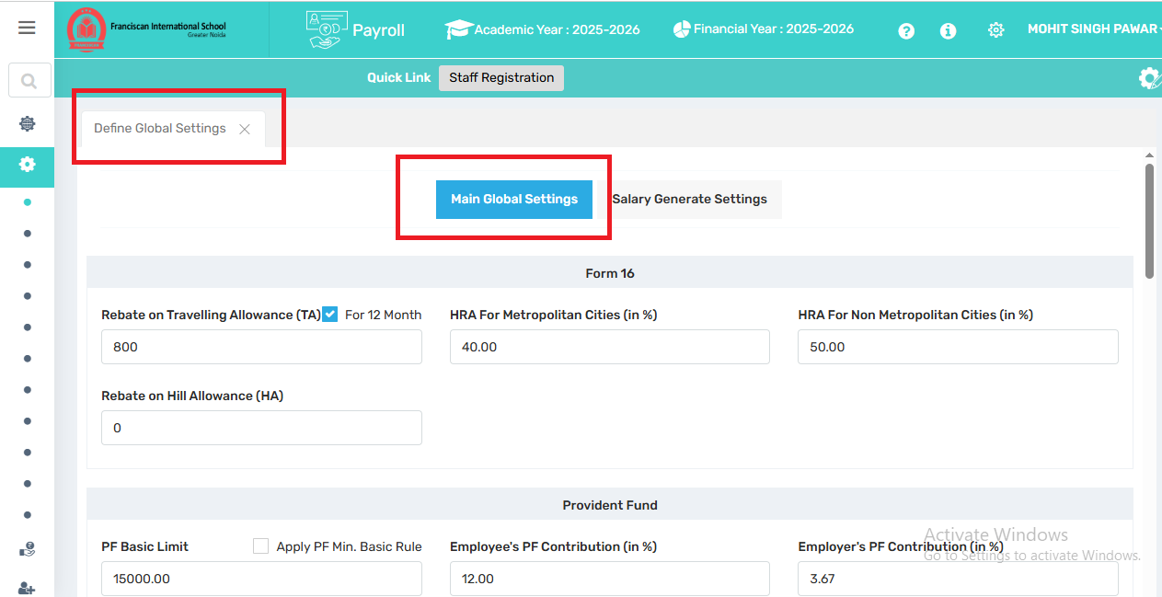
This is a by-default setting which comprises all the settings and values of the heads which has to be applied during the Salary Generation.

Here's a detailed breakdown of each section's functionality:
Global Payroll Settings (Form 16, Provident Fund)
Form 16 Settings:
Rebate on Travelling Allowance (TA): Rebate on TA in Form 16 refers to the tax exemption given for travel between home and office.
Like ₹800/month is tax-free. Enabled for 12 months = ₹9,600/year exemption.

HRA for Metropolitan Cities : This percentage is used while calculating HRA tax exemption under Income Tax rules.
For employees living in metropolitan cities (Delhi, Mumbai, Kolkata, Chennai), House Rent Allowance (HRA) exemption is calculated as:
50% of the basic salary.
For non-metropolitan cities, it's 40% of the basic salary.
Rebate on Hill Allowance (HA): HA is a special allowance given to employees working in hilly or high-altitude areas.Under Income Tax rules, a rebate/exemption is allowed on HA, and the amount varies based on the location — typically ranging from ₹300 to ₹7,000 per month, depending on the height and region.
This helps reduce the employee’s taxable income if HA is part of the salary structure.
Provident Fund (PF) and Pension Settings

Field Name | Description
PF Basic Limit | This is the salary cap (₹15,000) on which Provident Fund (PF) contributions are calculated. If salary exceeds this amount, contribution can still be limited to ₹15,000 based on the organization's policy.
Apply PF Min. Basic Rule | If checked, ensure that PF is calculated only if the basic salary is equal to or above ₹15,000. It helps apply the statutory minimum requirement for PF.
Employee's PF Contribution (%) | The percentage of basic salary deducted from the employee’s salary towards PF. Standard rate is 12% as per EPFO rules.
Employer's PF Contribution (%) | The portion contributed by the employer towards PF. Out of the total 12%, 3.67% goes directly into PF and the rest into the pension scheme.
Employer’s Pension Contribution (%) | 8.33% of the basic salary is directed from the employer’s share towards the Employee Pension Scheme (EPS).
Pension Age Limit | The age (usually 58 years) at which the employee becomes eligible to start receiving pension benefits under EPS.
Age of Retirement | The organization’s official retirement age. Typically 60 years, it marks the end of service for PF and pension calculations.
Use Ceiling | If checked, the PF calculation will be restricted to the wage ceiling limit (₹15,000), regardless of the actual basic salary. This ensures statutory compliance for organizations that choose to cap PF contributions.  Employer and employee PF contributions are calculated on ₹15,000 only, not the full basic salary.  🧊 Example 1: With PF Wage Cap  - Basic Salary: ₹30,000  - PF is calculated on ₹15,000 only  - Contribution = 12% × ₹15,000 = ₹1,800 (employee) + ₹1,800 (employer)  🔥 Example 2: Without PF Wage Cap (full basic)  - Basic Salary: ₹30,000  - PF = 12% × ₹30,000 = ₹3,600 (employee) + ₹3,600 (employer)  ✅ Why This Is Done:  - Organizations often choose to cap at ₹15,000 to control payroll costs and stay within legal minimum requirements.  - This is legally acceptable, but voluntary. Employers can choose to contribute above ₹15,000 if they want.
Admin/Inspection/Insurance Charges (by employer):
- Admin Charges (A/C No 2): 1.10%
- Inspection Charges (A/C No 22): 0.01%
- Death Insurance (A/C No 21): 0.50%
- Other Inspection Contributions: Minor percentages, regulatory.
Inspection's Total PF Contribution towards PF A/C:
The total amount contributed to the Provident Fund (PF) account by both:
- Employer's contribution, and
- Employee's contribution,
for the purpose of inspection, audit, or compliance review.

ESI & Miscellaneous Settings

Field Name | Description
Employee's Contribution (in %) | The percentage of the employee's gross salary deducted for ESI. As per current ESI rules, it's 1.75% of gross salary.
Employer's Contribution (in %) | The percentage of gross salary contributed by the employer towards ESI. The standard rate is 4.75%.
Gross Salary Limit | The maximum gross monthly salary an employee can earn to be eligible for ESI. The limit is currently ₹21,000. If an employee’s salary exceeds this amount, they are not eligible for ESI.
Use Ceiling | If checked, the ESI contribution will be restricted to the ₹21,000 limit, even if the actual gross salary is higher. This ensures contributions are capped as per statutory rules.

Change Sorting Order
Salary Sheet Settings

Gratuity & Bonus Settings

Field Name | Description
Max Limit of Amount | The maximum amount of gratuity payable to an employee. In this case, it is set to ₹1,00,000. As per Indian law, the statutory limit is ₹20 lakhs, but organizations can define their own internal caps.
Total Service | The number of years the employee has completed in service. Gratuity is generally payable after completing 5 years of continuous service.
Date of Confirmation (Checkbox) | If checked, the calculation of gratuity will consider the employee’s confirmation date instead of the joining date. This is used when gratuity eligibility starts from the confirmation of employment.

Bonus:

Use Case:
This module standardizes salary processing, tax compliance, and statutory deductions. Once configured, these values:
- Automatically apply to payroll calculations for all employees.
- Ensure compliance with laws (e.g., EPF Act, ESI Act, Income Tax Act).
- Simplify Form 16 generation and audit trails.
7.1.ii. Salary Generate Settings:
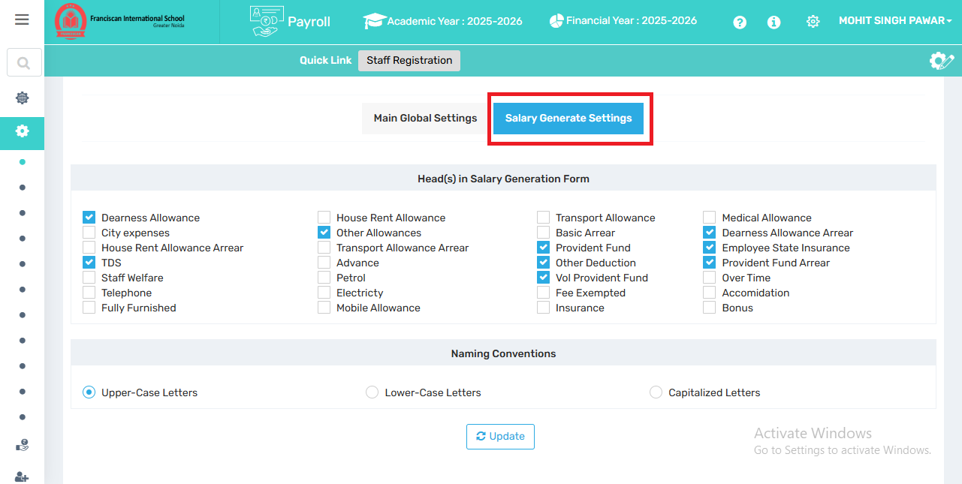
- ✅ Salary Generate Settings – Currently active. This section allows configuration of what components appear when generating a salary.
2. Head(s) in Salary Generation Form
This section shows a list of salary heads or components that can be included in salary processing.
Each checkbox toggles whether the specific head will be active during salary generation.

✅ Checked = Included in Salary generation page.

⬜ Unchecked = Excluded or not used
Examples from the image:
- ✅ Dearness Allowance, TDS, Other Allowances, Provident Fund, Voluntary Provident Fund, Employee State Insurance etc., will be calculated as part of salary.

These options are customizable based on the school’s specific payroll policy.
3. Naming Conventions
Choose how the system will display names or text in payroll documents :
- Upper-Case Letters – Selected in the image (e.g., JOHN DOE)
- Lower-case letters (e.g., john doe)
- Capitalized Letters (e.g., John Doe)
This impacts how staff names or salary components appear on generated reports/slips.
4. Update Button
After making any changes, click "Update" to apply the settings.
7.2.Change Academic Year:
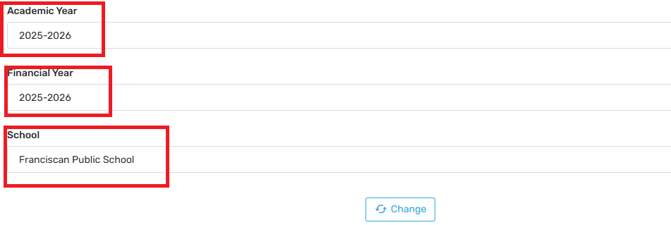
This page is designed to provide user-specific control over Academic/Financial year selection. Changing the academic year here:
- Only impacts the logged-in user's view.
- Does NOT alter the system-wide academic year for the school or for other users.
Fields Description:

1. Academic Year
- Dropdown to select the academic session (e.g., 2025–2026).
- This affects reports, salary records, and data categorized under the selected school year.

2. Financial Year
- Dropdown to select the corresponding financial year.
- Used for payroll accounting, tax computation, TDS, PF, ESI, etc., based on the correct financial cycle.

3. School
- If multiple schools or branches are managed under one ERP system, you can select the specific school (in this case, Franciscan Public School).

4. Change Button
- 🔄 Clicking the “Change” button applies the selected session and school context.
- It refreshes all salary processing, records, and reports to match the selected session and year.
Use Case:
- Prevents errors in data entry or salary slips by ensuring you're operating under the right year.
Enables transition between academic/financial sessions (e.g., moving from 2024–2025 to 2025–2026).
- Necessary before generating reports, initiating payroll processing, or transferring sessions.
Use Case Example:
- Let’s say you’ve just begun the 2025–2026 session in your school. Before processing June 2025 payroll:
- You come here
- Select Academic Year: 2025–2026, Financial Year: 2025–2026
- Click Change
- Now all payroll activities reflect that session.
7.3. Salary Calculation Based On:
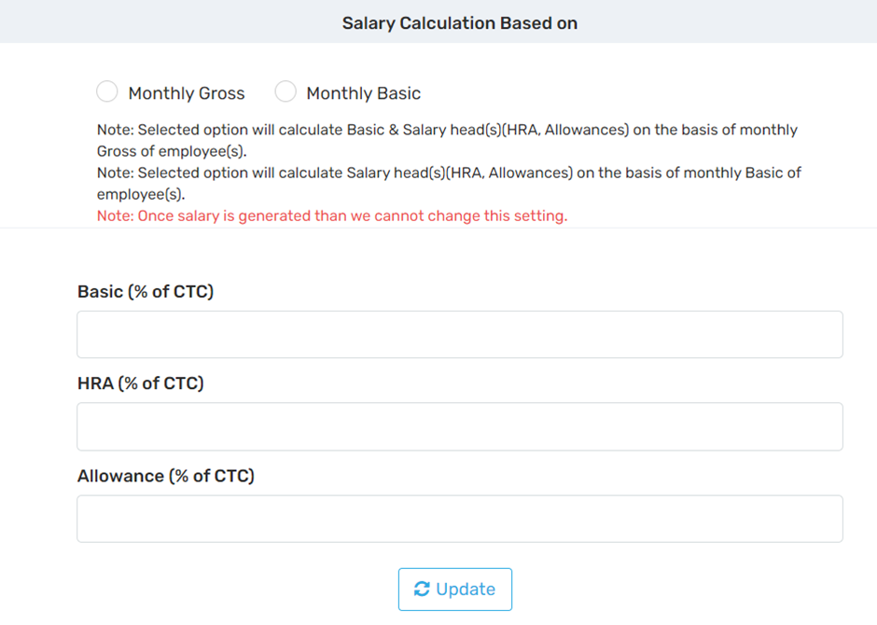
This setting allows the organization to choose the basis for calculating various salary heads like Basic, HRA, and Allowances:
- Monthly Gross:
Salary components (Basic, HRA, Allowances) will be calculated as a percentage of the employee’s gross salary.
- Monthly Basic:
Salary components will be calculated based on the employee’s basic salary only.
⚠️ Important Note: Once salary is generated for any employee, this setting cannot be changed.

✅ Functionality Purpose:
- This setup drives the logic behind salary structure calculation.
- Ensures consistency and automation when processing payroll each month.
- Helps maintain compliance with statutory requirements (e.g., minimum basic for PF, tax, etc.).
- Once set, the system uses these configurations to auto-distribute the CTC into salary components.
7.4. Define Staff Type:
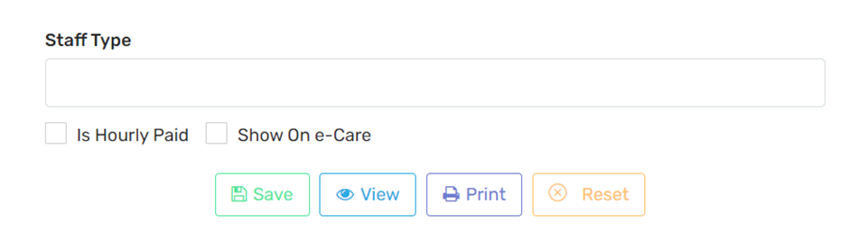
This section is used to create and categorize different types of staff in your institution for payroll and visibility purposes.

Fields Description:

1. Staff Type (Text Box)
- Enter the name of the staff category, e.g.:
Teaching Staff, Non-Teaching Staff, Administrative Staff, Hourly Workers, Contractual Staff, etc.
- This classification helps group employees for salary structure, reporting, and payroll processing.

2. Is Hourly Paid (Checkbox)
- Tick this box if the staff type is paid on an hourly basis rather than a fixed monthly salary.
- Useful for:
Part-time teachers, Lab assistants, Activity/resource-based staff
- Enables the payroll system to calculate wages based on hours worked instead of fixed monthly pay.

3. Show on e-Care (Checkbox)
- Tick this if you want this staff type to be visible in the e-Care portal or mobile app.
- Common use cases:
  - Making staff visible for parent-school communication
  - Internal school directory
- If unticked, the staff type remains internal to HR/payroll only.
Button Function
- ✅ Save Saves the defined staff type and options into the system
- 👁️ View Displays a list of existing staff types already created
- 🖨️ Print Allows you to print the list of staff types (for admin records/reporting)
- 🔄 Reset Clears the form for fresh entry
Use Case:
- Helps in segmenting employees based on roles and payment nature.
- Facilitates custom payroll rules (e.g., hourly vs. monthly).
- Enables better reporting and filtering for payslip generation, taxation, and compliance.
- Connects Admin and parent communication via the e-Care platform.
7.5. Define Qualification:
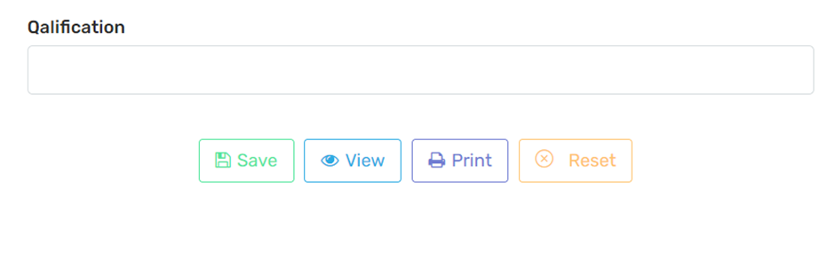
This feature is part of the employee master setup, helping HR/admins to manage employee qualifications systematically.
Fields Description:

1. Qualification (Text Box)
- Here, the user types the name of the qualification that will be associated with employees, such as:
B.Ed, M.Sc, MBA, Ph.D., Diploma, etc.
- These entries can later be linked to staff profiles for documentation, filtering, reporting, or salary structure.
✅ Save | Saves the entered qualification to the ERP system
👁️ View | Displays a list of previously saved qualifications
🖨️ Print | Allows printing the qualification list for record-keeping or audits
🔄 Reset | Clears the text field so you can enter a new qualification
7.6. Define Designation:
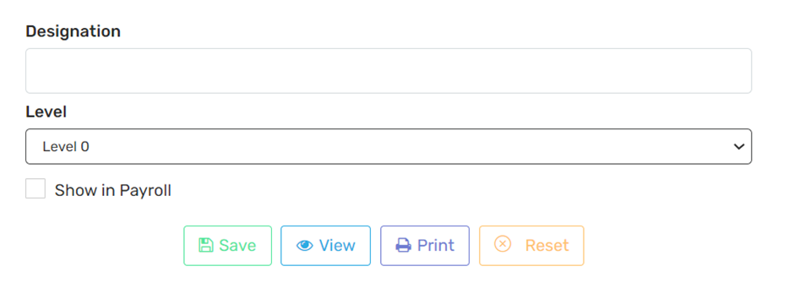
This section helps define and structure the designations of employees such as Teacher, Accountant, Principal, Clerk, etc., and link them to levels and visibility in payroll.
Field Description:

1. Designation (Input Field)
- Enter the title or role of the employee (e.g., Teacher, Driver, Office Admin, Coordinator).
- These designations are later mapped to employees during profile creation or salary assignment.

2. Level (Dropdown)
- Represents the hierarchical or pay scale level.
- Common use cases:
  - Level 0: Entry-level staff
  - Level 1: Mid-level
  - Level 2+: Senior positions like Principal, HOD, Admin
- Helps in structuring salary bands, access levels, or benefit eligibility.

3. Show in Payroll (Checkbox)
- If checked, this designation will be available for payroll processing.
- If left unchecked, the designation will exist in the system (possibly for reporting or other non-salary roles), but not appear in salary-related operations.
If left unchecked, the designation will exist in the system (possibly for reporting or other non-salary roles), but not appear in salary-related operations.
✅ Save Stores the entered designation in the system database
👁️ View Displays a list of already defined designations
🖨️ Print Allows printing of designation data for records
🔄 Reset Clears the current form for fresh entry
Important Notes:
Ensures clear classification of employee roles for streamlined payroll setup.
Supports designation-wise salary reports, filters, and analytics.
Aligns with the staff hierarchy and organizational workflow.
7.7. Define Department
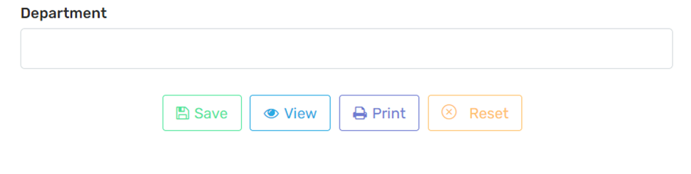
This section allows Payroll Admins to manage organizational departments, which is crucial for categorizing employees, structuring salary budgets, and generating department-wise reports.
Field Description:
Department (Text Field) Enter the name of a new department (e.g., Mathematics, Admin, Accounts, IT, Transport, etc.). This helps in grouping staff based on functional or academic divisions.
Save (Green Button) Saves the entered department to the ERP database. This department will be available across payroll settings, salary structures, reports, etc.
View (Blue Button) Displays a list of all previously created departments. Helpful for reviewing or avoiding duplicates.
Print (Purple Button) Prints the list of departments. Useful for administrative records or audits.
Reset (Orange Button) Clears the form input to allow re-entry or correction.
USE CASE:
Once departments are defined, they are used in:

Module/Section | Purpose
Employee Master Setup | Assign each employee to a department.
Salary Generation | Filter salary processing by department.
Reports | Generate department-wise salary slips, TDS, PF, or ESI reports.
Increment Planning | Apply increments department-wise.
7.8. Upload Staff Photo:
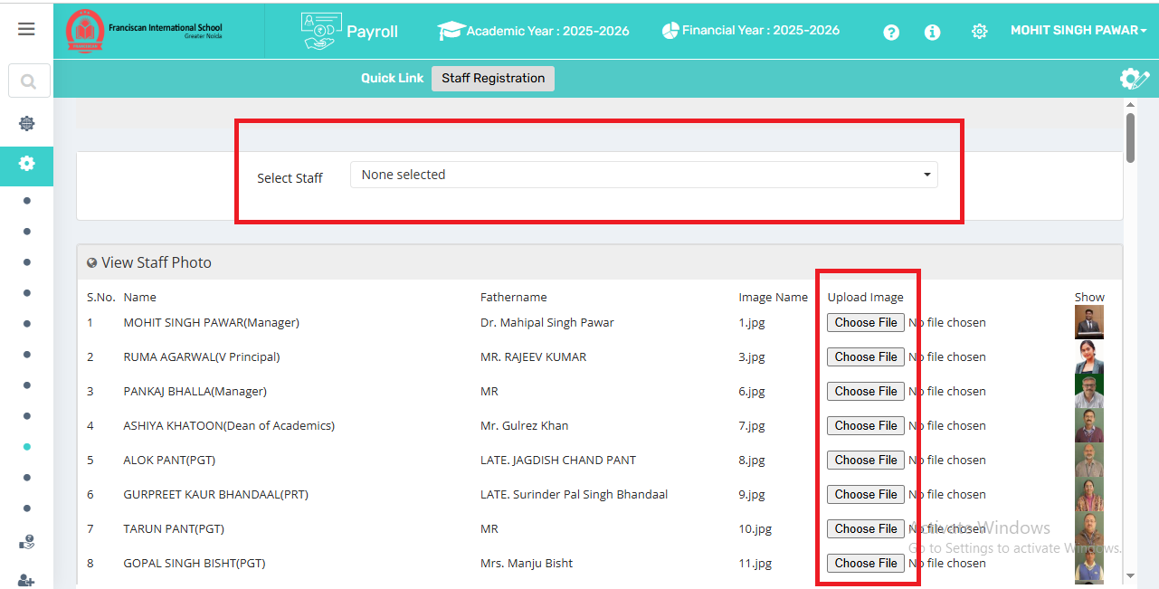
Upload Staff Photo in the Payroll ERP system (FranciscanCare Payroll module). Uploaded photographs are displayed in reports, salary slips, ID cards, and other documents.
Field Description:

Component | Description
Select Staff (Dropdown) | Allows you to search and select an employee (e.g., Mohit Singh Pawar) from the employee database. Once selected, you can upload or change the photo.
View Staff Photo (Section Below) | Displays a list of all staff with their existing uploaded photos, if any. It includes:  S.No., Name and Designation, Filename of the photo, File input (Choose File) for uploading a new or updated photo, Photo Preview (on the right under “Show”)
Choose File (Button) | Lets you browse your computer and select a .jpg, .png, or similar image file to upload as the employee’s photo.
Search Option in Dropdown | Helps quickly locate a staff member from a large list of employees.
Photo Preview (Right side) | Small image previews show already uploaded photos, so admins can visually confirm if the correct photo is in place.
Use Case:
Payroll & Salary Slip Personalization Staff photos appear on printed salary slips and reports for identity confirmation.
ID Card Generation Staff ID cards are auto-generated using these photos.
Administrative Identification Helps HR/Management quickly identify individuals in lists.
Audit & Compliance Enhances record authenticity in physical or digital audits.
7.9. Download Photo:
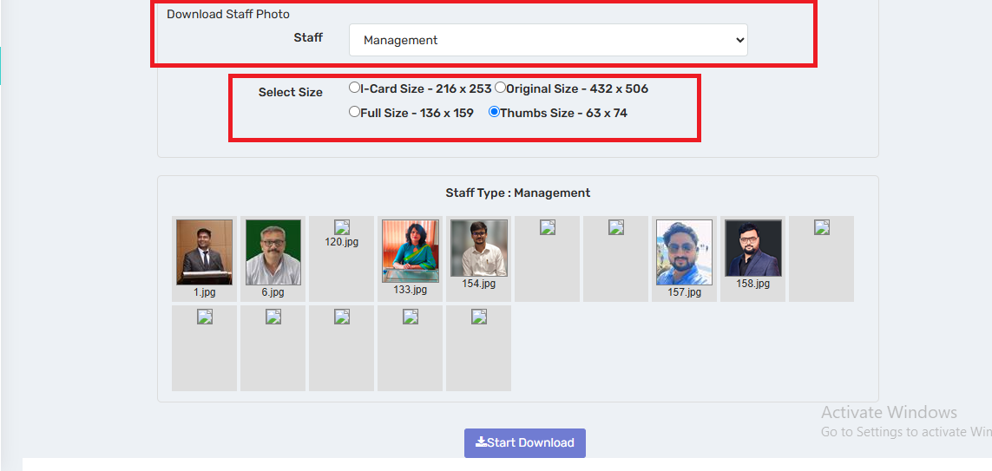
This section allows authorized users (like HR or Admin) to view and download staff photos for a specific category (e.g., Management). These photos may be used for: Payroll records, ID cards, Staff profiles, Attendance systems, Documentation or audits
Field Description:
- Staff Dropdown (Staff: Management):
  - Lets the user filter staff by department or designation type (e.g., Teaching, Non-teaching, Management).
  - Currently selected: Management – so only management staff photos are shown.
- Size Options (Select Size):
The user can choose the desired photo resolution before downloading. Four options are available:
  - Card Size – 216 x 253 px: Used for ID cards or printed materials.
  - Original Size – 432 x 506 px: High-resolution original photo.
  - Full Size – 136 x 159 px: Suitable for profile views.
  - Thumbs Size – 63 x 74 px: Small thumbnails for quick preview or listing.
- Download Functionality:
  - Likely allows the bulk download or individual download of these images, based on the chosen size.
  - Could be used for syncing with ID card printing software or records in the Payroll section.
7.10 Define Staff Document Type:
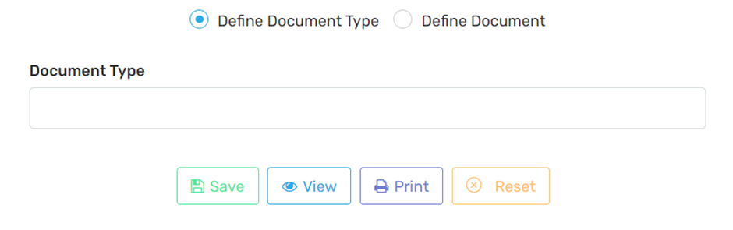
This feature allows administrators to set up the types of documents that need to be collected from staff members for payroll, and compliance purposes.
Define Document Type / Define Document:
- Define Document Type (selected in the screenshot):
Used to create new document categories like:
  - PAN Card
  - Aadhaar Card
  - Degree Certificate
  - Bank Passbook
- Define Document:
Used to upload actual documents for a specific staff member under the defined types.
Document Type Input Field:
- Here, you manually type the name of the document category.
- Example: "Medical Certificate" or "Appointment Letter"
Buttons:
- Save: Saves the document type.
- View: Shows a list of already defined document types.
- Print: Allows printing the list of document types.
- Reset: Clears the input field to start fresh.
8. Payroll Master:
8.1.i. Staff Registration:
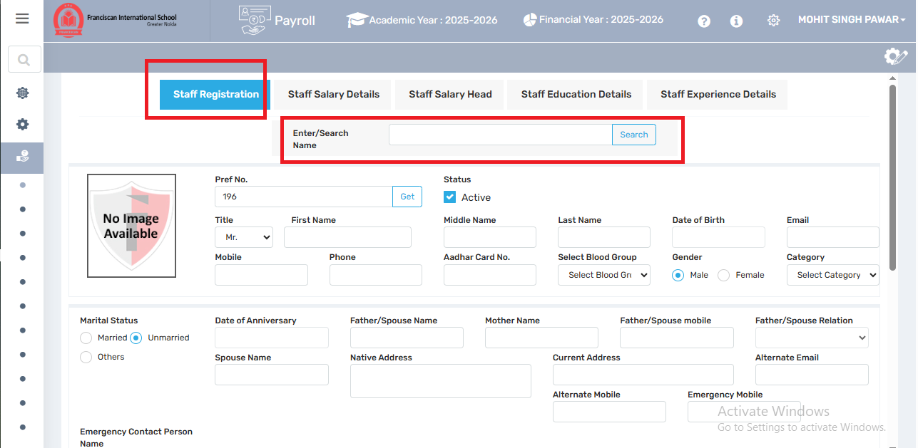
Basic Personal Information

Purpose: Identify the staff member and collect essential personal details.
Field | Description
Pref. No. | Staff serial or unique code
Title, First, Middle, Last Name | Full name breakdown
Date of Birth | Used for ID, legal & age-related calculations
Email, Mobile, Phone | Contact info
Aadhar Card No. | National ID in India
Select Blood Group | Medical records
Gender | Male/Female options
Category | Staff category (e.g., Teaching, Admin, Support)

Section 2: Family & Contact Details
Marital Status | Options: Married / Unmarried / Others.
Date of Anniversary | For married staff.
Spouse, Father, Mother Names | Family details.
Father/Spouse Mobile & Relation | Contact and relationship.
Native Address / Current Address | Permanent and residential address.
Alternate Email / Mobile / Emergency Mobile | Backup contact info.
Emergency Contact Person Name | For emergencies.
Section 3: Employment Details
Qualification | Educational background.
Role / Designation / Department | Job-related information.
Staff Type / Wings | Category of staff and wing assignment (e.g., Primary, Admin).
Date of Joining / Date of Retire / Extend | Employment period.
Subject Expertise | Specific subjects taught.
Section 4: Identity and Classification
Nationality / Religion | Demographic classification.
CBSE ID / Family ID | IDs used by the school/board.
Remarks | Additional comments.
State / National Teacher Code | Government identifiers for teachers.
Section 5: Financial Nominee Details
Nominee for PF / Gratuity | Person nominated to receive benefits.
Gratuity Nominee Aadhar / Phone No. | Identification and contact for the nominee.
Section 6: Additional Declarations
Checkboxes for required documents and roles:
- Child Protection
- Police Clearance Certificate
- Medical Fitness Certificate
- Special Educator (If applicable)
- Auto Assign Leaves: System will assign standard leave entitlements automatically.
8.1.ii Staff Salary Details
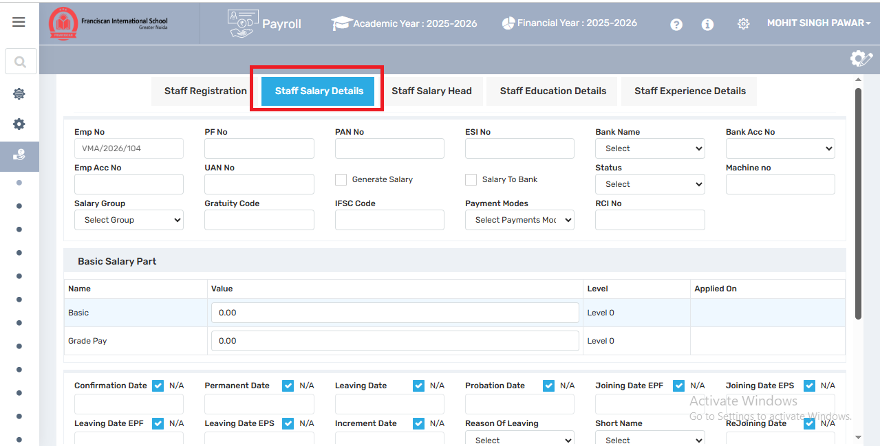
Where salary structures, amounts, and pay heads are entered.
Top Section: Employee Identification & Banking Details
Emp No | Unique Employee Number (e.g., VMA/2026/105).
PF No / UAN No | Provident Fund number and Universal Account Number for retirement benefits.
PAN No | Tax Identification Number for income tax.
ESI No | Employee State Insurance number.
Bank Name / Bank Acc No / IFSC Code | Banking details used for salary transfer.
Emp Acc No | Internal employee account code, if used.
Machine No | Biometrics/attendance machine reference.
Status | Employment status (active, resigned, etc.).
Generate Salary | Checkbox to include the employee in the monthly payroll run.
Salary To Bank | Checkbox to mark if salary should be directly transferred to the bank.
Salary Group | Grouping for salary structure (helps assign pre-defined salary templates).
Gratuity Code | Internal code for gratuity calculation group.
Payment Modes | How salary will be paid: Bank, Cash, Cheque, etc.
RCI No | Relevant if the staff is registered with RCI (for special educators, etc.).
Basic Salary Part
Basic | Base pay amount.
Grade Pay | Additional fixed amount based on position/grade.
Level | Pay level as per pay matrix (e.g., Level 0, 1, etc.).
Applied On | Effective date of the salary structure.
Employment Milestone Dates
These fields are used for historical tracking, compliance, and statutory filings.
Confirmation Date | When an employee was confirmed post-probation.
Permanent Date | Date when permanent employment status was given.
Probation Date | Probation start date.
Increment Date | Last date of salary increment.
Leaving Date / Reason of Leaving | If resigned/terminated, these are required.
Leaving Date EPF / EPS | When PF/EPS was closed (used for regulatory reporting).
Joining Date EPF / EPS | Used for Provident Fund/Employee Pension Scheme compliance.
Short Name | Optional nickname/alias for internal reference.
Rejoining Date | If employee rejoins after a break.
MACP Dates (Career Progression)
MACP 1, 2, 3 | Dates of career progression under Modified Assured Career Progression Scheme (often used in schools/Govt. settings).
Extension Dates
Extension Start Date / End Date | Used if an employee continues temporarily post-retirement or contract extension.
Use Case:
The Salary Details page allows administrators to:
- Define how salaries are processed and disbursed.
- Ensure legal compliance with statutory bodies like EPFO, ESI, Income Tax, etc.
- Maintain historical and banking records of each staff member.
- Prepare for automation of salary calculation and payslip generation.

8.1.iii. Staff Salary Head:
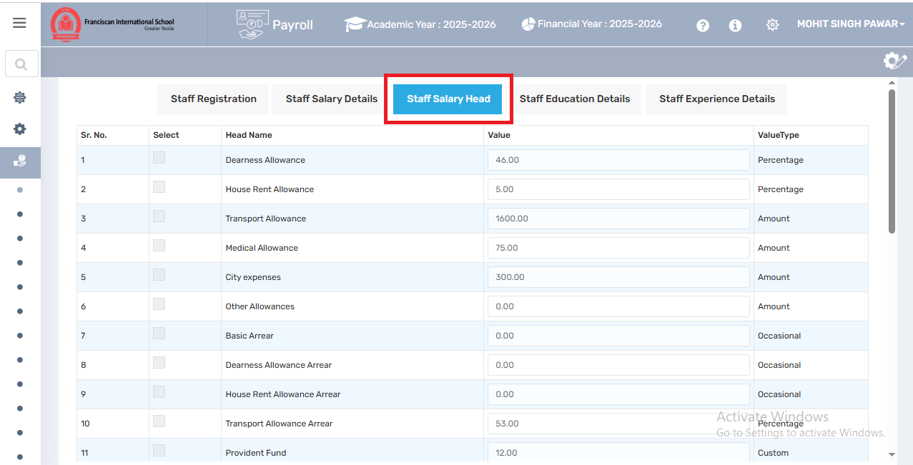
- This section allows Payroll administrators to:
- Assign salary components (heads) like allowances and arrears to individual staff members.
- Set values and types for each salary component.
- Customize payroll calculations for each employee.

Column | Description
Sr. No. | Serial number for easy reference.
Select | Checkbox to select a salary head for editing or bulk action.
Head Name | Name of the salary component (e.g., Dearness Allowance, Transport Allowance, Medical Allowance, etc.).
Value | The numeric amount assigned to the component (e.g., ₹46, ₹1600, etc.). Can be a percentage or fixed amount.
Value Type | Indicates whether the value is:

Use Case:
This section is used:
- During salary setup for a new staff member.
- When editing an existing employee's salary (e.g., allowance revisions).
- For adding temporary payouts like arrears or bonuses.
- For generating accurate monthly payslips.

8.1.iv. Staff Education Details
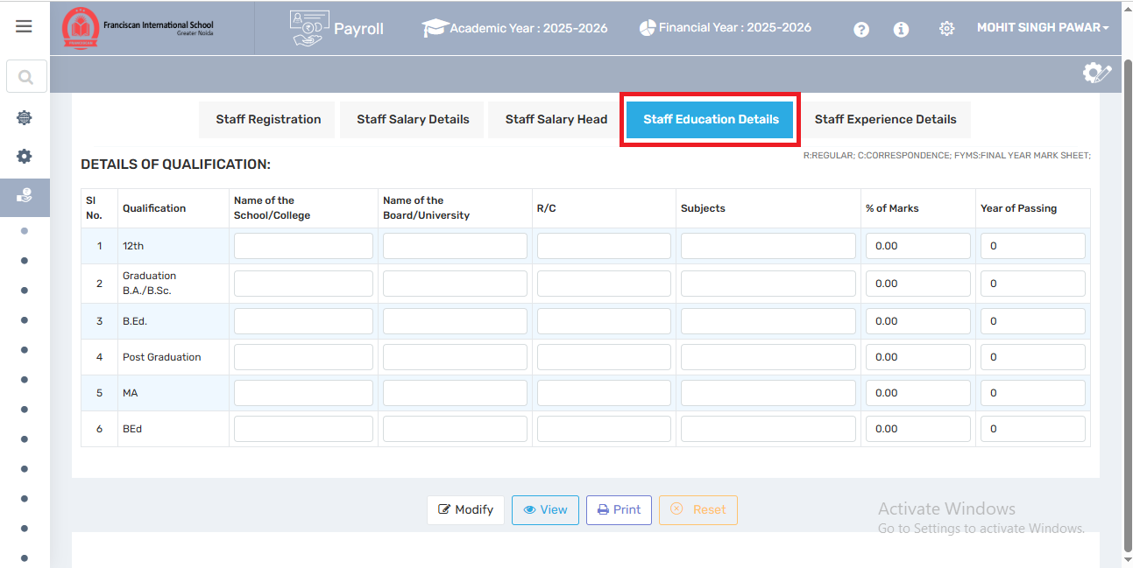
To collect, store, and manage the academic background of employees for HR records, payroll grading, and compliance/audit requirements.

Field Name | Description
Sl. No. | Serial number of the entry (1, 2, 3...).
Qualification | Pre-filled list of common qualifications like 12th, B.A., B.Ed., M.A., etc.
Name of the School/College | Institution name where the qualification was completed.
Name of the Board/University | Affiliated board or university (e.g., CBSE, Delhi University).
R/C (Regular/Correspondence) | Indicates mode of education

8.1.v. Staff Experience Details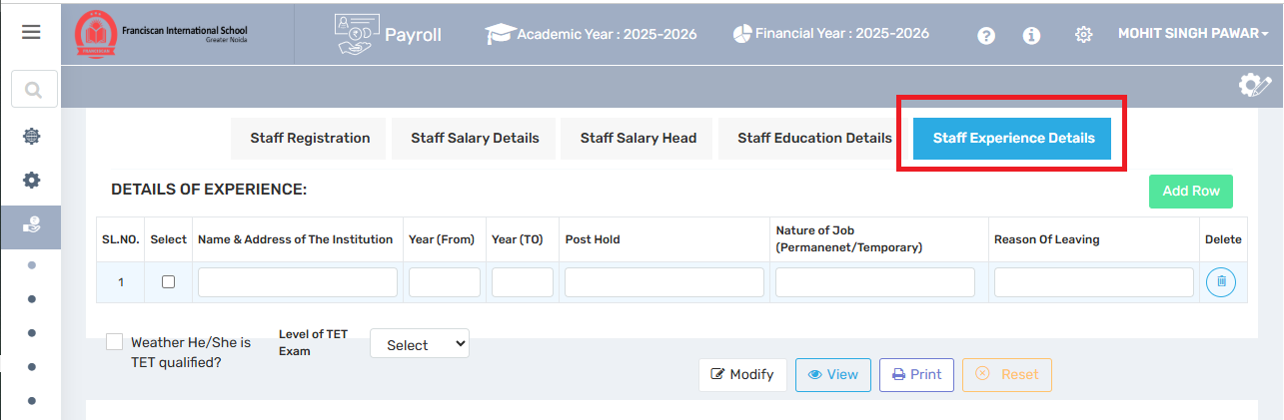
Staff Experience Details tab is used to record, track, and manage the work experience history of an employee (staff) in an educational institution or other organizations
- SL. NO. / Select Checkbox:
  - Automatically generated serial number for each experience entry.
  - Checkbox may be used for selecting specific entries for batch actions (like deletion or editing).
- Name & Address of the Institution:
  - Enter the name and location of the previous organization where the staff member was employed.
- Year (From) and Year (To):
  - Specify the start and end year of the staff member's service at the respective institution.
- Post Hold:
  - The designation or role the staff member held in that institution (e.g., PGT, TGT, Admin, Clerk).
- Nature of Job (Permanent/Temporary):
  - Select whether the position held was Permanent or Temporary.
- Reason of Leaving:
  - State the reason why the staff member left the previous job (e.g., Resigned, Transferred, Terminated).
- Delete Icon:
  - Used to delete a specific row or experience entry.
- Add Row Button:
  - Adds another row to input additional experiences for the same staff member.

8.1.vi. Other Information:
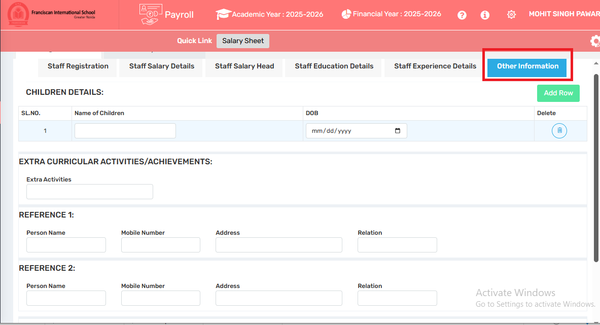
This section is used to capture personal and background information about staff members that may not fall directly under salary, education, or work experience.

8.2. Define salary account:
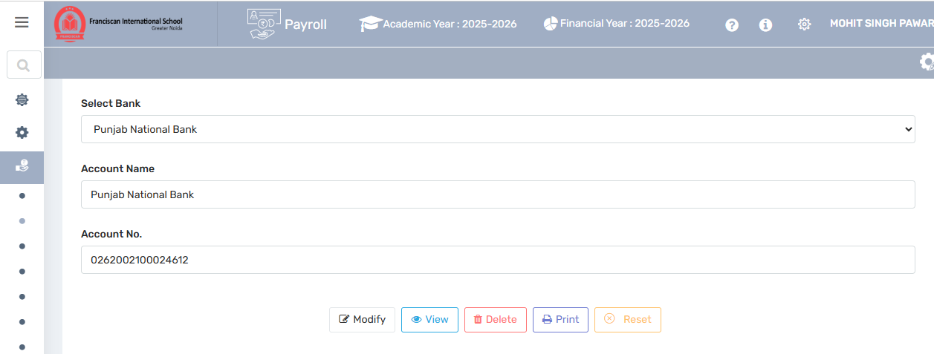
This section is used by the school administration or accounts department to set up the official school bank account that will be used to distribute salaries to all staff. It acts as the default salary disbursement account in the payroll system.

Field Description:

Select Bank
- Dropdown list to choose the bank where the school’s salary account is maintained.
- Common options: SBI, ICICI, HDFC, PNB, etc.
✅ This bank will be used to process salary payments for all staff.
2. Account Name
- Enter the name of the account as registered with the bank (usually the name of the school or trust).
Example: "Franciscan International School Salary A/C"
3. Account No.
- Enter the exact account number of the school’s salary bank account.
- This account will be the source of funds for all payroll transactions (salary credit to staff accounts).
8.3. Define Salary Month:
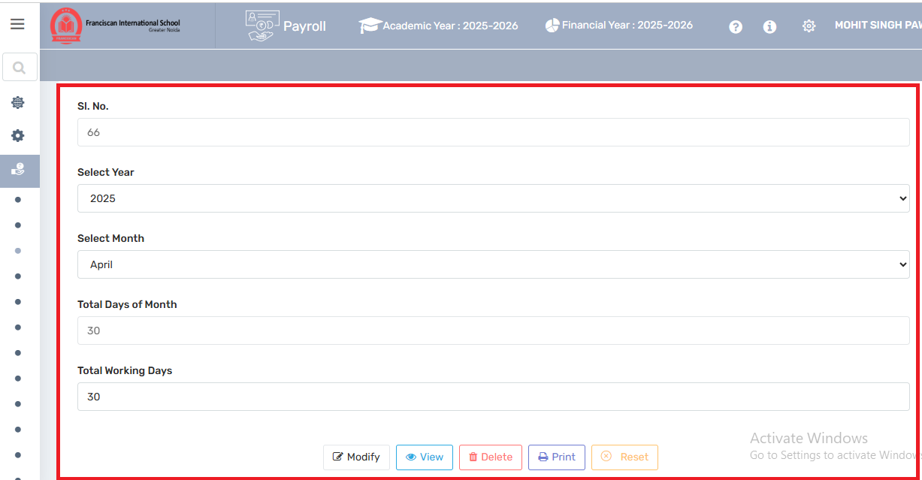

Users can define a specific month for which an employee’s salary is being calculated, processed, and paid.
SI. No.: A system-generated serial number for internal tracking of each month's setup.
Select Year: The academic or financial year for which the payroll is being defined.
Select Month: The specific month (e.g., April) for which the salary process is being configured.
Total Days of Month: Total number of calendar days in the selected month (April has 30 days). This value is important for prorating salary when joining/leaving mid-month or for partial working days.
Total Working Days: Number of actual working days in the selected month, excluding holidays (like Sundays, public holidays, etc.). This figure is used to calculate per-day salary and Leave Without Pay (LOP) deductions.
8.4. Assign Info Bulk:
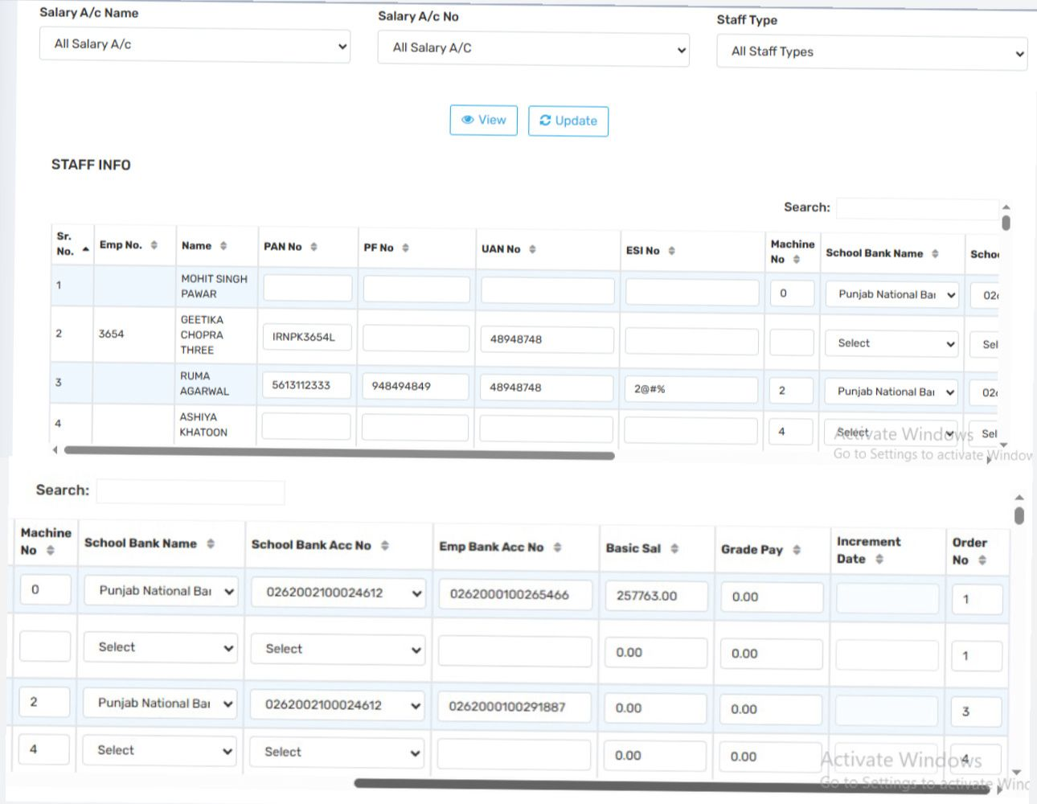
This section is used to define and manage salary account details of all employees — linking their employment details to their salary disbursement bank accounts and payroll structure.
Salary A/c Name: Choose a specific salary account (e.g., "Teaching Staff", "Non-teaching Staff", etc.)
Salary A/c No: Select a specific account number if available.
Staff Type: Filter between types of employees like Full-Time, Part-Time, Contractual, etc.
Buttons:
View: Display the current records based on selected filters.
Update: Save changes made in the staff info table.
This is where actual staff salary account-related data is entered/managed. Let’s break down the fields:

Sr. No / Emp No / Name
Auto-generated and editable employee information for identification.
PAN No / PF No / UAN No / ESI No
These are statutory and compliance identifiers:
PAN No: For income tax tracking.
PF No: Provident Fund number.
UAN No: Universal Account Number for PF.
ESI No: Employee State Insurance number.

Machine No
Represents biometric machine ID linked to attendance.

School Bank Name
The bank where the school holds the salary account (used for crediting salary in bulk via bank integration).
School Bank Acc No
The school’s bank account number from which salary will be credited.
Emp Bank Acc No

The employee’s personal bank account number for receiving salary.
Basic Salary
The fixed basic salary assigned to the employee.
Grade PayAdditional salary component based on the employee’s grade/rank.
Increment DateThe last increment date or next scheduled increment.
Order NoInternal order sequence, may relate to payroll processing or reporting.
Use Case:
You can add, update, or correct employee account and payroll details from this page.

8.5.Create Salary structure:
8.5.i. Define Salary Head:
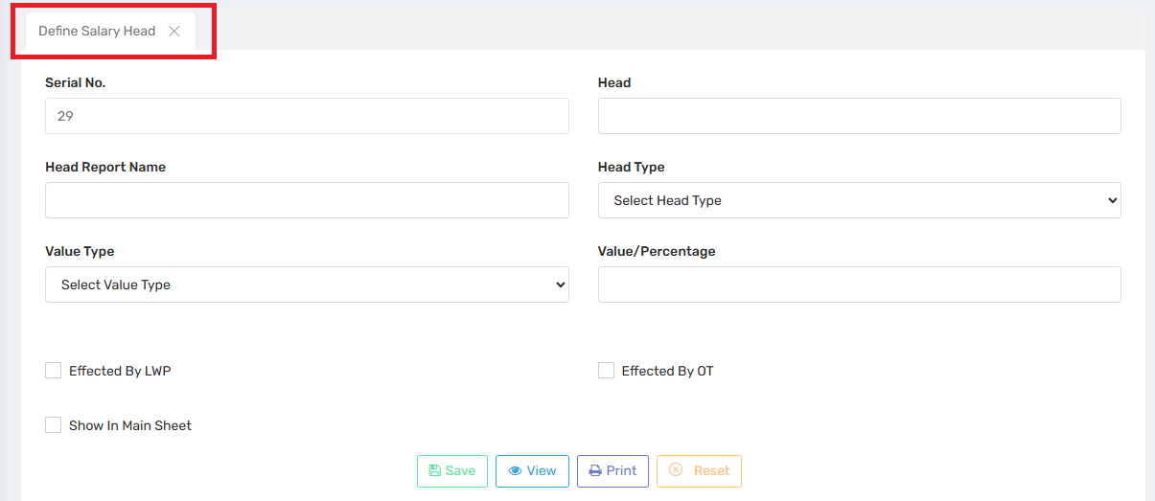
This section is used to create and configure different salary components, such as Basic Pay, HRA, DA, Bonus, Deductions, etc., which form part of the salary structure.
Serial No. | Auto-generated or manually assigned unique number for the salary head (used for ordering/display).
Head | The name of the salary component (e.g., Basic Salary, HRA, Provident Fund, TDS).
Head Report Name | Short/alternate label for reporting (used in reports or payslips). Often an abbreviation.
Head Type | Classification of the head, such as: - Earning (adds to salary) - Deduction (reduces salary) - Reimbursement, etc.
Value Type | Determines how the value is calculated: - Fixed Amount - Percentage of Basic/Total - Formula-based, etc.
Value/Percentage | The actual value or rate (e.g., 10 for 10%, or ₹1000 if fixed).
Effected By LWP | If ticked, this salary head will reduce if the employee has Leave Without Pay.
Effected By OT | If ticked, this salary head changes based on Overtime work.
Show In Main Sheet | If checked, this head will appear in the main salary processing sheet and payslip summary.
8.5.ii. Relate Static Dynamic Head:
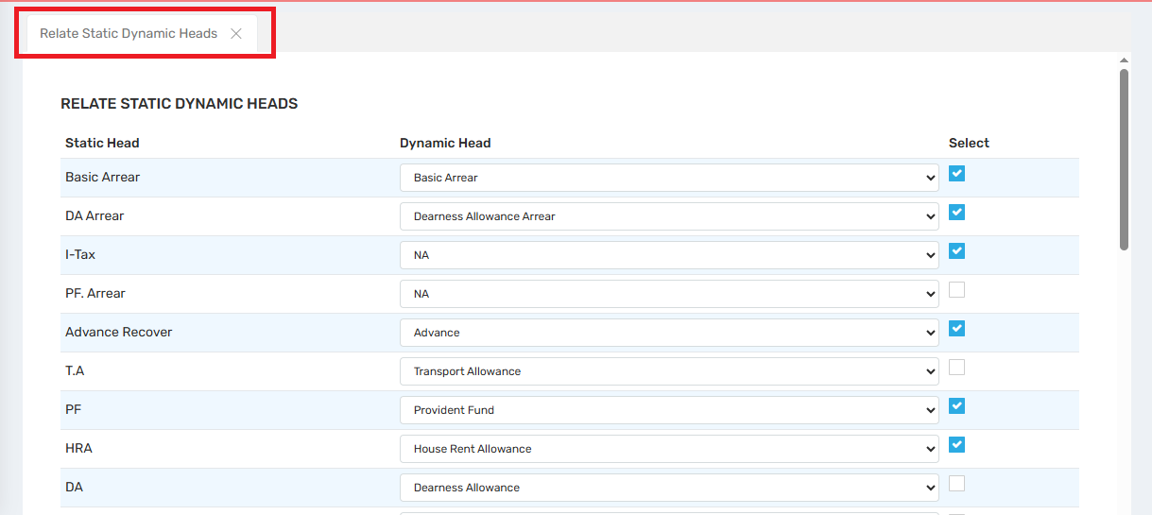
This feature allows the system to link predefined (static) salary components with actual (dynamic) heads used during salary processing.
- Static Head: Predefined or system-based salary components.
- Dynamic Head: Custom or user-defined salary heads configured during payroll setup (e.g., "House Rent Allowance", "Transport Allowance").
Mapping ensures that:
- The salary data is calculated, displayed, and reported correctly.
- Arrears, recoveries, and statutory deductions align properly with the configured heads.

8.5.iii. Define Salary Group:
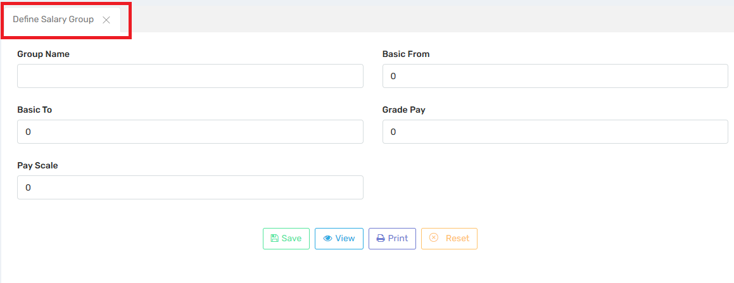
This section is used to create different salary groups or bands based on basic pay slabs. Each group defines the range of basic salary and associated values like grade pay and pay scale.
Group Name: Enter a name for the salary group (e.g., TGT Grade I, Admin Level II). This helps identify the band.
Basic From: Lower limit of the basic salary for the group (e.g., ₹20,000).
Basic To: Upper limit of the basic salary (e.g., ₹30,000). Employees within this range fall under this group.
Grade Pay: Fixed additional pay associated with the group, often used in government-style pay systems.
Pay Scale: A reference code or number indicating the full pay scale (can be internal or regulatory).
Actions at the Bottom
- Save: Saves the defined salary group into the system.
- View: Displays existing salary groups.
- Print: Allows printing of the group details for records.
- Reset: Clears all the fields to start fresh.
8.5.iv. Assign Salary Head to Group:
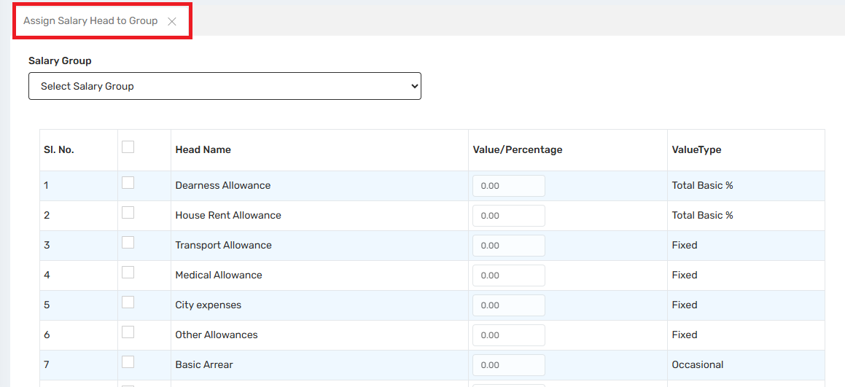
This setup defines what components (allowances, arrears, deductions) an employee in a specific salary group is entitled to, and how much they receive—either as a fixed amount or as a percentage of basic pay.

Field | Description
Salary Group | A dropdown where you select the group (defined in the previous screen) for which you're configuring salary heads.
Sl. No. | Serial number for reference.
Head Name | The name of the salary component, e.g., Dearness Allowance, HRA, Medical Allowance, etc.
Value/Percentage | This is the amount or percentage assigned to the head. If the Value Type is Total Basic %, the number entered here is a percentage of the Basic Pay. If it’s Fixed, this will be a fixed amount.
Value Type | Indicates how the amount is calculated: Total Basic % – calculated as a percentage of basic pay.Fixed – same amount for all employees in that group.Occasional – not paid every month, only when applicable.

Usage Flow
- Select a Salary Group from the dropdown.
- Tick the checkbox beside each applicable salary head.
- Enter the value for each head based on its type:
  - If Total Basic % → enter the percentage (e.g., 10 for 10%).
  - If Fixed → enter the fixed amount (e.g., 2000).
- Click Save (button likely appears further down) to apply the configuration.

8.5.v. Assign Salary Group to Staff:
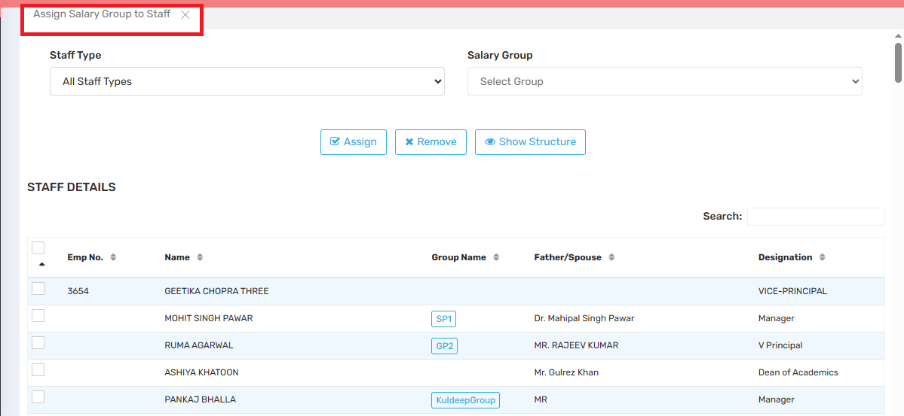
Assign Salary Group to Staff. This part of the payroll system is essential for linking individual staff members with the correct salary structure (i.e., salary group) that has already been defined.
Functionality: Assign Salary Group to Staff
This interface allows HR or Payroll Admins to:
🔹 Assign a Salary Group (predefined pay scale and allowances)
🔹 To one or more staff members
🔹 Based on their Staff Type, designation, or manually selecting them.

Field/Button | Purpose
Staff Type | Dropdown to filter staff based on their job category (e.g., Teaching, Non-teaching, Admin).
Salary Group | Dropdown to select the predefined salary group to be assigned to selected staff members.
Staff Details Table | Displays employees with columns like:Emp No.,Name,Current Group Name,Father/Spouse,Designation.
Check Boxes (left column) | Allows selection of individual or multiple staff members for bulk assignment.
Assign (button) | Assigns the selected Salary Group to the checked staff members.
Remove (button) | Removes the assigned salary group from selected staff members (useful for reassignment or corrections).
Show Structure (button) | Displays the salary breakup and allowance structure of the selected group before assigning it.

Workflow
- Filter by Staff Type (optional).
- Select Salary Group from dropdown.
- Check the boxes next to staff to whom you want to assign this group.
- Click Assign to apply to the salary group.
- (Optional) Use Show Structure to preview what the group includes (DA, HRA, etc.).
- If needed, click Remove to undo assignments.

8.5.vi. Bulk Salary Head Assign:
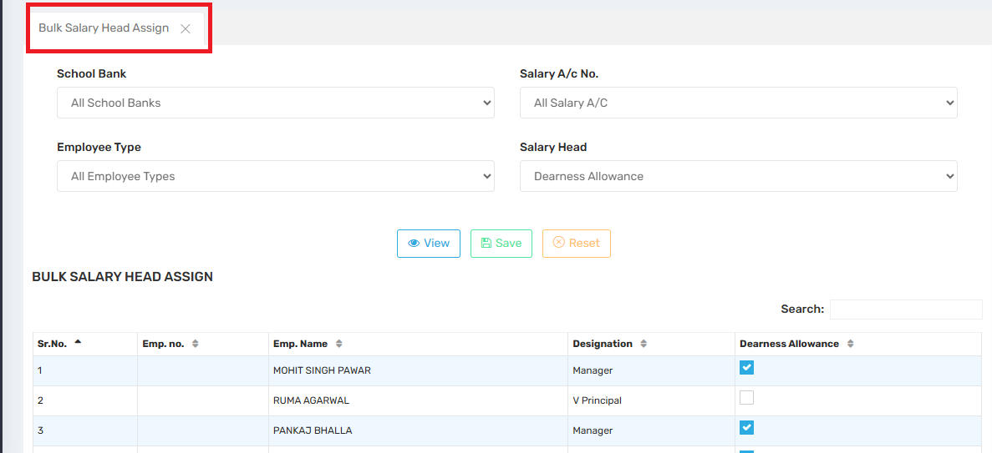
This functionality allows payroll administrators to assign or update specific salary components (like allowances or deductions) to multiple employees at once.

Field/Button | Purpose
School Bank | Filter staff by the bank their salary account is linked to. (Useful if processing bank-specific payroll batches.)
Salary A/c No. | Further filter by account numbers if needed.
Employee Type | Filter by job type (Teaching, Admin, Support Staff, etc.).
Salary Head | Dropdown to select the allowance/deduction you want to assign in bulk (e.g., Dearness Allowance, HRA).
View (🔍) | Loads the employee list based on selected filters.
Save (💾) | Applies the changes (e.g., assign checked salary head to those employees).
Reset (✖️) | Clears all selections and resets the form.

Workflow (Example)
- Select Dearness Allowance from the Salary Head dropdown.
- Use optional filters (e.g., only Teaching Staff, or specific Bank).
- Click View – the system will list matching staff.
- Check the boxes next to employees you want to assign this allowance to.
- Click Save to apply the changes.
8.5.vii. Bulk Salary Head Entry:
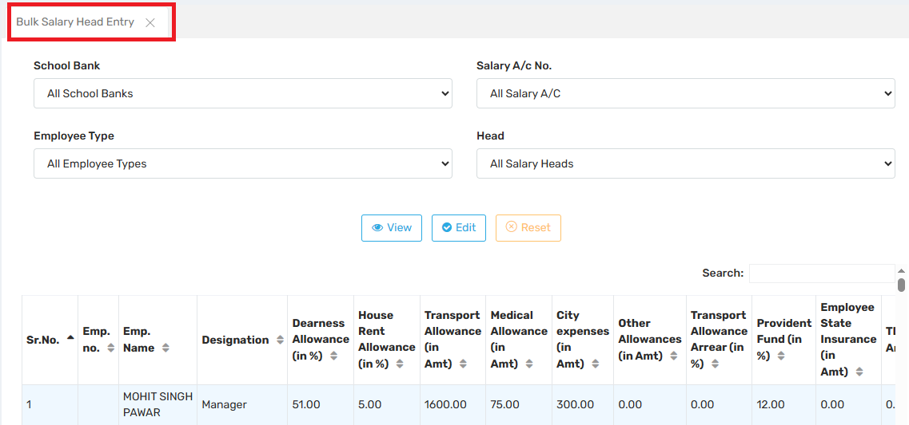
The user can manage and update salary heads (i.e., components of salary like allowances, deductions, etc.) for one or more employees in bulk.
Filter Options (Top Section)
These dropdowns allow users to filter data before viewing or editing salary information:
- School Bank – Filter by the bank used by employees (default: All School Banks).
- Salary A/c No. – Filter by salary account number (default: All Salary A/C).
- Employee Type – Filter by type of employee (default: All Employee Types).
- Head – Select a particular salary head (default: All Salary Heads).
🔘 Action Buttons
- View: Displays salary data for filtered employees.
- Edit: Allows editing of salary-related fields.
- Reset: Clears all filters and selections.
Use Case
This tool is primarily used by payroll administrators to:
- Enter and manage bulk salary data,
- Adjust various salary components,
- Ensure accuracy in payroll processing.

8.5.viii. Define 7th CPC Level:
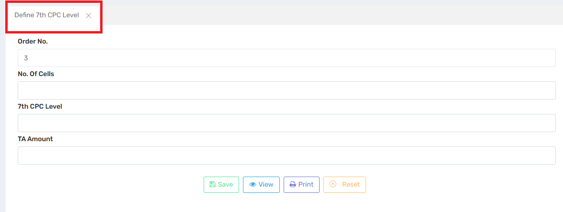
This module is specifically used for configuring and managing pay structures based on the 7th Central Pay Commission (CPC), which is a standardized government pay matrix used across many educational and government institutions in India.
Field | Purpose
Name | Enter the full name of the TDS deductee (usually the employee or a vendor).
Father’s Name | For identity verification and record-keeping, especially in legal and tax documents.
Designation | Select the role or title of the deductee (e.g., Teacher, Admin, Manager).
Place | Location or branch where the deductee is based. It can be used for jurisdictional or reporting segregation.
Save | Click to save the TDS deductee entry to the system for payroll processing and tax return preparation.

Field Name | Purpose & Function
Order No. | A unique sequence number to maintain the order of CPC levels. This helps organize entries systematically.
No. of Cells | Represents the number of steps (or pay stages) within that CPC level. Each cell corresponds to an increment level.
7th CPC Level | The CPC level being defined (e.g., Level 1 to Level 18). Determines the basic pay scale range.
TA Amount | Transport Allowance for the selected level. This gets added to the gross salary for the employee under that level.
Action Buttons at Bottom
Button | Function
Save | Saves the CPC level configuration.
View | Displays existing entries for review or editing.
Print | Prints the CPC configuration (useful for audits and documentation).
Reset | Clears all input fields to allow fresh entry.
Use case:

Purpose | Benefit
Government Pay Compliance | Ensures the school follows 7th CPC standards for employee compensation.
Automated Salary Calculation | Once CPC levels are defined, the system uses these values to auto-calculate Basic Pay, TA, and increments.
Audit Readiness | Maintains clear, printable records of pay level configurations.
Transparency | Helps ensure uniform pay structure across employees at the same level.
8.5.ix. Define 7th Commission Basic:
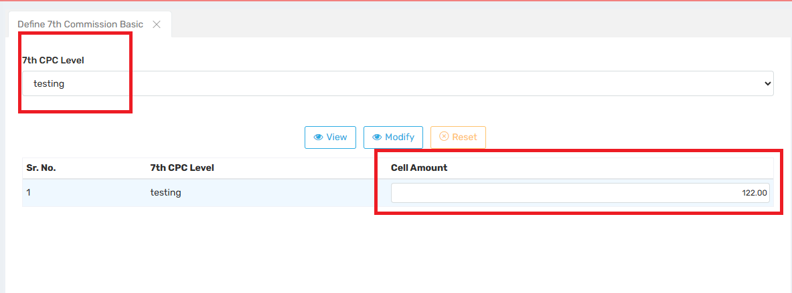
Users can define the basic pay values (cell amounts) associated with specific 7th CPC Levels, which are required for correctly calculating employee salaries.
7th CPC Level: Allows the user to select a particular 7th CPC Level (e.g., Level 1, Level 10).
Cell Amount: Monetary value of the specific cell under the selected CPC level.
Example: 122.00 is the amount set for one of the cells in the "testing" level.
In the real system, there would typically be multiple cells per level, each representing a higher pay step as an employee gains experience or promotions.
Use Case:
This screen is essential for:
- Creating salary matrices under 7th CPC for employees.
- Defining structured increment levels per CPC grade.
- Linking basic pay values to employees based on their grade level and years of service.
Workflow Example:
- If a teacher is at 7th CPC Level 6, Cell 5, their basic salary will be picked from this matrix (e.g., ₹25,500), and all allowances (HRA, DA, etc.) are calculated based on this basic pay.

8.5.x. Bulk Head Remark Entry:
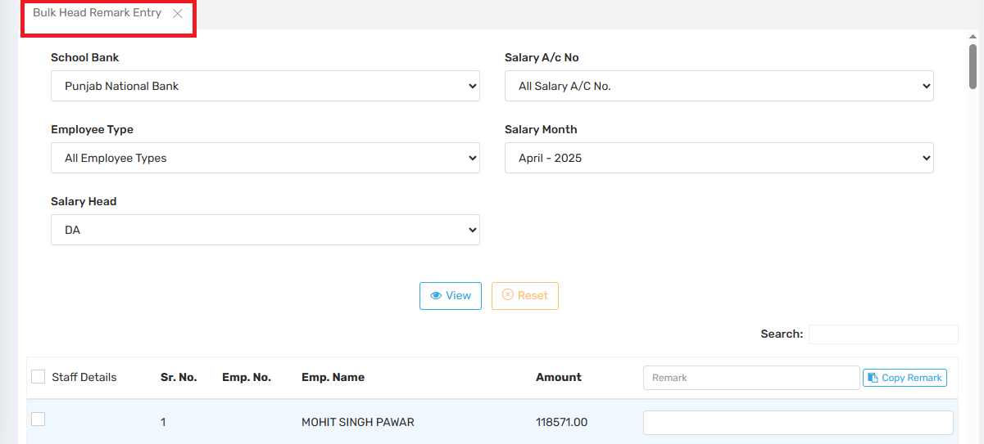
To enter, update, or annotate salary head values (like DA, HRA, etc.) for multiple employees in one go, typically for internal records, auditing, or administrator notes.
ey Functional Elements

📌 Filters at the Top
These help to narrow down the employee list based on criteria:
- School Bank: Filters employees whose salaries are disbursed through the selected bank (e.g., Punjab National Bank).
- Salary A/c No: Can further narrow it to specific account numbers, but in this case, it’s set to All Salary A/C No.
- Employee Type: Allows filtering by type such as Teaching, Non-teaching, Contractual, etc. Here, it's set to All Employee Types.
- Salary Month: The salary month for which the remark will be applied (e.g., April 2025).
- Salary Head: Specifies which component you want to annotate. In this case, it's DA (Dearness Allowance).
Main Table
This section shows a list of employees who match the filter criteria:
- Staff Details Checkbox: Lets you select individual or multiple employees.
- Sr. No., Emp. No., Emp. Name: Identifiers for the employee.
- Amount: Displays the amount for the selected salary head (e.g., ₹118,571 for DA for Mohit Singh Pawar).
- Remark Field: Input field where you can enter text remarks for the selected employee(s).
- Copy Remark Button: Lets you copy the same remark to multiple selected rows to save time.
Action Buttons
- View: Loads the data based on the selected filters.
- Reset: Clears current selections and inputs.
Use Case Example
Let’s say HR wants to note that DA for April 2025 includes a special adjustment due to inflation. They can:
- Select April 2025 → DA → Filter employees.
- Type “Includes inflation adjustment” in the Remark box.
- Click “Copy Remark” to apply it to all listed employees.
- Save/update records.

8.6. TDS Configuration:
8.6.i. Define Income Tax Slab:
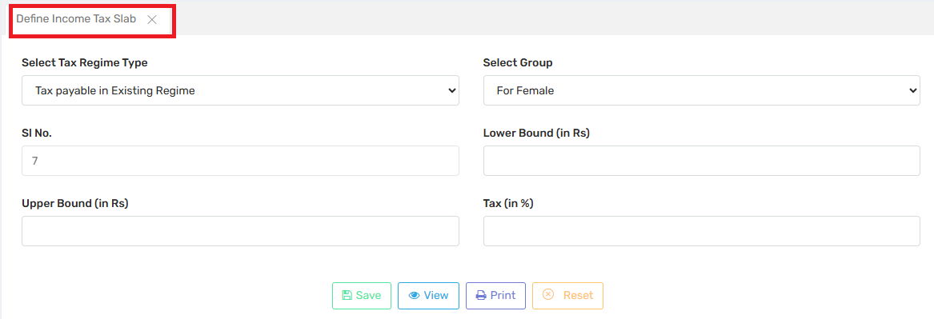
Users can configure tax slabs for different categories of employees based on the Income Tax Regime. It helps ensure that the correct tax percentage is deducted from an employee’s salary according to applicable laws and group-specific slabs.
1. Select Tax Regime Type: Allows you to choose the taxation system:
Existing Regime (with exemptions & deductions).
New Regime (lower rates but without exemptions).
2. Select Group: Used to define tax slabs separately for:
Male,Female,Senior Citizens
3. Sl. No.: The serial number for maintaining the order of slabs (e.g., 5). It helps when defining multiple slabs for progressive taxation.
4. Lower Bound (in Rs):The minimum income for the slab to apply.
5. Upper Bound (in Rs):The maximum income for the slab.
6. Tax (in %): The rate of income tax applicable to income falling within the defined bounds.
Benefits
- Ensures accurate tax calculation based on income and demographic.
- Complies with Government of India TDS regulations.
- Allows different slabs for different regimes and groups.
- Easily auditable and printable.

8.6.ii. Relate IT Slab To Staff:
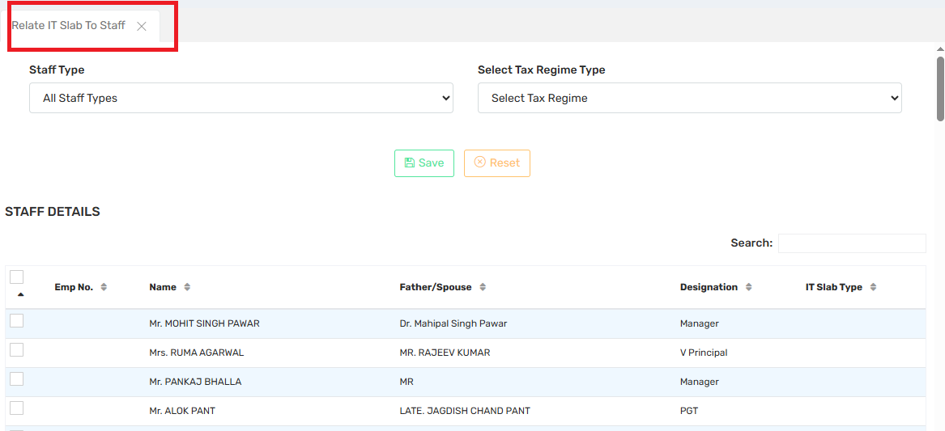
Users can map each staff member to a specific Income Tax Regime (Old or New) so that the correct TDS (Tax Deducted at Source) is calculated during salary processing.

Key Functional Elements

1. Staff Type (Dropdown)
- Allows filtering of staff by employment category:
  - Example: Teaching, Non-Teaching, Admin, etc.
  - Selected option: All Staff Types (shows everyone).

2. Select Tax Regime Type (Dropdown)
- Provides the options to choose:
  - Old Tax Regime – with exemptions/deductions.
  - New Tax Regime – lower tax rates, no exemptions.
- This regime will be assigned to the selected staff members.
STAFF DETAILS Table
Column | Description
✅ Checkbox | To select one or more employees.
Emp No. | Unique employee number.
Name | Employee name.
Father/Spouse | Name of the father/spouse of the employee.
Designation | Current job role or title.
IT Slab Type | Indicates which Income Tax Slab is currently assigned to that employee.

8.6.iii. Define IT Head:
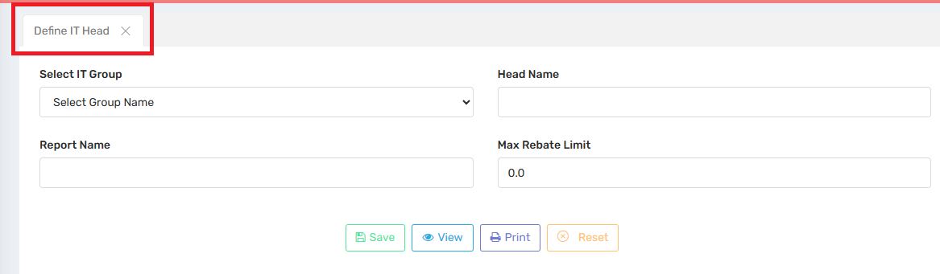
Users can create and manage specific tax deduction heads (like LIC, Tuition Fee, HRA Rent Paid) under a broader IT Group (like Section 80C, Section 80D, HRA, etc.).

Field | Description
Sl. No. | Serial number or ID for the IT Head Group entry. (e.g., 11 in this case)
IT Head Group Name | Name of the rebate/deduction section (e.g., “Section 80C”, “HRA”, “NPS”, etc.)
Max Rebate Limit | Maximum amount eligible for deduction under this head (e.g., ₹1,50,000 for 80C)
Percentage | Applicable percentage of deduction allowed (often 100%, but varies in some cases)

Use Case Example:
To define Section 80D (Medical Insurance Premium):
- Sl. No.: 12
- IT Head Group Name: Section 80D
- Max Rebate Limit: 25000
- Percentage: 100
- Click Save
Once saved, this rebate option will be available to assign to staff when calculating their taxable income and TDS.
8.6.iv. Define TDS Deductee:
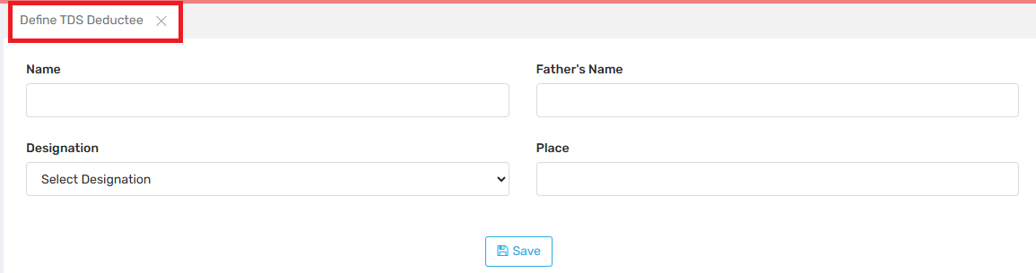
This section is used to record the details of individuals or employees for whom TDS (Tax Deducted at Source) is applicable. It is an essential part of payroll compliance and tax reporting.
This is typically used for:
- Contractors, consultants, or part-time workers.
- Employees where TDS needs to be manually set or reported for statutory compliance.
- Mapping specific personnel as deductees in TDS returns (e.g. Form 24Q).
Field Description:
Field Name | Function / Input Required
Name | Enter the full name of the person whose TDS will be deducted.
Father’s Name | Enter the father’s name for identification purposes (important for official/government documentation).
Designation | Select the designation of the person from the dropdown (like Teacher, Consultant, Clerk, etc.).
Place | Input the location of the person (e.g. city or branch office). Used for records or jurisdictional purposes.

8.7. Pay Scale Configuration:
8.7.i. Define Pay Scale:
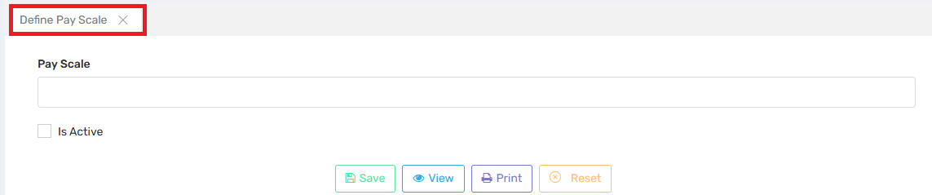
Admin users can create and manage pay scales for employees. It refers to a structured salary range or band assigned to different positions or employee categories.
Ensures salary structure consistency across departments.
Essential for automated payroll calculation based on grade/level.
Facilitates easier reporting, budgeting, and audits.

Field | Purpose
Pay Scale | Text box where you enter the name or label of the pay scale (e.g., Grade A, Level 1, Payscale-5400-20200). This helps group employees with similar salary structures.
Is Active | Checkbox to activate or deactivate the pay scale. Only active pay scales are available for assignment to employees. Useful for phasing out outdated structures.

8.7.ii. Define Pay Scale Amount:
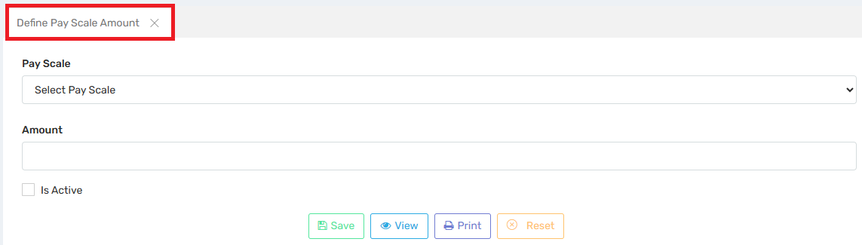
Users can assign a specific monetary value to a defined pay scale. This is a crucial step in the payroll setup process because it links the Pay Scale Name (created in the previous step) with its corresponding salary amount.

Field | Description
Pay Scale | A dropdown to select from existing pay scales (defined earlier). This is the pay grade for which you want to set a salary amount.
Amount | The fixed gross salary or basic salary associated with that particular pay scale.
Is Active | Checkbox to indicate whether this pay scale amount is currently active and should be used in salary calculations.

Button | Function
💾 Save | Saves the pay scale amount against the selected pay scale.
👁 View | Displays a list of all defined pay scale amounts. Useful for review or editing.
🖨 Print | Prints the list or details of pay scale amounts.
❌ Reset | Clears the current form entries.
Purpose in Payroll Configuration
This is a critical step because it directly influences:
- Monthly salary calculations
- Budget planning and payroll forecasting
- Automatic generation of payslips and TDS
Without this configuration, the system won’t know how much salary to associate with each employee based on their pay scale.
Workflow Summary
- Define Pay Scale – Set up structure/names (e.g., Grade A, Level 2).
- Define Pay Scale Amount – Assign monetary values to each pay scale.
- Map Employees to Pay Scales – Based on role/designation.
- Run Payroll – System pulls amounts based on assigned pay scales.
8.7.iii. Define Grade Pay:
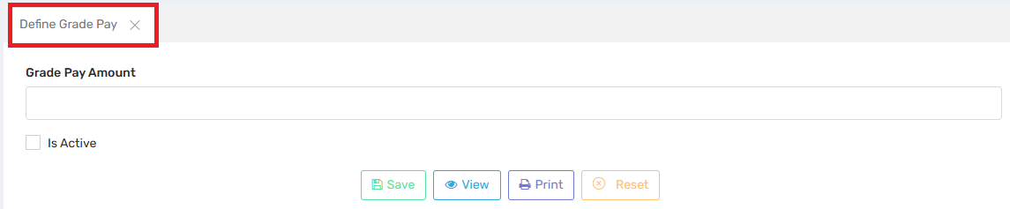
Users can define the fixed salary amount associated with a position, rank, or level, and it is usually added to the basic pay or pay scale amount to determine the total gross salary.
Field | Description
Grade Pay Amount | Enter the specific grade pay (e.g., ₹1,800, ₹4,200) that will be added to the base pay.
Is Active | Checkbox to activate or deactivate the grade pay value for payroll processing.

Button | Function
💾 Save | Saves the grade pay value in the system.
👁 View | Displays a list of all existing grade pay configurations for review/edit.
🖨 Print | Allows printing of the grade pay configuration report.
❌ Reset | Clears all entered data on the screen to allow fresh input.
Purpose in Payroll Structure
Grade Pay is typically used to:
- Differentiate staff within the same pay scale based on role, rank, or experience.
- Provide transparency in pay structure.
- Add an additional layer of categorization to salary setup.
Example Calculation in Payroll
If an employee is assigned:
- Pay Scale Amount: ₹25,000
- Grade Pay: ₹4,200
Then:
Gross Pay (before allowances/deductions) = ₹25,000 + ₹4,200 = ₹29,200
Workflow Summary with Grade Pay
- Define Pay Scale – Name of the pay scale (e.g., Level 3).
- Define Pay Scale Amount – Assign a base amount to the pay scale.
- Define Grade Pay – Assign an additional fixed amount to enhance the pay level.
- Map to Employee Profile – Combine Pay Scale + Grade Pay in employee configuration.
- Run Payroll – The system calculates salaries based on these components.
8.7.iv. Define Fixation:
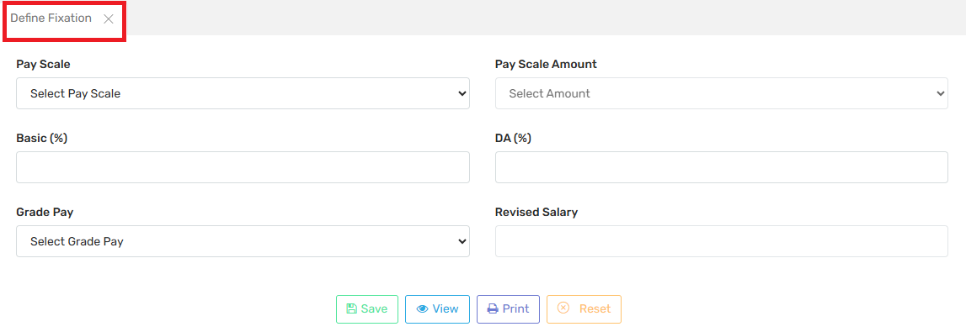
This functionality is used to fix or configure an employee’s salary structure based on different salary components like Pay Scale, Basic (% of pay scale), DA (Dearness Allowance %), and Grade Pay. It is crucial for implementing salary revisions or setting up new employee salaries according to defined structures.

Field | Description
Pay Scale | Select a predefined pay scale from the dropdown (configured earlier).
Pay Scale Amount | Auto-populated or selectable value linked to the chosen pay scale.
Basic (%) | Percentage of the Pay Scale Amount considered as Basic Pay.  E.g., if Pay Scale Amount is ₹30,000 and Basic is 50%, then Basic Pay = ₹15,000.
DA (%) | Dearness Allowance percentage added over Basic Pay.  E.g., if Basic is ₹15,000 and DA is 12%, then DA = ₹1,800.
Grade Pay | Select a grade pay (configured earlier) to be added to the total salary.
Revised Salary | Final computed salary based on Pay Scale Amount, Basic %, DA %, and Grade Pay. This is calculated either manually or automatically based on formulas.

Button | Function
💾 Save | Saves the fixation settings.
👁 View | Displays existing fixation records.
🖨 Print | Prints the fixation details for documentation.
❌ Reset | Clears all fields to start fresh.
Sample Salary Fixation Calculation
If:
- Pay Scale Amount = ₹30,000
- Basic (%) = 50% → ₹15,000
- DA (%) = 10% → ₹1,500
- Grade Pay = ₹4,200
Then:
Revised Salary = Basic + DA + Grade Pay = ₹15,000 + ₹1,500 + ₹4,200 = ₹20,700
Workflow
- Define Pay Scale & Amount
- Define Grade Pay
- Define Fixation
- Assign to Employee Profile
- Generate Salary Slip via Payroll Run

8.7.v. Assign Pay Scale to Staff:
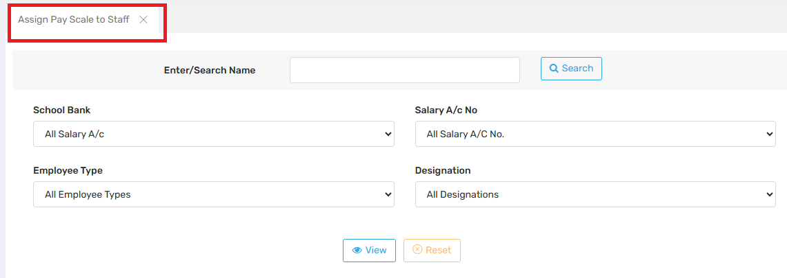
This step is essential in the salary configuration process where the defined pay scales are mapped or assigned to individual staff members based on filters like bank, designation, employee type, etc.

Field Name | Purpose
Enter/Search Name | Enter a staff name to search and assign pay scale to a specific individual.
School Bank | Filter staff based on the bank associated with their salary account. Useful for bank-wise payroll processing.
Salary A/c No. | Allows narrowing down staff using their salary account numbers.
Employee Type | Filter staff by type (e.g., Teaching, Non-teaching, Admin, Contractual).
Designation | Filter by designation (e.g., PGT, TGT, Principal, Clerk, etc.) to assign pay scales to a specific role category.

Button | Function
🔍 Search | Retrieves staff list based on selected filters.
👁 View | Displays the currently assigned pay scales to filtered employees.
🔄 Reset | Clears all selected filters for a fresh search or entry.
Workflow Summary:
Define Pay Scale → Set Pay Scale Names & Amounts.
- Define Grade Pay → Configure grade pay values.
- Define Fixation → Fix salary structure using pay scale + DA + grade pay.
- Assign Pay Scale to Staff (This Screen) → Link that configuration to staff profiles.
- Payroll Processing → System uses these assignments to auto-calculate monthly salaries.
Example Use Case
- Admin wants to assign the new Pay Scale "PS-2025-A" with Grade Pay to all TGT Teachers in Bank A.
- They filter:
  - School Bank = Bank A
  - Employee Type = Teaching
  - Designation = TGT
- Then they search, view, and assign the updated pay scale.

8.8. Modify Staff in Bulk:
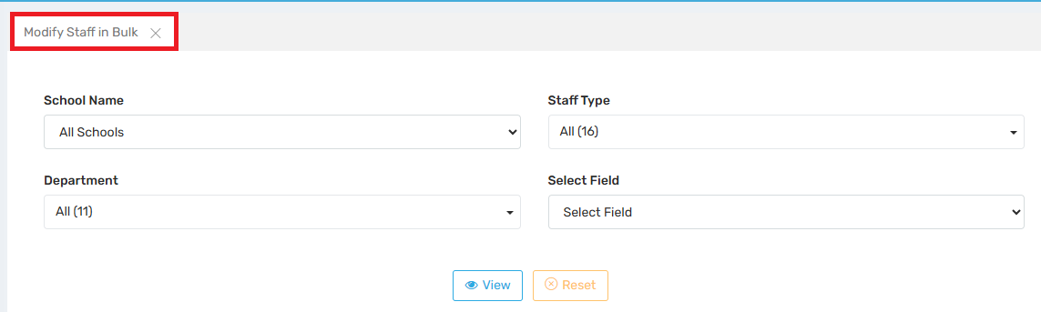
Users can update or edit specific payroll-related fields for multiple employees at once quickly and efficiently.

Key Purpose
- Save time by avoiding manual updates for each individual staff profile.
- Ensure consistency across departments or staff types for fields like pay scale, DA, designation, bank account details, etc.
- Useful during policy changes, annual revisions, or data corrections.
Field Description
Field Name | Purpose
School Name | Select a specific school (useful if the system serves a group of institutions) or “All Schools” for bulk operations across institutions.
Staff Type | Choose from different staff categories like Teaching, Non-teaching, Admin, Contractual, etc.
Department | Filter based on internal departments (e.g., Science, Admin, Sports). Helps apply changes specific to departments.
Select Field | This is the critical part where you choose which specific payroll-related field you want to update in bulk (e.g., Pay Scale, Designation, Bank Details, etc.).

Button | Function
👁 View | Displays a list of staff members matching the filter criteria, allowing you to make changes in the selected field.
🔄 Reset | Clears all filters to allow a new selection.

Use Cases
- Annual pay scale revision for all Teaching Staff in the Science Department.
- Updating Bank A/c numbers after a school-wide salary account migration.
- Assigning or modifying DA % or Grade Pay for staff of a specific school.
- Bulk promotion update (e.g., TGT → PGT for multiple staff).
Workflow
- Define Pay Scale/Fields → Initial configuration
- Assign Pay Scale to Staff → Individual or filtered mapping
- Modify Staff in Bulk → Mass corrections/updates based on new data or policies
- Process Payroll → Ensures accurate and updated data is used
8.9. Rejoin Staff:
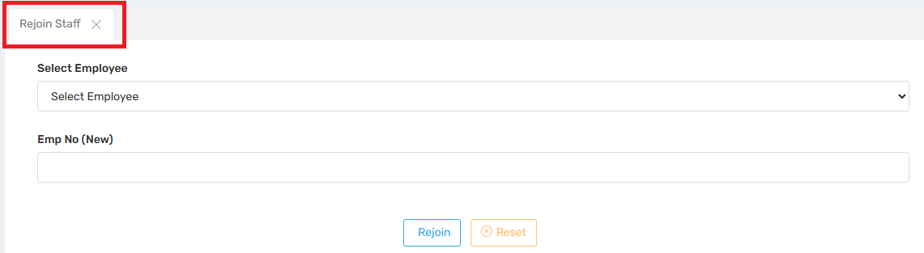
Users can use this feature when a previously separated or resigned employee returns to service and needs to be reactivated in the payroll system.

Field Name | Purpose
Select Employee | Dropdown to choose the staff member who previously resigned or was deactivated. The system likely filters to show only inactive/resigned staff.
Emp No (New) | Assign a new Employee ID/Number for the staff member being rejoined. This helps in maintaining old records separately while continuing payroll under a fresh identity if required.

Button | Function
🔁 Rejoin | Reactivates the selected employee’s profile, reassigning them a new employee number and re-linking them into payroll processing.
❌ Reset | Clears the form fields to start over.
Use Cases
- An employee who resigned or was terminated is re-hired.
- Contractual or temporary staff is reappointed for a new session or financial year.
- Returning employees due to long leaves, sabbaticals, or transfers from other branches.
- A new employee ID is generated for HR/payroll continuity.
- Old records remain intact for audit/history.
- Rejoined staff will now appear in payroll processing, pay scale assignment, attendance, and other modules.
- You may need to assign them designation, pay scale, department, etc. again after rejoining.

8.10. Generate Barcode:
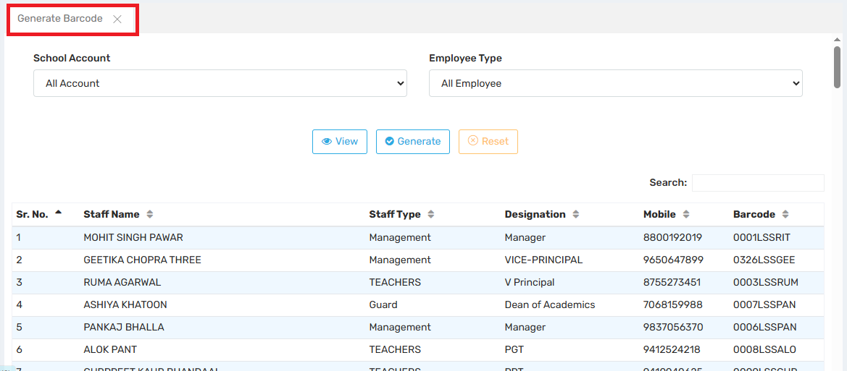
This module is designed to generate unique barcodes for employees, which can be used for: Payroll identification, Attendance tracking (via barcode scanners), Staff ID card generation, Streamlining HR and administrative processes
Field Descriptions:

Filters:
- School Account: Dropdown to filter employees based on different school accounts if multiple institutions/departments are managed.
- Employee Type: Filter by role types (e.g., Management, Teachers, Non-teaching, etc.)

2. Buttons:
- View: Displays the list of employees based on selected filters.
- Generate: Creates new barcodes for selected employees or all employees.
- Reset: Clears filters or current selections.

3. Search:
- A search bar is provided to find employees quickly by name, designation, or other parameters.

Use Case Examples:
- When generating salary slips or reports, barcode IDs ensure unique identification.
- During staff attendance or access control, scanned barcodes speed up verification.
- Barcodes also be printed on ID cards for physical identification.

8.11. Assign transport to Staff:
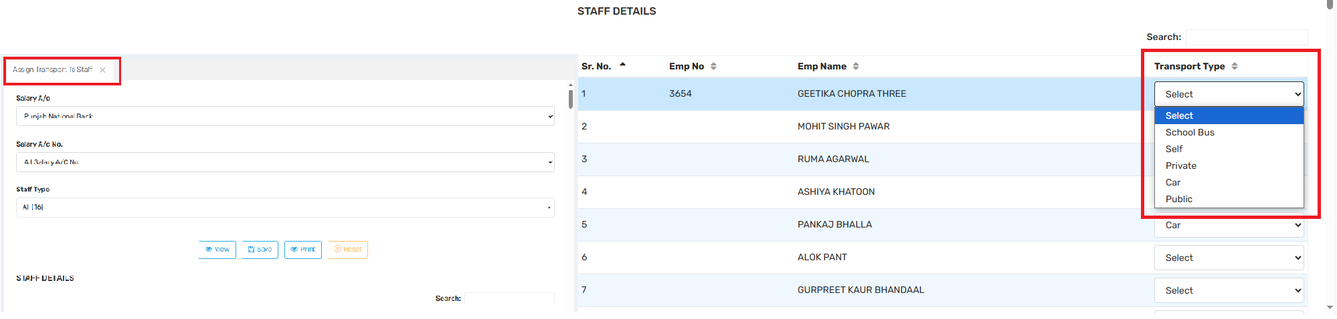
This section allows users to assign and manage transportation details for employees within the organization.This helps in managing transportation logistics and calculating transport allowances or deductions
Field Description:
Each staff member has a dropdown where you can select their mode of transport. Available options:
- School Bus: Uses institution-provided transport
- Self: Drives their own vehicle
- Private: Hired/third-party transport
- Car: Uses a personal or assigned car
- Public: Uses public transportation
- Select: Default/blank selection (not yet assigned)

2. Staff Details Table (right side):
Column | Description
Sr. No. | List index
Emp No | Unique Employee ID
Emp Name | Full name of the staff member
Transport Type | Assigned transport mode (as above)

3. Form Filters (left side):
- Salary A/c: Bank used for salary disbursal
- Salary A/c No.: Associated account number
- Staff Type: Filter staff by department or role

Use Case Examples:
- The Accounts team can calculate transport allowance based on the selected type.
- The Admin department can generate bus route plans based on who uses the school bus.

8.12. Insurance:
8.12.i. Insurance Vendor:
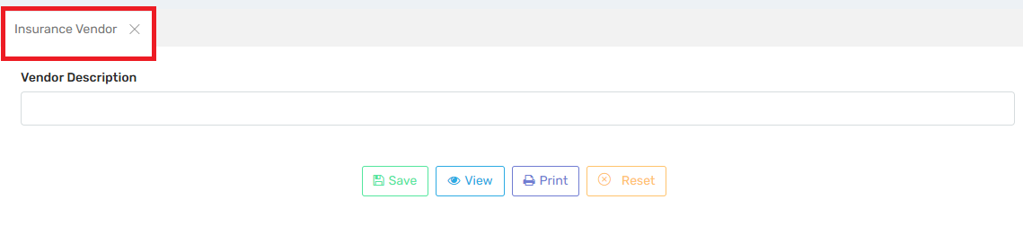
This section is used to define and maintain a list of insurance vendors (third-party companies) that provide insurance services to the school staff—such as health, accidental, or life insurance. This can be linked to payroll deductions or benefits.
Field Description:

Field / Button | Functionality
Vendor Description | A text box where you enter the name or description of the insurance vendor. Example: “LIC of India - Group Term Plan” or “Star Health - Staff Mediclaim.”
Save | Saves the entered insurance vendor to the ERP database.
View | Displays a list of already added insurance vendors.
Print | Allows you to print the insurance vendor list for records or audits.
Reset | Clears the current input field so you can re-enter or start fresh.
Use Case:
- Centralized database of all insurance service providers.
- Enables easy linking of vendor details to staff insurance records.
- Streamlines insurance deduction and premium payment tracking in payroll.
8.12.ii. Relate Policy with Employee:
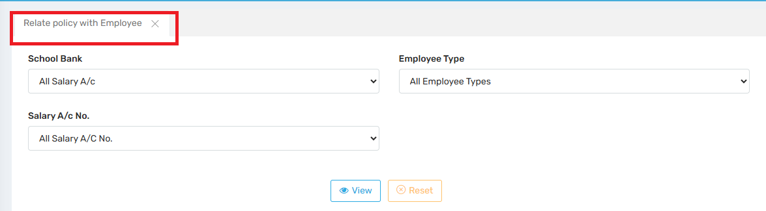
This section is used to assign or manage insurance or financial policies (like health insurance, salary accounts, etc.) for employees based on: Their school bank, Their salary account number, Their employee type (e.g., teaching, non-teaching, contract, etc.)

Field Descriptions:
Field | Description
School Bank | Select a specific bank (or "All Salary A/c") associated with employee salary disbursement. Useful if employees are grouped by bank.
Salary A/c No. | Narrow down to specific salary account numbers if policies are tied to individual accounts.
Employee Type | Filter employees by their job category (e.g., Regular, Contractual, Temporary, Teaching, Admin Staff).
Action Buttons:
- 👁️ View: After setting filters, this button displays the list of employees matching the criteria so that policy linking can be reviewed or applied.
- ❌ Reset: Clears all selected filters to allow fresh selection.
Use Case:
If the school is providing Group Health Insurance:
- You may only want to assign this to the teaching staff.
- You can filter by Employee Type = Teaching and School Bank = Punjab National Bank, then click View to see eligible employees and relate them to the insurance policy.
8.12.iii. Related Policies with Month:
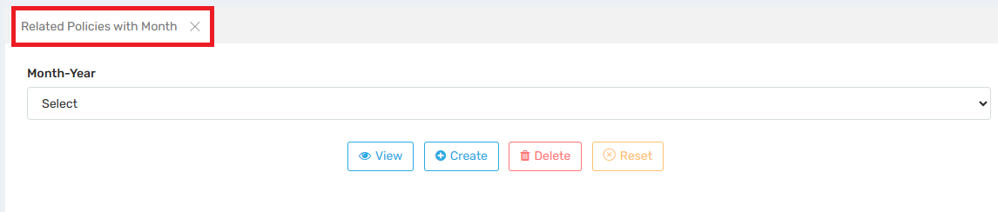
This section is used to assign, view, or manage insurance-related policies (e.g., health insurance, accidental insurance, salary deductions) for a particular Month-Year. This ensures that policy-related deductions or benefits are calculated accurately during payroll processing.
Field | Description
Month-Year (Dropdown) | Select the payroll month and year for which you want to assign or manage employee insurance/policy data.

🔘 Button Functions:Use Case:

Button | Action
👁️ View | Displays existing policies already linked to the selected month. Useful for verification or audit.
➕ Create | Allows admin to assign new policies (e.g., insurance premium deductions) for the selected month. This would affect the payroll for that period.
🗑️ Delete | Removes previously assigned policy associations for that specific month, which can reverse or remove deductions.
❌ Reset | Clears the selected month and resets the form for fresh input.
Let’s say the school has an insurance policy where ₹500 is deducted monthly for health insurance:
- Go to “Related Policies with Month”.
- Select June 2025 as Month-Year.
- Click Create to link the insurance deduction with June’s payroll.
- The payroll engine will now automatically deduct ₹500 from employees who are enrolled in the policy.

8.13. Professional Tax Slab:
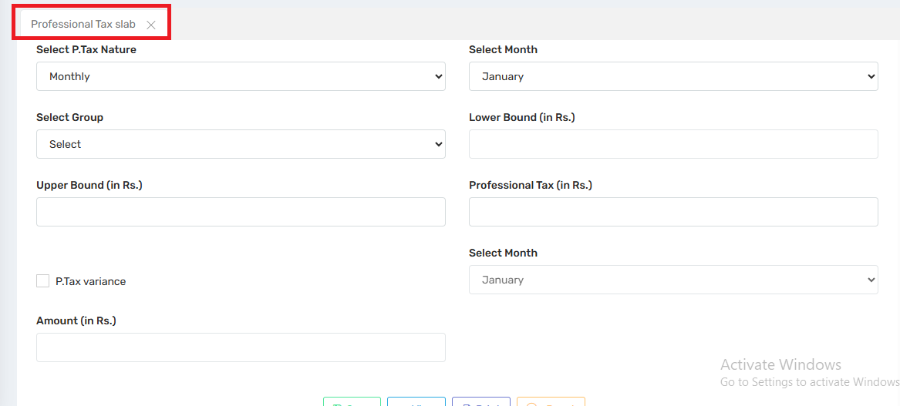
This section is used for defining professional tax rules that are applied to employees based on their salary range.
Field | Description
Select P.Tax Nature | Choose if the tax is to be applied Monthly or Yearly (in this case: Monthly).
Select Month | The month for which the professional tax rule applies (e.g., January).
Select Group | Employee group or category this tax rule applies to (e.g., Teaching Staff, Admin Staff).
Lower Bound (in Rs.) | Minimum salary from which the tax slab starts applying.
Upper Bound (in Rs.) | Maximum salary till which this slab applies.
Professional Tax (in Rs.) | Amount of professional tax to be deducted for employees within the specified salary range.
P.Tax Variance (Checkbox) | If checked, it indicates that the tax varies based on special conditions (e.g., different rates in different months like February).

Use Case Example:
If you want to deduct ₹200 for professional tax from employees earning between ₹10,000 to ₹15,000 for January:
- P.Tax Nature: Monthly
- Select Month: January
- Group: Admin Staff
- Lower Bound: 10000
- Upper Bound: 15000
- Professional Tax: 200
- Save
This setup will apply a ₹200 deduction from eligible employees during January payroll processing.
8.14. Upload Staff Document:
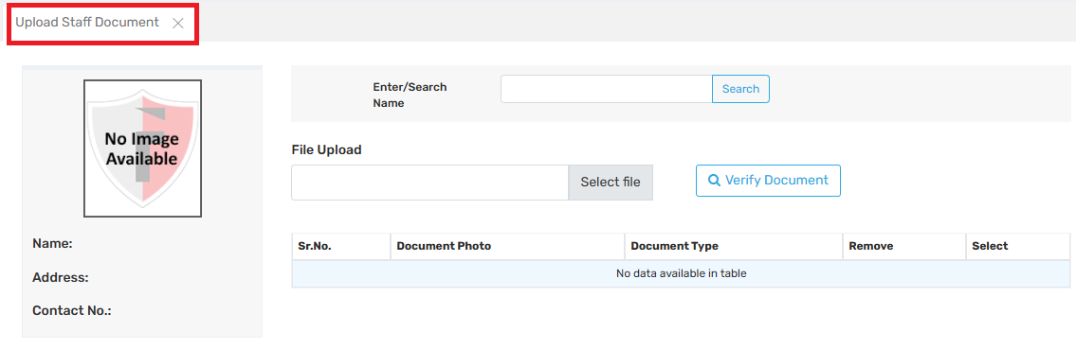
In this section users can upload, manage, and verify important documents related to employees, such as ID proofs, address proofs, qualification certificates, contracts, etc.
Field Description:

Area | Function
Search Bar (Enter/Search Name) | Enter the staff member's name to search for their profile in the ERP system.
Photo Section (Left Panel) | Displays the staff member’s profile image (currently shows “No Image Available” if not uploaded).
Staff Info Section | Shows Name, Address, and Contact Number of the selected employee.
File Upload | Used to upload documents: 1. Click Select File to browse and choose the document. 2. Use Verify Document to validate the file before submission (could include checking for valid format, size, etc.).
Document Table | Displays a list of previously uploaded documents with columns: • Sr. No. • Document Photo (preview/icon) • Document Type (e.g., Aadhar, PAN, etc.) • Remove (to delete) • Select (to view/edit the document).

9. Recruitment:
9.1. Interview Type:
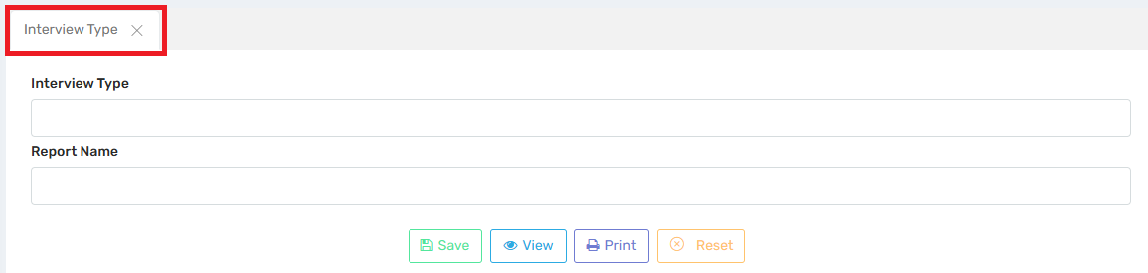
Users can define and manage various interview categories that can later be used for scheduling interviews, generating reports, and tracking candidate evaluations.

Field | Function
Interview Type | Input field to specify the type of interview, e.g., “HR Round”, “Technical Round”, “Demo Class”, “Principal Interaction”, etc.
Report Name | Field to enter the name that will appear in reports or printouts (may be the same or slightly modified for display).
Save Button (💾 Save) | Stores the new interview type into the system.
View Button (👁 View) | Displays a list of all previously entered interview types.
Print Button (🖨 Print) | Generates a printable report of interview types for documentation.
Reset Button (✖ Reset) | Clears the input fields so the user can enter new data.

Example Use Case:
Let’s say a school wants to streamline hiring and categorize interviews:
- HR logs into the Payroll ERP.
- Open the “Interview Type” module.
- Enters:
  - Interview Type: Technical Round
  - Report Name: Subject Knowledge Assessment
- Clicks Save.
9.2. Assessment Type:
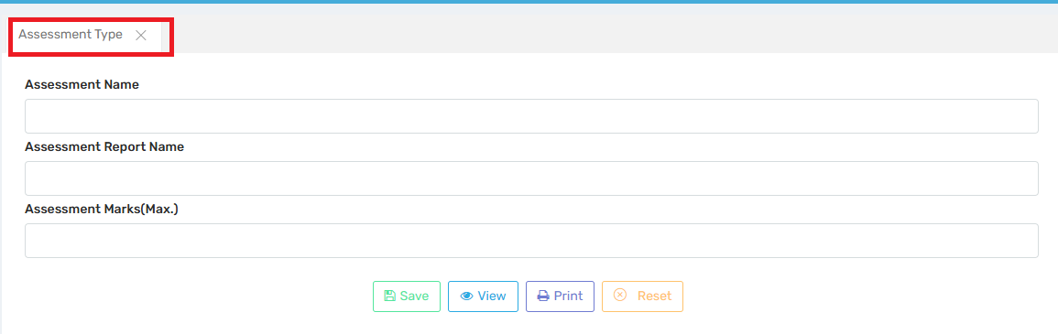
This section is part of the staff evaluation process, especially useful during recruitment or performance appraisals.
Field Name | Purpose
Assessment Name | Enter the type of assessment (e.g., "Demo Class", "Subject Knowledge", "Communication Skills").
Assessment Report Name | Specify how this assessment should appear in reports or printouts. May be similar or formatted differently for reporting purposes.
Assessment Marks (Max.) | Enter the maximum marks that can be awarded for this type of assessment (e.g., 10, 25, 50, etc.).

Button | Function
💾 Save | Saves the entered assessment type into the ERP system for future use.
👁 View | Displays a list of all defined assessment types.
🖨 Print | Allows the user to print the list or specific assessment type configuration.
✖ Reset | Clears the input fields for fresh data entry.
Use Case Example:
Let’s say the Admin department is organizing interviews for a new teacher. They may need to assess candidates on:
- Assessment Name: Demo Class
- Report Name: Classroom Teaching
- Max Marks: 20
Once these are saved, they can be selected during interview evaluations, allowing structured grading and report generation.
9.3. Interview Slot:
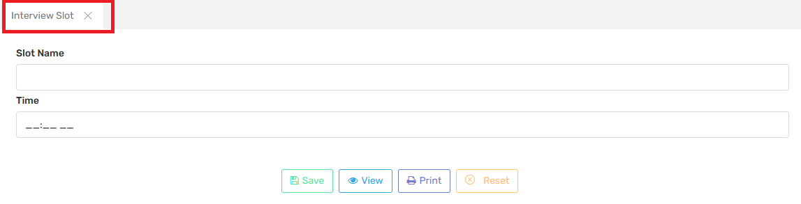
Users can create and manage time slots for candidate interviews in an organized and systematic way. It helps users to allocate specific interview times and avoid conflicts or overlaps.
Field Description:
Field Name | Purpose
Slot Name | A custom name/label for the interview slot. Example: Morning Slot, Slot A, Round 1, Panel Interview 1, etc.
Time | Time of the slot (can be in hh:mm AM/PM format). Used to schedule when the interview will be conducted.
9.4. Job Posting:
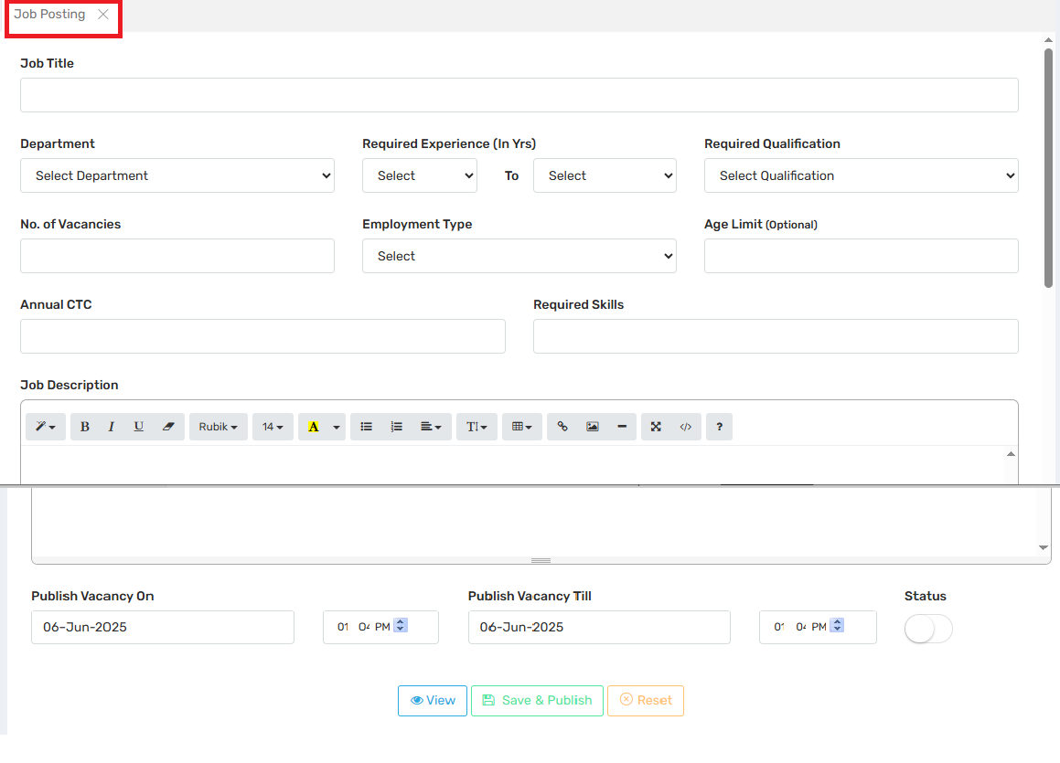
To post internal or external job vacancies and manage the hiring process efficiently by specifying all necessary details related to the job opening.
Job Title | Title of the position being offered (e.g., “Math Teacher”, “Admin Executive”).
Department | Selects the department where the vacancy exists (e.g., Teaching, Administration, IT).
Required Experience (In Yrs) | Minimum and maximum years of experience required for the job.
Required Qualification | Academic qualifications required for the role (e.g., B.Ed, MBA).
No. of Vacancies | Number of openings for this job role.
Employment Type | Type of employment (e.g., Full-time, Part-time, Contract).
Age Limit (Optional) | Specifies any age criteria for applicants.
Annual CTC | Cost to Company (salary package) for the role.
Required Skills | Lists key skills needed (e.g., MS Excel, Python, Classroom Management).
Job Description | A rich-text editor allows HR to define the role, responsibilities, expectations, and additional notes.

Publishing Controls:
Publish Vacancy On | Date and time when the job post becomes visible to applicants.
Publish Vacancy Till | Date and time until the post remains active.
Status Toggle | Turns the job posting on/off (i.e., active/inactive).
Use Case:
Centralizes and streamlines hiring.
Ensures all HR stakeholders have a clear record of open positions.
Helps integrate job postings with interview scheduling and applicant tracking.
Makes audit and compliance easier by keeping recruitment data structured.
9.5. Application Received:
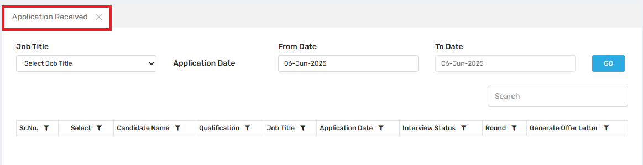
In this Section users can track, view, filter, and process job applications submitted by candidates in response to job postings.
Field Description:
Component | Purpose / Function
Job Title Dropdown | Filters applications based on the job post they applied to (e.g., Teacher, HR Executive).
From Date / To Date | Allows filtering applications by submission date range.
Search Box | Lets you search for a candidate by name or keyword.
GO Button | Triggers the filtering operation based on the selected criteria.

Sr. No. | Auto-generated serial number.
Select | Checkbox for selecting applications for batch operations (like generating offer letters).
Candidate Name | Displays the full name of the applicant.
Qualification | Shows academic qualifications as filled in by the candidate.
Job Title | Indicates the job post applied for.
Application Date | Date when the candidate submitted the application.
Interview Status | Shows current status (e.g., Scheduled, Not Scheduled, Selected, Rejected).
Round | Indicates which interview round the candidate is currently in (e.g., 1st, 2nd, Final).
Generate Offer Letter | Option/button to generate and issue an offer letter to the selected candidate(s).

Use Case:
- After a job is posted, candidates apply online.
- HR/Admin reviews those applications here.
- Applications are filtered by date, job, or qualifications.
- From this dashboard, you can:
  - View interview status
  - Assign interview rounds
  - Move to final offer stage
- Streamlines hiring without manually managing spreadsheets or emails.
Workflow:
This screen integrates with:
- Job Posting – pulls the job titles
- Interview Slot Management – links with interview status
- Offer Letter Generation – enables issuing offer letters directly

9.6. Slot Assigning:
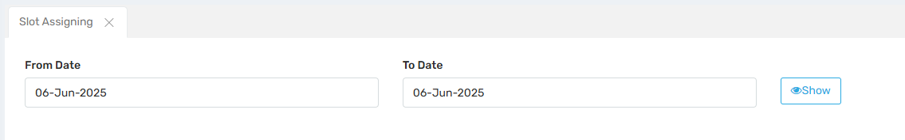
To assign interview time slots to shortlisted candidates for specific dates. This is a key step in organizing structured interview rounds.
Field Description:

Field | Function
From Date | Start date of the time range within which interview slots are to be viewed or scheduled.
To Date | End date of the time range for the interview slots.
Show Button | When clicked, it displays available or already-assigned interview slots for the selected date range.
Workflow:
- Admin selects a date range (usually the date of scheduled interviews).
- Clicks the “Show” button to:
  - View a list of candidates.
  - View existing slot assignments (if any).
  - Assign or reassign interview slots manually.
- Assignments might include:
  - Time slot (e.g., 10:00 AM – 10:30 AM)
  - Interview panel
  - Round number (e.g., Round 1 / Technical / HR)
- Once assigned, these slots are saved and become visible in the Interview Tracking module.
9.7. Travel Plan Approval:
9.8. HR Entry Forms:

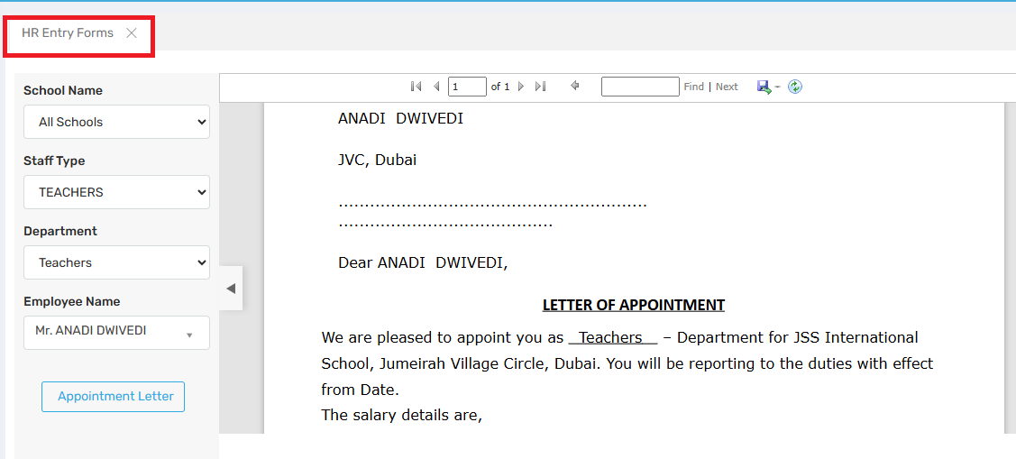Users can generate and issue appointment letters for newly recruited or existing employees based on their role, school, and department.
Field | Description
School Name | Dropdown to select the specific school (if part of a group or trust).
Staff Type | Choose the type of staff – e.g., Teaching, Non-Teaching, Management, Admin, etc.
Department | Filter to select the relevant department (e.g., Management, HR, IT).
Employee Name | Select the specific employee from a filtered list based on the above fields.
Appointment Letter (Button) | Generates and opens/downloads the official appointment letter for the selected employee. Usually formatted as a PDF with date, terms, salary, and designation details.

9.9. HR Exit Forms:
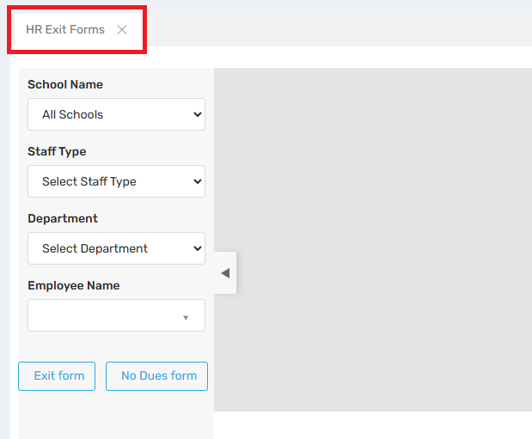
The Users can use this form to manage the employee exit process in a structured and compliant manner, including documentation like Exit Form and No Dues Certificate.

Field | Purpose
School Name | Allows admin to choose the specific school (useful for group institutions).
Staff Type | Filters employees by type: Teaching, Non-teaching, Admin, Support, etc.
Department | Further narrows down the search (e.g., IT, Accounts, Management).
Employee Name | Dropdown that populates based on the above selections to choose the existing employee.
Exit Form (Button) | Generates or accesses the exit formalities document, usually detailing resignation, last working day, HR clearance, etc.
No Dues Form (Button) | Generates the No Dues Certificate, confirming the employee has cleared dues with all departments (IT, Library, Accounts, etc.).

Workflow Example:
- Admin selects the School, Staff Type, Department, and Employee Name.
- Clicks:
  - “Exit Form” to document the resignation/termination.
  - “No Dues Form” to ensure the employee has settled responsibilities and returned items.
- Both forms are typically saved or printed and added to the employee’s exit file.
10. Advance
10.1. Fix Advance A/c (Advance Account Configuration):
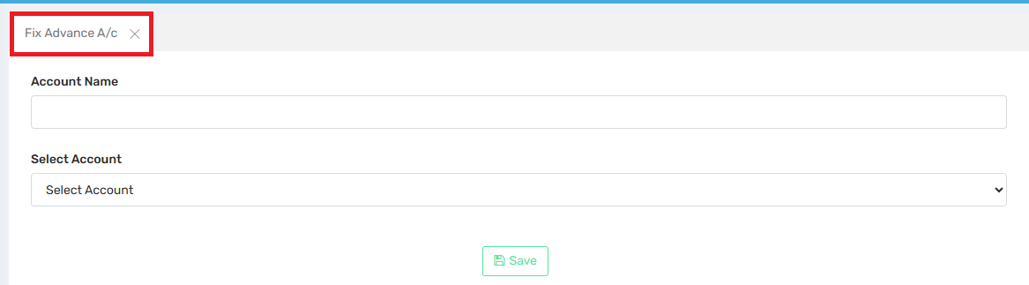
This section is used to map or configure employee advance accounts within the payroll system. This ensures that any advance salary, loans, or recoveries are correctly linked to a specific account for proper payroll processing, deductions, and reporting.
Account Name: Input field to define a unique name for the advance account (e.g., “Salary Advance”, “Festival Advance”, “Loan A/c”).
Select Account: Dropdown to choose the linked account from the organization’s chart of accounts (e.g., Advance Payable, Staff Loan Receivable).
Save Button: Saves the configuration so that this account can be used during payroll processing or while disbursing advances.

Workflow:
- Accountant enters an Account Name for the type of advance being tracked.
- Selects the correct ledger/account from the ERP’s internal accounting system.
- Clicks Save to fix the mapping.
- Once saved:
  - This mapping is used in salary processing when advances are given or recovered.
  - Helps in proper tracking and reconciliation with the financial system.
  - Ensures that salary slips and account ledgers show correct deductions.

Use Case:
- An employee takes a ₹10,000 advance for medical treatment.
- HR maps “Medical Advance” to “Advance to Employees” account.
- When processing salary, the system deducts part of the advance from monthly salary based on this configuration.

10.2. Employment Form:
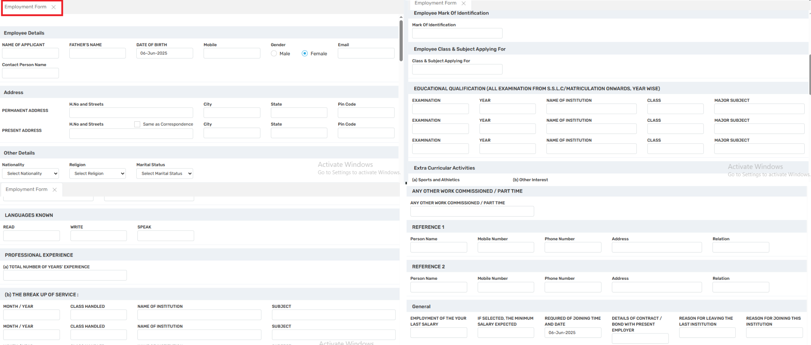
Users can use this to register a new employee into the ERP system with complete personal, contact, academic, and job history. This information feeds into modules like payroll, attendance, leave, appraisal, and compliance.

Field Description:

Employee Details:
- Name of Applicant, Father’s Name, DOB, Gender, Contact Info: Core identification and contact information.
- Contact Person Name: For emergencies or reference.
🏠 Address Section:
- Permanent & Present Address: For correspondence, verification, and HR record keeping.
- Checkbox for "Same as Correspondence" helps in auto-filling the address.
📌 Other Personal Information:
- Nationality, Religion, Marital Status: Often required for background checks, legal compliance, and demographic records.
🗣️ Languages Known:
- Indicates multilingual abilities which may be relevant for teaching or communication roles.
🧠 Educational Qualification:
- Exam Name, Year, Institution, Class, Major Subject: To validate qualifications and teaching subject expertise.
💼 Professional Experience:
- Total Years of Experience
- Breakup of Service (Month/Year, Class Handled, Subject, Institution):
  - Used for determining salary bands, seniority, and appropriate posting.
  - Often integrated with salary scale & eligibility for promotions.
🏫 Class & Subject Applying For:
- HR notes down the class level (e.g., Primary, Secondary) and subject the candidate is being hired for.
🆔 Employee Mark of Identification:
- A physical identifier (scar, mole, etc.) for biometric or identification verification.
🏅 Extra-Curricular Activities:
- Assesses employee's contributions beyond academics (sports, music, etc.).
🧾 Other Work Commissioned / Part-Time:
- Used to check for conflicts of interest or additional skill sets.
👥 References (1 & 2):
- Person Name, Contact Info, Relation: Used for background checks or emergency reference.
📌 General Section:
- Last Employment & Salary
- Expected Salary
- Required Joining Date
- Bond with Current Employer
- Reason for Leaving Previous & Joining This Institution
10.3. Advance Entry:
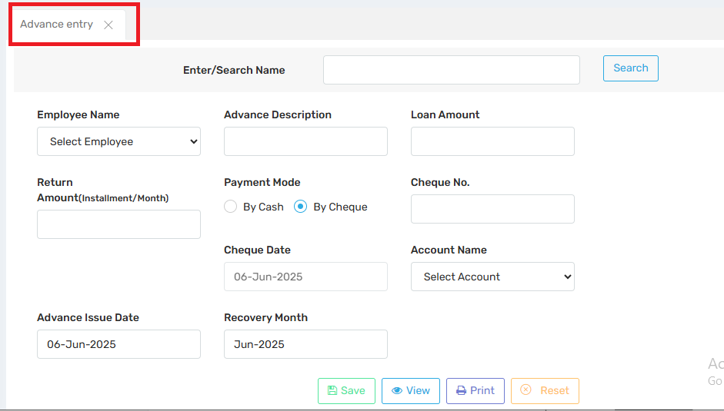
This section is used to manage and record employee salary advances or loans, and set up the repayment schedule directly within the payroll system.
Enter/Search Name:
- Used to search existing advance records for a particular employee.
- Useful for viewing, editing, or auditing past advances.
Employee Name:
- Dropdown to select the employee receiving the advance.
- Automatically pulls the employee's profile linked to payroll.
Advance Description:
- A short note about the purpose or reason for the advance (e.g., “Medical Emergency”, “Festival Loan”)
Loan Amount:
- Total amount given to the employee as an advance
Return Amount (Installment/Month):
- Amount to be deducted monthly from the employee's salary.
.
- Used to calculate the number of months required for full recovery.
Payment Mode:
- Specifies how the amount is disbursed:
  - By Cash
  - By Cheque
Cheque No. / Cheque Date:
- Used if the disbursement is done through a cheque.
- Maintains banking and audit compliance.
Account Name:
- The internal account or ledger from which the advance is issued (e.g., "Advance Salary", "Staff Loan Account").
Advance Issue Date:
- The date on which the advance was issued to the employee.
Recovery Month:
The month in which the repayment starts.
Used by the payroll engine to schedule deductions from that specific payroll cycle.
Use Case:
Automatic deductions from salary—no manual tracking needed.
Improves financial transparency and employee trust.
Helps HR manage recoverable accounts efficiently.
Reduces errors in EMI deduction and loan tracking.

10.4. Advance Repayment:
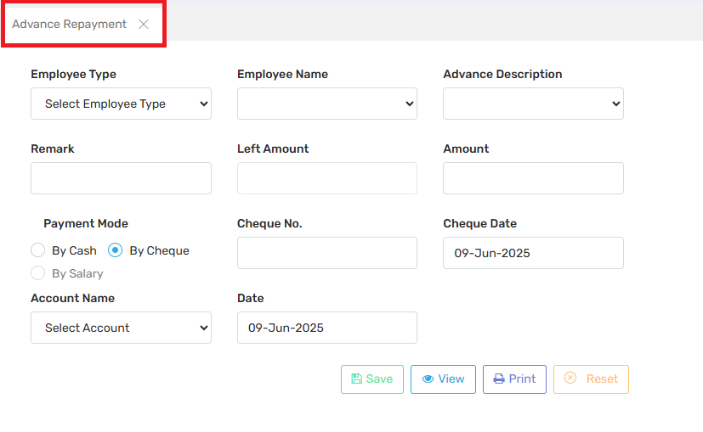
This section is used to track and record repayments made by employees manually (outside automatic salary deductions), such as cash, cheque, or salary adjustment. It helps maintain accurate balances and audit records.
Field Description:
Employee Type:Dropdown to filter employees by type (e.g., Teaching, Non-Teaching, Admin).
Employee Name:Dropdown to select the name of the employee who is repaying the advance. Linked to records created in the Advance Entry section.
Advance Description:Selects the specific advance or loan the repayment is linked to.
Left Amount:Displays the remaining balance to be paid for the selected advance.
Auto-fetched based on employee and advance selected.
Amount:The actual repayment amount being made in this entry.
Remark:Optional comments (e.g., “Partial repayment for June”, “Cheque cleared”).
Payment Mode:Options to specify how the repayment is being made:
  - By Cash
  - By Cheque
  - By Salary (i.e., deducted from salary, useful for off-cycle or partial salary adjustments)
Cheque No. / Cheque Date:Required only if payment mode is Cheque.
Account Name:The ledger/account to which the repayment is credited (e.g., “Advance Salary Recovery Account”).
Date:The transaction date of the repayment.
Use Cases:
- Employees repays in cash directly to the office.
- Cheque repayments that need to be logged for auditing.
- Partial repayments outside regular payroll deduction cycles.
- Advance clearing on exit when an employee is leaving and repays manually.

10.5. Advance Report:
10.5.1 Advance Entry Report:
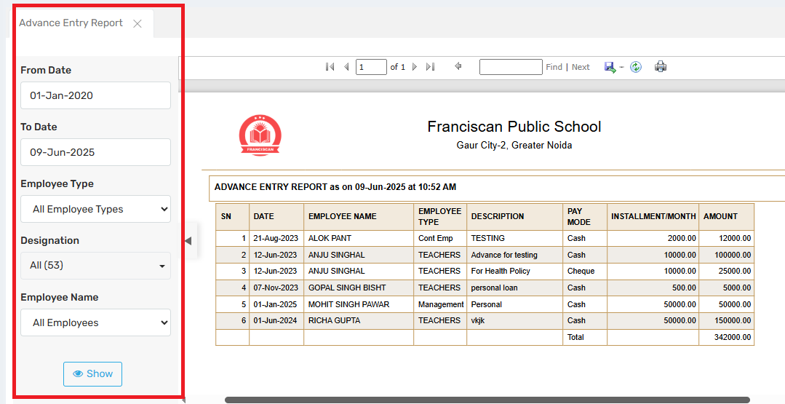
To review, track, and audit all salary advances or loan entries issued to employees, filtered by date, type, designation, or employee name.
Used to customize the report output based on various filters:
Field Descriptions:
- From Date & To Date:
  - Defines the date range of the report.
  - Only advances issued within this date range will be shown.
- Employee Type:
  - Allows filtering by employee category (e.g., Teaching, Non-Teaching, Admin).
  - Useful in organizations with varied staff structures.
- Designation:
  - Filters advances by specific job titles (e.g., Accountant, Teacher, Coordinator).
  - Helps narrow down reporting to specific roles.
- Employee Name:
  - Allows selection of an individual employee.
  - Useful for generating reports for one staff member.
- Show Button:
  - Generates the report using the selected filters.

📊 Report Output (Right Side):
This section displays the actual report of advance entries:

Report Header:
- Title: ADVANCE ENTRY REPORT as on [Date & Time]
- School Name and Academic Year: Ensures clear audit tracking.
- Printed on: Indicates when the report was generated.

Table Columns:
Column | Description
SN | Serial number for entries
Date | Date of advance entry
Employee Name | Name of the employee who took the advance
Employee Type | Category of the employee
Description | Reason or label for the advance (e.g., Medical, Festival)
Pay Mode | Payment method used (Cash, Cheque)
Installment/Month | Monthly EMI to be deducted
Amount | Total amount issued

Use Cases:
- Admin review of issued advances for payroll processing.
- Audit reports for compliance and tracking.
- Follow-up on pending recoveries.
- Cross-verification with repayment records.
10.5.2. Advance Repayment Report: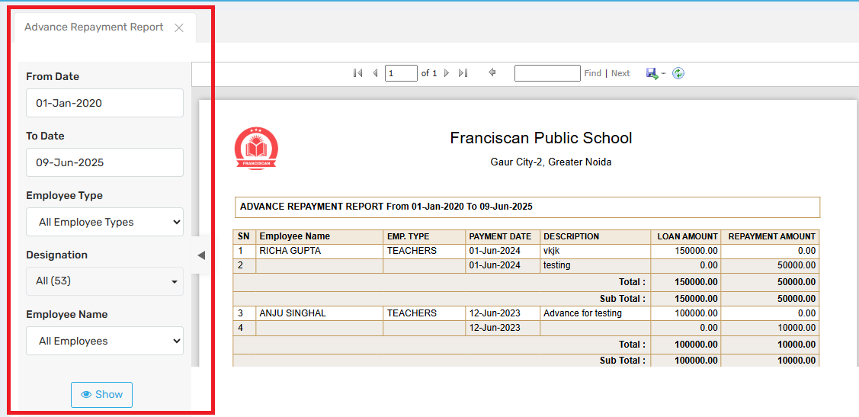This report tracks the repayment status of salary advances taken by employees over a selected period. It is useful for:
- Admin department to verify recovery progress.
- Ensuring employee advances are being paid back on time.
- Transparency and audit readiness.
Field Descriptions:
Field | Function
From Date / To Date | Sets the range for which advance repayments are to be viewed.
Employee Type | Filter by staff category (e.g., Teaching, Non-Teaching).
Designation | Narrow down to specific job roles.
Employee Name | Filter repayment report for a specific employee.
Show Button | Generates the report as per selected filters.

SN | Serial number.
Employee Name | Name of the employee who took the advance.
EMP. TYPE | Designation category (e.g., TEACHERS).
PAYMENT DATE | Date when repayment was recorded.
DESCRIPTION | Notes or reason for the advance (optional).
LOAN AMOUNT | The amount initially advanced to the employee.
REPAYMENT AMOUNT | Amount paid back by the employee on that date.

10.5.3. Advance Ledger Report: 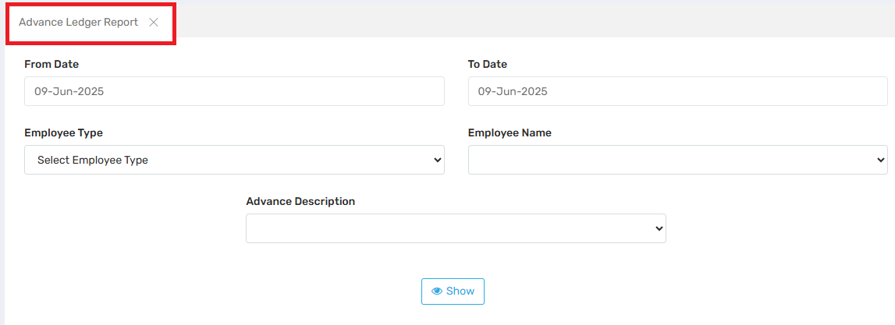The Advance Ledger Report provides a detailed, transaction-wise ledger for each employee who has taken an advance, showing:
- Advance amounts issued
Repayments made
- Pending balances
- Dates and descriptions of each transaction
This functions much like a mini-statement or passbook for each employee’s advance account.
Field Description:

Field | Function
From Date / To Date | Define the time range to retrieve advance records. Helps in filtering based on a specific payroll cycle or financial year.
Employee Type | Allows filtering by type (e.g., Teachers, Admin Staff, etc.). Essential for segment-wise reporting.
Employee Name | Select a specific employee to view their advance ledger.
Advance Description | Filter based on the purpose or remarks entered during advance disbursement (e.g., "medical loan", "housing loan", etc.).
Show Button | Generates the advanced ledger report based on selected parameters.

11. Salary Structure:
11.1. Leave LWP Manual: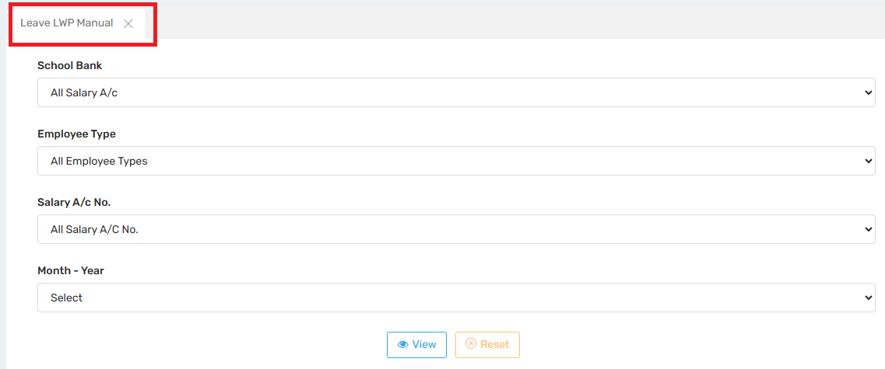 This section is used to manually enter or adjust unpaid leave (LWP) data for employees. When an employee takes leave beyond their entitled quota (e.g., casual/sick leave), it becomes LWP and results in salary deductions.
Field | Descriptions
School Bank (Salary A/c) | Filters employees based on the salary account/bank through which payments are made (helpful if multiple banks are used for disbursing salaries).
Employee Type | Segregates staff based on roles (e.g., Teaching, Admin, Support Staff), enabling targeted LWP entry.
Salary A/c No. | Further filters based on specific salary accounts under the school’s payroll system.
Month - Year | Select the payroll month for which you want to view or update LWP entries.

Key Functionalities:
- Manual Entry/Editing: HR can input or correct the number of LWP days for individual employees.
- Impact on Salary: The LWP days directly reduce the monthly gross salary proportionally.
- Real-time Sync with Payroll: Once LWP is entered and saved, the deduction is automatically reflected in the monthly salary sheet.
- Audit Trail: Maintains records of manually entered leaves for verification or future audits.
📋 Example Use Case:
If an employee takes 5 days of LWP in June 2025, and their monthly salary is ₹30,000:
- Per day salary = ₹30,000 / 30 = ₹1,000
- Deduction = 5 × ₹1,000 = ₹5,000
- Final payable salary = ₹25,000
This calculation is handled automatically once LWP is entered via this section.
11.2. Occasional Allowance/Deduction: 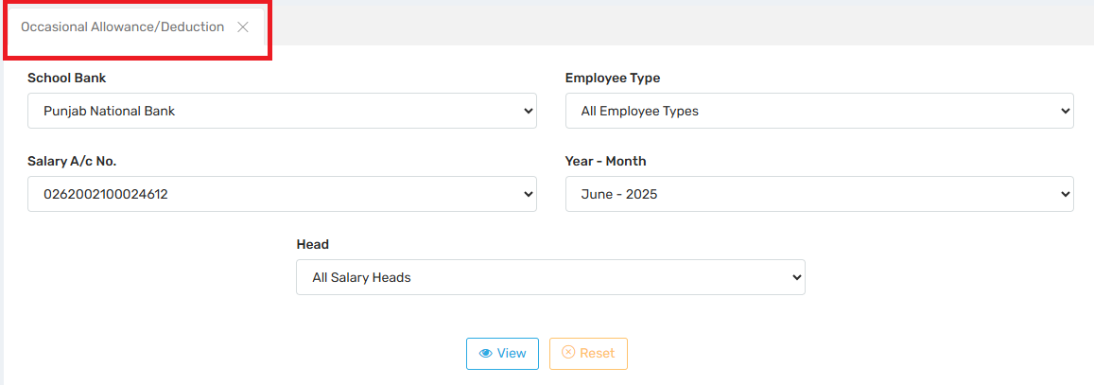This section is used to credit or debit special payments or deductions that are not part of the regular salary structure. These can be incentives, bonuses, penalties, recoveries, etc., that apply only in specific months.
Field Descriptions:
School Bank | Filters employees by the bank account used for salary disbursement (e.g., Punjab National Bank in your screenshot).
Salary A/c No. | Targets employees under a specific salary account number for precise adjustments.
Employee Type | Filters by role category (e.g., Teaching, Admin) to manage entries for specific groups.
Year - Month | Sets the target month for which the occasional payment or deduction will be applied.
Head | Selects the salary component (e.g., Bonus, Festival Advance, Penalty) under which the allowance/deduction will be categorized.

🔧 Key Functionalities
- Temporary Adjustments: Unlike fixed components like Basic Pay or HRA, these are one-time and non-recurring.
- Customized Entries: Can be positive (allowance) or negative (deduction) based on the salary head.
- Employee-Specific or Group-Wise: Adjustments can be made for individuals or entire groups based on filters.

📋 Example Use Cases
- Occasional Allowance:
  - Teacher awarded ₹2,000 for organizing an event.
  - Select Bonus or custom head → Enter amount → Reflected in June salary.
- Occasional Deduction:
  - Admin staff broke school equipment → ₹500 deducted.
  - Select Penalty or similar deduction head → Enter amount → Deducted from net pay.
11.3. Salary Generation: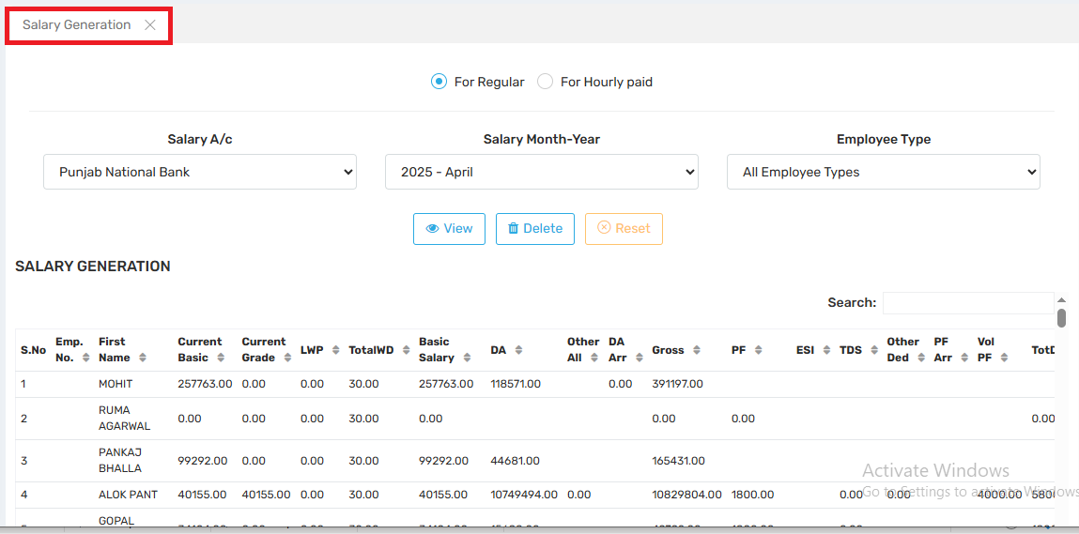 This interface is used to generate, preview, and finalize salary for employees based on predefined salary structures, attendance (LWP), and any occasional allowances/deductions.
For Regular / Hourly Paid Allows switching between monthly salaried (regular) staff and hourly wage employees.
Field Description:
For Regular / Hourly Paid | Allows switching between monthly salaried (regular) staff and hourly wage employees.
Salary A/c | Filters the salary computation based on the bank account used for salary disbursement.
Salary Month-Year | Selects the payroll period for which the salary is being processed (e.g., April 2025).
Employee Type | Filters by roles (e.g., Teaching Staff, Admin Staff) to view salary records group-wise.

View | Previews the generated salary data based on filters.
Delete | Deletes the generated salary sheet for the selected month (use with caution).
Reset | Clears the current selection/filter values.

Workflow
- System pulls fixed salary structure → Basic, DA, HRA, etc.
- Applies variables like LWP, occasional allowances/deductions.
- Calculates gross → Adds all earnings.
- Deducts liabilities → PF, ESI, TDS, loans.
- Generates net salary ready for:
  - Slip printing
  - Bank transfers
  - Ledger updates
11.4. Bank Statement: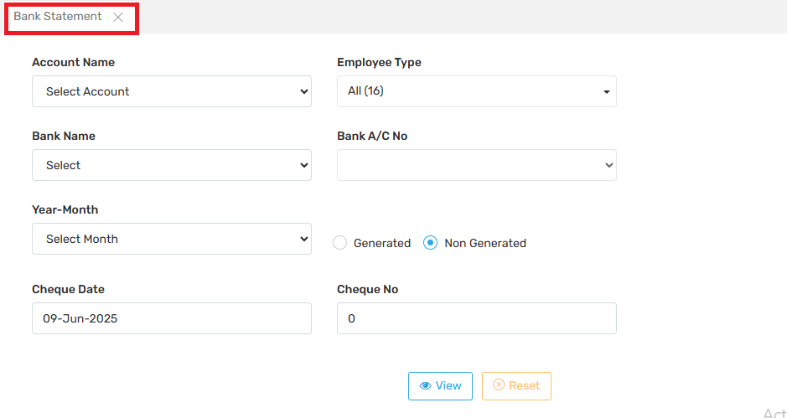 This section generates a bank statement or cheque statement, which is sent to the bank to release salary payments to employees. It acts as a bridge between the payroll system and the banking system.
Field Description:
Account Name | The specific salary account from which payments will be disbursed (usually a current account in the school's bank).
Employee Type | Filter by employee category (e.g., Teaching, Non-teaching, Contractual, etc.) to generate statements only for relevant groups.
Bank Name | Select the bank responsible for executing the salary transfer (e.g., Punjab National Bank).
Bank A/C No | The corresponding bank account number linked to the school from which the funds will be deducted.
Year-Month | Select the salary period (month and year) for which the payment needs to be processed.
Generated / Non Generated | Indicates whether a bank statement for the selected period already exists:
- Generated: Already processed; useful for auditing or rechecking.
- Non Generated: Fresh generation of statements needed for payment. |
| Cheque Date | The date printed on the cheque (or the processing date for electronic transfers). |
| Cheque No | If payment is via cheque, enter the cheque number here (usually 0 for bank transfer or auto-generated cases). |
Workflow:
Step | Description
Step 1: Salary Generation | Salaries are calculated and finalized in the system.
Step 2: Bank Statement | This screen compiles a list of all net payable salaries by employee and generates a bank advice format.
Step 3: Disbursement | The bank statement is shared with the bank for bulk salary credit to individual employee accounts.
Step 4: Confirmation | Once processed by the bank, the status can be marked as "Generated" for records.

11.5.Insurance Statement: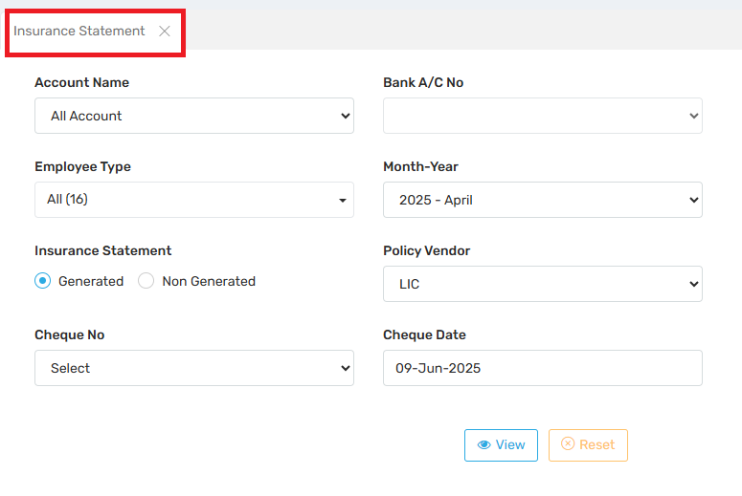 This section is used to generate and track insurance premium statements for staff, which are paid by the school to selected insurance vendors (e.g., LIC, Star Health). It helps schools manage monthly premium payments efficiently and maintain financial transparency.
Field Description:
Account Name | Dropdown to select a particular salary account. If “All Account” is selected, the report will include all salary heads or departments.
Bank A/C No | Select the bank account from which the insurance premium will be or has been paid.
Employee Type | Filter to choose between different employee groups (e.g., teaching, non-teaching, contractual). “All (16)” implies 16 employees included.
Month-Year | Select the month and year for which the insurance premium report is being generated.
Insurance Statement | Choose between:
- Generated – Previously generated statement.
- Non-Generated – To create or view a new, unissued statement.
Policy Vendor Select the insurance provider (e.g., LIC, Star Health) as entered earlier in the “Insurance Vendor” section.
Cheque No Enter the cheque number used for the payment to the insurance vendor.
Cheque Date The date the cheque was issued for the premium payment.
View (Button) Click to generate/view the statement based on selected filters.
Reset (Button) Clears all filters/entries for a fresh start.

11.6. Cheque Statement: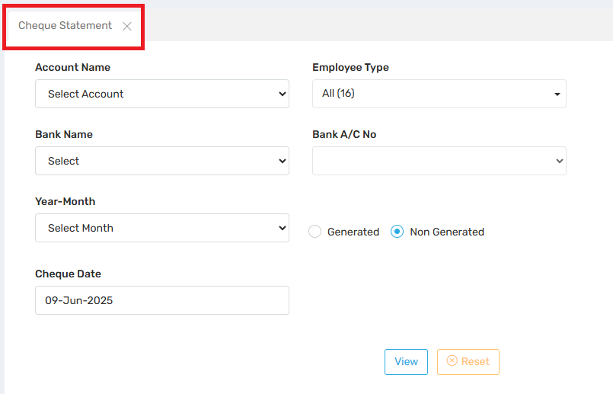 This module allows schools or institutions to:
- Generate a cheque-wise salary payment statement.
- Manage payments for employees from bank transfers.
- Track and document cheque payments for accounting and auditing purposes.
Field Description:
Account Name | The salary disbursement account (like “Staff Salary Account”) from which the payment is made.
Employee Type | Lets you filter by employee group — such as teaching, non-teaching, admin, or all staff.
Bank Name | The bank from which the cheque will be issued (linked with the selected account).
Bank A/C No | The bank account number of the institution issuing the salary cheques.
Year-Month | Select the payroll month for which the cheque payments are being made (e.g., May 2025).
Generated / Non Generated
- Generated: Displays already generated cheque statements.
- Non Generated: For creating a new cheque payment statement.
Cheque Date The date that will appear on the cheque (usually the salary disbursal date).
Workflow:
Step | Function
1. Salary Generation | Payroll is run, including salary calculations for all employees.
2. Payment Mode Filtering | Employees marked for cheque payments are filtered.
3. Cheque Statement Generation | This module compiles the net payable amounts for those employees and prepares a cheque summary.
4. Disbursal | Based on this statement, physical cheques are signed and distributed to employees.
Use Case:

Manual Payment Support | Useful for employees without bank accounts or in special payment cases.
Audit Compliance | Maintains clear records of cheque disbursement per employee.
Flexibility | Allows organizations to manage hybrid payment modes (bank + cheque).

11.7.IT Head Entry: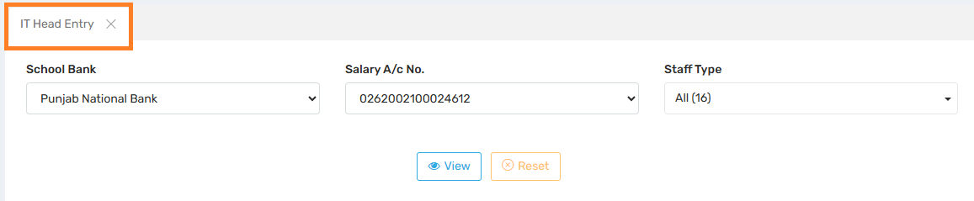 This section is specifically designed to manage and record Income Tax (IT)-related salary head entries for employees. It ensures accurate calculation, deduction, and record-keeping of TDS (Tax Deducted at Source) or other IT deductions as part of the payroll.
Field Description:

Salary Component | Relevance
Earnings | Basic, DA, HRA, Allowances, etc.
Deductions | EPF, ESI, TDS (Income Tax) → This module manages these IT heads.
Net Pay | Earnings - Deductions
This helps in defining or viewing the income tax head data per employee or group, which eventually reflects under deductions in payslips and statutory reports.

Salary Heads Definition | The admin defines the IT Head (e.g., "Income Tax", "TDS") as a deduction in salary structure.

IT Head Entry | Using this screen, IT deductions are applied, updated, or reviewed employee-wise or bulk.

Payslip Generation | The IT amount reflects under deductions in payslips.

Reporting | Used in form-16, TDS returns, and statutory reports.

Use Case:

Tax Compliance | Ensures employees' TDS is properly deducted and recorded.
Payroll Accuracy | Avoids over/under deductions in salary.
Statutory Filing | Forms the base for quarterly/yearly TDS filing and Form-16 generation.

11.8. TDS Entry: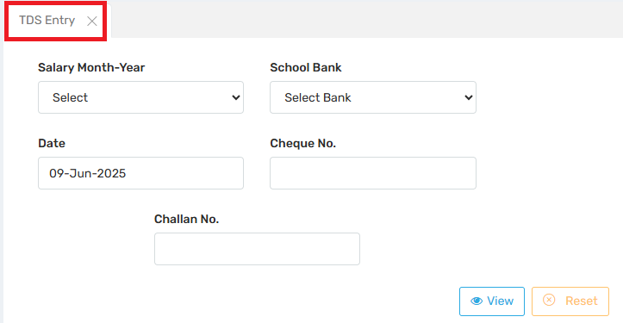 This form is used to record the payment of deducted TDS to the government, ensuring that the organization remains compliant with statutory regulations and that employee TDS deductions are properly mapped against the government Challan/receipt.
Field Description:

Field | Description
Salary Month-Year | Selects the month for which TDS was deducted from employee salaries.
School Bank | The bank account through which the TDS payment was made to the government.
Date | The date on which the TDS was deposited. Pre-filled or manually editable.
Cheque No. | The cheque or transaction number used for depositing TDS. (If online, this could be UTR No.)
Challan No. | The Govt-issued Challan number (e.g., from NSDL portal or TRACES) confirming payment of TDS.
View | Displays existing entries for the given month, bank, etc.
Reset | Clears the form for a fresh entry.

Use Case:
. Salary Processing | TDS is calculated and deducted from employee salaries using the IT Head Entry screen.

2. TDS Entry (this screen) | Admin enters details of the actual payment of TDS to the government using a Challan No. and bank reference.

3. TDS Reporting & Filing | These entries are used for Form-24Q, TRACES portal, and Form-16 generation for employees.

Example Use case:
Suppose:
- Salary for May 2025 is processed, and ₹15,000 is deducted as TDS.
- On 9-June-2025, school deposits ₹15,000 to the government via PNB using cheque no. 09876 and gets Challan No. TDSJUN25/001.
- Admin uses this section to record:
  - Month-Year: May 2025
  - Bank: Punjab National Bank
  - Cheque No.: 09876
  - Challan No.: TDSJUN25/001
  - Date: 09-Jun-2025
This is now stored and referenced during quarterly returns.
11.9. Gratuity Calculations: 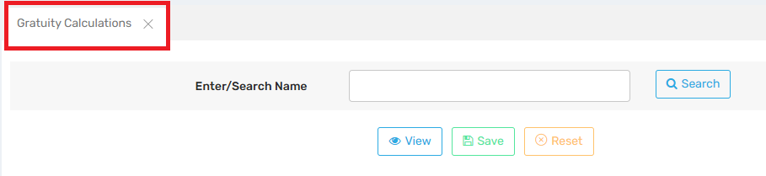This screen allows Payroll Administrators to calculate and view gratuity amounts payable to employees, typically at the time of retirement, resignation, or separation after a minimum period of service (usually 5 years as per Indian law).
Field Description:
Enter/Search Name | You can enter the name of the employee to retrieve their payroll and service data.
Search | Pulls up the employee record, including joining date, last salary, and duration.
View | Displays gratuity calculation details based on fetched data.
Save | Saves the gratuity details in the system for future reference and auditing.
Reset | Clears the form to allow for a new search or re-entry.

Use case:
1. Service Completion/Exit | Gratuity is triggered when an employee completes 5+ years of service.
2. Payroll Reference | The last drawn salary is pulled from the payroll database.
3. Gratuity Calculation | This module calculates the eligible gratuity payout.
4. Disbursement | Based on this output, finance processes and releases the gratuity amount.
5. Audit/Report | The saved data helps in compliance, audits, and employee exit records.
Example Use Case:
- Employee: Rakesh Sharma
- Last Drawn Salary (Basic + DA): ₹40,000
- Years of Service: 8 years
Gratuity = (40,000 × 15 × 8) ÷ 26 = ₹1,84,615.38
This amount will be calculated and stored using this module for further payment and record.
11.10. Bonus Calculations: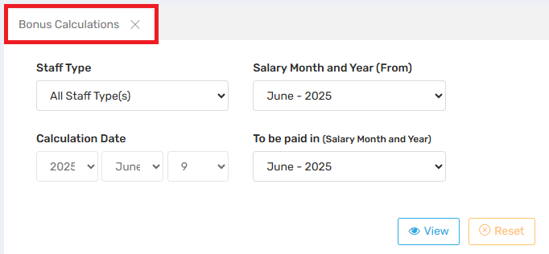 This feature is used for calculating, reviewing, and planning bonus disbursements for staff members.
Field Description:
Staff Type | Choose specific categories like Teaching, Non-Teaching, Admin, etc., or select "All Staff Type(s)".
Salary Month and Year (From) | Sets the start month from which salary data should be considered for bonus calculation (e.g. annual performance bonus based on June 2025–May 2026).
Calculation Date | Specifies the exact date the system should use for computing eligibility and amounts. Useful for audit trail.
To be Paid in (Salary Month and Year) | Selects the payroll cycle/month when the bonus should be credited to employees' accounts.
View | Displays a calculated list of employees with their eligible bonus amounts before saving or processing.
Reset | Clears all selected fields for a new entry.

Example Use Case
Scenario:
- Admin wants to give a 10% annual bonus to all staff for the year ending June 2025.
- Staff Type: All
- Salary From: June 2024
- Bonus Paid In: June 2025
- Calculation Date: 09-June-2025
Process:
This section allows admin to view and verify the eligible bonus amounts. Once confirmed, bonuses can be paid in June 2025 payroll.
11.11. Increment:
11.11.i. Auto Increment: 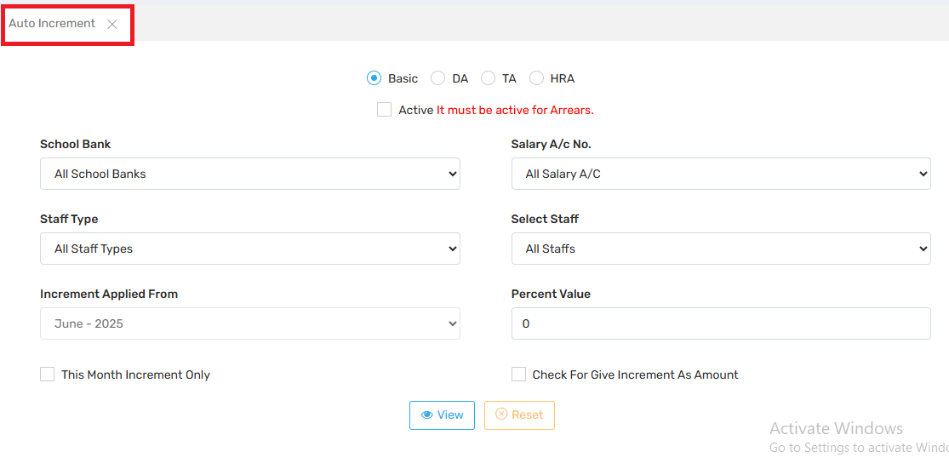This feature allows payroll departments to:
- Apply bulk or individual salary increments.
- Automate salary adjustments without editing each employee profile manually.
- Control which component of salary the increment applies to (e.g., Basic only).
- Configure arrears in case of backdated increments.

Field | Function
Basic / DA / TA / HRA (Radio buttons) | Select which salary component to apply the increment to. Most increments are on the Basic pay.
Active (Checkbox) | Must be checked if arrears are to be calculated and disbursed for backdated increments.
School Bank | Choose the bank account linked to the school for filtering staff by bank. Useful in multi-bank setups.
Salary A/c No. | Filters staff by salary account number. Normally set to "All" unless targeting specific accounts.
Staff Type | Apply increment to a specific type (e.g., Teaching, Non-Teaching) or all.
Select Staff | Apply to all or selected individuals.
Increment Applied From | The effective month and year from which the increment should reflect in salary.
Percent Value | Enter the percentage by which the chosen component (e.g., Basic) should be increased.
This Month Increment Only (Checkbox) | Applies the increment only for the selected month, not permanently updating salary structure.
Check For Give Increment As Amount | Instead of % increase, input a flat amount-based increment (e.g., ₹2000 more in Basic).
View | Displays the increment preview before applying.
Reset | Clears all selected inputs.

Use Case:
Basic / DA / TA / HRA | Directly updates the corresponding component in the salary structure.
Gross Pay | Adjusted based on new component values.
Statutory Deductions (e.g., PF, ESIC) | May increase if they are based on Basic.
Payslip | Shows revised salary from the effective month onward.

Use Case Example:
Scenario:
Management decides to increase the Basic Pay of all teaching staff by 10% starting from June 2025.

Inputs:
- Component: Basic
- Staff Type: Teaching Staff
- Increment Applied From: June 2025
- Percent Value: 10
- Active: ✅ (if arrears are to be generated)
When executed, the system:
- Calculates 10% of current Basic for each eligible staff.
- Updates their Basic salary in the structure.
- Reflects the change in June's payroll.
- Optionally calculates arrears if the increment is declared late.

11.11.ii. Increment Rollback: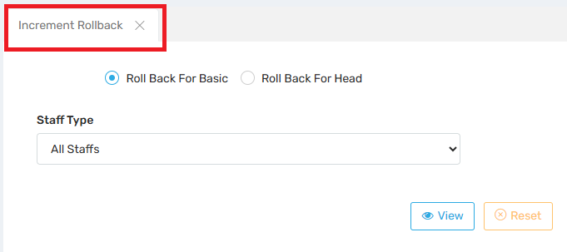 This section is used to undo or reverse previously applied salary increments for staff.
Field Description:
Roll Back for Basic (Selected) | Reverts the Basic salary back to its value before the last increment. Useful when basic pay increments are rolled back.
Roll Back for Head | Allows rollback for a specific salary head/component, like DA, HRA, TA, etc., rather than just Basic.
Staff Type | Filters which group of employees the rollback should apply to (e.g., Teaching, Admin, etc.). “All Staffs” means it will apply across all employees.
View Button | Displays a preview list of staff with their current incremented salary and the salary it will roll back to.
Reset Button | Clears selections and resets the form.

📍 Use Case:

Let’s say a 10% increment was applied to Basic pay of all teaching staff in June 2025, but it was either premature or incorrect.

With This Rollback:
- The Basic salary will be reverted to what it was before June 2025.
- All dependent values (e.g., PF, Gross Pay) may also update accordingly if they are linked to Basic.
- If arrears had been generated for the increment, those may also need to be manually reversed or adjusted via another module.
⚠️ Important Tips
- Always preview using the View button before executing rollback.
- If staff had already been paid based on incremented values, arrears adjustments may need to be done separately.
- Check if rollback affects statutory deductions or net pay and inform the finance team accordingly.

11.12. Staff Salary Structure: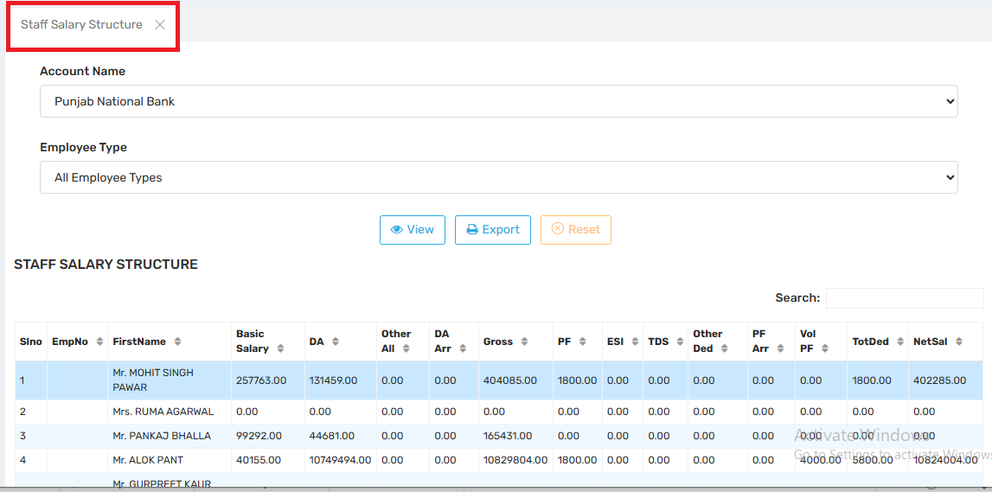 It allows administrators to view, verify, and export detailed salary breakdowns for all staff associated with a specific bank account and employee type.
Field Description:
Account Name | Filters staff by the bank account they are mapped to (e.g., Punjab National Bank). Useful for batch salary transfers.
Employee Type | Filters by type (e.g., Teaching, Admin, Support Staff). “All Employee Types” shows every employee.

Use Cases :

✅ Final salary verification before generating payslips or salary transfers.
- ✅ Audit and compliance checks for individual salary components.
- ✅ Exporting salary structure for bank uploads or department reports.
- ✅ Troubleshooting discrepancies in Net Salary or Deductions.

⚠️ Important Note:
- Zero salaries may indicate inactive employees, pending assignments, or new joiners not yet configured.

11.13. Generate Salary Status: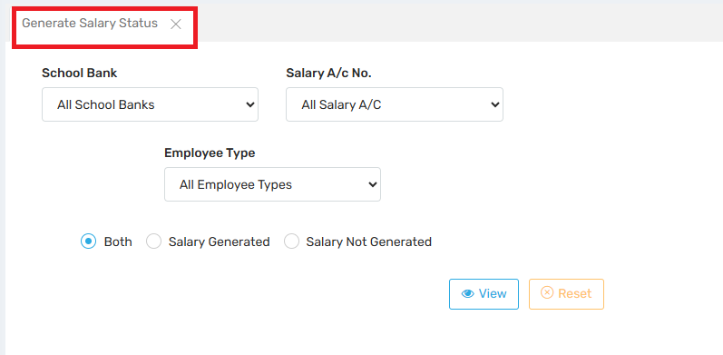 This section is used to monitor the salary generation status for all or specific employees before processing payroll disbursement or running final payroll reports.
Field Description:
School Bank | Filters employees by the school’s mapped bank (e.g., Punjab National Bank, SBI, etc.). Useful if different banks are used for different staff groups.
Salary A/c No. | Filters further by the specific salary account (in case of multiple accounts in the same bank).
Employee Type | Lets you view only certain types of employees (e.g., Teaching, Admin, Support Staff) or all of them.
Status Option:  🔘 Both  🔘 Salary Generated  🔘 Salary Not Generated | - Both: Shows all employees regardless of salary status.  - Salary Generated: Shows only employees for whom salary has been processed this month.  - Salary Not Generated: Identifies employees who were skipped or pending during the salary run (very useful for error correction).

🔍 View | Displays a list of employees with their salary generation status based on selected filters.
🔄 Reset | Clears all selected filters and resets the view.

🛠️ Use Cases
- ✅ Verify Salary Processing: Before final disbursement, ensure salaries are generated for all staff.
- ⚠️ Error Identification: Quickly spot employees who might have been left out of the payroll run.
- 🔄 Follow-Up: Allows admin to go back and generate pending salaries before month-end closing.
- 📊 Bank-Wise Reports: Helps in preparing bank-specific salary transfer sheets.

11.14. Daily Wages Attendance: 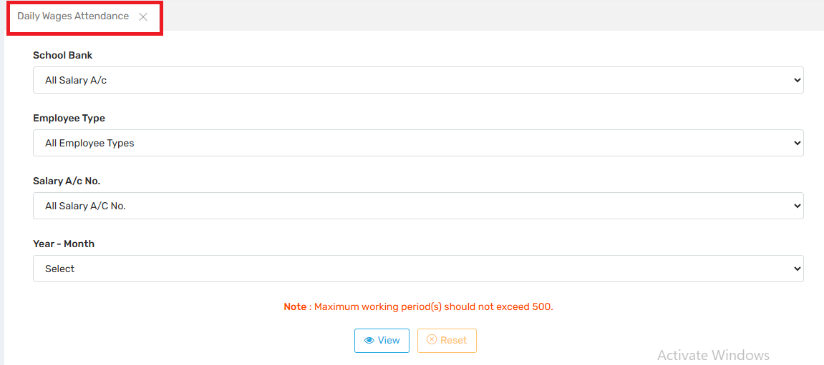This section is used to manage and track the attendance of daily wage employees, whose salaries are calculated based on the number of days they worked rather than a fixed monthly pay.
Field Description:
School Bank | Filters employees based on the school bank linked to their payroll.
Employee Type | Filters data by specific types of employees (e.g., Contractual, Daily Wagers, Admin Support).
Salary A/c No. | Further filters employees by their specific salary account number.
Year – Month | Selects the target month and year for which the daily wage attendance data is to be viewed or updated.

🛠️ Use Cases:

✅ Attendance-Based Salary Calculation: Attendance from here feeds directly into the salary module.

📉 Cost Monitoring: Helps monitor how many days daily wage employees have worked — directly tied to monthly expenditures.

📋 Auditing & Validation: Useful for reconciling attendance data with biometric or manual logs.

⚠️ Error Prevention: Avoids salary generation errors by showing attendance gaps.

⚠️ Important Note:

"Maximum working period(s) should not exceed 500"
- This message is a validation rule.
- It ensures that the total number of attendance entries (or working days across multiple employees) does not exceed 500 records in one query.
- Useful for system performance and avoiding data overload.
12. Salary Reports:
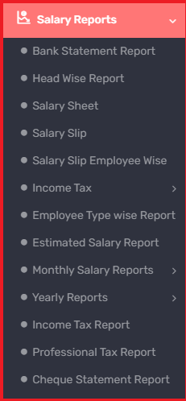
This section provides access to various reports that are essential for salary processing, auditing, statutory compliance, and financial planning.
Bank Statement Report | This module generates official salary transfer letters addressed to the bank, directing it to disburse salary payments into employees’ bank accounts. It's used primarily for salary processing via cheque or bank transfer.

Head Wise Report | Breaks down salary components (Basic, HRA, DA, PF, etc.) for each employee or department. Useful for analyzing how salary expenses are distributed.

Salary Sheet | A consolidated report showing all salary details — basic pay, allowances, deductions, net salary — for selected employees in a given month.

Salary Slip | Allows download or printing of individual salary slips.

Salary Slip Employee Wise | Enables viewing/generation of salary slips filtered by specific employees. Useful for resolving salary queries.

Income Tax ⏵ | Contains sub-options like:

TDS Entry Report
- Purpose: To view or enter employee-wise TDS (Tax Deducted at Source) deductions.
- Functionality:
  - Displays the amount of TDS deducted each month.
  - Can be used for internal verification or correction before submission.
  - Basis for quarterly and annual TDS filing.
📅 2. Quarterly Form 24Q
- Purpose: Generate Quarterly TDS Return (Form 24Q).
- Functionality:
  - Required to be filed with the Income Tax Department.
  - Covers salary payments and TDS deductions on a quarterly basis.
  - Includes PAN, deduction amounts, challan details.
📑 3. TDS 24Q
- Purpose: View or export detailed employee-wise data related to TDS Form 24Q.
- Functionality:
  - Data grouped by quarter and employee.
  - Used for compiling official quarterly submissions.
📄 4. Gross Form 16
- Purpose: Preview the gross version of Form 16 before finalizing.
- Functionality:
  - Summarizes employee salary, deductions, exemptions, and TDS.
  - Used for verification before issuing the final Form 16.
📂 5. Form 16
- Purpose: Generate official Form 16, the annual TDS certificate.
- Functionality:
  - Issued to employees for income tax filing.
  - Includes all components: salary earned, deductions, taxable income, and TDS deducted and deposited.
  - Can be downloaded and printed from here.
📊 6. TDS Report
- Purpose: Summary report of TDS deducted and deposited for all employees.
- Functionality:
  - Shows month-wise or employee-wise TDS figures.
  - Useful for accounts audit and compliance tracking.
  - Often used for reconciliation with challan deposits.

Employee Type Wise Report | Generates salary reports grouped by employee categories (e.g., Teaching, Admin, Contractual). Helps in departmental budgeting.

Estimated Salary Report | Predicts upcoming salary payments based on current data (attendance, increments, etc.) — useful for budget planning.

Monthly Salary Reports ⏵ | Detailed monthly breakdown of salaries. Options often include month-wise comparisons, attendance linkages, etc.

Yearly Reports ⏵ | Summarizes total salary disbursed per employee over the year — often used in audits, annual reviews, and tax filing.

Income Tax Report | Generates cumulative tax deduction statements per employee — useful for statutory compliance and employee proofing.

Professional Tax Report | Lists PT deductions made from employees, state-specific. Essential for PT filing and audit trails.

Cheque Statement Report | Lists payments made by cheque instead of direct bank transfer — useful for handling exceptions or manual payments.
13. Reports:
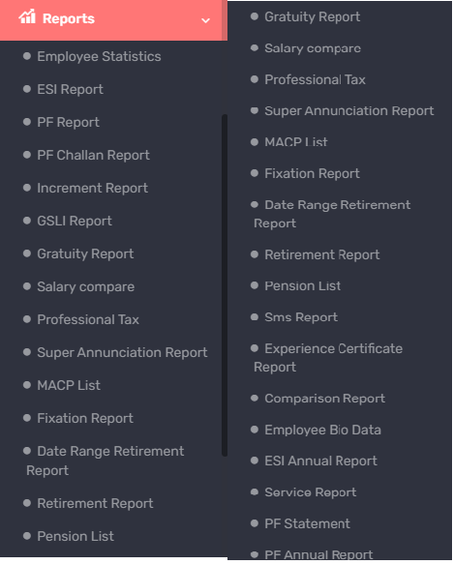
These reports are mainly related to statutory compliance, employee lifecycle events (retirement, gratuity, pension), and financial/statistical analysis. Below is a detailed explanation of each report and its functionality:
Employee Statistics | Provides a summary of all employees, categorized by department, designation, gender, etc. Useful for HR analytics.

ESI Report | Lists contributions and deductions under the Employee State Insurance scheme. Required for statutory filings.

PF Report | Details Provident Fund deductions per employee. Tracks employee and employer contributions.

PF Challan Report | Generates PF challans required for monthly filing to EPFO. Includes UAN, wages, and amounts.

Increment Report | Shows history and schedule of employee salary increments — useful for planning and audit.

GSLI Report | Generates the Group Savings Linked Insurance report showing premium deductions and coverage.

Gratuity Report | Calculates gratuity liabilities based on employee tenure and last drawn salary. Useful for retirement planning and statutory compliance.

Salary Compare | Compares salary structures or amounts across different periods, departments, or employees. Helpful in cost analysis.

Professional Tax | Shows PT deductions employee-wise or department-wise. Needed for PT returns.

Super Annuation Report | Lists employees under the superannuation scheme and contributions made.

MACP List | Displays employees eligible for Modified Assured Career Progression benefits. Typically for govt. or aided institutions.

Fixation Report | Shows salary revision/grade pay fixation details. Important during pay commission changes.

Date Range Retirement Report | Lists employees retiring within a specific date range. Useful for succession planning.

Retirement Report | Gives a comprehensive view of upcoming and past retirements.

Pension List | Lists retired employees receiving pension. Includes details like amount, bank, and eligibility.

SMS Report | Shows logs of SMS notifications sent from the payroll module (e.g., salary alerts, PF updates).

Experience Certificate Report | Generates ready-to-print experience certificates for employees leaving the organization.

Comparison Report | Used to compare two types of data — for instance, planned vs actual salary, two different time periods, etc.

Employee Bio Data | Provides full biodata of employees: personal, professional, and employment details.

ESI Annual Report | Compiles annual data related to ESI deductions and benefits.

Service Report | Lists details of an employee's service history: joining date, designations, leaves, etc.

PF Statement | Generates individual employee PF statements for any selected date range.

PF Annual Report | Consolidated report of PF deductions and contributions for all employees in a financial year.

