Timetable Module-

Relation Master-

1. Timetable Global Setting
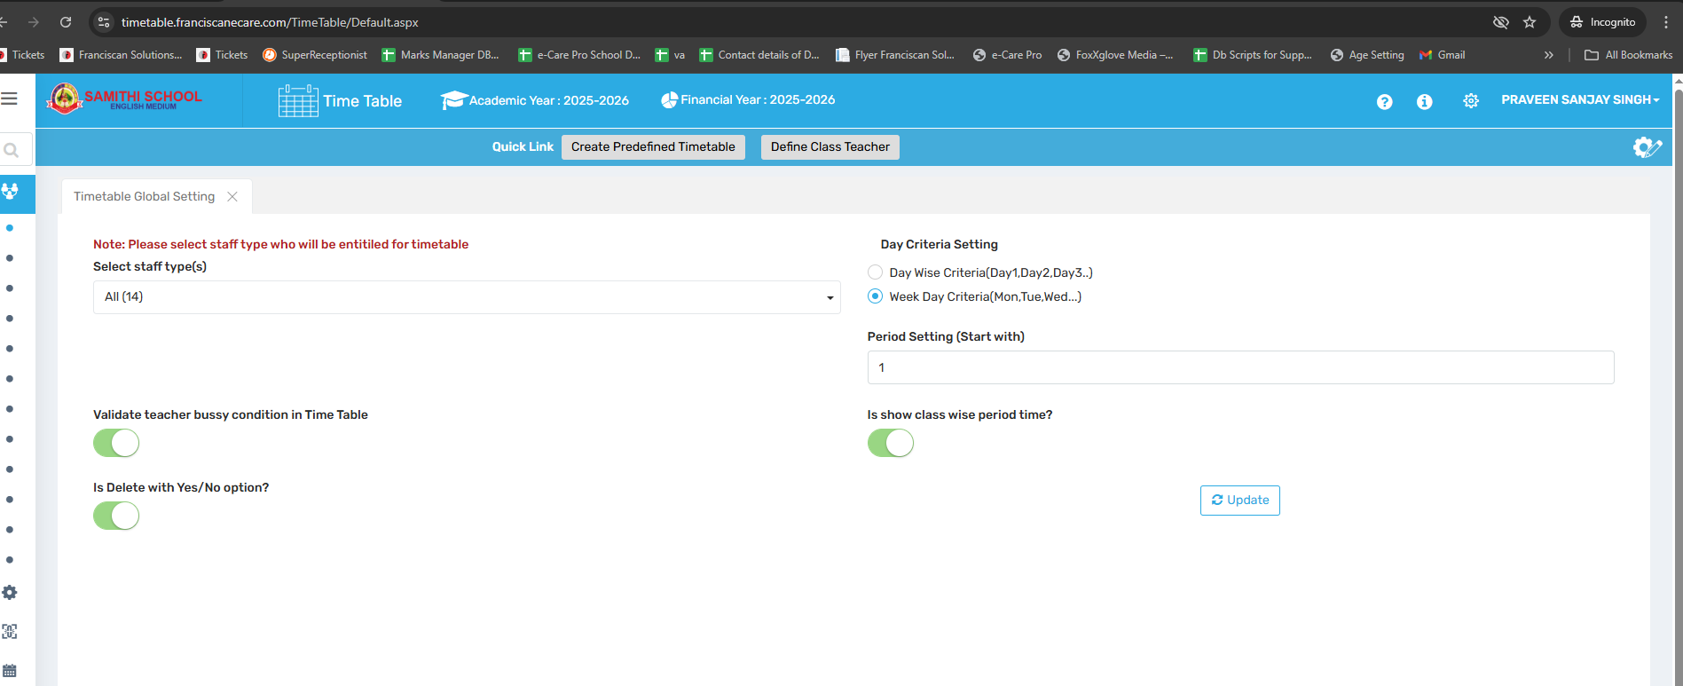

🎯 Purpose
To configure foundational settings for timetable generation such as staff type, day format, period numbering, and teacher availability.

📍 Navigate to:
Time Table Module → Relation Master → Timetable Global Setting

Field Description
- Select staff type(s): Enables selection of staff categories (e.g., Teaching, Non-Teaching) for whom the timetable is to be created.
- Day Criteria Setting: Allows the format of days in the timetable—Day Wise (Day 1, Day 2) or Weekday Wise (Mon, Tue, etc.).
- Period Setting (Start with): Defines whether period numbering begins at 0 or 1.
- Validate teacher busy condition: Prevents double-booking by checking if a teacher is already assigned in a given period.
- Show class-wise period time: Enables configuration of custom period times per class.
- Is Delete with Yes/No option?:

✅ Use Case
- Customize timetable format and scheduling logic
- Set up school-specific period or day logic
- Prevent overlapping assignments for teachers

⚠ Important Notes
- Changes affect timetable structure for the selected academic year
- Improper settings may result in incorrect auto-generation behavior
- Applies per academic session, not globally

2. Teacher Setting
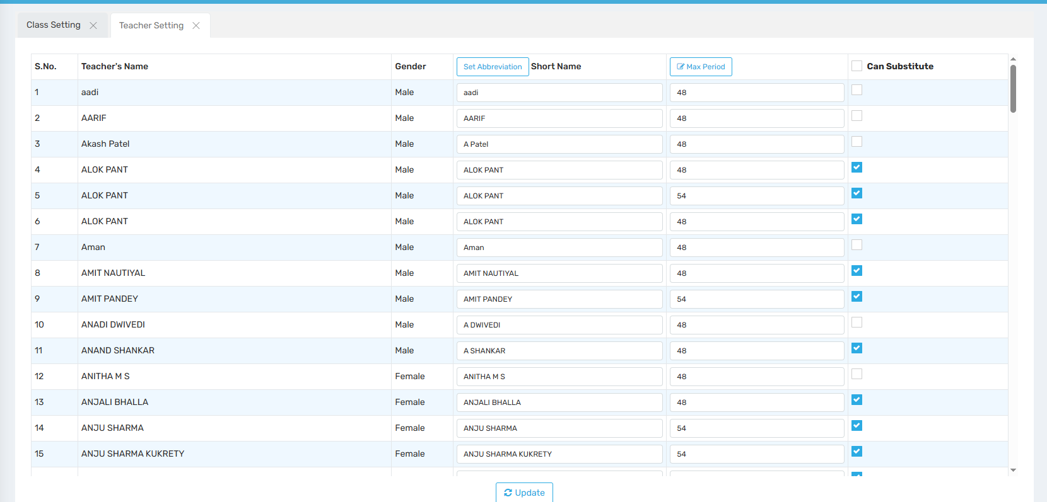

🎯 Purpose
To define teacher workload limits and substitution rules.

📍 Navigate to:
Time Table Module → Relation Master → Teacher Setting

Field Description
- Maximum number of periods: Sets a limit on how many periods a teacher can be assigned.
- Teacher substitution settings: Enables or configures teacher substitution handling.

✅ Use Case
- Ensure fair teacher workload distribution
- Handle temporary teacher absences without disrupting classes

⚠ Important Notes
- Exceeding the maximum limit may be restricted during timetable generation
- Substitution logic must be pre-defined for auto-generation to consider it

3. Class Setting
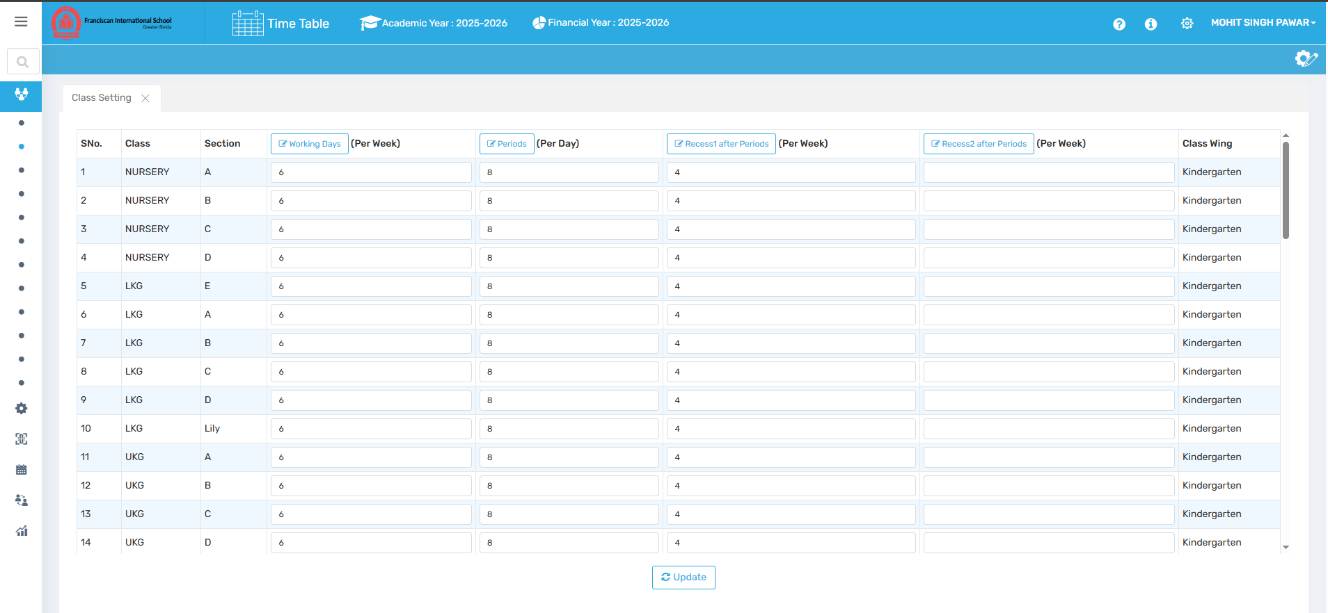

🎯 Purpose
To set class-wise rules like working days and number of periods per day.

📍 Navigate to:
Time Table Module → Relation Master → Class Setting

Field Description
- Class-wise working days: Specify which days a class has sessions (e.g., Mon–Fri).
- Number of periods per day: Set total periods each day for a class.
- Periods after recess: Define how many periods are conducted post-recess.

✅ Use Case
- Create lighter schedules for junior classes
- Tailor daily schedules based on class requirements

⚠ Important Notes
- Inconsistent settings across classes may cause generation issues
- Must align with overall school policy

4. Define Subject
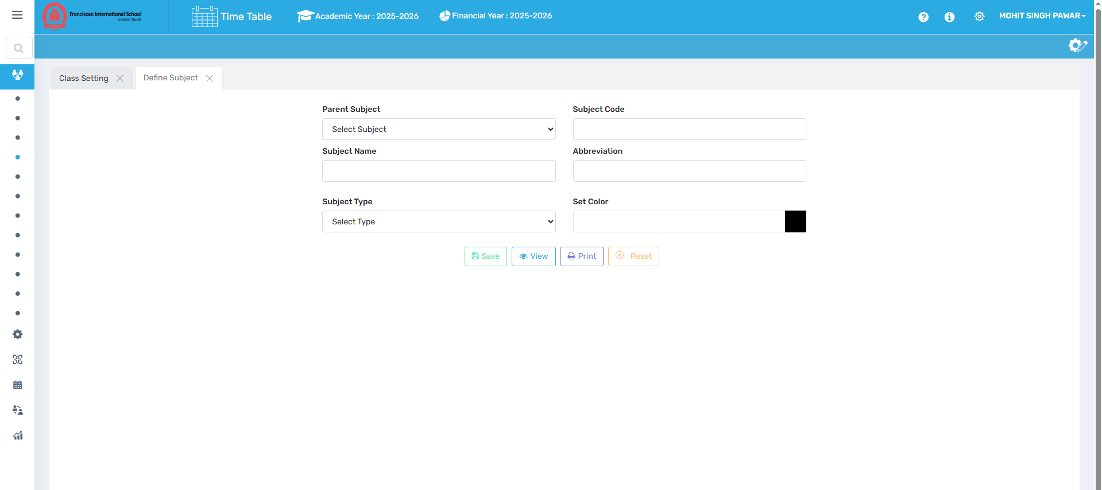

🎯 Purpose
To create and define all subjects offered by the school.

📍 Navigate to:
Time Table Module → Relation Master → Define Subject

Field Description
- Parent Subject: The broad subject category (e.g., Science).
- Subject Name / Code / Abbreviation: Full subject name, short code, and abbreviated name.
- Subject Type: Classifies subject as core, elective, etc.
- Color Code: Assigns a color to the subject for easy identification in timetables.

✅ Use Case
- Organize subjects clearly for different classes
- Make subject blocks visually distinct in the timetable

⚠ Important Notes
- Subject code must be unique
- The subject structure directly affects period allotment and reporting

5. Assign Subject to Class
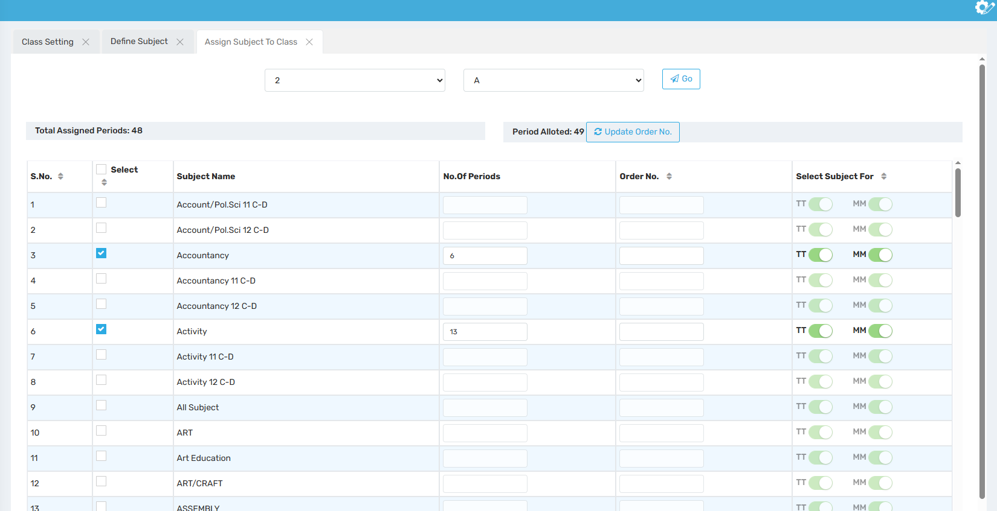

🎯 Purpose
To allocate subjects and define their weekly period counts for each class.

📍 Navigate to:
Time Table Module → Relation Master → Assign Subject to Class

Field Description
- Class Selection: Choose which class to assign subjects to.
- Subject Assignment: List of subjects to be linked to the class.
- Period Allocation: Assign weekly number of periods per subject.

✅ Use Case
- Customize subject load based on grade level
- Ensure proper allocation of teaching time

⚠ Important Notes
- Period count must match school policy and subject weightage
- All subjects should be assigned before generating the timetable

6. Period Allotment
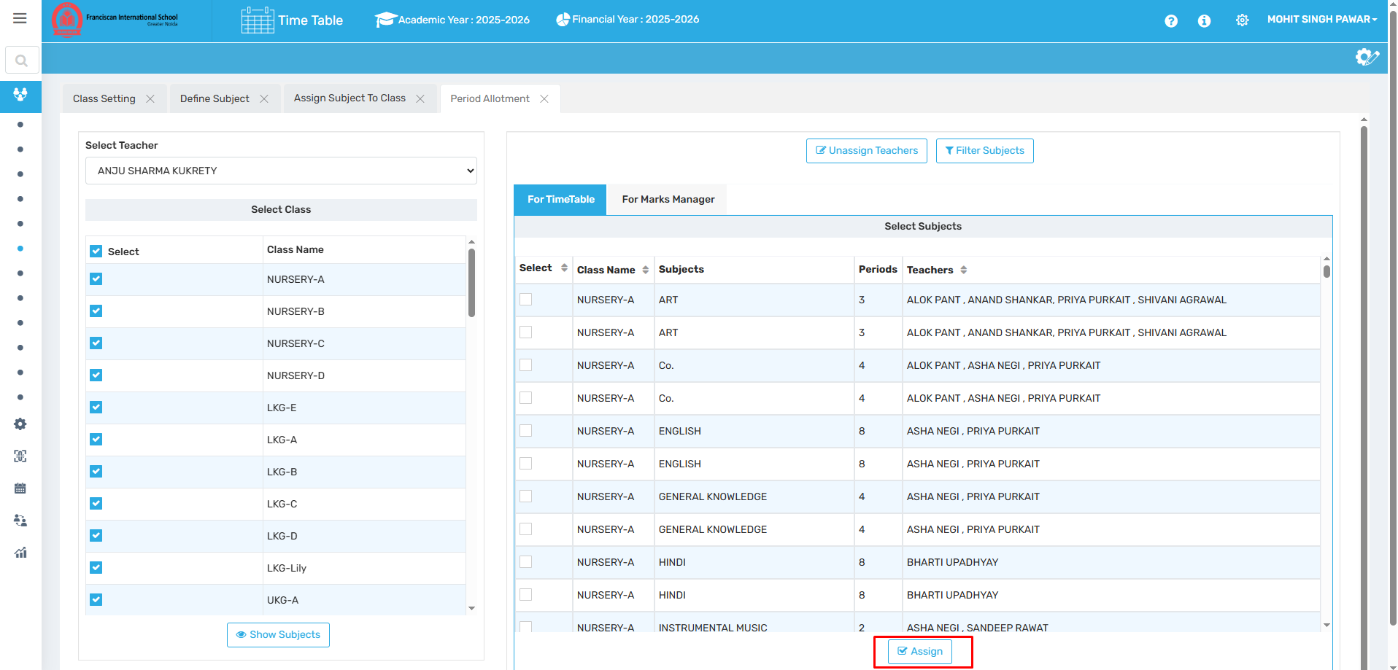

🎯 Purpose
To assign specific subjects and classes to teachers, ensuring balanced distribution of workload.

📍 Navigate to:
Time Table Module → Relation Master → Period Allotment

Field Description
- Assign Classes & Subjects to Teachers: Link a subject and class combination to a specific teacher.
- Modify Assignments: Change or update previously assigned periods or teacher allocations.

✅ Use Case
- Allocate subjects to teachers as per expertise
- Make dynamic adjustments during the academic year

⚠ Important Notes
- Accurate assignments are crucial before timetable generation
- Overlapping assignments may trigger validation errors

7. Define Resource
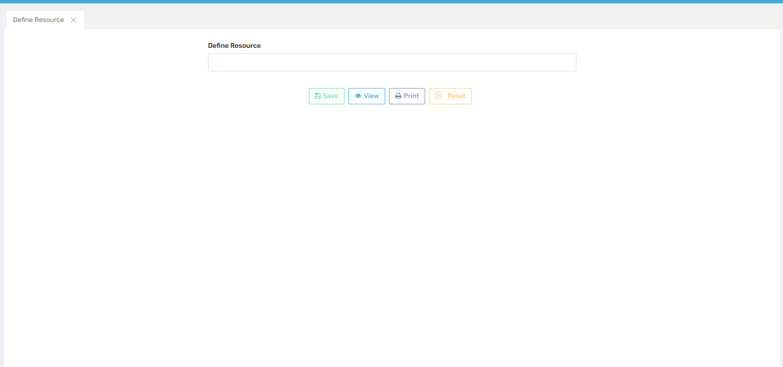

🎯 Purpose
To define physical or digital resources (e.g., labs, equipment) required for teaching specific subjects.

📍 Navigate to:
Time Table Module → Relation Master → Define Resource

Field Description
- Resource Name: Input the name of the resource (e.g., Chemistry Lab).
- Resource Type/Category: Classify the type of resource.
- Availability Details: Define resource availability if applicable.

✅ Use Case
- Ensure resource-based subjects (e.g., lab sessions) are properly scheduled
- Prevent scheduling conflicts for shared resources

⚠ Important Notes
- All resources must be created before linking them to subjects
- Conflicts may arise during auto-generation if the same resource is double-booked

8. Relate Resource to Subject
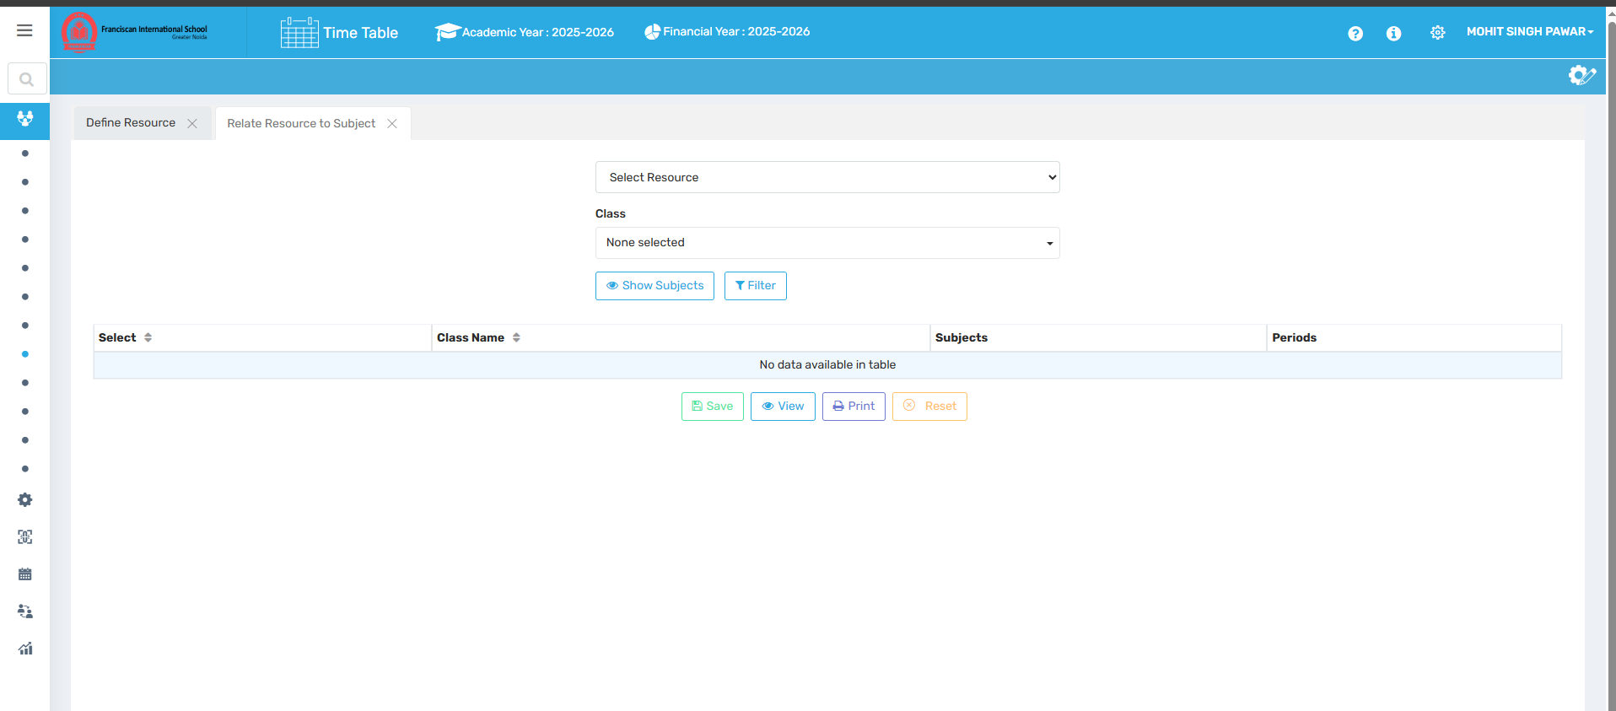

🎯 Purpose
To link predefined resources (e.g., Labs, Projectors) to specific subjects and classes.

📍 Navigate to:
Time Table Module → Relation Master → Relate Resource to Subject

Field Description
- Select Resource: Choose the defined resource to associate.
- Choose Classes: Select one or more classes that use the resource.
- Save Configuration: Save the subject-resource relationship.

✅ Use Case
- Automatically reserve labs when science periods are scheduled
- Prevent overlapping use of limited equipment

⚠ Important Notes
- Ensure subjects needing special resources are properly linked
- Unlinked resources won’t be reflected in the timetable

9. Define Class Teacher
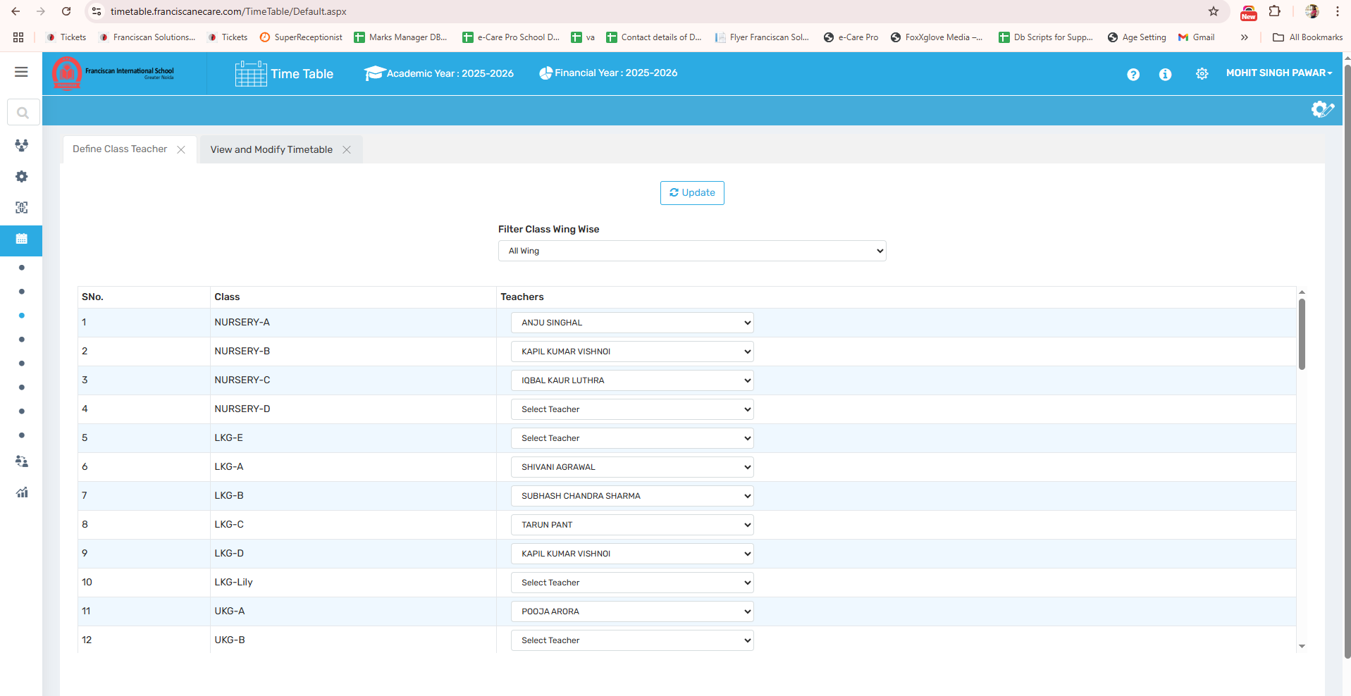

🎯 Purpose
To assign a designated teacher as the class teacher for each section.

📍 Navigate to:
Time Table Module → Relation Master → Define Class Teacher

Field Description
- Select Class & Section: Choose the class-section combo.
- Assign Teacher: Pick a teacher to be the class teacher.

✅ Use Case
- Enable administrative responsibility assignment
- Required for substitution and teacher-wise reports

⚠ Important Notes
- Only one class teacher can be assigned per section
- Ensure no duplicate class teacher entries

10. Class Teacher Subject
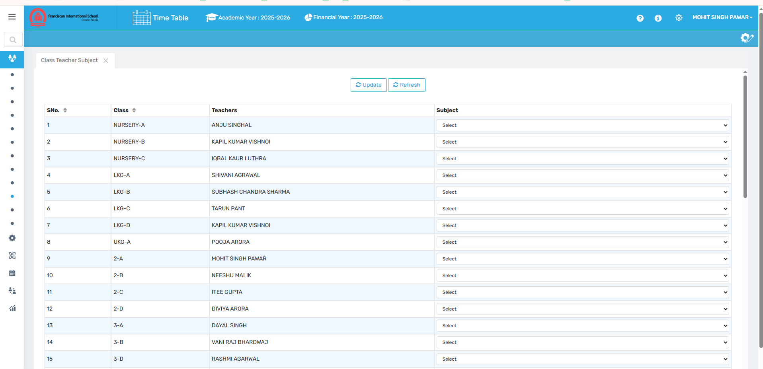

🎯 Purpose
To assign a specific subject to the class teacher, typically the subject they are responsible for teaching.

📍 Navigate to:
Time Table Module → Relation Master → Class Teacher Subject

Field Description
- Select Class & Teacher: Choose from defined class teachers.
- Assign Subject: Allocate the primary subject the class teacher handles.

✅ Use Case
- Common in primary or integrated teaching roles
- Enables subject tracking for class teachers

⚠ Important Notes
- Subject must already be defined and assigned to the class
- Class teacher’s subject must align with period allotment

11. Period Time Setting
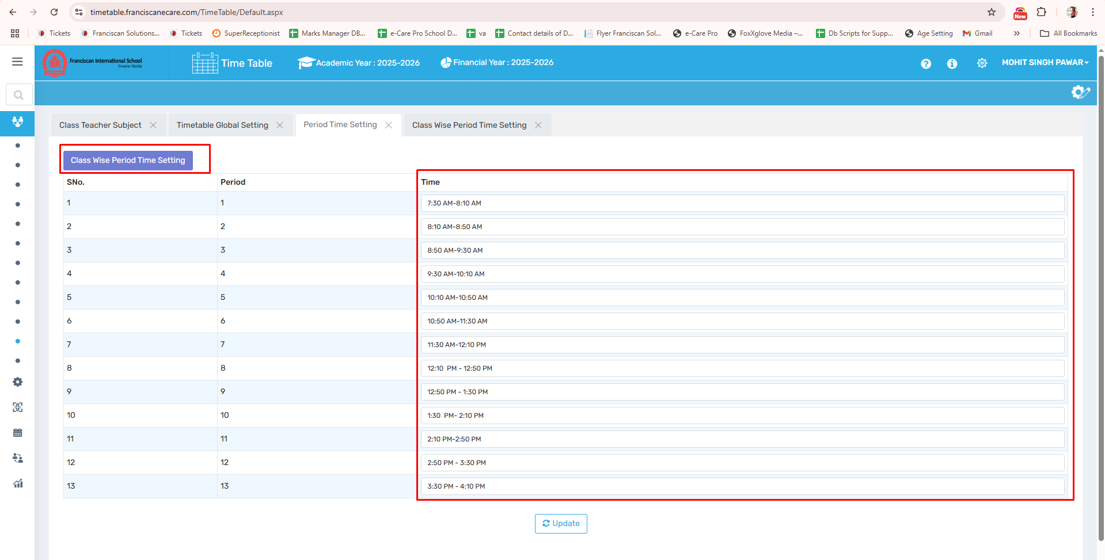

🎯 Purpose
To configure default and class-specific time slots for each period in the timetable.

📍 Navigate to:
Time Table Module → Relation Master → Period Time Setting

Field Description
- General Period Time: Define time slots for periods (e.g., 9:00–9:40 AM).
- Class-Wise Period Time: Customize period durations for specific classes.

✅ Use Case
- Assign longer periods for senior or lab-based classes
- Reflect real-time scheduling in printed timetables

⚠ Important Notes
- Time settings affect visibility in reports and schedule view
- Changes impact period conflict validation logic

12. Period Allotment (New)

Mater Settings-

1. Change Academic Year
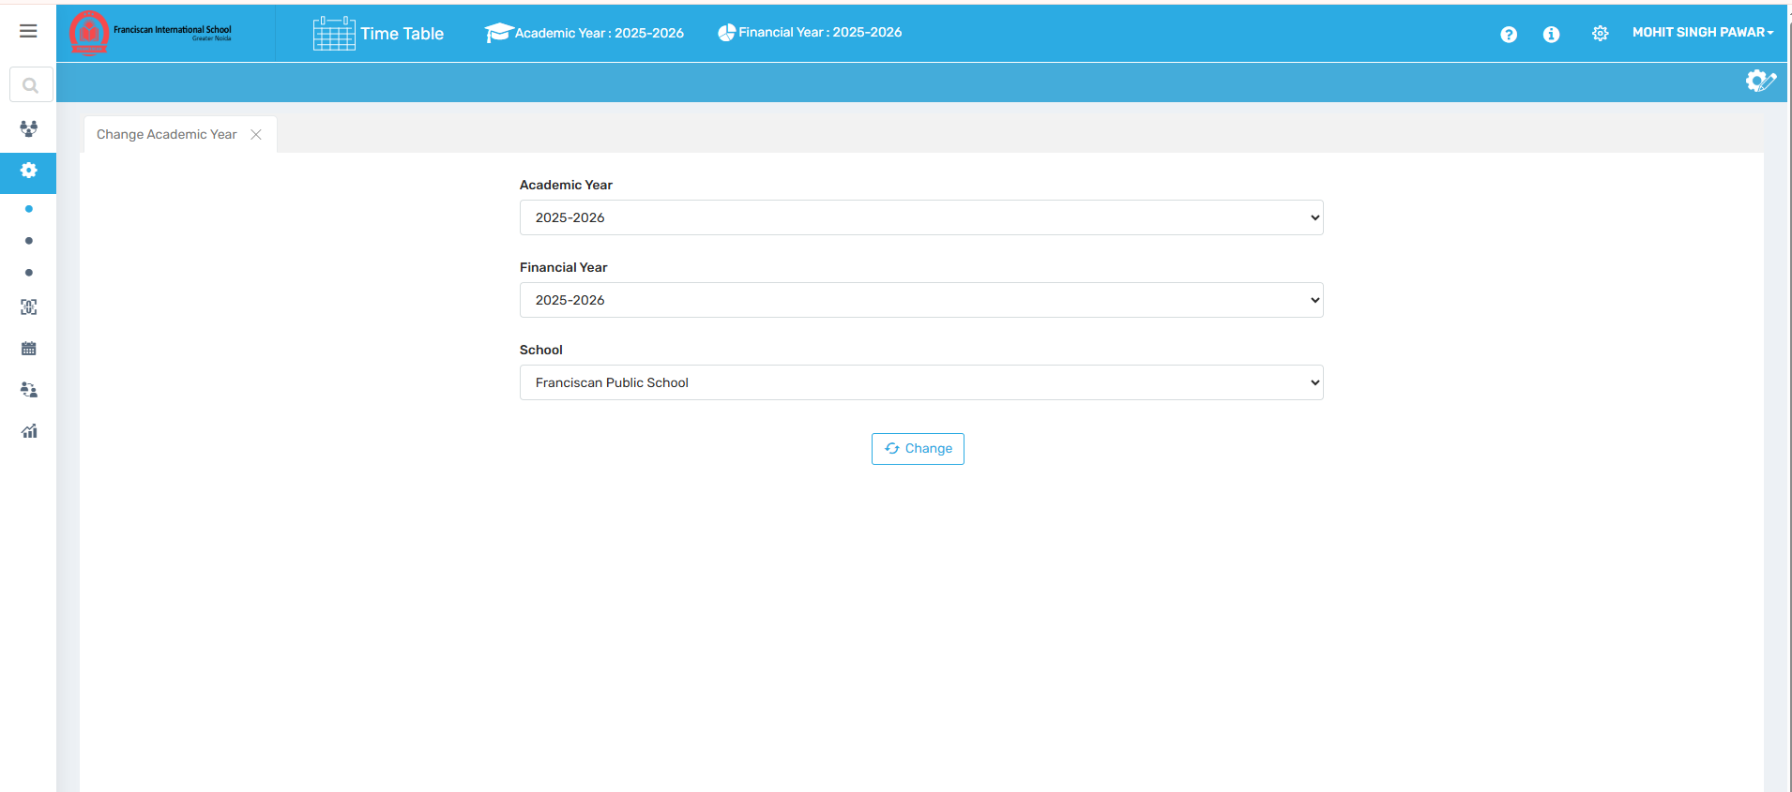

🎯 Purpose
To switch the working academic year for viewing or editing previous or upcoming timetables.

📍 Navigate to:
Time Table Module → Master Setting → Change Academic Year

Field Description
- Academic Year Selector: Dropdown or button to switch between available academic years.
- Apply Changes: Button to confirm and apply the selected year for the session.

✅ Use Case
- View past timetables for reporting
- Plan upcoming year’s schedule without affecting current data

⚠ Important Notes
- Changes are session-specific and may reset upon logout
- Does not affect global software settings unless stored per profile

2. Quick Link
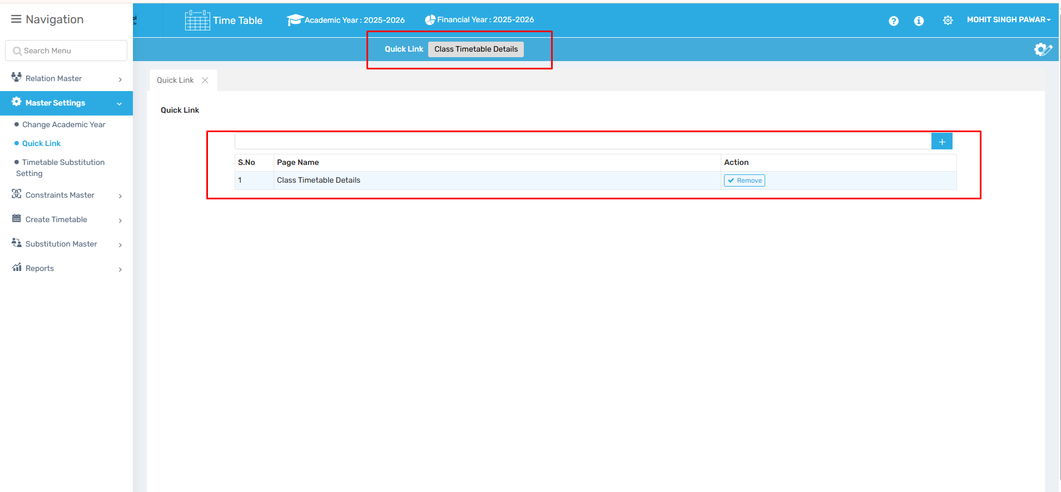

🎯 Purpose
To create shortcuts for frequently used timetable pages or modules.

📍 Navigate to:
Time Table Module → Master Setting → Quick Link

Field Description
- Add Page Link: Choose a page to bookmark for quick access.
- Remove Page Link: Delete previously saved links.

✅ Use Case
- Speed up access to commonly used functions
- Helpful for admins managing multiple tasks

⚠ Important Notes
- Quick links are user-specific
- No impact on timetable data or configuration

3. Timetable Substitution Setting
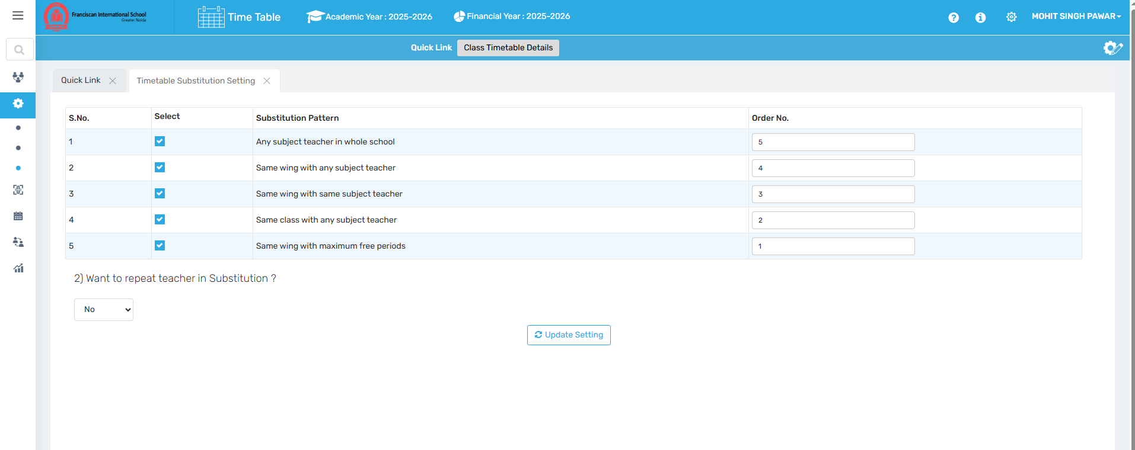

🎯 Purpose
To configure preferences for teacher substitution and define rules for repeated or restricted substitutions.

📍 Navigate to:
Time Table Module → Master Setting → Timetable Substitution Setting

Field Description
- Allow Repeated Substitution: Toggle to permit or block frequent substitutions of the same teacher.
- Preferences: Set custom rules or filters for substitution (if supported).

✅ Use Case
- Improve fairness in substitution load
- Enforce substitution policies automatically

⚠ Important Notes
- Affects automatic substitution assignment
- Needs to align with school policies on teacher availability

Constraints Master-

1. Parallel Allocation
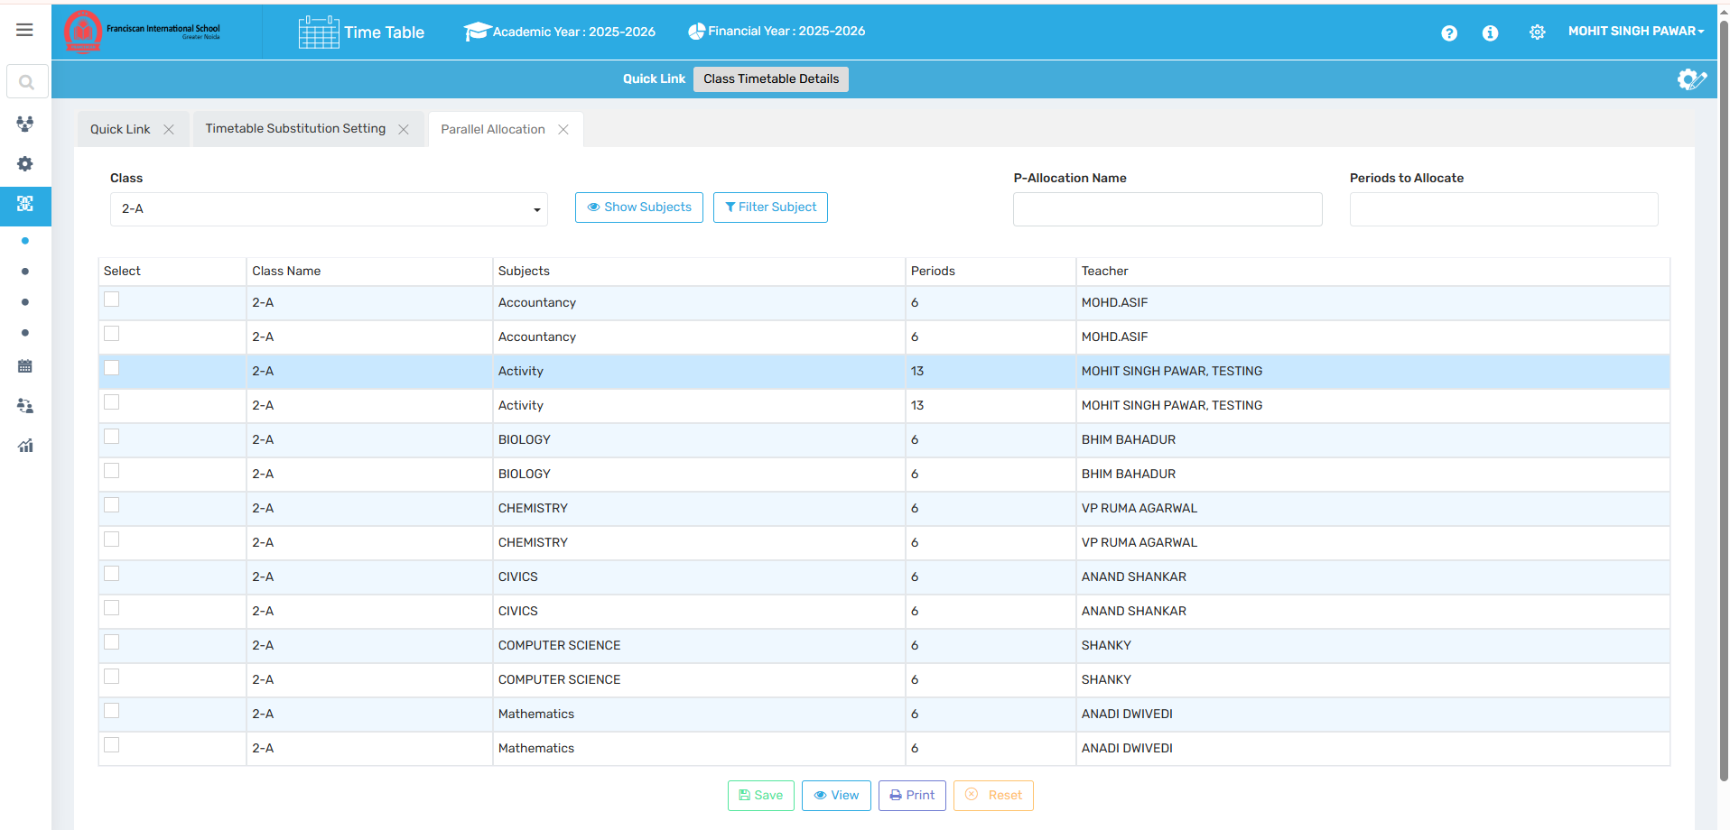

🎯 Purpose
To schedule two optional subjects simultaneously in the same period, taught by different teachers.

📍 Navigate to:
Time Table Module → Constraints Master → Parallel Allocation

Field Description
- Class & Subjects: Select a class and optional subjects to be scheduled concurrently.
- Periods to Allocate: Define number of times this allocation should appear weekly.
- P-Allocation Name: Name the rule for easy identification.

✅ Use Case
- Schedule elective subjects (e.g., Music and Art) in parallel
- Maintain flexibility in optional subject groupings

⚠ Important Notes
- Ensure subject combinations don’t cause conflicts
- Used only when optional streams are available

2. Fixed Allocation
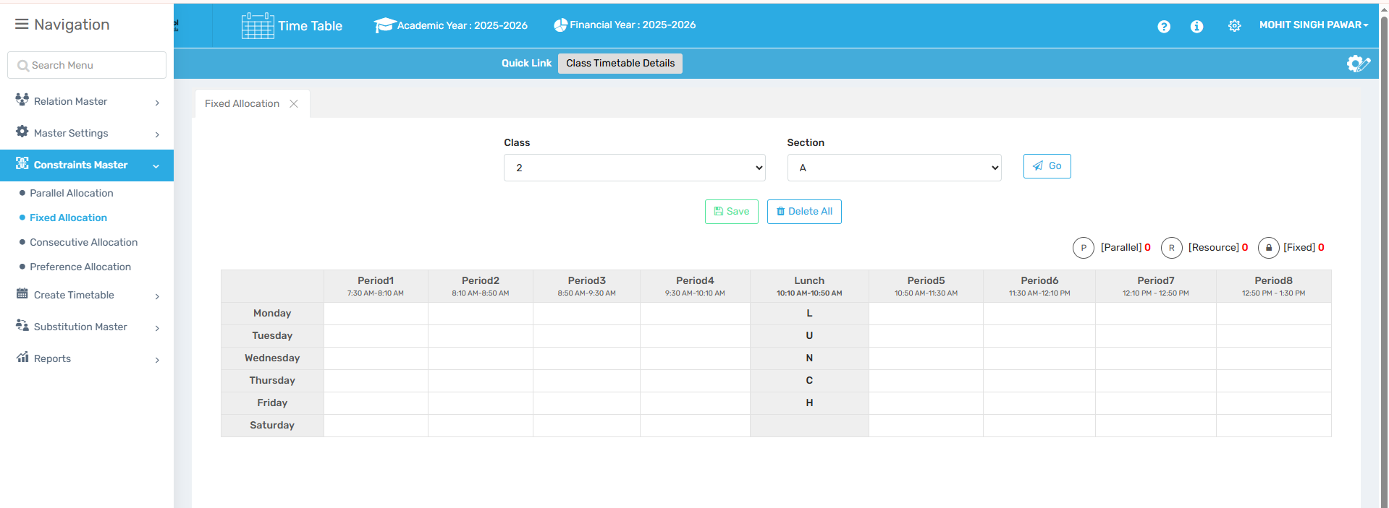

🎯 Purpose
To permanently assign a specific period to a teacher that remains unchanged during timetable regeneration.

📍 Navigate to:
Time Table Module → Constraints Master → Fixed Allocation

Field Description
- Class & Section: Select where the fixed assignment will apply.
- Assign Period: Click on a period and assign a teacher.
- Delete Fixed Allocation: Option to remove existing fixed assignments.

✅ Use Case
- Lock periods for critical sessions like labs or assemblies

⚠ Important Notes
- Fixed slots are not modified by auto-generation
- Overuse may limit scheduling flexibility

3. Consecutive Allocation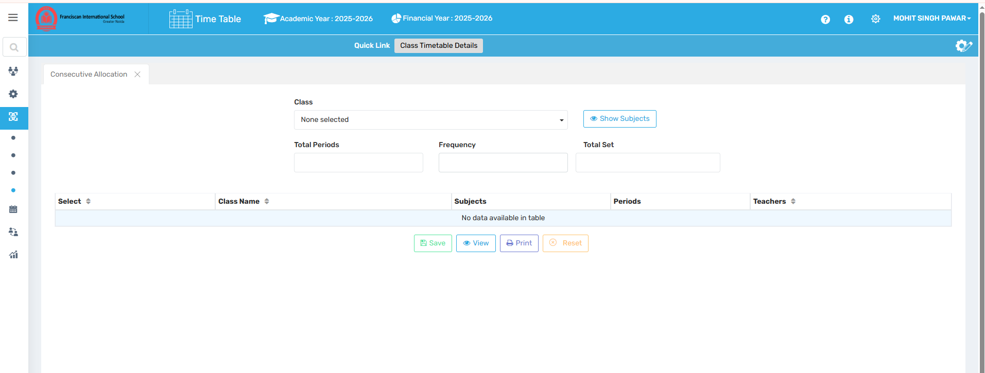

🎯 Purpose
To allocate two or more periods back-to-back for subjects that need extended teaching time.

📍 Navigate to:
Time Table Module → Constraints Master → Consecutive Allocation

Field Description
- Class & Subject: Choose the subject requiring consecutive slots.
- Number of Consecutive Periods: Set how many continuous periods are needed.
- Save: Apply the rule for timetable generation.

✅ Use Case
- Useful for lab sessions, project work, or subjects needing uninterrupted time blocks

⚠ Important Notes
- Avoid excessive consecutive blocks to prevent teacher/student fatigue
- Conflicts may occur if period availability is low

4. Preference Allocation
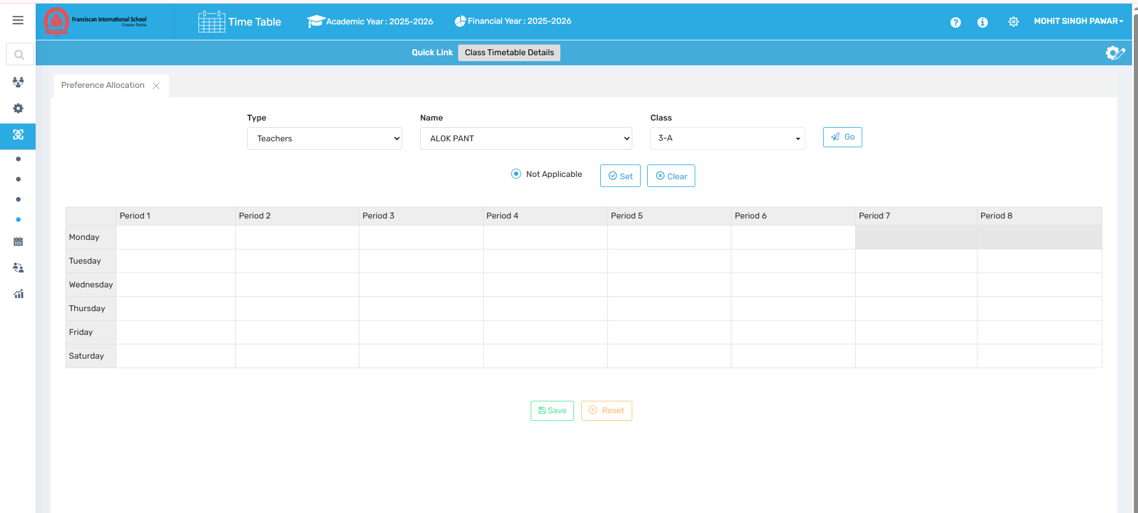

🎯 Purpose
To define preferred teaching periods or free period preferences for subjects and teachers based on school policies.

📍 Navigate to:
Time Table Module → Constraints Master → Preference Allocation

Field Description
- Preferred Periods: Assign preferred periods for specific subjects or teachers.
- Free Period Conditions: Define when teachers should or shouldn’t be assigned classes.

✅ Use Case
- Give senior teachers lighter first or last periods
- Avoid assigning certain subjects in early or late slots

⚠ Important Notes
- May override default auto-allocation logic
- Conflicts with fixed/consecutive/parallel rules should be avoided

Create Timetable-

1. Create Predefined Timetable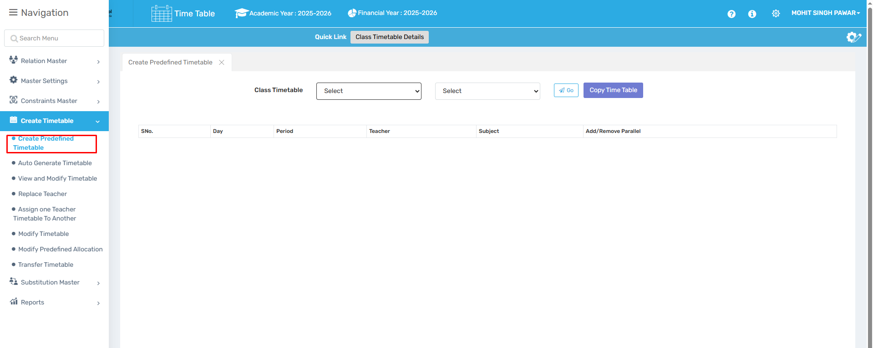

🎯 Purpose
To manually create a timetable by assigning periods and teachers for each class.

📍 Navigate to:
Time Table Module → Create Timetable → Create Predefined Timetable

Field Description
- Select Class and Section: Choose the class-section to work with.
- Assign Subjects & Teachers: Manually map each subject to a teacher.
- Save & Reverse Setting: Save the setup and confirm structure.
- Define Class Teacher: Link a class teacher after defining the structure.

✅ Use Case
- For schools that prefer full manual timetable design
- Allows custom structuring before automation is considered

⚠ Important Notes
- Manual setup must be complete to avoid scheduling gaps
- Reverse setting finalizes the structure for generation or export

2. Auto Generate Timetable-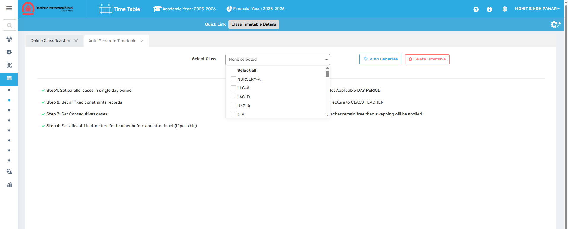

🎯 Purpose
To automatically generate a class timetable using all configured settings, constraints, and preferences.

📍 Navigate to:
Time Table Module → Create Timetable → Auto Generate Timetable

Field Description
- Select Class: Choose the target class for which the timetable should be generated.
- Click Auto Generate: Starts the automatic scheduling process.
- Delete Existing Timetable: Remove old timetables before regeneration if needed.

✅ Use Case
- Rapidly create complete timetables once all prerequisites are set
- Ensure data-driven, conflict-free scheduling

⚠ Important Notes
- Requires full setup: teacher, subject, period, and constraint data
- Review auto-generated results before final use

3. View and Modify Timetable
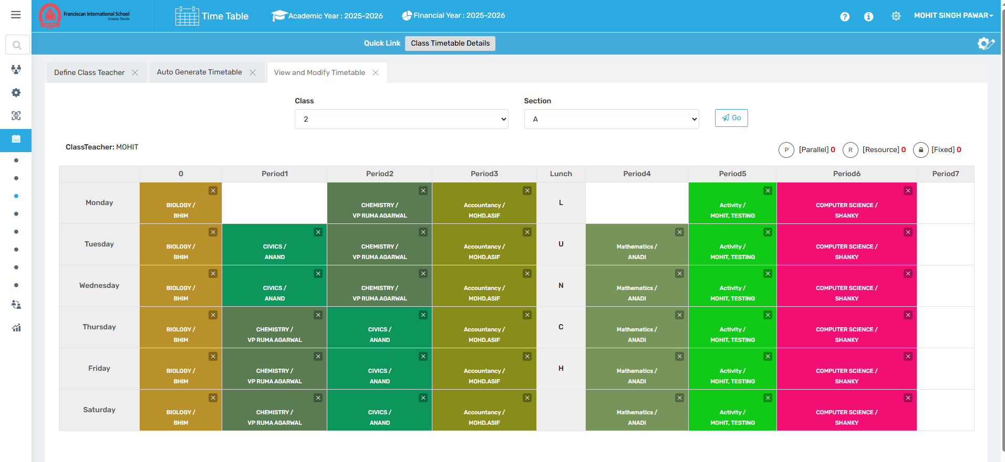

🎯 Purpose
To view and manually adjust the generated timetable as needed.

📍 Navigate to:
Time Table Module → Create Timetable → View & Modify Timetable

Field Description
- Timetable Viewer: Shows current schedule per class or teacher.
- Manual Edits: Modify specific periods, subjects, or teachers.

✅ Use Case
- Make quick fixes to generated timetables
- Accommodate last-minute staff or subject changes

⚠ Important Notes
- Manual changes override generated settings
- Keep track of edits for consistency and audit

4. Replace Teacher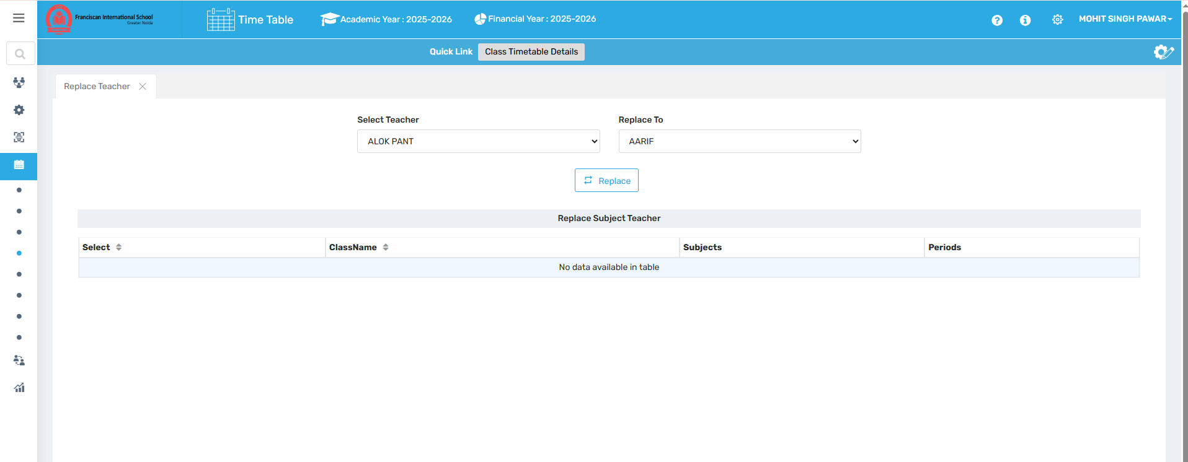

🎯 Purpose
To reassign all or selected timetable slots from one teacher to another.

📍 Navigate to:
Time Table Module → Create Timetable → Replace Teacher

Field Description
- Select Old & New Teacher: Choose the departing and incoming teacher.
- Apply Transfer: Migrate all scheduled periods to the new teacher.

✅ Use Case
- Replace a teacher who has resigned, gone on leave, or been reassigned
- Maintain continuity without redesigning the timetable

⚠ Important Notes
- Ensure the new teacher is qualified for all subjects assigned
- Review the updated schedule for possible overloads

5. Assign One Teacher Timetable to Another
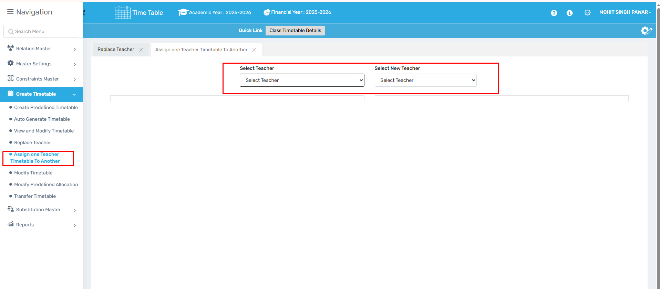

🎯 Purpose
To copy the entire timetable of one teacher and assign it to another teacher.

📍 Navigate to:
Time Table Module → Create Timetable → Assign One Teacher Timetable to Another

Field Description
- Source & Target Teacher: Select the teacher whose timetable should be copied and the one to receive it.
- Confirm Assignment: Finalize the transfer.

✅ Use Case
- Onboard a replacement teacher quickly
- Handle mid-year staffing transitions smoothly

⚠ Important Notes
- Should only be used if the replacement teacher handles identical subjects/classes
- Review load balance post-assignment

6. Modify Timetable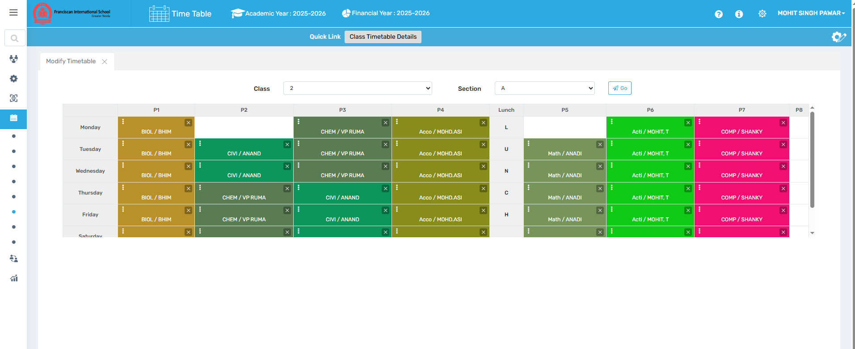

🎯 Purpose
To make changes to an already existing timetable on a per-period basis.

📍 Navigate to:
Time Table Module → Create Timetable → Modify Timetable

Field Description
- Select Class or Teacher View: Choose the format to view existing timetable.
- Edit Specific Entries: Update subject, teacher, or resource assigned to a period.

✅ Use Case
- Adjust for unexpected changes like staff absence
- Resolve clashes or correct manual input

⚠ Important Notes
- Use with caution—modifications can override system logic
- Log all changes for administrative transparency

7. Modify Predefined Allocation
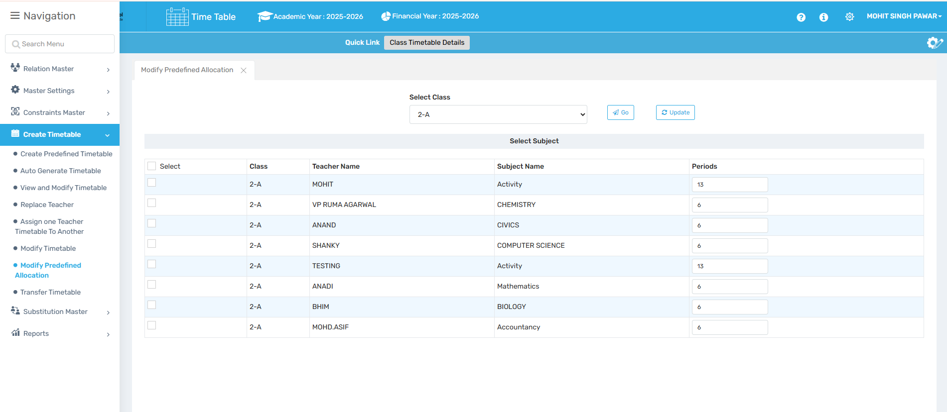

🎯 Purpose
To adjust manually set allocations for specific periods within the predefined timetable.

📍 Navigate to:
Time Table Module → Create Timetable → Modify Predefined Allocation

Field Description
- Period Selection: Choose the specific slot you want to modify.
- Edit Allocation: Change subject, teacher, or timing.

✅ Use Case
- Tweak previously fixed period setups
- Realign assignments post-review or audits

⚠ Important Notes
- Only applies to manually created timetables
- Ensure consistent changes across related classes or periods

8. Transfer Timetable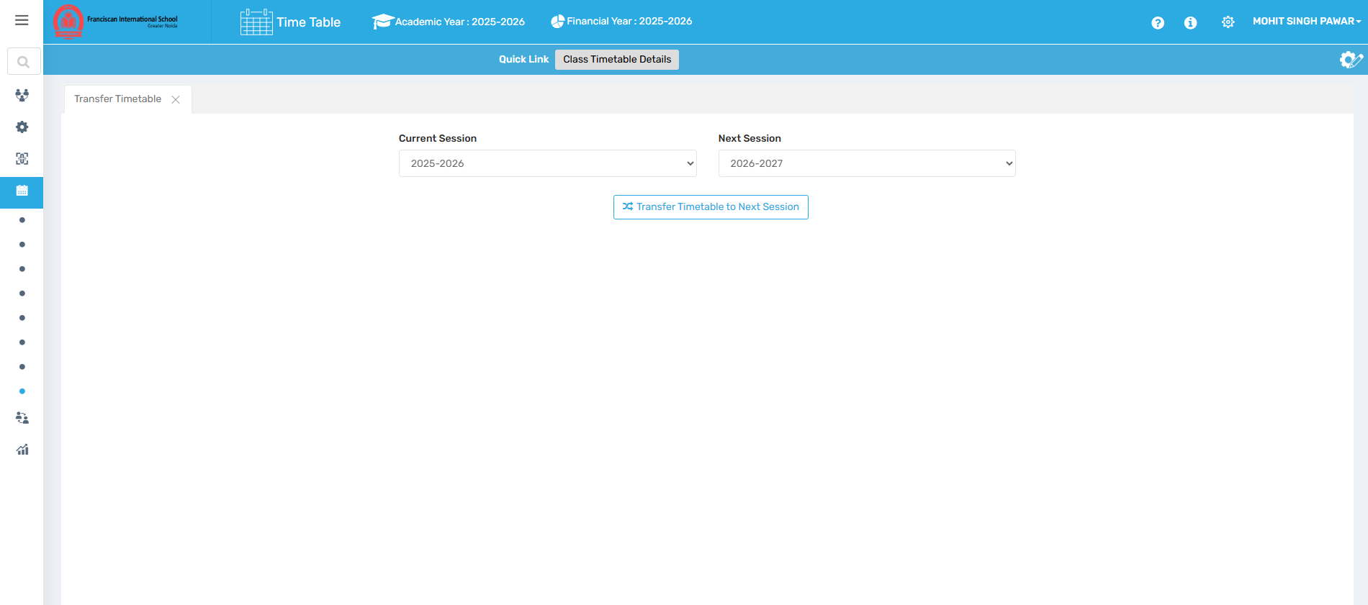

🎯 Purpose
To move timetable data from one academic year to another for continuity or reference.

📍 Navigate to:
Time Table Module → Create Timetable → Transfer Timetable

Field Description
- Select Source & Target Year: Choose academic years for transfer.
- Initiate Transfer: Copy timetable structure/data to the new year.

✅ Use Case
- Use last year’s timetable as a base for planning
- Save setup time for recurring structures

⚠ Important Notes
- Review transferred data for changes in staff, subjects, or periods
- Clean-up may be required post-transfer

Substitution Master-

1. Mark Attendance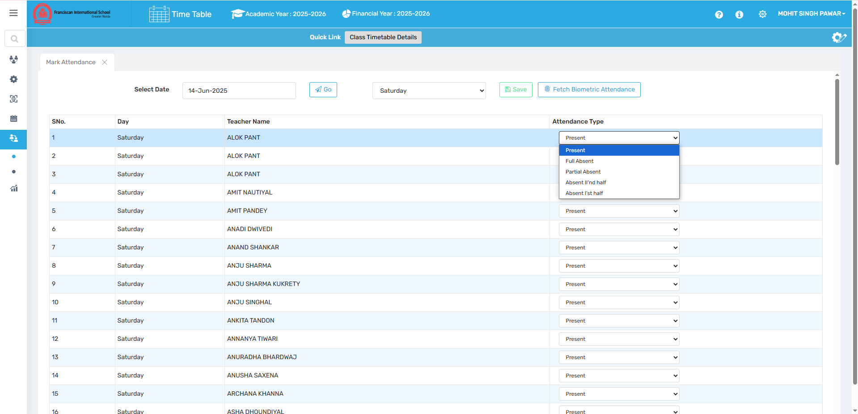

🎯 Purpose
To record teacher attendance manually or automatically through integrated biometric systems.

📍 Navigate to:
Time Table Module → Substitution Master → Mark Attendance

Field Description
- Manual Marking: Input teacher attendance data manually.
- Biometric Fetch: Import attendance from biometric devices (if integrated).

✅ Use Case
- Keep track of teacher presence for substitution planning
- Maintain attendance records for HR or payroll processing

⚠ Important Notes
- Manual entries should be verified for accuracy
- Biometric integration must be configured in system settings

2. Substitution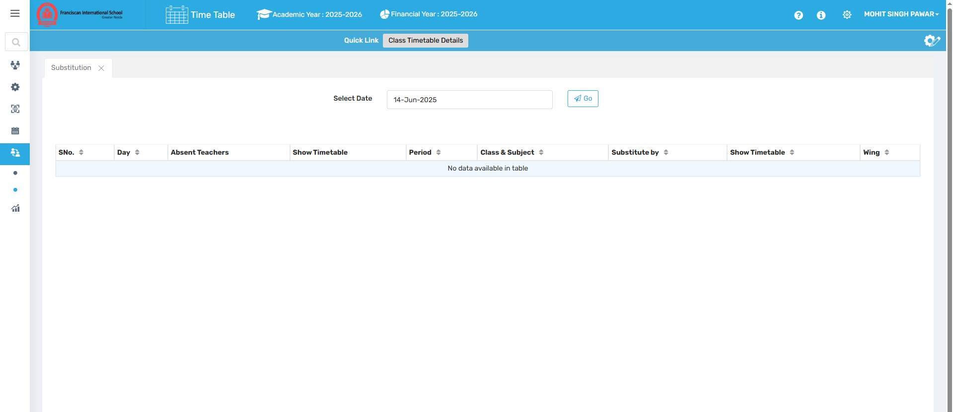

🎯 Purpose
To view and manage teacher substitutions due to absence or special scheduling needs.

📍 Navigate to:
Time Table Module → Substitution Master → Substitution

Field Description
- Absent Teacher Selection: Choose the teacher who is unavailable.
- Assign Substitute: Select a replacement teacher for the affected period(s).
- Save Changes: Confirm and apply the substitution.

✅ Use Case
- Handle sudden absences or leave efficiently
- Ensure no classes go untaught during staff shortages

⚠ Important Notes
- Substitute must not have a conflicting class in the same period
- Frequent substitutions may affect consistency of instruction

Reports-

1. Class Timetable Detail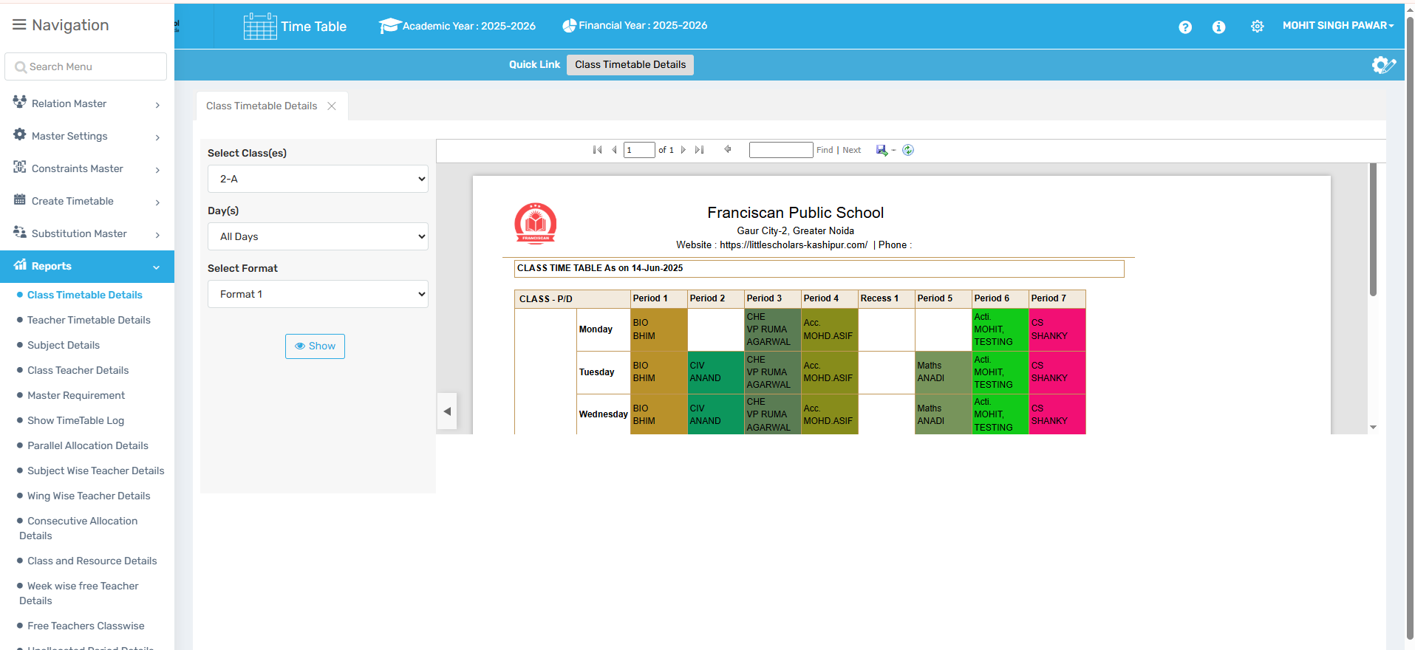

🎯 Purpose
To generate and review detailed timetable reports for individual classes.

📍 Navigate to:
Time Table Module → Reports → Class Timetable Detail

Field Description
- Select Class: Choose the class for which the report should be generated.
- View/Print: Display or print the class timetable.

✅ Use Case
- Share weekly schedules with class teachers and students
- Use during audits or inspections

⚠ Important Notes
- Ensure timetable is finalized before printing or distributing
- Class assignments should be complete to avoid gaps

2. Teacher Timetable Details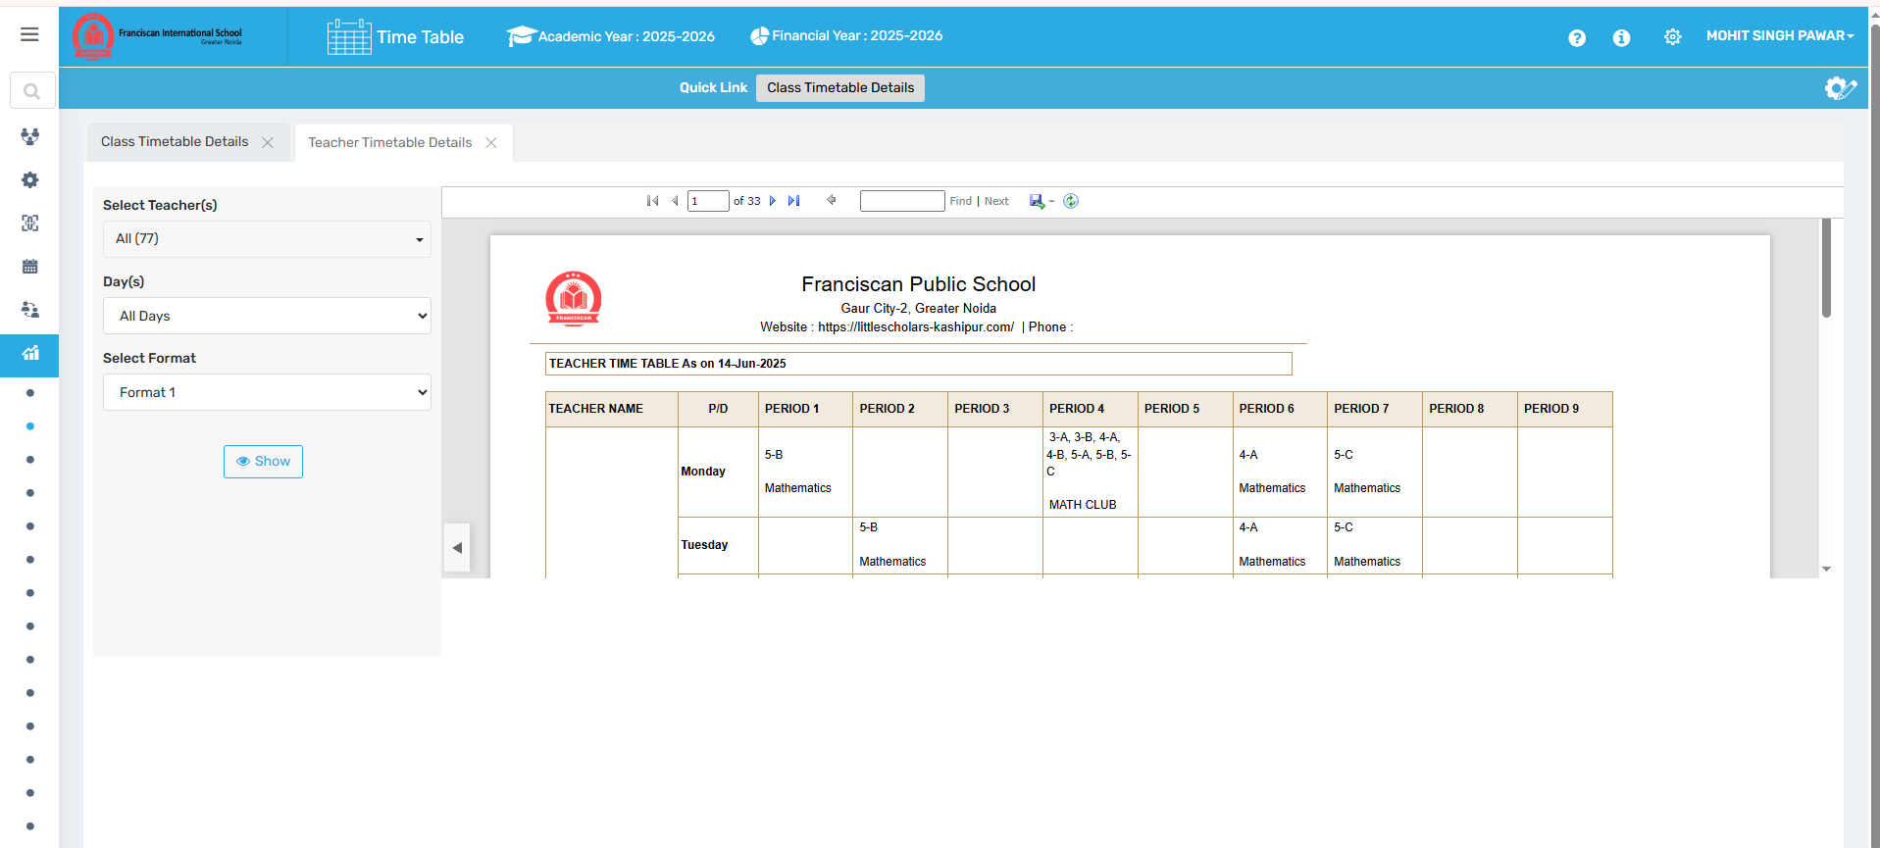

🎯 Purpose
To view and export detailed teaching schedules for individual teachers.

📍 Navigate to:
Time Table Module → Reports → Teacher Timetable Details

Field Description
- Select Teacher: Choose the teacher whose schedule is to be displayed.
- Report Output: Shows period-wise teaching assignments.

✅ Use Case
- Help teachers plan their day/week
- Track teacher workload

⚠ Important Notes
- May include free periods for visibility
- Changes in teacher assignments will reflect here

3. Subject Details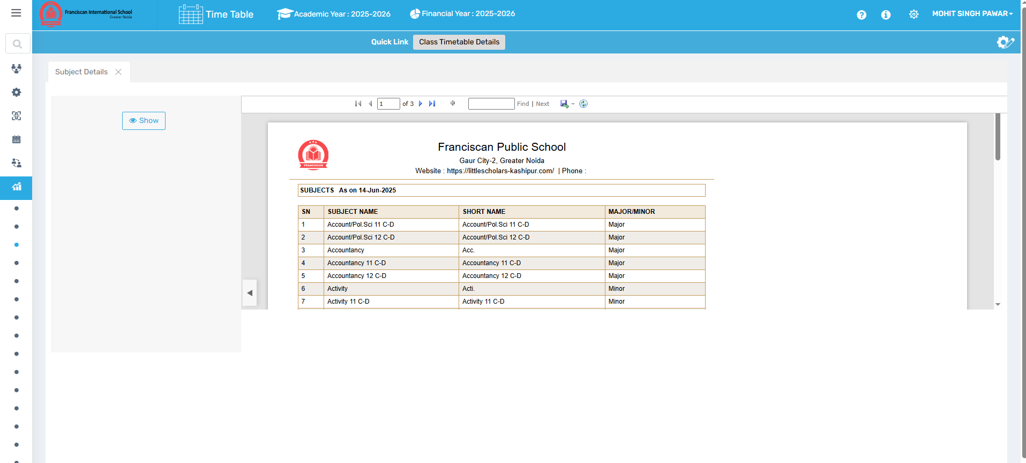

🎯 Purpose
To view reports related to each subject including codes, types, and assignments.

📍 Navigate to:
Time Table Module → Reports → Subject Details

Field Description
- Subject Overview: Displays data for each subject such as code, type, and related class.

✅ Use Case
- Check subject setup consistency across classes
- Validate subject codes for exam or report generation

⚠ Important Notes
- Must match defined subjects under "Define Subject"
- Misconfiguration here may cause display errors elsewhere

4. Class Teacher Details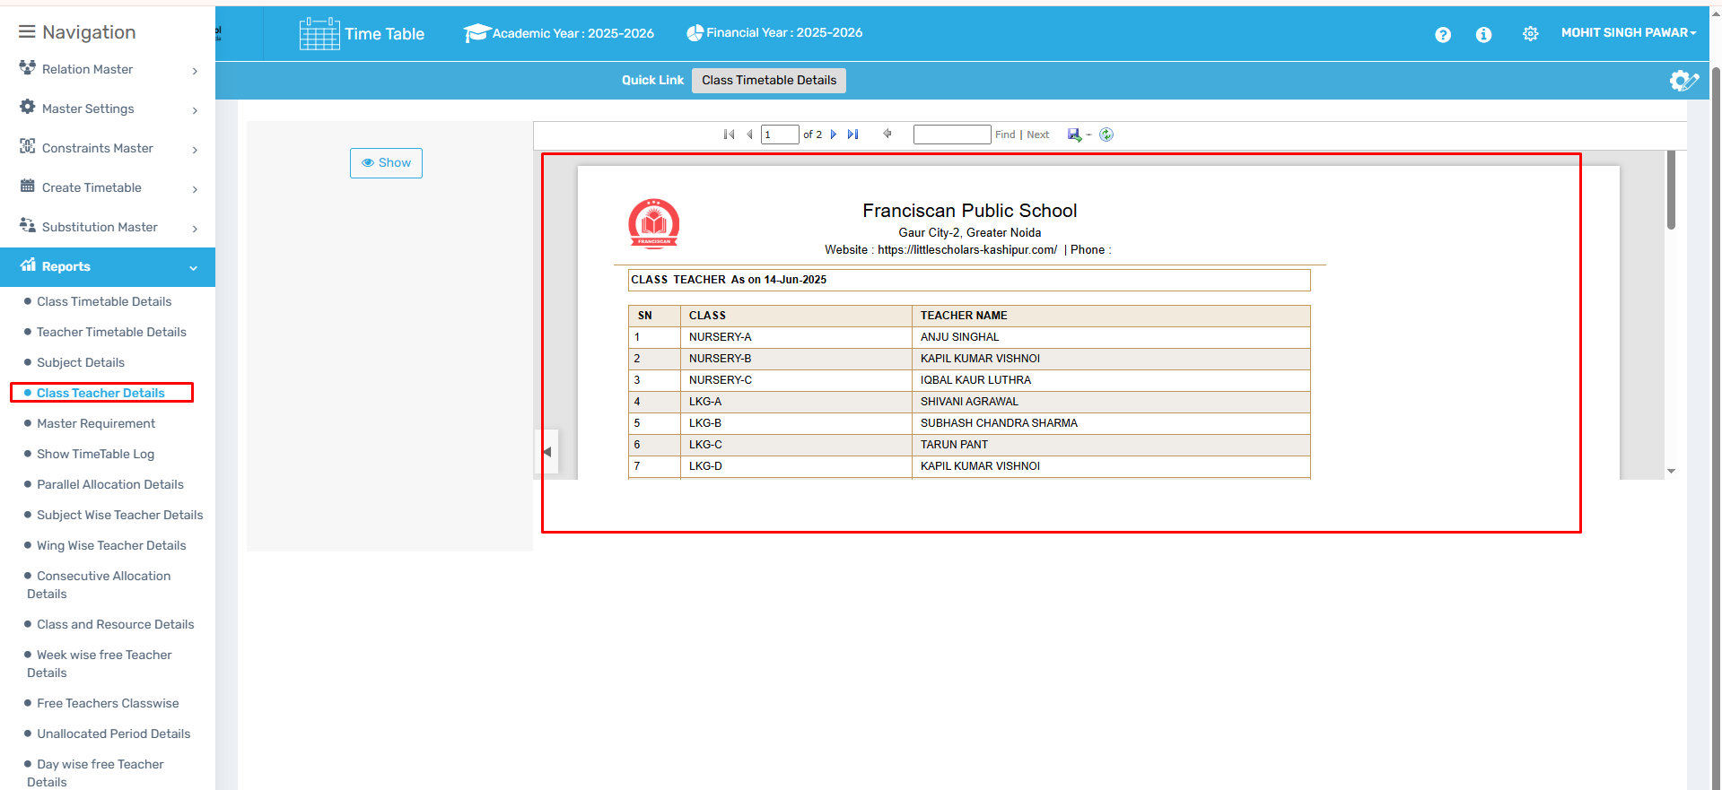

🎯 Purpose
To view the list of class teachers assigned to each section.

📍 Navigate to:
Time Table Module → Reports → Class Teacher Details

Field Description
- Class and Section Listing: Shows which teacher is assigned to each class-section combo.

✅ Use Case
- Review class teacher assignments
- Cross-check for duplication or missing assignments

⚠ Important Notes
- Ensure each section has exactly one class teacher
- Update if teacher resigns or is replaced

5. Master Requirement
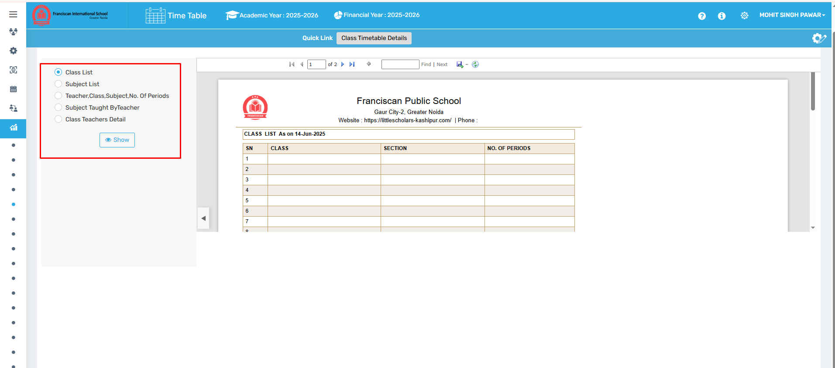

🎯 Purpose
To generate blank templates/lists for data validation and entry readiness.

📍 Navigate to:
Time Table Module → Reports → Master Requirement

Field Description
Includes blank or base reports for:
- Class List
- Subject List
- Teacher List
- Subject-wise Teacher List
- Class-Subject-Period Mapping

✅ Use Case
- Used during audits or to prepare for bulk data entry
- Identify configuration gaps before timetable generation

⚠ Important Notes
- Data shown is non-operational (i.e., blank or unassigned lists)
- Meant for administrative review or checklist planning

6. Parallel Allocation
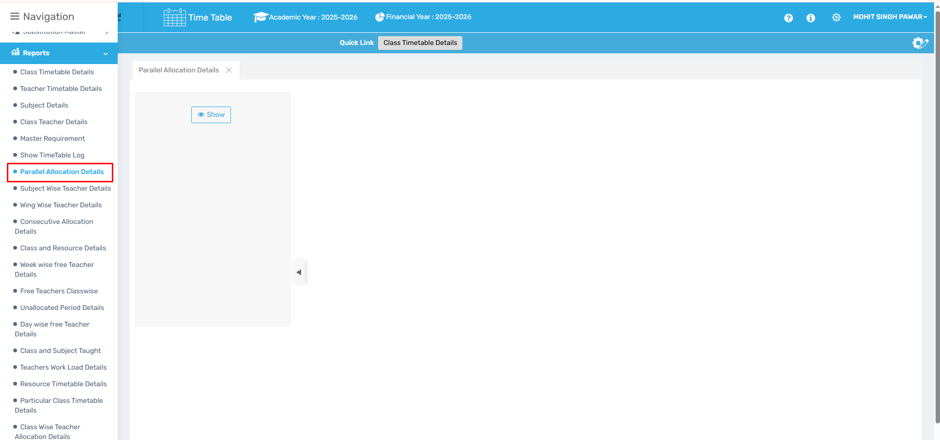

🎯 Purpose
To provide a detailed report of all configured parallel subject allocations.

📍 Navigate to:
Time Table Module → Reports → Parallel Allocation

Field Description
- Parallel Allocation Report: Displays subjects scheduled at the same time with different teachers, per class.

✅ Use Case
- Validate if optional subjects are scheduled correctly
- Check for possible period overlap or resource sharing

⚠ Important Notes
- Review to ensure subject load balance between options
- Misconfigured parallel setups can cause generation errors

7. Subject Wise Teacher Details
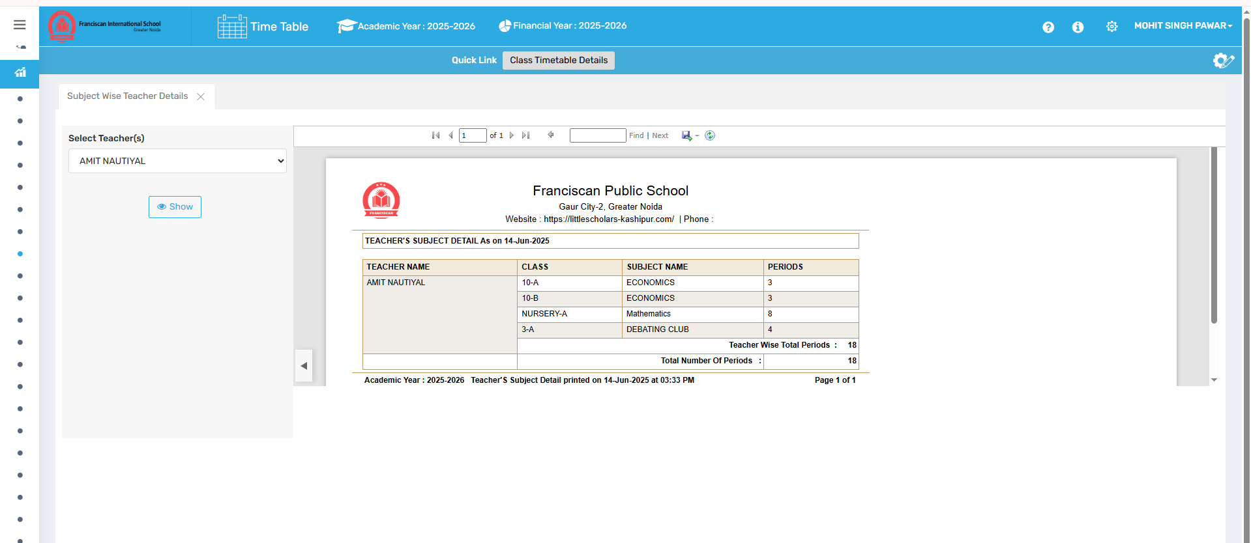

🎯 Purpose
To generate a report showing which teachers are assigned to which subjects.

📍 Navigate to:
Time Table Module → Reports → Subject Wise Teacher Details

Field Description
- Subject-Teacher Mapping: Organized display of subjects and their assigned teachers.

✅ Use Case
- Verify teacher allocation per subject
- Prepare academic reports or evaluation plans

⚠ Important Notes
- Ensure accuracy in subject assignment to reflect true teaching load
- Any unassigned subject may indicate a data gap

8. Wing Wise Teacher Details
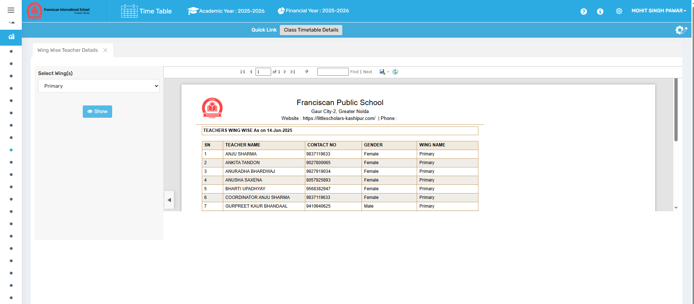

🎯 Purpose
To view teacher distribution across academic wings (e.g., Primary, Middle, Senior).

📍 Navigate to:
Time Table Module → Reports → Wing Wise Teacher Details

Field Description
- Teacher-Wing Report: Shows categorized teacher assignments by school wing.

✅ Use Case
- Balance staff distribution across school wings
- Used in HR and performance analysis

⚠ Important Notes
- Teacher-wing mapping must be predefined in staff profiles

9. Consecutive Allocation Details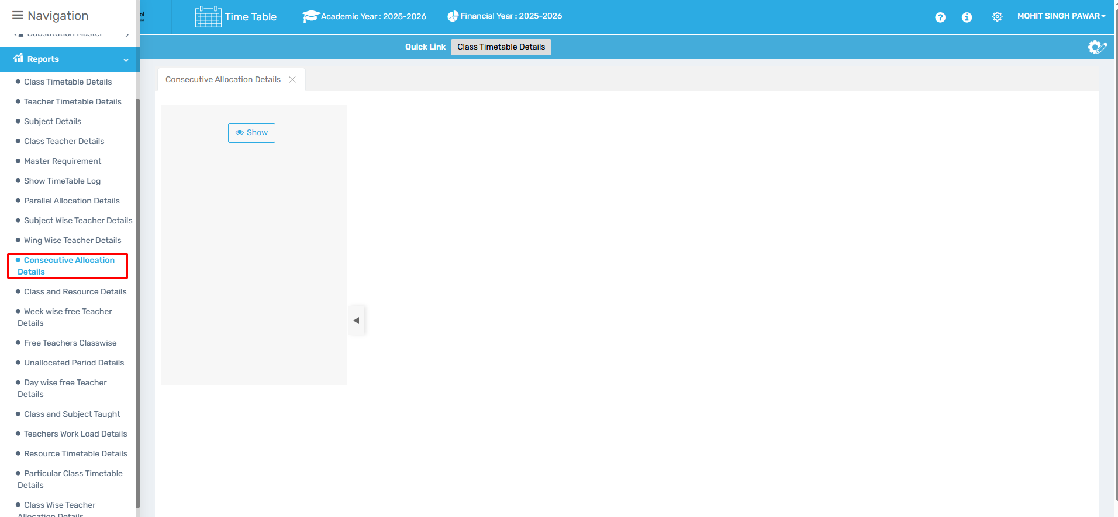

🎯 Purpose
To generate a report listing all subjects configured for consecutive period allocations.

📍 Navigate to:
Time Table Module → Reports → Consecutive Allocation Details

Field Description
- Class-Subject Mapping: Displays consecutive period settings per subject.

✅ Use Case
- Audit long-duration subject sessions (labs, projects)
- Validate uninterrupted teaching blocks

⚠ Important Notes
- Conflicts may arise if too many subjects require back-to-back slots

10. Class and Resource Detail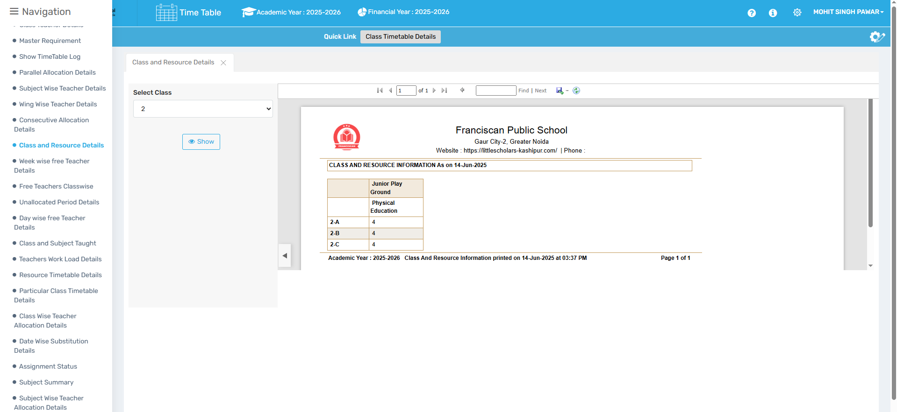

🎯 Purpose
To view which resources (labs, equipment) are assigned to which classes.

📍 Navigate to:
Time Table Module → Reports → Class and Resource Detail

Field Description
- Class-wise Resource Assignment: Shows all resources linked to each class.

✅ Use Case
- Audit resource allocation
- Plan room and equipment usage efficiently

⚠ Important Notes
- Ensure correct mapping during resource setup to avoid empty entries

11. Week Wise Free Teacher Details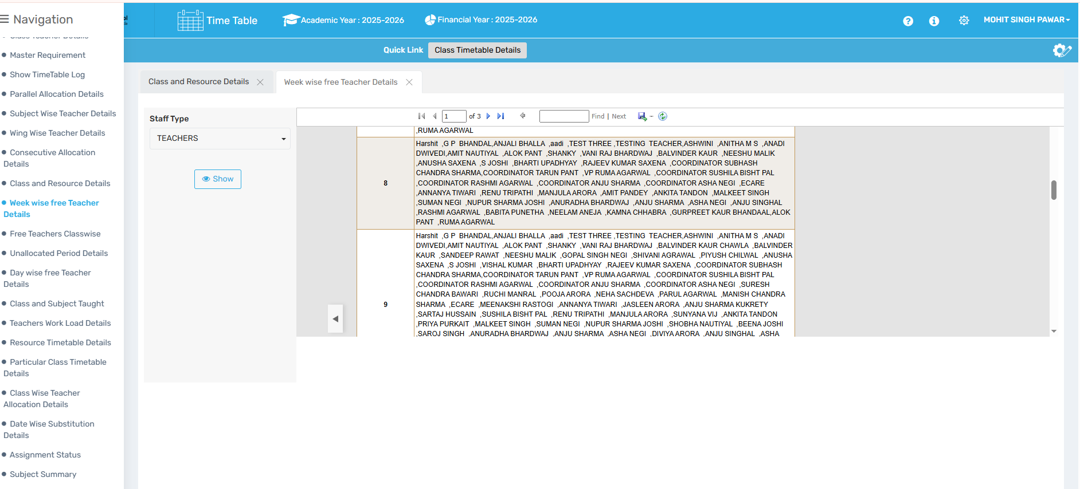

🎯 Purpose
To display weekly free periods available for each teacher.

📍 Navigate to:
Time Table Module → Reports → Week Wise Free Teacher Details

Field Description
- Teacher Period Matrix: Shows free slots week-wise.

✅ Use Case
- Plan meetings or substitutions
- Optimize teacher schedules

⚠ Important Notes
- May include breaks and non-teaching hours if not configured correctly

12. Free Teacher Class Wise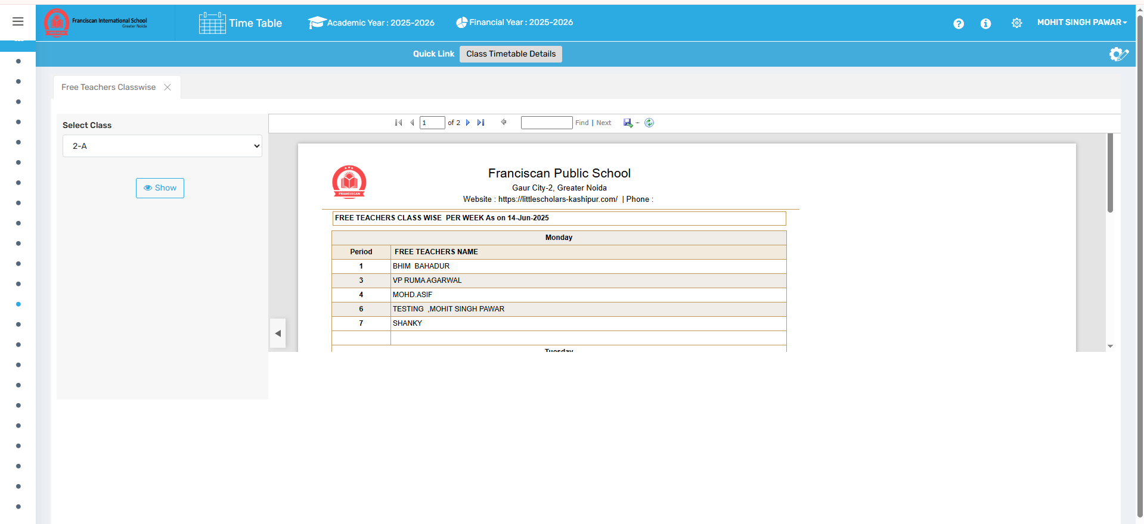

🎯 Purpose
To display free periods of teachers organized by class.

📍 Navigate to:
Time Table Module → Reports → Free Teacher Class Wise

Field Description
- Class-wise Teacher Free Slots: Shows teacher availability per class schedule.

✅ Use Case
- Easily locate available teachers for a specific class period
- Substitute planning at the class level

⚠ Important Notes
- Ensure class periods are fully allocated to reflect correct data

13. Unallocated Period Details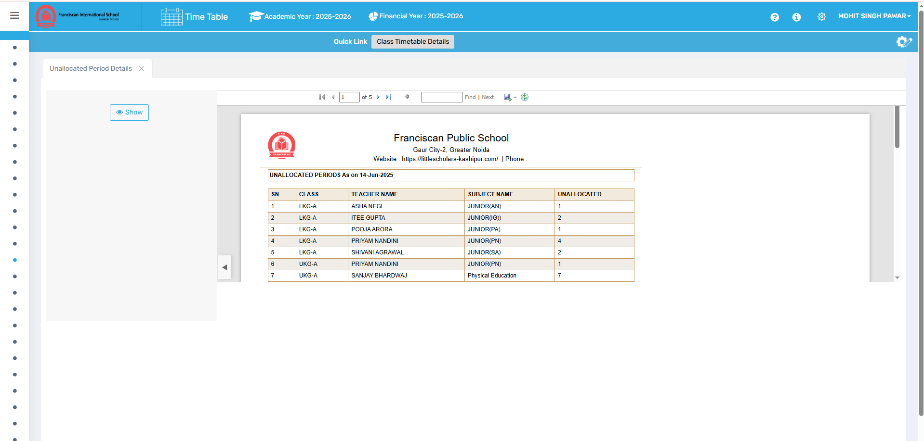

🎯 Purpose
To show periods that have not been assigned to any teacher or subject.

📍 Navigate to:
Time Table Module → Reports → Unallocated Period Details

Field Description
- List of Empty Slots: Displays all class periods without a subject or teacher.

✅ Use Case
- Quickly identify incomplete timetables
- Use during timetable audits or readiness checks

⚠ Important Notes
- Should be empty for finalized timetables
- Indicates potential issues if present after timetable generation

14. Day Wise Free Teacher Details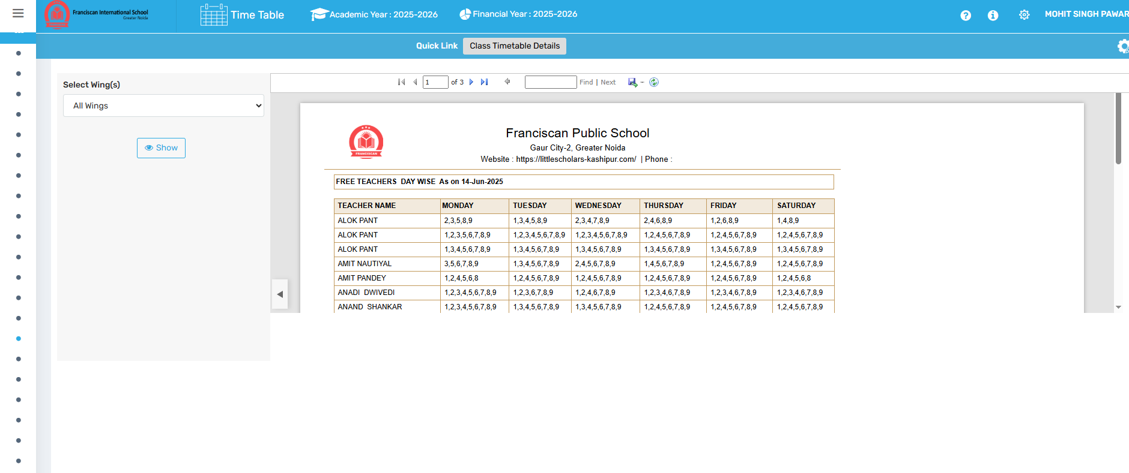

🎯 Purpose
To view teacher availability organized by each day of the week.

📍 Navigate to:
Time Table Module → Reports → Day Wise Free Teacher Details

Field Description
- Daily Availability Chart: Shows which teachers are free each day.

✅ Use Case
- Schedule co-curricular or extra periods
- Plan multi-day events and training

⚠ Important Notes
- Ensure teaching slots are accurately defined per day

15. Class and Subject Taught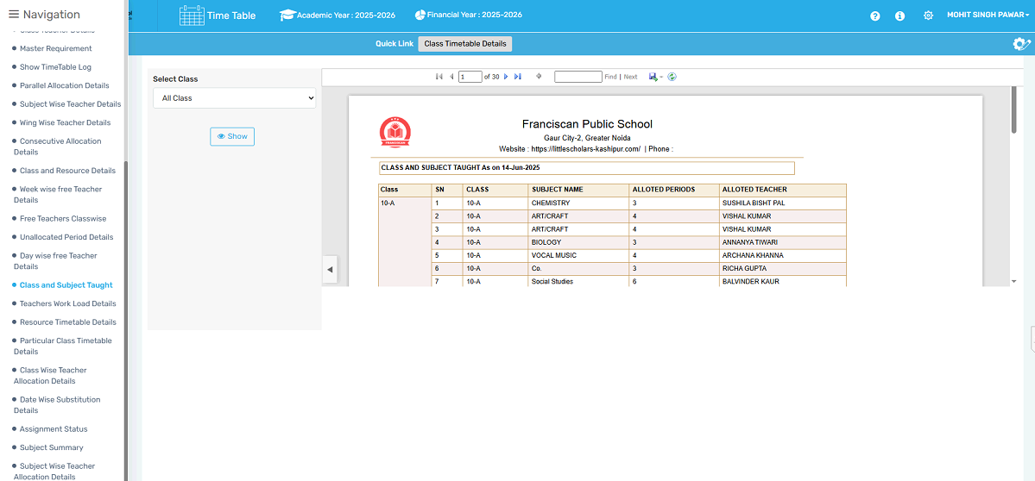

🎯 Purpose
To list all subjects taught in each class and the respective teachers responsible.

📍 Navigate to:
Time Table Module → Reports → Class and Subject Taught

Field Description
- Class-Subject-Teacher Table: Displays class-wise subject mapping with teacher names.

✅ Use Case
- Validate subject coverage per class
- Use for academic planning and parent queries

⚠ Important Notes
- Must align with period allotment and assignment records

16. Teachers Workload Details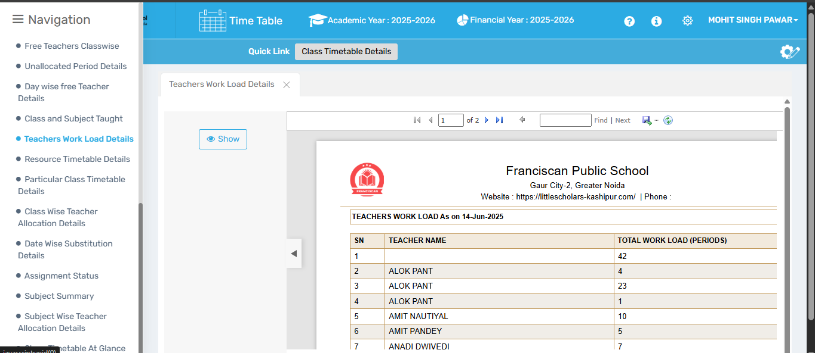

🎯 Purpose
To view all teaching and non-teaching responsibilities assigned to a teacher.

📍 Navigate to:
Time Table Module → Reports → Teachers Workload Details

Field Description
- Workload Report: Includes subject periods, substitutions, admin duties, etc.

✅ Use Case
- Assess staff performance and work balance
- Plan resource distribution fairly

⚠ Important Notes
- Ensure non-teaching duties are also entered for accurate reporting

17. Resource Timetable Details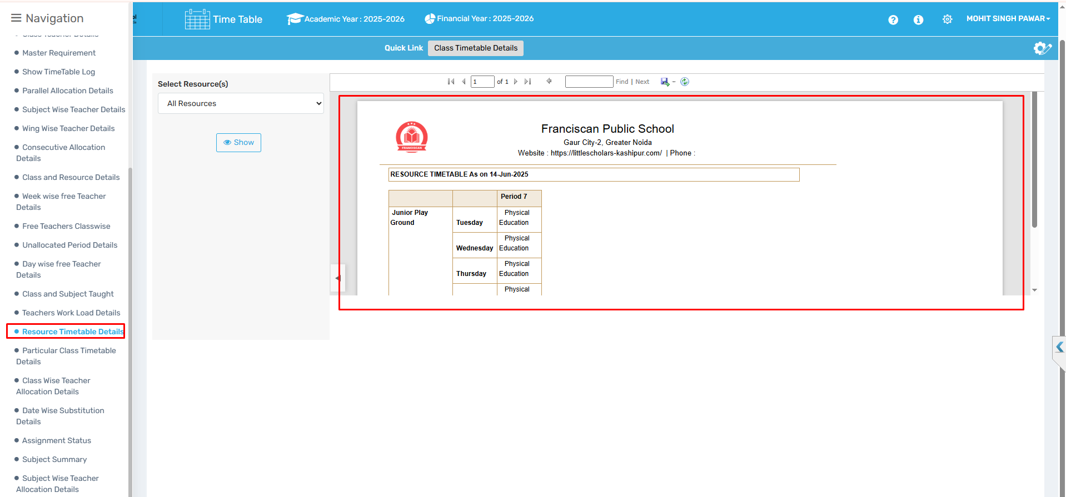

🎯 Purpose
To track resource usage (e.g., labs, AV rooms) via detailed scheduling reports.

📍 Navigate to:
Time Table Module → Reports → Resource Timetable Details

Field Description
- Timetable View: Shows which resource is used during each period.

✅ Use Case
- Avoid scheduling conflicts over shared resources
- Optimize infrastructure usage

⚠ Important Notes
- All resources must be linked to subjects/classes to appear

18. Particular Class Timetable Detail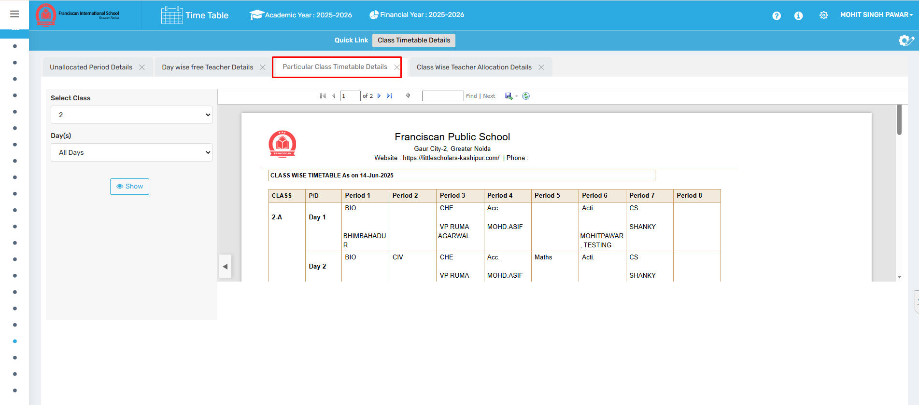

🎯 Purpose
To generate a detailed period-wise timetable report for one specific class.

📍 Navigate to:
Time Table Module → Reports → Particular Class Timetable Detail

Field Description
- Daily Timetable View: Displays subject, teacher, and period for selected class.

✅ Use Case
- Print and distribute to class students and teachers
- Use for exam invigilation or supervision planning

⚠ Important Notes
- Cross-check with subject and teacher assignments

19. Class Wise Teacher Allocation Details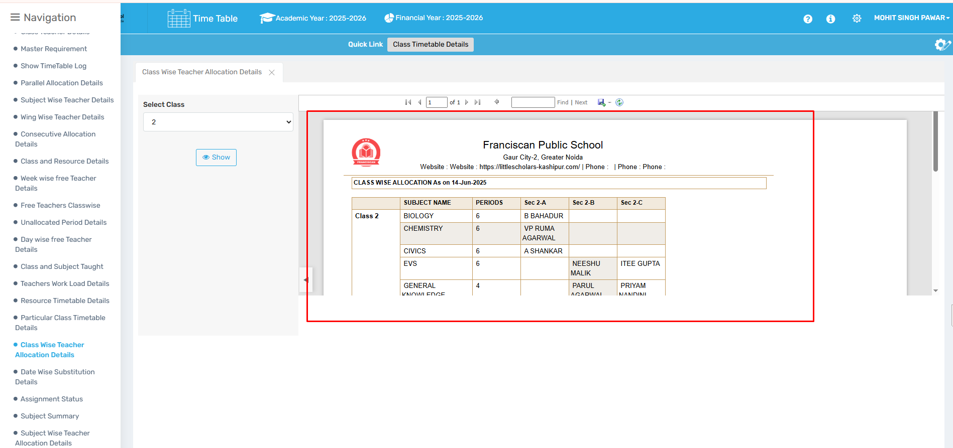

🎯 Purpose
To view which teachers are assigned to each subject in every class.

📍 Navigate to:
Time Table Module → Reports → Class Wise Teacher Allocation Details

Field Description
- Class-Subject-Teacher Mapping: Organized view by class.

✅ Use Case
- Ensure even subject distribution
- Spot any missing allocations

⚠ Important Notes
- Relies on accurate input from “Assign Subject to Class” and “Period Allotment”

20. Date Wise Substitution Details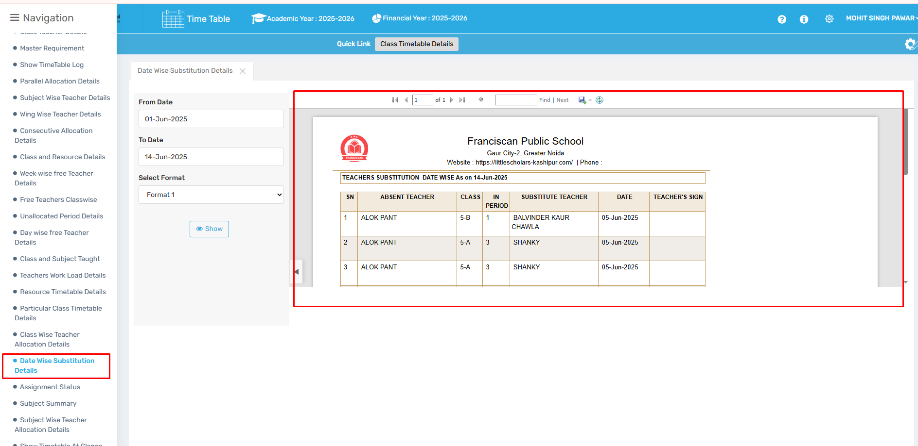

🎯 Purpose
To display all teacher substitutions categorized by date.

📍 Navigate to:
Time Table Module → Reports → Date Wise Substitution Details

Field Description
- Substitution Log: Shows original and substitute teacher with date and class.

✅ Use Case
- Review substitution trends
- Prepare monthly substitution logs

⚠ Important Notes
- Ensure daily attendance data is synced or manually entered

21. Assignment Status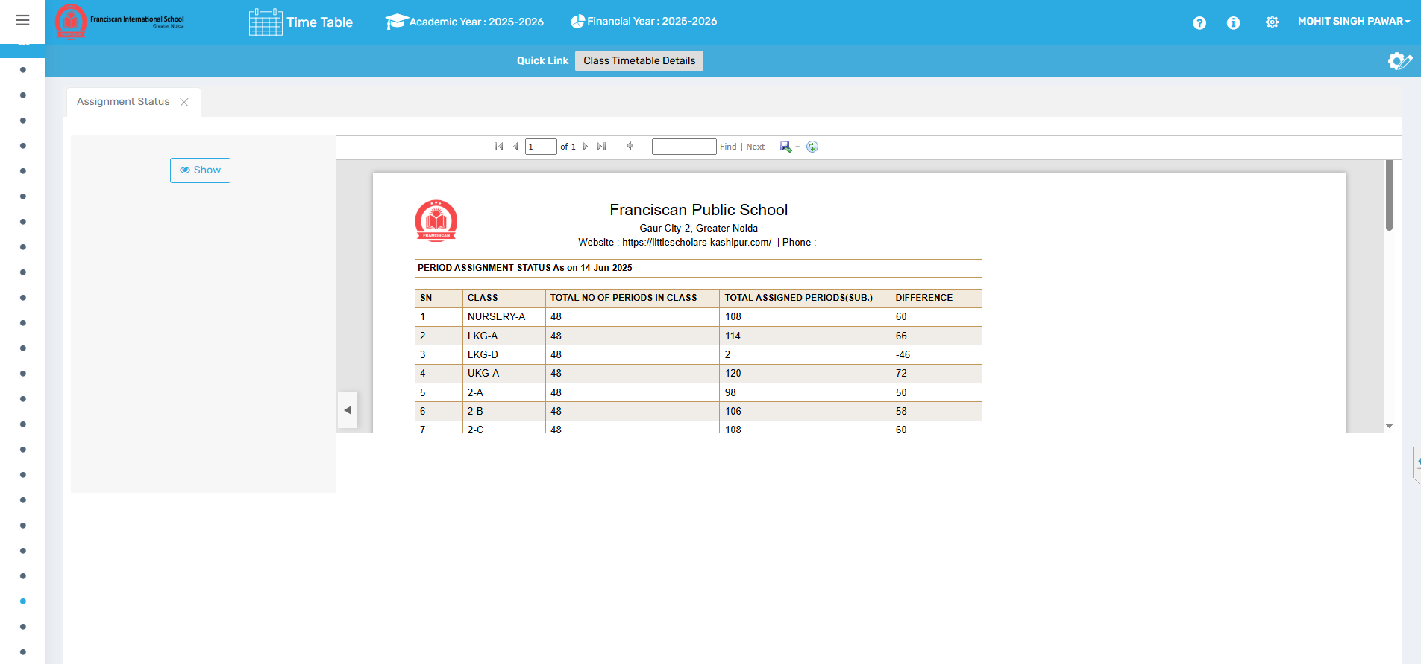

🎯 Purpose
To review which timetable components have been assigned and which remain pending.

📍 Navigate to:
Time Table Module → Reports → Assignment Status

Field Description
- Progress View: Shows completion of subjects, periods, and teacher assignments.

✅ Use Case
- Checklist for timetable readiness
- Identify configuration gaps quickly

⚠ Important Notes
- Use before timetable generation for completeness check

22. Subject Summary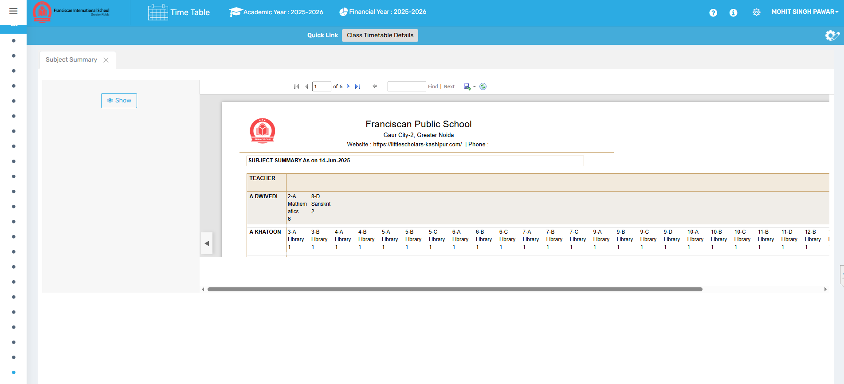

🎯 Purpose
To get a summarized view of all subjects, teachers assigned, and total periods.

📍 Navigate to:
Time Table Module → Reports → Subject Summary

Field Description
- Subject Overview: Includes total classes, teacher name, and number of periods per week.

✅ Use Case
- Planning teacher workload
- Checking curriculum coverage

⚠ Important Notes
- Review for any discrepancies in total period count

23. Subject Wise Teacher Allocation Details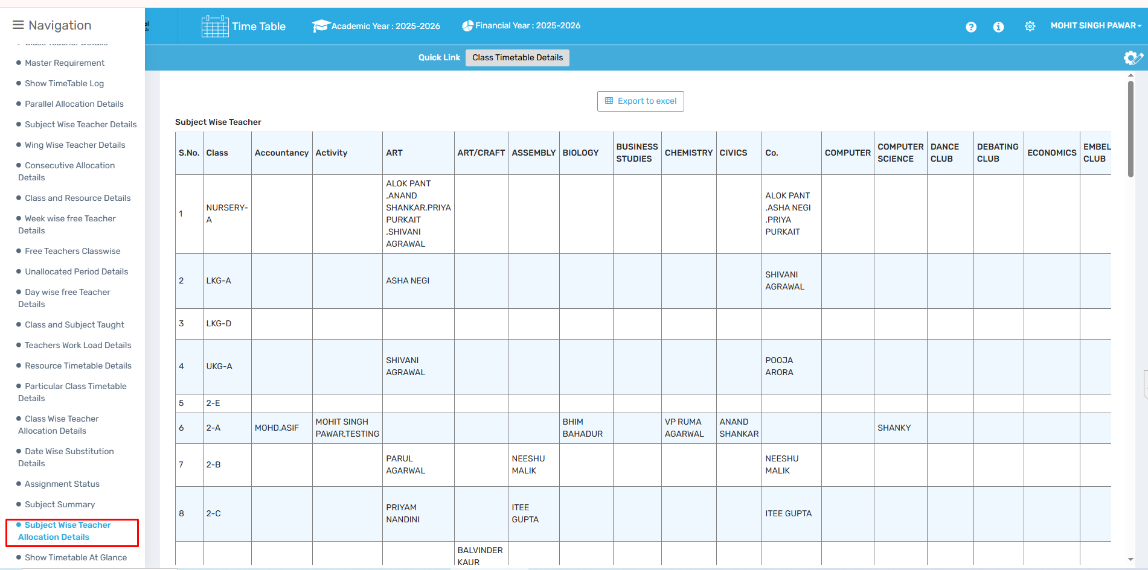

🎯 Purpose
To show a detailed mapping of each subject with the respective teacher and class.

📍 Navigate to:
Time Table Module → Reports → Subject Wise Teacher Allocation Details

Field Description
- Subject–Class–Teacher Report: Complete view of all teaching assignments by subject.

✅ Use Case
- Academic audit readiness
- Ensure subject distribution is balanced

⚠ Important Notes
- Needs accurate teacher and class setup beforehand

24. Show Timetable at a Glance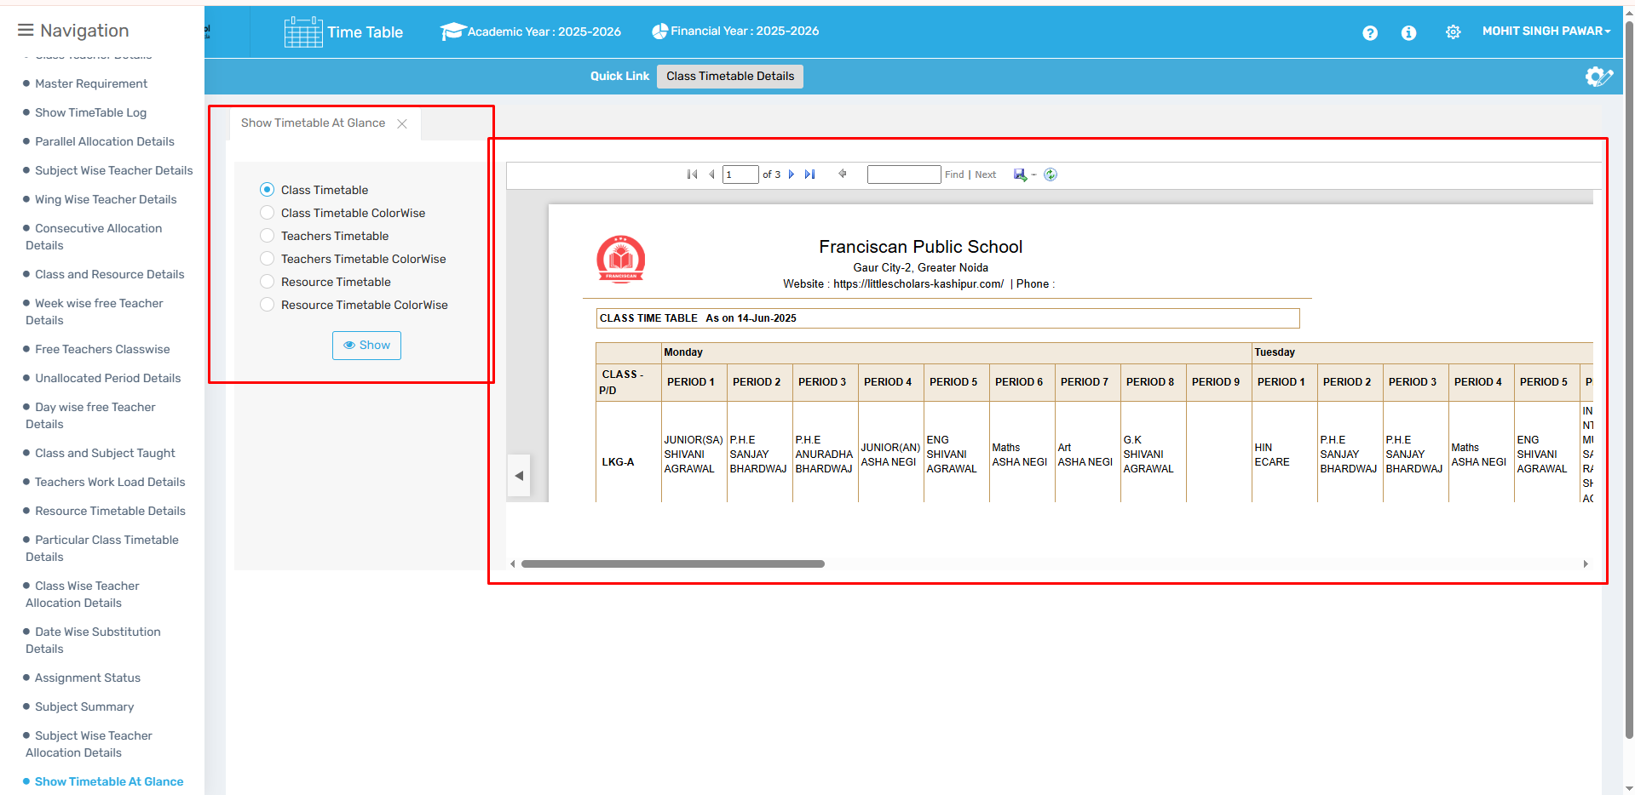

🎯 Purpose
To provide a one-screen visual of the entire timetable across all classes and teachers.

📍 Navigate to:
Time Table Module → Reports → Show Timetable at a Glance

Field Description
- Unified Timetable View: Grid showing full schedule in snapshot mode.

✅ Use Case
- Planning, reporting, and printing reference timetables
- Easily spot conflicts or overloads

⚠ Important Notes
- Best used for final version review
- Ensure all configurations are complete before relying on this report

