
Franciscan Solutions Pvt Ltd.

e-Care
Menu Overview
- Search Bar
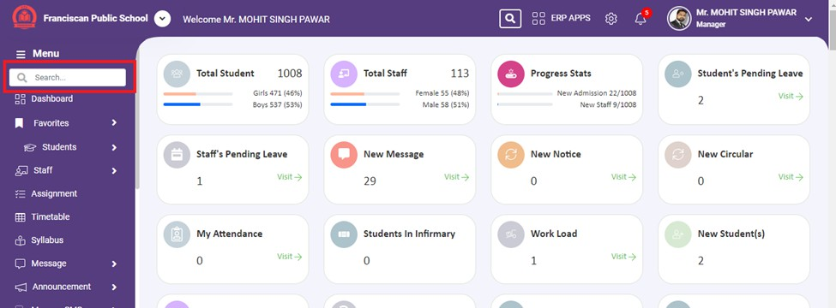
  - The search bar allows users to quickly find specific features or records within the ERP system by typing keywords.

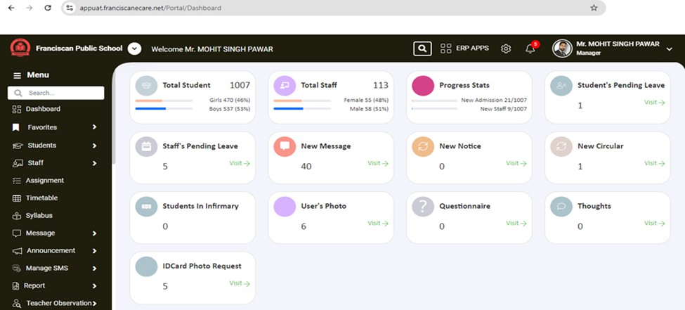
- Dashboard: This option takes the user to the main dashboard, where they can get an overview of key metrics, notifications, and quick access to essential features.

1. Favorites

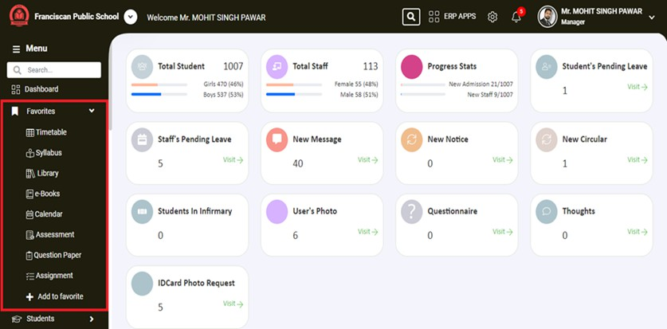
  - The Favorites section, indicated by a dropdown arrow, allows users to access their most frequently used features or pages quickly. Users can customize this list according to their needs.

- Students

- This is the main menu item for accessing student-related features. Clicking on the dropdown arrow expands the section to reveal more options related to student management.
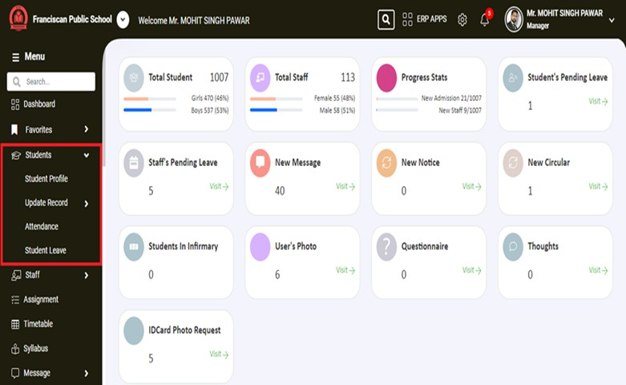

  - Student Profile

    - Clicking this option takes you to the section where individual student profiles can be viewed and managed, including personal details, academic records, and contact information.

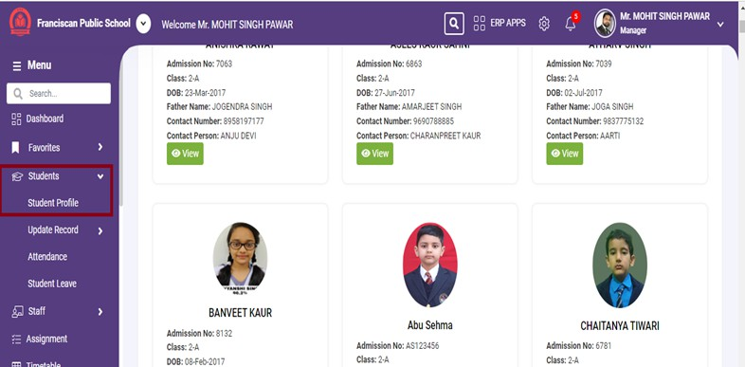

You can search Student with various filter options. Like

    - Name: Allows filtering students by their names.

    - Admission Number: Allows filtering students by their admission numbers.

    - Class: Allows filtering students by their class.

    - Father Name: Allows filtering students by the name of their father.

    - Contact Number: Allows filtering students by their contact number.

    - Next to the "Filter by" dropdown, there is a text input box labeled "Type here..." where users can enter specific search terms to further refine the list based on the chosen filter option.

- User can also filter students by their boarding status like

  - Boarding: Displays only boarding students.

  - Day Scholar: Displays only day scholar students.

  - All: Displays all students, regardless of boarding status.

  - By default, the selection will be "All."

  - Clicking the View button will navigate the user to a detailed page about the selected student. Like :

    - Personal details: The "Personal details" section of the student information page provides a comprehensive overview of various aspects related to the student..

    - Attendance: View detailed attendance records.

    - Academic Performance: View academic performance and grades.

    - Fee Details: View fee-related information and payment history.

    - Infirmary Visit: View records of visits to the school infirmary.

    - Medical Card: View medical details and history.

    - Library Transaction Details: View details of library transactions.

    - Transport Details: View details related to school transport.

    - Infraction Details: View details of any infractions or disciplinary actions.

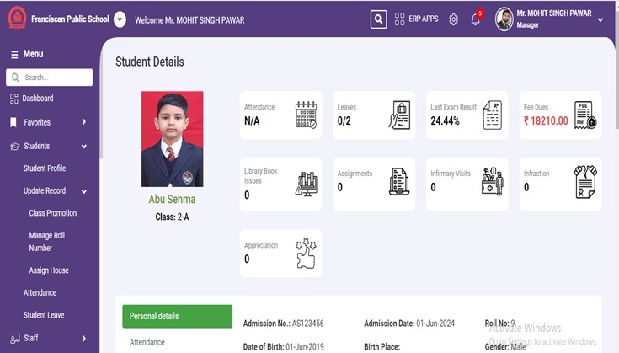

Summary Information:

- Attendance: Displays the student's attendance status. Clicking on this icon will provide a detailed report of the student's attendance records.

- Leaves: Shows the number of leaves taken by the student. Clicking on this icon will provide detailed information on the leaves taken by the student.

- Last Exam Result: Shows the result of the last exam. Clicking on this icon will provide a detailed report of the student's performance in the last exam.
- Fee Dues: Indicates the amount of fee dues. For example, ₹ 46550.00 indicates the outstanding fee balance. Clicking on this icon will provide a detailed report on the fee payment history and outstanding amounts.

- Library Book Issues: Shows the number of library books issued to the student. Clicking on this icon will provide detailed information on the books issued to and returned by the student.

- Assignments: Indicates the number of assignments. Clicking on this icon will provide detailed information on the assignments given to the student and their submission status.

- Infirmary Visits: Shows the number of visits to the school infirmary. Clicking on this icon will provide a detailed report of the student's medical visits and any treatments received.

- Infraction: Indicates the number of infractions recorded. Clicking on this icon will provide detailed information on the infractions or disciplinary actions taken.

- Class Promotion:

This option is used to promote students to the next class. At the end of the academic year, this feature helps in updating the student's class status in the system.

Teachers can select the current class of the students who need to be promoted. Teachers needs to click on the "Select" field to choose the class from the available options in the dropdown menu. After selecting the class, the teacher or administrator needs to click the green "Go" button. Clicking this button will initiate the class promotion process, displaying a list of students in the selected class who are eligible for promotion.

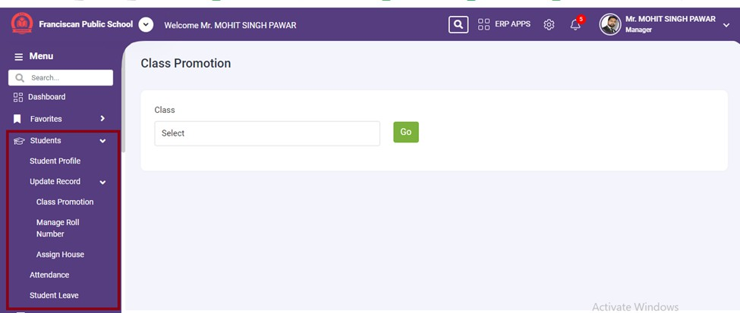

- Manage Roll Number:

This option allows the management of roll numbers for students. Administrators can assign or update roll numbers as needed, ensuring that each student has a unique roll number within their class.

Teachers can select the class for which they want to manage roll numbers. Teacher needs to click on the "Select" field to choose the class from the available options in the dropdown menu. After selecting the class, the teacher or administrator needs to click the green "Go" button. Clicking this button will display the list of students in the selected class, allowing the teacher to manage and update their roll numbers.
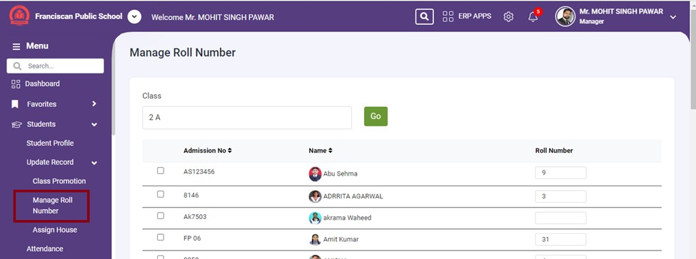

- Assign House:

This option is used to assign or change the house or group a student belongs to within the school. Houses are often used in schools to organize students for various activities and competitions.

Teachers can select the class for which they want to Assign the defined House. Teacher needs to click on the "Select" field to choose the class from the available options in the dropdown menu. After selecting the class, the teacher or administrator needs to click the green "Go" button. Clicking this button will display the list of students in the selected class, allowing the teacher to manage and update their Houses.

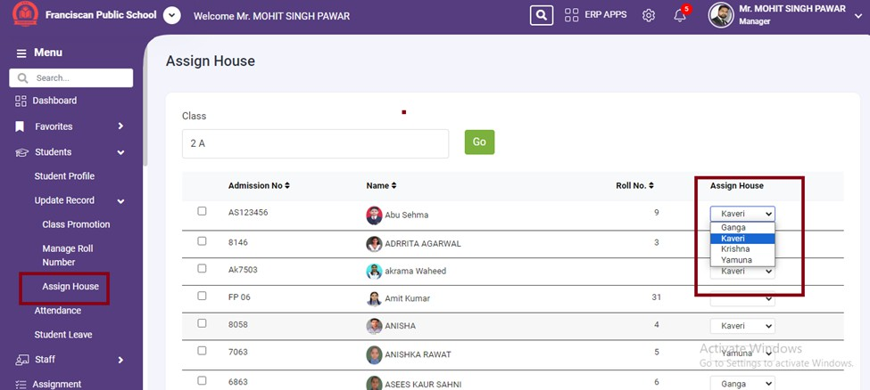

- Attendance
  - This option provides access to the attendance management section, where daily attendance records can be viewed and managed.

Date Selection: Teachers or administrators can select the date for which they want to view the attendance summary. Clicking the "Go" button will update the summary for the selected date.

Search Class: Allows searching for a specific class to quickly locate its attendance summary. Attendance Table:
Provides an overview of attendance for each class, including the number of students present, absent, on leave, and late. The "View" icon allows accessing detailed attendance records for a specific class.
This feature provides an efficient way to monitor and manage attendance across all classes, ensuring that teachers and administrators can easily track student attendance and identify any issues.

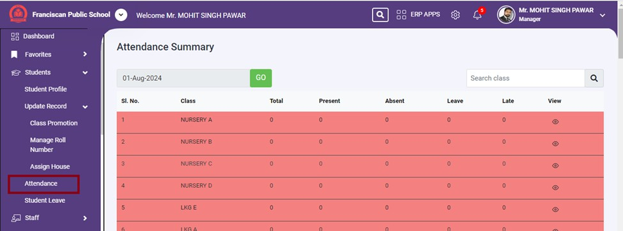

- . Leave
  - It allows users (teachers or administrators) to review, approve, or reject leave applications submitted by students.

Tabs:

Pending: Shows the leave applications that are awaiting a decision. Approved: Displays the leave applications that have been approved. Rejected: Displays the leave applications that have been rejected.

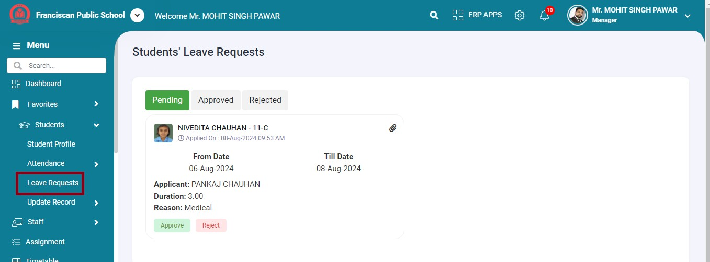

- Staff

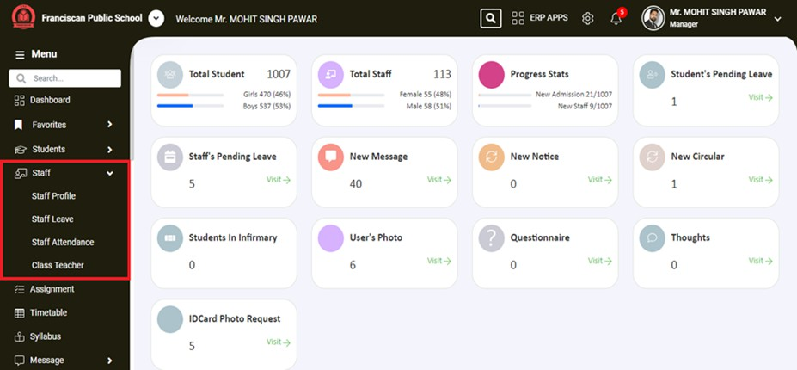

- Staff Profile: This option likely leads to a page or section where you can view the profiles of the staff members. This includes personal information, contact details, job roles, etc.
  - Users can filter and search for staff members.

  - Each staff member is displayed with basic information on a card.

  - · Users can click the "View" button to access detailed profiles.

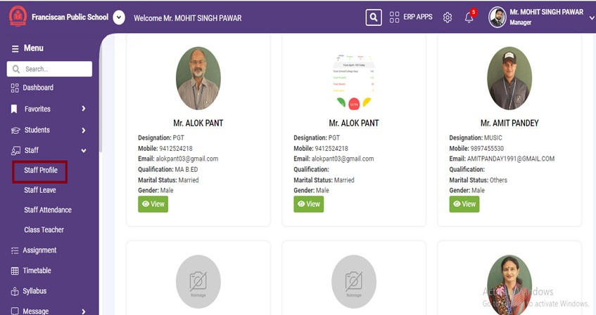

- Class Teacher: This option allows you to view class teachers.

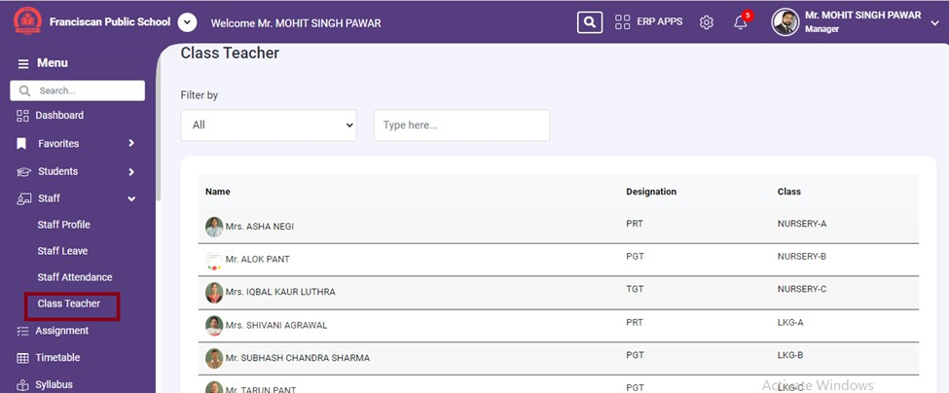

- Leave: This option is related to managing staff leave. This section allows users, probably administrators or managers, to review the status of staff leave requests and take appropriate actions.

§ Pending: Shows the leave applications that are awaiting a decision.

§ Approved: Displays the leave applications that have been approved.

§ Rejected: Displays the leave applications that have been rejected.

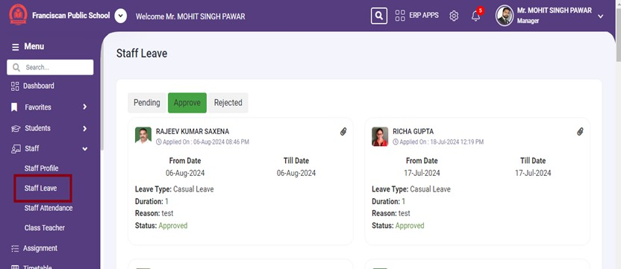

- Assignment: This option allows users to manage assignments. This could include Post/View assignments for students.
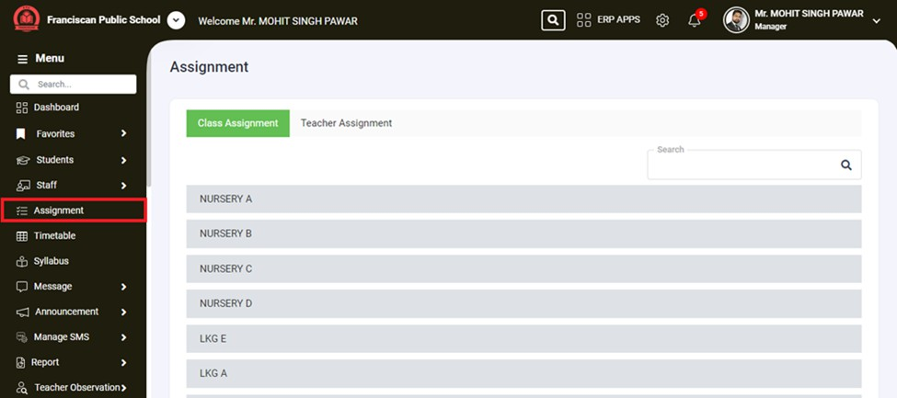

- Timetable: This option leads to a section where users can view Class & Teacher Timetable.

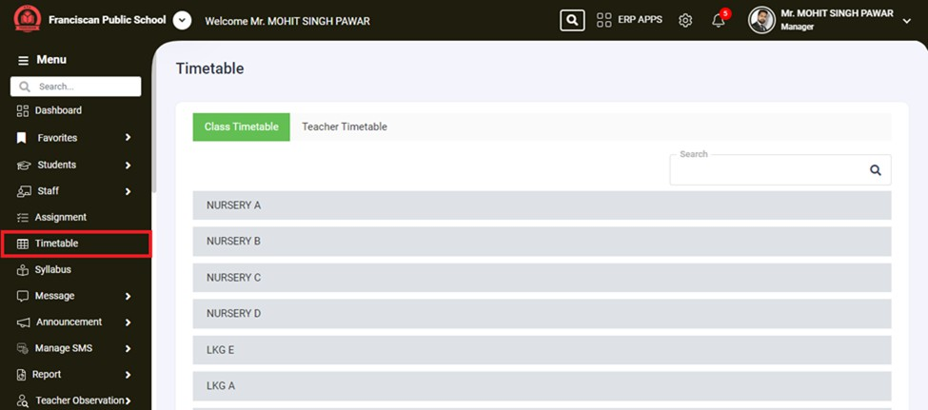

- Syllabus: This option is related to managing the syllabus for different classes.

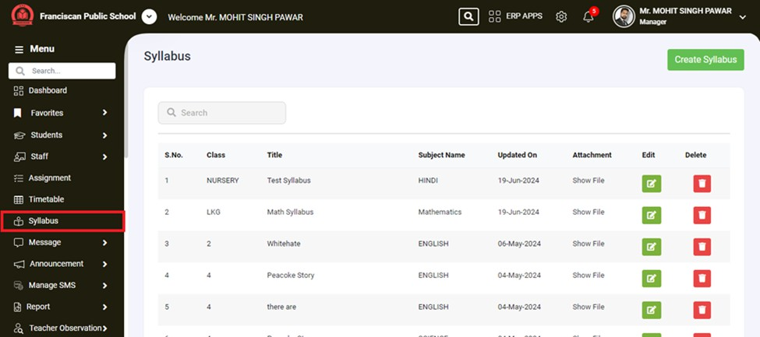

- Message: This is the main category for messaging functions. The arrow next to it indicates that this section can be expanded to reveal more options.

- Compose Message: This option likely allows users to create and send new messages. It could include features like selecting recipients, writing messages, and attaching files.

- Inbox: This option probably leads to the user's inbox, where they can view received messages. It might include features like reading, replying to, and organizing messages.

- Sent Messages: This option likely displays messages that the user has sent. It might include features like viewing sent messages, tracking message status, and resending messages if needed.

- Specified Message: This option is less clear but might refer to messages that are specifically categorized or tagged for easy retrieval. It could include important notices, flagged messages, or messages with specific criteria.

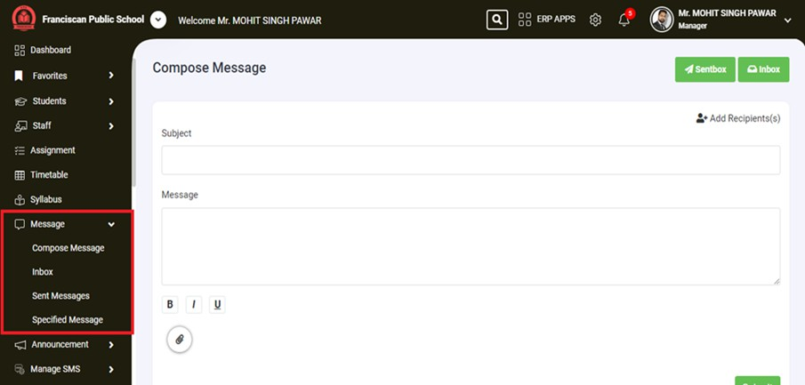

- Announcements

- Circular - This sub-item under "Announcement" likely refers to general circulars or notices issued by the school administration. These could be important notifications or information meant for a broad audience, such as all students, parents, or staff.

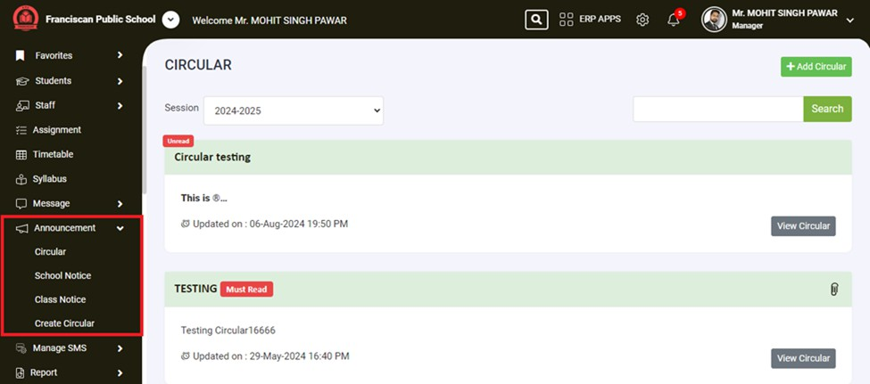

- School Notice: This option likely pertains to notices specific to the entire school. These notices could include important announcements regarding school events, holidays, policies, or any other information relevant to the entire school community.
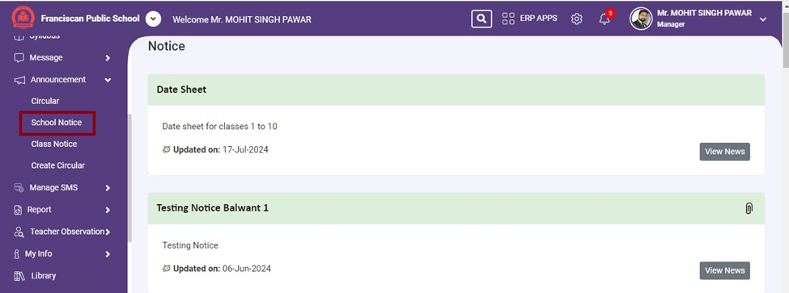

- Class Notice- This sub-item is probably used to manage and view notices specific to individual classes. Teachers or class administrators might use this to post announcements that are relevant only to the students and parents of a particular class.

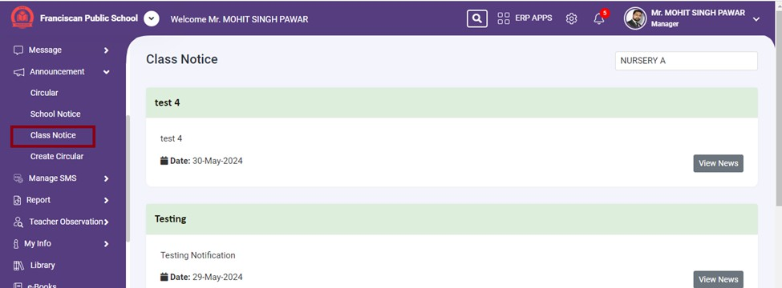

11 Create Circular

- Add Circular:

- The user clicks the "Add Circular" button to create a new circular. This action likely opens a new form where they can input the circular's title, content, intended audience, and other relevant details.

- View Circular:

- To view an existing circular, the user clicks the "View Circular" button next to the respective circular. This action would display the full content of the circular, allowing the user to read all the details.

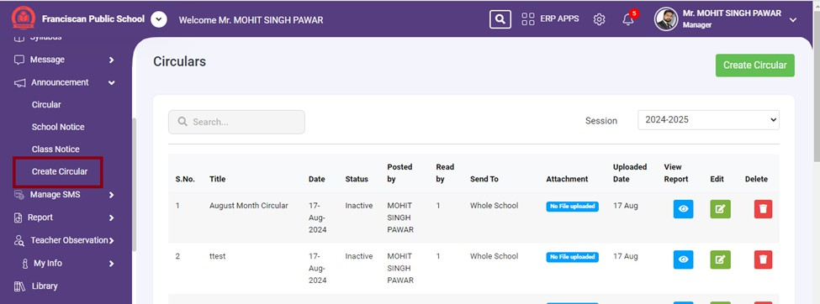

Send SMS:

- The user can use this option to send out general messages. This could involve writing the message, selecting a predefined list of recipients, and sending the message.

How to Send SMS -

Select SMS Subject: Choose an appropriate subject from the dropdown menu.

Choose Language: Select the language for the SMS.

Compose SMS or Use Template:

Either type the SMS message in the provided text area or select a template from the right panel.

Personalize with Codes: Use message codes if needed to personalize the SMS. Toggle Copy to Sender: Decide whether to send a copy of the SMS to yourself. Select Recipients: Choose the recipients from the "Send To" dropdown menu.
Send the SMS: After composing and reviewing the message, proceed to send the SMS to the selected recipients.

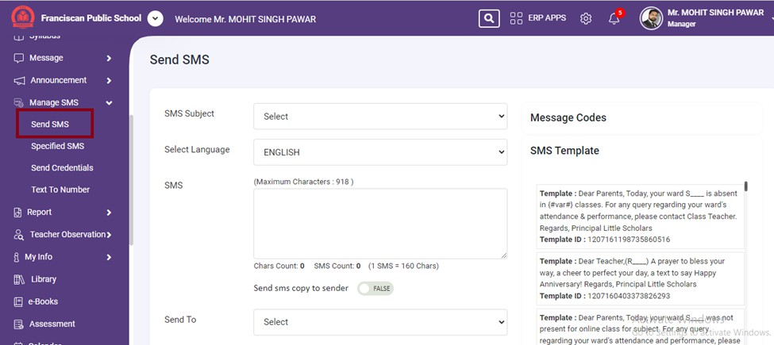

Send Credentials:

- This interface is designed to send login credentials

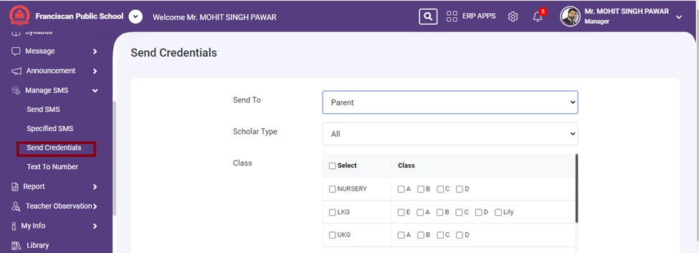

Specified SMS:

- This interface is designed to send specific types of SMS messages, such as birthday, anniversary, or religious messages.

Steps to Use the Interface:

Select SMS Type:

  - Choose the type of SMS you want to send from the dropdown menu (Birthday, Anniversary, Religion).

Compose SMS or Use Template:

  - Either type the SMS message in the provided text area or select a template from the right panel.

Toggle Copy to Sender:

  - Decide whether to send a copy of the SMS to yourself by toggling the switch.

Select Date:

  - Use the date picker to select the relevant date for the SMS (e.g., birthday date, anniversary date).

Fetch Contacts:

  - Click the "Get Contact" button to fetch the list of relevant contacts based on the selected SMS type and date.

Send the SMS:

  - After composing and reviewing the message, proceed to send the SMS to the selected recipients.

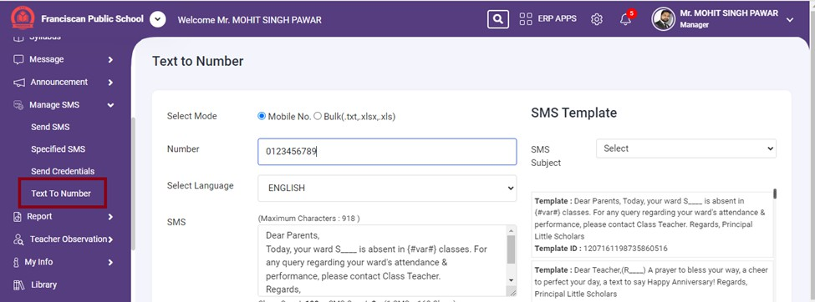

Text To Number:

- This interface allows users to send SMS messages to specific mobile numbers or upload a list of numbers in bulk.

Steps to Use the Interface:

Select Mode:

  - Choose either "Mobile No." for individual numbers or "Bulk" for uploading a file with multiple numbers.

Enter Number or Upload File:

  - If "Mobile No." is selected, enter the mobile number in the "Number" field.

  - If "Bulk" is selected, upload the file containing the numbers in the specified format (.txt, .xlsx,
.xls).

Choose Language:

  - Select the language for the SMS from the dropdown menu.

Compose SMS or Use Template:

  - Either type the SMS message in the provided text area or select a template from the right panel.

Send SMS:

  - Click the "Send SMS" button to send the composed message to the specified number(s).

Report:

- This section is likely part of a navigation menu that allows users to access various reports related to different aspects of school management

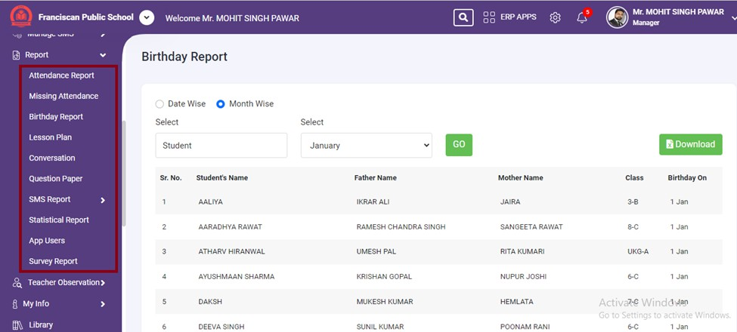

Attendance Report:

- This option allows users to view and generate reports on student attendance. It likely includes detailed information on attendance records for different classes or individual students.

Missing Attendance:

- This report focuses on identifying students who have missing attendance records. It helps in tracking students who have not been marked present or absent on certain days.

Birthday Report:

- This report provides information on students' birthdays. It might include a list of upcoming birthdays, allowing the school to prepare for celebrations or send greetings.

Lesson Plan:

- This report likely includes information on the lesson plans created by teachers. It can help in reviewing and planning the curriculum for different subjects and classes.

Conversation:

- This option might provide a report on conversations or communications within the ERP system. It could include logs of messages exchanged between teachers, students, and parents.

Question Paper:

- This report might include information on question papers used for exams or assessments. It can help in managing and reviewing the exam materials.

SMS Report:

- This option provides reports related to SMS communications. The arrow next to it indicates that it can be expanded to reveal more specific SMS-related reports.

App Users:

- This report provides information on the users of the school's mobile app. It include details on app usage, active users, and user demographics.

Survey Report:

- This report includes results from surveys conducted within the school. It can help in gathering feedback from students, parents, and staff on various topics.

Teacher Observation

The user can create a record regarding the behavior of the teacher and can also maintain the record of teaching of the teacher in the class.

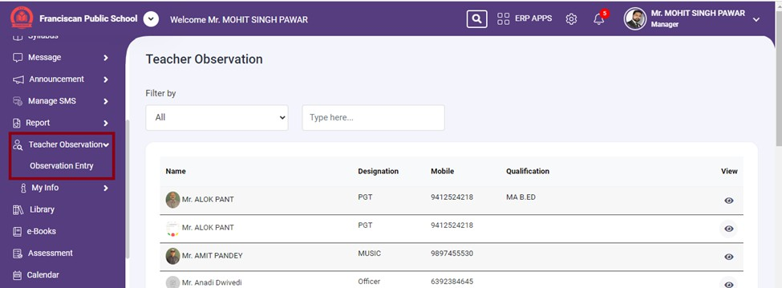

My Info :

View Attendance:

- Click on the "My Attendance" sub-menu item to access the attendance records. Users can review their attendance history, check for any discrepancies, and ensure that all attendance data is up-to-

date.

Manage Leave:

- Select the "My Leave" sub-menu item to view leave balances and apply for leave. Users can fill out leave application forms, submit them for approval, and track the status of their leave requests.
Access Payslips:

- Click on the "Payslip" sub-menu item to view and download payslips. Users can select the desired month and download the payslip for that period, providing a detailed breakdown of their earnings and deductions.

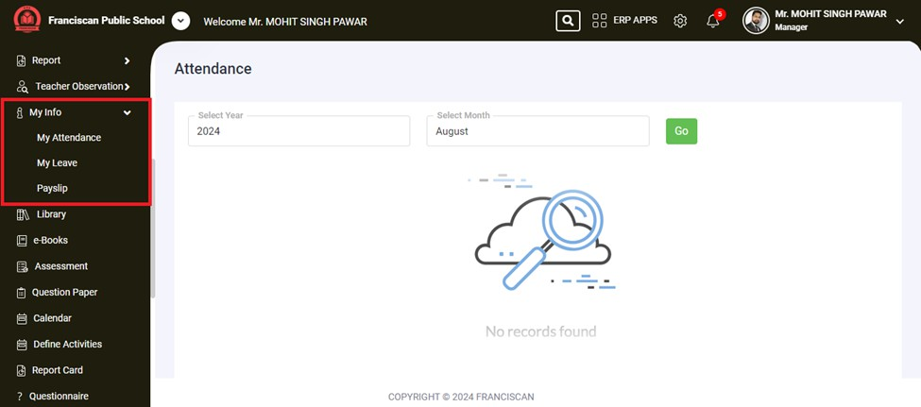

Library: This interface allows users to search for books and manage their library transactions. Here’s a detailed explanation of each section:
- Latest Books: This tab likely displays a list of the most recently added books to the library. Users can browse new arrivals and see what’s new in the library collection.
- My Library Transaction: This tab likely provides access to the user's personal library transactions. Users can view their borrowing history, check due dates, and manage their library account.

- Books: This interface allows users to search for and access digital books.Here’s a detailed explanation of each section:

  - My School Library: This tab likely displays the collection of e-books available in the school’s own digital library. Users can browse and read e-books that the school has provided.
  - Mega e-books Collection: This tab likely provides access to a larger collection of e-books, possibly from an external or partnered source. It expands the range of available e-books beyond what is in the school's own library.
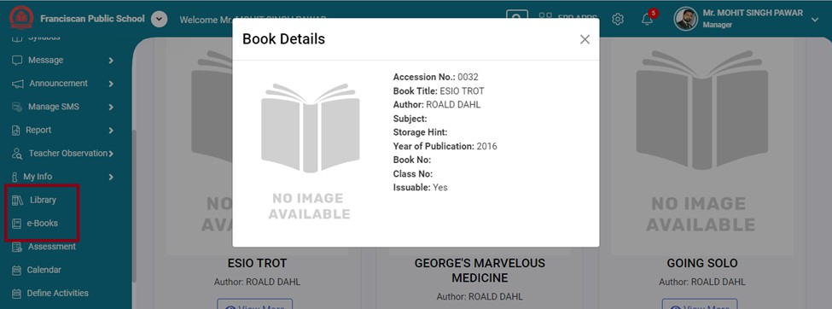

Assessment: Create, manage, and view assessments and exams.

Question Paper: Upload, view, and manage question papers. Calendar: View and manage the school calendar and schedules. Define Activities: Schedule and organize school activities and events. Report Card: To view report cards.
Leave: This interface allows users (likely staff or teachers) to apply for leave, view pending leave requests, and check their leave history.

Apply:

The active tab where users can apply for leave by filling out the necessary details.

Pending:

This tab likely shows the list of leave requests that are pending approval. Users can view the status of their submitted leave applications.

History:

This tab likely displays the history of past leave requests, including approved, rejected, and canceled leaves. Users can review their leave records.

Questionnaire: This interface appears to be designed for users to ask questions or share information.

Thoughts: This interface is designed for users to share their thoughts
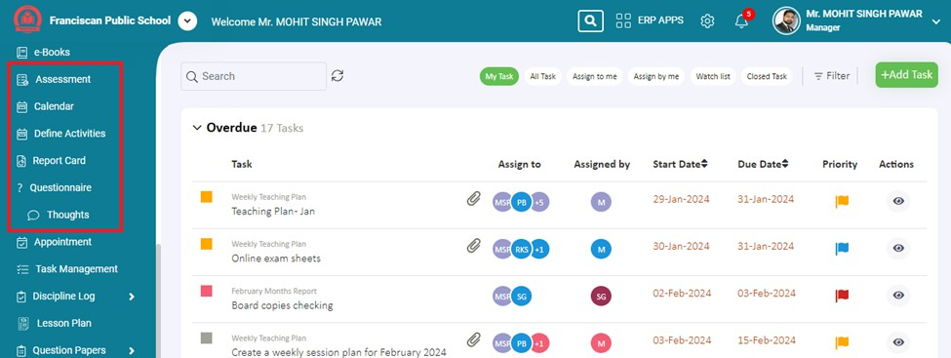

Appointment: This interface provides an organized way for users to manage and view their appointments, ensuring that they can easily keep track of approved, pending, and rejected appointments.

Tabs:

- All: Shows all appointments.
- Only me: Shows appointments that are specifically for the user.
- Today: Filters and shows appointments scheduled for today.
- Upcoming: Filters and shows upcoming appointments.

Approved:
Shows the number of approved appointments. The user can click on this tab to view details of appointments that have been approved.

Pending:
Shows the number of pending appointments. The user can click on this tab to view details of appointments that are awaiting approval.

Rejected:

Shows the number of rejected appointments. The user can click on this tab to view details of appointments that have been rejected.
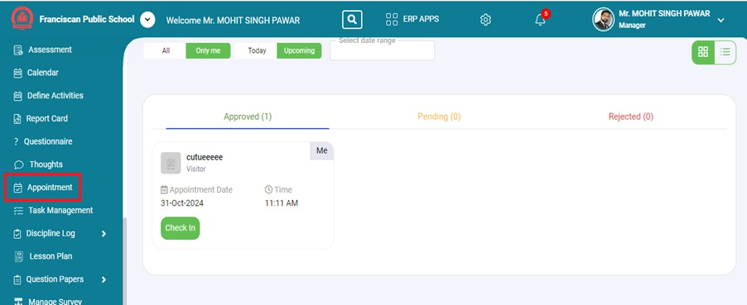

Task Management - This interface allows users to manage and view tasks, particularly focusing on overdue tasks.
Here’s a detailed explanation of each section:

Filters and Actions:

Search Bar:

  - Allows users to search for specific tasks using keywords.

Filter Buttons:

  - My Task: Filters to show tasks assigned to the user.

  - All Task: Displays all tasks.

  - Assign to me: Shows tasks that are specifically assigned to the user.

  - Assign by me: Displays tasks that the user has assigned to others.

  - Watch list: Shows tasks that the user is watching.

  - Closed Task: Displays tasks that have been closed or completed.

  - Filter: Additional filter options to further narrow down the task list.

Add Task Button:

○ + Add Task: Allows the user to add a new task.

Task List:

Task Status:

  - Overdue: Displays tasks that are overdue, with the number of overdue tasks indicated (18 Tasks in this case).

Task Details:

  - Task: The name and category of the task (e.g., General Task List, Weekly Teaching Plan).

  - Assign to: The individuals or groups to whom the task is assigned. Icons with initials represent users.
  - Assigned by: The person who assigned the task.

  - Start Date: The date when the task was started.

  - Due Date: The deadline for completing the task.

  - Priority: Indicates the priority of the task with colored flags (e.g., red for high priority, yellow for medium priority).
  - Actions: An icon (eye) that likely allows the user to view more details about the task.

How to Use This Interface:

View Overdue Tasks:

  - The main list shows tasks that are overdue. Users can see details like the task name, who it’s assigned to, who assigned it, start and due dates, and priority.

Filter Tasks:

  - Use the filter buttons at the top (e.g., My Task, All Task) to narrow down the task list to view specific categories of tasks.

Search for Tasks:

  - Use the search bar to find specific tasks quickly by entering relevant keywords.

Add New Tasks:

  - Click on the "+ Add Task" button to create a new task. This would likely open a form where details about the task can be entered.

View Task Details:

  - Click on the eye icon under the "Actions" column to view more details about a particular task.
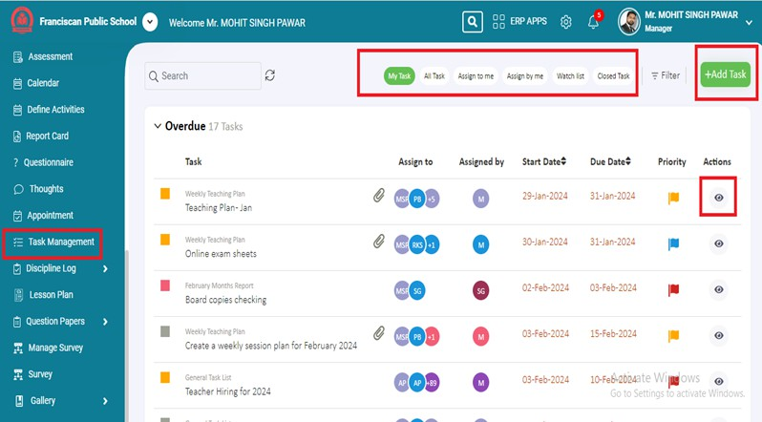

Discipline Log
This section is used to manage and log disciplinary actions and recognitions within the school. Here’s a detailed explanation of each item in the menu:

Menu Items and Functions:

Infraction Types:

  - Allows users to define and manage different types of infractions or rule violations. This could include categories such as tardiness, cheating, bullying, etc.

Consequences:

  - Used to define the consequences or disciplinary actions associated with different infractions. This might include detention, suspension, counseling, etc.

Appreciation Types:

  - Allows users to define various types of appreciations or positive recognitions. This could include categories such as excellent behavior, academic achievements, extracurricular accomplishments, etc.

Appreciation Rewards:

  - Used to define the rewards associated with different types of appreciation. This might include certificates, medals, public recognition, etc.

Appreciation:

  - Allows users to log and manage appreciations given to students. This is where positive behavior and achievements are recorded.

Infraction:

  - Allows users to log and manage infractions committed by students. This is where disciplinary actions are recorded.
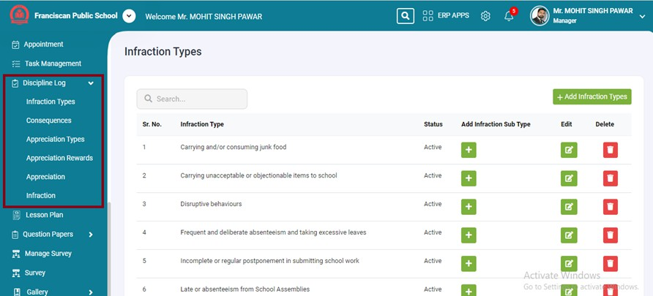

Mark Attendance: This interface is designed for teachers or administrators to mark student attendance for a specific class and subject.

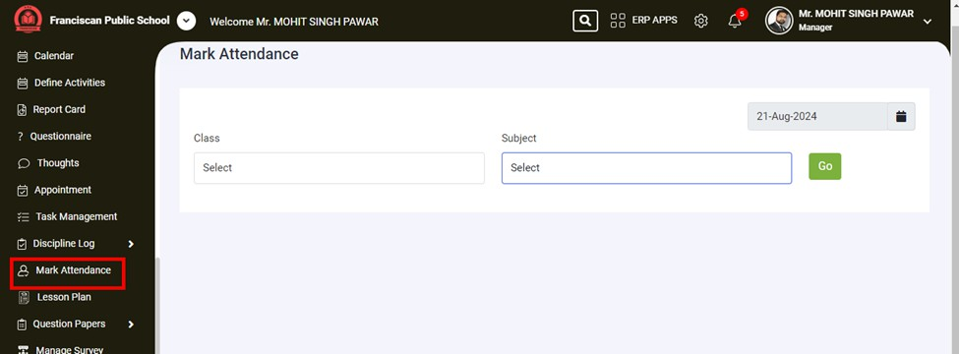

Lesson Plans : This interface is designed for teachers or administrators to create and manage lesson plans.

How to Use This Interface:

Create a New Lesson Plan:

  - Click the "Create Lesson Plan" button to start creating a new lesson plan. This will open a new form where you can enter details such as the lesson objectives, activities, materials needed, and assessment methods.

Filter Existing Lesson Plans:

  - If you have existing lesson plans and want to find specific ones, click the filter icon (funnel shape) to apply filters. You can filter by subject, date, class, or other criteria to narrow down the list of lesson plans displayed.

View and Manage Lesson Plans:

  - Once lesson plans are created and saved, they will appear in the main display area. From there, you can view, edit, or delete lesson plans as needed.

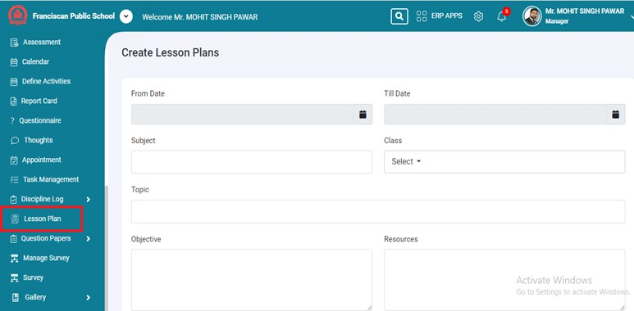

Question Bank : This interface helps teachers and administrators efficiently manage a repository of questions that can be reused for various assessments

How to Use This Interface:

Add a New Question:

  - Click the "Add Question Bank" button to open the "Add Question" page.

  - Fill in the details such as question type, class, subject, chapter, weightage, and the question text.

  - Attach any relevant files if necessary.

  - Click the "Post Question" button to save the question.

Search for Questions:

  - Use the search bar on the main page to find specific questions by entering relevant keywords.

Edit or Delete Questions:

  - Use the "Edit" and "Delete" options in the respective columns to modify or remove existing questions from the question bank.

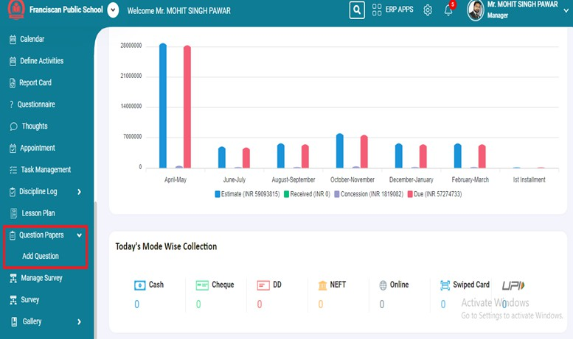

Survey : This interface allows users to view and manage surveys that have been published, including information on the survey's publication date, open period, and the user's response date.

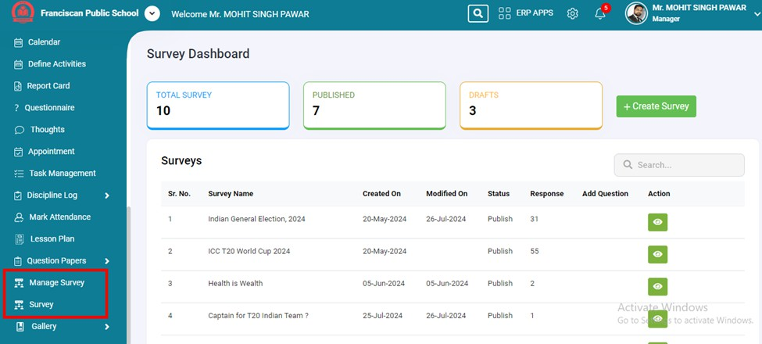

Gallery: This section is used to manage and view various types of media, including photos and videos.

Photo Albums:

- Users can view collections of photos uploaded on the school website.

Video Albums:

- Users can view collections of videos organized into albums.

Favorites:

- Allows users to access their favorite media items. Users can mark certain photos or videos as favorites for quick and easy access.

Media Gallery:

- Provides access to all media contents.

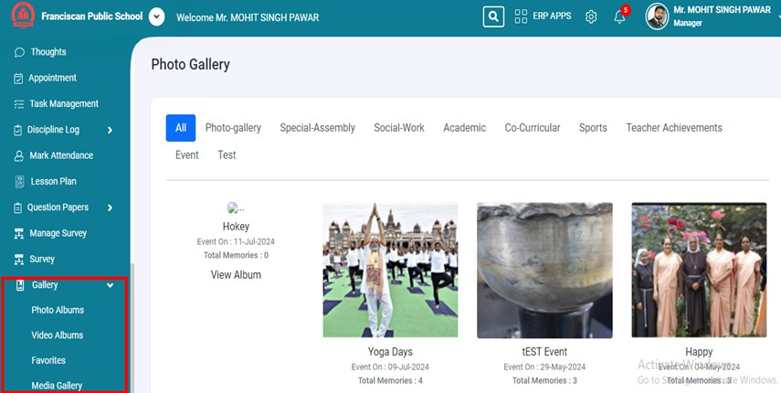

- The ERP Apps tab, located on the right-hand side of the title bar, provides users with access to various modules, including Fees, Payroll, Admission, Library, Attendance, Time Table, Marks Manager, and others. This tab serves as a centralized hub, allowing users to conveniently access all these modules from a single location.

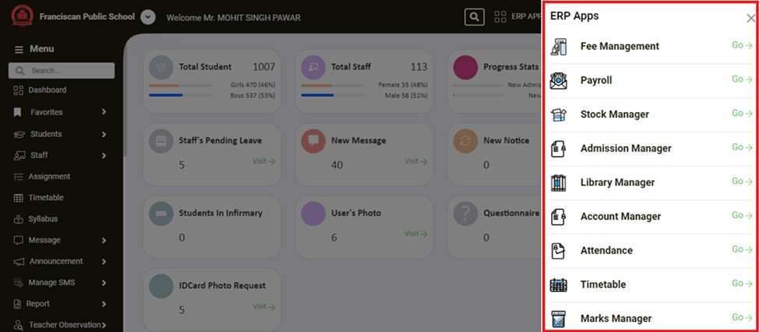

- The Settings tab, located on the right-hand side of the title bar, allows users to grant permissions for different modules to various users, including staff members, students, parents, and other members. This tab enables the control of content visibility based on the roles assigned to each user, ensuring that the appropriate information is accessible to the right individuals.

